Seoul Air 2017 DM Featureplot

Minjung Kang

Tue Dec 11 11:11:11 2018

rm(list=ls())

> A <- read_csv("KMJ037_(SeoulAir)c.csv")  
> A$Y <-as.factor(A$Y)  
> A$Time <-as.factor(A$Time)  
> A$Date <-as.factor(A$Date)  
> A$District <-as.factor(A$District)  
>   
> set.seed(123)

### Data Visualization - featureplot

> X <- A[, 4:8]  
> Y <- A$Y  
>   
>   
> myS <- visualizationFUN(X,Y, "scatter")  
> myS

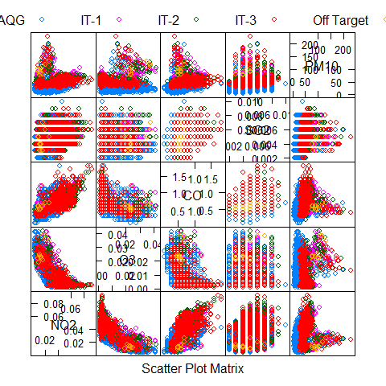

> myE <- visualizationFUN(X,Y, "ellipse")  
> myE

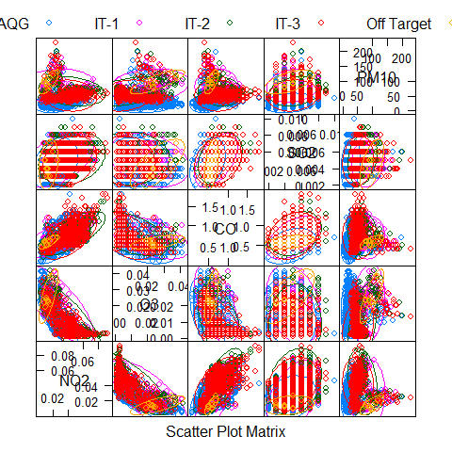

> myD <- visualizationFUN(X,Y, "density")  
> myD

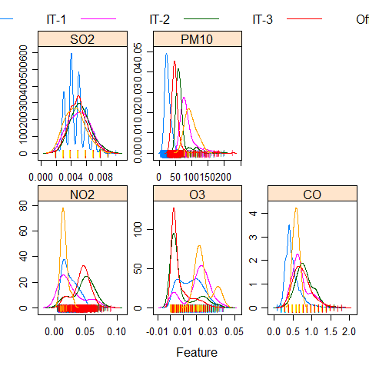

> myB <- visualizationFUN(X,Y, "box")  
> myB

