Seoul Air Pollution ggplot

MinJung Kang

2018-12-12

### Boxplot by District

G_District <- ggplot(A,  
 aes(x = District,  
 y = PM2.5,  
 group = District)) + theme_bw() + theme(axis.text.x = element_text(angle = 45,  
 hjust = 1,  
 vjust = 1))  
G_District + geom_boxplot()

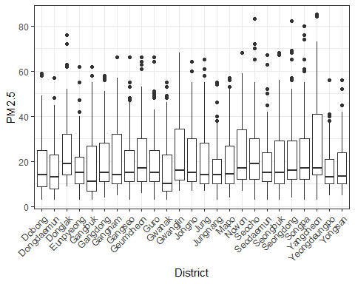

### Boxplot by Date

A$Date <- as.factor(A$Date)  
G_Date <-ggplot(A, aes(x= Date, y= PM2.5,  
 group = Date,  
 fill = Date))  
G_Date + geom_boxplot() + theme_bw() + theme(axis.text.x = element_text(angle = 45,  
 hjust = 1,  
 vjust = 1))

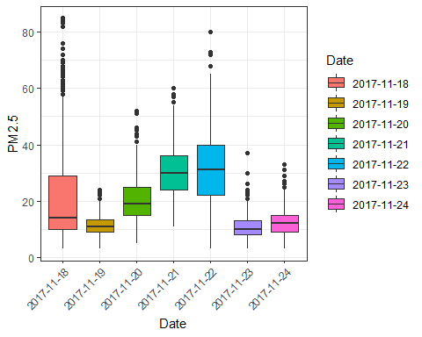

### Boxplot by Time

G_Time <-ggplot(A, aes(x= Time, y= PM2.5,  
 group = Time))  
G_Time + geom_boxplot() + theme_bw()

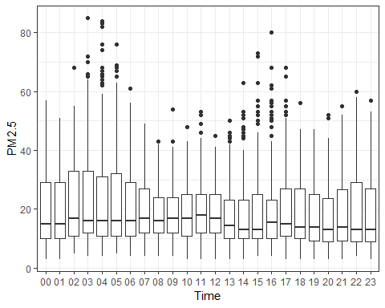

### Scatterplot

G_point <- ggplot(data = A,  
 aes(x = PM2.5, y = PM10))  
G_point + geom_point() + geom_smooth() + theme_bw()

## `geom_smooth()` using method = 'gam' and formula 'y ~ s(x, bs = "cs")'

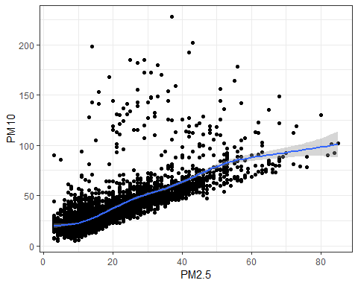

### Scatterplot

G1 <- ggplot(data = A,  
 aes(x = PM2.5, y = NO2, color = Y, fill = Y)) + geom_point(alpha=0.3) + theme_bw()  
G2 <- ggplot(data = A,  
 aes(x = PM2.5, y = O3, color = Y, fill = Y)) + geom_point(alpha=0.3) + theme_bw()  
G3 <- ggplot(data = A,  
 aes(x = PM2.5, y = CO, color = Y, fill = Y)) + geom_point(alpha=0.3) + theme_bw()  
G4 <- ggplot(data = A,  
 aes(x = PM2.5, y = SO2, color = Y, fill = Y)) + geom_point(alpha=0.3) + theme_bw()  
G5 <- ggplot(data = A,  
 aes(x = PM2.5, y = PM10, color = Y, fill = Y)) + geom_point(alpha=0.3) + theme_bw()  
  
grid.arrange(G1, G2, G3, G4, G5, nrow = 3)

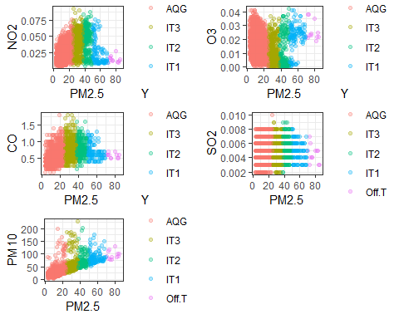

### Scatterplot Extra

P1 <- ggplot(data = A, aes(x = PM2.5, y = PM10)) + geom_point(alpha=0.3) + theme_bw()  
P2 <- ggMarginal(P1, type="density")  
P3 <- ggMarginal(P1, type="boxplot")  
P4 <- ggMarginal(P1, type="histogram")  
  
grid.arrange(P1, P2, P3, P4, nrow = 2)

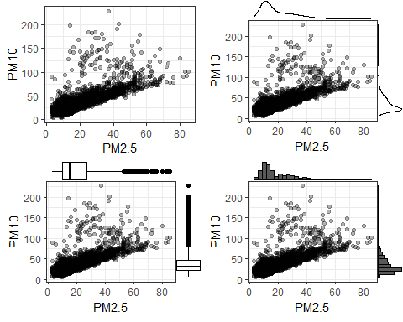

### Histogram PM2.5

Histo <- ggplot(A, aes(x = PM2.5)) + theme_bw()  
Histo + geom_histogram(bins=10)

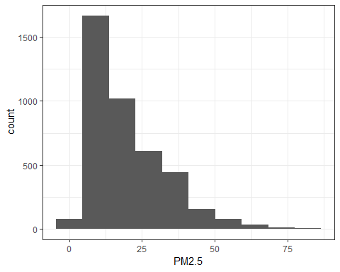

Histo + geom_histogram(binwidth=10)

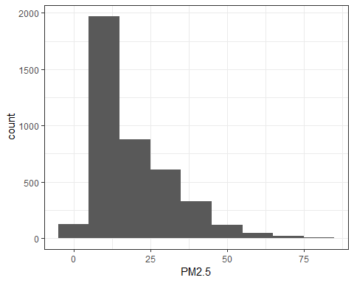

### Histogram PM10

Histo10 <- ggplot(A, aes(x = PM10)) + theme_bw()  
Histo10 + geom_histogram(bins=10)

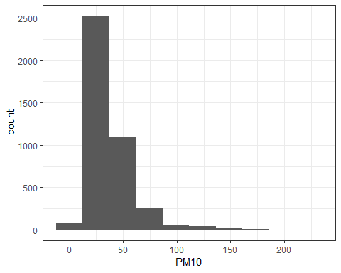

Histo10 + geom_histogram(binwidth=10)

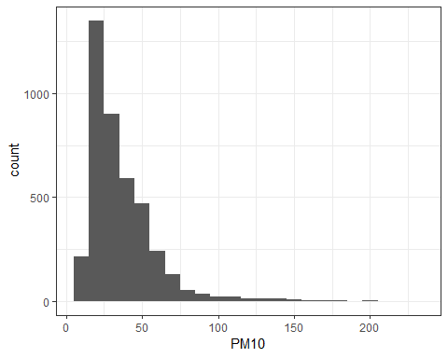

### Density PM2.5

Dens <- ggplot(A, aes(x=PM2.5)) + theme_bw()  
Dens + geom_density()

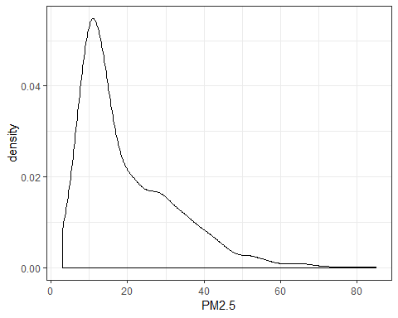

### Density by Date

Dens_Date <- ggplot(A, aes(x=PM2.5, color= Date, fill = Date))  
Dens_Date + geom_density(alpha=0.2) + theme_bw()

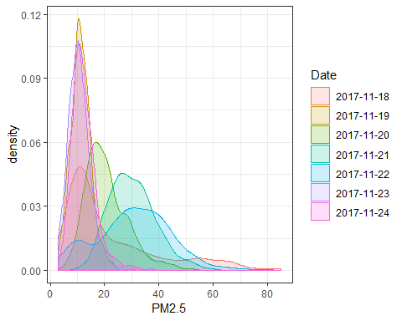

### Bar by Airclass

A$Date <- as.factor(A$Date)  
A$Time <- as.factor(A$Time)  
A$airclass <- as.factor(A$Y)  
  
  
Date_Bar <- ggplot(data = A, aes(x = Date , fill = Y))  
Date_Bar + geom_bar(position="fill") + theme_bw()

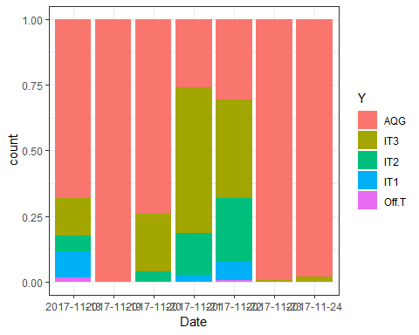

District_Bar <- ggplot(data = A, aes(x = District , fill = Y))  
District_Bar + geom_bar(position="fill") + theme_bw() + theme(axis.text.x =  
 element_text(angle = 45,  
 hjust = 1,  
 vjust = 1))

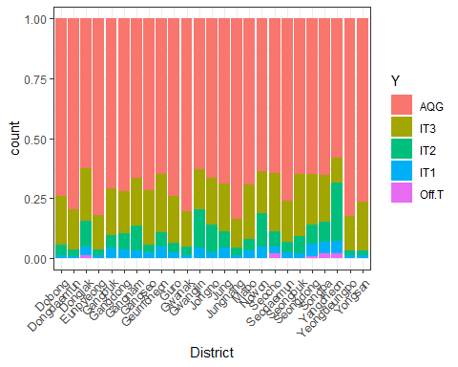

Time_Bar <- ggplot(data = A, aes(x = Time , fill = Y))  
Time_Bar + geom_bar(position="fill") + theme_bw()

