Section (7) group 2

- هايدى عاطف زكريا - منال ثابت نتعى

- نبيل نشات نبيل - مينا صلاح ذكي - منار اسحق كامل - نورهان حنا لويز

- نانسي يوسف يعقوب

Parking system

System Request_ parking system

|  |  |
| --- | --- |
| Project sponsor | , management the project, parking system |
| Business  Need | The officials of this project consider that it is a system to provide places, prevent street congestion and reduce accidents that occur to cars that are parked on the streets, and that it provides places in public facilities, international shopping centers or even universities, which is difficult to find places to park cars in such these places |
| Business  Requirements | By using this system through the mobile application, which will be downloaded or downloaded, whether it is Android or iOS, the places will be reserved inside the building to park the car. This building is next to shopping places, malls, universities, malls or crowded places where it is difficult to park cars.  Customers will be able to reserve parking spaces through the application with ease and pay the reservation fees through the application on their phones  And it also allows the user to extend the period of reservation of places as he wants  If the customer frequents this place, he can reserve a place for a period of more than one day, extending to a week or a month, as he likes, which provides the customer with comfort and safety to his car. |
| Business Value | With the start of the project, it will be a new idea for the users, and with the crowding, the number of users will increase  And we expect and increase the number of users through crowding and increasing the number of cars used, choosing places where there are many cars that need to be parked.  And thus increase the income  Provide offers to users and thus increase the number of users and increase the income  Ease of payment and parking, which facilitates the process of parking for users, and thus increase users  Customer subscriptions on a weekly, monthly or annual basis will increase income  Making the building work day and night, i.e. day and night periods $30,000  Ease of payment and parking, which facilitates use and increases the number of users $ 55,000  Reducing maintenance cycles by $20,000  Increased consumer use over time $65,000  Placing the building in shopping areas, which increases the number of consumers and increases income by $85,000 |

|  |  |
| --- | --- |
| Special Issues  Or Constraints | The difficulty of having places to make the building next to shopping places or crowding places in general  The high cost of the building  The long time it will take To create this system |

Feasibility Analysis Assessment Factors:

* Technical Feasibility:

Tune source’s risk regarding Familiarity with application is moderately low.

* Due to the recent technological development, the user has experience in dealing with mobile applications, whether it is iOS or android, in addition to the ease of using the building system.
* The marketing department has a very suitable environment for this project due to the need for it in addition to their experience in marketing.
* Engineers and programmers have extensive experience in android and iOS, in addition to external support from programmers and engineers with experience in building system.

Tune source’s risk regarding Familiarity with Technology is moderately low.

* The It department has knowledge of databases and internet technology.
* Consultants are readily available provide help in this project.

The project size is considered complex.

* The project team will likely consist of 4 programmers ,3 Engineers and 4 marketers and Lots of workers at the beginning of the project.
* The project time frame about 5 years somewhat critical, since the system is needed to maintain our competitive position in the market.
* One of the advantages of the project is that it provides parking spaces in crowded places at reasonable prices and safety and provides easy-to-use services for the user.

The compatibility with tune source’s existing technical infrastructure should be good.

* The application, the system, and the elements of each are harmoniously matched.
* There are few risks in project.
* Economic Feasibility:

|  |  |
| --- | --- |
| DEVELOPMENT COSTS | OPERATIONAL COSTS |
| development training  hardware and software  data conversion costs  vendor installation  consultant fees  office space and equipment  Development team salaries | software licensing fees  Hardware upgrades.  Communications charges  software upgrades  Hardware repairs  User training |
| Tangible Benefits | Intangible Benefits |
| Reductions in staff  Reductions in IT costs  Increased sales | Increased brand recognition  Improved customer service  Increased market share |

|  |  |  |  |  |  |  |
| --- | --- | --- | --- | --- | --- | --- |
|  | 2023 | 2024 | 2025 | 2026 | 2027 | Total |
| Benefits |  |  |  |  |  |  |
|  |  |  |  |  |  |  |
| Increased sales |  | 250,000 | 350,000 | 400,000 | 470,000 | 1,470,000 |
| Reduction in customer complaints calls |  | 150,000 | 250,000 | 250,000 | 250,000 | 900,000 |
| Reduced inventory costs |  | 100,000 | 100,000 | 150,000 | 150,000 | 500,000 |
| Total Benefits |  | 500,000 | 700,000 | 800,000 | 870,000 | 2,870,000 |
|  |  |  |  |  |  |  |
| Development Costs |  |  |  |  |  |  |
| 2 servers @ $250,000 | 100,000 | 0 | 0 | 0 | 0 | 100,000 |
| Preparing the building | 100,000 | 0 | 0 | 0 | 0 | 100,000 |
| Build Database | 80,000 | 0 | 0 | 0 | 0 | 80,000 |
| Prepare QR Code | 50,000 | 0 | 0 | 0 | 0 | 50,000 |
| Software license | 100,000 | 0 | 0 | 0 | 0 | 100,000 |
| Server software | 120,000 | 0 | 0 | 0 | 0 | 120,000 |
| Development labor | 150,000 | 0 | 0 | 0 | 0 | 150,000 |
| Total Development Costs | 700,000 | 0 | 0 | 0 | 0 | 700,000 |
|  |  |  |  |  |  |  |
| Operational Costs |  |  |  |  |  |  |
| Hardware |  | 100,000 | 100,000 | 250,000 | 250,000 | 700,000 |
| Software |  | 70,000 | 70,000 | 200,000 | 200,000 | 540,000 |
| Operational labor |  | 60,000 | 60,000 | 100,000 | 100,000 | 320,000 |
| Update |  | 70,000 | 70,000 | 50,000 | 50,000 | 240,000 |
| Total Operational Costs |  | 300,000 | 300,000 | 600,000 | 600,000 | 1,800,000 |
|  |  |  |  |  |  |  |
| Total Costs | 700,000 | 300,000 | 300,000 | 600,000 | 600,000 | 2,500,000 |
|  |  |  |  |  |  |  |
| Total Benefits – Total Costs | (700,000) | 200,000 | 400,000 | 200,000 | 270,000 | 370,000 |
|  |  |  |  |  |  |  |
| Cumulative Net Cash Flow | (700,000) | (500,000) | (100,000) | 100,000 | 370,000 |  |
|  |  |  |  |  |  |  |
| Return on Investment (ROI) |  | ((2,870,000-2,500,000)/2,500,000) *100=14.8%s |  |  |  |  |
|  |  |  |  |  |  |  |
| Break-Event Point |  | 2+((200,000-100,000)/200,000) = 2.5 Years |  |  |  |  |

|  |  |  |
| --- | --- | --- |
|  | | |
|  | 2023 | 2024 | | 2025 | 2026 | 2027 | Total |
| **Benefits** |  |  | |  |  |  |  |
| Increased sales |  | 250,000 | | 350,000 | 400,000 | 470,000 | 1,470,000 |
| Reduction in customer complaints calls |  | 150,000 | | 250,000 | 250,000 | 250,000 | 900,000 |
| Reduced inventory costs |  | 100,000 | | 100,000 | 150,000 | 150,000 | 500,000 |
| **Total Benefits** |  | 500,000 | | 700,000 | 800,000 | 870,000 | 2,870,000 |
| **Present Value Total Benefits** |  | 454,545.4545 | | 578,512.3967 | 601,051.8407 | 594,221.7062 | 2,228,331.398 |
| **Development Costs** |  |  | |  |  |  |  |
| 2 servers @ $250,000 | 100,000 | 0 | | 0 | 0 | 0 | 100,000 |
| Preparing the building | 100,000 | 0 | | 0 | 0 | 0 | 100,000 |
| Build Database | 80,000 | 0 | | 0 | 0 | 0 | 80,000 |
| Prepare QR Code | 50,000 | 0 | | 0 | 0 | 0 | 50,000 |
| Software license | 100,000 | 0 | | 0 | 0 | 0 | 100,000 |
| Server software | 120,000 | 0 | | 0 | 0 | 0 | 120,000 |
| Development labor | 150,000 | 0 | | 0 | 0 | 0 | 150,000 |
| **Total Development Costs** | 700,000 | 0 | | 0 | 0 | 0 | 700,000 |
|  |  |  | |  |  |  |  |
| **Operational Costs** |  |  | |  |  |  |  |
| Hardware |  | 100,000 | | 100,000 | 250,000 | 250,000 | 700,000 |
| Software |  | 70,000 | | 70,000 | 200,000 | 200,000 | 540,000 |
| Operational labor |  | 60,000 | | 60,000 | 100,000 | 100,000 | 320,000 |
| Update |  | 70,000 | | 70,000 | 50,000 | 50,000 | 240,000 |
| **Total Operational Costs** |  | 300,000 | | 300,000 | 600,000 | 600,000 | 1,800,000 |
|  |  |  | |  |  |  |  |
| **Total Costs** | 700,000 | 300,000 | | 300,000 | 600,000 | 600,000 | 2,500,000 |
| **Present Value Total Cost** | 700,000 | 272,727.2727 | | 247,933.8843 | 450,788.8805 | 409,808.0732 | 2,081,258.111 |
| **NPV (PV Total Benefits -PV Total Costs)** |  |  | |  |  |  | 147,073.287 |

* Organizational Feasibility

|  |
| --- |
| Leader A leader: (Mina Salah)  . Initiates the project  . Allocates his or her time to the project  . Promotes the project  . Provides resources  Analysis A analyst: (Nabil Nashat)  Analysis A design: (Nancy Yousuf)  Planning A planer: (Manal Thabet and Manar Ishaq)  Programmers A programmer: (Nourhan Hanna and Heidi Atef)  . make and Android or iOS app  . make the database  . make the system of building  Organizational  management  . Organizational management  . Know about the project  . Budget enough money for the project  . Encourage users to accept and use the system  System users  . Users who use this system must have cars  . users must be over +18 years old |

Work plan

|  |  |  |  |  |  |  |  |  |  |  |
| --- | --- | --- | --- | --- | --- | --- | --- | --- | --- | --- |
|  |  |  | Estimated | | | Actual | | |  |  |
| Task ID | Task Name | Assigned To | Duration  (Days) | Start Date | Finish Date | Start Date | Finish Date | Duration  Variance | Dependency | Status |
| 1 | Planning | Manar Isaac, Mina Salah, Manal Thabet | 122 | 1/1/2023 | 30/4/2023 |  |  |  |  |  |
| 1.1 | System Request | Mina Salah, Manar Isaac | 31 | 1/1/2023 | 31/1/2023 |  |  |  |  | Open |
| 1.1.1 | Business Need | Manar Isaac | 6 | 1/1/2023 | 6/1/2023 |  |  |  |  | Open |
| 1.1.2 | Business Requirements | Manar Isaac | 9 | 7/1/2023 | 15/1/2023 |  |  |  | 1.1.1 | Open |
| 1. 1.3 | Business Value | Mina Salah | 10 | 16/1/2023 | 25/1/2023 |  |  |  | 1.1.2 | Open |
| 1.1.4 | Special Issues  Or Constraints | Mina Salah | 6 | 26/1/2023 | 31/1/2023 |  |  |  | 1. 1.3 | Open |
| 1.2 | Schedule | Manal Thabet | 19 | 1/2/2023 | 19/2/2023 |  |  |  | 1.1 | Open |
| 1.3 | Budget | Manal Thabet | 12 | 20/2/2023 | 3/3/2023 |  |  |  |  | Open |
| 1.4 | Resources | Manal Thabet | 12 | 4/3/2023 | 15/3/2023 |  |  |  | 1.3 | Open |
| 1.5 | Organizing | Haidy Atef | 28 | 16/3/2023 | 12/4/2023 |  |  |  | 1.4 | Open |
| 1.5.1 | Provide  resources | Haidy Atef | 10 | 16/3/2023 | 25/3/2023 |  |  |  | 1.4 | Open |
| 1.5.2 | Search about needs of users | Haidy Atef | 10 | 26/3/2023 | 4/4/2023 |  |  |  | 1.5.1 | Open |
| 1.5.3 | Feedback | Haidy Atef | 8 | 5/4/2023 | 12/4/2023 |  |  |  | 1.5.2 | Open |
| 1.6 | Risk | Manal Thabet | 18 | 13/4/2023 | 30/4/2023 |  |  |  | 1.5 | Open |
| 2 | Analysis | Nancy Youssef | 31 | 1/5/2023 | 31/5/2023 |  |  |  | 1 |  |

|  |  |  |  |  |  |  |  |  |  |  |
| --- | --- | --- | --- | --- | --- | --- | --- | --- | --- | --- |
| 2.1 | System proposal | Analysist | 3 | 1/5/2023 | 3/5/2023 |  |  |  |  |  |
| 2.2 | Develop analysis strategy | Nanay  Yousuf | 6 | 4/5/2023 | 9/5/2023 |  |  |  |  | open |
| 2.2.1 | Business analysis | Analysist | 6 | 4/5/2023 | 9/5/2023 |  |  |  |  | open |
| 2.3 | Determine business requirements | Analysist | 9 | 10/5/2023 | 18/5/2023 |  |  |  | 2.2 | open |
| 2.3.1 | Interview | Nancy  Yousuf | 9 | 10/5/2023 | 18/5/2023 |  |  |  |  | open |
| 2.3.2 | Questionnaire | Analysist | 9 | 10/5/2023 | 18/5/2023 |  |  |  |  | open |
| 2.3.3 | Group workshop | Analysist | 9 | 10/5/2023 | 18/5/2023 |  |  |  |  | open |
| 2.4 | Create concept for new system | Analysist | 5 | 19/5/2023 | 23/5/2023 |  |  |  | 2.2,2.3 | open |
| 2.5 | Create model | Analysist | 8 | 24/5/2023 | 31/5/2023 |  |  |  | 2.2,2.3,2.4 | open |
| 2.5.1 | Infrastructure analysis | Nancy  Yousuf | 2 | 24/5/2023 | 25/5/2023 |  |  |  |  | open |
| 2.5.2 | Process model | Nancy  Yousuf | 3 | 26/5/2023 | 28/5/2023 |  |  |  |  | open |
| 2.5.3 | Data model | Analysist | 3 | 29/5/2023 | 31/5/2023 |  |  |  | 2.5.2 | open |
| 3 | Design phase |  | 61 | 1/6/2023 | 31/7/2023 |  |  |  |  |  |
| 3.1 | Building design |  | 30 | 1/6/2023 | 1/7/2023 |  |  |  |  | open |
| 3.1.1 | electrical design of the building | The electrical engineers | 10 | 1/6/2023 | 10/6/2023 |  |  |  |  | open |
| 3.1.2 | mechanical design of the building | The mechanical engineers | 10 | 11/6/2023 | 20/6/2023 |  |  |  | 3.1 | open |
| 3.1.3 | programing design of the building | The software engineers | 10 | 21/6/2023 | 30/6/2023 |  |  |  | 3.1 , 3.2 | open |
| 3.2 | Application design | Nabil Nashaat | 31 | 1/7/2023 | 31/4/2023 |  |  |  |  | open |
| 3.2.1 | Design the database | Nabil Nashaat | 15 | 1/7/2023 | 15/7/2023 |  |  |  |  | open |
| 3.2.2 | Make the UI & UX design | Nabil Nashaat | 16 | 16/7/2023 | 31/7/2023 |  |  |  |  | open |
| 4 | Implementation | Nourhan Hanna | 153 | 1/8/2023 | 31/12/2023 |  |  |  |  |  |
| 4.1 | Application | Nourhan Hanna | 92 | 1/8/2023 | 31/10/2023 |  |  |  |  |  |
| 4.1.1 | Build Database | Nourhan Hanna | 31 | 1/8/2023 | 31/8/2023 |  |  |  |  |  |
| 4.1.2 | Build Frontend | Nourhan Hanna | 31 | 1/8/2023 | 31/8/2023 |  |  |  |  |  |
| 4.1.3 | Test Frontend | Nourhan Hanna | 17 | 1/9/2023 | 17/9/2023 |  |  |  | 4.1.2 |  |
| 4.1.4 | Build Backend | Nourhan Hanna | 31 | 1/8/2023 | 31/8/2023 |  |  |  |  |  |
| 4.1.5 | Test Backend | Nourhan Hanna | 17 | 1/9/2023 | 17/9/2023 |  |  |  | 4.1.4 |  |
| 4.1.6 | Integration | Nourhan Hanna | 13 | 18/9/2023 | 30/9/2023 |  |  |  | 4.1.3, 4.1.5 |  |
| 4.1.7 | App Test | Nourhan Hanna | 16 | 1/10/2023 | 16/10/2023 |  |  |  | 4.1.6 |  |
| 4.1.8 | Repair app problems if exist | Nourhan Hanna | 15 | 17/10/2023 | 31/10/2023 |  |  |  |  |  |
| 4.2 | The Building | Nourhan Hanna | 92 | 1/8/2023 | 31/10/2023 |  |  |  |  |  |
| 4.2.1 | Build the building | Nourhan Hanna | 61 | 1/8/2023 | 30/9/2023 |  |  |  |  |  |
| 4.2.2 | Electricity System | Nourhan Hanna | 31 | 1/10/2023 | 31/10/2023 |  |  |  | 4.2.1 |  |
| 4.2.3 | Mechanic System | Nourhan Hanna | 31 | 1/10/2023 | 31/10/2023 |  |  |  | 4.2.1 |  |
| 4.3 | Link the system of the building with the app | Nourhan Hanna | 30 | 1/11/2023 | 30/11/2023 |  |  |  | 4.1,4.2 |  |
| 4.4 | Test whole system | Nourhan Hanna | 16 | 1/12/2023 | 16/12/2023 |  |  |  | 4.3 |  |
| 4.5 | Training Users | Nourhan Hanna | 15 | 17/12/2023 | 31/12/2023 |  |  |  | 4.4 |  |

|  |  |  |  |
| --- | --- | --- | --- |
| Name | position | Purpose of interview | Meeting |
| **Leonardo DiCaprio** | **user** | **Opinion in the System** | **Mon , March 1**  **8 :00-90:00 PM** |
| **Brad Pitt** | **Manager** | **Inquire about the system and how it works and other things in the system** | **Wed, March 1**  **4:00 -4:25 PM** |
| **Jason Statham** | **Supervisor** | **Inquire about the building, how it is built, materials used, quality, and so on** | **Mon, March 1**  **1 :00 – 1:40 PM** |
| **Andrew Rafeek** | **user** | **The problems he faces with parking and his opinion on the application and its idea** | **Fri, March 25 6:00-7:00** |
| **Ahmed Ezzat** | **Student at FCI** | **Problems and needs** | **Tue, March 29 8:00-9:00 P.M** |
| **Beshoy Fayez** | **User** | **Get customer’s feed back about current abdication features** | **Mon. march 1**  **8:00:9:00 pm** |
| **John Amir** | **project manager** | **Understand how to manage the project, the most important points that management focuses on** | **Tue, March 17 7:00-8:00 P.M** |
| **Eng:Hany Zakaria** | **User of car and he is engineer of electricity** | **We want to know his opinion on the idea of the parking project and he will help us a lot because he is an electrical engineer, he will quickly understand the idea of the project and we will know some information about his use of his car** | **Friday**  **March 25**  **6:00-7:00pm** |
| **Mounir tharwat** | **Student at the Faculty of Civil Engineering, Assiut University** | **We will know his superficial opinion about the idea of the project, especially the building and its system** | **Saturday**  **March 26**  **2:00-2:30pm** |
| **Mostafa hassan** | **Car shop manager** | **We will know from him which problems are faced while manufacturing cars and a lot of information about users of cars** | **Monday**  **March 28**  **10:00-11:00am** |
| **Aly Mohamed** | **User of car** | **We will know from him what problems he faces in his car on the road and when he park his car** | **Wednesday**  **March30**  **3:00-3:30pm** |

Interviews:

|  |
| --- |
| **Interview Notes Approved by:** Leonardo DiCaprio, Brad Pitt, Jason Statham |
| Person Interviewed: Leonardo DiCaprio, Brad Pitt, Jason Statham  Interviewer: Mina Salah  Purpose of interview:   * Opinion in the System. * Inquire about the system and how it works and other things in the system. * Inquire about the building, how it is built, materials used, quality, and so on.   Summary of interview:  User:  Presenting the system to the user, what is their opinion of the system and how to use the applications in the system and work on them and what is not surprising about the system? What can it change and what do you think is good? And the places where the building will be located, the offers it will present, and the publicity that will happen to the system.  Manager:  What is the idea of ​​the project, what are the problems of the project, during the construction period of the project, the expected profits and the break event point of the project, and is the project hinging in Egypt or not?  supervisor  A question about the building details, the number of floors, and what raw materials are used in terms of hardware, electricity, programming, the quality of the materials used, the experience of the people who worked on the system, and more details.  Open Items:   * Do you think the project will succeed in Egypt? * What is the actual cost of the building? * Does the room accommodate one or more cars?   Detailed Notes:  1 What do you think about crowding problems?  I see that congestion precedes problems for many people, accidents and exploitation of people in parking spaces  2 Ok, if we create a system that solves these problems, it will not be good  Of course, it will be good, especially if it solves the problem of congestion and cars that will be parked on the sides of the sidewalk or in parking spaces.  3 Ok, do you like when you go to the building to book such periods, or what are the periods that you can book?  By God, I will see I will sit like this, and on this basis, I will book. I mean, I can book an hour or two or three or five or a whole day, but if there are offers, I can make more than this, but the important thing is that you are safe  4 Ok, what do you think of a building in crowded places to park?  I don't understand. Explain what you mean if I can't park the cars far from the streets, crowds, and parking spaces  5-Ok, what do you think is special in the building that saves you from parking easily?  - I mean, if, for example, it is possible to enter the atmosphere of the building while it is parked with itself, it will remain well and pure, and the building will be solid or strong, and the car will be safe and away from theft  6 You like to pay me?  I mean, if online, it will be fine at all. I mean, I can pay the bank account, or Fawry, or anything else online  7 Ok, what quality of protection system do you like for the building so that cars are not stolen?  Ah, the protection system is at the highest level, because you don't have to pay money and leave the car, and I'm afraid for it  8 Ok, where do you expect the building to be located?  It can be found in international shopping places, large malls, partnerships, and so on  9 Ok, there will be an application on the phone for payment and reservation, what do you think of it?  Aha, this will be good and will save people a lot of their time, especially people who stay busy, but they work on IOS and Android  10 What do you think if every Arab woman has a room alone, or it is not normal for her to have more than one Arab woman in the place of one room  I don't know how, by God, but if he remains safe and does not happen to the Arabic something normal  11 What do you think is the average payment range, and people do not disclose that the prices are high?  I mean, it can be in a range of 20 to 50 dollars per hour  12 If we make offers because people are tempting people to stop, I mean, the longer the period increases, there will be more discount offers  Aha, this will be very good, especially if someone is going to be sitting for a long time, and it will not be clear that the price will be high.  13 Ok, if we make advertisements for the building, it will not be better because people know the system  Of course, because people know everything about the building, and I hope there will be an explanation from A to Z  And I hope there is an explanation for every need in the system, for example, prices and periods, reservation, method of payment, protection for payment, and pictures showing this.  14 The last question, which provinces can this system be in?  I think it means the governorates that are known for their overcrowding, especially Cairo and Giza  1 What is the idea of ​​the project?  It is a system based on a number of things, the first of which is the building in which cars are parked and applied. The reservation and payment are made through it, and there remain grace periods for the reservation, and if it ends, the reservation and payment and the money that were paid are lost.  2 The idea of ​​the project, where did you get it?  - The idea is through the congestion problems that we see every day in public places and places where there is a high density of residents who have cars  3 It will take a long time to use, and if it does, it is not possible for new ideas to come out that will be better.  Aha, it's going to take a long, long time  It takes a long time, about a year, to be established, but since the idea is new and it did not happen in Egypt before that, and there will be many offers, this will make us number one in Egypt  4 Ok, he will answer what I behave in this way  I mean, about 2.5 years later  5 You think the project is easy in Egypt  Aha, because there are a lot of cars in Egypt  6 Ok, do you think what good offers you can offer for customers?  There are many offers. You can discuss with the department in question about this  7 Ok, who are the people who benefit from this system, or this system is not limited to whom?  Anyone who has a car and has a license to ensure that the person is the owner, not the car thief?  8 What is the cost of the whole building  By God, the building differs from one facility to another, according to the quality of the things that have been used  1 What are the working periods of the building during construction  Work periods from 8 am to 4 pm, work will be done every day, and during maintenance, work will be from 8 pm to 4 am  2 What are the quality of the people who will work in the building and how much experience do they have?  The highest level of efficiency, as there is a team for each specialty and they have worked on such a project before  3 What type of elevator is used?  It is made of very durable materials to bear the weight of cars and was imported from Germany, especially to this building, and it is a type of cart  4 How many people are in each team?  Five people per team  5 What are the places of construction of the building  It will be in crowded places and the first building will be built in Cairo  6 What is the number of floors of the building and the area of ​​each floor and how many cars will it accommodate  It will consist of seven floors, and each floor will accommodate approximately 20 cars. |

|  |
| --- |
| **Interview Notes Approved by:** Beshoy Fayez |
| **person interviewed:** _ Beshoy Fayez  Automotive Software Engineer  **Interviewer:** _ Manal Thabet  **purpose of interview**  - Get customer feedback about current application features  - Get more information about the customer needs to improve and add new features to  the application  - Determine the suggested proper price for the system services  **Summary of interview**  - Adding points and offers to encourage the customers  - Adding parking lots for bikes and motorcycles  - It is preferable to start with Malls  **Expected challenge and Proposed solutions to tackle:**  **Challenge:**  - Reserving a parking lot without using it  **Proposed soln:**  - Canceling the reservation in 15 minutes if parking lot was not in use  **Open points:**  - Schedule another interview with Eng. Beshoy Fayez and the project's sponsor to  discuss adding Mechanical services and garage services to the application  - Discussion with the team members adding new features to the application  **Detailed Notes**  **● What is your opinion about the current application's features?!**  - It is really beneficial and meets my needs. It is crucial as well to solve the current  problem of finding parking lots beside the crowded places.  **● What do you think, which places should we have to start with?!**  - Beside Clubs, Malls, Stadiums and the Governmental entities.  **● Do you prefer to pay in cash or by visa card?!**  - By visa for sure  **● Do you think that adding points and offers would encourage you?!**  - Yep. 100%  **● Do you prefer to pay in advance or once you leave?!**  - If I know how much time I would spend in the place, I will pay in advance to make  use of the offers. But in case I don't know, I will have to pay during leaving.  **● What do you think is the fair price for this service hourly?!**  - 10 pounds for the first hour is a fair price, but it shall decrease over time. 7 pounds is  a fair price for the second hour and so on.This scenario would encourage me to use  this application.  **● Are there any other features that you think we have to add to the application?!**  - Adding parking lots for bikes and motorcycles not only vehicles  - Providing mechanical services  - Providing garage services  **● What problems and challenges do you expect us to tackle?!**  - It is a huge problem that someone reserved a parking lot without using it for a long  time. If we generalized this scenario, the application wouldn't fix the issue of finding  parking lots as it was supposed to.  **● We are taking that into our consideration and trying to find a solution for it.**  **What is your proposal to tackle this problem?!**  - I expect that you will cancel the reservation automatically.  **● We will cancel the reservation in 15 minutes if the parking lot was not used** |

|  |
| --- |
| **Interview Notes Approved by: Andrew Rafeek** |
| **Person Interviewed: Andrew Rafeek,**  **Student at FCI**  **Interviewer: Nabil Nashaat**  **Purpose of interview:**   * Determine the problems that he face when he want to park on the street. * Determine how useful the application is to him. * Determine what the user needs in the application. * Determines his preferred ways to pay for the services of the application.   **Summary of interview:**   * The problems: * Most of the time, especially in crowded areas, there is no empty space to park the car. * There are also problems with the workers responsible for parking because they ask for a lot of money in exchange for finding a place to park the car. * A lot of time is spent finding a place to park. * There is a fear of the user that something might happen to his car while it is inside the building. * Requirements: * That the building be monitored from the inside, and that the user be allowed to make sure of the presence of his car and that nothing happened to it inside the building at any time * The program sends a message to the user containing the number of places available in the building to park the car. * That there is financial insurance on the cars inside the building to ensure that the price of the car is returned to the user in any case of theft or any disaster that occurs to the building that leads to the destruction of cars.   **Open Items:**  The extent of the success of the application in Egypt.  The user’s needs. |

|  |
| --- |
| **Interview Notes Approved by: Ahmed Ezzat** |
| **Person Interviewed: Ahmed Ezzat,**  **Student at FCI**  **Interviewer: Nourhan Hanna**  **Purpose of interview:**   * Understand the problems that the user face when he wants to park their car. * Determine what the user needs in the application. * Determine information requirements in future system.   **Summary of interview:**   * The problems: * Parking in the street makes it crowded. * Don't know whether there is a place to park. * A lot of time is spent finding a place to park. * Sometimes the cars crash because of parking wrong. * Requirements: * QR Code or Password for the reservation information. * A camera to see the car in the slot at any time.   **Open Items:**  User's needs. |

|  |
| --- |
| Interview Notes Approved by: John Amir |
| **Person Interviewed:** John Amir  project manager  **Interviewer:** Nancy Yousuf  **Purpose of interview:**  Understand the reports submitted by the project. Understand how to manage the project, the most important points that management focuses on, the improvements that must be applied, and the problems that must be addressed.  **Summary of interview:**   * Reports have been generated for everything in the project. the information that is not used and missing information are noted on the reports. * three biggest problems with the current system are: * Not providing sufficient funding to cover the project. * The lack of sufficient security for the user. * There is no physical payment method by money for services. * Requirements: * The security measures that have been followed to preserve the user's ownership and privacy. * Providing cash payment service to the customer.   **Open Items:**  More information about the services provided to the customer and more information about the shopping campaign for the product.  **Detailed Nots:**  **Will the project be successful?** Yes, I think the project will be a great success.  **Why?** Because of the availability of the main ingredients  For the success of the project from the work team and the appropriate environment.  **Were a suitable location chosen for the project?** Since the project will be carried out underground and will not occupy a large area on the surface of the earth, the administration decided to establish the initial version of the project in the city center.  **Was the necessary information collected for the project?** Yes, the necessary information for the project was collected by quoting information related to the soil on which the project will be built. **How much will the project cost?** The project requires a high budget to implement. **Was there a marketing campaign for the project before its launch?** Yes, TEDA has received a large number of users.  **Can you explain how the customer deals with the use of material things?** Once the customer chooses the appropriate reservation for him and the money is paid through the visa, a message will be sent to him containing his QR CODE. **Are there any problems facing the project?** The project is facing a lack of funding. **Would you like to add improvements?** Yes, we would like to make attractive discounts and offers as soon as the project is opened to attract the client. |

|  |
| --- |
| Interviews Notes Approved by: Hany Zakaria, Mounir tharwat, Mostafa hassan, Aly Mohamed |
| Persons interviewed, Eng:Hany Zakaria, Mounir tharwat, Mostafa hassan, Aly Mohamed  Interviewer:Haidy Atef  Purpose of interviews:1)The purpose of the interview with the car user, who is an electrical engineer, is that we will learn from him information about his opinion on the project, as well as information about electricity in the building.  2) The purpose of interviewing a civil engineering student is to know a lot of information about the building 3) The purpose of the interview with the manager of the car shop, to find out from him information about the quantity of cars in the last period and their size 4) The purpose of interviewing an Arabic user is to find out information about his use of car and how to use it before suggesting this project  Summury of interviews:  Through each personal interview with the user, the manager and the student, we knew their opinion about the project and what is the best type of corner, which is the corner corner in order to save space, and what is the method of payment that will comfort them, whether it is annual or monthly, and how do you see the project after many years.  Knowing the capabilities of car users, because this will help us determine the amount of reservation or payment, because if the subscription is expensive, the number of subscribers will be few.  The manager’s interview stated that if this project idea is implemented, it will increase his production of cars and will bring a lot of profit to him because the building will prevent accidents, which will increase the purchase of cars even if they are at a high cost because the building will preserve them.  Problems faced by car users such as congestion and many accidents, lack of parking spaces.  Open items: What is your expected booking cost?  What governorate do you see that needs this building more than any other governorate?  Can you book per year for your car?  Details note:  ☺ what do you think the building should have many floors up or fewer floors with a larger area in width? He suggested that it be higher, of course, because this would reduce pollution, and the cars would not work, but their engines would work, and it would also save space for the land, He also said in terms of electricity, it would also be better.  What is your opinion about this project? His opinion that this progict is great idea and it will be more comfortable for the users of cars .How do you see the project after many years? He will be very successful and every year he will develop more  How many years did you buy the car?  He bought the car about four years ago,  Is this your first car?  This is his second car.  ☺From my interview with the civil engineering student who is graduating, he has a lot of information about buildings. I asked him about the best types of parking? There is a parallel corner and it has a vertical and corner corner, and he said that the best types of corner parking are because it saves spaces and the parking space is limited.  What areas can we build this building in? Commercial places .  What do you think, the payment is monthly or annually, or every time you park your car?  He prefer to pay monthly.  ☺ Can he make how many cars a year? The manager is producing about100 a car  What are the widespread models of the last few years? he famous cars produced by Kia Cerato, Nissan Sunny, Toyota Corolla and Skoda Octavia.what is your opinion about our progect? The project is great, but care must be taken to avoid danger. Do you have any suggestions about the building, or would you like, for example, to have something to say?  he suggests a good idea, in which there will be a reduction in booking for users who are annually committed to the subscription.  ☺ Where did you leave your car? He answered that he parked it on the street normally  Have you had accidents before and you are leaving? once when he parked out of traffic, there was a car that rammed his car and broke things.  How much salary? How would you like to pay? Cash, or with a visa? He preferred to pay with a visa  What are your capabilities, what do you do?he works at a company, My monthly income is twenty thousand pounds.  Can you suggest anything about the building? So that we know if there are a large number of users who will be able to book or not  You, as a user, will leave your car in the building. What are your suggestions for the building?  he suggest that number of workers input the building is large. What are the problems you face while using the car?  Lots of overcrowding and no places to park. |
| Interviews Notes Approved by: **Nader Fayez** |
| **Person Interviewed: Nader Fayez,**  **User**  **Interviewer: Manar Isaac**  **Purpose of Interview:**  **I want to ask him about his opinion on parking project, and if he want to add something else.**  **Summary of Interview:**  **\*The requirements:**  **_ qualified security men**  **_ A credit card machine**  **\*The problems:**  **_Many accidents happened because of crowd.**  **_ there is Pollution Open items:**  **_In what places do you prefer the parking to be billed?**  **_which way will be better for you to book a parking place, online or offline?**  **Interviewer:** Good afternoon, sir  **Interviewee:** Good afternoon  **Interviewer:** how are you doing today?  **Interviewee:** very good thank you, how are you?  **Interviewer:** good thank you, can I ask you some question about a **running** parking app , we would appreciate it if you could answer it  **Interviewee:** yes of course with pleasure  **Do you want to pay the charges Cash or by credit card?**  **I think credit card will be an easy way, so I will choose it.**  **Which way will be better for you to book a parking place, online or offline?**  **I think online is a good way to save more time.**  **Do you prefer the charges to be?**  **played weekly or monthly?**  **I don't know, but I think weekly will be alright.**  **Interviewer:** The prices are differed according to the time of the day you choose to park, Is it acceptable for you or not?  **Interviewee:** How much the prices are different?  **Interviewer:** Not much it's in the same average.  **Interviewee:** Do you have a list of prices?  **Interviewer:** yes, we have a list of prices you can choose what you prefer from it.  **Interviewee:** If you have this list right now can I see it?  **Interviewer:** Yes, I have it right now, here you are.  **Interviewee:** I see the prices are quite acceptable.  **In what places do you prefer the parking to be billed?**  **In the crowded places where I can't find an empty place.**  **Interviewer:** Do you prefer to be self-serviced or have someone to park for you?  **Interviewee:** If I choose to use someone to park for me, how much it will cost me?  **Interviewer:** Not much, just ten pounds. That's all thank you so much for your cooperation. |

# Function Requirement

# مينا صالح زكي

**the user**

operations

* **1 The system allows different booking periods for users**
* **2 The system allows online payment**
* **3 The system provides a high protection system for the building**
* **4 The system provides a high protection system for the application of reservation and payment**
* **5 Online reservations are allowed**
* **6 Provides the customer with reservations at any time within 24 hours**

Information

* **1 Allows users to see where they will park before parking**
* **2 Provides information on parking prices according to parking periods**
* **3 Displays information about the building, the application, and parking methods inside the building**
* **4Provides information on booking methods**
* **5 Provides information to users on the offers that the system will provide on booking periods**
* **6 The system must have information about every person who parked in the building**
* **7 Allowing the customer to make feedback every certain period**
* **8 Allowing the client to get acquainted with the experiences of the people who will work in the building from**
* **1 electrical engineer**
* **2 programming engineers**
* **3 mechanical engineers**
* **4 workers, mortals and supervisors**
* **5 project managers**
* **6 The organizing company for this project**
* **Quality of hardware and server used**
* **The size of the database in the building**
* **Allow users to know the materials used in the building and the type of elevator in the building**
* **Provides a view for users to know the type of protection in the building or application**
* **Provides information on the whereabouts of the building in the governorate**

## Director

operations

* **1 The system allows managers to communicate directly with building workers**
* **2 Allow propaganda about the system in many places, which leads to an increase in knowledge about the building**
* **3 It gives managers the right to prevent those who do not meet the conditions of detention by preventing them from being detained**
* **4 Allowing coaches to know how to connect the building, the application, and the databases**
* **5 It gives managers the right to show views of the building from the inside through pictures**

information

* **1 The manager is allowed to know the revenue of the system during a certain period through the application**
* **2 Users over the age of 18 who have a car license are allowed to use the system**
* **3 Provides sufficient information about users**
* **4 The system provides sufficient information about who works in it**
* **Allow users, after a certain period, to get their money back if they want to cancel the reservation**

# Nonfunction Requirement

* **1 Where through the application it gives periods such as hours, days, weeks or months**
* **2 Where the customer can pay online via the bank account, Fawry, or through the post, or it can be paid during the parking period, or cash can be paid if he wants when going to the building**
* **3 Where the system enters the customer's data and confirms the data on the account, the email to its owner and confirms the identity**
* **4 Where there are a lot of security personnel in the building, high security system cameras, etc.**
* **5 Where it is allowed for the customer to see the parking through pictures, he sends the message directly after booking about the place where he will be parked**
* **6Where in the application on the phone there is a feature that supports allowing viewing of offers, parking periods, prices, and everything new that comes with a notice to users**
* **7 Where it provides information about the building and the application through the instructions that are found when downloading the application and remains in its place in the application**
* **8 Where there is also information about booking, types of reservation, and how reservations are made**
* **9The application also provides advertisements that the system will do about the offers that are in the reservation**
* **10 Where information will be collected upon registration and the data will be saved in the system's databases**
* **11 Where a notice will come every certain period for the customer to put feedback about his opinion on the service**
* **12 Reservations will be available within 24 hours, meaning all day long**
* **13 The customer will have the ability to identify who worked in the system to reassure his heart on the quality of manufacturing and construction and the company founding to this system through the application**
* **14 It will provide information about the location of the building in the governorate by knowing the name of the client's governorate**
* **15 Those who work in the building will have different characteristics from ordinary users, so they will have the ability to communicate with managers**
* **16 There will be constant propaganda about the system, which will be carried out by managers**
* **Managers will determine who has the ability to deal with the system**
* **17 The system will have sufficient information about each user, whose data will be saved in the databases**
* **18 The system will have information about who works in the system, which will be in the hands of managers**

زكريا عاطف هايدي **Functional Requirement Process oriented Description**

**A process the system must perform, a process the system must do**

Examples

The system has an online reservation



There will be training for the workers who will work in the building There will be a full monthly inspection of the building and equipment Workers must be trained a lot to deal with car users

**Information _oriented**

***Information the system must contain***

* **The building will contain a large number of parked cars**



* **The system contains databases and electrical devices**
* **The system should have a lot of publicity**
* **The system has a fixed place for each car you will park in, and this place is suitable for its size**
* **The system has excellent protection for every car and for the building**
* **The system works all day long**

## Nonfunctional Requirement

**Operational**

**Description**

* **The physical and technical environment in which the system will operate**
* **Examples**
* **by using mobile application which will be download it will run on android or ios**



* **The site is available to everyone to book**
* **The building will have a lot of workers**
* **There will be a continuous monthly announcement about the building**

**performance**

* **The speed, capacity ,and reliability of the system**
* **Quickly open the site for reservations in two seconds**
* **Speed parking is available in the building so that there are no delays for car users**
* **The building is available to car users 24 hours a day**
* **The system has a large capacity to park many cars**

**security**

* **Who has authorized access to the system under what circumstance**
* **Users have the privacy of safety for themselves and their cars**
* **, as each user has his own email, code or reservation and his own payment method.**
* **Each user will pay at any time as long as he is subscribed**

## Culture and political

* **Cultural and political factors and legal requirement that affect the system**
*  **The workers in the building must be in the same language as the prefecture in which the building is located**
* **The propaganda of the building should be spread in many provinces**

## منار اسحق كامل

**Description Examples**

**Process oriented A process these stem must**

* **do. _The system will provide**
* **cleaning Serviceteam**
* **clients light Porsches**
* **Changing greensand refill gas**
* **tank.**

## Information oriented Information the system must

* **contain. _Accredits machine will**
* **be provided in the building.**
* **_There will be security**
* **Camera sine very levulinate**
* **building.**
* **_There will be qualified**
* **Security uredinium**
* **system.**

**لقد أرسلت** •

## Nonfunctional requirement Description Example’s operational the physical and technical

**environment in which the system will operate_There will be an application Which will be easier to Access and easier-to-use.**

## performance The speed ,capacity ,and

reliability of the system _The building must-have more than one entry so the

Customers save time.

security Who has authorized access to the system under what circumstance

_The workers should be between20_40yearsold.

_Toma censure that the Worker’s don' theocratical record.

Culture and political Cultural land political factors And Lega requirement

Affect the system

_The workers must do Psychological test before Getting the job.

## نانسي يوسف يعقوب

Requirements Determination

## Functional Requirements

* **Admin Functional Requirements**
* **The system must allow the administrator to log into the control panel.**
* **The system must allow the administrator to view the Control Panel settings.**
* **The system must allow the administrator to log off.**
* **Managing Admin**
* **The system must allow the super admin to view admins.**
* **The system must allow the super admin to delete admins.**
* **Postal Administration**
* **The system must allow the super admin to delete a reported post.**
* **The system must allow the super admin to delete a reported comment.**
* **4.Manage users**
* **The system must allow all admin to delete a user.**
* **The system must allow all admin to add a user.**
* **The system must allow all admin to search for a user.**
* **6.Supervisor Functional requirements**
* **The system must allow the Supervisor to log into the system.**
* **The system must allow the Supervisor to add**
* **Offers and advertisements on the application.**
* **The system must allow the Supervisor to review the personal information of customers**

## custemers Functional requirements

* + **The system must allow the customer to log into the system.**
  + **The system must allow the customer to view the offered offers.**
  + **The system must allow the customer to view the details of the program (description, what you will learn, content, periods available for booking, requirements, reviews and system evaluations)**
  + **The system must allow the customer to book the period he wants.**
  + **The system must allow the customer to search for the best offers offered by the system.**
  + **The system must allow the customer to create a personal file on the application.**
  + **The system must allow the customer to view and modify his personal file.**
  + **The system must allow the customer to pay online and offline.**
  + **The system must allow the customer to check on his car through the surveillance cameras.**
  + **The system must allow the customer to receive his car even if the time specified for the expiry of the reservation has not yet come.**
  + **The system must provide the customer with car insurance.**
  + **The system must provide offers and discounts to the customer**

### Nonfunctional Requirements

Operational

* + **The system must be connected to mobile devices.**
  + **The application must allow operation on different operating systems.**
  + **The building must be provided with surveillance systems through surveillance cameras.**
  + **The system must be able to function**

### Performance

* + **Any interaction between the user and the system must not exceed two seconds.**
  + **The building should be able to park more than 50 cars.**
  + **The system downloads the new status parameter within five minutes of the change.**
  + **The system must be available for use 24 hours a day, 365 days a year.**

### Security

* + **Only the line manager can see the personal records of the employees.**
  + **Customers can see their reservation history.**
  + **The system includes all available virus protection methods.**

1. **Cultural and Political**

* **The system should be able to distinguish between the American currency, the European currency, and the Egyptian currency.**
* **The application should contain both Arabic and English languages.**

## منال ثابت نتعي

Functional: _

* + **The system shall allow customers to reserve their preferred**
* **parking lot**
  + **The system shall allow you to reserve parking lot online**
  + **The system shall allow reservations, before you come for a**
* **period**
  + **The system shall allow cancellation of the reservation, in case**
* **you do not come**
  + **The system shall show the empty and occupied lots in the**
* **building online**
  + **The system shall record customer data**
  + **The system shall record data and the number of times the**
* **customer has booked parking lots**
  + **The system will automatically cancel the reservation if the**
* **customer does not come within 15 minutes**

### Non-Function: _

* + **The system shall be compatible with any web browser**
  + **The system shall run on Android and IOS mobile phones**
  + **The system shall be updated with periodic offers and points**
  + **The system shall interact with the building system**
  + **The system shall update the parking lots’ status on change of the**
* **status of any of the lots.**
  + **The system shall be available for 24 hours 7 days**
  + **The system shall support 500 simultaneous users**
  + **The system shall accept paying in national currency or Euro or**
* **Dollar**
  + **The system shall include all available safeguards from viruses,**
* **worms, Trojan horses.**

## .نورهان حنا لويز

**FUNCTIONAL REQUIREMENTS:**

* **Admin must be able to Define new parking areas, specify a range of parking lots, the parking cost per minute/hour, and other details.**
* **admin must be able to update data of existing parking areas.**
* **admin must be able to view the information of all registered parking areas.**
* **The parking operator must be able to Send the vehicle plate number and reservation password (Session ID) to a central server for verification once users check in.**
* **parking operator must be able to Issue bills to users on checkout.**
* **User must be able to Register for the service and enter personal and vehicle details.**
* **User must be able to find a parking area from the list of areas, registered by parking admins.**
* **User must be able to view the details of a selected parking area such as the name, worth per minute, number of total available lots.**
* **The user must be able to Reserve an obtainable parking space and specify the duration of the reservation.**
* **Backend management system must be able to Authenticate users and admins before updating any sensitive information.**
* **Backend management system must be able to Accept reservation of parking lots based on availability.**
* **The backend management system must be able to Generate a Session ID for every reservation and send it to the user.**
* **Backend management system must be able to enable modification of parking lot status by operators.**
* **Backend management system must be able to Auto-cancel reservation if the user fails to succeed in among the window period.**

### Non-Functional Requirements:

* **Parking overview should have data displayed in real time.**
* **Booking should take place no more than 7 seconds.**
* **An email confirmation about successful booking should come in less than 5 minutes.**

## نبيل نشات نبيل

**Functional Requirement**

Examples Process oriented

-The system allows the user to see his car in the building at any time through cameras.

* The system allows electronic payment.
  + **-**The application allows the presence of ads on it, which leads to increased profits.
  + Information oriented
  + _The presence of a record for each user showing him the days he parked his car in the building and the presence of discounts after a certain number of reservations

### Nonfunctional requirement Examples

operational

* the system should be able to work on any screen (responsive) and any web browser.
* The system must work with the same efficiency and features in Android and iOS. performance
* the system the system must work quickly and efficiently and be ready to be used by many people at the same time and that there is no problem with it because of the large number of users

### security

_The place should be monitored by cameras inside and out.

_The online payment process should be completely safe for users. Culture and political

_The system must support the conversion of currencies from the Egyptian pound to any other currency

Use Case:

|  |  |  |
| --- | --- | --- |
| Use Case Name: Online payment | ID:UC_1 | Priority: High |

|  |
| --- |
| Actor: Parking system user |
| Description: It helps to make online payments after booking through the application |
| Trigger: It helps to make online payments after booking through the application  Type: ✓ External Temporal |
| Preconditions:  1 That she has an account or email on the system or a registration worker in the system  2 Where did I make a reservation before the payment process?  3 I must specify the online payment method before I start paying  4 I have to select the account that I want to use |
| Normal Course:  1- That she has an account or email on the system or a registration information for steps:  worker in the system  2- Were did I make a reservation before the payment process?  3- I must specify the online payment method before I start paying  4- I have to select the account that I want to use number of account  5- Enter the password  6- I will do the password confirmation process number of password  7- Enter your personal data number of password  8- Enter the amount I am aiming for Information about user  9- You will receive a confirmation message that the account is amount of money  correct and the data is correct message  10- I will get a message from the bank that the amount has been deducted message  11- User data will be placed in databases |
| Alternative Courses:  1 If the account is empty or does not exist, number of account  he will let him enter another account  5- Enter the password number of password  6- I will do the password confirmation process number of password  7- Enter your personal data  8- Enter the amount I am aiming for Information about user  9- You will receive a confirmation message that the account is amount of money  correct and the data is correct message  10- I will get a message from the bank that the amount has been deducted message  11- User data will be placed in databases  or if it is true, he will let him enter the password number of password  2 and he will set the password |
|  |
| Postconditions:  1 The system must record the number of times this person is registered in the system in order to earn points  2 After every reservation or payment, a message will be sent specifying the points that you will get for free. |
| Exceptions:  1If the account number is wrong or does not exist, the customer will have to enter the account number again until the account is correct  2 If the password he entered is wrong, he will let him enter again  3 If the account does not cover the amount that will be withdrawn, it will receive a notification of illness  4 Verify that the data is correct |

|  |  |  |  |
| --- | --- | --- | --- |
| Summary Inputs | Source | Outputs | Destination |
| number of account  number of password  amount of money | User  User  User  User | message | Application |

|  |  |  |
| --- | --- | --- |
| Use Case Name: feedback | ID: UC_2 | Priority: High |

|  |
| --- |
| Actor: Parking system user |
| Description: It is a statement that comes to the user to put his opinion on the system in general and also provides suggestions |
| Trigger: And I am doing this function in order to know the opinion of people or customers about the system and to know better than it  Type: ✓ External Temporal |
| Preconditions:  1 The customer must be a user of the system several times  2 or be one of the main users of the system or workers in it |
| Normal Course:  1 He will send a notice every certain period of the system The system sends a notification to the user  in the name of feedback enter data  2 The user enters it and records his personal data answer the question  3 After that, there will be a question like this enter data of the question  3.1 What are the advantages of the system enter data of the question  3.2 What are the defects of the system enter data of the question  3.3 How often you have used the system I will make suggestions to the system  3.4 What do you think of the prices I will be on booking periods? I will make suggestions to the system 3.5 What do you think of the offers offered by the system I will make suggestions to the system  3.6 What are your suggestions for development? I will make suggestions to the system  3.7 What do you think about the level of advertising we do?  3 Send a confirmation message that the data is correct  The application sends a message confirming the data |
| Alternative Courses:  1 If he does not respond to a post, we will send another one to him as a reminder send another message to the user  2 If an error occurs during the data entry process, or if it will go back to saying it, re-enter the data again  re-enter the data again |
| Postconditions:  1 The system must record the feedback process in order to receive points  2 A message must be sent thank you for the feedback and the number of new points each time |
| Exceptions:  1 He can enter data that is not present in the system. We ask him to re-enter the data  2 It is possible that he does not fill the form, so we ask him to re-fill the form |

|  |  |  |  |
| --- | --- | --- | --- |
| Summary Inputs | Source | Outputs | Destination |
| enter data  answer the question  I will make suggestions to the system | User  User  User | re-enter the data again  send another message to the user  The application sends a message confirming the data | Application  Application  Application |

|  |  |  |  |  |  |  |
| --- | --- | --- | --- | --- | --- | --- |
| Use case name: Searching for the best offers | | | ID:uc_4 | | priority: high | |
| Actor: The Users | | | | | | |
| Describtion: This use case describes how the system searching for the best offers | | | | | | |
| Trigger: The customer's need for offers and discounts to reduce the financial compensation for the service  Type : External Temporal | | | | | | |
| Preconditions:  1-Login to the application.  2-Enter the password of his personal account.  3-Log in to your profile in the application. | | | | | | |
| **Normal course :**  1-Log in to my profile in the application.  2-The "List of Offers" button is popped.  3-The system displays The list of available offers.  4- When you select any of the offers by clicking on it, the information about the offer and its terms will appear.  5- The appropriate offer is selected by pressing the "choose" button.  6-Sign up for this offer using a form.  7-Enter your name, car number, password, and the date the offer you want appeared in this form.  8- The system asks the user to confirm the subscription to this offer and if this offer is available to this customer in this time (Alternative course).  9-System checks the validity of the data.  10-system displays success massage "You have been registered for this offer". | | | | Information for step:  Enter name ,password and email  List of offers  View available offers  View information about offers  Choose offer  Display a form  Enter name ,password, and car number ,and the date  Request confirmation  Subscribed | | |
| **Alternative course**:  1.1This offer is not available at this time for this user (branch at step 5).  1. The system asks the customer if he wants to book as soon as possible or cancel the subscription.  2a.The customer requests a reservation within the available period.  3a. the system changes Booking time request to Booking time available.  4a. System checks the validity of the data.  5a.system displays success massage "You have been registered for this offer".  2b. The system notifies the customer that the offer is not available at this time.  3b.The customer requests to cancel the subscription.  4b. The system terminates the use case. | | | | Request booking time available  Subscribed  Notification of unavailability of the offer  Cancellation | | |
| **Post conditions:**  1. You have subscribed to this offer. | | | | | | |
| **Exceptions:**  1. The user asks to exit.  2. The system start normal course again.  3. The user asks to request another offer.  **4.**Purchased in advance  4.1The customer has already subscribed to this offer and displays the message "You have already been redeemed".  **5.invalid data**  5.1 If the "Email" is invalid an error massage will be displayed "please, use a valid email address".  5.2 If the "Password" and the "Password confirmation "are not identical an error massage will be displayed "Password and Password confirmation should be identical ".  **6.Empty data**  6.1 If the user did not fill any field, an error massage will be displayed **"**Please fill in all the required fields**".** | | | | | | |
| summary inputs  **-**Enter name ,password and email  **-**Choose offer  **-**Enter name ,password, and car number ,and the date  **-**Request confirmation  **-**Request booking time available or  Cancellation | source  user  user  user  user  user | Outputs  **-**List of offers  **-**View information about offers  **-**Display a form  -Subscribed  -Notification of unavailability of the offer | | | | Destination  user interface  user interface  user interface  Registration data store  Building management |

|  |  |  |  |  |  |  |
| --- | --- | --- | --- | --- | --- | --- |
| **Use Case Name:** Register | | | **ID**: UC1 | | **Priority**: High | |
| **Actor:** User | | | | | | |
| **Description:** User registers an account | | | | | | |
| Trigger: the user clicks the “Sign Up” tab on the navigation bar.  Type: External | | | | | | |
| Preconditions: None | | | | | | |
| Normal Course:   1. The use case starts when the user clicks the   “Sign Up” tab on the navigation bar.   1. The system displays the signup page that allow   users to fill in their username/email address,  first and last name and their password.   1. The user keys in the details and clicks “Sign Up”   button.   1. If the information were valid the account will be   created and the system displays the user’s profile page.  If the Information were invalid (alternative course 1.1) | | | | Information for steps:  Username, email address, first name,  last name, and password  The user’s information  Valid or not | | |
| Alternative Courses:   * 1. Invalid fields (Information) (branch at step 4):  1. The system redisplays the signup page with invalid signup message 2. The user can re-enter the correct details | | | |  | | |
| Post Conditions:  The user’s details are stored in the database | | | | | | |
| Summary Inputs:  User name, email address, first name, last name, and password  The details valid or not | Source:  User  Database | Outputs:  User’s Information | | | | Destination:  Database |

|  |  |  |  |  |  |  |
| --- | --- | --- | --- | --- | --- | --- |
| **Use Case Name:** Sign in | | | **ID**: UC2 | | **Priority**: High | |
| **Actor:** User | | | | | | |
| **Description:** User tries to sign into the system. | | | | | | |
| Trigger: the user clicks the “Login” tab on the navigation bar.  Type: External | | | | | | |
| Preconditions: User has already had an account in the database of the application. | | | | | | |
| Normal Course:   1. The use case starts when the user clicks the   “Login” tab on the navigation bar.   1. The system displays the login page that allow   users to fill in their username/email address  and password.   1. The user enters in the details and clicks “Sign In”   button   1. The system checks the details in the database. 2. The system checks the details in the database   (Alternative course 2.1)   1. The system displays the user’s profile page. | | | | Information for steps:    User’s details  User’s details  Valid information or not | | |
| Alternative Courses:   * 1. Invalid password (branch at step 5):  1. The system displays a message telling the user   the password is wrong   1. The system asks the user if he want to change   the password or want to sign in another account  3a. The user asks to change the password  4a. The system asks the user to send him a code via  his email or phone.  5a.a. The user asks to send him the code via email  6a.a. The system sends the user the code  7a.a. The system asks the user to enter the code  8a.a The system checks the code if it is correct:  9a.a.a. the system asks the user to enter new  Password.  10a.a.a the system displays the user’s profile  Page  9a.a.b if the code is wrong:  The system displays a message to the user  Telling him the code is wrong  10a.a.b. the system asks the user to send him another  Code or to exit  10a.a.b.a. the user asks to get another code.  11a.a.b.a. step 4a starts again.  10a.a.b.b the user asks to exit.  11a.a.b.b the system terminates the use case.  5a.b. The user asks to send him the code via his phone.  6a.b the step 6a.a starts again.  3b. the normal case starts again. | | | |  | | |
| Post Conditions:  The user has access to the system. | | | | | | |
| Exceptions:  E1: The username or email is invalid (occurs in step 5):   1. The system displays a message telling the user that account doesn’t exist 2. The system asks the user if he wants to sign up or to exit   3a. The user asks to sign up  4a. The system opens the signup page  5a. The Normal course of sign up starts.  3b. The user asks to exit.  4b. The system terminates the use case. | | | | | | |
| Summary Inputs:  User’s details  Valid information or not | Source:  User  Database | Outputs:  User’s details | | | | Destination:  Database |

|  |  |  |  |  |  |
| --- | --- | --- | --- | --- | --- |
| **Use Case** Reservation Cancelation | | | **ID:** UC­2 | | **Priority:** High |
| **Actor:** Client(User) | | | | | |
| **Description:** The User could cancel the reservation at any time | | | | | |
| **Trigger:** A client decides to cancel the reservation and choose this option from the option list | | | | | |
| **Type:** | External | Temporal |  |  |  |
| **Preconditions:**   * The client has an account on the our Application/System * The client’s account has already a confirmed reservation | | | | | |
| **Normal Course:**   * 1. A client request cancelation of a previous reservation      1. The Client chooses the cancelation option from the option list      2. The Application/System verifies the client’s credentials (Alternative Course 1.1)      3. The Application displays all the client’s reservations      4. The client chooses the desired reservation to be canceled      5. The Application/System asks the client to confirm the reservation cancelation request or exit (Alternative Course 1.2)      6. A message shall be sent to the client with a confirmed reservation cancelation      7. A notification shall be sent to the Application Admins | | | | Information of Steps:  ß Cancelation option requested  ß Client’s Name and Password  àSystem outputs All reserved lots  ßClient chooses the desired reservation to be canceled  ßConfirmation request  àcancelation message notice  àAdmins cancelation notification  notice | |
| **Alternative course:**   * 1. The Password is invalid for the logged user account (branch at step 2)      1. The Application/System asks the user to re­enter the password 2a. The user re­enters the password (Three valid Trials)  1. The Application displays all the client’s reservations 2. The client chooses the desired reservation to be canceled 3. The Application/System asks the client to confirm the reservation cancelation request or exit (Alternative Course 1.2) 4. The amount of money will be restored to the Client’s account on our Application for future use 5. A message shall be sent to the client with a confirmed reservation cancelation 6. A notification shall be sent to the Application Admins   2b. The Client chooses forget password option[ Trigger for another use case]   1. The Application displays all the client’s reservations 2. The client chooses the desired reservation to be canceled 3. The Application/System asks the client to confirm the reservation cancelation request or exit (Alternative Course 1.2) 4. The amount of money will be restored to the Client’s account on our Application for future use 5. A message shall be sent to the client with a confirmed reservation cancelation 6. A notification shall be sent to the Application Admins    1. The user could confirm or Exit the reservation cancelation process (branch at step 5)       1. The Application/System asks the client to either confirm the requested cancelation or Exit the process   2a. The client requests to proceed with the cancelation request process   1. The amount of money will be restored to the Client’s account on our Application for future use 2. A message shall be sent to the client with a confirmed reservation cancelation 3. A notification shall be sent to the Application Admins   2b. The client requests to Exit the cancelation request process  3. The Application/System terminate the use case | | | | àSystem asks for password  ßClient enters password  àSystem outputs All reserved lots  ßClient chooses the desired reservation to be canceled  ßConfirmation request  àAmount of money transfer to the client’s account  àcancelation message notice  àAdmins cancelation notification notice  àSystem outputs All reserved lots  ßClient chooses the desired reservation to be canceled  ßConfirmation request  àAmount of money transfer to the client’s account  àcancelation message notice  àAdmins cancelation notification notice  ßClient’s proceed confirmation  àAmount of money transfer to the client’s account  àcancelation message notice  àAdmins cancelation notification notice  ßClient Exits process(cancelation) | |



|  |  |  |  |
| --- | --- | --- | --- |
| **Post Conditions:**   * The canceled reservation will be removed from the reservation list * The online map will be updated with the canceled parking lot * The client will be notified with the cancelation * The Admins will be notified | | | |
| **Exception:**  E1: The logged User Name is invalid   1. The Application/System displays a message” The Username is invalid” 2. The Application/System asks the user to create an account or to exit   3a. The client requests to create a new account (Trigger for another use case) 3b. The client requests to exit  4. The Application/System exits the use case | | | |
| **Summary Inputs** | **Source** | **Outputs** | **Destination** |
| ß Cancelation option requested  ß Client’s Name and Password  ßClient chooses the desired reservation to be canceled  ßConfirmation request  ßClient enters password  ßClient’s proceed confirmation  ßClient Exits process(cancelation) | Client Client Client  Client Client Client Client | àSystem outputs All reserved lots  àAmount of money transfer to the client’s account  àcancelation message notice  àAdmins cancelation notification notice  àSystem asks for password | Display screen Accounting Department Client’s account Admin’s accounts  Display screen |

|  |  |  |  |  |  |
| --- | --- | --- | --- | --- | --- |
| **Use Case** Automatic Reservation Cancelation | | **ID:** UC­7 | | **Priority:** High | |
| **Actor:** Operating System (another Software System) | | | | | |
| **Description:** The Application/System should cancel the reservation, after 15 minutes from the starting time of the  reservation for specific parking lot, if the client didn’t come | | | | | |
| **Trigger:** The Operating system will trigger this use case once the 15 minutes is elapsed | | | | | |
| **Type:** External  Temporal | | | | | |
| **Preconditions:**  ­ A confirmed valid reservation which fired an OS timer out | | | | | |
| **Normal Course:**   * 1. A client request cancelation of a previous reservation      1. The Software check the hardware sensor (Alternative Course 1.1)      2. A message shall be sent to the client      3. A notification shall be sent to the Application Admins | | | Information of Steps:  ß The sensor status  à System sends a message  à System sends a notification | | |
| **Alternative course:**   * 1. The parking lot is occupied or empty (branch at step 1) 1a. The parking lot is occupied   1b. The parking lot is empty   * + 1. Update the displayed online map to let this parking lot available for reservation again     2. A message shall be sent to the client     3. A notification shall be sent to the Application Admins | | | ß The sensor status  ß The sensor status  àSystem outputs All reserved lots  à System sends a message  à System sends a notification | | |
| **Post Conditions:**   * The automatically canceled reservation will be removed from the reservation list * The online map will be updated with the automatically canceled parking lot * The client will be notified with the cancelation * The Admins will be notified | | | | | |
| **Exception:** | | | | | |
| **Summary Inputs**  ß The sensor status | **Source**  HW sensor | **Outputs**  àSystem outputs All reserved lots  à System sends a message  à System sends a notification | | | **Destination**  Display screen Client’s account Admin’s accounts |

|  |  |  |  |  |  |
| --- | --- | --- | --- | --- | --- |
| *Use Case Name: Request to repair a car tire and add an accessory* | | | *ID: UC1* | | *Priority: High* |
| *Actor: User* | | | | | |
| *Description: The User needs to repair the car tire and adds an accessory to the car* | | | | | |
| *Trigger: When the User needs to fix the car* | | | | | |
| *Type:* ***External*** | | | | | |
| *Preconditions:*   1. *The user logs in to the system.* 2. *There must be a mechanic communicating with him.* | | | | | |
| *Normal Course:*   1. *Request to repair a car tire and add an accessory*    1. *The user is logged into the system.*    2. *The user will go to the repair box, for example, or he is talking to a mechanic.*    3. *He chooses if he needs anything or he need adding an accessory.*    4. *The system will be sent to the mechanic.*    5. *The user is contacted.* | | | |  | |
| *Post Conditions:*   1. *The system save the data on the datastore.* 2. *The system will communicate with the mechanic's email* 3. *A notification will be sent to the mechanic what the user wants* 4. *A message is sent to the user that he is waiting and his request will be executed in the next minutes.* | | | | | |
| *Exceptions:*   1. *If the user wrote in the language of the system, he did not understand it, it would send the user the message “Something went wrong”* 2. *If the car is damaged by mistake, there is a material compensation for the part that was damaged* | | | | | |
| *Summary Inputs* | *Source* | *Outputs* | | *Destinations* | |
| 1. *Request to repair a car tire .* 2. *add an accessory.* | *_ User* | 1. *New tires* 2. *New accessory* | | *_ User* | |

|  |
| --- |
| Use case name: car parking ID:uc_2 priority: high  Actor: car user |
| Describtion: The building will help reduce congestion by parking the cars through a specific system and rules for car users, and each one has his own online reservation |
| Trigger: Car users need a place to park so he will reverse a place online  Type External Temporal  👍 |
| Preconditions:  1-The user must have a reservation email  2-the user must have a password  -3A small part of the reservation price must be paid for the parking  4-The user must practice booking in order to be successful |
| Normal course: Information for steps:  -1Car users will book online user name and ID  -2It will determine the time they will park the car specified time  -3Determines how long he will leave his car delay  -4How much will it be reserved for? reserved cost  -5If you enter the wrong password reservation confirmation |
| Alternative course:  1.1-entered wrong password (branch at step 5)  1-The system will ask the user again for the correct password request again  2a-If the user enters the password incorrectly into the system, or if he forgets it,  he will be excited from the form Chanel request  3a-You will receive a message with a new password change password  4a-The form will be closed Chanel reservation  5a-The user will re-register with the correct password new reservation  2b-Reservation will be made  3b-the system terminates the use case |
| Postconditions:  -1The user must receive a reservation confirmation message  per user  -2The reservation is stored with the user in the system  3-the order will sent to the system |
| Exceptions:  1-Wrong user password  -2There is pressure on the site when booking  3- Delayed booking confirmation message |
| summary inputs source outputs destination  user name and ID user request again system  specified time user channel reservation user  delay user reservation confirmation system  reserved cost user new reservation system  change password system channel request user |

**Context Diagram**

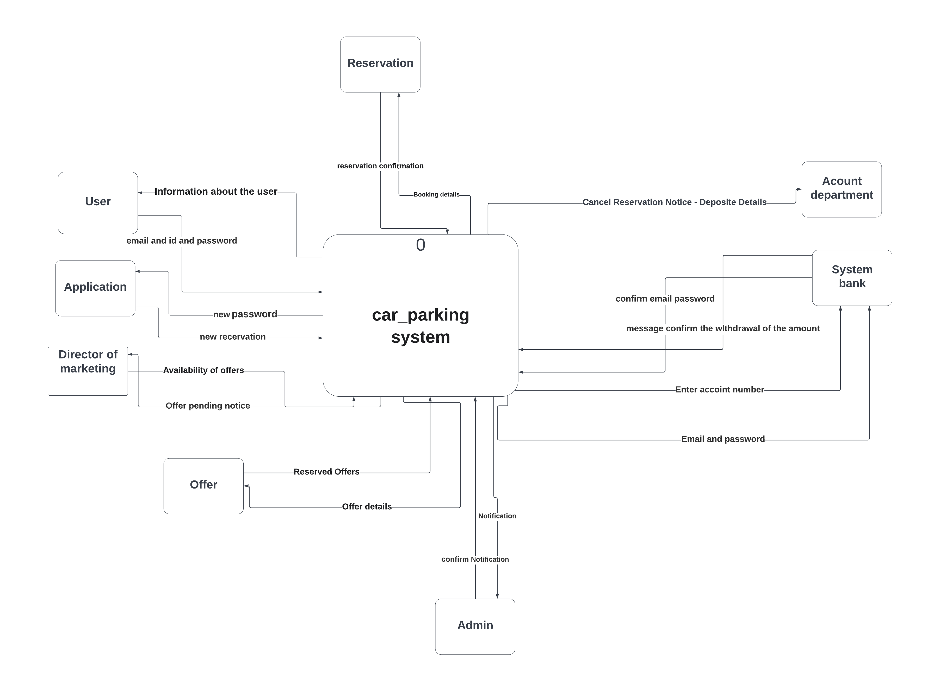

**Level 0 Data Flow Diagram**

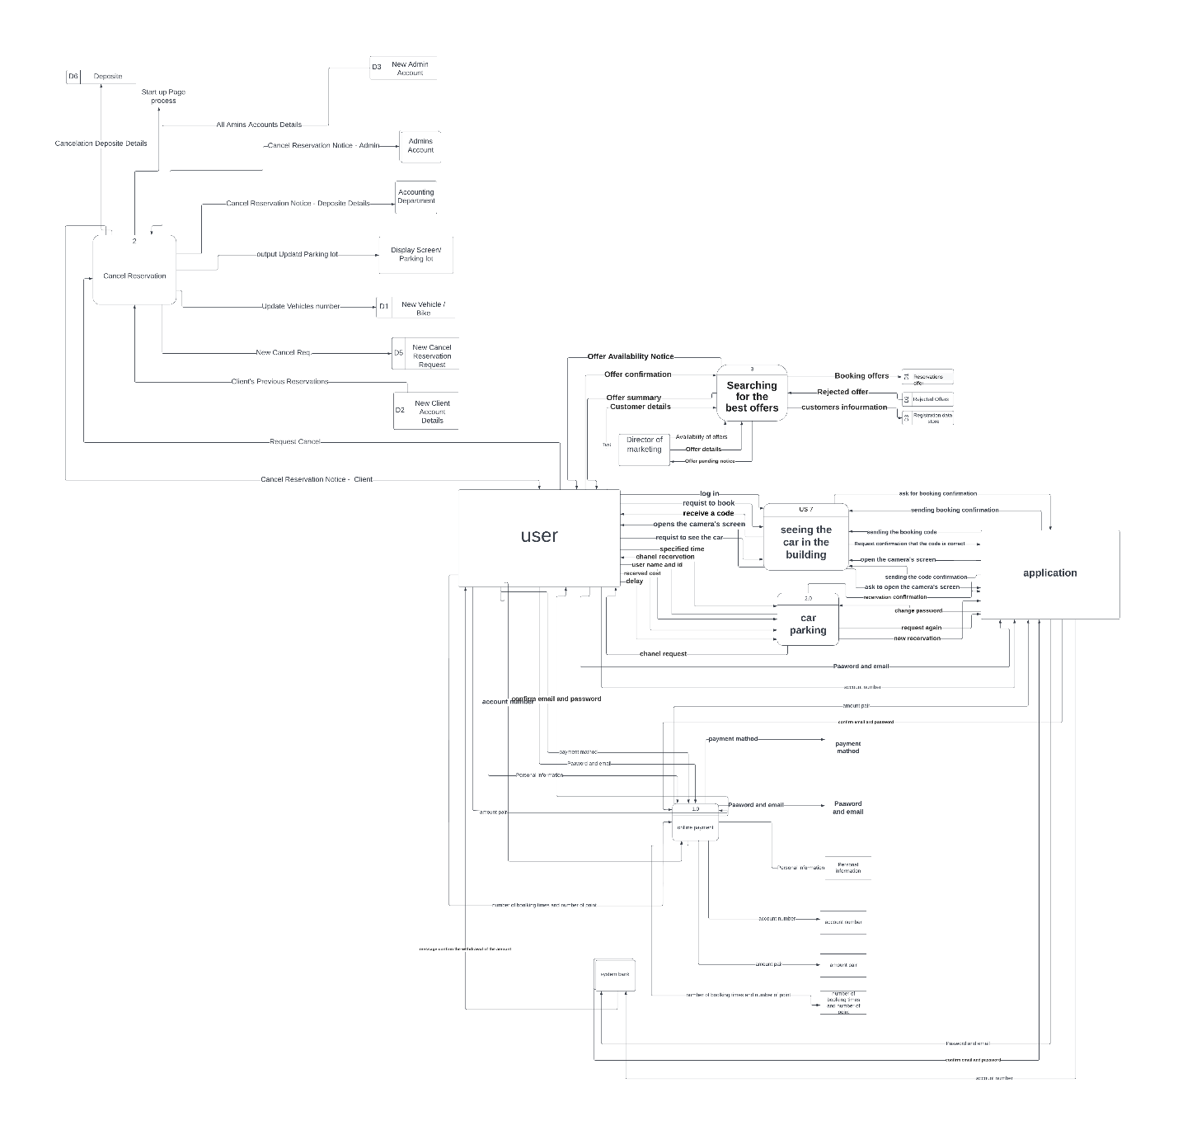

- منال ثابت نتعى

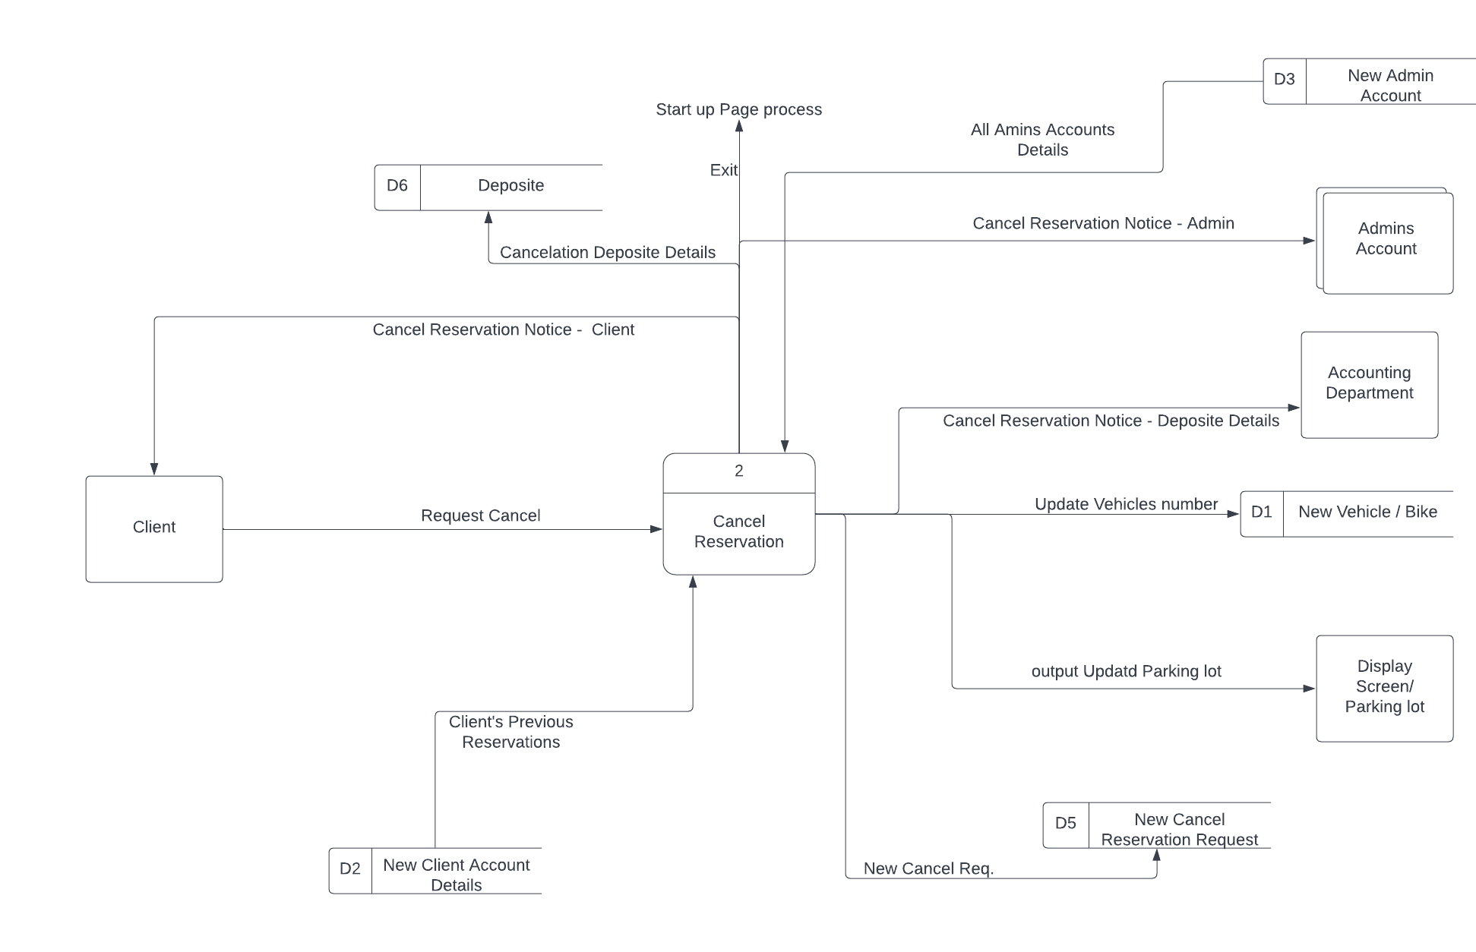

- هايدى عاطف زكريا

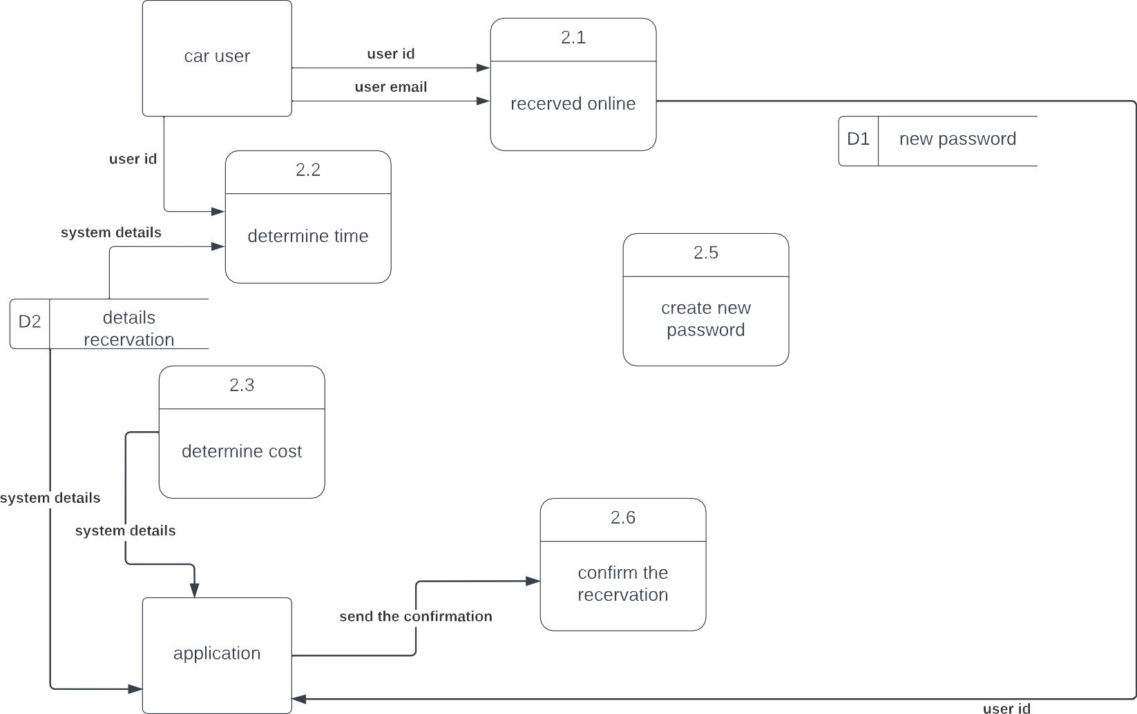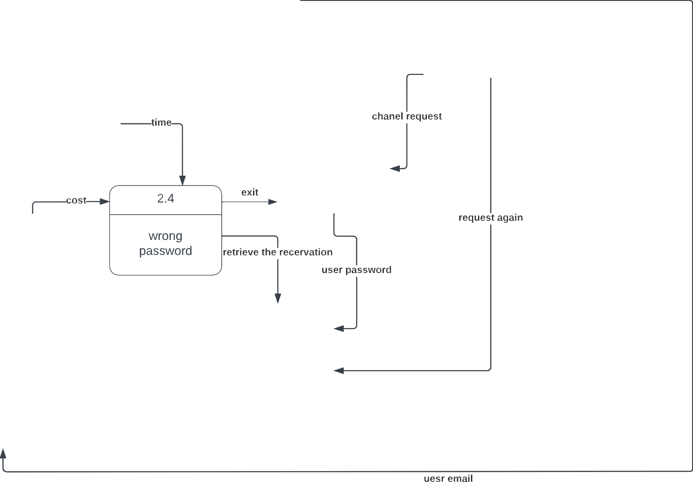

- نورهان حنا لويز

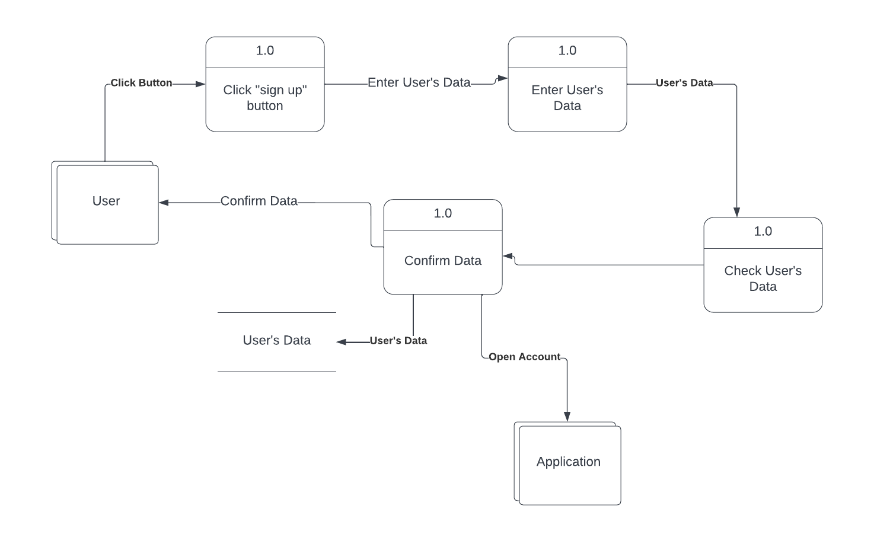

-منار اسحق كامل

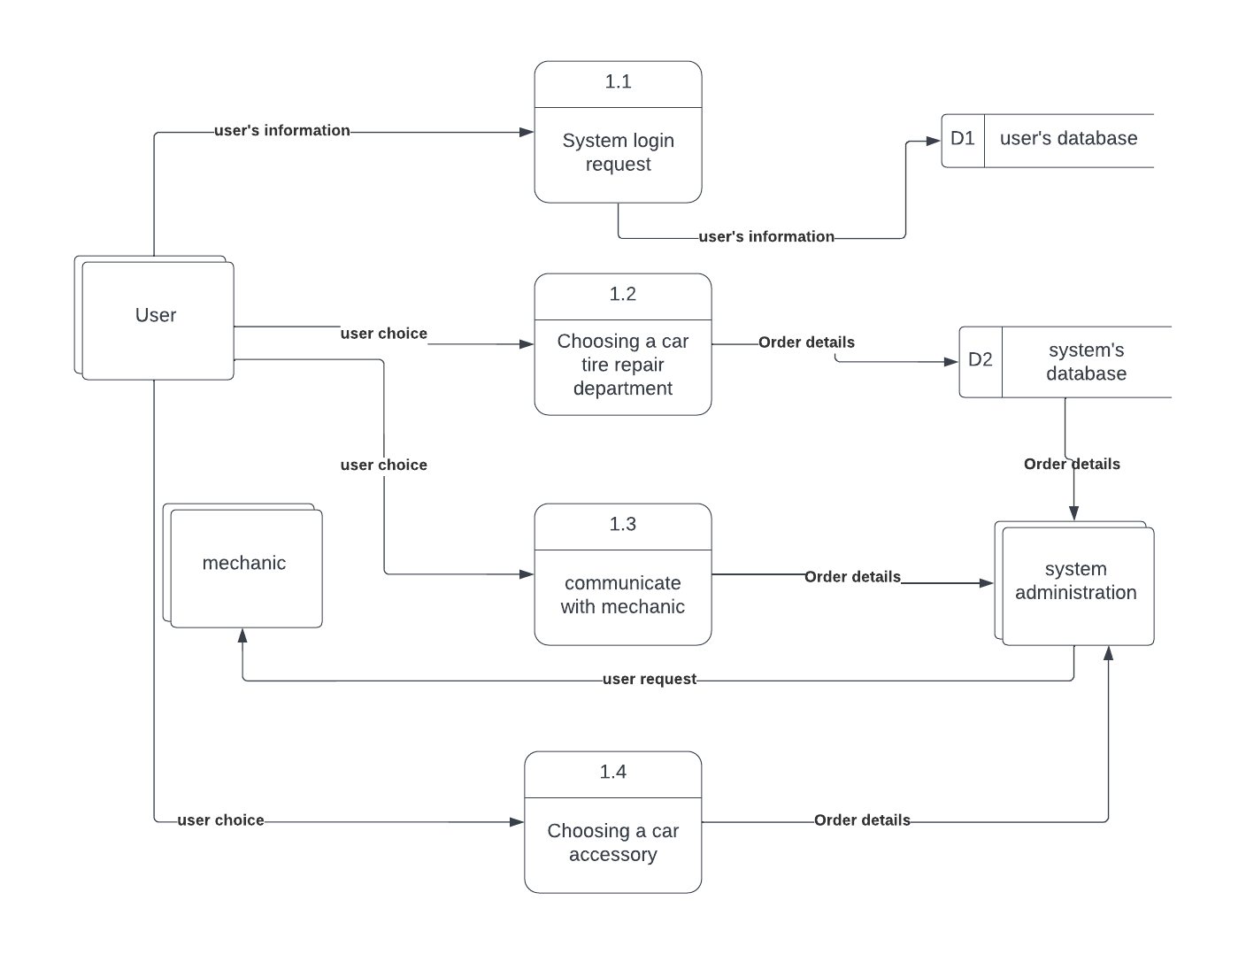

- نانسي يوسف يعقوب

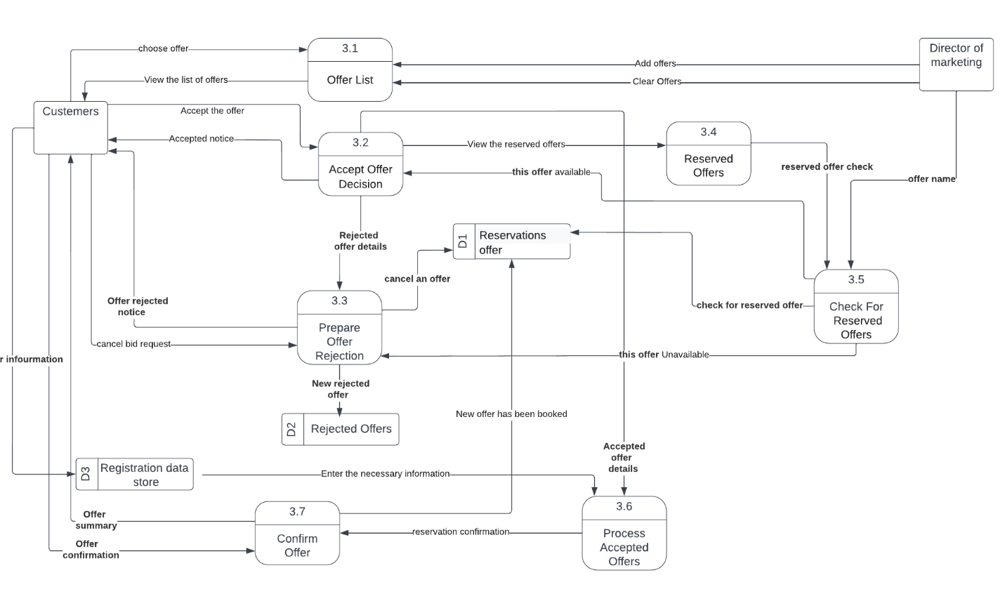

- نبيل نشات نبيل

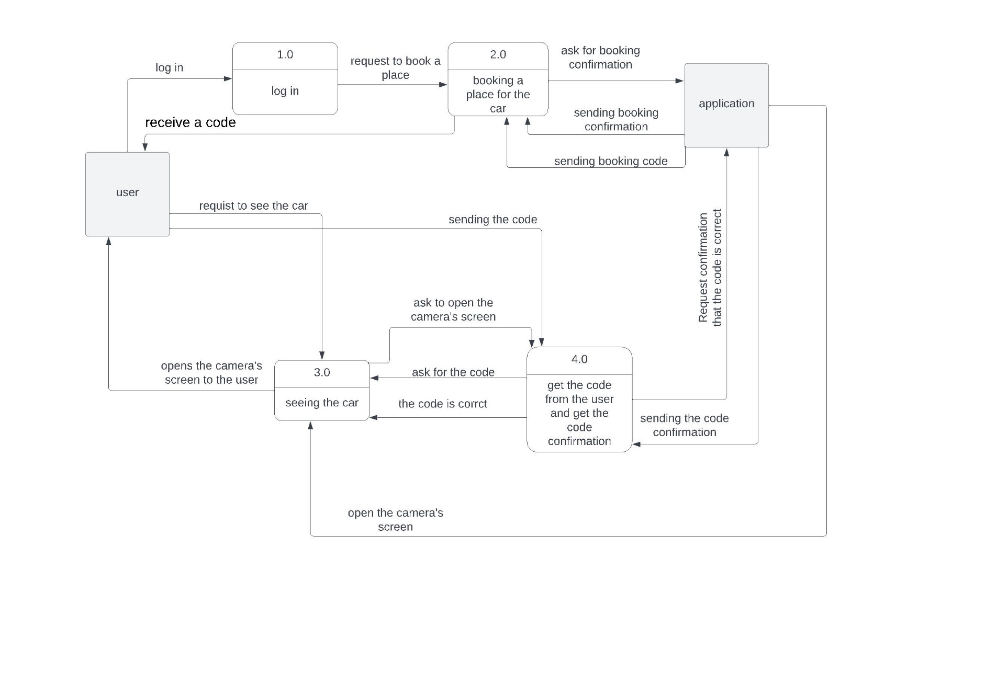

-مينا صلاح زكي

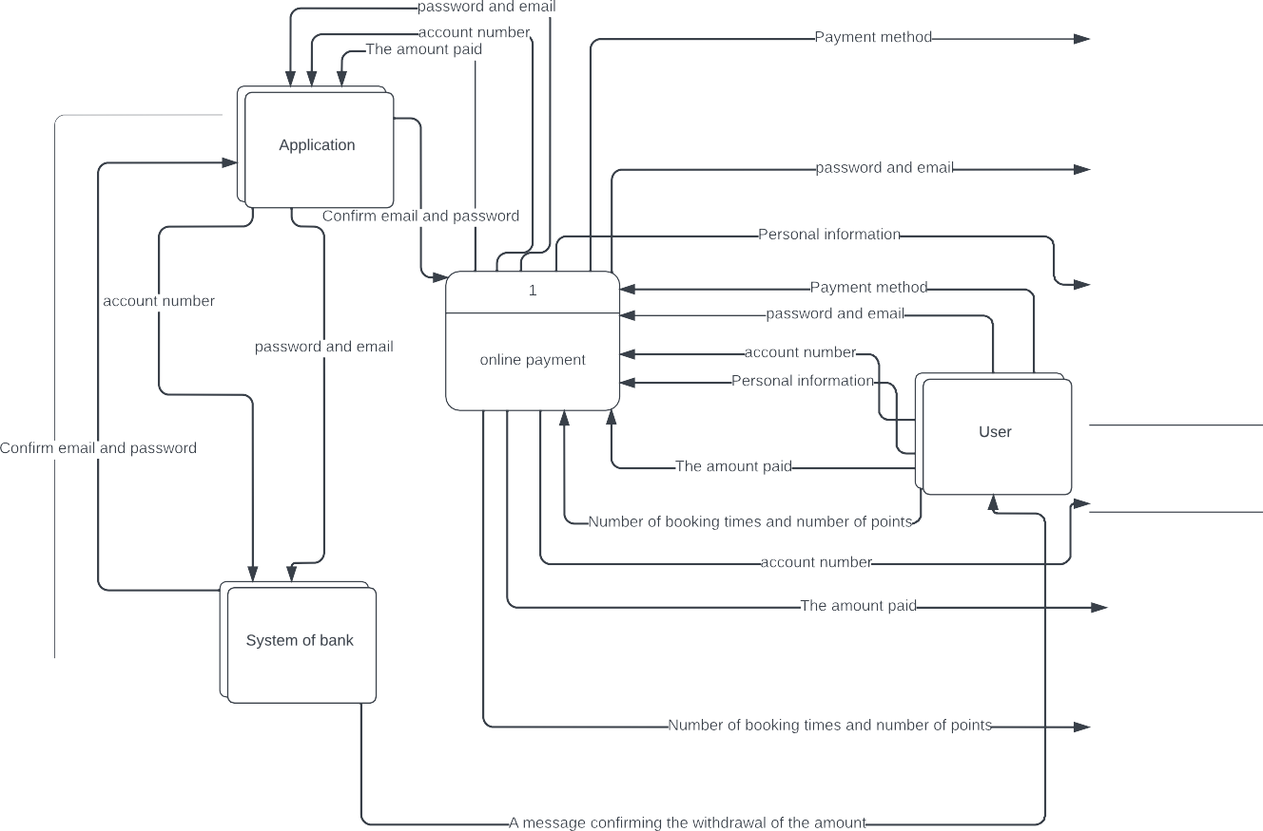

ERD

