**Create repo**

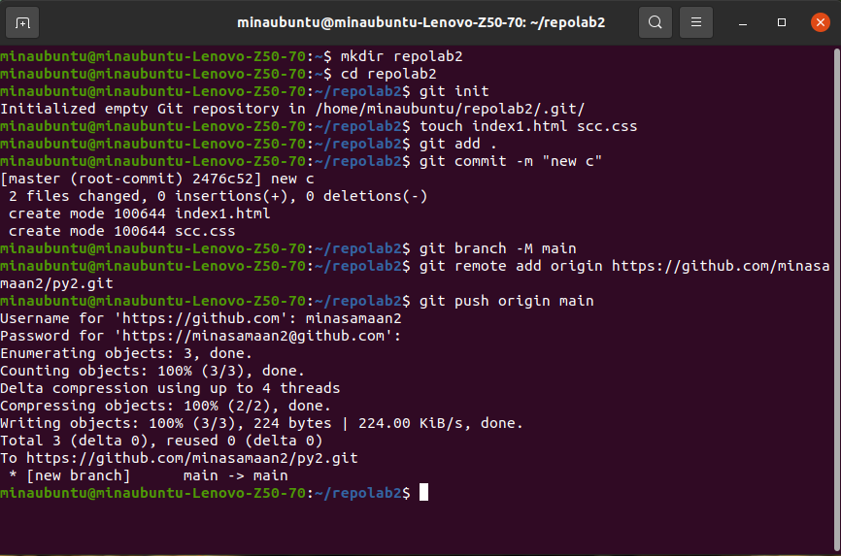

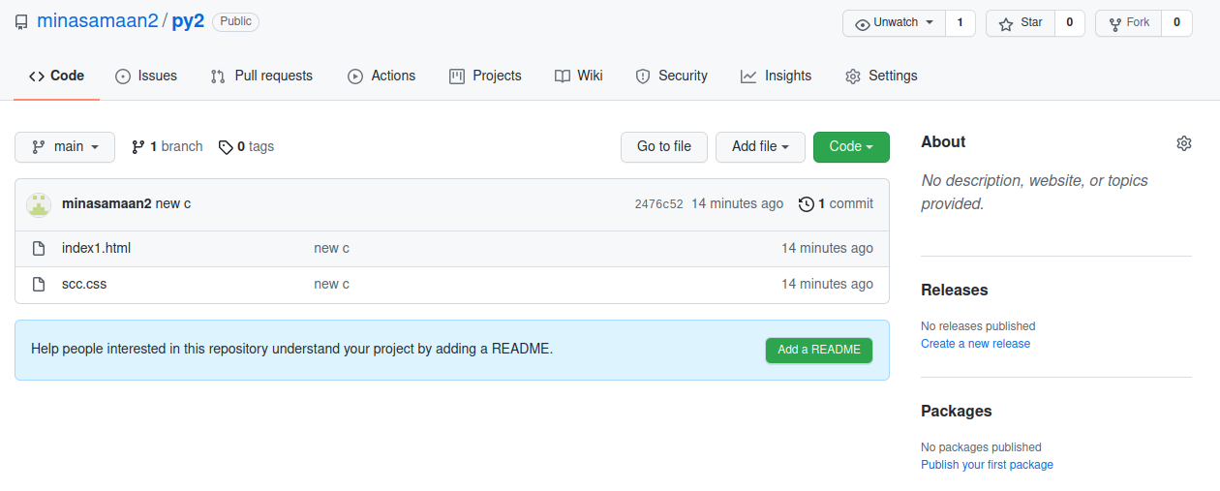

**Create branch dev and test**

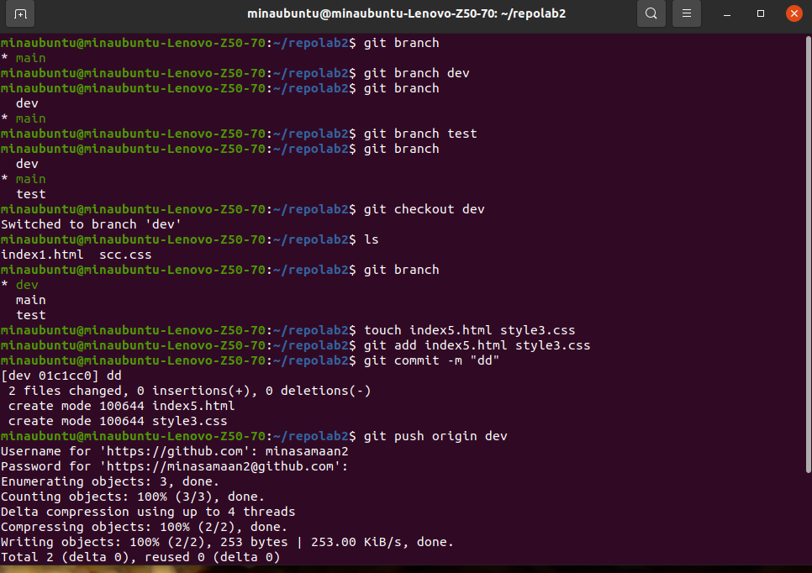

**Merge branch dev and test**

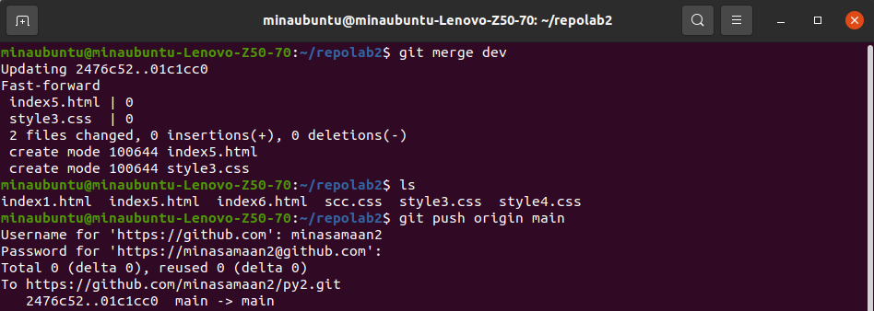

**Tell me how to remove them locally and remotly.**

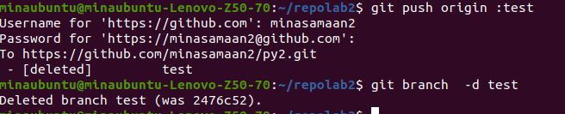

**create an annoted tag with tagname v1.4**

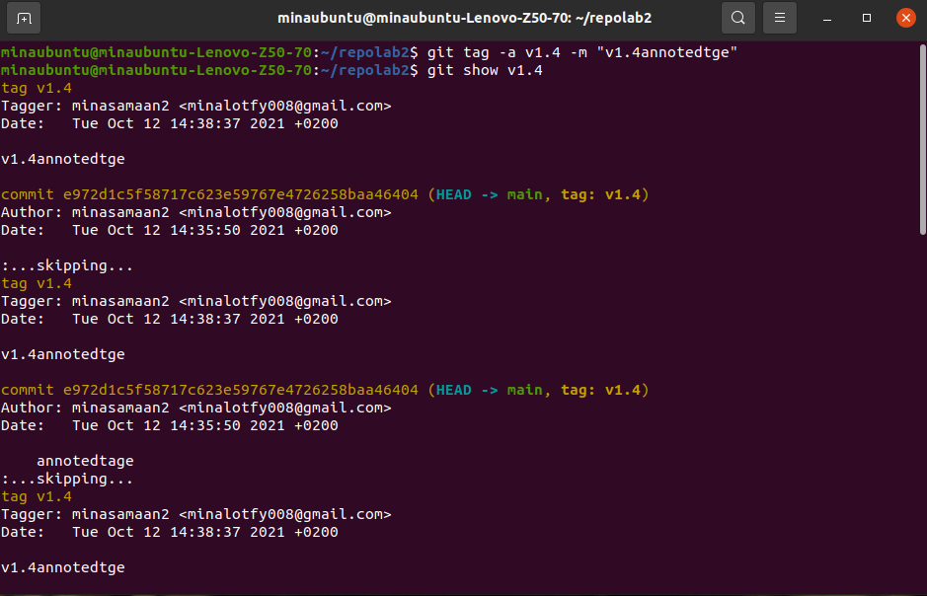

**tell me how to list tags locally.**

