Features 5000

**RNN**

**LSTM**

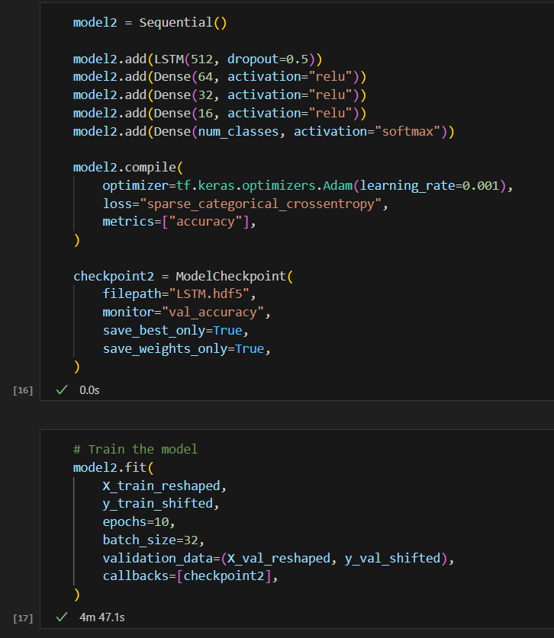

Features 10000

**RNN**

**LSTM**

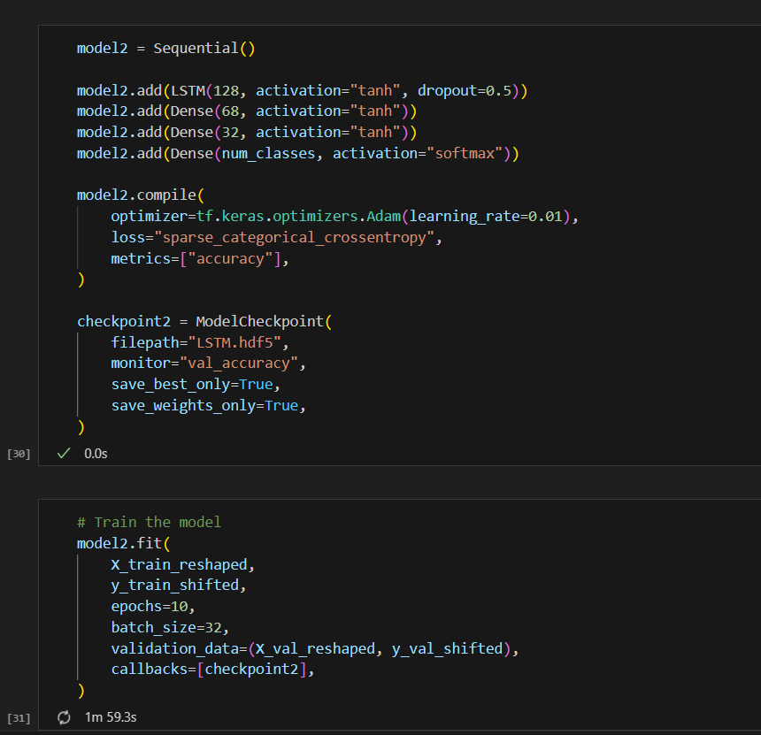

**RNN**

Features 1000

**LSTM**

**With Embedding**

**LSTM**

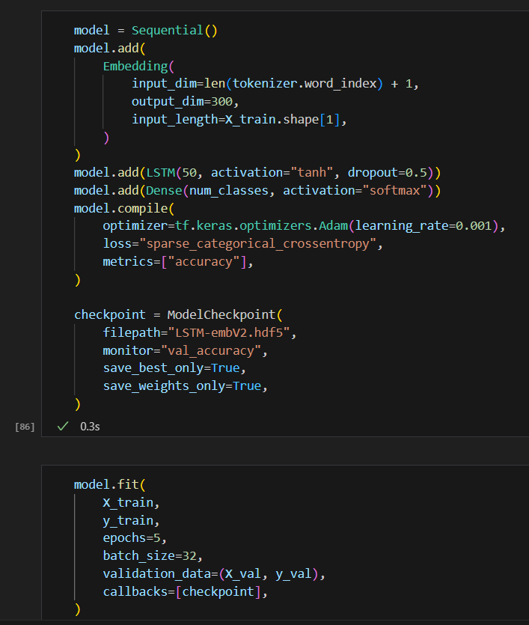

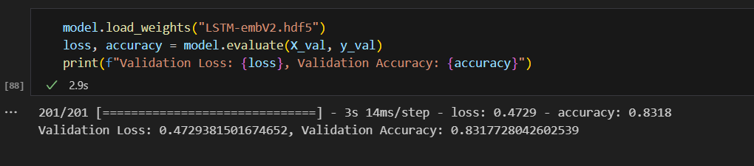

**LSTM**

**RNN**

**LSTM with regularization**

**best score** 0.84337

**LSTM Bidirectional with regularization**

