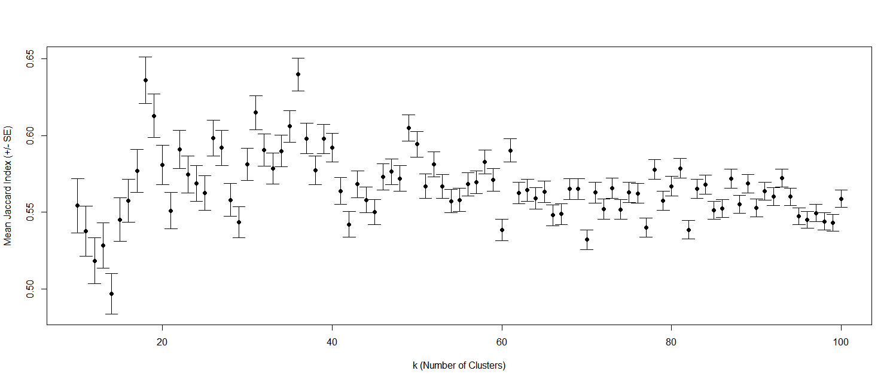

Supplemental Fig. S1 Bootstrapping and optimization of the number of clusters.



**Supplemental Fig. S2 The volume of drugs used in clinical of 36 drug clusters**.



**Supplemental Fig. S3 The antineoplastic drugs from this study and the AT**C. A. Antineoplastic drug clusters in this study. B. Drugs belong to ATC L class. C. Hierarchical structure of Cluster19 that focus on the leukemia treatment.