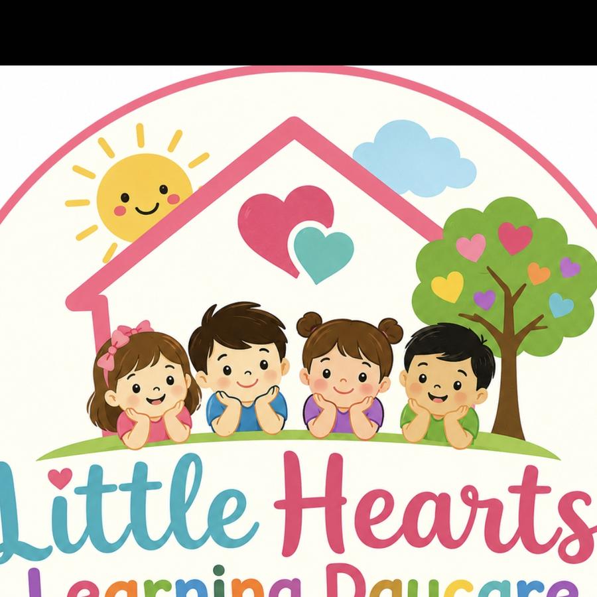
LITTLE HEARTS LEARNING DAYCARE
Where Little Hearts Grow, Learn & Shine Every Day
Parent Handbook
Version 11 — Revised July 2026
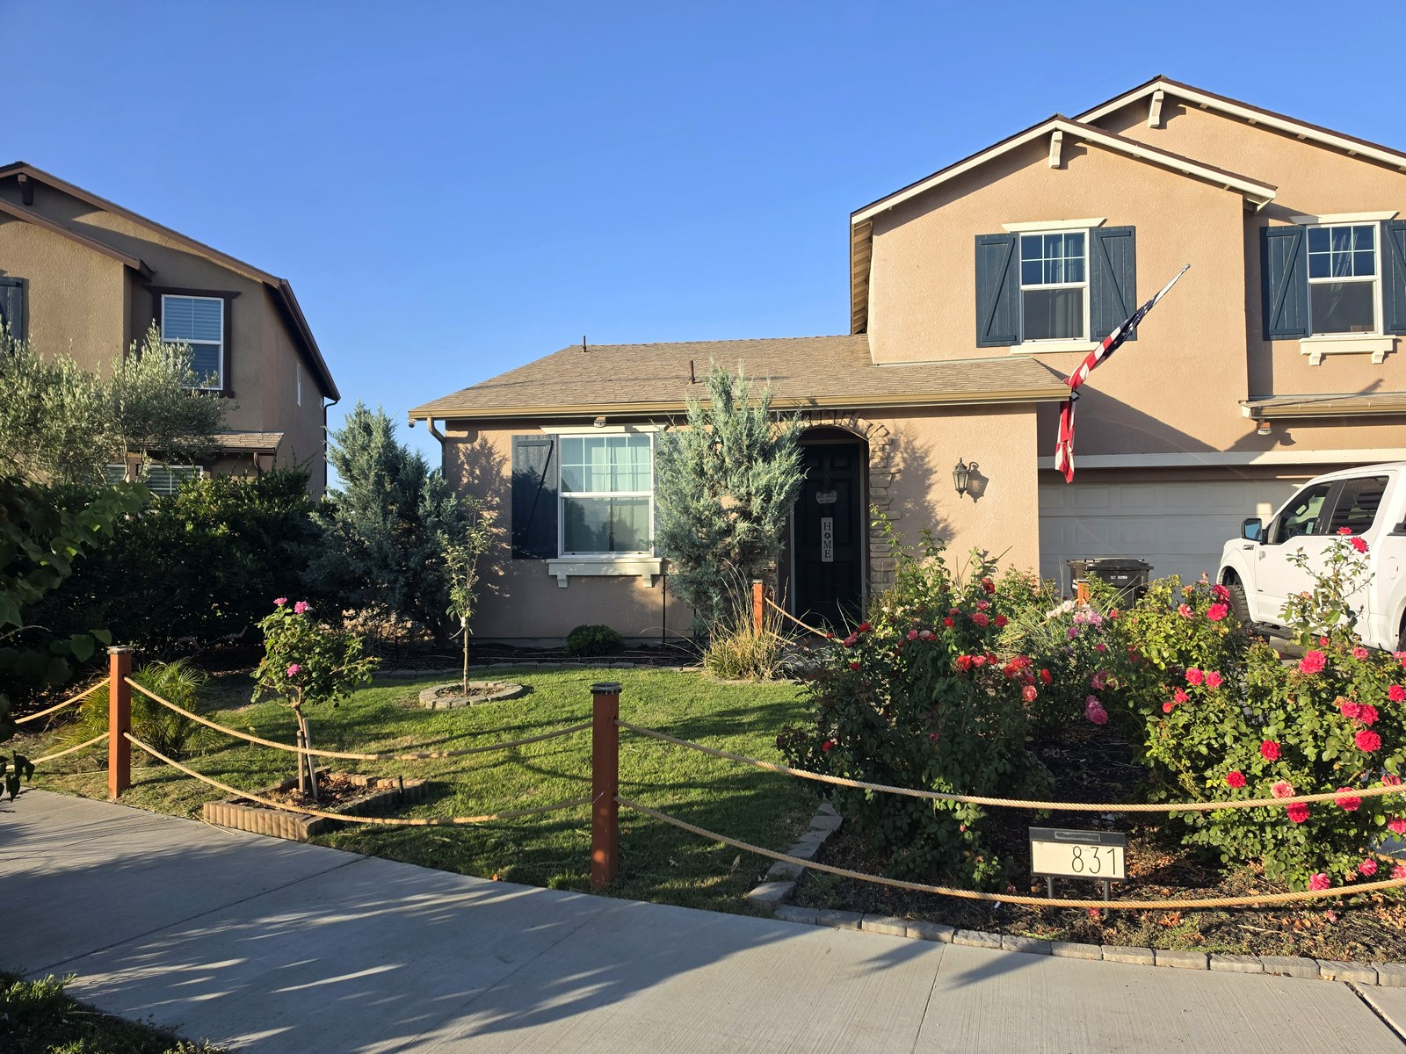
Our home at 831 Tuscany Ct, Lemoore, CA — a warm, welcoming place for your child to belong.
831 Tuscany Ct, Lemoore, CA 93245
(559) 773-9472 • mina.sreeves@gmail.com
Licensed by the California Department of Social Services, Community Care Licensing Division
Facility License Number: [Insert License Number]

Table of Contents

If the sections below do not appear automatically, right-click the table above and choose “Update Field” (Word) or press Ctrl/Cmd+A then F9.
- Section 1 — Welcome
- Section 2 — Contact Information & Hours of Operation
- Section 3 — Enrollment, Tuition & Daily Program
- Section 4 — Health & Safety Policies
- Section 5 — Parent Policies & Daily Procedures
- Section 6 — Emergency Procedures & Disaster Preparedness
- Section 7 — Parents' Rights & Children's Personal Rights
- Section 8 — Community Care Licensing Information
- Section 9 — Forms & Acknowledgements

Section 1 — Welcome

Welcome Letter
Welcome to Little Hearts Learning Daycare! We are honored that you are considering us — or have already chosen us — to care for your child. From the moment your family walks through our door, our goal is simple: to give your child a safe, loving, educational, home-like environment where they are known, celebrated, and excited to come back to every day. We believe children learn best through play, exploration, and warm relationships, and we look forward to building a genuine partnership with your family.
 | Meet Your Provider  Mina Sreeves, Owner & Licensed Provider  I started Little Hearts because I wanted children in our community to have more than child care — a true second home. Every activity, every wall in our learning space, and every routine here is planned with your child's growth and happiness in mind. I look forward to getting to know your family.

Mission Statement
At Little Hearts Learning Daycare, our mission is to provide exceptional childcare in a nurturing home environment where children feel safe, valued, and encouraged to reach their full potential. We foster kindness, curiosity, independence, confidence, and a lifelong love of learning.

Our Philosophy
We believe every child develops at their own pace. Through play-based learning, hands-on activities, music, reading, outdoor exploration, and positive guidance, we support each child's social, emotional, cognitive, and physical development while building strong partnerships with families.

Why Families Choose Little Hearts
- A true home-based setting — small group sizes and individualized attention you won't find in a large center
- A dedicated indoor learning space and a fully equipped, shaded outdoor play area for hands-on exploration every day
- Consistent, play-based curriculum supporting early literacy, math, and kindergarten readiness
- A licensed provider who is CPR/First Aid certified and trained in California health and safety standards
- Real, daily communication with families — not just a monthly newsletter

About Little Hearts Learning Daycare
Little Hearts Learning Daycare is a family child care home located at 831 Tuscany Ct, Lemoore, CA 93245, licensed and regulated by the California Department of Social Services, Community Care Licensing Division (CCLD), under Health and Safety Code Division 12 and Title 22 of the California Code of Regulations. We are committed to providing a clean, safe, welcoming environment with nutritious meals, educational activities, outdoor play, story time, arts and crafts, and individualized attention.
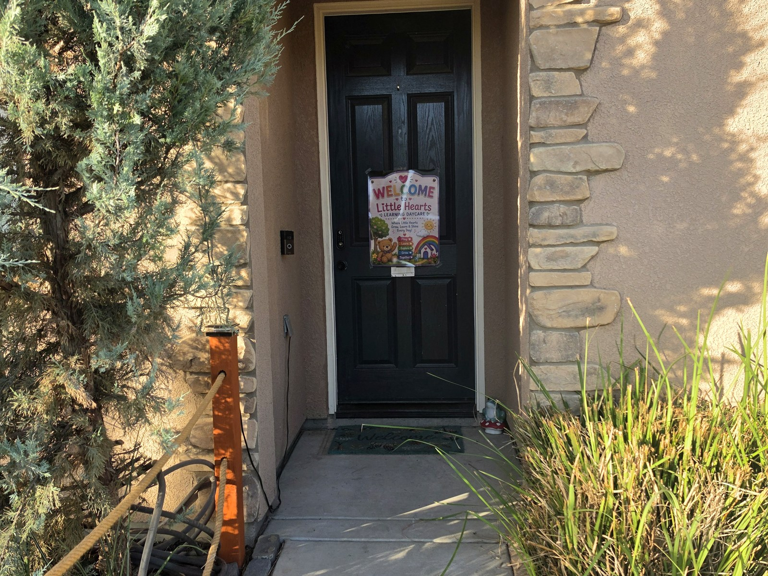  Every family is greeted with a warm welcome at our door. | 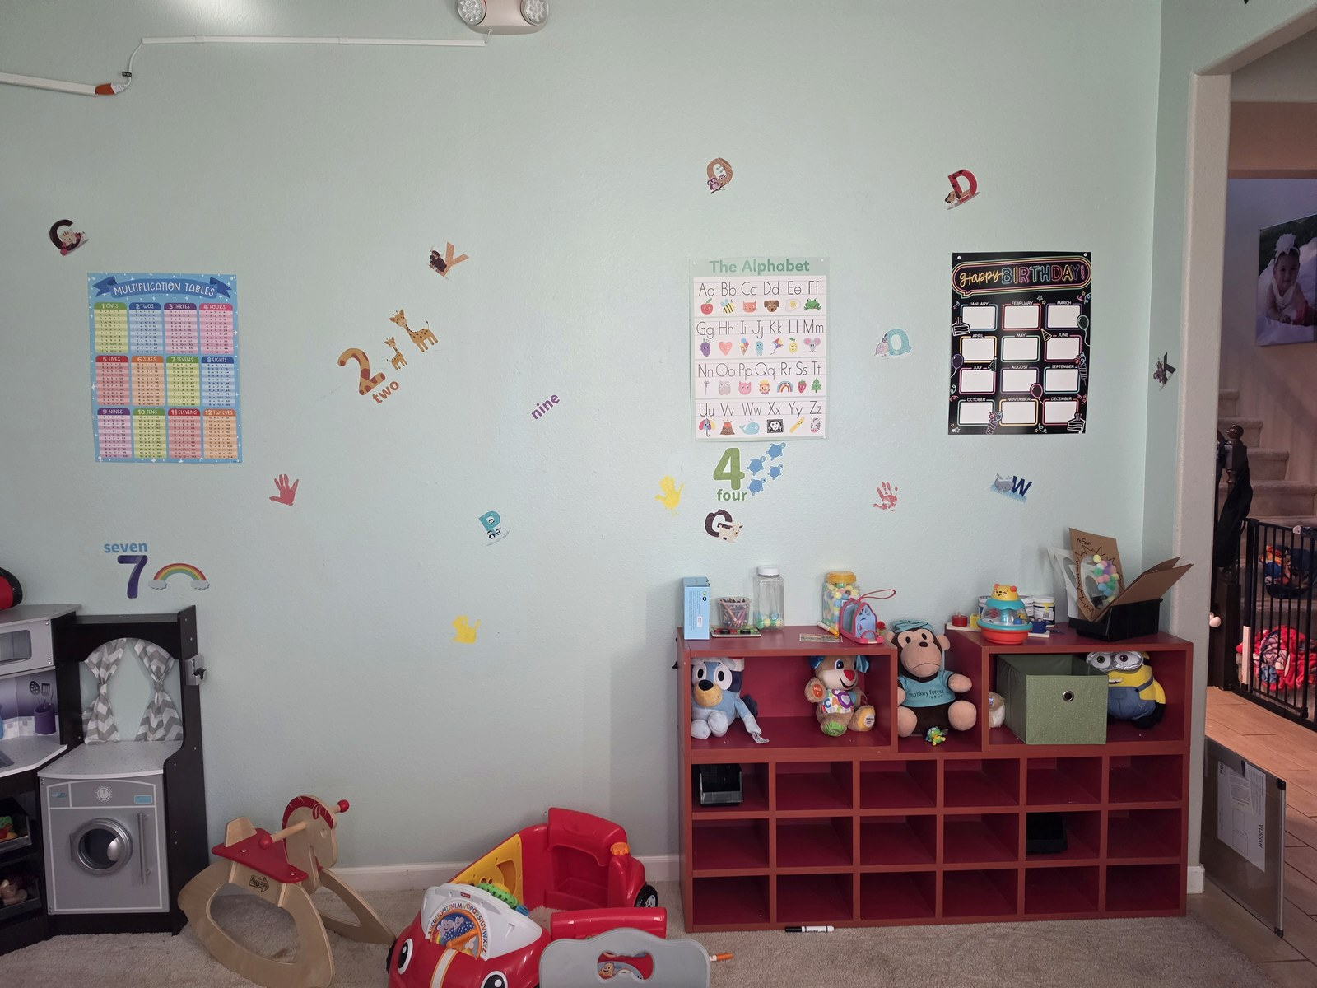  Our bright, print-rich learning space inside the home.
State law requires our license and, if applicable, the license of any assistant provider to be posted in a prominent, publicly accessible location in the home. Our current license and most recent facility evaluation report are available for review upon request.

Section 2 — Contact Information & Hours of Operation

Contact Information
Phone: _______________________________________________
Email: _______________________________________________
Address: _______________________________________________
Facility License Number: _______________________________________________
Licensed Capacity: _______________________________________________

Hours of Operation
Little Hearts Learning Daycare is open Monday through Friday, 6:00 AM – 6:00 PM. Weekend and holiday care may be available with advance notice and an additional fee. We are closed on major federal holidays and any additional dates communicated to families in advance.

Licensing Authority & Records
Little Hearts Learning Daycare operates in accordance with the California Health and Safety Code (Child Day Care Facilities Act) and Title 22, Division 12 of the California Code of Regulations, and is subject to inspection, evaluation, and complaint investigation by the Community Care Licensing Division (CCLD) of the California Department of Social Services (CDSS). Contact information for CCLD is provided in Section 8 of this handbook.

Section 3 — Enrollment, Tuition & Daily Program

Enrollment Procedures
Before a child may begin care, families must complete all required enrollment paperwork, including but not limited to:
- Identification and Emergency Information form
- Emergency contact information, including at least two individuals authorized for pick-up
- Immunization records meeting current California child care admission requirements
- Physician's report / health screening, if required for the child's age group
- Signed Parent Handbook Acknowledgement
- Enrollment deposit and Tuition Agreement
Children may not attend until all required documentation has been received. Immunization and enrollment records are maintained confidentially in accordance with Title 22 requirements.

Immunization Requirements
California law (Health and Safety Code §120335 and Title 22, §102418) requires that children be fully immunized according to the schedule required for their age before unconditional admission to a licensed family child care home. Personal belief exemptions are no longer accepted for required immunizations. A conditional admission or a medical exemption issued and submitted through the California Immunization Registry (CAIR-ME) by a licensed physician may be accepted in limited circumstances permitted by law. Families must provide current, complete immunization records at enrollment and update them as new immunizations are received.

Tuition & Payment Policies
Enrollment Type | Rate
Full-Time | $245 / week
Part-Time | $175 / week
Drop-In | $45 / day

Tuition is due every Monday before care begins. A $120 non-refundable enrollment fee is applied to the first week's tuition. Vacation weeks are billed to reserve your child's space. Late pick-up fees begin at $25 for the first 15 minutes and $10 for each additional 10 minutes.

Daily Schedule
Time | Activity
6:00 – 8:00 AM | Arrival & Free Play
8:00 AM | Breakfast
8:30 AM | Circle Time
9:00 AM | Learning Centers
10:00 AM | Outdoor Play
11:30 AM | Lunch
12:30 PM | Nap / Quiet Time
3:00 PM | Snack
3:30 PM | Art / STEM / Story Time
4:30 PM | Outdoor Play
5:00 – 6:00 PM | Pick-Up & Free Choice Activities

Curriculum
Our curriculum is play-based and designed to support social-emotional, cognitive, language, and physical development through reading, music, science, math, art, sensory exploration, dramatic play, outdoor learning, and kindergarten-readiness activities.
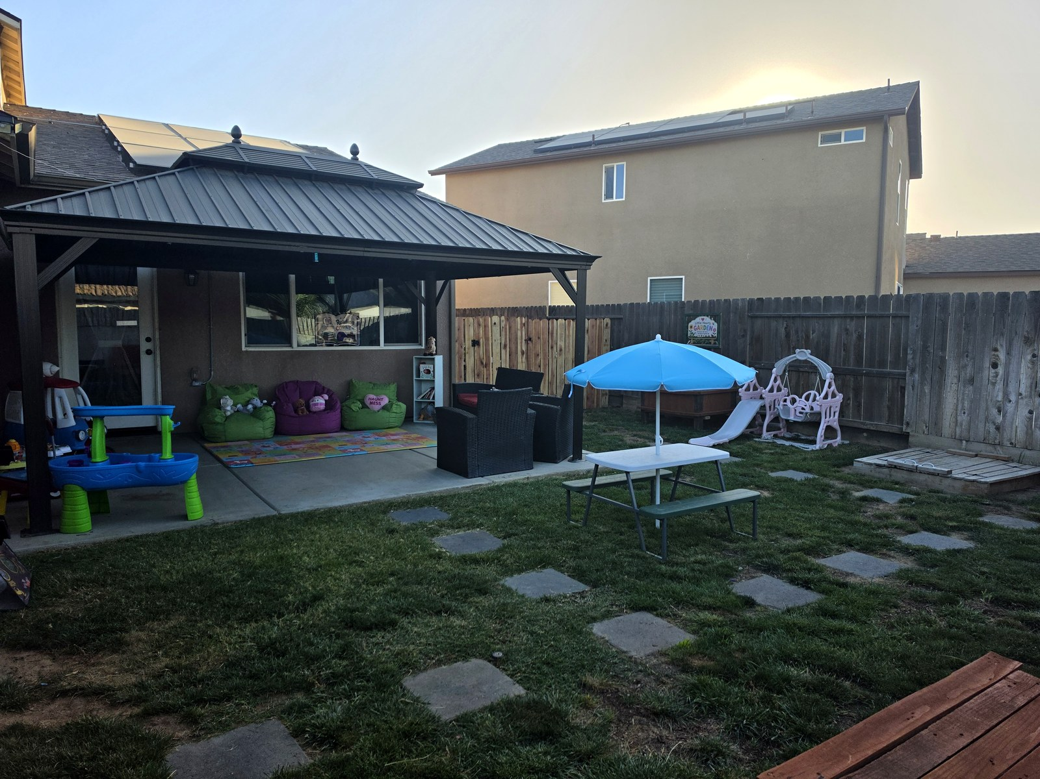  Our covered outdoor patio and yard — ready for play rain or shine. | 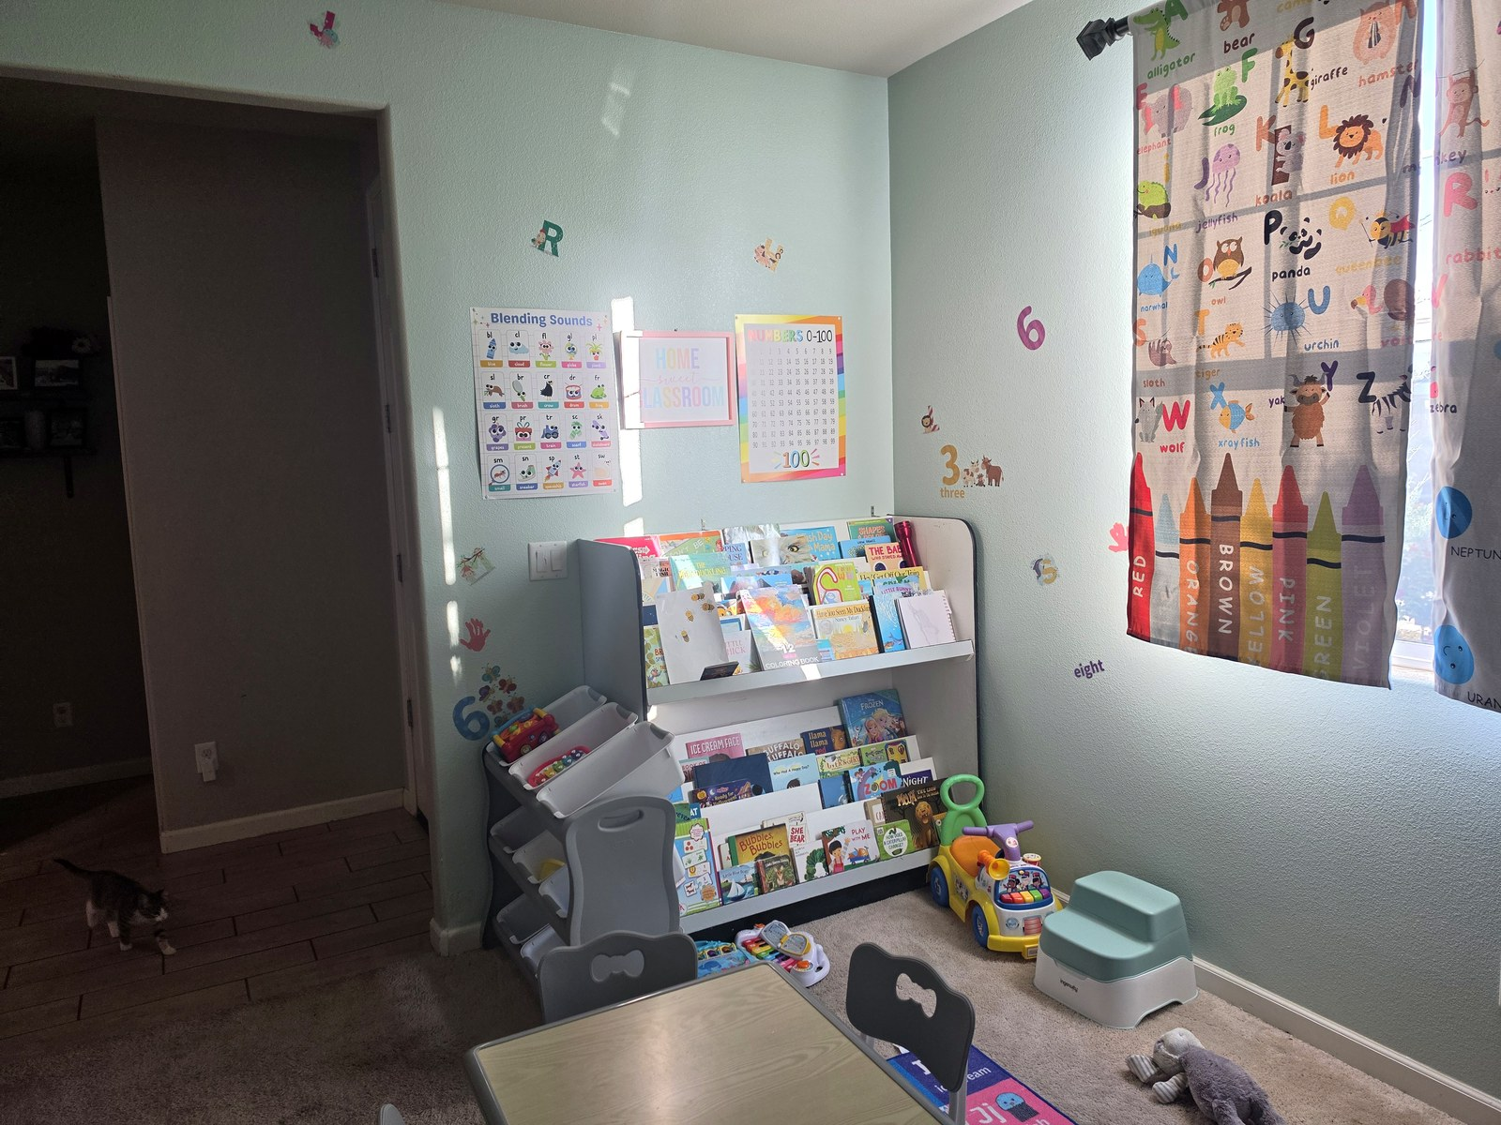  A cozy reading corner that makes story time a daily favorite.

What to Bring
Parents should provide a complete change of clothes, diapers and wipes (if needed), a nap blanket or comfort item (if appropriate), sunscreen if requested and authorized in writing, and any medication accompanied by a completed Medication Authorization form.

Section 4 — Health & Safety Policies

Health & Illness Exclusion Policy
To maintain a healthy environment for all children and staff, children who have a fever of 100.4°F or higher, vomiting, diarrhea, an unexplained rash, pink eye, or symptoms of a contagious illness must remain home. Children may return after they have been symptom-free for at least 24 hours without fever-reducing medication, or with a written release from a healthcare provider when appropriate. This policy is consistent with Title 22 requirements for the exclusion and readmission of ill children in licensed child care.

Medication Policy
Prescription and non-prescription medications will only be administered with written parent/guardian authorization on the required Medication Authorization form, as required by Title 22, §102425. Medication must be in its original container, labeled with the child's name and dosage instructions. A medication log will be completed each time medication is administered.

Allergy Policy
Parents must notify the daycare in writing of any food, medication, insect, or environmental allergies before enrollment. Emergency action plans and prescribed emergency medication (such as an epinephrine auto-injector) must be provided when applicable, along with written authorization for administration. Staff will make every reasonable effort to reduce exposure to known allergens.

Safe Sleep Policy
Infants will always be placed on their backs to sleep in an approved crib or play yard with a firm, tight-fitting mattress and fitted sheet. Cribs will remain free of pillows, blankets, bumper pads, stuffed animals, and other loose or soft items, consistent with current California licensing requirements for safe sleep and the prevention of Sudden Infant Death Syndrome (SIDS) and other sleep-related infant deaths.

Diapering Procedures
Diapers will be changed as needed using proper sanitation procedures consistent with Title 22 health and sanitation standards. Hands will be washed before and after each diaper change, and the diaper-changing surface will be cleaned and disinfected after every use.

Toilet Training
Toilet training is a partnership between parents and the daycare. Children will be encouraged using positive reinforcement and will never be punished for accidents. Families are asked to provide extra clothing during the training process.

Nutrition & Meals
Breakfast, lunch, and an afternoon snack are provided daily. Meals are planned to meet USDA nutritional guidelines for licensed child care whenever possible. Drinking water is available throughout the day. Parents must notify the daycare in writing of any dietary restrictions or allergies before attendance.

Cleaning & Sanitizing
Toys, tables, high-touch surfaces, bathrooms, and eating areas are cleaned and sanitized daily. Bedding is washed regularly, and the daycare follows California health and sanitation requirements under Title 22 to reduce the spread of illness.

Staff & Provider Health Requirements
Consistent with California law (Health and Safety Code §1597.055 and related provisions), the licensee, any assistant provider, and other adults residing in or regularly present in the home meet applicable tuberculosis clearance and immunization requirements for those working in a licensed family child care home.

Parent Health Responsibilities
Parents agree to keep emergency contact information current, notify the daycare promptly of any contagious illness, administer the first dose of a new medication at home when possible, and keep children home when they do not meet the health requirements outlined in this handbook.

Section 5 — Parent Policies & Daily Procedures

Behavior Guidance & Discipline Policy
Our goal is to guide children using positive, respectful teaching methods. We use redirection, positive reinforcement, natural consequences, problem-solving, and age-appropriate choices to encourage appropriate behavior. Consistent with California Health and Safety Code §1596.881 and Title 22 requirements, corporal punishment, humiliation, threats, withholding food, or any form of physical discipline is strictly prohibited.

Biting Policy
Biting can occur as part of normal child development, particularly among infants and toddlers. Staff will immediately care for the injured child, redirect the child who bit, document the incident on an Incident/Injury Report, and notify both families while maintaining confidentiality. If biting becomes repetitive, a behavior support plan will be developed together with the family.

Arrival & Departure Procedures
Parents must sign children in and out each day. Staff will greet each child, complete a brief wellness check, and communicate important information with families at drop-off and pick-up.

Authorized Pick-Up Policy
Children will only be released to individuals listed on the child's Authorized Pick-Up Form. Photo identification may be required at any time. Anyone not listed will not be permitted to take a child without written authorization from the parent or legal guardian.

Parent Communication
We believe communication is essential to a successful partnership. Families will receive updates through conversations at pick-up, text messages, email, newsletters, and the Brightwheel app when used.

Photo & Social Media Policy
Photos may be taken to document learning activities. Photos will only be shared according to the signed Media Release Form completed by the parent or guardian during enrollment.

Confidentiality
All information regarding children and families is kept confidential in accordance with Title 22 recordkeeping requirements. Records are securely maintained and only shared as permitted by law, as required by CCLD, or with written parent authorization.

Outdoor Play & Weather Policy
Outdoor play is an important part of our program and is scheduled daily when weather and air quality are safe. Outdoor activities may be modified or moved indoors during excessive heat, poor air quality, rain, or other unsafe conditions.

Screen Time Policy
Screen time is limited and used only for educational purposes, movement activities, or special occasions. Hands-on learning, reading, music, art, sensory activities, and outdoor play remain the primary focus of our daily program.

Termination of Care
Little Hearts Learning Daycare or a parent/guardian may terminate an enrollment agreement with written notice as specified in the Tuition Agreement. The daycare reserves the right to terminate care immediately in cases involving a threat to the health or safety of children or staff, non-payment of tuition, or repeated failure to comply with handbook policies.

Section 6 — Emergency Procedures & Disaster Preparedness
As required under Title 22, §102425.1, Little Hearts Learning Daycare maintains a written Disaster and Mass Casualty Plan addressing evacuation, relocation, and reunification procedures. A summary of key procedures is provided below; the complete plan is available for review upon request.

Fire Emergency Procedures
Monthly fire drills are conducted. In the event of a fire, children will be evacuated immediately using the posted evacuation routes. Attendance will be verified once everyone reaches the designated safe area. Emergency services will be contacted, and parents will be notified as soon as it is safe to do so.

Earthquake Procedures
During an earthquake, children and staff will “Drop, Cover, and Hold On.” After the shaking stops, everyone will be evacuated if necessary, attendance will be taken, injuries assessed, and parents notified of any significant emergency.

Lockdown & Shelter-in-Place
If a threat exists outside or near the daycare, doors will be locked, children moved to a secure location, attendance verified, and emergency responders contacted. Children will remain supervised until authorities determine it is safe.

Evacuation & Relocation
If the home cannot be occupied because of fire, natural disaster, or another emergency, children will be relocated to the designated emergency relocation site identified in our written disaster plan. Parents will be notified by phone or text with instructions for reunification.

Emergency Supplies
The daycare maintains emergency food, water, first aid supplies, flashlights, batteries, and emergency contact information to support children and staff during an emergency, consistent with Title 22 disaster-preparedness requirements.

Serious Incident & Injury Reporting
Consistent with Title 22, §102423, any serious injury, illness, accident, or unusual incident involving a child in care is documented on an Incident/Injury Report, and the parent/guardian is notified as soon as possible. CCLD is notified of reportable incidents as required by law.

Section 7 — Parents' Rights & Children's Personal Rights

Parents' Rights
As required by Title 22, §102423.4, parents and guardians of children enrolled at Little Hearts Learning Daycare have the right to:
- Enter and inspect the daycare during normal operating hours without prior notice
- Review the facility's current license and most recent licensing reports
- Receive information about their child's daily care, activities, and any incidents
- Review and receive copies of their child's records upon request
- File a complaint with Community Care Licensing without fear of retaliation or discrimination

Children's Personal Rights
Consistent with Title 22, §102416, every child in care at Little Hearts Learning Daycare has the right to:
- Be treated with dignity, respect, and personal consideration at all times
- Receive safe, healthy, and adequately supervised care
- Be free from corporal or unusual punishment, humiliation, mental or physical abuse, or punitive interference with daily functions such as eating, sleeping, or toileting
- Receive nutritious meals and snacks, adequate rest, and appropriate supervision
- Be free from the use of unauthorized or excessive medication or the use of restraints except as permitted by law

Mandated Reporter Statement
Family child care providers are mandated reporters under the California Child Abuse and Neglect Reporting Act (CANRA), Penal Code §11165.7. As required by law, the licensee and any staff are required to immediately report, or report as soon as practicably possible, any reasonable suspicion of child abuse or neglect to the appropriate county child protective services agency or law enforcement, followed by a written report within 36 hours.

Section 8 — Community Care Licensing Information

Community Care Licensing
Little Hearts Learning Daycare operates in accordance with the requirements of the California Department of Social Services, Community Care Licensing Division (CCLD), under Health and Safety Code Division 12 and Title 22, Division 12 of the California Code of Regulations. Our license and, if applicable, the most recent facility evaluation report are available for parents to review at any time.

How to Contact or File a Complaint with Community Care Licensing
Any parent, family member, or member of the public may contact CCLD with questions about licensing regulations or to file a complaint regarding this facility. Complaints may be filed anonymously, and a complainant's identity is kept confidential by law.
- Complaint Hotline: 1-844-LET-US-NO (1-844-538-8766)
- Email: letusno@dss.ca.gov
- Online: complaints.ccld.dss.ca.gov
- Mail: California Department of Social Services, Centralized Complaint and Information Bureau, 744 P Street, Sacramento, CA 95814
This handbook is intended to summarize our policies and relevant California licensing requirements for general informational purposes. It does not constitute legal advice. Current regulatory text controls in the event of any conflict, and families are encouraged to contact CCLD directly with questions about licensing law.

Section 9 — Forms & Acknowledgements

Parent Handbook Acknowledgement
I acknowledge that I have received, read, and understand the Little Hearts Learning Daycare Parent Handbook, Version 11. I agree to comply with the policies and procedures outlined in this handbook.
Parent/Guardian Name: _______________________________________________
Child's Name: _______________________________________________
________________________________________ Parent/Guardian Signature
Date: _______________________________________________

Enrollment Checklist
☐ Enrollment Form
☐ Emergency Contact Form
☐ Immunization Record
☐ Physician's Report (if required)
☐ Authorized Pick-Up List
☐ Medication Authorization (if applicable)
☐ Photo / Media Release
☐ Tuition Agreement
☐ Parent Handbook Acknowledgement

Medication Authorization
Child's Name: _______________________________________________
Medication: _______________________________________________
Dosage: _______________________________________________
Time(s) to Administer: _______________________________________________
________________________________________ Parent/Guardian Signature
Date: _______________________________________________

Incident / Injury Report
Date / Time: _______________________________________________
Child's Name: _______________________________________________
Description of Incident: _______________________________________________
First Aid Provided: _______________________________________________
Parent Notified (Yes / No) — Time: _______________________________________________
________________________________________ Staff Signature

Emergency Contact Form
Child's Name: _______________________________________________
Parent 1 — Phone: _______________________________________________
Parent 2 — Phone: _______________________________________________
Emergency Contact 1 — Phone: _______________________________________________
Emergency Contact 2 — Phone: _______________________________________________

Photo & Media Permission
☐ I authorize photos for classroom use only.
☐ I authorize photos for classroom and social media.
☐ I do not authorize photographs.
________________________________________ Parent/Guardian Signature
Date: _______________________________________________

