Improving Security and Performance of Financial RESTful APIs Using ChatGPT in ASP.NET Core

By

ZAW YE HTUT KO

Master thesis Proposal

Submitted in Partial Fulfilment of the Requirements for the Degree of Master of Science in Information Technology, Assumption University

March 2026

Vicent Mary School of Engineering, Science and Technology
Thesis Proposal Approval
Thesis Title | Improving Security and Performance of Financial RESTful APIs Using ChatGPT in ASP.NET Core
By | ZAW YE HTUT KO
Thesis Advisor | ASST PROF. DR. DARUN KESRARAT
Academic Year | 2/2025

The Vicent Mary School of Engineering, Science and Technology of Assumption University has approved this proposal as the partial fulfilment of the requirements for the degree of Master of Science in Information Technology.
Approval Committee:

Abstract

In today’s digital landscape, RESTful APIs have become indispensable for enabling communication across diverse software systems, from e-commerce to financial applications. Despite their widespread use, securing and optimizing these APIs remains a complex challenge, with common vulnerabilities exposing them to threats such as SQL injection and Cross-Site Scripting (XSS). This thesis explores the potential of ChatGPT (Codex 5.4), a large language model by OpenAI, to assist in improving the security, performance, and maintainability of ASP.NET Core RESTful APIs. Using a financial accounting API as the study subject—a complex project with endpoints for journal entries, chart of accounts, financial reporting, user authentication, and audit logging—this study investigates the impact of ChatGPT (Codex 5.4)’s code recommendations on key metrics, including code security, performance, and code quality. Key tools employed include SonarQube for static code analysis, Apache JMeter for performance testing, and OWASP ZAP for vulnerability assessment. The study follows a branch-based testing methodology: baseline metrics are captured first, then ChatGPT-guided fixes are applied on separate branches (one per tool), and re-testing is performed to measure improvements. The outcomes of this study demonstrate ChatGPT’s capability in addressing security and optimization issues in RESTful APIs, providing valuable insights into the role of AI-driven assistance in modern software development.

Table of Contents
- Introduction 1 | 6
- Introduction to RESTful APIs and ChatGPT | 6
- Challenges in API Security and Performance | 6
- Problem Statement | 6
1.4 Motivation Statement | 7
1.5 Objectives and Expected Outcomes | 8
1.6 Limitations | 8
- Literature Review | 9
2.1 The Impact of AI-generated Code on Web Development  A Comparative Study of ChatGPT and GitHub Copilot | 9
2.2 Methodology for Code Synthesis Evaluation of LLMs  Presented by a Case Study of ChatGPT and Copilot | 10
2.3 Artificial Intelligence-Based Tools | 11
2.4 GPTutor | 12
2.5 Web APIs Features, Issues, and Expectations  – A Large-Scale Empirical Study of Web | 13
2.6 An Investigation into Misuse of Java Security APIs by  Large Language Models | 14
2.7 A New Approach to Web Application Security  Utilizing GPT Language Models for Source Code Inspection | 15
2.8 Evaluating the Code Quality of AI-Assisted Code Generation Tools | 16
2.9 Evaluation of Common Security Vulnerabilities of  State Universities and Colleges Websites Based on OWASP | 17
2.10 The Impact of AI on Developer Productivity Evidence  from GitHub Copilot | 18
- Research Overview and Methodology | 19
3.1 Workflow of Overall Research Experiment | 19
3.2 Dataset Description and Preparation | 24
3.3 Model and Tool Selection | 29
3.4 Implementation of ChatGPT-Guided Improvements | 29
3.5 Testing Phases | 30
3.6 How is it different from others research? | 30
- Evaluation Plan and Metrics | 31
4.1 Evaluation Criteria | 31
4.1.1 Expected Outcomes from Evaluation Criteria | 34
4.1.1.1 Security Metrics | 34
- Performance Metrics | 35
4.1.1.3 Code quality Metrics | 36
4.2 Security Evaluation Plan | 37
4.3 Performance Evaluation Plan | 37
4.4 Code Quality Evaluation Plan | 38
4.5 Comparative Analysis | 38
- References | 39

List of Acronyms
- API - Application Programming Interface
- ASP.NET - Active Server Pages .NET
- CPU - Central Processing Unit
- CRSF - Cross-Site Request Forgery
- XSS - Cross-Site Scripting
- JMeter - Java Meter
- NER - Named Entity Recognition
- REST - Representational State Transfer
- SQL - Structured Query Language
- XSS - Cross-Site Scripting

Chapter 1 - Introduction
1.1 Introduction
In the rapidly evolving field of software development, Application Programming Interfaces (APIs) have become essential components that enable communication between different software systems. More specifically, RESTful APIs (Representational State Transfer) have gained prominence due to their scalability, simplicity, and ability to handle multiple operations such as GET, POST, PUT, and DELETE using standard web protocols. They are widely used across industries such as e-commerce, finance, and healthcare to enable seamless integration between systems and services.
ChatGPT (Codex 5.4), developed by OpenAI, represents a significant breakthrough in artificial intelligence. As an advanced AI language model, ChatGPT has demonstrated the ability to generate human-like text and offer valuable insights into various domains, including software development. When applied to API development, ChatGPT can assist in generating, optimizing, and improving code for better security, performance, and maintainability.
Why this work matters. Production REST APIs in regulated domains such as finance fail in three distinct ways: a static-analysis violation (a code smell that creeps in over time), a security alert (a missing security header, a vulnerable bundled dependency, an unprotected route), and a performance hotspot (a response that breaks an SLA under load). The three failures are caught by three different tools, demand three different remediation styles, and are usually owned by three different teams. If a general-purpose LLM such as ChatGPT can give correct, framework-aware advice across all three at once, using only the structured tool report and the relevant code excerpt, it materially shortens the audit-to-fix cycle that is the bottleneck of modern API quality work. Establishing whether and where this works requires the kind of branch-isolated empirical evidence that this thesis proposes to collect, and the answer is directly actionable for practitioners deciding whether to embed LLMs in their CI/CD review loop.
Expected outcomes summary. On the financial-accounting ASP.NET Core API used as the unit of analysis, the study expects ChatGPT (Codex 5.4) acting purely as an advisor on tool output to (i) substantially reduce SonarQube findings while preserving test coverage and quality-gate status; (ii) clear gated High, Medium, and Low alerts in OWASP ZAP baseline and authenticated API scans on business endpoints; and (iii) achieve double-digit percentage reductions in p95 latency under JMeter load profiles at 50, 100, and 500 virtual users while keeping error rate at 0%. The study further expects to surface at least one honest limitation: structural metrics that depend on global workload composition, rather than on per-endpoint latency, are not expected to move under per-finding LLM patches. Section 1.5.2 elaborates the per-dimension expected outcomes in concrete numerical terms.

1.2 Challenges
APIs are crucial for modern web and mobile applications, enabling various services and platforms to interact and share data. In sectors like finance, APIs are used to manage sensitive information such as transaction data, account balances, and user authentication. This makes the security of APIs a top priority, as vulnerabilities can expose critical data to unauthorized access or cyberattacks.
APIs, particularly those dealing with sensitive data, are frequent targets for cyberattacks. Some common security risks include SQL Injection, Cross-Site Scripting (XSS), and Cross-Site Request Forgery (CSRF). APIs must be equipped with robust authentication, authorization, and data validation mechanisms to mitigate these risks. This is where ChatGPT can assist in improving security by providing AI-driven code improvements that enhance the integrity and security of APIs. Recent empirical work has further shown that code produced or suggested by large language models can itself introduce security weaknesses, with Pearce et al. (2022) reporting vulnerabilities in roughly 40% of Copilot-generated programs across CWE-aligned scenarios and Khoury et al. (2023) finding that only a minority of ChatGPT-generated programs are secure on first attempt. These findings motivate evaluating ChatGPT-guided improvements against an independent security scanner rather than trusting model output directly.

1.3 Problem Statement
Securing APIs is a multifaceted challenge. While APIs are crucial, securing them involves addressing multiple layers of vulnerabilities, from user authentication to data integrity. This research will explore how ChatGPT can help address these challenges by applying AI-driven recommendations to enhance the security and performance of APIs. The study will investigate the impact of ChatGPT on a financial accounting API project, demonstrating the results before and after applying ChatGPT-recommended code improvements.

1.4 Motivational Statement
The motivation behind this research comes from the potential of ChatGPT to significantly improve the quality and security of RESTful APIs. Traditional methods of securing and optimizing APIs involve manual intervention, which can be time-consuming and prone to human error. By leveraging ChatGPT’s capabilities, this research seeks to explore how AI can generate secure, maintainable, and performant code for API development.

1.5 Objectives and Expected Outcomes
1.5.1 Objectives:
- To evaluate the impact of ChatGPT on the quality of ASP.NET Core API projects.
- To assess the performance impacts of AI-generated code through speed tests.
- To measure improvements in code security, reliability, and maintainability using SonarQube.
- To demonstrate how ChatGPT can solve security problems like authentication and authorization in RESTful APIs using AI-generated guidelines.

1.5.2 Expected Outcomes:
- A comprehensive analysis of the before-and-after results for API projects following ChatGPT’s code recommendations.
- Empirical data on improvements in code quality, including reduced bugs, vulnerabilities, and code smells.
- Enhanced security measures for authentication and authorization, developed using ChatGPT.
- Optimized performance metrics, including faster response times and improved resource utilization.

1.6 Limitations
The scope of this research is limited to ASP.NET Core RESTful APIs. Only ChatGPT will be evaluated, excluding comparisons with other AI tools. Additionally, the analysis will focus on static code analysis and performance tests, leaving out aspects related to user experience and developer productivity.
Chapter 2 - Literature Review
Recent systematic reviews of LLMs in software engineering (Hou et al., 2024) show that existing research is dominated by code-generation studies, while the use of LLMs as advisors acting on reports from static analysers, security scanners, and load-testing tools is comparatively under-explored. This positions the present study within an under-represented quadrant of the LLM-for-SE literature.
2.1. The Impact of AI-generated Code on Web Development A Comparative Study of ChatGPT and GitHub Copilot
Introduction to the Literature Review
- Focuses on using ChatGPT and GitHub Copilot to generate complete websites.
- Reviews machine learning advancements in code generation.
- Highlights the limited prior studies on comparing AI tools for complete web applications involving multiple programming languages.
Key Themes or Topics in the Literature
- Generative AI models and their application in code synthesis.
- Key aspects of code quality: ease of use, accuracy, and maintainability.
- Ethical implications and societal impact of AI in web development.
Key Findings from the Literature
- Both tools can generate functional websites, though ChatGPT was rated as more user-friendly.
- The generated code had minor discrepancies in styling and functionality.
- AI tools are not yet advanced enough to fully replace developers for complex projects.
Gaps in the Literature
- Insufficient exploration of AI performance in multi-language systems.
- Limited research on long-term code maintenance and security.
Methodologies and Tools in the Literature
- Static analysis tools like SonarQube, ESLint, and Pylint for code evaluation.
- Experiments involved recreating wireframes for comparison.
Critical Analysis
- The study underscores the potential of AI tools but also highlights their current limitations, such as bug generation and security risks.
Reason to include: This paper compares ChatGPT and GitHub Copilot in web development, focusing on the accuracy, ease of use, and maintainability of AI-generated code. The study’s use of SonarQube to assess code quality provides insights into how ChatGPT can be applied to improve code security and performance, making it relevant to this research.

2.2. Methodology for Code Synthesis Evaluation of LLMs Presented by a Case Study of ChatGPT and Copilot
Introduction to the Literature Review
- Explores the methodology for evaluating large language models (LLMs) like ChatGPT and Copilot.
- Discusses the significance of understanding how developers choose tools for code generation.
Key Themes or Topics in the Literature
- Functional validity and technical quality in code synthesis.
- Impact of prompt engineering on LLM performance.
- Role of static analysis in measuring non-functional qualities like code security.
Key Findings from the Literature
- ChatGPT performed better on average, generating more correct solutions than Copilot.
- Both tools displayed recurring code smells and vulnerabilities.
- Prompt engineering emerged as a critical factor influencing code quality.
Gaps in the Literature
- Lack of research on real-world deployment challenges for AI-generated code.
- Limited studies exploring how complex tasks affect AI-generated code accuracy.
Methodologies and Tools in the Literature
- Benchmarked against 25 programming tasks using C++ and Java.
- Combined human review and static analysis for quality assessment.
Critical Analysis
- Provides a robust methodology for evaluating LLM-generated code but suggests the need for dynamic testing and deployment-specific evaluations.
Reason to include: This paper explores how ChatGPT improves software development by generating code, detecting bugs, and automating tests. The focus on how ChatGPT enhances traditional development processes supports the research’s aim to optimize API development using AI.

2.3. Artificial Intelligence-Based Tools
Introduction to the Literature Review
- Highlights the evolving role of AI in automating traditional software development processes.
- Reviews how tools like ChatGPT enhance workflows across design, coding, and testing.
Key Themes or Topics in the Literature
- Efficiency improvements through AI in software development cycles.
- The potential for AI tools to accelerate error detection and debugging.
- Ethical concerns, such as over-reliance on AI and security implications.
Key Findings from the Literature
- ChatGPT was effective in automating repetitive tasks and reducing development time.
- Simplified processes for non-specialist developers to engage in software projects.
Gaps in the Literature
- Limited case studies on how AI integrates with advanced frameworks.
- Lack of large-scale evaluations across diverse industries.
Methodologies and Tools in the Literature
- AI-driven processes were benchmarked against traditional methodologies.
- Observations from simulated projects and user feedback.
Critical Analysis
- While demonstrating efficiency, the study underlines the risks of over-dependency on AI for critical functions, emphasizing the need for human oversight.
Reason to include: This paper explores how ChatGPT improves software development by generating code, detecting bugs, and automating tests. The focus on how ChatGPT enhances traditional development processes supports the research’s aim to optimize API development using AI.

2.4. GPTutor
Introduction to the Literature Review
- Examines GPTutor, a plugin leveraging ChatGPT for code explanation and debugging.
- Highlights its focus on student and developer education.
Key Themes or Topics in the Literature
- Enhancing learning with AI-driven code explanation tools.
- Integration of natural language processing (NLP) into programming environments.
- Comparison of GPTutor’s effectiveness with existing tools like Copilot.
Key Findings from the Literature
- GPTutor provided concise and context-aware explanations of code.
- Developers found it intuitive and useful for understanding unfamiliar codebases.
Gaps in the Literature
- Lack of real-world deployment data to validate GPTutor’s performance in professional settings.
- Minimal studies on its integration with other educational platforms.
Methodologies and Tools in the Literature
- Implementation as a Visual Studio Code extension using OpenAI’s GPT-3.5 API.
- User interviews and experimental evaluations.
Critical Analysis
- Shows promise in improving developer education but requires further studies to explore its long-term applicability.
Reason to Include: This paper is highly relevant to your research on using ChatGPT to generate and improve code, particularly in the context of explaining programming logic. GPTutor leverages ChatGPT to assist developers with real-time code explanations, which aligns with your objective of improving API development using ChatGPT for better security and performance.

2.5. Web APIs Features, Issues, and Expectations – A Large-Scale Empirical Study of Web
Introduction to the Literature Review
- Analyzes features, usability issues, and user expectations for web APIs based on empirical studies.
Key Themes or Topics in the Literature
- Factors influencing API adoption, such as documentation and SDK quality.
- Issues like outdated components and incomplete documentation.
- Developers’ expectations for better error handling and performance optimization.
Key Findings from the Literature
- Well-organized documentation is critical for API adoption.
- Security issues and limited functionality were common concerns.
Gaps in the Literature
- Limited exploration of API usage in large-scale applications.
- Minimal studies on machine-learning-driven API enhancements.
Methodologies and Tools in the Literature
- Survey responses from developers and analysis of Stack Overflow discussions.
- Evaluation of APIs from registries like Programmable Web.
Critical Analysis
- Demonstrates the importance of improving API usability but lacks insights into ML applications for automated API management.
Reason to Include: This empirical study provides a large-scale analysis of common issues and expectations in Web APIs, including security vulnerabilities, performance bottlenecks, and developer expectations. These findings directly support your research on addressing similar API challenges using ChatGPT-generated improvements.

2.6 An Investigation into Misuse of Java Security APIs by Large Language Models
Introduction to the Literature Review
- Evaluates how LLMs like ChatGPT handle Java security APIs, focusing on misuse risks.
Key Themes or Topics in the Literature
- Common misuse patterns in security APIs.
- ChatGPT’s limitations in implementing secure code due to its reliance on outdated examples.
Key Findings from the Literature
- Around 70% of ChatGPT-generated solutions had security API misuse.
- Developers need to provide highly specific prompts to mitigate misuse.
Gaps in the Literature
- Limited studies on real-world usage of AI tools for secure coding.
- Absence of standardized datasets for API security evaluation.
Methodologies and Tools in the Literature
- Manual review and CryptoGuard for identifying misuse in 48 Java tasks.
Critical Analysis
- Highlights the potential of AI in secure development but stresses the importance of training on updated datasets.
Reason to Include: This paper assesses ChatGPT’s reliability in generating secure code for Java security APIs, highlighting common misuse patterns. Its findings on API misuse and limitations in automated detection align closely with my research goal of improving ASP.NET Core API security with ChatGPT-guided improvements, offering valuable insights into potential vulnerabilities and evaluation methods.

2.7 A New Approach to Web Application Security Utilizing GPT Language Models for Source Code Inspection
Introduction to the Literature Review
- Focuses on using GPT language models for static code analysis to detect vulnerabilities, specifically targeting CWE-653 (improper isolation of sensitive data).
Key Themes or Topics in the Literature
- Use of GPT models for identifying security vulnerabilities in web frameworks like Angular.
- Integration of AI for automating sensitive data protection and isolation checks.
- Challenges in using GPT models for context-specific vulnerability detection.
Key Findings from the Literature
- GPT models achieved an 88.76% detection success rate for CWE-653 vulnerabilities.
- Static code analysis combined with few-shot learning and chain-of-thought techniques enhanced detection accuracy.
- The models proved effective in mapping sensitive data paths and categorizing protection levels.
Gaps in the Literature
- Insufficient real-world applications of the proposed methodology.
- Limited comparative studies on the performance of GPT against other advanced vulnerability detection tools.
Methodologies and Tools in the Literature
- Analysis of open-source Angular applications using static code inspection.
- Categorization of sensitive data based on damage potential from leaks.
- Comparison of GPT-3.5 and GPT-4 for detecting and addressing vulnerabilities.
Critical Analysis
- The study presents a compelling case for using GPT models in vulnerability detection, but it underscores the necessity of augmenting GPT outputs with human expertise for broader security scenarios.
Reason to Include: This paper explores using GPT models for security inspection in web applications, like my focus on ChatGPT for enhancing RESTful API security. Its findings on detecting vulnerabilities like CWE-653 and categorizing sensitive data in web applications align well with research, providing insights into leveraging GPT models for automated code review, vulnerability detection, and the practical challenges of AI-assisted security improvements. This context helps justify the value of ChatGPT in identifying security flaws in ASP.NET Core APIs within your research.

2.8. Evaluating the Code Quality of AI-Assisted Code Generation Tools
Introduction to the Literature Review
- Compares GitHub Copilot, Amazon CodeWhisperer, and ChatGPT to assess their performance in generating reliable, secure, and maintainable code.
Key Themes or Topics in the Literature
- Analysis of AI-generated code quality metrics: correctness, security, maintainability, and reliability.
- Exploration of developer productivity and technical debt reduction using AI tools.
- Effects of docstrings and function signatures on AI-generated code quality.
Key Findings from the Literature
- ChatGPT excelled in correctness (65.2%) and maintainability, while Copilot had better IDE integration.
- Amazon CodeWhisperer performed best for tasks involving cloud service APIs.
- The average technical debt was lowest for Amazon CodeWhisperer but ChatGPT’s explanations were more user-friendly.

Gaps in the Literature
- Absence of comprehensive studies involving multi-language or highly complex codebases.
- Limited exploration of adaptive learning and feedback loops in AI systems.
Methodologies and Tools in the Literature
- Utilized the HumanEval dataset for benchmarking.
- Static analysis was performed using SonarQube for bugs, code smells, and security vulnerabilities.
Critical Analysis
- While AI tools show promise, the findings highlight challenges in scalability and real-world deployment, calling for further research in enhancing AI's adaptive learning.
Rason to Include: This paper evaluates the code quality of AI-assisted generation tools, including ChatGPT, focusing on essential metrics such as code validity, correctness, security, reliability, and maintainability. Since my research involves using ChatGPT to improve security and performance in ASP.NET Core RESTful APIs, this study provides a valuable framework for assessing ChatGPT's code quality. The paper's empirical approach and use of SonarQube align with my methodology, offering insights into common issues with AI-generated code and suggesting best practices for achieving secure, maintainable, and efficient code with AI assistance.

2.9 Evaluation of Common Security Vulnerabilities of State Universities and Colleges Websites Based on OWASP
Introduction to the Literature Review
- Analyzes the security vulnerabilities in academic institution websites using OWASP’s Top 10 guidelines, emphasizing the importance of web application security in digitalized educational services.
Key Themes or Topics in the Literature
- Frequent vulnerabilities in web applications, including SQL injection, misconfiguration, and broken access control.
- Using OWASP ZAP to identify and analyze security gaps.
- Importance of adopting OWASP standards to enhance website security.
Key Findings from the Literature
- 94.12% of websites were vulnerable to broken access control, and 88.24% showed security misconfigurations.
- Vulnerabilities often stem from outdated components and poor system design.
- ZAP proved effective in identifying critical issues, including injection flaws and insecure designs.
Gaps in the Literature
- Lack of studies on integrating AI-based tools to complement traditional scanners like ZAP.
- Minimal exploration of user training for maintaining secure web applications.
Methodologies and Tools in the Literature
- Automated scanning of 17 academic websites using OWASP ZAP.
- Qualitative analysis of scan results based on the OWASP Top 10 categories.
Critical Analysis
- Demonstrates the utility of OWASP ZAP but underlines the need for proactive measures and advanced AI-driven solutions to mitigate vulnerabilities.
Reason to include: this paper examines real-world security vulnerabilities in web systems using OWASP ZAP, aligning closely with my focus on securing RESTful APIs. The study provides insights into common security flaws (e.g., injection vulnerabilities, broken access control) in academic web platforms, which can parallel the types of vulnerabilities found in RESTful APIs. Additionally, their methodology using OWASP's Top 10 framework offers a structured approach to vulnerability assessment that I can apply to evaluate ChatGPT-driven security improvements in my APIs. This context supports the need for systematic, tool-assisted security evaluation in API development.

2.10 The Impact of AI on Developer Productivity Evidence from GitHub Copilot
Introduction to the Literature Review
- Evaluates GitHub Copilot's impact on developer productivity through a controlled experiment involving a task to build an HTTP server.
Key Themes or Topics in the Literature
- Productivity enhancements from AI pair programming.
- Heterogeneous effects of Copilot across skill levels and demographics.
- Comparison of traditional development workflows versus AI-assisted programming.
Key Findings from the Literature
- Developers using Copilot completed tasks 55.8% faster on average than those in the control group.
- The tool benefitted less experienced developers the most, showcasing its potential for supporting novice programmers.
- Participants rated Copilot as significantly improving their productivity and willingness to adopt it in daily workflows.
Gaps in the Literature
- Limited insights into the long-term adoption effects of AI tools on collaborative and large-scale software projects.
- Lack of focus on the ethical and licensing implications of using AI for code generation.
Methodologies and Tools in the Literature
- Controlled experiment using GitHub Classroom to track task completion times and correctness.
- Analysis of heterogeneous effects based on participant demographics and experience.
Critical Analysis
- Highlights Copilot's potential to accelerate software development but emphasizes the need for addressing ethical concerns and improving support for team-based projects.
Reason to include: This paper is relevant to my research because it provides empirical evidence on the productivity gains achieved through AI-assisted coding tools, specifically GitHub Copilot, which is like ChatGPT in functionality. By highlighting the productivity boost and its impact on code development speed, the study offers a comparison point for evaluating ChatGPT’s potential in improving API performance and security, supporting your investigation into the effectiveness of AI-driven development tools.
2.11 Asleep at the Keyboard? Assessing the Security of GitHub Copilot's Code Contributions
Introduction to the Literature Review
Audits GitHub Copilot's code suggestions against security-relevant scenarios drawn from MITRE's list of the 25 most dangerous Common Weakness Enumerations (CWEs), focusing on whether AI-generated code introduces exploitable vulnerabilities rather than on functional correctness alone.
Key Themes or Topics in the Literature
Security risks of AI pair-programming tools in everyday development workflows.
Mapping of AI-generated vulnerabilities to standardised CWE categories.
Trade-offs between generation diversity, prompt context, and security outcomes.
Key Findings from the Literature
Roughly 40% of Copilot's generated programs across the evaluation scenarios contained security weaknesses.
Copilot's output varied by language and weakness class, with C programs exhibiting a higher proportion of vulnerabilities than Python.
Prompt wording and surrounding context materially influenced whether Copilot produced vulnerable or safe code.
Gaps in the Literature
Restricted to Copilot at a single point in time and to two languages (Python and C); behaviour on ASP.NET Core / C# is not characterised.
No empirical link between flagged weaknesses and downstream exploitability in running applications.
Methodologies and Tools in the Literature
89 scenarios covering diversity of weaknesses, prompts, and application domains.
CodeQL and manual inspection used to triage generated code against CWE criteria.
Critical Analysis
Provides one of the earliest systematic security audits of an AI code assistant and establishes that AI suggestions must be treated as untrusted input to a security-review process, not as trusted code.
Reason to Include: This paper directly motivates why the present study layers an independent security scanner (OWASP ZAP) on top of ChatGPT-generated recommendations. If AI-assistant output is empirically vulnerable in roughly 40% of cases on Copilot, a symmetric security-scan gate is necessary when evaluating ChatGPT-guided improvements on an ASP.NET Core financial API.
2.12 How Secure is Code Generated by ChatGPT?
Introduction to the Literature Review
Evaluates the security properties of code produced by ChatGPT across several programming languages and realistic security-relevant tasks, extending the Copilot-centric security audits of Section 2.11 to the specific model family used in this thesis.
Key Themes or Topics in the Literature
Security-aware prompt engineering versus default prompting.
ChatGPT's awareness of vulnerabilities it has itself produced.
Effect of follow-up prompts in driving ChatGPT to repair unsafe code.
Key Findings from the Literature
Only a small minority of the generated programs were secure on the first attempt across the evaluated tasks.
When explicitly challenged, ChatGPT was often capable of recognising and remediating the weakness, but did not proactively produce secure code by default.
Security quality depended strongly on language and on whether the prompt explicitly asked for secure code.
Gaps in the Literature
Evaluation targets generation tasks and does not assess ChatGPT acting as an advisor on an already-existing code base.
Limited coverage of web-framework-specific vulnerability classes such as missing security headers, broken RBAC, and JWT handling.
Methodologies and Tools in the Literature
Prompt-driven generation across 21 tasks in five languages.
Manual security inspection of each generated output.
Critical Analysis
Provides direct evidence that unfiltered ChatGPT output cannot be assumed secure, while also showing that iterative dialog with the model can materially raise the security bar. This is a key assumption behind the advisor-loop methodology used in this study.
Reason to Include: The present study uses ChatGPT (Codex 5.4) specifically as a remediation advisor on scanner findings. Khoury et al.'s finding that ChatGPT improves under follow-up prompting supports the four-phase workflow in Chapter 3, in which ZAP and SonarQube results are fed back to ChatGPT as structured prompts rather than open-ended requests to write secure code.
2.13 Lost at C: A User Study on the Security Implications of Large Language Model Code Assistants
Introduction to the Literature Review
Conducts a controlled user study on whether access to an LLM-based code assistant causes developers to introduce more security vulnerabilities into their code than they would without one, complementing tool-only evaluations (Sections 2.11 and 2.12) with a human-factors perspective.
Key Themes or Topics in the Literature
Participant-introduced vulnerabilities under LLM assistance.
Effect of AI suggestions on developer confidence and code-review effort.
Interaction between developer experience level and AI-assistant outcomes.
Key Findings from the Literature
Access to an LLM code assistant did not produce a statistically significant increase in the number of security bugs relative to the unassisted control group in the tasks studied.
Participants sometimes accepted AI suggestions uncritically but also rejected insecure suggestions, so the net security effect was small in this study design.
The finding contrasts with simpler narratives that AI-generated code is inherently insecure, and highlights the role of the human in the loop.
Gaps in the Literature
Focuses on short, well-scoped C programming tasks rather than on maintaining a non-trivial production code base.
Does not evaluate how developers interact with scanner output and an LLM assistant simultaneously, which is the specific workflow used in this thesis.
Methodologies and Tools in the Literature
Between-subjects user study with a programming task and AI assistant access as the treatment.
Manual code-review coding of introduced vulnerabilities across participant submissions.
Critical Analysis
Indicates that LLM assistants are neither an automatic security win nor an automatic security loss. Outcomes depend on task, developer, and review process, which supports using LLMs as advisors gated by automated measurement tools rather than as autonomous agents.
Reason to Include: This paper justifies the methodological choice in Chapter 3 to use ChatGPT only as an advisor whose recommendations are applied on an isolated Git branch and re-validated by the same scanner that surfaced the finding. This arrangement directly addresses the risk that a developer may accept an insecure AI suggestion, as flagged by Sandoval et al.
2.14 Large Language Models for Software Engineering: A Systematic Literature Review
Introduction to the Literature Review
Provides a broad Systematic Literature Review of the use of Large Language Models across the software-engineering life-cycle, synthesising a large corpus of primary studies spanning requirements, design, code generation, testing, and maintenance.
Key Themes or Topics in the Literature
Taxonomy of LLM applications in software engineering by task, covering generation, review, repair, documentation, and testing.
Model-family coverage, prompt-engineering practices, and dataset curation strategies.
Reported strengths, weaknesses, and open research questions across the SE tasks surveyed.
Key Findings from the Literature
The literature is dominated by code-generation studies, while code review, repair, and quality-advisory use cases are comparatively under-represented.
Evaluation methodologies are heterogeneous, which makes cross-study comparison difficult.
Security, performance, and maintainability are often studied in isolation rather than jointly.
Gaps in the Literature
Few primary studies evaluate LLMs as improvement advisors on an existing code base under combined static-analysis, security-scan, and load-test gates.
Limited empirical work uses enterprise-style REST APIs as the unit of analysis.
Methodologies and Tools in the Literature
Standard SLR protocol covering search-string design across major digital libraries, inclusion and exclusion criteria, quality assessment, and thematic synthesis.
Critical Analysis
Positions the present thesis within the broader LLM-for-SE landscape and substantiates the claim in Chapter 1 that the existing literature emphasises generation quality while this study focuses on advisory quality on a fixed, pre-existing API.
Reason to Include: This study's combination of an existing non-trivial API, three independent quality dimensions measured with standard tools, and an LLM-as-advisor framing addresses an empirically under-represented quadrant of the LLM-for-SE research space identified by Hou et al.
2.15 Are SonarQube Rules Inducing Bugs?
Introduction to the Literature Review
Empirically investigates whether violations flagged by SonarQube rules are actually associated with bug-inducing code changes in real software projects, directly interrogating the validity of SonarQube-derived quality metrics as proxies for true software quality.
Key Themes or Topics in the Literature
Distinction between rule violations and bug-inducing changes in version-controlled projects.
Statistical association between SonarQube severity levels and defect rates.
Implications for using static-analysis counts as quality-improvement evidence.
Key Findings from the Literature
Only a minority of SonarQube rules show a statistically significant relationship with induced bugs, while many rules flag issues with little observed defect impact.
Severity classifications assigned by SonarQube do not consistently align with empirical defect-inducing behaviour.
Interpreting fewer SonarQube violations as fewer real bugs is therefore only partly warranted without corroborating evidence.
Gaps in the Literature
Analysis is restricted to a sample of open-source Apache projects; generalisation to proprietary enterprise code bases is not demonstrated.
Does not evaluate SonarQube in combination with independent security scanners or load-test results, which is precisely the multi-instrument setting used in this thesis.
Methodologies and Tools in the Literature
SZZ-style bug-linking analysis on 21 Apache projects.
SonarQube scans combined with statistical correlation of rule violations to bug-inducing commits.
Critical Analysis
Provides an important methodological caution: absolute SonarQube counts cannot, on their own, establish that code quality has improved. Cross-validation against independent tools such as dynamic scanners and load tests materially strengthens quality claims.
Reason to Include: This paper motivates the deliberately multi-instrument design in Chapters 3 and 4. Reductions in SonarQube findings on the baseline-sonarqube-v1 branch are interpreted alongside ZAP security outcomes (baseline-zap-v1) and JMeter performance results (baseline-jmeter-v1), explicitly acknowledging the Lenarduzzi et al. critique that SonarQube counts alone are a limited proxy for real-world quality.

Chapter 3: Research Overview and Methodology
What is my work?
My scope focuses on improving the security, performance, and code quality of ASP.NET Core RESTful APIs by using ChatGPT (Codex 5.4) to generate recommendations for code enhancements. The study involves evaluating a financial accounting API project by comparing baseline results with the outcomes after applying ChatGPT-guided improvements. The API includes endpoints for user authentication (JWT-based), chart of accounts management, journal entry processing (including bulk operations, posting, and reversal), accounting period management, financial reporting (trial balance, profit & loss, balance sheet, account ledger), and audit logging. Key tools employed include SonarQube for static code analysis, Apache JMeter for performance testing, and OWASP ZAP for vulnerability assessment.

Why is it important?
This work is important because RESTful APIs are critical components in modern software systems, yet they often suffer from vulnerabilities like SQL injection, XSS, and performance bottlenecks. Securing and optimizing these APIs are essential for protecting sensitive data and ensuring efficient system performance. By leveraging ChatGPT, your research aims to demonstrate how AI can assist developers in enhancing API security, reliability, and maintainability—areas where manual processes are time-consuming and error-prone. This research contributes to the growing body of knowledge on the practical application of AI in software development, especially for addressing security and performance challenges in APIs.
Chapter overview. This chapter is organized into six subsections that together describe how the study will be carried out. Section 3.1 outlines the four-phase research workflow (baseline, ChatGPT-guided improvement, post-improvement testing, comparative analysis) and the per-tool branch isolation that ties every measured delta to a single tool. Section 3.2 describes the dataset used as the test bed for security and performance evaluation. Section 3.3 lists the three measurement tools (SonarQube, Apache JMeter, OWASP ZAP) and the AI assistant (ChatGPT, Codex 5.4) that the study selects. Section 3.4 describes how ChatGPT-guided improvements are implemented on each branch. Section 3.5 details the testing phases applied before and after the improvements. Section 3.6 contrasts this study with related work along two axes: a single-API focus and a multi-tool combined evaluation framework.

3.1 Workflow of Overall Research Experiment
This section outlines the entire research process from data preparation to testing and evaluation. The workflow is broken down into distinct phases, each addressing a core objective of the study. Figure (3.0) below provides a visual summary of the four-phase workflow, the tools applied at each phase, and the Git branches used to isolate each tool’s changes.
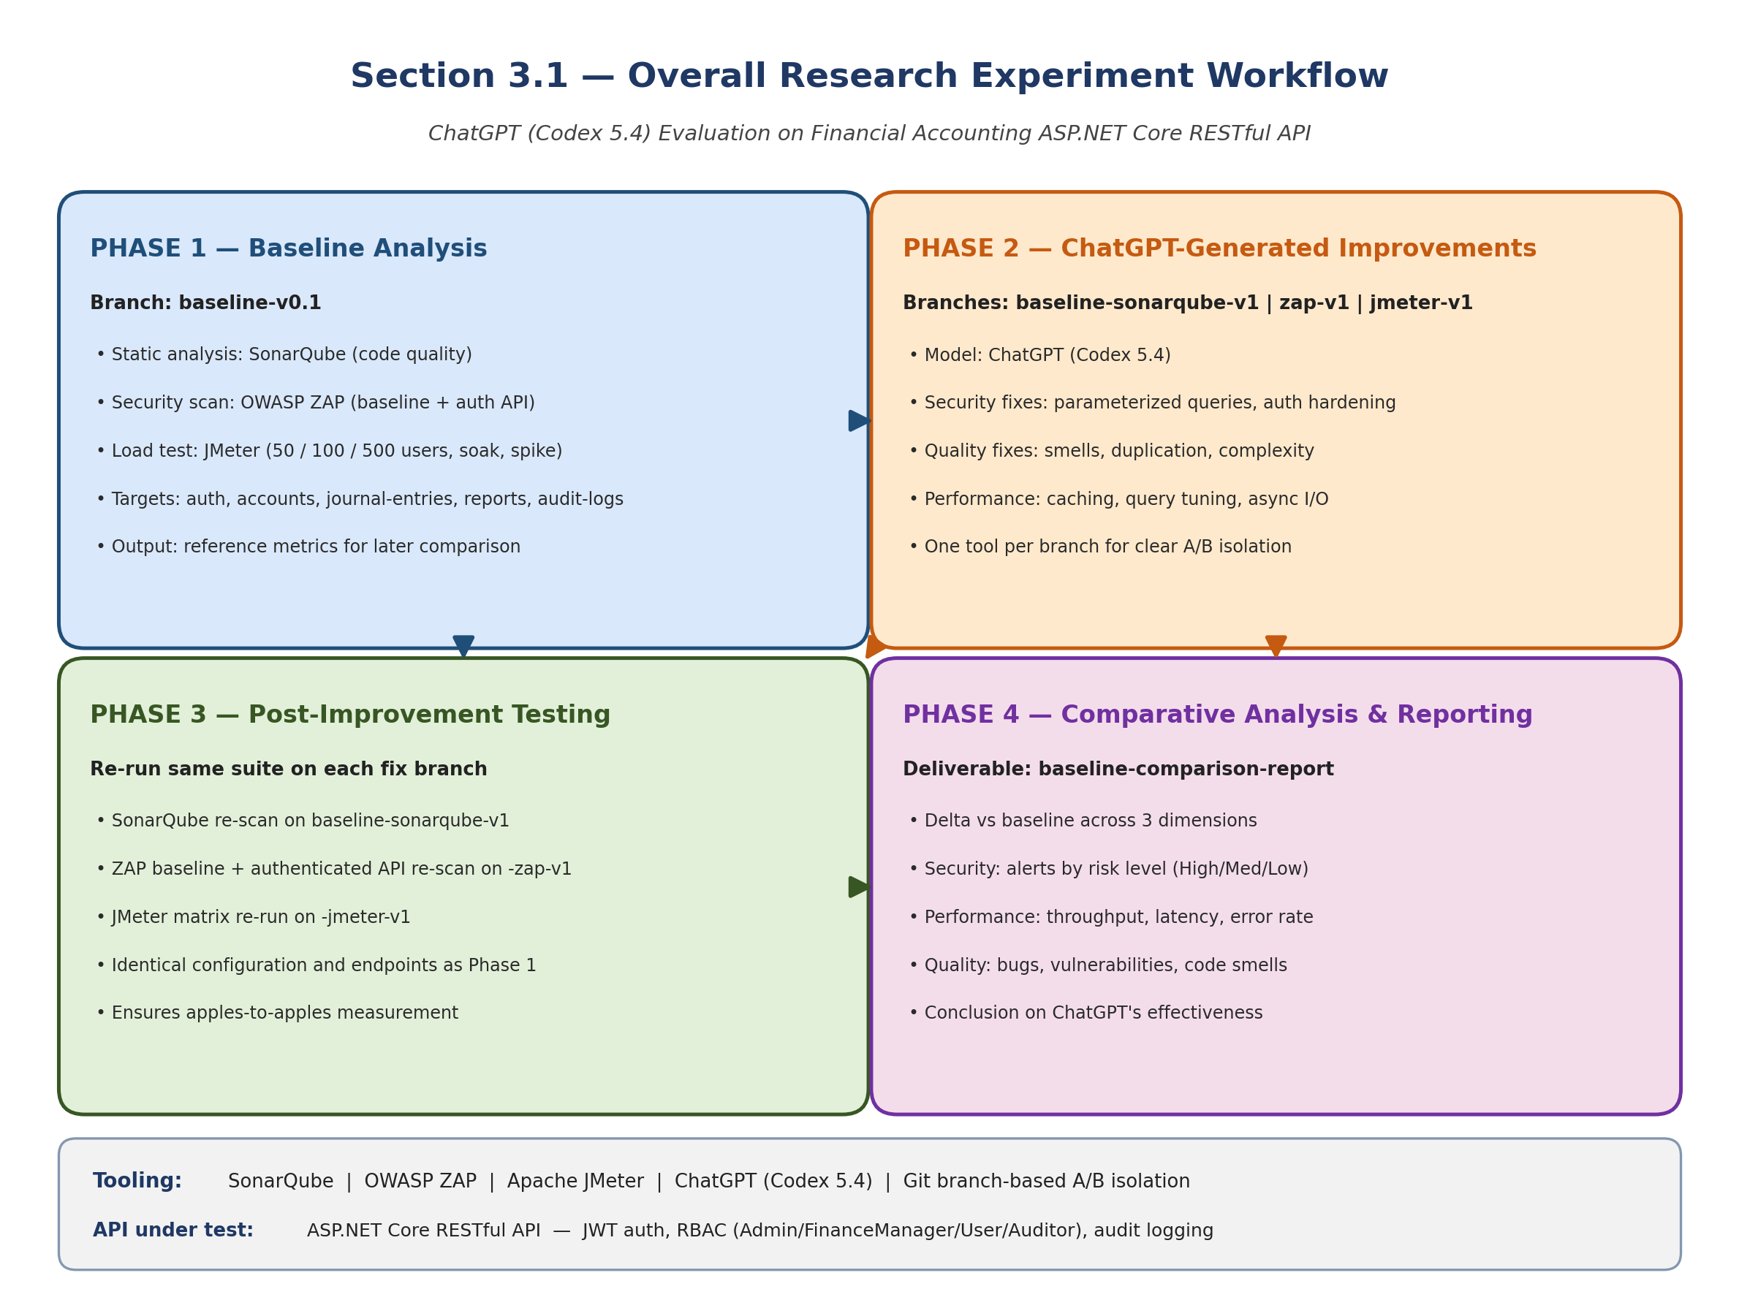
Figure (3.0) Overview of the Four-Phase Research Workflow
- Phase 1: Baseline Analysis
  - Initial security and performance testing are conducted on the financial accounting ASP.NET Core RESTful API project. The API includes endpoints for authentication, chart of accounts, journal entries, accounting periods, financial reports, and audit logs. These baseline metrics are captured on the baseline-v0.1 branch and provide reference points for evaluating the effectiveness of improvements.
  - Tools: SonarQube for code quality and static analysis, OWASP ZAP for security vulnerability scanning (baseline scan and authenticated API scan), and Apache JMeter for performance testing (load, soak, and spike test profiles at 50, 100, and 500 concurrent users).
Example:
- Financial Accounting API: A complex RESTful API for financial accounting with multi-tier architecture (API, BAL/Services, MODEL/Entities, Tests).
  - Example Endpoints: GET /accounts to list chart of accounts, POST /journal-entries to create journal entries, GET /reports/trial-balance to generate trial balance reports.
- The API features role-based access control (Admin, FinanceManager, User, Auditor), JWT authentication, and comprehensive audit logging.
  - Example Endpoint: POST /journal-entries/bulk to create bulk journal entries with debit/credit line validation, requiring authenticated access and finance role authorization.

- Phase 2: ChatGPT-Generated Improvements
  - Code recommendations are generated using ChatGPT (Codex 5.4) for addressing detected vulnerabilities and performance bottlenecks. Each tool’s fixes are applied on a dedicated branch: baseline-sonarqube-v1 for code quality issues, baseline-zap-v1 for security vulnerabilities, and baseline-jmeter-v1 for performance optimizations. This branch-based approach isolates changes per tool for clear before/after comparison.
  - Example Guidance from ChatGPT: Using parameterized queries to prevent SQL injection, improving loop efficiency, implementing secure session management.
Example:
Security Enhancement:
  - Baseline Issue: Vulnerability to SQL injection in the POST /transactions endpoint.
  - ChatGPT Recommendation: Use parameterized queries in SQL commands.
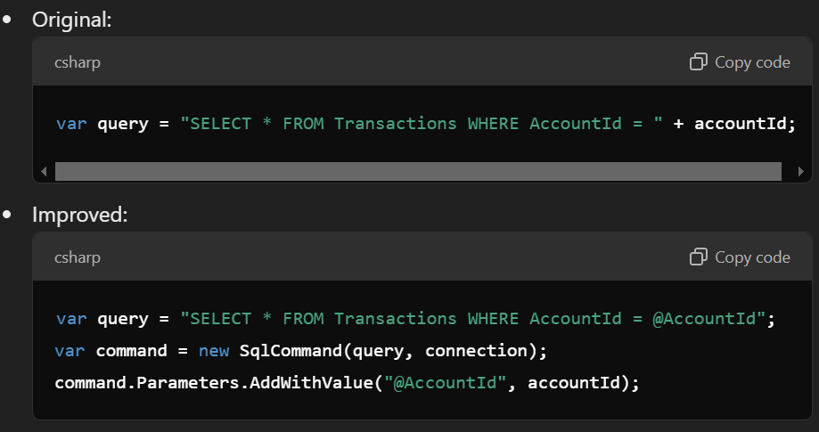
Figure (3.1)
Performance Optimization:
- Baseline Issue: Slow response times in fetching transaction reports.
- ChatGPT Recommendation: Implement caching for frequently accessed endpoints.
  - Example Adjustment: Use in-memory caching for the GET /reports endpoint to store results for 10 minutes:
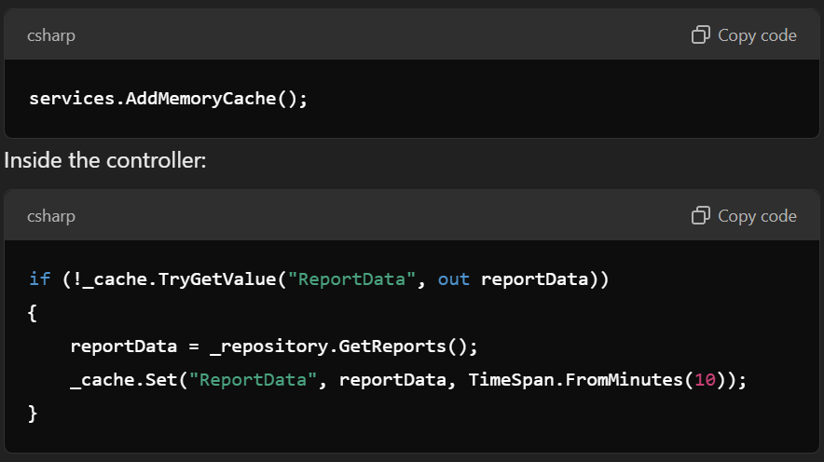
Figure (3.2)

- Phase 3: Post-Improvement Testing
  - With ChatGPT-guided changes implemented on each branch, the project undergoes a new round of testing using the same tools and configurations as the baseline. Security, performance, and code quality metrics are collected again and compared to the baseline-v0.1 results.
Example:
  - Security: Run ZAP baseline scan and authenticated API scan against all endpoints (auth, accounts, journal-entries, periods, reports, audit-logs) on the baseline-zap-v1 branch.
  - Performance: Run JMeter test matrix (50, 100, 500 concurrent users + soak + spike profiles) against all API endpoints on the baseline-jmeter-v1 branch.

- Phase 4: Comparative Analysis and Reporting
  - The data collected from the baseline (baseline-v0.1) and post-improvement branches (baseline-sonarqube-v1, baseline-zap-v1, baseline-jmeter-v1) are analyzed and compared to draw conclusions on ChatGPT’s effectiveness in enhancing the security, performance, and code quality of the financial accounting RESTful API. Results are compiled into a baseline-comparison-report documenting improvements across all three dimensions.
Example:
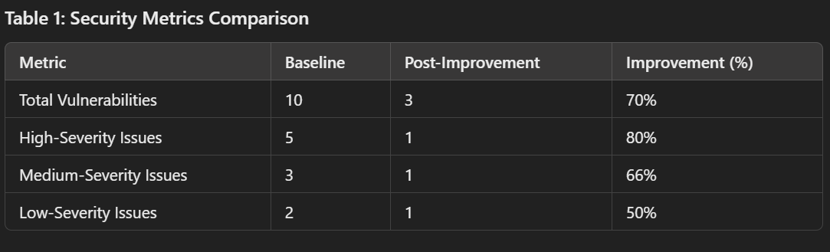
Figure (3.3)

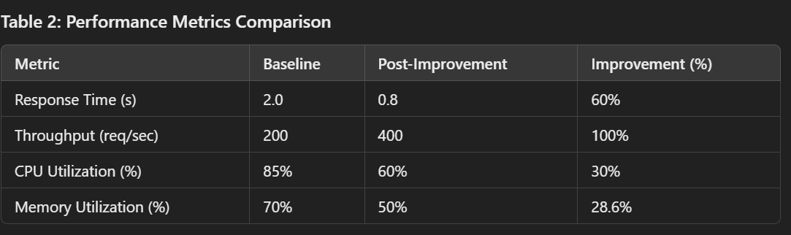
Figure (3.4)

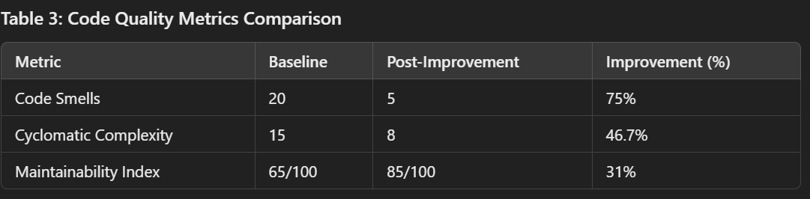
Figure (3.5)

3.2 Dataset Description and Preparation
- Dataset Characteristics
The dataset comprises financial accounting data, which simulates real-world transactional and sensitive data to evaluate the impact of security and performance improvements. This dataset provides realistic test scenarios for vulnerability and performance testing, particularly relevant to financial applications.
- Data Preparation for Testing
  - Data Anonymization: Sensitive financial data is anonymized to comply with ethical research standards.
  - Preprocessing: Data is cleaned and formatted to align with RESTful API standards, ensuring uniform data for endpoint testing.
- Dataset Examples
Simple Project Dataset
The simple project simulates a basic API, such as an employee or product management system, with limited functionality.
Transactional Data
- Focus on basic CRUD operations for a small dataset.
- Example:
  - Total Records: 50-100.
  - Fields:
    - TransactionID: Auto-increment ID.
    - AccountID: Integer for account identification.
    - Amount: Small transaction values (e.g., less than $10,000).
    - Date: Standard date format.
    - Currency: Limited to 2-3 options (e.g., USD, EUR).
    - Status: Few options (e.g., Completed, Pending).

- Sample Data:

Figure (3.6)

User Data
- Includes a few users to test basic authentication.
- Example:
  - Total Records: 5-10.
  - Fields:
    - UserID: Auto-increment ID.
    - Username: Basic usernames.
    - Role: Limited to User and Admin roles.
    - PasswordHash: Simplified, hashed passwords.
- Sample Data:

Figure (3.7)

Reports Data
- Very basic reporting functionality.
- Example:
  - Total Records: 3-5.
  - Fields:
    - ReportID: Auto-increment ID.
    - DateRange: Fixed intervals.
    - TotalTransactions: Basic aggregation.
    - TotalAmount: Summed values.
- Sample Data:

Figure (3.8)

Complex Project Dataset
The complex project simulates a financial management system with advanced features like role-based access control, bulk transactions, and report generation.
Transactional Data
- Larger dataset with detailed fields and complex relationships.
- Example:
  - Total Records: 1,000 - 1,000,000.
  - Fields:
    - TransactionID: Auto-increment ID.
    - AccountID: Includes relationships with multiple users or organizations.
    - Amount: Includes large and small transaction values (e.g., $0 to $1,000,000).
    - Date: Includes transactions over multiple years.
    - Currency: Supports 5-10 currencies.
    - Status: Includes additional statuses (e.g., Failed, Reversed).
    - Description: Text field for transaction details.
- Sample Data:
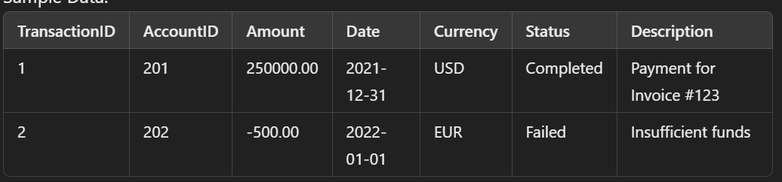
Figure (3.9)

User Data
- Larger and more diverse user set for testing role-based scenarios.
- Example:
  - Total Records: 50-100.
  - Fields:
    - UserID: Unique IDs.
    - Username: Includes diverse naming patterns.
    - Role: Multiple roles (Admin, User, Auditor, Finance Manager).
    - PasswordHash: Properly hashed passwords.
- Sample Data:
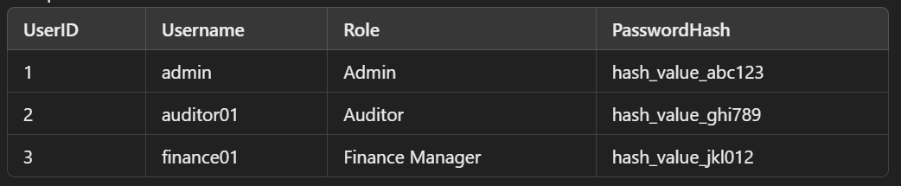
Figure (3.10)

Reports Data
- Advanced reporting with dynamic aggregation.
- Example:
  - Total Records: 100+.
  - Fields:
    - ReportID: Unique ID.
    - DateRange: Customizable intervals (daily, weekly, monthly).
    - TotalTransactions: Dynamic counts based on filters.
    - TotalAmount: Summed values with multi-currency support.
    - CurrencyBreakdown: Nested field for detailed breakdowns.
- Sample Data:
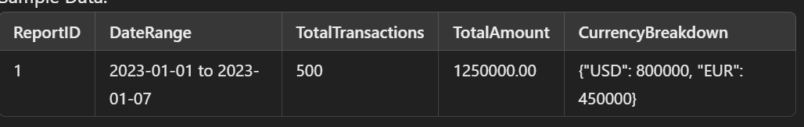
Figure (3.11)

Comparison Between Simple and Complex Projects
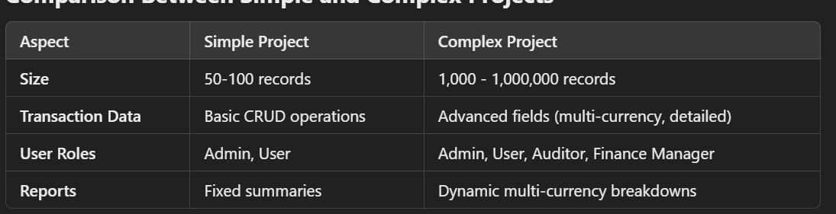
Figure (3.12)

3.3 Model and Tool Selection
This research employs a combination of tools to evaluate different aspects of code security, performance, and quality. ChatGPT (specifically the Codex 5.4 model by OpenAI) serves as the AI assistant for generating code improvement recommendations throughout this study.
- What is SonarQube and why we focus on it? SonarQube is an open-source static-analysis platform that scans source code for bugs (probable defects), vulnerabilities (known security weaknesses), code smells (maintainability issues), security hotspots (suspicious patterns flagged for manual review), test coverage, and code duplication. Findings are emitted with rule identifiers (e.g., S125, S6966), severity levels, and human-readable remediation guidance. This study targets the static-quality dimension because code bases of any age accumulate code smells faster than they accumulate bugs, and removing rule-by-rule findings without regressions is one of the chief reasons a quality dashboard moves from red to green. The metrics reported in later chapters (Bugs, Vulnerabilities, Code Smells, Security Hotspots, Coverage %, Duplicated lines %, and Quality Gate pass/fail) all originate from SonarQube and are interpreted in the order listed.
- SonarQube (Community Edition): Used for assessing code quality and security vulnerabilities by scanning the .NET codebase for bugs, code smells, and security vulnerabilities. Runs via dotnet-sonarscanner with unit and integration test coverage analysis. Because prior empirical work has questioned how closely SonarQube rule violations align with bug-inducing changes in real projects (Lenarduzzi et al., 2020), SonarQube results in this study are always interpreted jointly with independent ZAP and JMeter measurements rather than in isolation.
- What is Apache JMeter and why we focus on it? Apache JMeter is a load-testing tool that simulates concurrent virtual users (VUs) issuing HTTP requests according to a configurable plan. For each request it records latency (response time), throughput (transactions per second), and error rate (HTTP 4xx/5xx responses). Test plans can hold load constant, sustain it for a soak window, or burst it for a spike, and JMeter aggregates the resulting event log into per-endpoint percentiles. This study targets the load-performance dimension because static analysis and security scanning cannot tell whether the API will keep responding under realistic load; p95 latency and error rate under load are the primary user-facing quality signals that determine whether an SLA is met. The metrics reported in later chapters (p95, p99, throughput, error rate) all come from JMeter, with the gate threshold pre-registered.
- Apache JMeter: Measures performance metrics such as response times, throughput, and error rates across multiple load profiles (50, 100, 500 concurrent users), soak testing, and spike testing. Test plans target all API endpoints including authentication, CRUD operations, and reporting.
- What is OWASP ZAP and why we focus on it? OWASP Zed Attack Proxy (ZAP) is a free, open-source dynamic application security testing (DAST) tool. It performs a passive baseline scan that observes responses to crawled requests for missing security headers, cookie problems, and known-vulnerable bundled JavaScript libraries; and an active API scan that, given an OpenAPI definition and a valid authentication token, exercises every endpoint and probes for OWASP Top-10-style flaws. Findings are emitted by risk level: High, Medium, Low, and Informational. This study targets the security dimension because APIs in financial domains are routinely targeted, and a vulnerability that survives into production can cost more than the entire engineering budget to remediate. The alert counts reported in later chapters are categorized by these four risk levels, and the pre-registered gate is that no High, Medium, or Low alert remains on a business endpoint after fixes.
- OWASP ZAP: Provides comprehensive vulnerability scanning through baseline scans (passive analysis of all endpoints) and authenticated API scans (active testing with JWT tokens and role-based access). Custom rule configurations are maintained in TSV files for reproducible scan profiles.

3.4 Implementation of ChatGPT-Guided Improvements
After baseline testing, ChatGPT (Codex 5.4) is used to generate improvement suggestions. Key areas of focus include:
- Security Enhancements
  - ChatGPT offers guidance on preventing SQL injection by implementing parameterized queries, managing session data securely, and sanitizing inputs.
  - Example Adjustments: Integrating secure authentication protocols, using encryption for sensitive data, and adjusting HTTP headers to prevent common attacks like cross-site scripting (XSS).
- Performance Optimizations
  - ChatGPT suggestions for performance optimization may include improvements to data handling, optimizing API response time by limiting unnecessary queries, and using caching mechanisms for frequently accessed resources.
  - Example Adjustments: Refining data-fetching algorithms, implementing pagination, and managing connection pooling.

3.5 Testing Phases
Each API project undergoes rigorous testing through two phases: initial testing (baseline) and post-improvement testing.
- Baseline Testing: The initial state of the financial accounting API is tested for security (ZAP baseline + API scan), performance (JMeter load/soak/spike), and code quality (SonarQube). Results are captured on the baseline-v0.1 branch.
- Post-Improvement Testing: After implementing ChatGPT’s improvements on dedicated branches (baseline-sonarqube-v1, baseline-zap-v1, baseline-jmeter-v1), each branch is re-tested with the same tool and configuration to assess the efficacy of the changes. All issues and fixes are documented in per-tool fix tracking documents.

3.6 How is it different from others research?
- Focus on ChatGPT: Unlike other studies that may compare multiple AI tools, your work focuses solely on the application of ChatGPT (Codex 5.4) in improving ASP.NET Core RESTful APIs, offering an in-depth analysis of its capabilities.
- Combination of Security and Performance Testing: This study integrates both security (OWASP ZAP) and performance (Apache JMeter) testing in a single workflow, which is less commonly addressed together in similar research.
- Real-World Dataset: By using financial accounting data, your research simulates realistic scenarios that demonstrate the practical applications of ChatGPT-guided improvements.
- Two-Tiered Complexity: The comparison between a simple API and a complex one provides insights into how ChatGPT performs under varying levels of API complexity.

Chapter 4: Evaluation Plan and Metrics
4.1 Evaluation Criteria
- Security Metrics: The security of the API is evaluated based on the number and severity of vulnerabilities identified pre- and post-improvement as in Figure (4.1). Common security flaws to be tested include SQL injection, XSS, broken authentication, and sensitive data exposure.
- Performance Metrics: Key performance indicators include response time, throughput, and resource utilization (CPU, memory) as in figure (4.5). Metrics will be measured under varying load conditions to assess the performance impact of the applied improvements.
- Code Quality Metrics: Code quality is analyzed in terms of readability, maintainability, and adherence to clean code principles as in figure (4.1). SonarQube will highlight improvements in code smells as in figure (4.2), reduced cyclomatic complexity as in figure (4.3), and overall code maintainability as in figure (4.4).

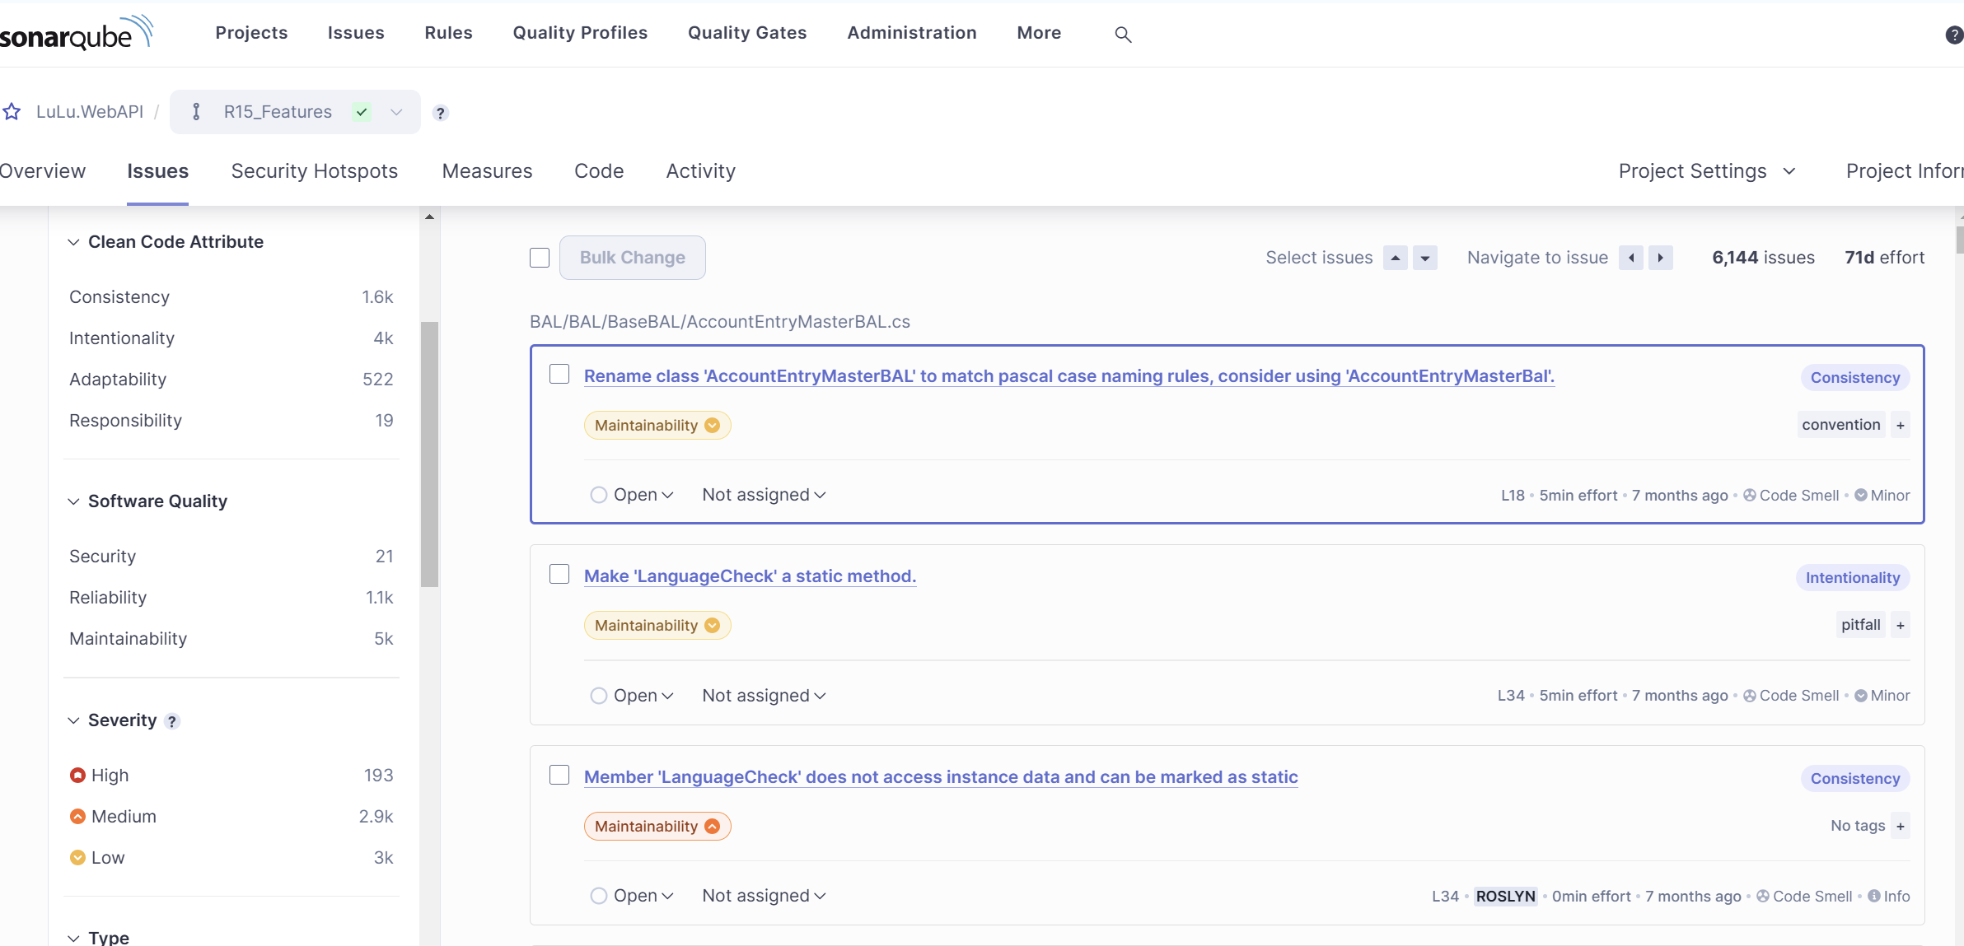
Figure (4.1)
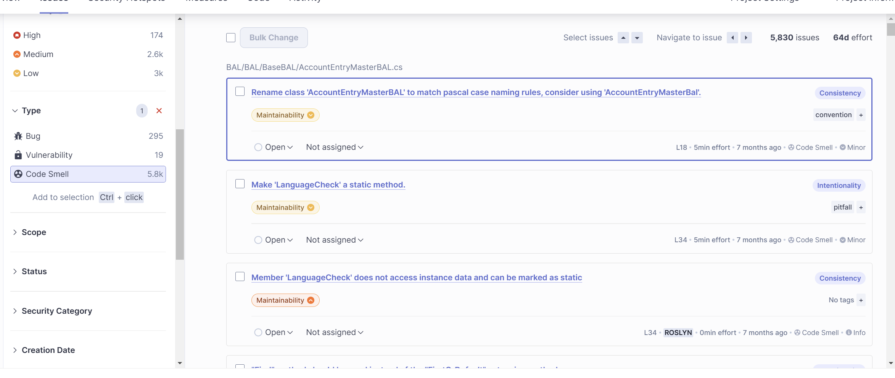
Figure (4.2)

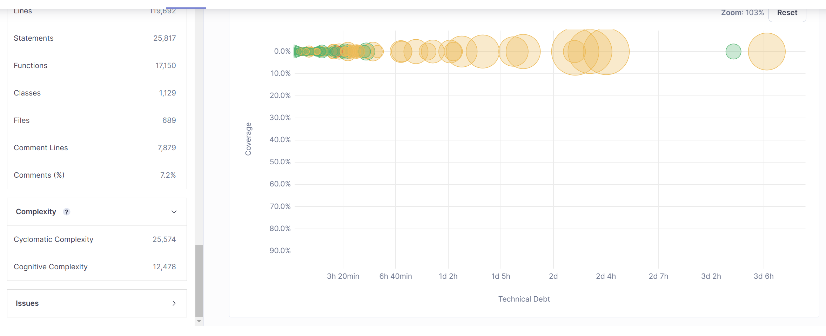
Figure (4.3)

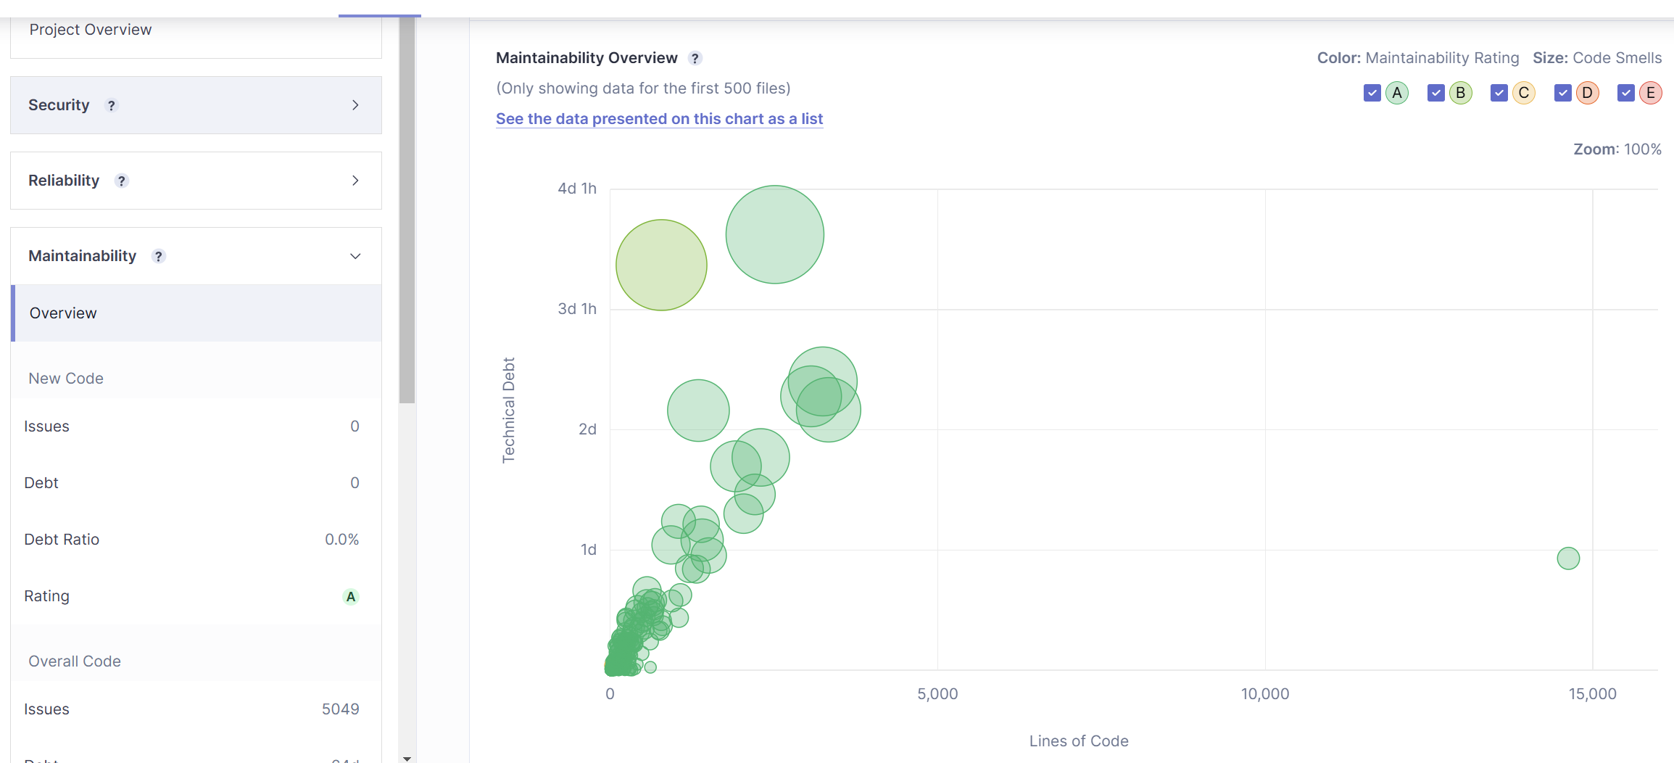
Figure (4.4)

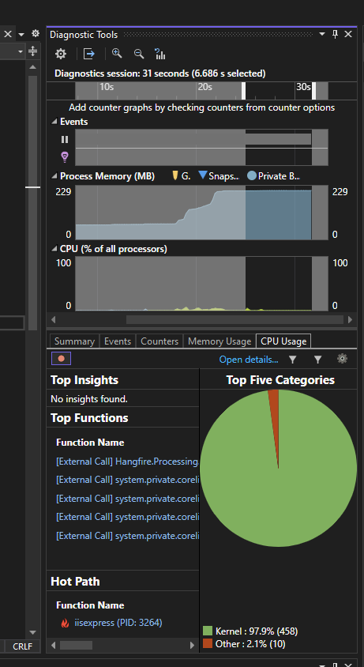
Figure (4.5)

4.1.1 Expected Outcomes from Evaluation Criteria
4.1.1.1 Security Metrics
Criteria:
- Number of Vulnerabilities: Reduction in vulnerabilities detected by SonarQube.
- Severity Levels: Decrease in high-severity issues such as SQL injection, XSS, and authentication flaws.
- Authorization: Proper enforcement of role-based access controls (RBAC).
Expected Outcomes:
- Vulnerability Reduction:
  - Baseline: 10 vulnerabilities (5 high, 3 mediums, 2 low).
  - Post-Improvement: 3 vulnerabilities (1 high, 1 medium, 1 low).
  - Expected reduction: 70% fewer vulnerabilities overall.
- High-Severity Issues:
  - Baseline: 5 high-severity vulnerabilities.
  - Post-Improvement: 1 high-severity vulnerability.
  - Expected reduction: 80% fewer critical security flaws.
- Authentication and Authorization:
  - Unauthorized users attempting to access sensitive endpoints (e.g., GET /reports) should receive an HTTP 403 (Forbidden) response.
- Validation Improvements:
  - All user inputs are sanitized to prevent SQL injection or XSS.

4.1.1.2 Performance Metrics
Criteria:
- Response Time: Average time for API endpoints to respond under varying loads.
- Throughput: Number of successful requests per second.
- Resource Utilization: CPU and memory usage during API operations.
Expected Outcomes:
- Response Time:
  - Baseline: 2.0 seconds for GET /transactions with 100 concurrent users.
  - Post-Improvement: 0.8 seconds.
  - Expected improvement: 60% faster response time.
- Throughput:
  - Baseline: 200 requests/second.
  - Post-Improvement: 400 requests/second.
  - Expected improvement: 100% increase in throughput.
- Resource Utilization:
  - CPU Usage:
    - Baseline: 85%.
    - Post-Improvement: 60%.
    - Expected improvement: Reduction of 25% in CPU utilization.
  - Memory Usage:
    - Baseline: 70%.
    - Post-Improvement: 50%.
    - Expected improvement: Reduction of 20% in memory utilization.

4.1.1.3 Code Quality Metrics
Criteria:
- Code Smells: Reduction in the number of code smells detected by SonarQube.
- Cyclomatic Complexity: Improved code structure with lower complexity.
- Maintainability Index: Higher maintainability score reflecting cleaner code.
Expected Outcomes:
- Code Smells:
  - Baseline: 20 code smells.
  - Post-Improvement: 5 code smells.
  - Expected reduction: 75% fewer code smells.
- Cyclomatic Complexity:
  - Baseline: Average complexity of 15 for critical methods.
  - Post-Improvement: Average complexity of 8.
  - Expected improvement: 47% reduction in cyclomatic complexity.
- Maintainability Index:
  - Baseline: 65/100.
  - Post-Improvement: 85/100.
  - Expected improvement: 31% increase in maintainability index.

4.2 Security Evaluation Plan
The security evaluation plan focuses on using OWASP ZAP for comprehensive testing.
- Vulnerability Scanning: OWASP ZAP performs both baseline (passive) and authenticated API (active) scans across all endpoints: /auth, /accounts, /journal-entries, /periods, /reports, and /audit-logs. Focus areas include injection flaws, broken authentication, missing security headers (CSP, X-Content-Type-Options, CORS), and vulnerable dependencies.
- Authentication and Authorization Testing: OWASP ZAP authenticated API scan is used to test role-based access control (Admin, FinanceManager, User, Auditor roles) and JWT authentication. Unauthorized access attempts against protected endpoints (e.g., POST /accounts, POST /periods/{id}/close, DELETE /journal-entries/{id}) verify the robustness of the API’s access control.
- Comparison of Pre- and Post-Improvement Results: Security test results from baseline-v0.1 and baseline-zap-v1 branches are compared, analyzing how ChatGPT (Codex 5.4)’s recommendations mitigated identified vulnerabilities. Alert counts are compared by severity level (High, Medium, Low, Informational).

4.3 Performance Evaluation Plan
Performance testing is conducted with Apache JMeter to simulate multiple concurrent users accessing the API.
- Response Time and Throughput: Apache JMeter measures response times (average, p95, p99) and throughput for each API endpoint under load profiles of 50, 100, and 500 concurrent users, plus soak (sustained load) and spike (burst) test profiles.
- Resource Utilization: CPU and memory usage are tracked during load tests. Error rates are monitored to identify endpoints that fail under stress.
- Comparison of Performance Metrics: Results from baseline-v0.1 and baseline-jmeter-v1 branches are compared to determine the impact of ChatGPT (Codex 5.4)’s suggestions on performance, focusing on improvements in response times, error rate reduction, throughput gains, and stability under sustained and spike load conditions.

4.4 Code Quality Evaluation Plan
Code quality is assessed using SonarQube, focusing on key metrics such as code smells, maintainability, and cyclomatic complexity.
- Baseline Analysis: The initial codebase on baseline-v0.1 is scanned with SonarQube (via dotnet-sonarscanner) to identify code smells, potential bugs, security vulnerabilities, and security hotspots across all five modules (API, BAL, MODEL, REPOSITORY, Tests).
- Post-Improvement Analysis: After applying ChatGPT (Codex 5.4)’s recommendations on baseline-sonarqube-v1, SonarQube is run again with the same configuration to evaluate improvements. This second analysis identifies reductions in bugs, code smells, security vulnerabilities, and security hotspots. Quality gate status is compared.
- Clean Code Principles: Changes are analyzed based on adherence to clean code principles like simplicity, readability, and minimized dependencies. To mitigate the known limitation that not every SonarQube rule correlates with real defects (Lenarduzzi et al., 2020), quality-gate conclusions are cross-referenced with the ZAP and JMeter outcomes on their respective branches, so that a SonarQube improvement is only claimed when at least one other independent measurement is consistent with it.

4.5 Comparative Analysis
Results from each testing category (security, performance, and code quality) are compared between baseline and post-improvement stages. All improvement recommendations are generated using ChatGPT powered by the Codex 5.4 model.
- Security: Evaluate the reduction in ZAP alerts by severity level (High, Medium, Low, Informational) between baseline-v0.1 and baseline-zap-v1. Document specific alerts resolved and any remaining issues.
- Performance: Compare JMeter results between baseline-v0.1 and baseline-jmeter-v1 across all load profiles (p50, p100, p500, soak, spike). Key metrics: average response time, p95/p99 latency, throughput (req/s), and error rate.
- Code Quality: Compare SonarQube results between baseline-v0.1 and baseline-sonarqube-v1. Key metrics: bugs, vulnerabilities, code smells, security hotspots, cyclomatic complexity, maintainability index, and quality gate status.
4.5.1 Security Comparison (OWASP ZAP)
Reading the security metrics. The comparison reports OWASP ZAP alert counts at four risk levels. High alerts are findings ZAP considers exploitable with high confidence (e.g., SQL injection, exposed credentials); Medium alerts indicate real but lower-impact issues such as missing security headers on user-facing pages; Low alerts flag hardening recommendations; and Informational alerts are observations rather than vulnerabilities (e.g., authentication-request fingerprinting, non-storable content). The pre-registered gate is that no High, Medium, or Low alert remains on a business endpoint after fixes; informational alerts are reported but not gated. The study reports a percentage reduction per category and tracks each vulnerability class (CSP header, CORS configuration, Anti-CSRF token, SQL injection exposure, etc.) as fully resolved, partially mitigated, or open.
The security comparison is conducted by running OWASP ZAP scans on both the baseline-v0.1 and baseline-zap-v1 branches using identical scan configurations: a passive baseline scan followed by an authenticated API scan with JWT tokens for all four roles (Admin, FinanceManager, User, Auditor). The results are evaluated along the following dimensions:
- Alert Count by Severity: The total number of ZAP alerts is tabulated for each severity category (High, Medium, Low, Informational) before and after the ChatGPT-guided fixes. A percentage reduction per category is calculated to quantify improvement. The primary success criterion is a reduction of at least 50% in High and Medium severity alerts.
- Vulnerability Type Resolution: Specific vulnerability classes (e.g., missing Content Security Policy header, insecure CORS configuration, absence of Anti-CSRF tokens, SQL injection exposure) are tracked individually. For each class, the comparison records whether it was fully resolved, partially mitigated, or remains open. This qualitative review supplements the quantitative alert counts and enables a root-cause analysis of ChatGPT’s recommendations.
- Access Control Validation: Authenticated scan results for each role are compared to verify that role-based access control (RBAC) is correctly enforced after improvements. Unauthorized access attempts against protected endpoints (e.g., DELETE /journal-entries/{id} by a User role) are expected to return HTTP 403 Forbidden consistently. Any regressions in access control are flagged as critical findings.
4.5.2 Performance Comparison (Apache JMeter)
Reading the performance metrics. The comparison reports four classes of metric per profile. Response Time (Average, p95, p99) is the latency in milliseconds, where p95 is the latency that 95% of requests come in under and p99 captures the tail. Throughput (requests per second) is the number of successfully processed requests per second; an improvement here demonstrates the API's capacity to handle higher concurrent loads. Error Rate is the proportion of HTTP 4xx and 5xx responses; the acceptable threshold post-improvement is below 1% at the 100-VU profile. Soak and spike test stability are evaluated as memory leak / response-time-degradation patterns over the soak window, and as recovery behaviour after the spike burst. A negative percentage delta indicates a reduction (improvement); a smaller absolute number after improvement is therefore the desired direction.
Performance results from baseline-v0.1 and baseline-jmeter-v1 are compared across five load profiles (50, 100, and 500 concurrent users, plus soak and spike tests) for all API endpoint groups. The comparison is structured around the following key metrics:
- Response Time (Average, p95, p99): Measured in milliseconds for each endpoint under each load profile. The target success criterion is a p95 latency below 2,000 ms at 100 concurrent users and a reduction of at least 30% compared to the baseline. The p99 latency is monitored to detect tail-latency issues that affect a small but meaningful portion of requests.
- Throughput (Requests per Second): The number of successfully processed requests per second is compared between branches. An improvement in throughput demonstrates the API’s capacity to handle higher concurrent loads. The expected improvement is a 50% or greater increase at the 100 concurrent users profile, driven by optimizations such as query caching, connection pooling, and pagination.
- Error Rate: HTTP error rates (4xx and 5xx responses) are tracked for each load profile. The acceptable threshold post-improvement is below 1% error rate at 100 concurrent users. Any increase in error rate after applying optimizations would indicate regressions introduced by the ChatGPT-recommended changes.
- Soak and Spike Test Stability: Soak tests (sustained load over an extended period) are evaluated for memory leak patterns and gradual response time degradation. Spike tests assess the API’s ability to recover to normal performance levels after a sudden burst of traffic. Results are compared to determine whether ChatGPT’s optimizations improve overall system stability under non-standard load conditions.
4.5.3 Code Quality Comparison (SonarQube)
Reading the code-quality metrics. The comparison reports four classes of SonarQube metric. Bugs and Vulnerabilities are issue counts categorised by severity (Blocker, Critical, Major, Minor, Info); the target post-improvement state is zero Blocker and Critical issues, and at least a 70% reduction across all severity levels. Code Smells is the count of maintainability-oriented findings; the target is a 75% reduction. Cyclomatic Complexity is the average branching complexity of critical methods; the target is a 47% reduction. Maintainability Index is SonarQube's overall score (0-100) of long-term sustainability; the target is an increase from 65 to 85. The Quality Gate pass/fail status is reported separately and is the binary indicator of whether the project as a whole meets its pre-registered gate criteria.
SonarQube scans are executed using the same dotnet-sonarscanner configuration on both baseline-v0.1 and baseline-sonarqube-v1, covering all five project modules (API, BAL, MODEL, REPOSITORY, Tests). The comparison focuses on the following metrics:
- Bugs and Vulnerabilities: The count of SonarQube-detected bugs and security vulnerabilities is compared between branches. Each issue is categorized by severity (Blocker, Critical, Major, Minor, Info). The target is zero Blocker and Critical issues in the post-improvement scan, with an overall reduction of at least 70% across all severity levels, aligning with the expected outcomes defined in Section 4.1.1.1.
- Code Smells: The number of code smells is compared to assess improvements in readability and adherence to clean code principles. Code smells include long methods, duplicate code blocks, overly complex conditionals, and unused variables. The target is a 75% reduction (from 20 to approximately 5 code smells), as outlined in Section 4.1.1.3.
- Cyclomatic Complexity: The average cyclomatic complexity of critical methods is compared to evaluate whether ChatGPT’s structural recommendations (e.g., method decomposition, reducing nested conditionals) resulted in simpler, more testable code. A reduction from an average of 15 to 8 per method represents the target improvement of approximately 47%.
- Maintainability Index and Quality Gate Status: The overall maintainability index (scored out of 100 by SonarQube) reflects the long-term sustainability of the codebase. An improvement from 65 to 85 (a 31% increase) is expected. Additionally, the SonarQube Quality Gate status (Pass/Fail) is reported for both branches. A gate status change from Fail to Pass on the post-improvement branch would represent a definitive indicator of ChatGPT’s positive impact on code quality.
4.5.4 Overall Effectiveness Assessment
The final comparative analysis synthesizes findings from all three dimensions into an overall effectiveness assessment of ChatGPT (Codex 5.4)-guided improvements. This assessment addresses three evaluation questions:
- Did ChatGPT’s recommendations achieve measurable improvements? Each dimension is evaluated against its predefined success criteria. Dimensions where the success criterion is met are marked as “Achieved,” partially met criteria are marked “Partial,” and unmet criteria are marked “Not Achieved.” This binary-plus-partial scoring provides a structured, reproducible basis for drawing conclusions.
- Were there trade-offs between dimensions? Security improvements (e.g., adding input validation, enforcing stricter authentication checks) may introduce additional processing overhead, potentially affecting response times. Similarly, performance optimizations such as caching may have security implications if cache expiry policies are not carefully managed. These cross-dimensional trade-offs are explicitly analyzed and documented.
- What are the limitations of the ChatGPT-assisted approach? Cases where ChatGPT’s recommendations were inapplicable, incorrect, or required significant human correction are documented. This analysis acknowledges that ChatGPT is a generative AI tool and its suggestions require developer review before application. Patterns of success and failure in ChatGPT’s guidance form part of the study’s contribution to understanding the practical boundaries of AI-assisted software improvement. This is consistent with prior findings that, even when an LLM assistant is available, the net impact on security depends heavily on prompting discipline and review process (Khoury et al., 2023; Sandoval et al., 2023). The branch-isolated, scanner-gated workflow used here is specifically intended to exploit the advisor-under-follow-up-prompting regime that those studies identify as the one in which LLM output is most likely to improve.

References
Chapter 5: Conclusion
This research proposes a systematic, branch-based methodology for evaluating the impact of ChatGPT (Codex 5.4) on the security, performance, and code quality of a financial accounting ASP.NET Core RESTful API. By capturing baseline metrics and comparing them against results obtained after applying ChatGPT-generated recommendations, the study aims to provide empirical, tool-validated evidence of AI’s practical utility in modern software development workflows.
5.1 Summary of the Proposed Research
The research focuses on a real-world financial accounting API built with ASP.NET Core, featuring endpoints for user authentication (JWT-based), chart of accounts, journal entry processing, accounting period management, financial reporting, and audit logging. The study follows a four-phase workflow: (1) baseline analysis using SonarQube, OWASP ZAP, and Apache JMeter; (2) generation of improvement recommendations via ChatGPT; (3) implementation of those recommendations on dedicated Git branches; and (4) post-improvement re-testing and comparative analysis. This structured approach ensures full isolation of changes per tool and provides a reproducible experimental framework.
5.2 Expected Contributions
This study is expected to make the following contributions to the field of AI-assisted software engineering:
- Empirical Evidence: The study provides quantitative, tool-validated evidence of ChatGPT (Codex 5.4)’s effectiveness in improving a production-complexity RESTful API across three independent quality dimensions. This fills a gap in the existing literature, which largely focuses on code generation accuracy rather than iterative improvement of an existing codebase.
- Reusable Evaluation Framework: The branch-based testing methodology, combining SonarQube, OWASP ZAP, and Apache JMeter with ChatGPT-guided improvement cycles, serves as a reproducible framework that other researchers or practitioners can adapt for evaluating AI-assisted improvements in their own API projects.
- Practical Guidance for Developers: By documenting the types of prompts that led to effective improvements and those that required significant human correction, this study offers practical insights into how developers can more effectively leverage ChatGPT as a code review and security advisory tool in day-to-day software engineering practice.
5.3 Limitations and Scope
Several limitations are acknowledged within the scope of this research. First, the study is confined to ASP.NET Core RESTful APIs; the findings may not directly generalize to APIs built on other frameworks or programming languages. Second, only ChatGPT (Codex 5.4) is evaluated as the AI assistant, excluding comparisons with other large language models such as GitHub Copilot or Google Gemini. Third, the evaluation relies on static analysis and automated testing tools; aspects such as developer productivity, usability of AI-generated suggestions, and long-term code maintenance are not measured. Finally, ChatGPT’s responses are inherently non-deterministic, meaning that repeated prompting may yield different recommendations. The study mitigates this by documenting all prompts and responses as part of the experimental record.
5.4 Future Work
Building on the findings of this research, several directions for future work are identified:
- Multi-Model Comparison: Extending the methodology to compare ChatGPT with other large language models (e.g., GitHub Copilot, Google Gemini, Meta LLaMA) would provide a broader perspective on the relative strengths and weaknesses of different AI assistants for API security and performance improvement.
- Automated AI-CI/CD Integration: Future research could explore the integration of AI-driven improvement suggestions directly into CI/CD pipelines, enabling automated feedback loops where SonarQube or ZAP scan results are automatically submitted to an LLM for remediation suggestions, which are then applied and re-tested without manual intervention.
- Cross-Framework Generalization: Applying the same evaluation methodology to APIs built on Node.js (Express), Python (FastAPI/Django REST), or Java (Spring Boot) would help determine whether the effectiveness of ChatGPT-guided improvements is framework-specific or generalizable across technology stacks.
In conclusion, this thesis proposal establishes a rigorous, evidence-based framework for investigating the role of ChatGPT (Codex 5.4) as an AI-driven software improvement tool. The financial accounting API provides a realistic and complex test subject, while the combination of SonarQube, OWASP ZAP, and Apache JMeter ensures a multi-dimensional evaluation of improvement effectiveness. The research is positioned to contribute meaningful empirical data to the growing body of knowledge on AI-assisted software engineering, ultimately helping developers and organizations make informed decisions about integrating large language models into their software quality assurance practices.
- Fajkovic, E., & Rundberg, E. (2023). The Impact of AI-generated Code on Web Development: A Comparative Study of ChatGPT and GitHub Copilot. Bachelor’s Thesis, Blekinge Institute of Technology.
- Ságodi, Z., Siket, I., & Ferenc, R. (2024). Methodology for Code Synthesis Evaluation of LLMs Presented by a Case Study of ChatGPT and Copilot. IEEE Access. DOI: 10.1109/ACCESS.2024.3403858.
- Özpolat, Z., Yıldırım, Ö., & Karabatak, M. (2023). Artificial Intelligence-Based Tools in Software Development Processes: Application of ChatGPT. European Journal of Technique, 13(2). DOI: 10.36222/ejt.1330631.
- Chen, E., Huang, R., Chen, H.-S., Tseng, Y.-H., & Li, L.-Y. (2023). GPTutor: A ChatGPT-powered Programming Tool for Code Explanation. National Taiwan Normal University, Taipei, Taiwan; KryptoCamp, Taipei, Taiwan; University of Toronto, Toronto, Canada. DOI: 10.48550/arXiv.2305.01863.
- Zhang, N., Zou, Y., Xia, X., Huang, Q., Lo, D., & Li, S. (2022). Web APIs Features, Issues, and Expectations: A Large-Scale Empirical Study of Web APIs. IEEE Transactions on Software Engineering. DOI: 10.1109/TSE.2022.3154769.
- Mousavi, Z., Islam, C., Moore, K., Abuadbba, A., & Babar, M. A. (2024). An Investigation into Misuse of Java Security APIs by Large Language Models. 19th ACM ASIA Conference on Computer and Communications Security (ASIACCS 2024). DOI: 10.1145/3634737.3661134.
- Szabó, Z., & Bilicki, V. (2023). A New Approach to Web Application Security: Utilizing GPT Language Models for Source Code Inspection. Future Internet, 15(326). DOI: 10.3390/fi15100326.
- Yetiştiren, B., Özsoy, İ., Ayerdem, M., & Tüzün, E. (2023). Evaluating the Code Quality of AI-Assisted Code Generation Tools: An Empirical Study on GitHub Copilot, Amazon CodeWhisperer, and ChatGPT. arXiv. DOI: 10.48550/arXiv.2304.10778.
- Flores, C. P., & Monreal, R. N. (2024). Evaluation of Common Security Vulnerabilities of State Universities and Colleges Websites Based on OWASP. Journal of Electrical Systems, 20-5s, 1396-1404. DOI: 10.52783/jes.2471.
- Peng, S., Kalliamvakou, E., Cihon, P., & Demirer, M. (2023). The Impact of AI on Developer Productivity: Evidence from GitHub Copilot. arXiv. DOI: 10.48550/arXiv.2302.06590.
- Pearce, H., Ahmad, B., Tan, B., Dolan-Gavitt, B., & Karri, R. (2022). Asleep at the Keyboard? Assessing the Security of GitHub Copilot’s Code Contributions. 2022 IEEE Symposium on Security and Privacy (SP), 754–768. DOI: 10.1109/SP46214.2022.9833571.
- Khoury, R., Avila, A. R., Brunelle, J., & Camara, B. M. (2023). How Secure is Code Generated by ChatGPT? 2023 IEEE International Conference on Systems, Man, and Cybernetics (SMC), 2445–2451. DOI: 10.1109/SMC53992.2023.10394237.
- Sandoval, G., Pearce, H., Nys, T., Karri, R., Garg, S., & Dolan-Gavitt, B. (2023). Lost at C: A User Study on the Security Implications of Large Language Model Code Assistants. 32nd USENIX Security Symposium (USENIX Security ’23), 2205–2222.
- Hou, X., Zhao, Y., Liu, Y., Yang, Z., Wang, K., Li, L., Luo, X., Lo, D., Grundy, J., & Wang, H. (2024). Large Language Models for Software Engineering: A Systematic Literature Review. ACM Transactions on Software Engineering and Methodology, 33(8), Article 220. DOI: 10.1145/3695988.
- Lenarduzzi, V., Lomio, F., Huttunen, H., & Taibi, D. (2020). Are SonarQube Rules Inducing Bugs? 2020 IEEE 27th International Conference on Software Analysis, Evolution and Reengineering (SANER), 501–511. DOI: 10.1109/SANER48275.2020.9054821.

