
Evaluating ChatGPT for Security, Performance, and Code-Quality Improvement of a Financial Accounting REST API: A Branch-Isolated Baseline Study
By
ZAW YE HTUT KO

Master Thesis Report
Submitted in Partial Fulfilment of the Requirements for the Degree of Master of Science in Information Technology, Assumption University

September 2026
Vincent Mary School of Engineering, Science and Technology
Thesis Approval

Thesis Title: Evaluating ChatGPT for Security, Performance, and Code-Quality Improvement of a Financial Accounting REST API: A Branch-Isolated Baseline Study By: Zaw Ye Htut Ko
Thesis Advisor: Dr. Darun Kesrarat
Academic Year: 2026
The Vincent Mary School of Engineering, Science and Technology of Assumption University has approved this proposal as the partial fulfillment of the requirements for the degree of Master of Science in Computer Science.
Approval Committee:
_____________________________ |  | _____________________________
(Dr. Darun Kesrarat) |  | ( )
Advisor |  | Committee
_____________________________ |  | _____________________________
( ) |  | ( )
Committee |  | Committee

September 2026

Abstract
This full report evaluates how ChatGPT (Codex 5.4), used as an AI-assisted code improvement advisor, can improve the security, performance, and code quality of a financial accounting RESTful API implemented in ASP.NET Core. The study uses one existing API codebase, not a public financial dataset, and measures before-and-after changes across three independent tool gates: SonarQube for static code quality, OWASP ZAP for security scanning, and Apache JMeter for load performance. The evaluated API includes authentication, users, accounts, journal entries, accounting periods, financial reports, and audit logs. Baseline measurements are taken from the common baseline branch, while post-improvement measurements are taken from dedicated branches for each tool: SonarQube remediation branch, OWASP ZAP remediation branch, and JMeter remediation branch. The results show that the SonarQube branch reduced retained C# findings from 28 to 0 and achieved an OK quality gate; the ZAP branch cleared all gated High, Medium, and Low business-endpoint alerts; and the JMeter branch produced large p95 latency reductions across normal, soak, and spike profiles, with the remaining caveat that the mixed-workload drift heuristic still fails. The report therefore demonstrates that ChatGPT can be useful as an advisor when its recommendations are applied on isolated branches and verified by repeatable tools, while also showing that human review and automated regression testing remain necessary. The conference reviews requested clearer representative code evidence, explicit prompt templates, stronger result interpretation, and clearer limits on generalizability and human intervention. The revised final report therefore keeps the existing branch evidence and adds prompt-template and human-effort traceability so the report aligns with the camera-ready manuscript.

Table of Contents
Abstract 3
Table of Figures 6
List of Tables 7
List of Acronyms 8
Chapter 1 - Introduction 11
1.1 Introduction 11
1.2 Challenges 12
1.3 Problem Statement 13
1.5 Objectives, Measurements, and Outcomes 14
1.5.1 Objectives: 14
1.5.2 Measured Outcomes: 15
1.6 Limitations 15
2.1 The Impact of AI-generated Code on Web Development A Comparative Study of ChatGPT and GitHub Copilot 16
2.2 Methodology for Code Synthesis Evaluation of LLMs Presented by a Case Study of ChatGPT and Copilot 17
2.3 Artificial Intelligence-Based Tools 18
2.4 GPTutor 19
2.5 Web APIs Features, Issues, and Expectations – A Large-Scale Empirical Study of Web 20
2.6 An Investigation into Misuse of Java Security APIs by Large Language Models 21
2.7 A New Approach to Web Application Security Utilizing GPT Language Models for Source Code Inspection 22
2.8 Evaluating the Code Quality of AI-Assisted Code Generation Tools 23
2.9 Evaluation of Common Security Vulnerabilities of State Universities and Colleges Websites Based on OWASP 24
2.10 The Impact of AI on Developer Productivity Evidence from GitHub Copilot 25
2.11 Asleep at the Keyboard? Assessing the Security of GitHub Copilot's Code Contributions 26
2.12 How Secure is Code Generated by ChatGPT? 27
2.13 Lost at C: A User Study on the Security Implications of Large Language Model Code Assistants 28
2.14 Large Language Models for Software Engineering: A Systematic Literature Review 30
2.15 Are SonarQube Rules Inducing Bugs? 31
3.1.1 Testing Environment and Reproducibility 35
3.1.2 Selected Source-Code Evidence 50
3.1.3 Prompt-Template Evidence and Reproducibility 53
3.1.4 Human-Effort Traceability 54
3.2 Dataset Description and Preparation 56
3.3 Model and Tool Selection 62
3.4 Implementation of ChatGPT-Guided Improvements 65
3.5 Testing Phases 66
3.6 How is it different from others research? 66
3.7 Security Evaluation Plan 68
3.8 Performance Evaluation Plan 69
3.9 Code Quality Evaluation Plan 70
Chapter 4: Results and Discussion 71
4.1 Evaluation Criteria and Decision Rules 71
4.2 Code-Quality Outcome 73
4.3 Security Outcome 76
4.4 Performance Outcome 77
4.5 Overall Assessment and Trade-offs 79
4.6 Web Application Evidence for Current APIs 81
Chapter 5: Conclusion 89
5.1 Summary of the Completed Study 89
5.2 Main Findings 89
5.3 Contributions 90
5.4 Limitations and Future Work 90
REFERENCES 91
APPENDICES 94
Appendix A - Repository and Environment 95
Appendix B - Branch and Commit Provenance 96
Appendix C - Selected Source-Code Evidence 97
C.1 Role-Based Authorization at the API Boundary 97
C.2 Accounting Integrity and Audit Trace 98
C.3 HTTP Response Hardening Used for ZAP Remediation 98
C.4 Concurrency-Safe Report Caching Used for JMeter Remediation 99
C.5 Deterministic Research-Data Parameters 100
C.6 Traceability to the Thesis Results 100
4.2 / Table 4.2: sonarqube-primary 100
4.3: zap-primary 100
4.4 / Table 4.4: jmeter-primary 101
3.2 / Tables 3.7-3.8: deterministic-data 101
3.1.1 and 3.5: automated-regression 101
4.6 / Figures 4.1-4.7: working-application 102
Appendix D - Reproduction Commands and Profiles 103
Appendix E - Result Traceability 104
Appendix F - Research-Tool Dashboards and Results 105
SonarQube Dashboards 105
baseline-overview 105
baseline-issues 106
remediation-overview 107
remediation-issues 108
OWASP ZAP Dashboards 109
baseline-before-summary 109
baseline-after-summary 110
api-before-summary 111
api-after-summary 112
Apache JMeter Dashboards 113
baseline-p50-dashboard 113
baseline-p100-dashboard 114
baseline-p500-dashboard 115
baseline-soak-dashboard 116
baseline-spike-dashboard 117
remediation-p50-dashboard 118
remediation-p100-dashboard 119
remediation-p500-dashboard 120
remediation-soak-dashboard 121
remediation-spike-dashboard 122
Appendix G - Working Application Demonstration 123
Appendix H - Known Limitations 124
Table of Figures
Figure 3.1. Phase 1 - Baseline analysis workflow. 38
Figure 3.2. Phase 2 - LLM-guided improvements workflow. 40
Figure 3.3. Phase 3 - Post-improvement testing workflow. 45
Figure 3.4. Phase 4 - Comparative analysis and reporting workflow. 46
Figure 3.5. Representative chart-of-accounts rows from the live seeded database. 60
Figure 3.6. Representative users and role assignments from the live seeded database. 60
Figure 3.7. Representative journal entries and balanced debit-credit lines. 61
Figure 3.8. Representative accounting-period rows from the live seeded database. 61
Figure 3.9. Trial-balance sample derived from posted journal-entry lines. 62
Figure 3.10. Representative audit-log rows from report-generation workflows. 62
Figure 4.1. Web application login screen with demo role credentials. 82
Figure 4.2. Admin dashboard showing live API counts and report summary. 83
Figure 4.3. Trial balance report generated from the live reports API. 84
Figure 4.4. Audit-log screen available to Admin and Auditor roles. 85
Figure 4.5. Auditor role view with restricted navigation. 86
Figure 4.6. Research-evidence page mapping screens to API coverage. 87
Figure 4.7. Expanded journal-entry lines showing account-level debit and credit evidence. 88
Figure F.1. SonarQube baseline overview dashboard. 105
Figure F.2. SonarQube baseline issues dashboard. 106
Figure F.3. SonarQube remediation overview dashboard. 107
Figure F.4. SonarQube remediation issues dashboard. 108
Figure F.5. OWASP ZAP baseline before summary dashboard. 109
Figure F.6. OWASP ZAP baseline after summary dashboard. 110
Figure F.7. OWASP ZAP api before summary dashboard. 111
Figure F.8. OWASP ZAP api after summary dashboard. 112
Figure F.9. Apache JMeter baseline p50 dashboard dashboard. 113
Figure F.10. Apache JMeter baseline p100 dashboard dashboard. 114
Figure F.11. Apache JMeter baseline p500 dashboard dashboard. 115
Figure F.12. Apache JMeter baseline soak dashboard dashboard. 116
Figure F.13. Apache JMeter baseline spike dashboard dashboard. 117
Figure F.14. Apache JMeter remediation p50 dashboard dashboard. 118
Figure F.15. Apache JMeter remediation p100 dashboard dashboard. 119
Figure F.16. Apache JMeter remediation p500 dashboard dashboard. 120
Figure F.17. Apache JMeter remediation soak dashboard dashboard. 121
Figure F.18. Apache JMeter remediation spike dashboard dashboard. 122
List of Tables
Table 3.1. Four-phase workflow for baseline capture and branch-isolated remediation evidence. 34
Table 3.2. Testing environment and reproducibility configuration. 35
Table 3.3. API endpoint coverage used for side-by-side security and performance evidence. 41
Table 3.4. SonarQube code-quality remediation evidence by rule, file, and fix. 43
Table 3.5. OWASP ZAP before-and-after security evidence. 47
Table 3.6. JMeter before-and-after performance profile comparison. 48
Table 3.7. Selected before-and-after code evidence linked to reviewer comments. 49
Table 3.8. Prompt-template traceability used in remediation runs. 53
Table 3.9. Human-effort traceability for accepted remediation fixes. 54
Table 3.10. Repo-seeded test-data configuration. 56
Table 3.11. Seeded entity coverage for the API behavior under test. 58
Table 4.1. Evaluation criteria used to judge full-report remediation success. 72
Table 4.2. SonarQube before-and-after quality metrics. 73
Table 4.3. Maintainability-focused code-quality comparison. 74
Table 4.4. Performance hotspot comparison for reviewer-visible report endpoints. 78
Table 4.5. Overall outcome and closure matrix. 79

List of Acronyms
AI - Artificial Intelligence
API - Application Programming Interface
ARM - Azure Resource Manager
ASP.NET - Active Server Pages .NET
BAL - Business Access Layer
CI/CD - Continuous Integration / Continuous Delivery
COEP - Cross-Origin Embedder Policy
COOP - Cross-Origin Opener Policy
CORP - Cross-Origin Resource Policy
CORS - Cross-Origin Resource Sharing
CPU - Central Processing Unit
CRUD - Create, Read, Update, Delete
CSRF - Cross-Site Request Forgery
CSP - Content Security Policy
CWE - Common Weakness Enumeration
DAST - Dynamic Application Security Testing
DTO - Data Transfer Object
EF - Entity Framework
GPT - Generative Pre-trained Transformer
GUID - Globally Unique Identifier
HTTP - Hypertext Transfer Protocol
IDE - Integrated Development Environment
IEEE - Institute of Electrical and Electronics Engineers
JSON - JavaScript Object Notation
JWT - JSON Web Token
LINQ - Language Integrated Query
LLM - Large Language Model
ML - Machine Learning
MVC - Model-View-Controller
NCLOC - Non-Comment Lines of Code
NER - Named Entity Recognition
NLP - Natural Language Processing
OWASP - Open Worldwide Application Security Project
p50 - 50th-percentile latency (median)
p95 - 95th-percentile latency
p99 - 99th-percentile latency
RBAC - Role-Based Access Control
REST - Representational State Transfer
SDK - Software Development Kit
SE - Software Engineering
SLA - Service-Level Agreement
SLR - Systematic Literature Review
SQL - Structured Query Language
SZZ - Sliwerski-Zimmermann-Zeller algorithm
TSV - Tab-Separated Values
UI - User Interface
URL - Uniform Resource Locator
VU - Virtual User
XSS - Cross-Site Scripting
ZAP - Zed Attack Proxy

Chapter 1 - Introduction

1.1 Introduction
RESTful APIs are web interfaces that expose resources through standard HTTP methods such as GET, POST, PUT, and DELETE. They are widely used in financial systems because they let client applications, reporting tools, and back-office services exchange account, journal-entry, period, report, and audit-log data through a predictable contract. Prior Web API research emphasizes that API reliability, documentation, security, and performance are central adoption concerns (Zhang et al., 2023). In a financial accounting context, weak authentication, unsafe input handling, slow reporting endpoints, or unclear access-control rules can directly affect confidentiality, integrity, and system availability.
ChatGPT (Codex 5.4), accessed through OpenAI’s Codex coding environment, is used in this study as an advisory tool rather than as an autonomous developer. The model receives scanner output, error traces, and code context, then suggests code changes. A human developer reviews those suggestions, applies selected changes on isolated Git branches, and verifies them with the same tool that produced the baseline finding. This distinction matters because prior studies show that LLM-generated code can introduce security weaknesses if it is accepted without review (Pearce et al., 2022; Khoury et al., 2023; Sandoval et al., 2023).
Why this work matters. Production REST APIs in regulated domains such as finance fail in three distinct ways: a static-analysis violation (a code smell that creeps in over time), a security alert (a missing security header, a vulnerable bundled dependency, an unprotected route), and a performance hotspot (a response that breaks an SLA under load). The three failures are caught by three different tools, demand three different remediation styles, and are usually owned by three different teams. If a general-purpose LLM such as ChatGPT can give correct, framework-aware advice across all three at once, using only the structured tool report and the relevant code excerpt, it materially shortens the audit-to-fix cycle that is the bottleneck of modern API quality work. Establishing whether and where this works requires the kind of branch-isolated empirical evidence that this thesis proposes to collect, and the answer is directly actionable for practitioners deciding whether to embed LLMs in their CI/CD review loop.
Expected outcomes summary. On the financial-accounting ASP.NET Core API used as the unit of analysis, the study expects ChatGPT (Codex 5.4) acting purely as an advisor on tool output to (i) substantially reduce SonarQube findings while preserving test coverage and quality-gate status; (ii) clear gated High, Medium, and Low alerts in OWASP ZAP baseline and authenticated API scans on business endpoints; and (iii) achieve double-digit percentage reductions in p95 latency under JMeter load profiles at 50, 100, and 500 virtual users while keeping error rate at 0%. The study further expects to surface at least one honest limitation: structural metrics that depend on global workload composition, rather than on per-endpoint latency, are not expected to move under per-finding LLM patches. Section 1.5.2 elaborates the per-dimension expected outcomes in concrete numerical terms.

1.2 Challenges
APIs are crucial for modern web and mobile applications because they allow independent systems to exchange data and trigger business operations. In finance, this includes authentication, account management, journal-entry posting, financial reporting, and audit-log retrieval. Because these operations handle sensitive records, API failures can expose user identity data, financial balances, and operational audit trails. Security and performance therefore need to be evaluated together: an API that is secure but too slow can fail operational requirements, while a fast API with weak access control can create unacceptable risk.
APIs that handle sensitive data are frequent targets for attack. SQL injections occur when untrusted input is allowed to alter a database query; Cross-Site Scripting (XSS) occurs when unsafe content can be executed by a client; and Cross-Site Request Forgery (CSRF) abuses an authenticated user session to submit unintended actions. RESTful APIs also require strong authentication, role-based authorization, input validation, secure headers, and careful error handling. In this study, OWASP ZAP is used to detect web/API security weaknesses, while role-based tests verify that Admin, FinanceManager, User, and Auditor permissions are enforced correctly.

1.3 Problem Statement
The problem addressed in this report is that traditional API improvement work is fragmented. Static analysis identifies maintainability issues, security scanners identify missing headers or vulnerability patterns, and load tests identify slow endpoints, but these findings are often handled separately. For the financial accounting API used in this study, the current challenge is to determine whether ChatGPT (Codex 5.4) can convert those tool findings into practical code improvements without introducing regressions. The report therefore compares common baseline branch with three isolated post-improvement branches and asks whether the same tools show measurable gains after the ChatGPT-guided changes.

1.4 Motivational Statement
The motivation behind this research is practical. Manual API hardening is time-consuming because a developer must read scanner output, identify the affected code path, understand the security or performance implication, implement a fix, run regression tests, and repeat the measurement. This loop is especially slow when the issue crosses layers such as controller authorization, service logic, Entity Framework queries, response headers, and test setup. ChatGPT may reduce this time by helping interpret tool findings and proposing fix candidates, but its output must still be validated because incorrect advice can create new security, performance, or maintainability problems.

1.5 Objectives, Measurements, and Outcomes

1.5.1 Objectives:
- To evaluate the impact of ChatGPT on the quality of ASP.NET Core API projects.
- To assess the performance impacts of AI-generated code through speed tests.
- To measure improvements in code security, reliability, and maintainability using SonarQube.
- To demonstrate how ChatGPT can solve security problems like authentication and authorization in RESTful APIs using AI-generated guidelines.

1.5.2 Measured Outcomes:
- A side-by-side before-and-after comparison of the API project following ChatGPT-guided code recommendations, using branch names, tool outputs, and measurement units for each comparison.
- Code quality evidence from SonarQube, including C# finding count, Bugs, Vulnerabilities, Code Smells, Security Hotspots, coverage percentage, duplicated-line density percentage, and Quality Gate status.
- Security evidence from OWASP ZAP, including High, Medium, Low, and Informational alert counts before and after improvements, plus role-based access-control checks for Admin, FinanceManager, User, and Auditor.
- Performance evidence from Apache JMeter, including average response time, p95 and p99 latency in milliseconds, throughput in transactions per second, error rate percentage, and soak/spike drift percentage.

1.6 Limitations
The scope of this full report is limited to one ASP.NET Core financial accounting RESTful API and to ChatGPT (Codex 5.4) accessed through OpenAI’s Codex coding environment. The study does not compare multiple AI assistants. The analysis focuses on automated static analysis, security scanning, and load testing; it does not evaluate user experience or developer productivity through a human-subject study. The findings therefore support conclusions about this API and this measurement workflow, not universal claims about all APIs or all LLMs.
Chapter 2 - Literature Review
Recent systematic reviews of LLMs in software engineering (Hou et al., 2024) show that existing research is dominated by code-generation studies, while the use of LLMs as advisors acting on reports from static analysers, security scanners, and load-testing tools is comparatively under-explored. This positions the present study within an under-represented quadrant of the LLM-for-SE literature.

2.1 The Impact of AI-generated Code on Web Development A Comparative Study of ChatGPT and GitHub Copilot
This study focuses on using ChatGPT and GitHub Copilot to generate complete websites. It reviews machine learning advancements in code generation. It highlights the limited prior studies on comparing AI tools for complete web applications involving multiple programming languages. The principal themes are: Generative AI models and their application in code synthesis; Key aspects of code quality: ease of use, accuracy, and maintainability; Ethical implications and societal impact of AI in web development. The methods are described as follows: Static analysis tools like SonarQube, ESLint, and Pylint for code evaluation; Experiments involved recreating wireframes for comparison. The reported findings are: Both tools can generate functional websites, though ChatGPT was rated as more user-friendly; The generated code had minor discrepancies in styling and functionality; AI tools are not yet advanced enough to fully replace developers for complex projects. The reported research gaps are: Insufficient exploration of AI performance in multi-language systems; Limited research on long-term code maintenance and security. The critical assessment is: The study underscores the potential of AI tools but also highlights their current limitations, such as bug generation and security risks. This source is relevant to the thesis because this paper compares ChatGPT and GitHub Copilot in web development, focusing on the accuracy, ease of use, and maintainability of AI-generated code. The study’s use of SonarQube to assess code quality provides insights into how ChatGPT can be applied to improve code security and performance, making it relevant to this research.

2.2 Methodology for Code Synthesis Evaluation of LLMs Presented by a Case Study of ChatGPT and Copilot
This study explores the methodology for evaluating large language models (LLMs) like ChatGPT and Copilot. It discusses the significance of understanding how developers choose tools for code generation. The principal themes are: Functional validity and technical quality in code synthesis; Impact of prompt engineering on LLM performance; Role of static analysis in measuring non-functional qualities like code security. The methods are described as follows: Benchmarked against 25 programming tasks using C++ and Java; Combined human review and static analysis for quality assessment. The reported findings are: ChatGPT performed better on average, generating more correct solutions than Copilot; Both tools displayed recurring code smells and vulnerabilities; Prompt engineering emerged as a critical factor influencing code quality. The reported research gaps are: Lack of research on real-world deployment challenges for AI-generated code; Limited studies exploring how complex tasks affect AI-generated code accuracy. The critical assessment is: Provides a robust methodology for evaluating LLM-generated code but suggests the need for dynamic testing and deployment-specific evaluations. This source is relevant to the thesis because this paper explores how ChatGPT improves software development by generating code, detecting bugs, and automating tests. The focus on how ChatGPT enhances traditional development processes supports the research’s aim to optimize API development using AI.

2.3 Artificial Intelligence-Based Tools
This study highlights the evolving role of AI in automating traditional software development processes. It reviews how tools like ChatGPT enhance workflows across design, coding, and testing. The principal themes are: Efficiency improvements through AI in software development cycles; The potential for AI tools to accelerate error detection and debugging; Ethical concerns, such as over-reliance on AI and security implications. The methods are described as follows: AI-driven processes were benchmarked against traditional methodologies; Observations from simulated projects and user feedback. The reported findings are: ChatGPT was effective in automating repetitive tasks and reducing development time; Simplified processes for non-specialist developers to engage in software projects. The reported research gaps are: Limited case studies on how AI integrates with advanced frameworks; Lack of large-scale evaluations across diverse industries. The critical assessment is: While demonstrating efficiency, the study underlines the risks of over-dependency on AI for critical functions, emphasizing the need for human oversight. This source is relevant to the thesis because this paper explores how ChatGPT improves software development by generating code, detecting bugs, and automating tests. The focus on how ChatGPT enhances traditional development processes supports the research’s aim to optimize API development using AI.

2.4 GPTutor
This study examines GPTutor, a plugin leveraging ChatGPT for code explanation and debugging. It highlights its focus on student and developer education. The principal themes are: Enhancing learning with AI-driven code explanation tools; Integration of natural language processing (NLP) into programming environments; Comparison of GPTutor’s effectiveness with existing tools like Copilot. The methods are described as follows: Implementation as a Visual Studio Code extension using OpenAI’s GPT-3.5 API; User interviews and experimental evaluations. The reported findings are: GPTutor provided concise and context-aware explanations of code; Developers found it intuitive and useful for understanding unfamiliar codebases. The reported research gaps are: Lack of real-world deployment data to validate GPTutor’s performance in professional settings; Minimal studies on its integration with other educational platforms. The critical assessment is: Shows promise in improving developer education but requires further studies to explore its long-term applicability. This source is relevant to the thesis because this paper is highly relevant to this research on using ChatGPT to generate and improve code, particularly in the context of explaining programming logic. GPTutor leverages ChatGPT to assist developers with real-time code explanations, which aligns with your objective of improving API development using ChatGPT for better security and performance.

2.5 Web APIs Features, Issues, and Expectations – A Large-Scale Empirical Study of Web
This study analyzes features, usability issues, and user expectations for web APIs based on empirical studies. The principal themes are: Factors influencing API adoption, such as documentation and SDK quality; Issues like outdated components and incomplete documentation; Developers’ expectations for better error handling and performance optimization. The methods are described as follows: Survey responses from developers and analysis of Stack Overflow discussions; Evaluation of APIs from registries like Programmable Web. The reported findings are: Well-organized documentation is critical for API adoption; Security issues and limited functionality were common concerns. The reported research gaps are: Limited exploration of API usage in large-scale applications; Minimal studies on machine-learning-driven API enhancements. The critical assessment is: Demonstrates the importance of improving API usability but lacks insights into ML applications for automated API management. This source is relevant to the thesis because this empirical study provides a large-scale analysis of common issues and expectations in Web APIs, including security vulnerabilities, performance bottlenecks, and developer expectations. These findings directly support this research on addressing similar API challenges using ChatGPT-generated improvements.

2.6 An Investigation into Misuse of Java Security APIs by Large Language Models
This study evaluates how LLMs like ChatGPT handle Java security APIs, focusing on misuse risks. The principal themes are: Common misuse patterns in security APIs; ChatGPT’s limitations in implementing secure code due to its reliance on outdated examples. The methods are described as follows: Manual review and CryptoGuard for identifying misuse in 48 Java tasks. The reported findings are: Around 70% of ChatGPT-generated solutions had security API misuse; Developers need to provide highly specific prompts to mitigate misuse. The reported research gaps are: Limited studies on real-world usage of AI tools for secure coding; Absence of standardized datasets for API security evaluation. The critical assessment is: Highlights the potential of AI in secure development but stresses the importance of training on updated datasets. This source is relevant to the thesis because this paper assesses ChatGPT’s reliability in generating secure code for Java security APIs, highlighting common misuse patterns. Its findings on API misuse and limitations in automated detection align closely with my research goal of improving ASP.NET Core API security with ChatGPT-guided improvements, offering valuable insights into potential vulnerabilities and evaluation methods.

2.7 A New Approach to Web Application Security Utilizing GPT Language Models for Source Code Inspection
This study focuses on using GPT language models for static code analysis to detect vulnerabilities, specifically targeting CWE-653 (improper isolation of sensitive data). The principal themes are: Use of GPT models for identifying security vulnerabilities in web frameworks like Angular; Integration of AI for automating sensitive data protection and isolation checks; Challenges in using GPT models for context-specific vulnerability detection. The methods are described as follows: Analysis of open-source Angular applications using static code inspection; Categorization of sensitive data based on damage potential from leaks; Comparison of GPT-3.5 and GPT-4 for detecting and addressing vulnerabilities. The reported findings are: GPT models achieved an 88.76% detection success rate for CWE-653 vulnerabilities; Static code analysis combined with few-shot learning and chain-of-thought techniques enhanced detection accuracy; The models proved effective in mapping sensitive data paths and categorizing protection levels. The reported research gaps are: Insufficient real-world applications of the proposed methodology; Limited comparative studies on the performance of GPT against other advanced vulnerability detection tools. The critical assessment is: The study presents a compelling case for using GPT models in vulnerability detection, but it underscores the necessity of augmenting GPT outputs with human expertise for broader security scenarios. This source is relevant to the thesis because this paper explores using GPT models for security inspection in web applications, like this study focuses on ChatGPT for enhancing RESTful API security. Its findings on detecting vulnerabilities like CWE-653 and categorizing sensitive data in web applications align well with research, providing insights into leveraging GPT models for automated code review, vulnerability detection, and the practical challenges of AI-assisted security improvements. This context helps justify the value of ChatGPT in identifying security flaws in ASP.NET Core APIs within this research.

2.8 Evaluating the Code Quality of AI-Assisted Code Generation Tools
This study compares GitHub Copilot, Amazon CodeWhisperer, and ChatGPT to assess their performance in generating reliable, secure, and maintainable code. The principal themes are: Analysis of AI-generated code quality metrics: correctness, security, maintainability, and reliability; Exploration of developer productivity and technical debt reduction using AI tools; Effects of docstrings and function signatures on AI-generated code quality. The methods are described as follows: Utilized the HumanEval dataset for benchmarking; Static analysis was performed using SonarQube for bugs, code smells, and security vulnerabilities. The reported findings are: ChatGPT excelled in correctness (65.2%) and maintainability, while Copilot had better IDE integration; Amazon CodeWhisperer performed best for tasks involving cloud service APIs; The average technical debt was lowest for Amazon CodeWhisperer but ChatGPT’s explanations were more user-friendly. The reported research gaps are: Absence of comprehensive studies involving multi-language or highly complex codebases; Limited exploration of adaptive learning and feedback loops in AI systems. The critical assessment is: While AI tools show promise, the findings highlight challenges in scalability and real-world deployment, calling for further research in enhancing AI's adaptive learning. This source is relevant to the thesis because this paper evaluates the code quality of AI-assisted generation tools, including ChatGPT, focusing on essential metrics such as code validity, correctness, security, reliability, and maintainability. Since my research involves using ChatGPT to improve security and performance in ASP.NET Core RESTful APIs, this study provides a valuable framework for assessing ChatGPT's code quality. The paper's empirical approach and use of SonarQube align with my methodology, offering insights into common issues with AI-generated code and suggesting best practices for achieving secure, maintainable, and efficient code with AI assistance.

2.9 Evaluation of Common Security Vulnerabilities of State Universities and Colleges Websites Based on OWASP
This study analyzes the security vulnerabilities in academic institution websites using OWASP’s Top 10 guidelines, emphasizing the importance of web application security in digitalized educational services. The principal themes are: Frequent vulnerabilities in web applications, including SQL injection, misconfiguration, and broken access control; Using OWASP ZAP to identify and analyze security gaps; Importance of adopting OWASP standards to enhance website security. The methods are described as follows: Automated scanning of 17 academic websites using OWASP ZAP; Qualitative analysis of scan results based on the OWASP Top 10 categories. The reported findings are: 94.12% of websites were vulnerable to broken access control, and 88.24% showed security misconfigurations; Vulnerabilities often stem from outdated components and poor system design; ZAP proved effective in identifying critical issues, including injection flaws and insecure designs. The reported research gaps are: Lack of studies on integrating AI-based tools to complement traditional scanners like ZAP; Minimal exploration of user training for maintaining secure web applications. The critical assessment is: Demonstrates the utility of OWASP ZAP but underlines the need for proactive measures and advanced AI-driven solutions to mitigate vulnerabilities. This source is relevant to the thesis because this paper examines real-world security vulnerabilities in web systems using OWASP ZAP, aligning closely with this study focuses on securing RESTful APIs. The study provides insights into common security flaws (e.g., injection vulnerabilities, broken access control) in academic web platforms, which can parallel the types of vulnerabilities found in RESTful APIs. Additionally, their methodology using OWASP's Top 10 framework offers a structured approach to vulnerability assessment that I can apply to evaluate ChatGPT-driven security improvements in my APIs. This context supports the need for systematic, tool-assisted security evaluation in API development.

2.10 The Impact of AI on Developer Productivity Evidence from GitHub Copilot
This study evaluates GitHub Copilot's impact on developer productivity through a controlled experiment involving a task to build an HTTP server. The principal themes are: Productivity enhancements from AI pair programming; Heterogeneous effects of Copilot across skill levels and demographics; Comparison of traditional development workflows versus AI-assisted programming. The methods are described as follows: Controlled experiment using GitHub Classroom to track task completion times and correctness; Analysis of heterogeneous effects based on participant demographics and experience. The reported findings are: Developers using Copilot completed tasks 55.8% faster on average than those in the control group; The tool benefitted less experienced developers the most, showcasing its potential for supporting novice programmers; Participants rated Copilot as significantly improving their productivity and willingness to adopt it in daily workflows. The reported research gaps are: Limited insights into the long-term adoption effects of AI tools on collaborative and large-scale software projects; Lack of focus on the ethical and licensing implications of using AI for code generation. The critical assessment is: Highlights Copilot's potential to accelerate software development but emphasizes the need for addressing ethical concerns and improving support for team-based projects. This source is relevant to the thesis because this paper is relevant to my research because it provides empirical evidence on the productivity gains achieved through AI-assisted coding tools, specifically GitHub Copilot, which is like ChatGPT in functionality. By highlighting the productivity boost and its impact on code development speed, the study offers a comparison point for evaluating ChatGPT’s potential in improving API performance and security, supporting your investigation into the effectiveness of AI-driven development tools.

2.11 Asleep at the Keyboard? Assessing the Security of GitHub Copilot's Code Contributions
This study audits GitHub Copilot's code suggestions against security-relevant scenarios drawn from MITRE's list of the 25 most dangerous Common Weakness Enumerations (CWEs), focusing on whether AI-generated code introduces exploitable vulnerabilities rather than on functional correctness alone. The principal themes are: Security risks of AI pair-programming tools in everyday development workflows; Mapping of AI-generated vulnerabilities to standardised CWE categories; Trade-offs between generation diversity, prompt context, and security outcomes. The methods are described as follows: 89 scenarios covering diversity of weaknesses, prompts, and application domains; CodeQL and manual inspection used to triage generated code against CWE criteria. The reported findings are: Roughly 40% of Copilot's generated programs across the evaluation scenarios contained security weaknesses; Copilot's output varied by language and weakness class, with C programs exhibiting a higher proportion of vulnerabilities than Python; Prompt wording and surrounding context materially influenced whether Copilot produced vulnerable or safe code. The reported research gaps are: Restricted to Copilot at a single point in time and to two languages (Python and C); behaviour on ASP.NET Core / C# is not characterised; No empirical link between flagged weaknesses and downstream exploitability in running applications. The critical assessment is: Provides one of the earliest systematic security audits of an AI code assistant and establishes that AI suggestions must be treated as untrusted input to a security-review process, not as trusted code. This source is relevant to the thesis because this paper directly motivates why the present study layers an independent security scanner (OWASP ZAP) on top of ChatGPT-generated recommendations. If AI-assistant output is empirically vulnerable in roughly 40% of cases on Copilot, a symmetric security-scan gate is necessary when evaluating ChatGPT-guided improvements on an ASP.NET Core financial API.

2.12 How Secure is Code Generated by ChatGPT?
This study evaluates the security properties of code produced by ChatGPT across several programming languages and realistic security-relevant tasks, extending the Copilot-centric security audits of Section 2.11 to the specific model family used in this thesis. The principal themes are: Security-aware prompt engineering versus default prompting; ChatGPT's awareness of vulnerabilities it has itself produced; Effect of follow-up prompts in driving ChatGPT to repair unsafe code. The methods are described as follows: Prompt-driven generation across 21 tasks in five languages; Manual security inspection of each generated output. The reported findings are: Only a small minority of the generated programs were secure on the first attempt across the evaluated tasks; When explicitly challenged, ChatGPT was often capable of recognising and remediating the weakness, but did not proactively produce secure code by default; Security quality depended strongly on language and on whether the prompt explicitly asked for secure code. The reported research gaps are: Evaluation targets generation tasks and does not assess ChatGPT acting as an advisor on an already-existing code base; Limited coverage of web-framework-specific vulnerability classes such as missing security headers, broken RBAC, and JWT handling. The critical assessment is: Provides direct evidence that unfiltered ChatGPT output cannot be assumed secure, while also showing that iterative dialog with the model can materially raise the security bar. This is a key assumption behind the advisor-loop methodology used in this study. This source is relevant to the thesis because the present study uses ChatGPT (Codex 5.4) specifically as a remediation advisor on scanner findings. Khoury et al.'s finding that ChatGPT improves under follow-up prompting supports the four-phase workflow in Chapter 3, in which ZAP and SonarQube results are fed back to ChatGPT as structured prompts rather than open-ended requests to write secure code.

2.13 Lost at C: A User Study on the Security Implications of Large Language Model Code Assistants
This study conducts a controlled user study on whether access to an LLM-based code assistant causes developers to introduce more security vulnerabilities into their code than they would without one, complementing tool-only evaluations (Sections 2.11 and 2.12) with a human-factors perspective. The principal themes are: Participant-introduced vulnerabilities under LLM assistance; Effect of AI suggestions on developer confidence and code-review effort; Interaction between developer experience level and AI-assistant outcomes. The methods are described as follows: Between-subjects user study with a programming task and AI assistant access as the treatment; Manual code-review coding of introduced vulnerabilities across participant submissions. The reported findings are: Access to an LLM code assistant did not produce a statistically significant increase in the number of security bugs relative to the unassisted control group in the tasks studied; Participants sometimes accepted AI suggestions uncritically but also rejected insecure suggestions, so the net security effect was small in this study design; The finding contrasts with simpler narratives that AI-generated code is inherently insecure, and highlights the role of the human in the loop. The reported research gaps are: Focuses on short, well-scoped C programming tasks rather than on maintaining a non-trivial production code base; Does not evaluate how developers interact with scanner output and an LLM assistant simultaneously, which is the specific workflow used in this thesis. The critical assessment is: Indicates that LLM assistants are neither an automatic security win nor an automatic security loss. Outcomes depend on task, developer, and review process, which supports using LLMs as advisors gated by automated measurement tools rather than as autonomous agents. This source is relevant to the thesis because this paper justifies the methodological choice in Chapter 3 to use ChatGPT only as an advisor whose recommendations are applied on an isolated Git branch and re-validated by the same scanner that surfaced the finding. This arrangement directly addresses the risk that a developer may accept an insecure AI suggestion, as flagged by Sandoval et al.

2.14 Large Language Models for Software Engineering: A Systematic Literature Review
This study provides a broad Systematic Literature Review of the use of Large Language Models across the software-engineering life-cycle, synthesising a large corpus of primary studies spanning requirements, design, code generation, testing, and maintenance. The principal themes are: Taxonomy of LLM applications in software engineering by task, covering generation, review, repair, documentation, and testing; Model-family coverage, prompt-engineering practices, and dataset curation strategies; Reported strengths, weaknesses, and open research questions across the SE tasks surveyed. The methods are described as follows: Standard SLR protocol covering search-string design across major digital libraries, inclusion and exclusion criteria, quality assessment, and thematic synthesis. The reported findings are: The literature is dominated by code-generation studies, while code review, repair, and quality-advisory use cases are comparatively under-represented; Evaluation methodologies are heterogeneous, which makes cross-study comparison difficult; Security, performance, and maintainability are often studied in isolation rather than jointly. The reported research gaps are: Few primary studies evaluate LLMs as improvement advisors on an existing code base under combined static-analysis, security-scan, and load-test gates; Limited empirical work uses enterprise-style REST APIs as the unit of analysis. The critical assessment is: Positions the present thesis within the broader LLM-for-SE landscape and substantiates the claim in Chapter 1 that the existing literature emphasises generation quality while this study focuses on advisory quality on a fixed, pre-existing API. This source is relevant to the thesis because this study's combination of an existing non-trivial API, three independent quality dimensions measured with standard tools, and an LLM-as-advisor framing addresses an empirically under-represented quadrant of the LLM-for-SE research space identified by Hou et al.

2.15 Are SonarQube Rules Inducing Bugs?
This study empirically investigates whether violations flagged by SonarQube rules are associated with bug-inducing code changes in real software projects, directly interrogating the validity of SonarQube-derived quality metrics as proxies for true software quality. The principal themes are: Distinction between rule violations and bug-inducing changes in version-controlled projects; Statistical association between SonarQube severity levels and defect rates; Implications for using static-analysis counts as quality-improvement evidence. The methods are described as follows: SZZ-style bug-linking analysis on 21 Apache projects; SonarQube scans combined with statistical correlation of rule violations to bug-inducing commits. The reported findings are: Only a minority of SonarQube rules show a statistically significant relationship with induced bugs, while many rules flag issues with little observed defect impact; Severity classifications assigned by SonarQube do not consistently align with empirical defect-inducing behaviour; Interpreting fewer SonarQube violations as fewer real bugs is therefore only partly warranted without corroborating evidence. The reported research gaps are: Analysis is restricted to a sample of open-source Apache projects; generalisation to proprietary enterprise code bases is not demonstrated; Does not evaluate SonarQube in combination with independent security scanners or load-test results, which is precisely the multi-instrument setting used in this thesis. The critical assessment is: Provides an important methodological caution: absolute SonarQube counts cannot, on their own, establish that code quality has improved. Cross-validation against independent tools such as dynamic scanners and load tests materially strengthens quality claims. This source is relevant to the thesis because this paper motivates the deliberately multi-instrument design in Chapters 3 and 4. Reductions in SonarQube findings on the SonarQube remediation branch are interpreted alongside ZAP security outcomes (OWASP ZAP remediation branch) and JMeter performance results (JMeter remediation branch), explicitly acknowledging the Lenarduzzi et al. critique that SonarQube counts alone are a limited proxy for real-world quality.

Chapter 3: Proposed Methodology

This full report focuses on improving the security, performance, and code quality of one ASP.NET Core financial accounting RESTful API by using ChatGPT (Codex 5.4) as a code-improvement advisor. The API surface evaluated in the report includes authentication, user profile access, chart of accounts, journal entries, accounting periods, financial reports, and audit logs. The study compares common baseline branch with three isolated improvement branches: SonarQube remediation branch for code quality, OWASP ZAP remediation branch for security, and JMeter remediation branch for performance. The toolchain consists of SonarQube, OWASP ZAP, Apache JMeter, dotnet test, and Git branch-based comparison.

Why is it important?
This work is important because RESTful APIs are critical components in modern software systems, yet they often suffer from vulnerabilities such as SQL injection, missing security headers, weak authorization, and performance bottlenecks under load. Securing and optimizing these APIs is essential for protecting sensitive data and maintaining reliable service. This report demonstrates how ChatGPT can assist developers by interpreting tool findings and suggesting fixes, while the final acceptance decision remains based on repeatable measurements rather than trust in AI output alone.
Chapter overview. This chapter is organized into six subsections that together describe how the study will be carried out. Section 3.1 outlines the four-phase research workflow (baseline, ChatGPT-guided improvement, post-improvement testing, comparative analysis) and the per-tool branch isolation that ties every measured delta to a single tool. Section 3.2 describes the dataset used as the test bed for security and performance evaluation. Section 3.3 lists the three measurement tools (SonarQube, Apache JMeter, OWASP ZAP) and the AI assistant (ChatGPT, Codex 5.4) that the study selects. Section 3.4 describes how ChatGPT-guided improvements are implemented on each branch. Section 3.5 details the testing phases applied before and after the improvements. Section 3.6 contrasts this study with related work along two axes: a single-API focus and a multi-tool combined evaluation framework.

Table 3.1. Four-phase workflow for baseline capture and branch-isolated remediation evidence.
Phase | Purpose | Evidence branch
1. Baseline capture | Run the v0.1 branch against SonarQube, OWASP ZAP, and JMeter before remediation. | common baseline branch
2. Static-code remediation | Apply maintainability and code-smell fixes, then preserve rule IDs and affected files for traceability. | SonarQube remediation branch
3. Security remediation | Move security headers ahead of Swagger/OpenAPI, update vulnerable Swagger dependencies, and reduce exposed UI surface. | OWASP ZAP remediation branch
4. Performance remediation | Optimize report generation, account-ledger access, database indexes, caching, and compression, then rerun JMeter profiles. | JMeter remediation branch

This chapter is organized as an evidence-based remediation workflow rather than a tool checklist. The project first records a measurable baseline, then isolates static-analysis, security, and load-test fixes on separate branches so each improvement can be compared against the same starting point.

3.1.1 Testing Environment and Reproducibility
Table 3.2. Testing environment and reproducibility configuration.
Environment item | Value | Why it matters
API runtime | ASP.NET Core 8.0 Web API in Development mode | Application under test
Database | SQL Server local database named Financial | Repeatable local test data
Host | Windows 11 workstation | Same host used for baseline and fix-branch runs
Load test tool | Docker image justb4/jmeter:5.5 | JMeter p50, p100, p500, soak, spike profiles
Security test tool | Docker image ghcr.io/zaproxy/zaproxy:stable | OWASP ZAP baseline and authenticated API scans
Branches compared | common baseline branch, SonarQube remediation branch, OWASP ZAP remediation branch, JMeter remediation branch | Controls before/after evidence

All comparisons were executed against the same ASP.NET Core 8.0 financial-accounting API and the local SQL Server Financial database on a Windows 11 host. This matters because the performance claims depend on keeping the runtime, database, and host constant while changing only the remediation branch.
JMeter was run through the Docker image justb4/jmeter:5.5, and OWASP ZAP was run through the stable container image ghcr.io/zaproxy/zaproxy:stable. The branch sequence used for comparison was common baseline branch, SonarQube remediation branch, OWASP ZAP remediation branch, and JMeter remediation branch.
The seeded dataset used 120 accounts, 30,000 journal entries, and at least 5,000 posted entries for report-generation paths. The primary authenticated roles were Admin, FinanceManager, User, and Auditor, which allowed the tests to exercise both normal accounting workflows and protected administrative surfaces.
API area | Representative routes | Purpose in the study
Authentication | POST /auth/login | Obtain a JWT access token
User identity | GET /users/me; POST /users | Read the current identity; create users as an administrator
Accounts | GET /accounts; GET /accounts/{accountId}; GET /accounts/{accountId}/balance; POST /accounts; PUT /accounts/{accountId} | Browse and maintain the chart of accounts and inspect balances
Journal entries | GET /journal-entries; GET /journal-entries/{id}; POST /journal-entries; POST /journal-entries/bulk; POST /journal-entries/{id}/post; POST /journal-entries/{id}/reverse; DELETE /journal-entries/{id} | Create, review, post, reverse, and delete balanced entries
Accounting periods | GET /periods; POST /periods; POST /periods/{periodId}/close | Manage period creation and closure
Reports | GET /reports/trial-balance; GET /reports/profit-loss; GET /reports/balance-sheet; GET /reports/account-ledger | Generate the principal financial statements and account ledger
Audit logs | GET /audit-logs | Review traceable system actions
Issue categories used for comparison: security issues are grouped by OWASP ZAP risk level and vulnerability class such as missing security headers, vulnerable JavaScript library exposure, CORS/header hardening, SQL injection exposure, authentication behavior, and access-control behavior. Performance issues are grouped by endpoint and load profile, using average latency, p95/p99 latency in milliseconds, throughput in transactions per second, error rate percentage, soak drift, and spike recovery drift. Code-quality issues are grouped by SonarQube category, including Bugs, Vulnerabilities, Code Smells, Security Hotspots, Quality Gate status, coverage percentage, duplicated-line density, and specific rule IDs such as S125, S6966, S107, and S1192.
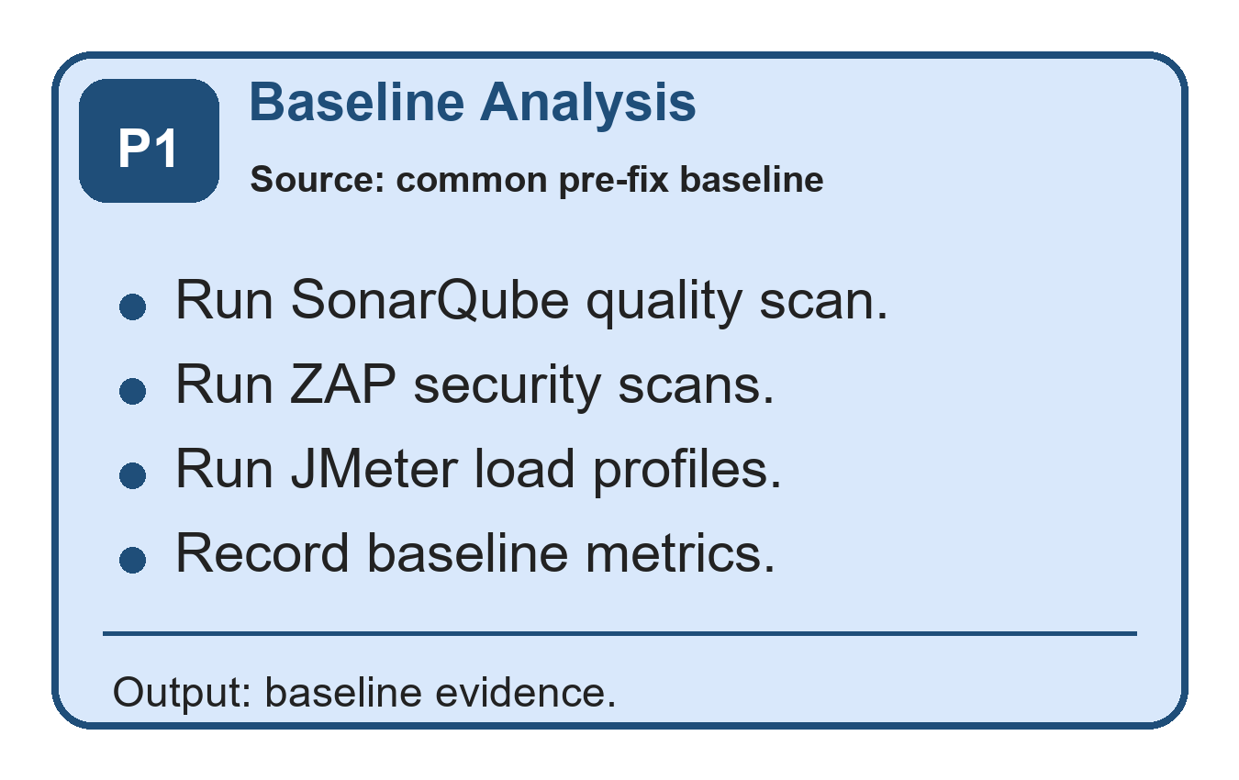
Figure 3.1. Phase 1 - Baseline analysis workflow.

- Phase 1: Baseline Analysis
  - Initial security and performance testing are conducted on the financial accounting ASP.NET Core RESTful API project. The API includes endpoints for authentication, chart of accounts, journal entries, accounting periods, financial reports, and audit logs. These baseline metrics are captured on the common baseline branch and provide reference points for evaluating the effectiveness of improvements.
  - Tools: SonarQube for code quality and static analysis, OWASP ZAP for security vulnerability scanning (baseline scan and authenticated API scan), and Apache JMeter for performance testing (load, soak, and spike test profiles at 50, 100, and 500 concurrent users).
Example:
- Financial Accounting API: A complex RESTful API for financial accounting with multi-tier architecture (API, BAL/Services, MODEL/Entities, Tests).
Workflow | Representative route | Example use
Accounts | GET /accounts | List the chart of accounts
Journal entries | POST /journal-entries | Create a balanced journal entry
Bulk journals | POST /journal-entries/bulk | Create a validated batch with finance-role authorization
Reports | GET /reports/trial-balance | Generate a trial-balance report
- The API features role-based access control (Admin, FinanceManager, User, Auditor), JWT authentication, and comprehensive audit logging.

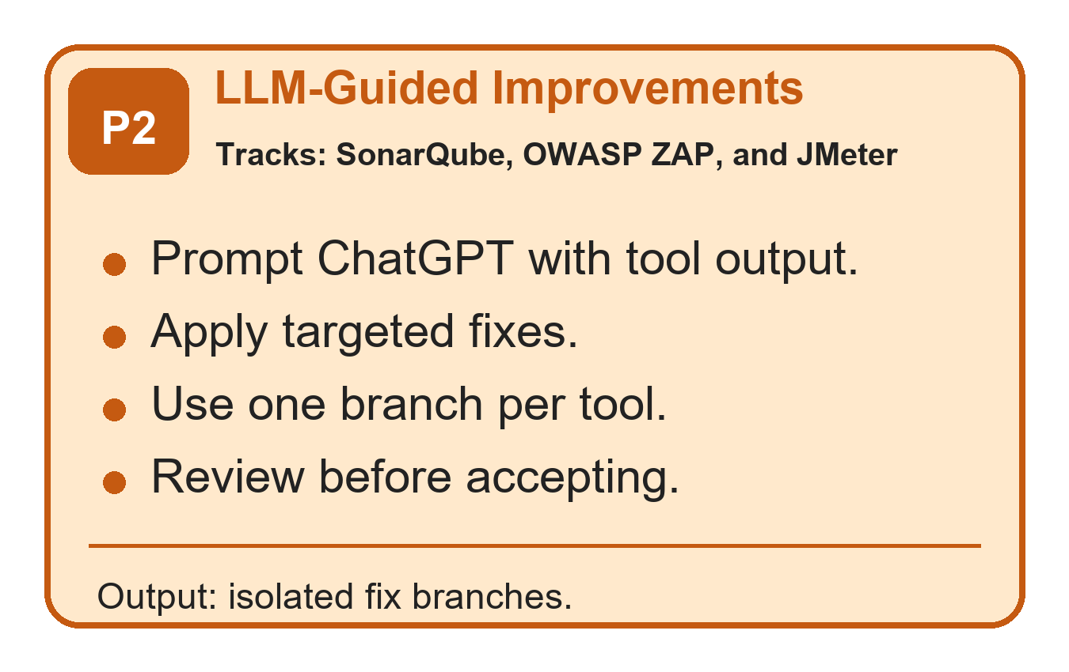
Figure 3.2. Phase 2 - LLM-guided improvements workflow.

- Phase 2: ChatGPT-Generated Improvements
  - Code recommendations are generated using ChatGPT (Codex 5.4) through OpenAI’s Codex coding environment. ChatGPT receives tool findings, relevant code snippets, and expected constraints, then suggests candidate fixes. The candidate fixes are not accepted automatically: each one is reviewed, applied on a dedicated branch, tested with dotnet test, and re-measured with the same tool that produced the baseline finding. This process explains why a recommendation is considered useful only when the after-measurement improves without breaking regression tests.
  - Example Guidance from ChatGPT: Using parameterized queries to prevent SQL injection, improving loop efficiency, implementing secure session management.
Example:
Security Enhancement:
  - Baseline Issue: Security and validation risk in write endpoints such as POST /journal-entries and POST /journal-entries/bulk, where untrusted input must not affect database query behavior or bypass authorization.
  - ChatGPT Recommendation: preserve Entity Framework parameterization, validate DTO input, reject unauthorized roles, and keep write endpoints protected by JWT authentication and role policies.
Table 3.3. API endpoint coverage used for side-by-side security and performance evidence.
Category | Representative endpoints | Evidence source | Reviewer relevance
Authentication | /api/auth/register, /api/auth/login, /api/auth/me | ZAP authenticated scan, API smoke coverage | Role-aware access and token-protected flows
Users | /api/users, /api/users/{id}, /api/users/{id}/status | ZAP authenticated scan | Administrative user management
Accounts | /api/accounts, /api/accounts/{id}, /api/accounts/{id}/ledger | JMeter core and complex profiles | Ledger browsing and account-level reporting
Journal entries | /api/journalentries, /api/journalentries/{id}, /api/journalentries/post | JMeter bulk and query profiles | High-volume transaction workflow
Periods | /api/periods, /api/periods/{periodId}/close | API smoke coverage | Accounting period setup and close controls
Reports | /api/reports/trial-balance, /api/reports/profit-loss, /api/reports/balance-sheet | JMeter complex, soak, and spike profiles | Performance-critical financial reporting
Audit logs | /api/auditlogs | ZAP authenticated scan and manual role checks | Traceability for sensitive accounting actions
Performance Optimization:
- Baseline Issue: Slow p95 latency in report endpoints, especially GET /reports/trial-balance, GET /reports/profit-loss, GET /reports/balance-sheet, and GET /reports/account-ledger during spike and soak profiles.
- ChatGPT Recommendation: Implement caching for frequently accessed endpoints.
  - Example Adjustment: Use in-memory caching for the GET /reports endpoint to store results for 10 minutes:
Table 3.4. SonarQube code-quality remediation evidence by rule, file, and fix.
Rule or area | File | Before | After | Status
S107 | JournalEntriesController.cs | Controller action used eight query parameters. | Introduced JournalEntryQueryDto and passed one query model to the service. | Code smell removed
S2325 | ServiceManager.cs | Private helper did not access instance state. | Converted helper to static. | Code smell removed
S3267/S6602 | JournalEntryService.cs | Loops and LINQ operations were less maintainable. | Rewrote selected loops and lookup calls with clearer collection operations. | Code smell removed
S6966 | Program.cs | Application startup used blocking Run. | Changed startup to await app.RunAsync(). | Code smell removed
Summary | C# project | 28 retained SonarQube findings in baseline. | 0 retained findings after fixes; Quality Gate remained OK. | Closed

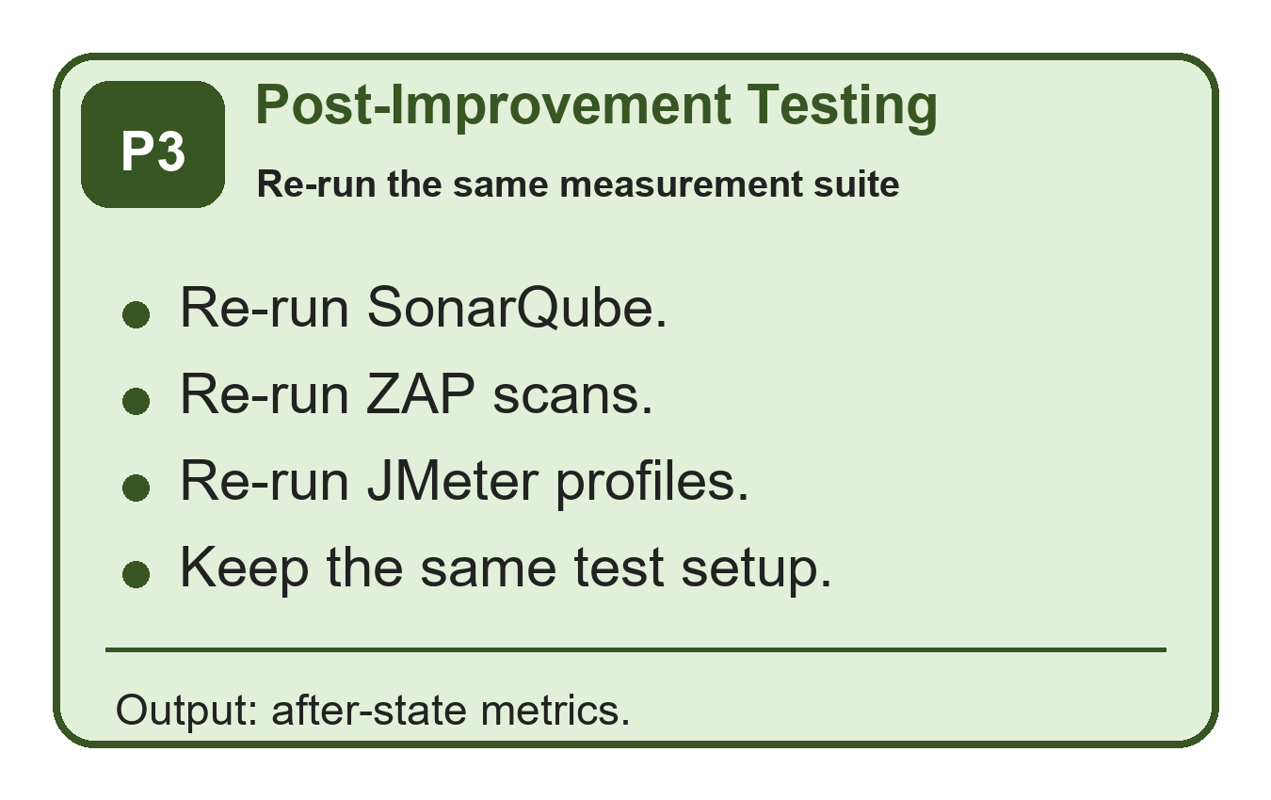
Figure 3.3. Phase 3 - Post-improvement testing workflow.
- Phase 3: Post-Improvement Testing
  - With ChatGPT-guided changes implemented on each branch, the project undergoes a new round of testing using the same tools and configurations as the baseline. Security, performance, and code quality metrics are collected again and compared to the common baseline branch results.
Example:
  - Security: Run ZAP baseline scan and authenticated API scan against all endpoints (auth, accounts, journal-entries, periods, reports, audit-logs) on the OWASP ZAP remediation branch.
  - Performance: Run JMeter test matrix (50, 100, 500 concurrent users + soak + spike profiles) against all API endpoints on the JMeter remediation branch.

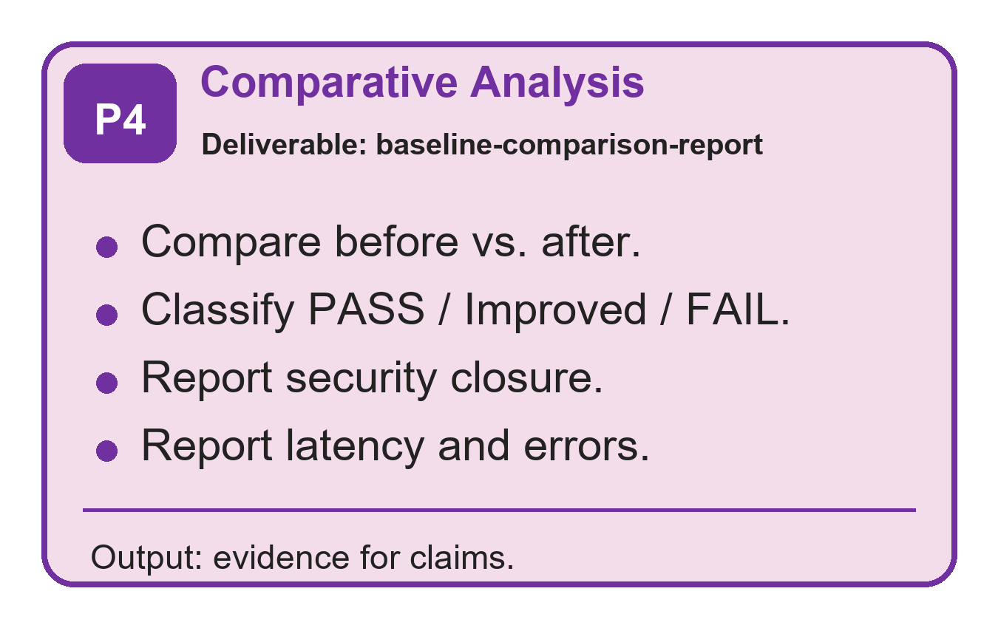
Figure 3.4. Phase 4 - Comparative analysis and reporting workflow.
- Phase 4: Comparative Analysis and Reporting
  - The data collected from the baseline (common baseline branch) and post-improvement branches (SonarQube remediation branch, OWASP ZAP remediation branch, JMeter remediation branch) are analyzed and compared to draw conclusions on ChatGPT’s effectiveness in enhancing the security, performance, and code quality of the financial accounting RESTful API. Results are compiled into a baseline-comparison-report documenting improvements across all three dimensions. Appendices A-E provide the exact environment, branch and commit provenance, selected code listings, reproduction commands, and claim-to-artifact traceability.
Table 3.5. OWASP ZAP before-and-after security evidence.
Scan | Severity | Before -> After | Vulnerability class | Fix applied
Baseline scan | Medium | 2 -> 0 | Missing CSP and exposed Swagger UI behavior. | SecurityHeadersMiddleware moved before Swagger; Swagger UI disabled unless explicitly enabled.
Baseline scan | Low | 6 -> 0 | Missing X-Content-Type-Options and modern isolation headers. | Added nosniff, COEP, COOP, CORP, and Permissions-Policy headers.
Baseline scan | Informational | 3 -> 4 | Residual informational notices after hardening. | Accepted as non-blocking because high/medium/low alerts were cleared.
Authenticated API scan | Low | 3 -> 0 | Authenticated endpoint header findings. | Same header middleware path now protects authenticated API responses.
Dependency risk | Low/Informational | DOMPurify warning removed | Swagger UI dependency bundled vulnerable DOMPurify. | Upgraded Swashbuckle.AspNetCore and Swagger filters packages.

Table 3.6. JMeter before-and-after performance profile comparison.
Profile | Metric | Baseline | After fixes | Change | Status
p50 | Total p95 response time | 49.45 ms | 13.00 ms | -73.71% | PASS
p100 | Total p95 response time | 261.95 ms | 34.00 ms | -87.02% | PASS
p500 | Total p95 response time | 176.00 ms | 28.00 ms | -84.09% | PASS
p100 | Throughput | 57.53 req/s | 59.82 req/s | +3.98% | PASS
p500 | Error rate | 0.00% | 0.00% | No regression | PASS
Soak | Total p95 response time | 970.95 ms | 56.00 ms | Improved | Drift still monitored
Spike | Total p95 response time | 6795.00 ms | 1420.00 ms | Improved | Recovery drift still monitored

Table 3.7. Selected before-and-after code evidence linked to reviewer comments.
Example | Before branch | Before code | After branch | After code | Reason
SonarQube maintainability | common baseline branch | public async Task<IActionResult> GetPaged(DateTime? from, DateTime? to, string? status, int? accountId, string? search, int page = 1, int pageSize = 20, string? sort = "entryDate_desc") | SonarQube remediation branch | public async Task<IActionResult> GetPaged([FromQuery] JournalEntryQueryDto query) | Replaced eight query parameters with one DTO, directly addressing S107.
ZAP security headers | common baseline branch | app.UseSwagger(); app.UseSwaggerUI(); ... app.UseMiddleware<SecurityHeadersMiddleware>(); | OWASP ZAP remediation branch | app.UseMiddleware<SecurityHeadersMiddleware>(); ... if (enableSwaggerDocument) app.UseSwagger(); if (enableSwaggerUi) app.UseSwaggerUI(); | Ensures Swagger/OpenAPI responses receive the same hardening headers and separates the UI switch from the JSON document.
JMeter report performance | common baseline branch | await _context.Reports.AddAsync(report); await _context.SaveChangesAsync(); | JMeter remediation branch | await _auditLogService.WriteAsync(actorUserId, "GENERATE_REPORT", "Reports", $"{reportType}:{periodId}", ipAddress, new { reportType, periodId, items = items.Count }); | Removed report snapshot write amplification from read-heavy report generation.

3.1.2 Selected Source-Code Evidence
The following excerpts are real source-code evidence from the compared Git branches. They are intentionally selected examples rather than full-file listings, because the purpose is to show how the measured SonarQube, ZAP, and JMeter improvements map back to concrete code changes.
Source-code evidence A: SonarQube maintainability fix in API/Controllers/JournalEntriesController.cs.
Before: common baseline branch
[HttpGet]
public async Task<IActionResult> GetPaged(
[FromQuery] DateTime? from,
[FromQuery] DateTime? to,
[FromQuery] string? status,
[FromQuery] int? accountId,
[FromQuery] string? search,
[FromQuery] int page = 1,
[FromQuery] int pageSize = 20,
[FromQuery] string? sort = "entryDate_desc")
{
var result = await _journalEntryService.GetPagedAsync(from, to, status, accountId, search, page, pageSize, sort);
return Ok(result);
}

After: SonarQube remediation branch
[HttpGet]
public async Task<IActionResult> GetPaged([FromQuery] JournalEntryQueryDto query)
{
var result = await _journalEntryService.GetPagedAsync(query);
return Ok(result);
}

This excerpt addresses the SonarQube maintainability issue by replacing a long query-parameter list with a single JournalEntryQueryDto request model.
Source-code evidence B: OWASP ZAP security-header fix in API/Program.cs.
Before: common baseline branch
var enableSwagger = app.Environment.IsDevelopment() || appSettings.EnableSwaggerInProduction;
if (enableSwagger)
{
app.UseSwagger();
app.UseSwaggerUI();
}

app.UseMiddleware<CorrelationIdMiddleware>();
app.UseMiddleware<GlobalExceptionMiddleware>();
app.UseMiddleware<SecurityHeadersMiddleware>();

After: OWASP ZAP remediation branch
app.UseMiddleware<CorrelationIdMiddleware>();
app.UseMiddleware<GlobalExceptionMiddleware>();
app.UseMiddleware<SecurityHeadersMiddleware>();

var enableSwaggerDocument = app.Environment.IsDevelopment() || appSettings.EnableSwaggerInProduction;
var enableSwaggerUi = enableSwaggerDocument && appSettings.EnableSwaggerUi;
if (enableSwaggerDocument)
{
app.UseSwagger();
}

if (enableSwaggerUi)
{
app.UseSwaggerUI();
}

This excerpt shows that the security-header middleware was moved before Swagger/OpenAPI middleware, so diagnostic responses receive the same hardening headers as API responses.
Source-code evidence C: JMeter performance fix in BAL/Services/FinancialReportService.cs.
Before: common baseline branch
private async Task PersistReportAsync(
string reportType,
int periodId,
Guid actorUserId,
string? ipAddress,
List<ReportItemDto> items)
{
var report = new FinancialReport
{
ReportType = reportType,
PeriodId = periodId,
GeneratedByUserId = actorUserId,
GeneratedAt = DateTime.UtcNow
};

foreach (var item in items)
{
report.ReportItems.Add(new FinancialReportItem
{
AccountId = item.AccountId,
DebitTotal = decimal.Round(item.DebitTotal, 2),
CreditTotal = decimal.Round(item.CreditTotal, 2),
Balance = decimal.Round(item.Balance, 2)
});
}

await _context.Reports.AddAsync(report);
await _context.SaveChangesAsync();
}

After: JMeter remediation branch
public async Task<AccountLedgerPayload> GetAccountLedgerPayloadAsync(int accountId, int periodId, Guid actorUserId, string? ipAddress)
{
var period = await GetPeriodOrThrowAsync(periodId);
var account = await _context.ChartOfAccounts.AsNoTracking().FirstOrDefaultAsync(x => x.AccountId == accountId);

var payload = await _accountLedgerCache.GetOrCreatePayloadAsync(
accountId,
periodId,
account.AccountType,
period.StartDate,
period.EndDate,
() => BuildAccountLedgerPayloadAsync(accountId, period, account));

await PersistReportAsync("Ledger", periodId, actorUserId, ipAddress, new List<ReportItemDto> { ... });
return payload;
}

private async Task PersistReportAsync(string reportType, int periodId, Guid actorUserId, string? ipAddress, List<ReportItemDto> items)
{
await _auditLogService.WriteAsync(
actorUserId,
"GENERATE_REPORT",
"Reports",
$"{reportType}:{periodId}",
ipAddress,
new { reportType, periodId, items = items.Count });
}

This excerpt shows the core performance change: report generation no longer persists full report snapshots during read-heavy paths, and account-ledger output can be served from the new cache-backed payload path while preserving audit logging.

3.1.3 Prompt-Template Evidence and Reproducibility
The remediation prompts used the same three-part structure across SonarQube, OWASP ZAP, and JMeter findings. This makes the LLM interaction auditable: the tool report states the measurable problem, the code excerpt bounds the editable context, and the instruction constrains the model to a minimal patch that must be re-tested.
Table 3.8. Prompt-template traceability used in remediation runs.
Prompt component | Content used in this study | Purpose
Context | Native tool finding: SonarQube rule id, ZAP alert metadata, or JMeter endpoint latency profile. | Anchors the model to a measured defect or hotspot.
Code excerpt | Smallest affected controller, service, middleware, configuration, or test block. | Prevents broad rewrites and keeps the proposed patch reviewable.
Instruction | Propose a minimal patch that keeps existing tests green, avoids new dependencies unless justified, and states how to re-measure the result. | Turns the LLM output into an auditable repair proposal rather than an accepted change.

3.1.4 Human-Effort Traceability
The following table records how much human intervention was required before a candidate fix was accepted. The important point is that ChatGPT supplied advice, but the acceptance gate was the developer review plus the same measurement tool that produced the original finding.
Table 3.9. Human-effort traceability for accepted remediation fixes.
Fix class | Evidence branch | LLM rounds | Human intervention | Acceptance evidence
SonarQube controller DTO refactor | SonarQube remediation branch | 1 | Reviewed route compatibility and service-layer signature. | Retained C# findings reduced from 28 to 0.
Security headers and Swagger hardening | OWASP ZAP remediation branch | 1-2 | Moved middleware order, split Swagger document/UI switches, reviewed package upgrade. | ZAP High/Medium/Low gated alerts cleared.
ARM/camelCase analyzer cleanup | SonarQube remediation branch | 2-3 | Manually corrected provider-specific conventions after initial model output was insufficient. | Analyzer accepted final template text.
Report-performance remediation | JMeter remediation branch | 1-2 | Reviewed cache/audit tradeoff and removed read-path report snapshot writes. | p95 latency reduced substantially across constant, soak, and spike profiles.
Mixed-workload drift | JMeter remediation branch | Not resolved | Human interpretation required because the metric depends on workload composition. | Recorded as residual limitation rather than claimed as fixed.

3.2 Dataset Description and Preparation
This study does not use production customer records or a public financial dataset. The data used in the tests is a repo-seeded financial accounting test dataset generated by scripts/phase4/seed-test-data.ps1 and loaded into the local SQL Server Financial database. This makes the dataset repeatable and auditable from the repository while avoiding confidentiality risk.
The seed configuration is deterministic in its parameters and naming patterns, including PeriodId 202601, 120 chart-of-account records, 30,000 journal entries, and at least 5,000 posted entries. Runtime-generated values such as GUID user IDs, password salts and hashes, timestamps, and identity values may differ between database runs, so the examples below show representative records based on the repo seed rules rather than private production rows.
Table 3.10. Repo-seeded test-data configuration.
Seed item | Repo-backed value | Purpose in the study
Script | scripts/phase4/seed-test-data.ps1 | Source of the repeatable test-data generation process
Database target | SQL Server database: Financial | Same local database target used for security and performance tests
Accounting period | PeriodId 202601; 2026-01-01 to 2026-12-31 | Period-sensitive report endpoints use this range
Accounts | AccountCount = 120 | Ensures all five account types are available for ledger and report paths
Journal entries | JournalEntryCount = 30,000 | Creates enough volume for load, soak, and spike tests
Posted entries | MinimumPostedEntries = 5,000 | Ensures report endpoints have posted transactions to aggregate
Admin credential | Local demo administrator credential (value omitted) | Used by JMeter and ZAP scripts for authenticated test setup
The dataset is used to test API behavior, not to make claims about real financial performance. Its purpose is to exercise authentication, authorization, accounting-period logic, balanced journal entries, financial-report aggregation, and audit logging under repeatable security and load-test conditions.
Table 3.11. Seeded entity coverage for the API behavior under test.
Entity | Repo-backed seeded or generated data | How it is produced | API behavior tested
Roles | Admin, User, Auditor, FinanceManager | Inserted if missing | RBAC and authenticated API scans
Users | Admin user plus probe users created by test scripts | Upserted or created with GUID UserId | Login, role-boundary, and audit-log tests
ChartOfAccounts | A/L/E/R/X account-code prefixes; Asset, Liability, Equity, Revenue, Expense | Generated until target account count is reached | Ledger and financial-report calculations
AccountingPeriods | PeriodId 202601 | Inserted or reset to open state | Trial balance, profit/loss, balance sheet, account ledger
JournalEntries | SEED-P and SEED-D reference numbers | Generated as posted and draft entries | Posting, bulk, report, and performance paths
JournalEntryLines | Balanced debit and credit lines | Generated for every seeded journal entry | Double-entry accounting validation
AuditLogs | LOGIN, CREATE_USER, CREATE_ACCOUNT, POST_ENTRY, GENERATE_REPORT, etc. | Written by application services during tests | Traceability and Auditor role checks
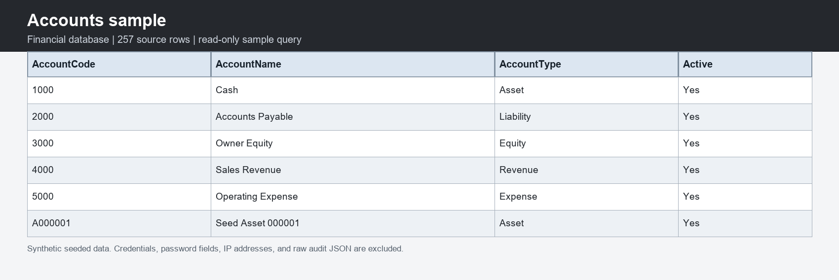
Figure 3.5. Representative chart-of-accounts rows from the live seeded database.
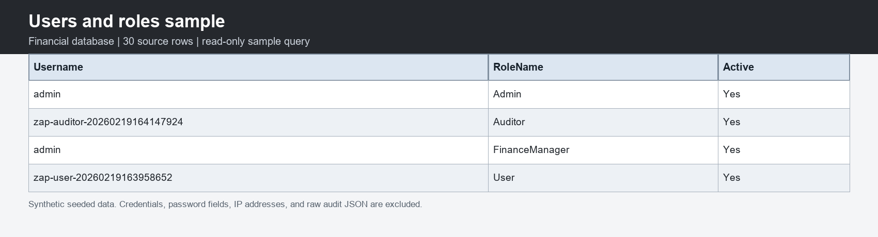
Figure 3.6. Representative users and role assignments from the live seeded database.
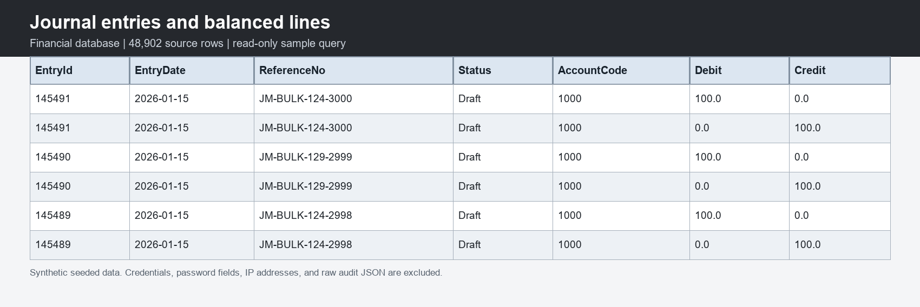
Figure 3.7. Representative journal entries and balanced debit-credit lines.
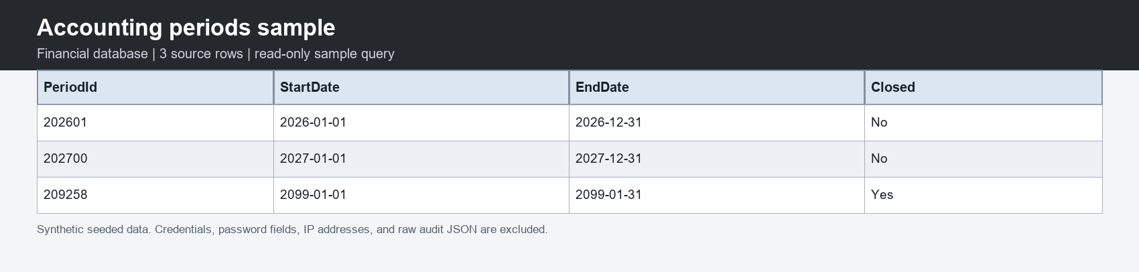
Figure 3.8. Representative accounting-period rows from the live seeded database.
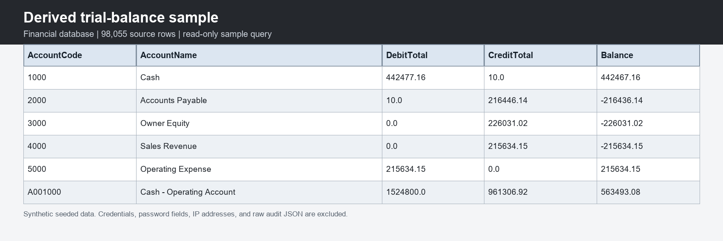
Figure 3.9. Trial-balance sample derived from posted journal-entry lines.
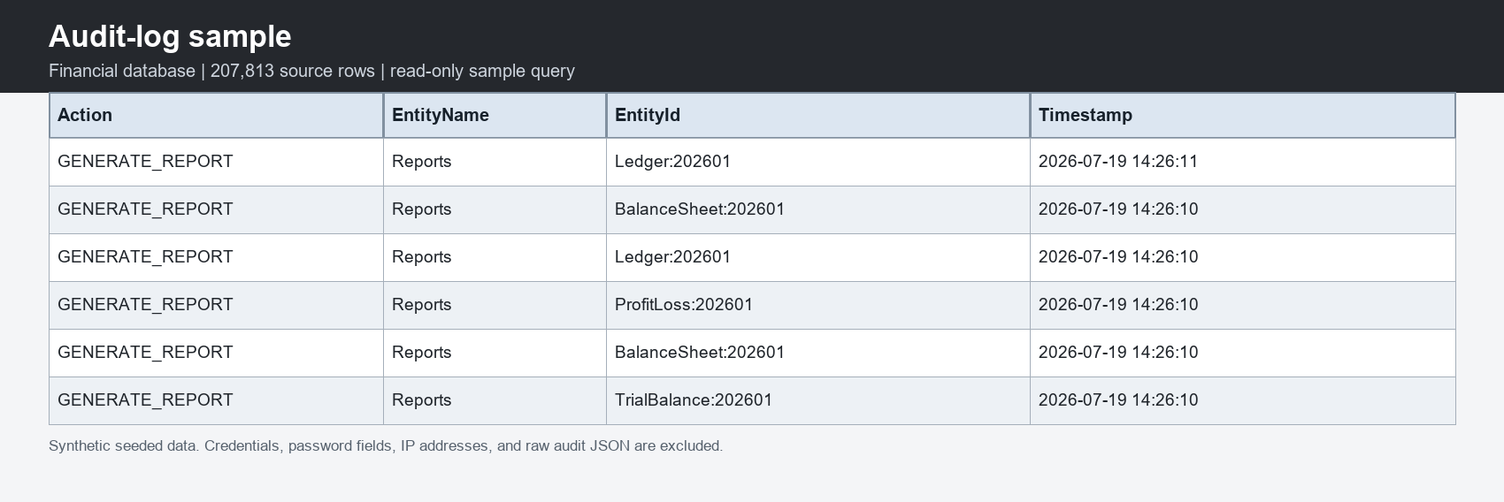
Figure 3.10. Representative audit-log rows from report-generation workflows.
Therefore, the study evaluates the financial accounting API and its code paths using repeatable repo-backed test data. The dataset is realistic enough to trigger the same endpoint behavior as financial records, but it is not real customer data and should not be interpreted as a production financial dataset.

3.3 Model and Tool Selection
This research employs a combination of tools to evaluate different aspects of code security, performance, and quality. ChatGPT (Codex 5.4), accessed through OpenAI’s Codex coding environment, serves as the AI assistant for generating code improvement recommendations throughout this study. The model is used as an advisor, not as an unsupervised implementation authority.
- What is SonarQube and why we focus on it? SonarQube is an open-source static-analysis platform that scans source code for bugs (probable defects), vulnerabilities (known security weaknesses), code smells (maintainability issues), security hotspots (suspicious patterns flagged for manual review), test coverage, and code duplication. Findings are emitted with rule identifiers (e.g., S125, S6966), severity levels, and human-readable remediation guidance. This study targets the static-quality dimension because code bases of any age accumulate code smells faster than they accumulate bugs, and removing rule-by-rule findings without regressions is one of the chief reasons a quality dashboard moves from red to green. The metrics reported in later chapters (Bugs, Vulnerabilities, Code Smells, Security Hotspots, Coverage %, Duplicated lines %, and Quality Gate pass/fail) all originate from SonarQube and are interpreted in the order listed.
- SonarQube (Community Edition): Used for assessing code quality and security vulnerabilities by scanning the .NET codebase for bugs, code smells, and security vulnerabilities. Runs via dotnet-sonarscanner with unit and integration test coverage analysis. Because prior empirical work has questioned how closely SonarQube rule violations align with bug-inducing changes in real projects (Lenarduzzi et al., 2020), SonarQube results in this study are always interpreted jointly with independent ZAP and JMeter measurements rather than in isolation.
- What is Apache JMeter and why we focus on it? Apache JMeter is a load-testing tool that simulates concurrent virtual users (VUs) issuing HTTP requests according to a configurable plan. For each request it records latency (response time), throughput (transactions per second), and error rate (HTTP 4xx/5xx responses). Test plans can hold load constant, sustain it for a soak window, or burst it for a spike, and JMeter aggregates the resulting event log into per-endpoint percentiles. This study targets the load-performance dimension because static analysis and security scanning cannot tell whether the API will keep responding under realistic load; p95 latency and error rate under load are the primary user-facing quality signals that determine whether an SLA is met. The metrics reported in later chapters (p95, p99, throughput, error rate) all come from JMeter, with the gate threshold pre-registered.
- Apache JMeter: Measures performance metrics such as response times, throughput, and error rates across multiple load profiles (50, 100, 500 concurrent users), soak testing, and spike testing. Test plans target all API endpoints including authentication, CRUD operations, and reporting.
- What is OWASP ZAP and why we focus on it? OWASP Zed Attack Proxy (ZAP) is a free, open-source dynamic application security testing (DAST) tool. It performs a passive baseline scan that observes responses to crawled requests for missing security headers, cookie problems, and known-vulnerable bundled JavaScript libraries; and an active API scan that, given an OpenAPI definition and a valid authentication token, exercises every endpoint and probes for OWASP Top-10-style flaws. Findings are emitted by risk level: High, Medium, Low, and Informational. This study targets the security dimension because APIs in financial domains are routinely targeted, and a vulnerability that survives into production can cost more than the entire engineering budget to remediate. The alert counts reported in later chapters are categorized by these four risk levels, and the pre-registered gate is that no High, Medium, or Low alert remains on a business endpoint after fixes.
- OWASP ZAP: Provides comprehensive vulnerability scanning through baseline scans (passive analysis of all endpoints) and authenticated API scans (active testing with JWT tokens and role-based access). Custom rule configurations are maintained in TSV files for reproducible scan profiles.

3.4 Implementation of ChatGPT-Guided Improvements
After baseline testing, ChatGPT (Codex 5.4) is used to generate improvement suggestions. Key areas of focus include:
- Security Enhancements
  - ChatGPT offers guidance on preventing SQL injection by implementing parameterized queries, managing session data securely, and sanitizing inputs.
  - Example Adjustments: Integrating secure authentication protocols, using encryption for sensitive data, and adjusting HTTP headers to prevent common attacks like cross-site scripting (XSS).
- Performance Optimizations
  - ChatGPT suggestions for performance optimization may include improvements to data handling, optimizing API response time by limiting unnecessary queries, and using caching mechanisms for frequently accessed resources.
  - Example Adjustments: Refining data-fetching algorithms, implementing pagination, and managing connection pooling.

3.5 Testing Phases
The same financial accounting API undergoes two testing phases: initial testing on common baseline branch and post-improvement testing on the relevant improvement branch. The study does not compare many unrelated APIs; instead, it evaluates seven endpoint groups inside one API so that the before-and-after results are attributable to controlled changes.
- Baseline Testing: The initial state of the financial accounting API is tested for security (ZAP baseline + API scan), performance (JMeter load/soak/spike), and code quality (SonarQube). Results are captured on the common baseline branch.
- Post-Improvement Testing: After implementing ChatGPT’s improvements on dedicated branches (SonarQube remediation branch, OWASP ZAP remediation branch, JMeter remediation branch), each branch is re-tested with the same tool and configuration to assess the efficacy of the changes. All issues and fixes are documented in per-tool fix tracking documents.

3.6 How is it different from others research?
- Focus on ChatGPT: Unlike studies that compare multiple AI tools, this work focuses on ChatGPT (Codex 5.4) as an improvement advisor for one ASP.NET Core RESTful API. The depth comes from measuring one API across security, performance, and code quality rather than from comparing many models superficially.
- Combination of Security and Performance Testing: This study integrates both security (OWASP ZAP) and performance (Apache JMeter) testing in a single workflow, which is less commonly addressed together in similar research.
- Realistic API Test Data: The study uses seeded and generated financial accounting records to simulate realistic accounting operations without using live customer data. The evaluation target is the API behavior and codebase, not a public financial dataset.
- Production-Complexity API Surface: The report focuses on one API with multiple endpoint categories, role-based access control, bulk journal-entry operations, report generation, and audit logging. This provides enough complexity to test whether ChatGPT-guided changes hold across different API responsibilities.

3.7 Security Evaluation Plan
The security evaluation plan focuses on using OWASP ZAP for comprehensive testing.
- Vulnerability Scanning: OWASP ZAP performs both baseline (passive) and authenticated API (active) scans across all endpoints: /auth, /accounts, /journal-entries, /periods, /reports, and /audit-logs. Focus areas include injection flaws, broken authentication, missing security headers (CSP, X-Content-Type-Options, CORS), and vulnerable dependencies.
- Authentication and Authorization Testing: OWASP ZAP authenticated API scan is used to test role-based access control (Admin, FinanceManager, User, Auditor roles) and JWT authentication. Unauthorized access attempts against protected endpoints (e.g., POST /accounts, POST /periods/{id}/close, DELETE /journal-entries/{id}) verify the robustness of the API’s access control.
- Comparison of Pre- and Post-Improvement Results: Security test results from common baseline branch and OWASP ZAP remediation branches are compared, analyzing how ChatGPT (Codex 5.4)’s recommendations mitigated identified vulnerabilities. Alert counts are compared by severity level (High, Medium, Low, Informational).

3.8 Performance Evaluation Plan
Performance testing is conducted with Apache JMeter to simulate multiple concurrent users accessing the API.
- Response Time and Throughput: Apache JMeter measures response times (average, p95, p99) and throughput for each API endpoint under load profiles of 50, 100, and 500 concurrent users, plus soak (sustained load) and spike (burst) test profiles.
- Resource Utilization: CPU and memory usage are tracked during load tests. Error rates are monitored to identify endpoints that fail under stress.
- Comparison of Performance Metrics: Results from common baseline branch and JMeter remediation branches are compared to determine the impact of ChatGPT (Codex 5.4)’s suggestions on performance, focusing on improvements in response times, error rate reduction, throughput gains, and stability under sustained and spike load conditions.

3.9 Code Quality Evaluation Plan
Code quality is assessed using SonarQube, focusing on key metrics such as code smells, maintainability, and cyclomatic complexity.
- Baseline Analysis: The initial codebase on common baseline branch is scanned with SonarQube (via dotnet-sonarscanner) to identify code smells, potential bugs, security vulnerabilities, and security hotspots across all five modules (API, BAL, MODEL, REPOSITORY, Tests).
- Post-Improvement Analysis: After applying ChatGPT (Codex 5.4)’s recommendations on SonarQube remediation branch, SonarQube is run again with the same configuration to evaluate improvements. This second analysis identifies reductions in bugs, code smells, security vulnerabilities, and security hotspots. Quality gate status is compared.
- Clean Code Principles: Changes are analyzed based on adherence to clean code principles like simplicity, readability, and minimized dependencies. To mitigate the known limitation that not every SonarQube rule correlates with real defects (Lenarduzzi et al., 2020), quality-gate conclusions are cross-referenced with the ZAP and JMeter outcomes on their respective branches, so that a SonarQube improvement is only claimed when at least one other independent measurement is consistent with it.

Chapter 4: Results and Discussion

4.1 Evaluation Criteria and Decision Rules
Decision rule. In this report, a result is judged successful rather than simply called good when the post-improvement branch meets the predefined acceptance target and shows no critical regression in the associated control metrics. An outcome is classified as Achieved when the complete target is met, Partially Achieved when the primary metric improves but a stated secondary condition or limitation remains, and Not Achieved when the target is missed or a material regression is introduced. Sections 4.2-4.5 apply this rule to the measured code-quality, security, and performance evidence.
- Security Metrics: The security of the API is evaluated with OWASP ZAP baseline and authenticated API scans. The endpoint groups tested include /auth, /accounts, /journal-entries, /periods, /reports, and /audit-logs. Findings are compared before and after improvement by severity level (High, Medium, Low, Informational) and by vulnerability class, including missing security headers, vulnerable dependency exposure, authentication behavior, authorization behavior, SQL injection exposure, and sensitive-data-in-URL observations.
- Performance Metrics: Performance is evaluated with Apache JMeter against the same endpoint groups under p50, p100, p500, soak, and spike profiles. Metrics include average response time, p95 latency, p99 latency in milliseconds, throughput in transactions per second, error rate percentage, soak drift percentage, and spike recovery drift percentage.
- Code Quality Metrics: Code quality is evaluated with SonarQube across the API, BAL, MODEL, REPOSITORY, and Tests modules. Metrics include Bugs, Vulnerabilities, Code Smells, Security Hotspots, Quality Gate status, coverage percentage, duplicated-line density, cyclomatic complexity indicators, and specific issue/rule IDs before and after the ChatGPT-guided branch.
Table 4.1. Evaluation criteria used to judge full-report remediation success.
Evaluation area | Measure | Acceptance target | Result
Static analysis | SonarQube retained findings and Quality Gate | Target: no blocker/critical retained issues; preserve Quality Gate OK | 28 retained findings reduced to 0; Quality Gate OK
Security | OWASP ZAP high/medium/low severity alerts | Target: no High or Medium alerts; reduce Low where practical | High 0, Medium 0, Low 0 after remediation
Performance | JMeter p95, throughput, error rate, soak/spike behavior | Target: p50/p100/p500 pass with no error-rate regression | Core profiles passed; soak/spike improved but drift remains monitored
Maintainability | Representative before/after code evidence | Target: selected code smells resolved with traceable branch evidence | DTO, middleware-order, and report-persistence examples documented

The evaluation compares baseline and remediated branches using the same toolchain and dataset described in Chapter 3. The purpose is not only to show that numbers improved, but also to connect each improvement to a concrete code or configuration change that can be reviewed and repeated.
Explanation: Figure (4.1) summarizes the evaluation criteria and shows that each dimension is measured twice: once on common baseline branch and once on the matching post-improvement branch.

4.2 Code-Quality Outcome
Code-quality comparison units: issue counts by SonarQube type, rule ID, affected file, quality-gate status, coverage percentage, duplicated-line density percentage, and fix description. The full report compares common baseline branch with SonarQube remediation branch.
Observed SonarQube result: retained baseline C# findings decreased from 28 to 0, Bugs stayed at 0, Vulnerabilities stayed at 0, Code Smells decreased from 21 to 0, and Security Hotspots stayed at 0. The final rerun reached Quality Gate = OK, coverage = 74.3%, and duplicated lines density = 0.0%.
Table 4.2. SonarQube before-and-after quality metrics.
Metric | Baseline | After fixes | Interpretation
Bugs | 0 | 0 | No regression
Vulnerabilities | 0 | 0 | No regression
Code smells | 21 | 0 | All retained code-smell findings closed
Security hotspots | 0 | 0 | No regression
Coverage | 74.3% | 74.3% | Preserved measured coverage
Duplicated lines | 0.0% | 0.0% | Preserved duplication baseline
As shown in Table 4.2, the code-smell findings were closed while coverage and duplicated-line density remained unchanged.

Table 4.3. Maintainability-focused code-quality comparison.
Area | Before | After | Effect
Controller parameter complexity | Long JournalEntriesController action signature | JournalEntryQueryDto request model | Improves readability and future extension
Startup lifecycle | Blocking app.Run() | await app.RunAsync() | Matches asynchronous ASP.NET Core hosting pattern
Constants and repeated literals | Repeated journal-entry values in service logic | Named constants | Reduces magic strings and repeated values
Infrastructure templates | ARM expressions flagged by analyzer | Explicit template functions and safer defaults | Cleaner deployment artifacts
The comparison in Table 4.3 links representative maintainability problems to the implemented structural changes and their expected engineering effect.
The SonarQube result is the cleanest closure case because the retained C# findings moved from 28 to 0 while bugs, vulnerabilities, hotspots, coverage, and duplication did not regress. The most important maintainability change is the replacement of long controller parameter lists with a request DTO, because that change reduces future API maintenance cost without changing the endpoint contract.
Outcome judgment: Achieved. The code-quality result is judged successful because the primary finding counts reached zero while every reported non-regression control remained stable. Retained findings decreased from 28 to 0 and code smells decreased from 21 to 0; Bugs, Vulnerabilities, and Security Hotspots stayed at 0; coverage remained 74.3%; duplicated-line density remained 0.0%; and the Quality Gate remained OK. The judgment therefore depends on both finding closure and preservation of the control metrics, not only on a lower issue count. The implementation excerpts and the fresh SonarQube dashboard evidence are reported separately in Appendices C and F.

4.3 Security Outcome
Security comparison units: counts by risk level, vulnerability class, affected endpoint, branch name, and resolved/remaining status. The full report compares common baseline branch with OWASP ZAP remediation branch.
Observed authenticated API scan result: High alerts stayed at 0, Medium alerts stayed at 0, Low alerts decreased from 3 to 0, and Informational alerts stayed at 5. The remaining informational alerts are reported as scanner observations rather than gated vulnerabilities.
Observed ZAP baseline scan result: High alerts stayed at 0, Medium alerts decreased from 2 to 0, Low alerts decreased from 6 to 0, and Informational alerts changed from 3 to 4. The gated security outcome is therefore achieved because all High, Medium, and Low baseline-scan alerts were cleared on business endpoints.
The ZAP result shows that the vulnerable surface was primarily configuration and dependency related. Moving the security-header middleware before Swagger means diagnostic endpoints receive the same headers as normal API responses, while separating Swagger UI from the OpenAPI JSON document reduces unnecessary browser-facing exposure.
Outcome judgment: Achieved within the defined OWASP ZAP scope. The security result is judged successful because the acceptance rule required no remaining High or Medium alerts and the removal of the observed Low alerts on the tested business endpoints. High alerts remained at 0, baseline Medium alerts decreased from 2 to 0, baseline Low alerts decreased from 6 to 0, and authenticated Low alerts decreased from 3 to 0. Informational alerts remain documented scanner observations and are not failures under the defined gate. This judgment does not claim complete security outside the scanned endpoints and configuration. The security-header implementation, scan provenance, and OWASP ZAP dashboards are provided in Appendices C, E, and F.

4.4 Performance Outcome
Performance comparison units: average latency, p95 latency, p99 latency in milliseconds, throughput in transactions per second, error rate percentage, and drift percentage. The full report compares common baseline branch with JMeter remediation branch.
Observed stress-profile result: soak total p95 latency decreased from 970.95 ms to 56.00 ms and spike total p95 latency decreased from 6795.00 ms to 1420.00 ms. The report records a remaining caveat: the mixed-workload soak and spike drift heuristics still fail because the last window is compositionally heavier, even though the main report endpoints improved substantially.
Observed JMeter result: p50 total p95 latency decreased from 49.45 ms to 13.00 ms, p100 total p95 latency decreased from 261.95 ms to 34.00 ms, and p500 total p95 latency decreased from 176.00 ms to 28.00 ms. Error rate remained 0.00% for p50, p100, and p500.
Table 4.4. Performance hotspot comparison for reviewer-visible report endpoints.
Endpoint | Profile metric | Baseline | After fixes | Main remediation
GET /api/reports/account-ledger/{id} | Soak p95 | 1783.95 ms | 279.00 ms | Account-ledger JSON cache and ledger balance reuse
GET /api/reports/account-ledger/{id} | Spike p95 | 8073.40 ms | 3435.95 ms | Cache reduced cost but spike recovery remains a risk
GET /api/reports/trial-balance | Spike p95 | 10585.00 ms | 1244.85 ms | Stopped persisting report snapshots during reads
GET /api/reports/profit-loss | Spike p95 | 7118.35 ms | 690.90 ms | Reused aggregated ledger balances
GET /api/reports/balance-sheet | Spike p95 | 5768.95 ms | 650.95 ms | Reduced repeated query work
POST /api/journalentries/bulk | Spike p95 | 1401.70 ms | 634.00 ms | Composite indexes and reduced write amplification
The endpoint evidence in Table 4.4 connects the largest endpoint-level p95 reductions to the corresponding remediation work.
The JMeter results show major p95 reductions in the normal p50, p100, and p500 profiles. The soak and spike runs also improved sharply, but they are reported more conservatively because recovery drift remained visible under stress. This is why the full report treats the core performance comments as addressed while preserving drift as a future monitoring item.
Outcome judgment: Achieved for core profiles and Partially Achieved for stress stability. The core performance result is judged successful because p50, p100, and p500 total p95 latency improved by 73.71% to 87.02% while the error rate remained 0.00%, satisfying the decision rule of improved p95 latency without an error-rate regression. The stress result is only partially achieved because soak and spike p95 latency improved substantially but the mixed-workload drift heuristic remained unresolved. This remaining condition prevents an unconditional conclusion that stress stability was fully achieved. The caching implementation, JMeter profiles, and fresh dashboard results are provided in Appendices C, D, E, and F.

4.5 Overall Assessment and Trade-offs
Table 4.5. Overall outcome and closure matrix.
Tool | Baseline evidence | After-fix evidence | Closure status
SonarQube | 28 retained findings | 0 retained findings | Closed
ZAP baseline scan | 2 Medium, 6 Low | 0 Medium, 0 Low | Closed
ZAP authenticated scan | 3 Low | 0 Low | Closed
JMeter core profiles | Higher p95 response times | p50/p100/p500 p95 improved 73.71%-87.02% | Closed
JMeter stress profiles | Soak/spike drift visible | Large p95 reductions but residual drift noted | Partially accepted risk
The closure matrix in Table 4.5 applies the decision rules consistently across static analysis, security scanning, and performance testing.

Overall, the code-quality criterion and the tested OWASP ZAP business-endpoint gate were achieved. The core JMeter performance criterion was also achieved through substantial p95 reductions with no core-profile error-rate regression. Stress-profile stability was partially achieved because the mixed-workload drift heuristic remained a documented limitation. These results support a positive but conditional outcome rather than a claim of complete security or universal performance stability.

4.6 Web Application Evidence for Current APIs
A React and Vite web application was added as a live validation artifact for the current ASP.NET Core financial accounting APIs. The application runs at http://localhost:5173 and connects to the API at http://localhost:5296, matching the CORS origins already configured in the backend. It demonstrates JWT login, role-aware navigation, account balances, expandable journal-entry debit and credit lines, accounting periods, reports, audit logs, user administration, and a research-evidence dashboard.
The local seed process creates four demo accounts for reproducible role testing: admin, finance-manager, normal-user, and auditor-user, using local-only demo credentials whose values are omitted from this report. The screenshots below were captured after seeding the local SQL Server database and logging in through the web application, so they validate the user-visible path rather than only the API response layer.
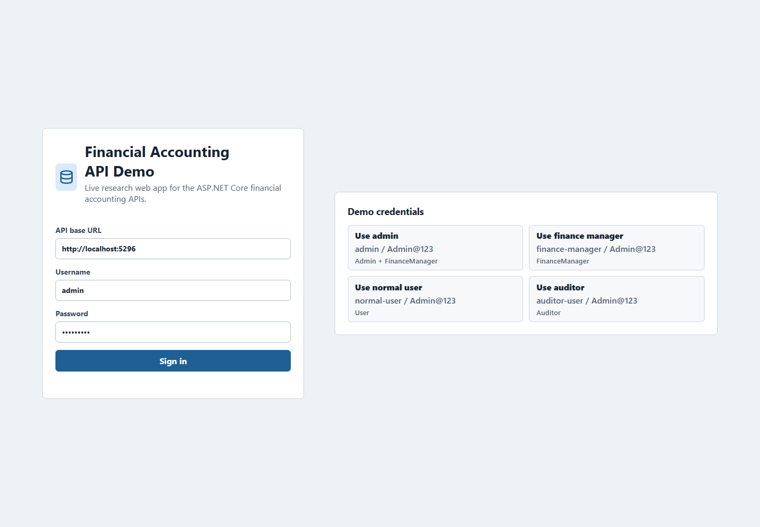
Figure 4.1. Web application login screen with demo role credentials.

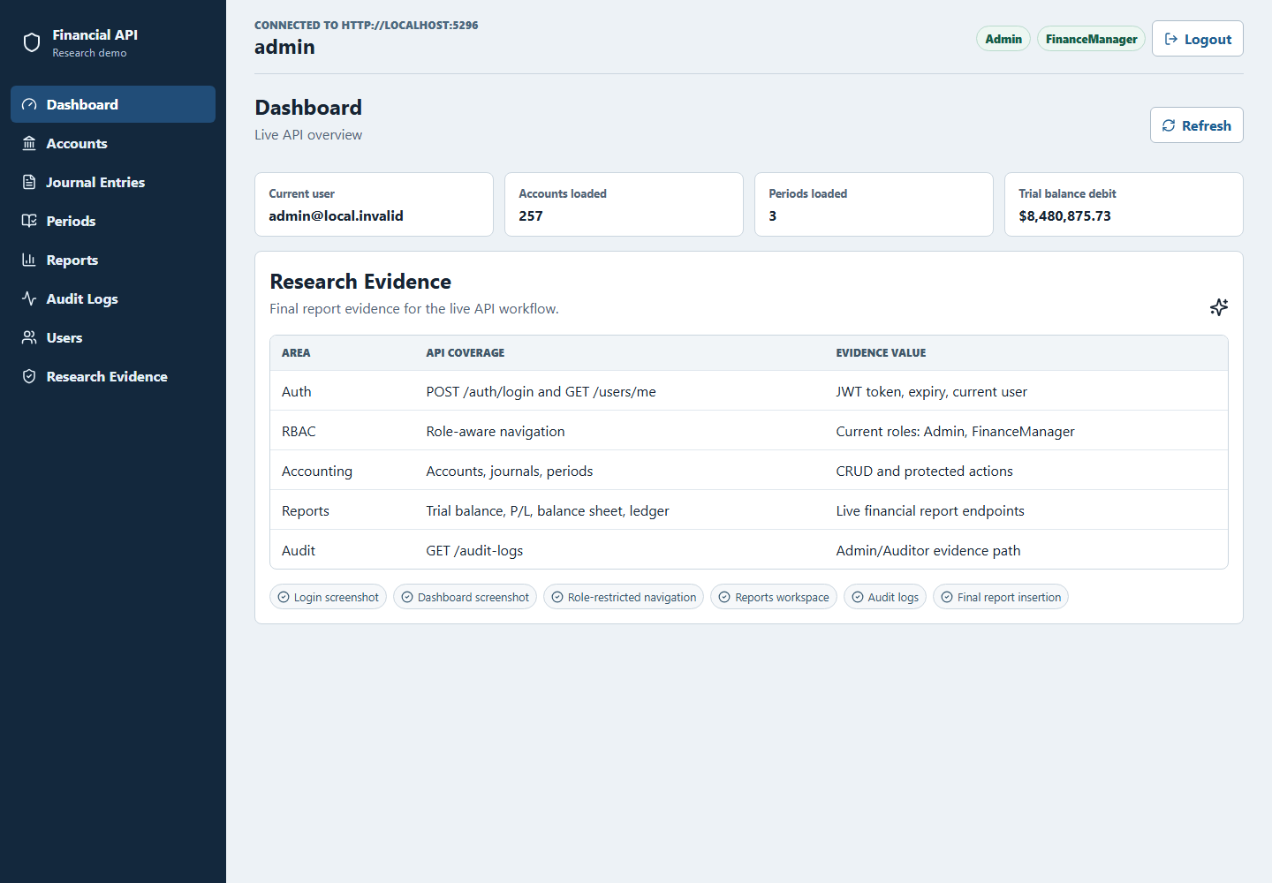
Figure 4.2. Admin dashboard showing live API counts and report summary.

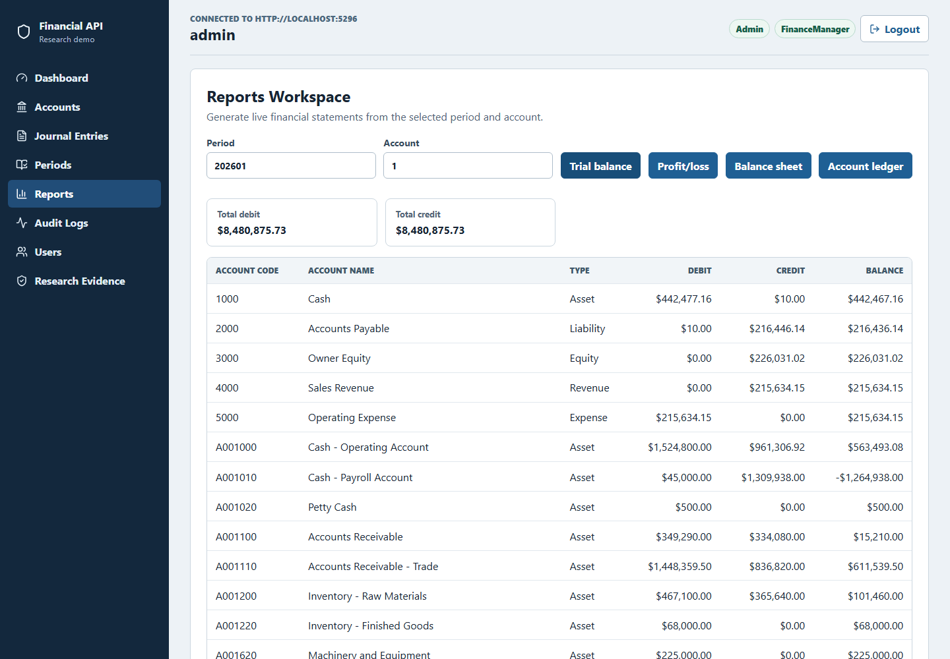
Figure 4.3. Trial balance report generated from the live reports API.

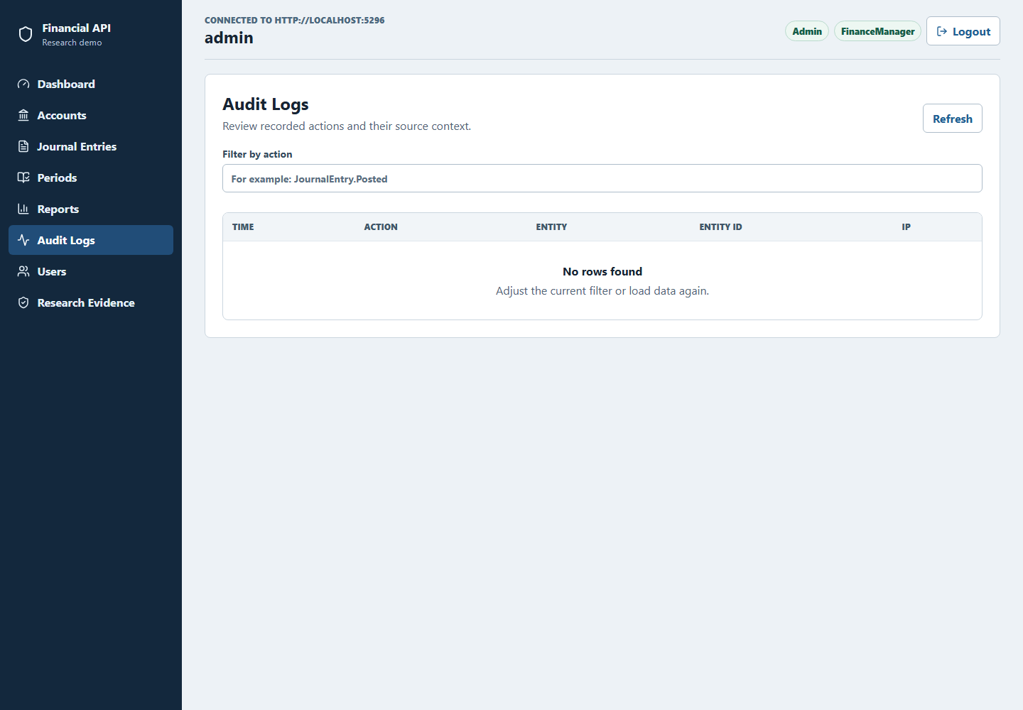
Figure 4.4. Audit-log screen available to Admin and Auditor roles.

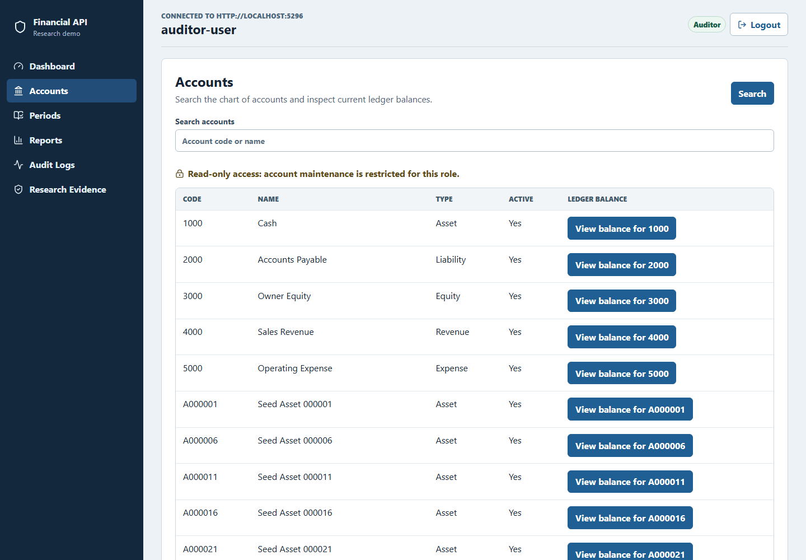
Figure 4.5. Auditor role view with restricted navigation.

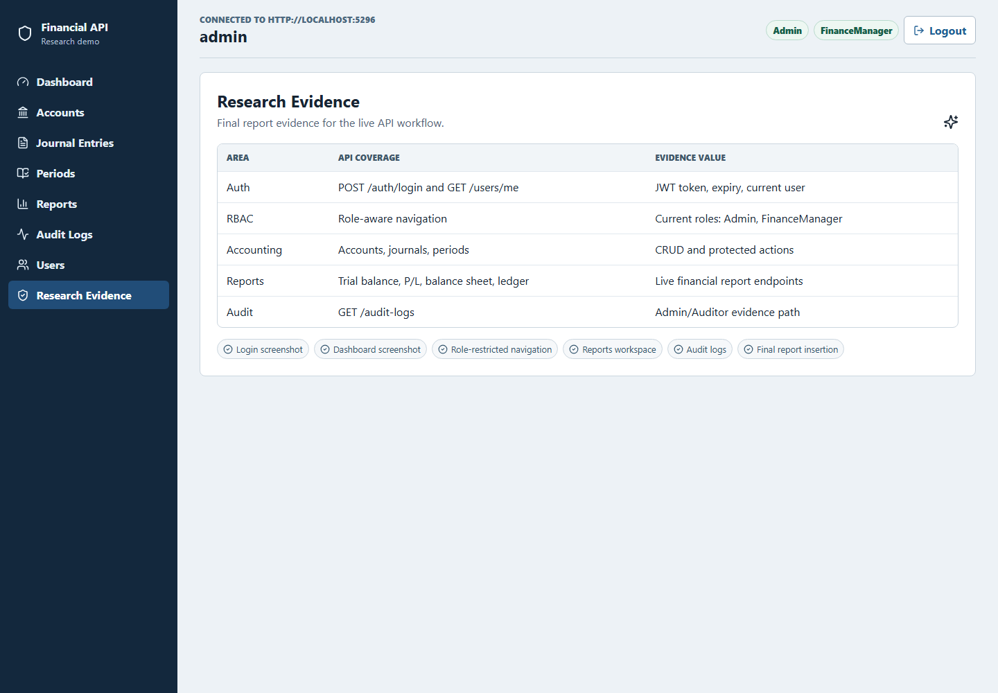
Figure 4.6. Research-evidence page mapping screens to API coverage.

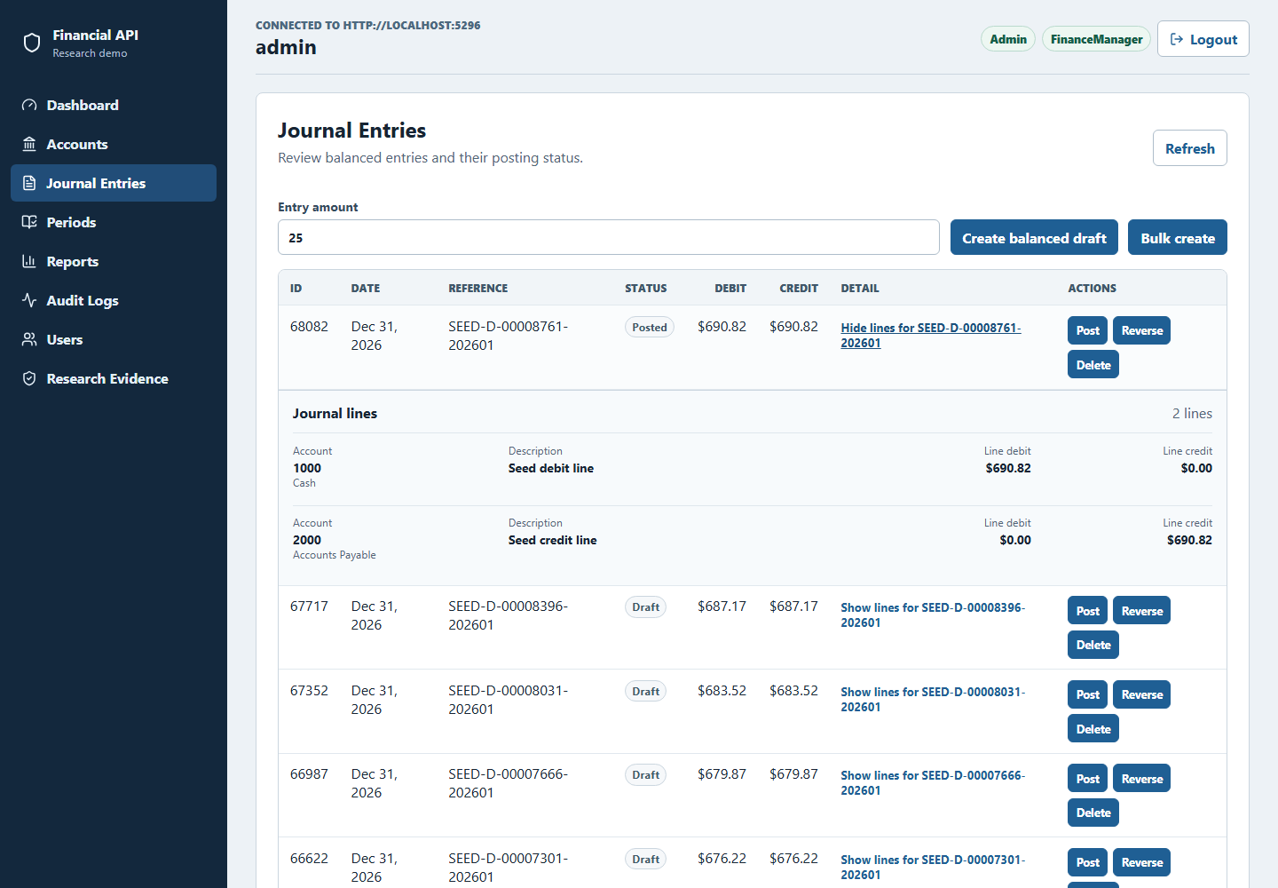
Figure 4.7. Expanded journal-entry lines showing account-level debit and credit evidence.

Chapter 5: Conclusion
This full report presented a systematic, branch-based evaluation of ChatGPT (Codex 5.4) as an improvement advisor for a financial accounting ASP.NET Core RESTful API. The work moved beyond the planning stage by executing the baseline measurement, applying selected ChatGPT-guided fixes on isolated branches, and comparing the measured outcomes across security, performance, and code quality.

5.1 Summary of the Completed Study
The study evaluated one production-complexity RESTful API with endpoint groups for authentication, users, accounts, journal entries, accounting periods, reports, and audit logs. Baseline results were captured on common baseline branch. Post-improvement results were captured on SonarQube remediation branch, OWASP ZAP remediation branch, and JMeter remediation branch. This branch structure made it possible to attribute each measured change to one improvement stream.

5.2 Main Findings
The SonarQube branch reduced retained C# findings from 28 to 0 and reached an OK quality gate with 74.3% coverage and 0.0% duplicated-line density. The OWASP ZAP branch cleared all gated High, Medium, and Low alerts on business endpoints in both baseline and authenticated API scans. The JMeter branch produced large p95 latency reductions, including p100 total p95 from 261.95 ms to 34.00 ms and spike total p95 from 6795.00 ms to 1420.00 ms, while retaining a documented caveat that the mixed-workload soak and spike drift heuristics still fail.

5.3 Contributions
The report contributes empirical evidence that ChatGPT can be useful as an advisor when its suggestions are constrained by existing code, applied on isolated branches, and validated with repeatable tools. It also contributes a reusable evaluation framework combining SonarQube, OWASP ZAP, Apache JMeter, dotnet test, and branch-based before/after comparison for RESTful API improvement studies.

5.4 Limitations and Future Work
The findings are limited to one ASP.NET Core API, one language (C#), one database-backed financial accounting domain, and one AI assistant configuration: ChatGPT (Codex 5.4) accessed through OpenAI's Codex coding environment. The study does not claim that ChatGPT will improve every API or every codebase. Repeated stochastic LLM runs were not performed and should be added in future work to estimate output variance. Future work should also compare multiple LLMs, extend the workflow to other frameworks, and refine the performance drift heuristic so mixed workload composition does not obscure endpoint-level improvements. Appendix H records the interpretation limits for the fresh reproduction runs; these runs supplement rather than replace the historical Chapter 4 measurements.

REFERENCES
Chen, E., Huang, R., Chen, H.-S., Tseng, Y.-H., & Li, L.-Y. (2023). GPTutor: A ChatGPT-powered programming tool for code explanation [Preprint]. arXiv. https://doi.org/10.48550/arXiv.2305.01863
Fajkovic, E., & Rundberg, E. (2023). The impact of AI-generated code on web development: A comparative study of ChatGPT and GitHub Copilot [Bachelor's thesis, Blekinge Institute of Technology]. DiVA. https://www.diva-portal.org/smash/record.jsf?pid=diva2:1769082
Flores, C. P., Jr., & Monreal, R. N. (2024). Evaluation of common security vulnerabilities of state universities and colleges websites based on OWASP. Journal of Electrical Systems, 20(5s), 1396-1404. https://doi.org/10.52783/jes.2471
Hou, X., Zhao, Y., Liu, Y., Yang, Z., Wang, K., Li, L., Luo, X., Lo, D., Grundy, J., & Wang, H. (2024). Large language models for software engineering: A systematic literature review. ACM Transactions on Software Engineering and Methodology, 33(8), Article 220, 1-79. https://doi.org/10.1145/3695988
Khoury, R., Avila, A. R., Brunelle, J., & Camara, B. M. (2023). How secure is code generated by ChatGPT? In 2023 IEEE International Conference on Systems, Man, and Cybernetics (SMC) (pp. 2445-2451). IEEE. https://doi.org/10.1109/SMC53992.2023.10394237
Lenarduzzi, V., Lomio, F., Huttunen, H., & Taibi, D. (2020). Are SonarQube rules inducing bugs? In 2020 IEEE 27th International Conference on Software Analysis, Evolution and Reengineering (SANER) (pp. 501-511). IEEE. https://doi.org/10.1109/SANER48275.2020.9054821
Mousavi, Z., Islam, C., Moore, K., Abuadbba, A., & Babar, M. A. (2024). An investigation into misuse of Java security APIs by large language models. In Proceedings of the 19th ACM Asia Conference on Computer and Communications Security (pp. 1299-1315). ACM. https://doi.org/10.1145/3634737.3661134
Özpolat, Z., Yıldırım, Ö., & Karabatak, M. (2023). Artificial intelligence-based tools in software development processes: Application of ChatGPT. European Journal of Technic, 13(2). https://doi.org/10.36222/ejt.1330631
Pearce, H., Ahmad, B., Tan, B., Dolan-Gavitt, B., & Karri, R. (2022). Asleep at the keyboard? Assessing the security of GitHub Copilot's code contributions. In 2022 IEEE Symposium on Security and Privacy (SP) (pp. 754-768). IEEE. https://doi.org/10.1109/SP46214.2022.9833571
Peng, S., Kalliamvakou, E., Cihon, P., & Demirer, M. (2023). The impact of AI on developer productivity: Evidence from GitHub Copilot [Preprint]. arXiv. https://doi.org/10.48550/arXiv.2302.06590
Ságodi, Z., Siket, I., & Ferenc, R. (2024). Methodology for code synthesis evaluation of LLMs presented by a case study of ChatGPT and Copilot. IEEE Access, 12, 72303-72316. https://doi.org/10.1109/ACCESS.2024.3403858
Sandoval, G., Pearce, H., Nys, T., Karri, R., Garg, S., & Dolan-Gavitt, B. (2023). Lost at C: A user study on the security implications of large language model code assistants. In 32nd USENIX Security Symposium (USENIX Security 23) (pp. 2205-2222). USENIX Association. https://www.usenix.org/conference/usenixsecurity23/presentation/sandoval
Szabó, Z., & Bilicki, V. (2023). A new approach to web application security: Utilizing GPT language models for source code inspection. Future Internet, 15(10), Article 326. https://doi.org/10.3390/fi15100326
Yetiştiren, B., Özsoy, I., Ayerdem, M., & Tüzün, E. (2023). Evaluating the code quality of AI-assisted code generation tools: An empirical study on GitHub Copilot, Amazon CodeWhisperer, and ChatGPT [Preprint]. arXiv. https://doi.org/10.48550/arXiv.2304.10778
Zhang, N., Zou, Y., Xia, X., Huang, Q., Lo, D., & Li, S. (2023). Web APIs: Features, issues, and expectations - A large-scale empirical study of Web APIs from two publicly accessible registries using Stack Overflow and a user survey. IEEE Transactions on Software Engineering, 49(2), 498-528. https://doi.org/10.1109/TSE.2022.3154769

APPENDICES
This Markdown file is the controlled source used to build the thesis appendices in the latest full-report DOCX. Historical measurements and fresh reproduction results are deliberately separated so that a later tool run does not overwrite the measurements reported in Chapter 4.

Appendix A - Repository and Environment
- Repository: https://github.com/minatozaki98/financial-accounting
- Canonical branch: codex/thesis-reproducibility-v1
- Thesis model identity: gpt-5.4
- Current paper source: Document/outputs/final-report-gpt55-comparison.docx
- Required platform: Windows, PowerShell, .NET, Node.js/npm, local SQL Server; Docker for the full research-tool gate
Quick start:
./scripts/thesis/Test-ThesisEnvironment.ps1 -Mode Fast
./scripts/thesis/Initialize-ThesisDatabase.ps1
./scripts/thesis/Invoke-ThesisVerification.ps1 -Mode Fast
./scripts/thesis/Invoke-ThesisDemo.ps1 -KeepRunning

Appendix B - Branch and Commit Provenance
Evidence role | Reference | Exact commit
baseline | origin/baseline-v0.1 | 7a0469d9401a3061941b44fcd46b3beca1c9c729
sonarqube-remediation | origin/baseline-sonarqube-v1 | a2279bcbdc20751529335cf72f8baac1bc6f994b
zap-remediation | origin/baseline-zap-v1 | 5f3bd3ccd9e0d460f52cac6a8a0d5fdceff1ce3d
jmeter-remediation | origin/baseline-jmeter-v1 | 3c9392d8dcecf986da5438962e20c5d862e8be08 (tested code: 78b08b62570dcf6fe436354e8e6b770ab2074445)

Appendix C - Selected Source-Code Evidence
The complete implementation is available in the repository at the commits recorded in Appendix B. Reproducing every source file in the thesis would make the appendix difficult to review and would duplicate the version-controlled repository. The listings below therefore show five representative implementation decisions: authorization at the API boundary, accounting-integrity validation and audit logging, HTTP response hardening, concurrency-safe report caching, and deterministic research-data sizing. Each excerpt is paired with its purpose and exact provenance.

C.1 Role-Based Authorization at the API Boundary
Source: API/Controllers/JournalEntriesController.cs, baseline-sonarqube-v1 at commit a2279bcb (lines 9-32 and 68-87).
[ApiController]
[Route("journal-entries")]
[Authorize]
public class JournalEntriesController : ControllerBase
{
[Authorize(Roles = "Admin,User,FinanceManager")]
[HttpPost]
public async Task<IActionResult> Create(
[FromBody] CreateJournalEntryRequestDto request)
{
var actorId = UserClaimsHelper.GetUserId(User);
if (!actorId.HasValue)
{
return Unauthorized();
}

var result = await _journalEntryService.CreateDraftAsync(
request,
actorId.Value,
HttpContext.Connection.RemoteIpAddress?.ToString());
return CreatedAtAction(nameof(GetById),
new { id = result.JournalEntryId }, result);
}

// Other read and mutation endpoints are omitted from this excerpt.

[Authorize(Roles = "Admin,FinanceManager")]
[HttpPost("{id:long}/post")]
public async Task<IActionResult> Post([FromRoute] long id)
{
var actorId = UserClaimsHelper.GetUserId(User);
if (!actorId.HasValue)
{
return Unauthorized();
}

var posted = await _journalEntryService.PostAsync(
id,
actorId.Value,
HttpContext.Connection.RemoteIpAddress?.ToString());
if (!posted)
{
return Problem(
statusCode: StatusCodes.Status404NotFound,
title: "Journal entry not found",
detail: "Draft journal entry was not found.");
}

return NoContent();
}
}
Explanation. Authentication is required for the complete controller, while role attributes narrow sensitive mutations. A normal user can create a draft, but only an administrator or finance manager can post it. The authenticated user identifier and client address are passed to the service so the resulting transaction can be attributed in the audit trail. This illustrates that authorization is enforced by the server rather than only by hiding controls in the web interface.

C.2 Accounting Integrity and Audit Trace
Source: BAL/Services/JournalEntryService.cs, baseline-sonarqube-v1 at commit a2279bcb (lines 209-238).
var period = await GetPeriodForDateAsync(entry.EntryDate);
if (period != null && period.IsClosed)
{
throw new InvalidOperationException(
"Cannot post journal entry in a closed accounting period.");
}

var debitTotal = entry.Lines.Sum(x => x.Debit);
var creditTotal = entry.Lines.Sum(x => x.Credit);
if (decimal.Round(debitTotal, 2) != decimal.Round(creditTotal, 2)
|| debitTotal <= 0m)
{
throw new InvalidOperationException(
"Journal entry must be balanced before posting.");
}

entry.Status = PostedStatus;
entry.PostedAt = DateTime.UtcNow;
await _context.SaveChangesAsync();

await _auditLogService.WriteAsync(
actorUserId,
"POST_ENTRY",
JournalEntriesEntityName,
journalEntryId.ToString(),
ipAddress,
new { debitTotal, creditTotal });
Explanation. Posting is blocked when the accounting period is closed or when debit and credit totals do not balance to two decimal places. Only after those invariants pass is the entry marked as posted and persisted. The same operation records the actor, action, entity, identifier, network address, and totals, providing evidence for both accounting correctness and traceability.

C.3 HTTP Response Hardening Used for ZAP Remediation
Source: API/Middleware/SecurityHeadersMiddleware.cs, baseline-zap-v1 at commit 5f3bd3cc (lines 17-34 and 37-63).
public async Task InvokeAsync(HttpContext context)
{
if (_options.Enabled)
{
context.Response.OnStarting(() =>
{
SetHeaderIfMissing(context, "Content-Security-Policy",
GetContentSecurityPolicy(context.Request.Path));
SetHeaderIfMissing(context, "X-Frame-Options",
_options.XFrameOptions);
SetHeaderIfMissing(context, "X-Content-Type-Options",
_options.XContentTypeOptions);
SetHeaderIfMissing(context, "Permissions-Policy",
_options.PermissionsPolicy);
SetHeaderIfMissing(context, "Cross-Origin-Opener-Policy",
_options.CrossOriginOpenerPolicy);
return Task.CompletedTask;
});
}

await _next(context);
}

private static void SetHeaderIfMissing(
HttpContext context, string headerName, string headerValue)
{
if (!string.IsNullOrWhiteSpace(headerValue)
&& !context.Response.Headers.ContainsKey(headerName))
{
context.Response.Headers[headerName] = headerValue;
}
}
Explanation. The middleware registers the security headers immediately before the response is sent, so the policy is applied consistently even when downstream handlers generate the response. Configuration remains external to the middleware, and an existing downstream header is not overwritten. These controls address browser-side classes reported by ZAP, including framing, MIME sniffing, content policy, permissions, and cross-origin isolation.

C.4 Concurrency-Safe Report Caching Used for JMeter Remediation
Source: BAL/Shared/AccountLedgerCache.cs, baseline-jmeter-v1 at commit 78b08b62 (lines 8-34).
public sealed class AccountLedgerCache : IAccountLedgerCache
{
private readonly ConcurrentDictionary<string,
Lazy<Task<AccountLedgerSnapshot>>> _entries = new();

public async Task<AccountLedgerSnapshot> GetOrCreateAsync(
int accountId,
int periodId,
string accountType,
DateTime startDate,
DateTime endDate,
Func<Task<AccountLedgerSnapshot>> factory)
{
var key = BuildKey(accountId, periodId, accountType,
startDate, endDate);
var lazy = _entries.GetOrAdd(
key,
_ => new Lazy<Task<AccountLedgerSnapshot>>(
factory, LazyThreadSafetyMode.ExecutionAndPublication));

try
{
return await lazy.Value;
}
catch
{
_entries.TryRemove(new KeyValuePair<string,
Lazy<Task<AccountLedgerSnapshot>>>(key, lazy));
throw;
}
}
}
Explanation. The cache key identifies the account, accounting period, account type, and date range. ConcurrentDictionary makes access thread-safe, while Lazy<Task<T>> with ExecutionAndPublication ensures concurrent requests share one in-flight calculation instead of issuing duplicate database work. If calculation fails, the failed entry is removed so a later request can retry. This is the implementation mechanism evaluated by the JMeter report-endpoint profiles; the fresh results in Appendix F are reported independently and do not assume that caching guarantees a faster result on every host run.

C.5 Deterministic Research-Data Parameters
Source: scripts/phase4/seed-test-data.ps1, baseline-v0.1 at commit 7a0469d9 (lines 1-10, with credential parameters intentionally omitted from this listing).
param(
[string]$ConnectionString,
[int]$PeriodId = 202601,
[string]$PeriodStart = "2026-01-01",
[string]$PeriodEnd = "2026-12-31",
[int]$AccountCount = 120,
[int]$JournalEntryCount = 30000,
[int]$MinimumPostedEntries = 5000
)
Explanation. The seed profile fixes the period and dataset volume used by the study. Explicit parameters make the database population reproducible and allow the same workload shape to be rebuilt without embedding credentials in the thesis. The parameters correspond to the dataset counts reported in Section 3.2 and the evidence manifests.

C.6 Traceability to the Thesis Results

4.2 / Table 4.2: sonarqube-primary
Historical result: 28 retained findings to 0; Quality Gate OK; coverage 74.3%; duplication 0.0%
Source files:
- API/Controllers/JournalEntriesController.cs
- API/Program.cs
- BAL/Services/JournalEntryService.cs
- Document/sonarqube-fixes.md
Historical artifacts:
- Document/sonarqube-fixes.md
- Document/outputs/final-report-gpt55-comparison.docx

4.3: zap-primary
Historical result: gated High, Medium, and Low business-endpoint alerts cleared
Source files:
- API/Middleware/SecurityHeadersMiddleware.cs
- API/Program.cs
- scripts/phase4/zap-baseline-rules.tsv
- scripts/phase4/zap-api-rules.tsv
- Document/zap-fixes.md
Historical artifacts:
- Document/security/zap-baseline-20260222-230133.html
- Document/security/zap-baseline-20260222-230133.json
- Document/security/zap-baseline-20260324-000724.html
- Document/security/zap-baseline-20260324-000724.json
- Document/security/zap-api-20260222-230133.html
- Document/security/zap-api-20260222-230133.json
- Document/security/zap-api-20260324-000856.html
- Document/security/zap-api-20260324-000856.json

4.4 / Table 4.4: jmeter-primary
Historical result: p50, p100, and p500 p95 improved; soak/spike improved with drift caveat
Source files:
- BAL/Services/FinancialReportService.cs
- BAL/Shared/AccountLedgerCache.cs
- BAL/Shared/SqlServerPerformanceIndexStartup.cs
- Document/performance/jmeter/financial-api-load-test.jmx
- Document/performance/jmeter/financial-api-soak-test.jmx
- Document/performance/jmeter/financial-api-spike-test.jmx
Historical artifacts:
- Document/baseline-comparison-report.md
- Document/jmeter-fixes.md
- Document/performance/thesis-evidence-20260222-231435.md
- Document/performance/thesis-evidence-20260222-231435.csv
- Document/performance/thesis-baseline-anchor.json

3.2 / Tables 3.7-3.8: deterministic-data
Historical result: 120 accounts, 30000 journal entries, at least 5000 posted entries
Source files:
- Document/sql/financial_accounting_schema.sql
- scripts/phase4/seed-test-data.ps1
Historical artifacts:
- Document/performance/thesis-evidence-20260222-231435.md
- Document/performance/test-summary-20260222-231435.md

3.1.1 and 3.5: automated-regression
Historical result: unit, integration, RBAC, and coverage checks support non-regression
Source files:
- tests/FinancialAccounting.UnitTests/FinancialAccounting.UnitTests.csproj
- tests/FinancialAccounting.IntegrationTests/FinancialAccounting.IntegrationTests.csproj
Historical artifacts:
- Document/performance/test-results-unit-20260222-231435/unit-20260222-231435.trx
- Document/performance/test-results-integration-20260222-231435/integration-20260222-231435.trx
- Document/performance/test-summary-20260222-231435.md

4.6 / Figures 4.1-4.7: working-application
Historical result: React/Vite client demonstrates current role-aware API workflows
Source files:
- WEB/package.json
- WEB/src/App.tsx
- WEB/src/lib/api.ts
- WEB/tests/e2e/research-demo.spec.ts
Historical artifacts:
- Document/outputs/web-app-evidence/01-login.png
- Document/outputs/web-app-evidence/02-dashboard-admin.png
- Document/outputs/web-app-evidence/03-reports-trial-balance.png
- Document/outputs/web-app-evidence/04-audit-logs.png
- Document/outputs/web-app-evidence/05-auditor-role-view.png
- Document/outputs/web-app-evidence/06-research-evidence.png
- Document/outputs/web-app-evidence/07-journal-entry-details.png

Appendix D - Reproduction Commands and Profiles
$RunId = Get-Date -Format 'yyyyMMdd-HHmmss'
$DemoPassword = $env:THESIS_DEMO_PASSWORD
if ([string]::IsNullOrWhiteSpace($DemoPassword)) { throw 'Set THESIS_DEMO_PASSWORD for this process.' }
# Create clean exact-ref worktrees; never switch a dirty checkout in place.
git worktree add .worktrees/appendix-baseline --detach 7a0469d9401a3061941b44fcd46b3beca1c9c729
git worktree add .worktrees/appendix-sonar --detach a2279bcbdc20751529335cf72f8baac1bc6f994b
git worktree add .worktrees/appendix-zap --detach 5f3bd3ccd9e0d460f52cac6a8a0d5fdceff1ce3d
git worktree add .worktrees/appendix-jmeter --detach 78b08b62570dcf6fe436354e8e6b770ab2074445
# SonarQube (use a secure process-local SONAR_TOKEN)
$SonarProjectKey = 'financial-accounting-thesis-baseline-v01'
./scripts/phase4/run-sonarqube-scan.ps1 -SonarToken $env:SONAR_TOKEN -ProjectKey $SonarProjectKey -SolutionPath API/API.csproj
# OWASP ZAP baseline and authenticated API scans
./scripts/phase4/run-zap-baseline.ps1 -TargetUrl 'http://localhost:5296/health/live' -OutputPrefix "zap-baseline-$RunId"
./scripts/phase4/run-zap-api.ps1 -OpenApiUrl 'http://localhost:5296/swagger/v1/swagger.json' -BaseUrl 'http://localhost:5296' -Username 'admin' -Password $DemoPassword -OutputPrefix "zap-api-$RunId"
# JMeter p50, p100, p500, soak, and spike
./scripts/phase4/run-jmeter-thesis-matrix.ps1 -BaseUrl 'http://localhost:5296' -Username 'admin' -Password $DemoPassword -PeriodId 202601 -AccountId 1 -RunTag $RunId
# Generate browser-capture cases from the versioned manifests.
./scripts/thesis/New-DashboardCaptureCases.ps1 -OutputPath '.tmp/dashboard-cases.json'
$env:THESIS_DASHBOARD_CASES = '.tmp/dashboard-cases.json'
npm run capture:appendix --prefix WEB

Appendix E - Result Traceability
Claim | Paper location | Historical result | Fresh reproduction result
sonarqube-primary | 4.2 / Table 4.2 | 28 retained findings to 0; Quality Gate OK; coverage 74.3%; duplication 0.0% | Execution PASS; gates OK/OK: baseline 17 issues, remediation 0 issues
zap-primary | 4.3 | gated High, Medium, and Low business-endpoint alerts cleared | Execution PASS/PASS; configured gates PASS_CONFIGURED_RULES/PASS_CONFIGURED_RULES: baseline raw alerts passive M3/L6, API M1/L3; remediation raw alerts passive M0/L0, API M1/L0
jmeter-primary | 4.4 / Table 4.4 | p50, p100, and p500 p95 improved; soak/spike improved with drift caveat | Execution PASS/PASS; core gates PASS/FAIL: p50 p95 33->199.9 ms; p100 255.9->1146.9; p500 106->1547.95; soak 443.95->171; spike 33401.75->4730.85
deterministic-data | 3.2 / Tables 3.7-3.8 | 120 accounts, 30000 journal entries, at least 5000 posted entries | PASS
automated-regression | 3.1.1 and 3.5 | unit, integration, RBAC, and coverage checks support non-regression | PASS
working-application | 4.6 / Figures 4.1-4.7 | React/Vite client demonstrates current role-aware API workflows | PASS

Appendix F - Research-Tool Dashboards and Results

SonarQube Dashboards

baseline-overview
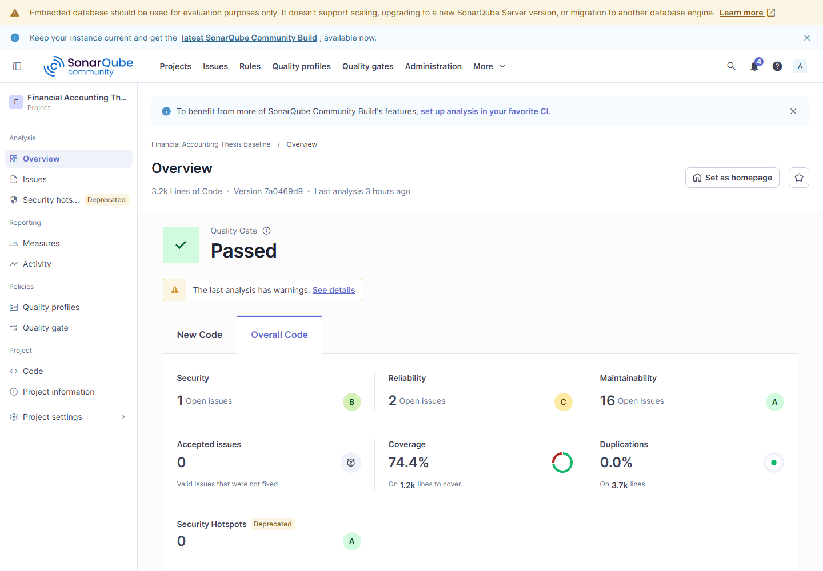
Figure F.1. SonarQube baseline overview dashboard.
Classification: fresh-reproduction; role: baseline; branch: origin/baseline-v0.1; commit: 7a0469d9; run: 20260922-183352; tool version: 26.7.0.124771; source: docs/appendix/verification-runs/research/sonar/baseline/summary.json.

baseline-issues
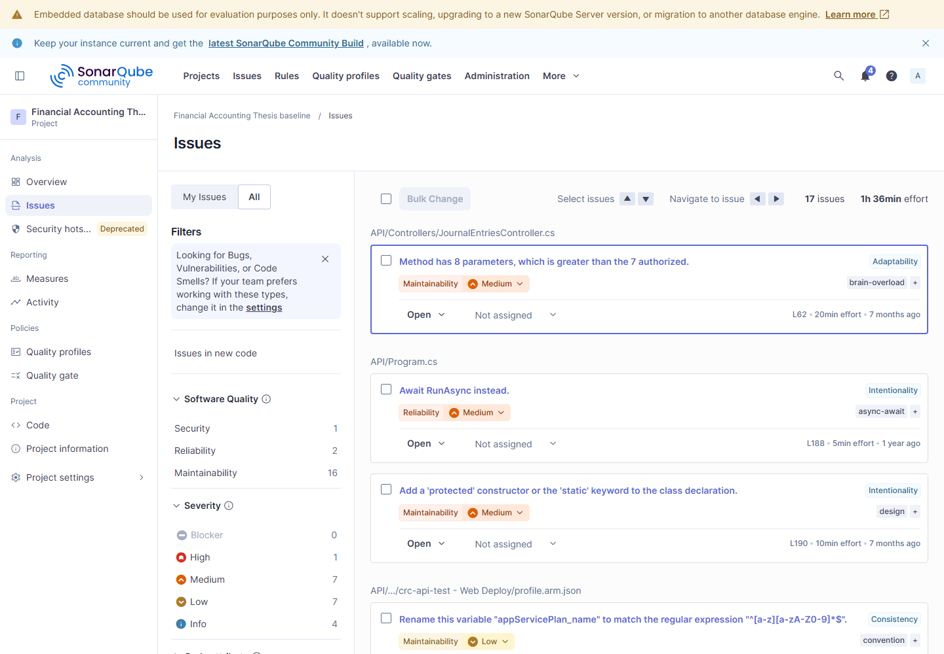
Figure F.2. SonarQube baseline issues dashboard.
Classification: fresh-reproduction; role: baseline; branch: origin/baseline-v0.1; commit: 7a0469d9; run: 20260922-183352; tool version: 26.7.0.124771; source: docs/appendix/verification-runs/research/sonar/baseline/summary.json.

remediation-overview
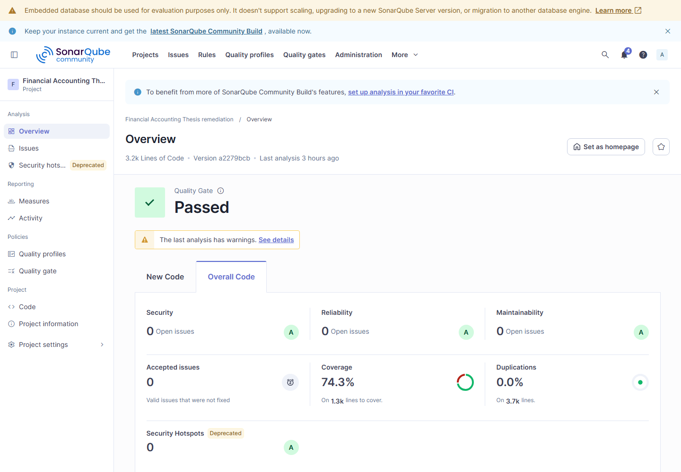
Figure F.3. SonarQube remediation overview dashboard.
Classification: fresh-reproduction; role: remediation; branch: origin/baseline-sonarqube-v1; commit: a2279bcb; run: 20260922-183352; tool version: 26.7.0.124771; source: docs/appendix/verification-runs/research/sonar/remediation/summary.json.

remediation-issues
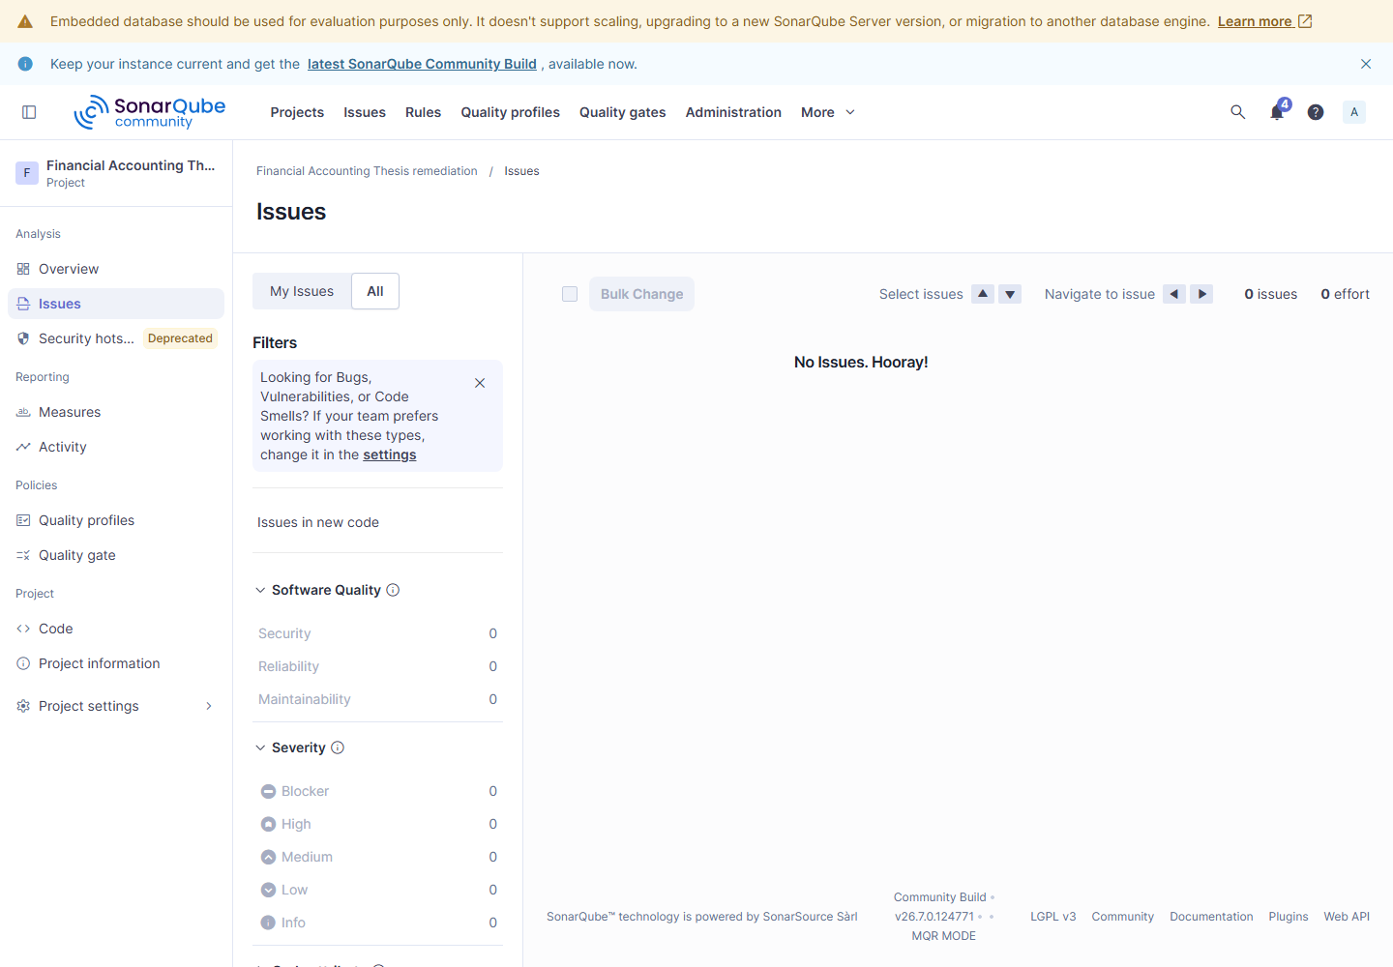
Figure F.4. SonarQube remediation issues dashboard.
Classification: fresh-reproduction; role: remediation; branch: origin/baseline-sonarqube-v1; commit: a2279bcb; run: 20260922-183352; tool version: 26.7.0.124771; source: docs/appendix/verification-runs/research/sonar/remediation/summary.json.

OWASP ZAP Dashboards

baseline-before-summary
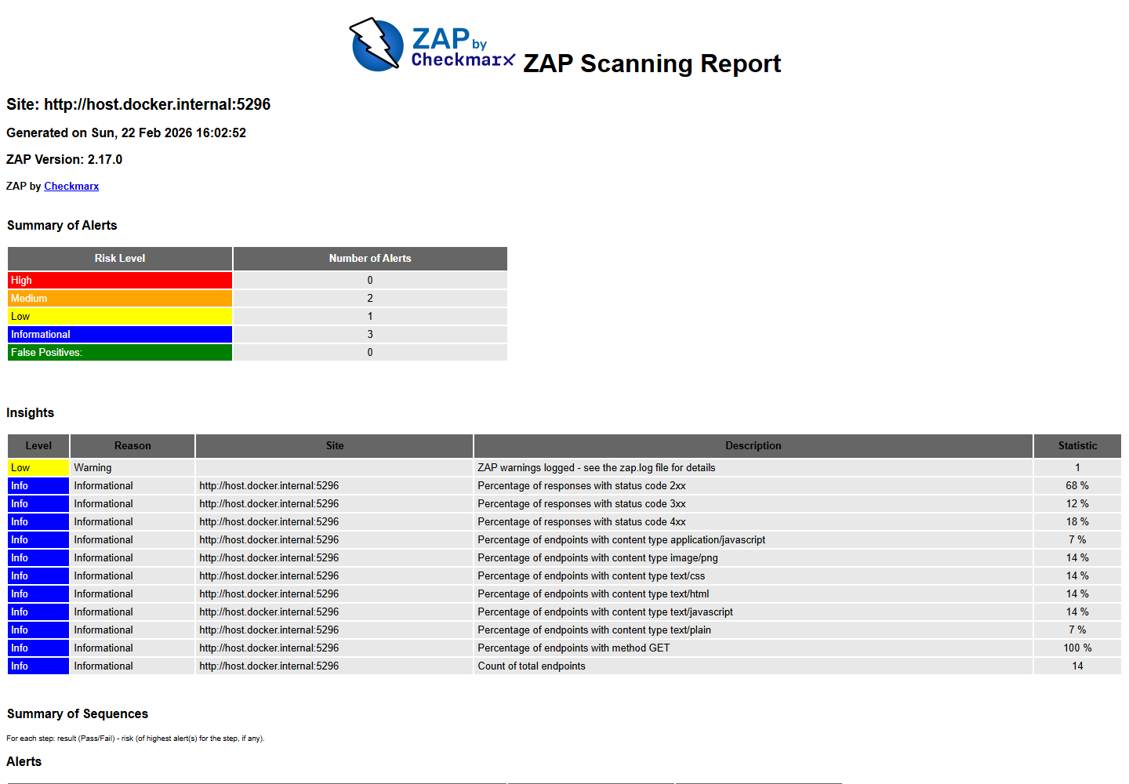
Figure F.5. OWASP ZAP baseline before summary dashboard.
Classification: rendered-historical; role: baseline; branch: origin/baseline-v0.1; commit: 7a0469d9; run: 20260222-230133; tool version: 2.17.0; source: Document/security/zap-baseline-20260222-230133.json.

baseline-after-summary
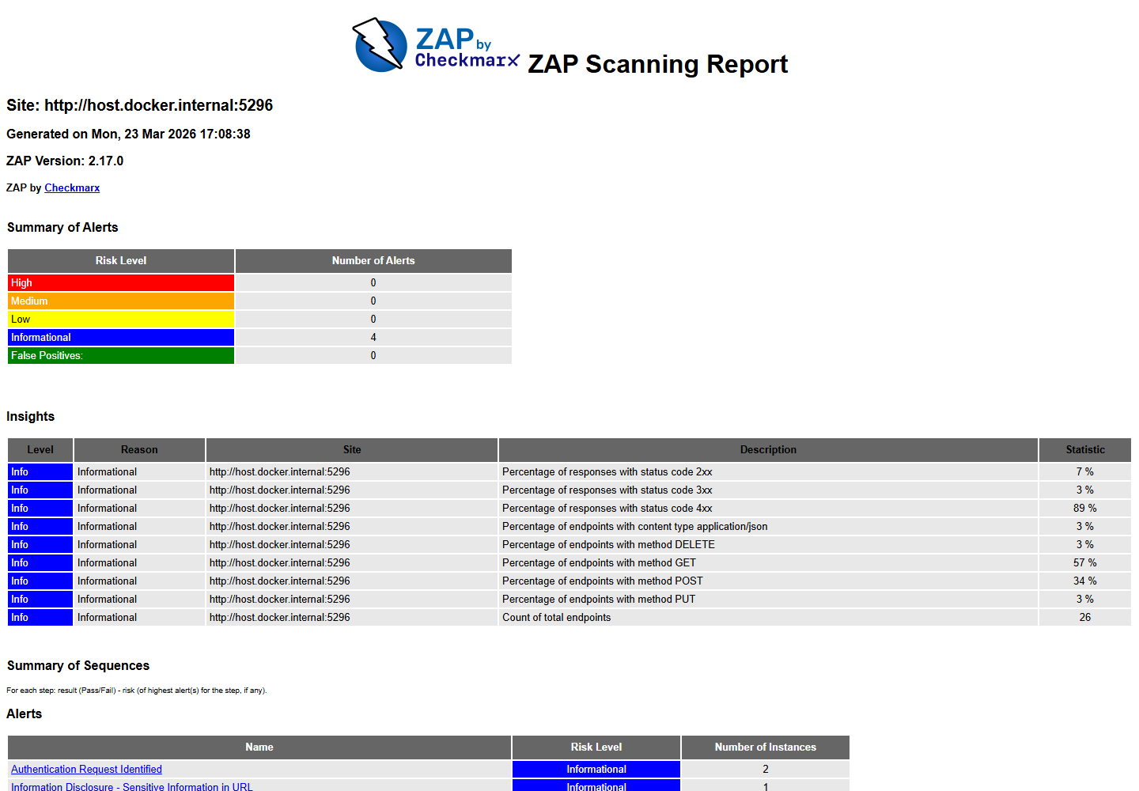
Figure F.6. OWASP ZAP baseline after summary dashboard.
Classification: rendered-historical; role: remediation; branch: origin/baseline-zap-v1; commit: 5f3bd3cc; run: 20260324-000724; tool version: 2.17.0; source: Document/security/zap-baseline-20260324-000724.json.

api-before-summary
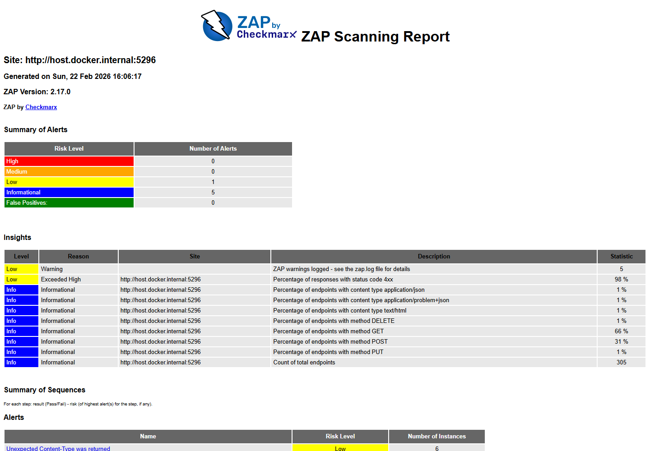
Figure F.7. OWASP ZAP api before summary dashboard.
Classification: rendered-historical; role: baseline; branch: origin/baseline-v0.1; commit: 7a0469d9; run: 20260222-230133; tool version: 2.17.0; source: Document/security/zap-api-20260222-230133.json.

api-after-summary
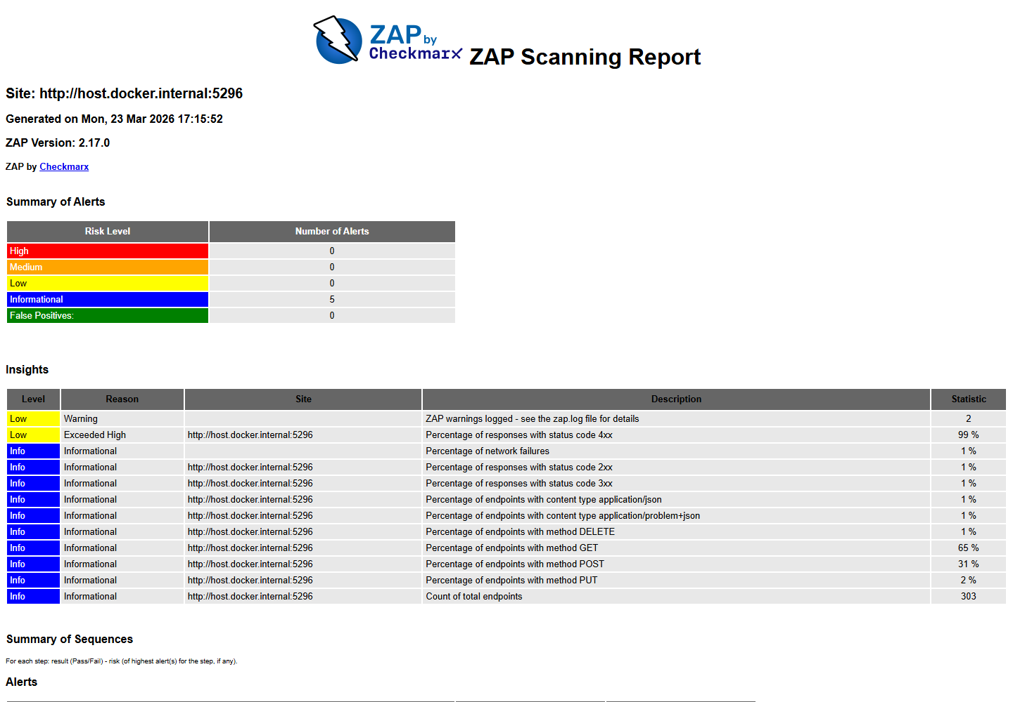
Figure F.8. OWASP ZAP api after summary dashboard.
Classification: rendered-historical; role: remediation; branch: origin/baseline-zap-v1; commit: 5f3bd3cc; run: 20260324-000856; tool version: 2.17.0; source: Document/security/zap-api-20260324-000856.json.

Apache JMeter Dashboards

baseline-p50-dashboard
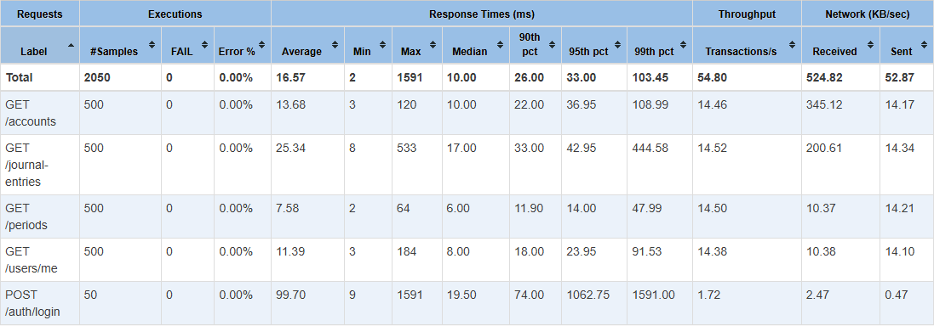
Figure F.9. Apache JMeter baseline p50 dashboard dashboard.
Classification: fresh-reproduction; role: baseline; branch: origin/baseline-v0.1; commit: 7a0469d9; run: baseline-20260922-192730; tool version: 5.5; source: docs/appendix/verification-runs/research/jmeter/baseline/report-baseline-20260922-192730-p50/statistics.json.

baseline-p100-dashboard
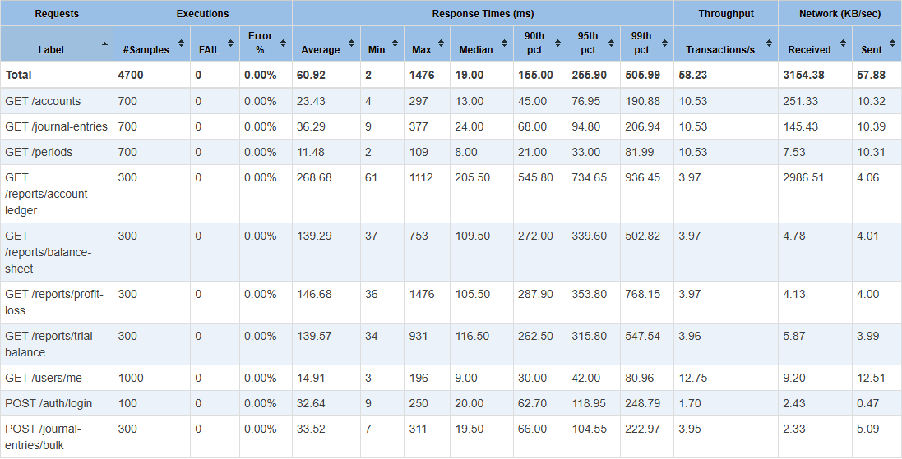
Figure F.10. Apache JMeter baseline p100 dashboard dashboard.
Classification: fresh-reproduction; role: baseline; branch: origin/baseline-v0.1; commit: 7a0469d9; run: baseline-20260922-192730; tool version: 5.5; source: docs/appendix/verification-runs/research/jmeter/baseline/report-baseline-20260922-192730-p100/statistics.json.

baseline-p500-dashboard
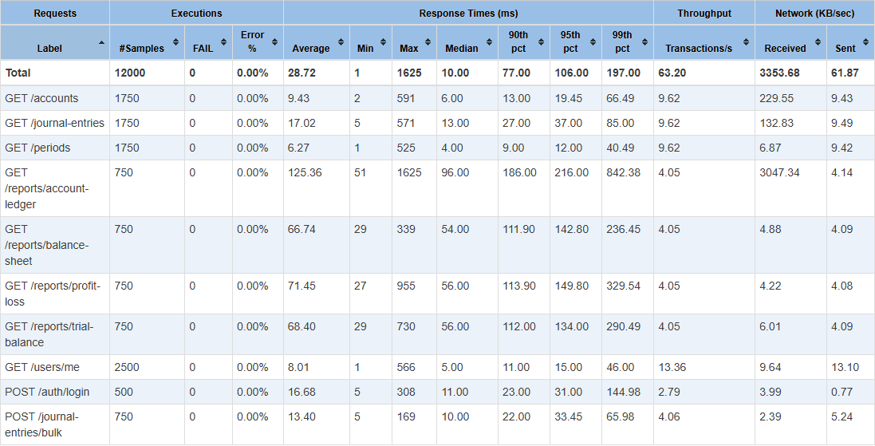
Figure F.11. Apache JMeter baseline p500 dashboard dashboard.
Classification: fresh-reproduction; role: baseline; branch: origin/baseline-v0.1; commit: 7a0469d9; run: baseline-20260922-192730; tool version: 5.5; source: docs/appendix/verification-runs/research/jmeter/baseline/report-baseline-20260922-192730-p500/statistics.json.

baseline-soak-dashboard
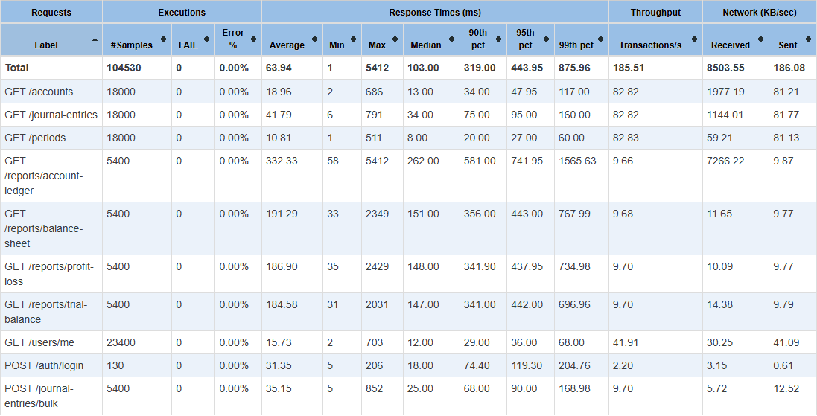
Figure F.12. Apache JMeter baseline soak dashboard dashboard.
Classification: fresh-reproduction; role: baseline; branch: origin/baseline-v0.1; commit: 7a0469d9; run: baseline-20260922-192730; tool version: 5.5; source: docs/appendix/verification-runs/research/jmeter/baseline/report-baseline-20260922-192730-soak/statistics.json.

baseline-spike-dashboard
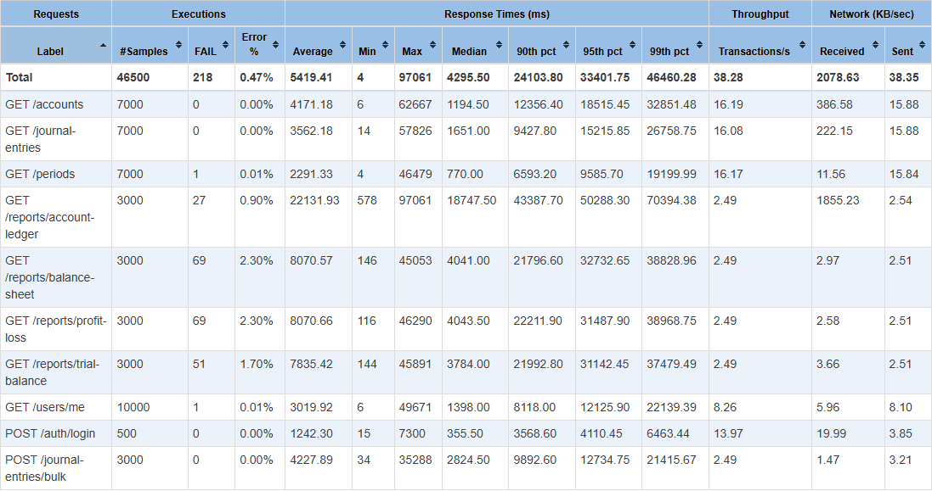
Figure F.13. Apache JMeter baseline spike dashboard dashboard.
Classification: fresh-reproduction; role: baseline; branch: origin/baseline-v0.1; commit: 7a0469d9; run: baseline-20260922-192730; tool version: 5.5; source: docs/appendix/verification-runs/research/jmeter/baseline/report-baseline-20260922-192730-spike/statistics.json.

remediation-p50-dashboard
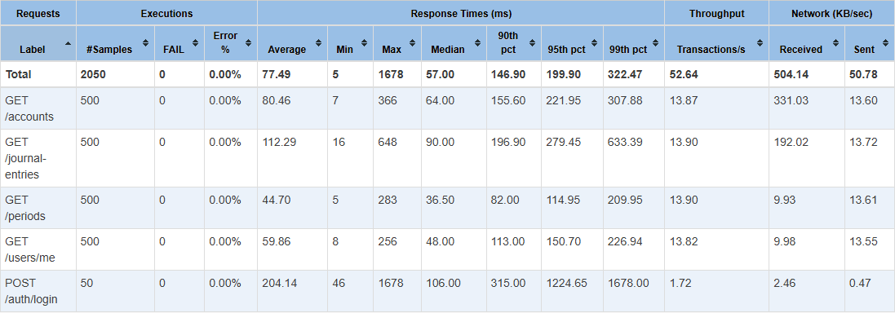
Figure F.14. Apache JMeter remediation p50 dashboard dashboard.
Classification: fresh-reproduction; role: remediation; branch: origin/baseline-jmeter-v1; commit: 78b08b62; run: remediation-20260922-200712; tool version: 5.5; source: docs/appendix/verification-runs/research/jmeter/remediation/report-remediation-20260922-200712-p50/statistics.json.

remediation-p100-dashboard
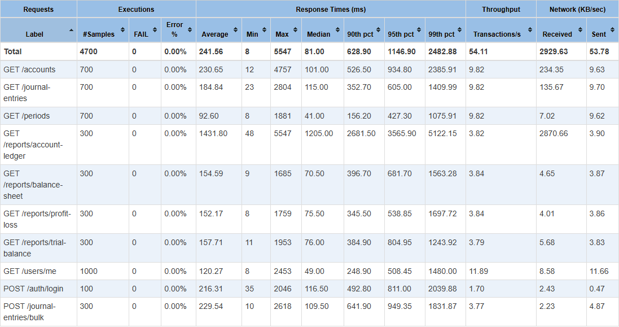
Figure F.15. Apache JMeter remediation p100 dashboard dashboard.
Classification: fresh-reproduction; role: remediation; branch: origin/baseline-jmeter-v1; commit: 78b08b62; run: remediation-20260922-200712; tool version: 5.5; source: docs/appendix/verification-runs/research/jmeter/remediation/report-remediation-20260922-200712-p100/statistics.json.

remediation-p500-dashboard
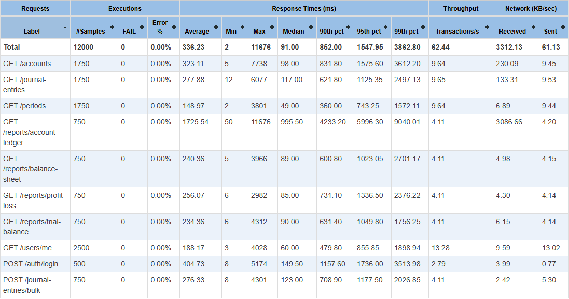
Figure F.16. Apache JMeter remediation p500 dashboard dashboard.
Classification: fresh-reproduction; role: remediation; branch: origin/baseline-jmeter-v1; commit: 78b08b62; run: remediation-20260922-200712; tool version: 5.5; source: docs/appendix/verification-runs/research/jmeter/remediation/report-remediation-20260922-200712-p500/statistics.json.

remediation-soak-dashboard
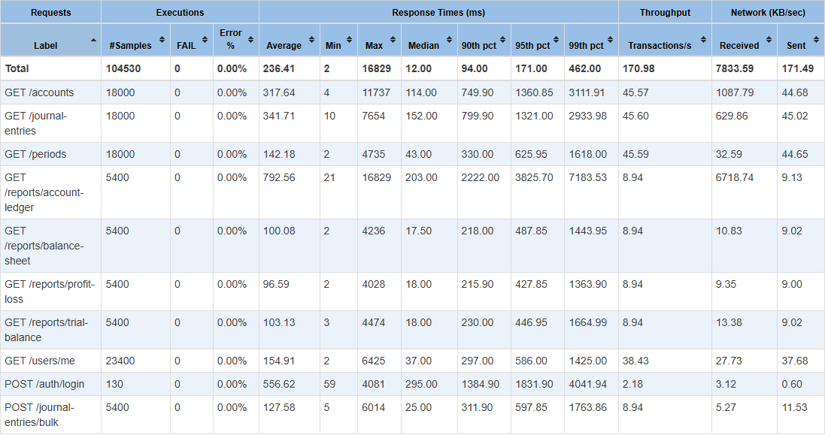
Figure F.17. Apache JMeter remediation soak dashboard dashboard.
Classification: fresh-reproduction; role: remediation; branch: origin/baseline-jmeter-v1; commit: 78b08b62; run: remediation-20260922-200712; tool version: 5.5; source: docs/appendix/verification-runs/research/jmeter/remediation/report-remediation-20260922-200712-soak/statistics.json.

remediation-spike-dashboard
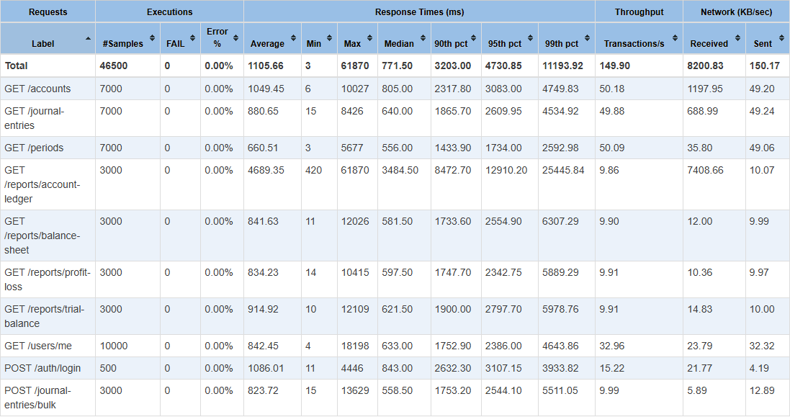
Figure F.18. Apache JMeter remediation spike dashboard dashboard.
Classification: fresh-reproduction; role: remediation; branch: origin/baseline-jmeter-v1; commit: 78b08b62; run: remediation-20260922-200712; tool version: 5.5; source: docs/appendix/verification-runs/research/jmeter/remediation/report-remediation-20260922-200712-spike/statistics.json.

Appendix G - Working Application Demonstration
- API live and ready endpoints: True / True
- Frontend smoke result: True
- Browser login/report/role workflow: PASS
- Demonstrated areas: login, role-aware navigation, accounts, journal lines, periods, reports, audit logs, user administration, and research evidence.
- Demo credentials are local-only and intentionally omitted from this appendix source.

Appendix H - Known Limitations
- The current paper evaluates one ASP.NET Core financial-accounting API and attributes remediation evidence to GPT-5.4.
- GPT-5.5 and new-API v2 work is supplemental and is not current-paper evidence.
- Fresh SonarQube, ZAP, and JMeter values can differ because of tool versions, host load, database state, and runtime conditions.
- The current local database exceeds the paper minimum dataset, so performance reruns must record their actual counts or use an isolated clean local database.
- Mixed-workload soak/spike drift remains a documented limitation.
- A dashboard screenshot is accepted only when its manifest links it to the same run and machine-readable source artifact.

