
Evaluating ChatGPT for Security, Performance, and Code-Quality Improvement of a Financial Accounting REST API: A Branch-Isolated Baseline Study
By
ZAW YE HTUT KO

Master Thesis Report
Submitted in Partial Fulfilment of the Requirements for the Degree of Master of Science in Information Technology, Assumption University

September 2026
Vincent Mary School of Engineering, Science and Technology
Thesis Approval

Thesis Title: Evaluating ChatGPT for Security, Performance, and Code-Quality Improvement of a Financial Accounting REST API: A Branch-Isolated Baseline Study By: Zaw Ye Htut Ko
Thesis Advisor: Dr. Darun Kesrarat
Academic Year: 2026
The Vincent Mary School of Engineering, Science and Technology of Assumption University has approved this proposal as the partial fulfillment of the requirements for the degree of Master of Science in Computer Science.
Approval Committee:
_____________________________ |  | _____________________________
(Dr. Darun Kesrarat) |  | ( )
Advisor |  | Committee
_____________________________ |  | _____________________________
( ) |  | ( )
Committee |  | Committee

September 2026

Abstract
This full report evaluates how ChatGPT (Codex 5.4), used as an AI-assisted code improvement advisor, can improve the security, performance, and code quality of a financial accounting RESTful API implemented in ASP.NET Core. The study uses one existing API codebase and compares a common baseline branch with isolated SonarQube, OWASP ZAP, and JMeter remediation branches. Fresh reproduction runs executed on September 22, 2026 provide the primary results. SonarQube 26.7 reduced 17 unique baseline issues to 0 while the Quality Gate remained OK; legacy Code Smells fell from 17 to 0, and coverage changed slightly from 74.4% to 74.3%. OWASP ZAP 2.17 passed the configured rules: the passive scan changed from 3 Medium and 6 Low alerts to 0 Medium and 0 Low, while the authenticated API scan retained one Medium HTTP Only Site observation and reduced Low alerts from 3 to 0. Apache JMeter 5.5 produced mixed results. Soak and spike aggregate p95 improved, but the remediation core gate failed because p100 p95 reached 1146.9 ms and p500 p95 reached 1547.95 ms. The evidence therefore supports a strong code-quality result, a configured-scope security improvement with a disclosed transport observation, and an unsuccessful core-performance outcome under the fresh host run. Historical measurements are retained separately in the appendices for provenance rather than used as the current result.

Table of Contents
Abstract 3
Table of Figures 10
List of Tables 12
List of Acronyms 13
Chapter 1 - Introduction 16
1.1 Introduction 16
1.2 Challenges 17
1.3 Problem Statement 18
1.4 Motivational Statement 19
1.5 Objectives, Measurements, and Outcomes 19
1.5.1 Objectives: 19
1.5.2 Measured Outcomes: 20
1.6 Limitations 20
Chapter 2 - Literature Review 21
2.1 The Impact of AI-generated Code on Web Development A Comparative Study of ChatGPT and GitHub Copilot 21
2.2 Methodology for Code Synthesis Evaluation of LLMs Presented by a Case Study of ChatGPT and Copilot 22
2.3 Artificial Intelligence-Based Tools 23
2.4 GPTutor 23
2.5 Web APIs Features, Issues, and Expectations – A Large-Scale Empirical Study of Web 24
2.6 An Investigation into Misuse of Java Security APIs by Large Language Models 25
2.7 A New Approach to Web Application Security Utilizing GPT Language Models for Source Code Inspection 26
2.8 Evaluating the Code Quality of AI-Assisted Code Generation Tools 27
2.9 Evaluation of Common Security Vulnerabilities of State Universities and Colleges Websites Based on OWASP 28
2.10 The Impact of AI on Developer Productivity Evidence from GitHub Copilot 29
2.11 Asleep at the Keyboard? Assessing the Security of GitHub Copilot's Code Contributions 30
2.12 How Secure is Code Generated by ChatGPT? 31
2.13 Lost at C: A User Study on the Security Implications of Large Language Model Code Assistants 32
2.14 Large Language Models for Software Engineering: A Systematic Literature Review 33
2.15 Are SonarQube Rules Inducing Bugs? 34
Chapter 3: Proposed Methodology 36
3.1 Research Design and Workflow 37
3.1.1 Testing Environment and Reproducibility 38
3.1.2 Selected Source-Code Evidence 46
3.1.3 Prompt-Template Evidence and Reproducibility 50
3.1.4 Human-Effort Traceability 50
3.2 Dataset Description and Preparation 51
3.3 Model and Tool Selection 56
3.4 Implementation of ChatGPT-Guided Improvements 58
3.5 Testing Phases 58
3.6 How is it different from others research? 59
3.7 Security Evaluation Plan 60
3.8 Performance Evaluation Plan 61
3.9 Code Quality Evaluation Plan 61
Chapter 4: Results and Discussion 63
4.1 Evaluation Criteria and Decision Rules 63
4.2 Code-Quality Outcome 64
4.3 Security Outcome 67
4.4 Performance Outcome 68
4.5 Overall Assessment and Trade-offs 70
4.6 Web Application Evidence for Current APIs 71
Chapter 5: Conclusion 79
5.1 Summary of the Completed Study 79
5.2 Main Findings 79
5.3 Contributions 80
5.4 Limitations and Future Work 80
REFERENCES 81
APPENDICES 84
Appendix A - Environment and Repository Provenance 84
Appendix B - Authentication, JWT, and RBAC Source Code 85
B.1 JWT Authentication Configuration 85
B.2 Controller-Level Role Enforcement 86
Appendix C - Journal-Entry Accounting Source Code 87
C.1 Balanced Journal-Entry Posting 87
C.2 Journal-Entry Reversal 89
Appendix D - Audit Logging and Traceability Source Code 90
D.1 Structured Audit-Log Writer 90
D.2 Auditor-Role Read Boundary 91
Appendix E - SonarQube Remediation Source Code 92
E.1 S107 Controller-Parameter Remediation 92
E.2 S6966 Asynchronous Host Shutdown 94
Appendix F - OWASP ZAP Security-Hardening Source Code 95
F.1 Response Security-Headers Middleware 95
F.2 Middleware Ordering and Swagger Exposure 96
Appendix G - JMeter Performance and Query-Optimization Source Code 98
G.1 Concurrency-Safe Account-Ledger Cache 98
G.2 Read-Only Ledger Query and Running Balance 99
G.3 Idempotent SQL Server Performance Indexes 100
Appendix H - Database Schema and Deterministic Seed Source Code 102
H.1 Deterministic Dataset Parameters 102
H.2 Double-Entry Schema Constraints and Indexes 103
Appendix I - Automated Test Source Code 105
I.1 Role-by-Endpoint Integration Matrix 105
I.2 Security and Performance Configuration Defaults Test 107
Appendix J - React Web Application and API Integration Source Code 107
J.1 Authenticated API Client 107
J.2 Role-Aware Navigation and Mutation Rules 108
Appendix K - Reproduction and Evidence-Automation Source Code 110
K.1 Exact-Commit Research Verification 110
K.2 Environment and Tool Readiness Checks 112
K.3 Reproduction Command Sequence 113
Appendix L - SonarQube, OWASP ZAP, and JMeter Dashboards 114
L.1 SonarQube baseline overview 114
L.2 SonarQube baseline issues 115
L.3 SonarQube remediation overview 116
L.4 SonarQube remediation issues 117
L.5 OWASP ZAP passive baseline before remediation 118
L.6 OWASP ZAP passive baseline after remediation 119
L.7 OWASP ZAP authenticated API before remediation 120
L.8 OWASP ZAP authenticated API after remediation 121
L.9 Apache JMeter baseline p50 122
L.10 Apache JMeter baseline p100 123
L.11 Apache JMeter baseline p500 124
L.12 Apache JMeter baseline soak 125
L.13 Apache JMeter baseline spike 126
L.14 Apache JMeter remediation p50 127
L.15 Apache JMeter remediation p100 128
L.16 Apache JMeter remediation p500 129
L.17 Apache JMeter remediation soak 130
L.18 Apache JMeter remediation spike 131
Appendix M - Result Traceability 131
Appendix N - Limitations and Complete Source Index 132
Table of Figures
Figure 3.1. Phase 1 - Baseline analysis workflow. 40
Figure 3.2. Phase 2 - LLM-guided improvements workflow. 41
Figure 3.3. Phase 3 - Post-improvement testing workflow. 43
Figure 3.4. Phase 4 - Comparative analysis and reporting workflow. 44
Figure 3.5. Representative chart-of-accounts rows from the live seeded database. 53
Figure 3.6. Representative users and role assignments from the live seeded database. 54
Figure 3.7. Representative journal entries and balanced debit-credit lines. 54
Figure 3.8. Representative accounting-period rows from the live seeded database. 54
Figure 3.9. Trial-balance sample derived from posted journal-entry lines. 55
Figure 3.10. Representative audit-log rows from report-generation workflows. 55
Figure 4.1. Web application login screen with demo role credentials. 72
Figure 4.2. Admin dashboard showing live API counts and report summary. 73
Figure 4.3. Trial balance report generated from the live reports API. 74
Figure 4.4. Audit-log screen available to Admin and Auditor roles. 75
Figure 4.5. Auditor role view with restricted navigation. 76
Figure 4.6. Research-evidence page mapping screens to API coverage. 77
Figure 4.7. Expanded journal-entry lines showing account-level debit and credit evidence. 78
Figure L.1. SonarQube baseline overview dashboard. 114
Figure L.2. SonarQube baseline issues dashboard. 115
Figure L.3. SonarQube remediation overview dashboard. 116
Figure L.4. SonarQube remediation issues dashboard. 117
Figure L.5. OWASP ZAP passive baseline before remediation dashboard. 118
Figure L.6. OWASP ZAP passive baseline after remediation dashboard. 119
Figure L.7. OWASP ZAP authenticated API before remediation dashboard. 120
Figure L.8. OWASP ZAP authenticated API after remediation dashboard. 121
Figure L.9. Apache JMeter baseline p50 dashboard. 122
Figure L.10. Apache JMeter baseline p100 dashboard. 123
Figure L.11. Apache JMeter baseline p500 dashboard. 124
Figure L.12. Apache JMeter baseline soak dashboard. 125
Figure L.13. Apache JMeter baseline spike dashboard. 126
Figure L.14. Apache JMeter remediation p50 dashboard. 127
Figure L.15. Apache JMeter remediation p100 dashboard. 128
Figure L.16. Apache JMeter remediation p500 dashboard. 129
Figure L.17. Apache JMeter remediation soak dashboard. 130
Figure L.18. Apache JMeter remediation spike dashboard. 131
List of Tables
Table 3.1. Four-phase workflow for baseline capture and branch-isolated remediation evidence. 37
Table 3.2. Testing environment and reproducibility configuration. 38
Table 3.3. API endpoint coverage used for side-by-side security and performance evidence. 42
Table 3.4. SonarQube code-quality remediation evidence by rule, file, and fix. 42
Table 3.5. OWASP ZAP before-and-after security evidence. 44
Table 3.6. JMeter before-and-after performance profile comparison. 45
Table 3.7. Selected before-and-after code evidence linked to reviewer comments. 45
Table 3.8. Prompt-template traceability used in remediation runs. 50
Table 3.9. Human-effort traceability for accepted remediation fixes. 51
Table 3.10. Repo-seeded test-data configuration. 52
Table 3.11. Seeded entity coverage for the API behavior under test. 52
Table 4.1. Evaluation criteria used to judge full-report remediation success. 64
Table 4.2. SonarQube before-and-after quality metrics. 65
Table 4.3. Maintainability-focused code-quality comparison. 66
Table 4.4. Performance hotspot comparison for reviewer-visible report endpoints. 69
Table 4.5. Overall outcome and closure matrix. 70

List of Acronyms
AI - Artificial Intelligence
API - Application Programming Interface
ARM - Azure Resource Manager
ASP.NET - Active Server Pages .NET
BAL - Business Access Layer
CI/CD - Continuous Integration / Continuous Delivery
COEP - Cross-Origin Embedder Policy
COOP - Cross-Origin Opener Policy
CORP - Cross-Origin Resource Policy
CORS - Cross-Origin Resource Sharing
CPU - Central Processing Unit
CRUD - Create, Read, Update, Delete
CSRF - Cross-Site Request Forgery
CSP - Content Security Policy
CWE - Common Weakness Enumeration
DAST - Dynamic Application Security Testing
DTO - Data Transfer Object
EF - Entity Framework
GPT - Generative Pre-trained Transformer
GUID - Globally Unique Identifier
HTTP - Hypertext Transfer Protocol
IDE - Integrated Development Environment
IEEE - Institute of Electrical and Electronics Engineers
JSON - JavaScript Object Notation
JWT - JSON Web Token
LINQ - Language Integrated Query
LLM - Large Language Model
ML - Machine Learning
MVC - Model-View-Controller
NCLOC - Non-Comment Lines of Code
NER - Named Entity Recognition
NLP - Natural Language Processing
OWASP - Open Worldwide Application Security Project
p50 - 50th-percentile latency (median)
p95 - 95th-percentile latency
p99 - 99th-percentile latency
RBAC - Role-Based Access Control
REST - Representational State Transfer
SDK - Software Development Kit
SE - Software Engineering
SLA - Service-Level Agreement
SLR - Systematic Literature Review
SQL - Structured Query Language
SZZ - Sliwerski-Zimmermann-Zeller algorithm
TSV - Tab-Separated Values
UI - User Interface
URL - Uniform Resource Locator
VU - Virtual User
XSS - Cross-Site Scripting
ZAP - Zed Attack Proxy

Chapter 1 - Introduction

1.1 Introduction
RESTful APIs are web interfaces that expose resources through standard HTTP methods such as GET, POST, PUT, and DELETE. They are widely used in financial systems because they let client applications, reporting tools, and back-office services exchange account, journal-entry, period, report, and audit-log data through a predictable contract. Prior Web API research emphasizes that API reliability, documentation, security, and performance are central adoption concerns (Zhang et al., 2023). In a financial accounting context, weak authentication, unsafe input handling, slow reporting endpoints, or unclear access-control rules can directly affect confidentiality, integrity, and system availability.
ChatGPT (Codex 5.4), accessed through OpenAI’s Codex coding environment, is used in this study as an advisory tool rather than as an autonomous developer. The model receives scanner output, error traces, and code context, then suggests code changes. A human developer reviews those suggestions, applies selected changes on isolated Git branches, and verifies them with the same tool that produced the baseline finding. This distinction matters because prior studies show that LLM-generated code can introduce security weaknesses if it is accepted without review (Pearce et al., 2022; Khoury et al., 2023; Sandoval et al., 2023).
Why this work matters. Production REST APIs in regulated domains such as finance fail in three distinct ways: a static-analysis violation (a code smell that creeps in over time), a security alert (a missing security header, a vulnerable bundled dependency, an unprotected route), and a performance hotspot (a response that breaks an SLA under load). The three failures are caught by three different tools, demand three different remediation styles, and are usually owned by three different teams. If a general-purpose LLM such as ChatGPT can give correct, framework-aware advice across all three at once, using only the structured tool report and the relevant code excerpt, it materially shortens the audit-to-fix cycle that is the bottleneck of modern API quality work. Establishing whether and where this works requires the kind of branch-isolated empirical evidence that this thesis proposes to collect, and the answer is directly actionable for practitioners deciding whether to embed LLMs in their CI/CD review loop.
Expected outcomes summary. On the financial-accounting ASP.NET Core API used as the unit of analysis, the study expects ChatGPT (Codex 5.4) acting purely as an advisor on tool output to (i) substantially reduce SonarQube findings while preserving test coverage and quality-gate status; (ii) clear gated High, Medium, and Low alerts in OWASP ZAP baseline and authenticated API scans on business endpoints; and (iii) achieve double-digit percentage reductions in p95 latency under JMeter load profiles at 50, 100, and 500 virtual users while keeping error rate at 0%. The study further expects to surface at least one honest limitation: structural metrics that depend on global workload composition, rather than on per-endpoint latency, are not expected to move under per-finding LLM patches. Section 1.5.2 elaborates the per-dimension expected outcomes in concrete numerical terms.

1.2 Challenges
APIs are crucial for modern web and mobile applications because they allow independent systems to exchange data and trigger business operations. In finance, this includes authentication, account management, journal-entry posting, financial reporting, and audit-log retrieval. Because these operations handle sensitive records, API failures can expose user identity data, financial balances, and operational audit trails. Security and performance therefore need to be evaluated together: an API that is secure but too slow can fail operational requirements, while a fast API with weak access control can create unacceptable risk.
APIs that handle sensitive data are frequent targets for attack. SQL injections occur when untrusted input is allowed to alter a database query; Cross-Site Scripting (XSS) occurs when unsafe content can be executed by a client; and Cross-Site Request Forgery (CSRF) abuses an authenticated user session to submit unintended actions. RESTful APIs also require strong authentication, role-based authorization, input validation, secure headers, and careful error handling. In this study, OWASP ZAP is used to detect web/API security weaknesses, while role-based tests verify that Admin, FinanceManager, User, and Auditor permissions are enforced correctly.

1.3 Problem Statement
The problem addressed in this report is that traditional API improvement work is fragmented. Static analysis identifies maintainability issues, security scanners identify missing headers or vulnerability patterns, and load tests identify slow endpoints, but these findings are often handled separately. For the financial accounting API used in this study, the current challenge is to determine whether ChatGPT (Codex 5.4) can convert those tool findings into practical code improvements without introducing regressions. The report therefore compares common baseline branch with three isolated post-improvement branches and asks whether the same tools show measurable gains after the ChatGPT-guided changes.

1.4 Motivational Statement
The motivation behind this research is practical. Manual API hardening is time-consuming because a developer must read scanner output, identify the affected code path, understand the security or performance implication, implement a fix, run regression tests, and repeat the measurement. This loop is especially slow when the issue crosses layers such as controller authorization, service logic, Entity Framework queries, response headers, and test setup. ChatGPT may reduce this time by helping interpret tool findings and proposing fix candidates, but its output must still be validated because incorrect advice can create new security, performance, or maintainability problems.

1.5 Objectives, Measurements, and Outcomes

1.5.1 Objectives:
- To evaluate the impact of ChatGPT on the quality of ASP.NET Core API projects.
- To assess the performance impacts of AI-generated code through speed tests.
- To measure improvements in code security, reliability, and maintainability using SonarQube.
- To demonstrate how ChatGPT can solve security problems like authentication and authorization in RESTful APIs using AI-generated guidelines.

1.5.2 Measured Outcomes:
- A side-by-side before-and-after comparison of the API project following ChatGPT-guided code recommendations, using branch names, tool outputs, and measurement units for each comparison.
- Code quality evidence from SonarQube, including C# finding count, Bugs, Vulnerabilities, Code Smells, Security Hotspots, coverage percentage, duplicated-line density percentage, and Quality Gate status.
- Security evidence from OWASP ZAP, including High, Medium, Low, and Informational alert counts before and after improvements, plus role-based access-control checks for Admin, FinanceManager, User, and Auditor.
- Performance evidence from Apache JMeter, including average response time, p95 and p99 latency in milliseconds, throughput in transactions per second, error rate percentage, and soak/spike drift percentage.

1.6 Limitations
The scope of this full report is limited to one ASP.NET Core financial accounting RESTful API and to ChatGPT (Codex 5.4) accessed through OpenAI’s Codex coding environment. The study does not compare multiple AI assistants. The analysis focuses on automated static analysis, security scanning, and load testing; it does not evaluate user experience or developer productivity through a human-subject study. The findings therefore support conclusions about this API and this measurement workflow, not universal claims about all APIs or all LLMs.

Chapter 2 - Literature Review
Recent systematic reviews of LLMs in software engineering (Hou et al., 2024) show that existing research is dominated by code-generation studies, while the use of LLMs as advisors acting on reports from static analysers, security scanners, and load-testing tools is comparatively under-explored. This positions the present study within an under-represented quadrant of the LLM-for-SE literature.

2.1 The Impact of AI-generated Code on Web Development A Comparative Study of ChatGPT and GitHub Copilot
This study focuses on using ChatGPT and GitHub Copilot to generate complete websites. It reviews machine learning advancements in code generation. It highlights the limited prior studies on comparing AI tools for complete web applications involving multiple programming languages. The principal themes are: Generative AI models and their application in code synthesis; Key aspects of code quality: ease of use, accuracy, and maintainability; Ethical implications and societal impact of AI in web development. The methods are described as follows: Static analysis tools like SonarQube, ESLint, and Pylint for code evaluation; Experiments involved recreating wireframes for comparison. The reported findings are: Both tools can generate functional websites, though ChatGPT was rated as more user-friendly; The generated code had minor discrepancies in styling and functionality; AI tools are not yet advanced enough to fully replace developers for complex projects. The reported research gaps are: Insufficient exploration of AI performance in multi-language systems; Limited research on long-term code maintenance and security. The critical assessment is: The study underscores the potential of AI tools but also highlights their current limitations, such as bug generation and security risks. This source is relevant to the thesis because this paper compares ChatGPT and GitHub Copilot in web development, focusing on the accuracy, ease of use, and maintainability of AI-generated code. The study’s use of SonarQube to assess code quality provides insights into how ChatGPT can be applied to improve code security and performance, making it relevant to this research.

2.2 Methodology for Code Synthesis Evaluation of LLMs Presented by a Case Study of ChatGPT and Copilot
This study explores the methodology for evaluating large language models (LLMs) like ChatGPT and Copilot. It discusses the significance of understanding how developers choose tools for code generation. The principal themes are: Functional validity and technical quality in code synthesis; Impact of prompt engineering on LLM performance; Role of static analysis in measuring non-functional qualities like code security. The methods are described as follows: Benchmarked against 25 programming tasks using C++ and Java; Combined human review and static analysis for quality assessment. The reported findings are: ChatGPT performed better on average, generating more correct solutions than Copilot; Both tools displayed recurring code smells and vulnerabilities; Prompt engineering emerged as a critical factor influencing code quality. The reported research gaps are: Lack of research on real-world deployment challenges for AI-generated code; Limited studies exploring how complex tasks affect AI-generated code accuracy. The critical assessment is: Provides a robust methodology for evaluating LLM-generated code but suggests the need for dynamic testing and deployment-specific evaluations. This source is relevant to the thesis because this paper explores how ChatGPT improves software development by generating code, detecting bugs, and automating tests. The focus on how ChatGPT enhances traditional development processes supports the research’s aim to optimize API development using AI.

2.3 Artificial Intelligence-Based Tools
This study highlights the evolving role of AI in automating traditional software development processes. It reviews how tools like ChatGPT enhance workflows across design, coding, and testing. The principal themes are: Efficiency improvements through AI in software development cycles; The potential for AI tools to accelerate error detection and debugging; Ethical concerns, such as over-reliance on AI and security implications. The methods are described as follows: AI-driven processes were benchmarked against traditional methodologies; Observations from simulated projects and user feedback. The reported findings are: ChatGPT was effective in automating repetitive tasks and reducing development time; Simplified processes for non-specialist developers to engage in software projects. The reported research gaps are: Limited case studies on how AI integrates with advanced frameworks; Lack of large-scale evaluations across diverse industries. The critical assessment is: While demonstrating efficiency, the study underlines the risks of over-dependency on AI for critical functions, emphasizing the need for human oversight. This source is relevant to the thesis because this paper explores how ChatGPT improves software development by generating code, detecting bugs, and automating tests. The focus on how ChatGPT enhances traditional development processes supports the research’s aim to optimize API development using AI.

2.4 GPTutor
This study examines GPTutor, a plugin leveraging ChatGPT for code explanation and debugging. It highlights its focus on student and developer education. The principal themes are: Enhancing learning with AI-driven code explanation tools; Integration of natural language processing (NLP) into programming environments; Comparison of GPTutor’s effectiveness with existing tools like Copilot. The methods are described as follows: Implementation as a Visual Studio Code extension using OpenAI’s GPT-3.5 API; User interviews and experimental evaluations. The reported findings are: GPTutor provided concise and context-aware explanations of code; Developers found it intuitive and useful for understanding unfamiliar codebases. The reported research gaps are: Lack of real-world deployment data to validate GPTutor’s performance in professional settings; Minimal studies on its integration with other educational platforms. The critical assessment is: Shows promise in improving developer education but requires further studies to explore its long-term applicability. This source is relevant to the thesis because this paper is highly relevant to this research on using ChatGPT to generate and improve code, particularly in the context of explaining programming logic. GPTutor leverages ChatGPT to assist developers with real-time code explanations, which aligns with your objective of improving API development using ChatGPT for better security and performance.

2.5 Web APIs Features, Issues, and Expectations – A Large-Scale Empirical Study of Web
This study analyzes features, usability issues, and user expectations for web APIs based on empirical studies. The principal themes are: Factors influencing API adoption, such as documentation and SDK quality; Issues like outdated components and incomplete documentation; Developers’ expectations for better error handling and performance optimization. The methods are described as follows: Survey responses from developers and analysis of Stack Overflow discussions; Evaluation of APIs from registries like Programmable Web. The reported findings are: Well-organized documentation is critical for API adoption; Security issues and limited functionality were common concerns. The reported research gaps are: Limited exploration of API usage in large-scale applications; Minimal studies on machine-learning-driven API enhancements. The critical assessment is: Demonstrates the importance of improving API usability but lacks insights into ML applications for automated API management. This source is relevant to the thesis because this empirical study provides a large-scale analysis of common issues and expectations in Web APIs, including security vulnerabilities, performance bottlenecks, and developer expectations. These findings directly support this research on addressing similar API challenges using ChatGPT-generated improvements.

2.6 An Investigation into Misuse of Java Security APIs by Large Language Models
This study evaluates how LLMs like ChatGPT handle Java security APIs, focusing on misuse risks. The principal themes are: Common misuse patterns in security APIs; ChatGPT’s limitations in implementing secure code due to its reliance on outdated examples. The methods are described as follows: Manual review and CryptoGuard for identifying misuse in 48 Java tasks. The reported findings are: Around 70% of ChatGPT-generated solutions had security API misuse; Developers need to provide highly specific prompts to mitigate misuse. The reported research gaps are: Limited studies on real-world usage of AI tools for secure coding; Absence of standardized datasets for API security evaluation. The critical assessment is: Highlights the potential of AI in secure development but stresses the importance of training on updated datasets. This source is relevant to the thesis because this paper assesses ChatGPT’s reliability in generating secure code for Java security APIs, highlighting common misuse patterns. Its findings on API misuse and limitations in automated detection align closely with my research goal of improving ASP.NET Core API security with ChatGPT-guided improvements, offering valuable insights into potential vulnerabilities and evaluation methods.

2.7 A New Approach to Web Application Security Utilizing GPT Language Models for Source Code Inspection
This study focuses on using GPT language models for static code analysis to detect vulnerabilities, specifically targeting CWE-653 (improper isolation of sensitive data). The principal themes are: Use of GPT models for identifying security vulnerabilities in web frameworks like Angular; Integration of AI for automating sensitive data protection and isolation checks; Challenges in using GPT models for context-specific vulnerability detection. The methods are described as follows: Analysis of open-source Angular applications using static code inspection; Categorization of sensitive data based on damage potential from leaks; Comparison of GPT-3.5 and GPT-4 for detecting and addressing vulnerabilities. The reported findings are: GPT models achieved an 88.76% detection success rate for CWE-653 vulnerabilities; Static code analysis combined with few-shot learning and chain-of-thought techniques enhanced detection accuracy; The models proved effective in mapping sensitive data paths and categorizing protection levels. The reported research gaps are: Insufficient real-world applications of the proposed methodology; Limited comparative studies on the performance of GPT against other advanced vulnerability detection tools. The critical assessment is: The study presents a compelling case for using GPT models in vulnerability detection, but it underscores the necessity of augmenting GPT outputs with human expertise for broader security scenarios. This source is relevant to the thesis because this paper explores using GPT models for security inspection in web applications, like this study focuses on ChatGPT for enhancing RESTful API security. Its findings on detecting vulnerabilities like CWE-653 and categorizing sensitive data in web applications align well with research, providing insights into leveraging GPT models for automated code review, vulnerability detection, and the practical challenges of AI-assisted security improvements. This context helps justify the value of ChatGPT in identifying security flaws in ASP.NET Core APIs within this research.

2.8 Evaluating the Code Quality of AI-Assisted Code Generation Tools
This study compares GitHub Copilot, Amazon CodeWhisperer, and ChatGPT to assess their performance in generating reliable, secure, and maintainable code. The principal themes are: Analysis of AI-generated code quality metrics: correctness, security, maintainability, and reliability; Exploration of developer productivity and technical debt reduction using AI tools; Effects of docstrings and function signatures on AI-generated code quality. The methods are described as follows: Utilized the HumanEval dataset for benchmarking; Static analysis was performed using SonarQube for bugs, code smells, and security vulnerabilities. The reported findings are: ChatGPT excelled in correctness (65.2%) and maintainability, while Copilot had better IDE integration; Amazon CodeWhisperer performed best for tasks involving cloud service APIs; The average technical debt was lowest for Amazon CodeWhisperer but ChatGPT’s explanations were more user-friendly. The reported research gaps are: Absence of comprehensive studies involving multi-language or highly complex codebases; Limited exploration of adaptive learning and feedback loops in AI systems. The critical assessment is: While AI tools show promise, the findings highlight challenges in scalability and real-world deployment, calling for further research in enhancing AI's adaptive learning. This source is relevant to the thesis because this paper evaluates the code quality of AI-assisted generation tools, including ChatGPT, focusing on essential metrics such as code validity, correctness, security, reliability, and maintainability. Since my research involves using ChatGPT to improve security and performance in ASP.NET Core RESTful APIs, this study provides a valuable framework for assessing ChatGPT's code quality. The paper's empirical approach and use of SonarQube align with my methodology, offering insights into common issues with AI-generated code and suggesting best practices for achieving secure, maintainable, and efficient code with AI assistance.

2.9 Evaluation of Common Security Vulnerabilities of State Universities and Colleges Websites Based on OWASP
This study analyzes the security vulnerabilities in academic institution websites using OWASP’s Top 10 guidelines, emphasizing the importance of web application security in digitalized educational services. The principal themes are: Frequent vulnerabilities in web applications, including SQL injection, misconfiguration, and broken access control; Using OWASP ZAP to identify and analyze security gaps; Importance of adopting OWASP standards to enhance website security. The methods are described as follows: Automated scanning of 17 academic websites using OWASP ZAP; Qualitative analysis of scan results based on the OWASP Top 10 categories. The reported findings are: 94.12% of websites were vulnerable to broken access control, and 88.24% showed security misconfigurations; Vulnerabilities often stem from outdated components and poor system design; ZAP proved effective in identifying critical issues, including injection flaws and insecure designs. The reported research gaps are: Lack of studies on integrating AI-based tools to complement traditional scanners like ZAP; Minimal exploration of user training for maintaining secure web applications. The critical assessment is: Demonstrates the utility of OWASP ZAP but underlines the need for proactive measures and advanced AI-driven solutions to mitigate vulnerabilities. This source is relevant to the thesis because this paper examines real-world security vulnerabilities in web systems using OWASP ZAP, aligning closely with this study focuses on securing RESTful APIs. The study provides insights into common security flaws (e.g., injection vulnerabilities, broken access control) in academic web platforms, which can parallel the types of vulnerabilities found in RESTful APIs. Additionally, their methodology using OWASP's Top 10 framework offers a structured approach to vulnerability assessment that I can apply to evaluate ChatGPT-driven security improvements in my APIs. This context supports the need for systematic, tool-assisted security evaluation in API development.

2.10 The Impact of AI on Developer Productivity Evidence from GitHub Copilot
This study evaluates GitHub Copilot's impact on developer productivity through a controlled experiment involving a task to build an HTTP server. The principal themes are: Productivity enhancements from AI pair programming; Heterogeneous effects of Copilot across skill levels and demographics; Comparison of traditional development workflows versus AI-assisted programming. The methods are described as follows: Controlled experiment using GitHub Classroom to track task completion times and correctness; Analysis of heterogeneous effects based on participant demographics and experience. The reported findings are: Developers using Copilot completed tasks 55.8% faster on average than those in the control group; The tool benefitted less experienced developers the most, showcasing its potential for supporting novice programmers; Participants rated Copilot as significantly improving their productivity and willingness to adopt it in daily workflows. The reported research gaps are: Limited insights into the long-term adoption effects of AI tools on collaborative and large-scale software projects; Lack of focus on the ethical and licensing implications of using AI for code generation. The critical assessment is: Highlights Copilot's potential to accelerate software development but emphasizes the need for addressing ethical concerns and improving support for team-based projects. This source is relevant to the thesis because this paper is relevant to my research because it provides empirical evidence on the productivity gains achieved through AI-assisted coding tools, specifically GitHub Copilot, which is like ChatGPT in functionality. By highlighting the productivity boost and its impact on code development speed, the study offers a comparison point for evaluating ChatGPT’s potential in improving API performance and security, supporting your investigation into the effectiveness of AI-driven development tools.

2.11 Asleep at the Keyboard? Assessing the Security of GitHub Copilot's Code Contributions
This study audits GitHub Copilot's code suggestions against security-relevant scenarios drawn from MITRE's list of the 25 most dangerous Common Weakness Enumerations (CWEs), focusing on whether AI-generated code introduces exploitable vulnerabilities rather than on functional correctness alone. The principal themes are: Security risks of AI pair-programming tools in everyday development workflows; Mapping of AI-generated vulnerabilities to standardised CWE categories; Trade-offs between generation diversity, prompt context, and security outcomes. The methods are described as follows: 89 scenarios covering diversity of weaknesses, prompts, and application domains; CodeQL and manual inspection used to triage generated code against CWE criteria. The reported findings are: Roughly 40% of Copilot's generated programs across the evaluation scenarios contained security weaknesses; Copilot's output varied by language and weakness class, with C programs exhibiting a higher proportion of vulnerabilities than Python; Prompt wording and surrounding context materially influenced whether Copilot produced vulnerable or safe code. The reported research gaps are: Restricted to Copilot at a single point in time and to two languages (Python and C); behaviour on ASP.NET Core / C# is not characterised; No empirical link between flagged weaknesses and downstream exploitability in running applications. The critical assessment is: Provides one of the earliest systematic security audits of an AI code assistant and establishes that AI suggestions must be treated as untrusted input to a security-review process, not as trusted code. This source is relevant to the thesis because this paper directly motivates why the present study layers an independent security scanner (OWASP ZAP) on top of ChatGPT-generated recommendations. If AI-assistant output is empirically vulnerable in roughly 40% of cases on Copilot, a symmetric security-scan gate is necessary when evaluating ChatGPT-guided improvements on an ASP.NET Core financial API.

2.12 How Secure is Code Generated by ChatGPT?
This study evaluates the security properties of code produced by ChatGPT across several programming languages and realistic security-relevant tasks, extending the Copilot-centric security audits of Section 2.11 to the specific model family used in this thesis. The principal themes are: Security-aware prompt engineering versus default prompting; ChatGPT's awareness of vulnerabilities it has itself produced; Effect of follow-up prompts in driving ChatGPT to repair unsafe code. The methods are described as follows: Prompt-driven generation across 21 tasks in five languages; Manual security inspection of each generated output. The reported findings are: Only a small minority of the generated programs were secure on the first attempt across the evaluated tasks; When explicitly challenged, ChatGPT was often capable of recognising and remediating the weakness, but did not proactively produce secure code by default; Security quality depended strongly on language and on whether the prompt explicitly asked for secure code. The reported research gaps are: Evaluation targets generation tasks and does not assess ChatGPT acting as an advisor on an already-existing code base; Limited coverage of web-framework-specific vulnerability classes such as missing security headers, broken RBAC, and JWT handling. The critical assessment is: Provides direct evidence that unfiltered ChatGPT output cannot be assumed secure, while also showing that iterative dialog with the model can materially raise the security bar. This is a key assumption behind the advisor-loop methodology used in this study. This source is relevant to the thesis because the present study uses ChatGPT (Codex 5.4) specifically as a remediation advisor on scanner findings. Khoury et al.'s finding that ChatGPT improves under follow-up prompting supports the four-phase workflow in Chapter 3, in which ZAP and SonarQube results are fed back to ChatGPT as structured prompts rather than open-ended requests to write secure code.

2.13 Lost at C: A User Study on the Security Implications of Large Language Model Code Assistants
This study conducts a controlled user study on whether access to an LLM-based code assistant causes developers to introduce more security vulnerabilities into their code than they would without one, complementing tool-only evaluations (Sections 2.11 and 2.12) with a human-factors perspective. The principal themes are: Participant-introduced vulnerabilities under LLM assistance; Effect of AI suggestions on developer confidence and code-review effort; Interaction between developer experience level and AI-assistant outcomes. The methods are described as follows: Between-subjects user study with a programming task and AI assistant access as the treatment; Manual code-review coding of introduced vulnerabilities across participant submissions. The reported findings are: Access to an LLM code assistant did not produce a statistically significant increase in the number of security bugs relative to the unassisted control group in the tasks studied; Participants sometimes accepted AI suggestions uncritically but also rejected insecure suggestions, so the net security effect was small in this study design; The finding contrasts with simpler narratives that AI-generated code is inherently insecure, and highlights the role of the human in the loop. The reported research gaps are: Focuses on short, well-scoped C programming tasks rather than on maintaining a non-trivial production code base; Does not evaluate how developers interact with scanner output and an LLM assistant simultaneously, which is the specific workflow used in this thesis. The critical assessment is: Indicates that LLM assistants are neither an automatic security win nor an automatic security loss. Outcomes depend on task, developer, and review process, which supports using LLMs as advisors gated by automated measurement tools rather than as autonomous agents. This source is relevant to the thesis because this paper justifies the methodological choice in Chapter 3 to use ChatGPT only as an advisor whose recommendations are applied on an isolated Git branch and re-validated by the same scanner that surfaced the finding. This arrangement directly addresses the risk that a developer may accept an insecure AI suggestion, as flagged by Sandoval et al.

2.14 Large Language Models for Software Engineering: A Systematic Literature Review
This study provides a broad Systematic Literature Review of the use of Large Language Models across the software-engineering life-cycle, synthesising a large corpus of primary studies spanning requirements, design, code generation, testing, and maintenance. The principal themes are: Taxonomy of LLM applications in software engineering by task, covering generation, review, repair, documentation, and testing; Model-family coverage, prompt-engineering practices, and dataset curation strategies; Reported strengths, weaknesses, and open research questions across the SE tasks surveyed. The methods are described as follows: Standard SLR protocol covering search-string design across major digital libraries, inclusion and exclusion criteria, quality assessment, and thematic synthesis. The reported findings are: The literature is dominated by code-generation studies, while code review, repair, and quality-advisory use cases are comparatively under-represented; Evaluation methodologies are heterogeneous, which makes cross-study comparison difficult; Security, performance, and maintainability are often studied in isolation rather than jointly. The reported research gaps are: Few primary studies evaluate LLMs as improvement advisors on an existing code base under combined static-analysis, security-scan, and load-test gates; Limited empirical work uses enterprise-style REST APIs as the unit of analysis. The critical assessment is: Positions the present thesis within the broader LLM-for-SE landscape and substantiates the claim in Chapter 1 that the existing literature emphasises generation quality while this study focuses on advisory quality on a fixed, pre-existing API. This source is relevant to the thesis because this study's combination of an existing non-trivial API, three independent quality dimensions measured with standard tools, and an LLM-as-advisor framing addresses an empirically under-represented quadrant of the LLM-for-SE research space identified by Hou et al.

2.15 Are SonarQube Rules Inducing Bugs?
This study empirically investigates whether violations flagged by SonarQube rules are associated with bug-inducing code changes in real software projects, directly interrogating the validity of SonarQube-derived quality metrics as proxies for true software quality. The principal themes are: Distinction between rule violations and bug-inducing changes in version-controlled projects; Statistical association between SonarQube severity levels and defect rates; Implications for using static-analysis counts as quality-improvement evidence. The methods are described as follows: SZZ-style bug-linking analysis on 21 Apache projects; SonarQube scans combined with statistical correlation of rule violations to bug-inducing commits. The reported findings are: Only a minority of SonarQube rules show a statistically significant relationship with induced bugs, while many rules flag issues with little observed defect impact; Severity classifications assigned by SonarQube do not consistently align with empirical defect-inducing behaviour; Interpreting fewer SonarQube violations as fewer real bugs is therefore only partly warranted without corroborating evidence. The reported research gaps are: Analysis is restricted to a sample of open-source Apache projects; generalisation to proprietary enterprise code bases is not demonstrated; Does not evaluate SonarQube in combination with independent security scanners or load-test results, which is precisely the multi-instrument setting used in this thesis. The critical assessment is: Provides an important methodological caution: absolute SonarQube counts cannot, on their own, establish that code quality has improved. Cross-validation against independent tools such as dynamic scanners and load tests materially strengthens quality claims. This source is relevant to the thesis because this paper motivates the deliberately multi-instrument design in Chapters 3 and 4. Reductions in SonarQube findings on the SonarQube remediation branch are interpreted alongside ZAP security outcomes (OWASP ZAP remediation branch) and JMeter performance results (JMeter remediation branch), explicitly acknowledging the Lenarduzzi et al. critique that SonarQube counts alone are a limited proxy for real-world quality.

Chapter 3: Proposed Methodology

This full report focuses on improving the security, performance, and code quality of one ASP.NET Core financial accounting RESTful API by using ChatGPT (Codex 5.4) as a code-improvement advisor. The API surface evaluated in the report includes authentication, user profile access, chart of accounts, journal entries, accounting periods, financial reports, and audit logs. The study compares common baseline branch with three isolated improvement branches: SonarQube remediation branch for code quality, OWASP ZAP remediation branch for security, and JMeter remediation branch for performance. The toolchain consists of SonarQube, OWASP ZAP, Apache JMeter, dotnet test, and Git branch-based comparison.
This work is important because RESTful APIs are critical components in modern software systems, yet they often suffer from vulnerabilities such as SQL injection, missing security headers, weak authorization, and performance bottlenecks under load. Securing and optimizing these APIs is essential for protecting sensitive data and maintaining reliable service. This report demonstrates how ChatGPT can assist developers by interpreting tool findings and suggesting fixes, while the final acceptance decision remains based on repeatable measurements rather than trust in AI output alone.
This chapter is organized into six subsections that together describe how the study will be carried out. Section 3.1 outlines the four-phase research workflow (baseline, ChatGPT-guided improvement, post-improvement testing, comparative analysis) and the per-tool branch isolation that ties every measured delta to a single tool. Section 3.2 describes the dataset used as the test bed for security and performance evaluation. Section 3.3 lists the three measurement tools (SonarQube, Apache JMeter, OWASP ZAP) and the AI assistant (ChatGPT, Codex 5.4) that the study selects. Section 3.4 describes how ChatGPT-guided improvements are implemented on each branch. Section 3.5 details the testing phases applied before and after the improvements. Section 3.6 contrasts this study with related work along two axes: a single-API focus and a multi-tool combined evaluation framework.

3.1 Research Design and Workflow
Table 3.1. Four-phase workflow for baseline capture and branch-isolated remediation evidence.
Phase | Purpose | Evidence branch
1. Baseline capture | Run the v0.1 branch against SonarQube, OWASP ZAP, and JMeter before remediation. | common baseline branch
2. Static-code remediation | Apply maintainability and code-smell fixes, then preserve rule IDs and affected files for traceability. | SonarQube remediation branch
3. Security remediation | Move security headers ahead of Swagger/OpenAPI, update vulnerable Swagger dependencies, and reduce exposed UI surface. | OWASP ZAP remediation branch
4. Performance remediation | Optimize report generation, account-ledger access, database indexes, caching, and compression, then rerun JMeter profiles. | JMeter remediation branch

This chapter is organized as an evidence-based remediation workflow rather than a tool checklist. The project first records a measurable baseline, then isolates static-analysis, security, and load-test fixes on separate branches so each improvement can be compared against the same starting point.

3.1.1 Testing Environment and Reproducibility
Table 3.2. Testing environment and reproducibility configuration.
Environment item | Value | Why it matters
API runtime | ASP.NET Core 8.0 Web API in Development mode | Application under test
Database | SQL Server local database named Financial | Repeatable local test data
Host | Windows 11 workstation | Same host used for baseline and fix-branch runs
Load test tool | Docker image justb4/jmeter:5.5 | JMeter p50, p100, p500, soak, spike profiles
Security test tool | Docker image ghcr.io/zaproxy/zaproxy:stable | OWASP ZAP baseline and authenticated API scans
Branches compared | common baseline branch, SonarQube remediation branch, OWASP ZAP remediation branch, JMeter remediation branch | Controls before/after evidence
All comparisons were executed against the same ASP.NET Core 8.0 financial-accounting API and the local SQL Server Financial database on a Windows 11 host. This matters because the performance claims depend on keeping the runtime, database, and host constant while changing only the remediation branch.
JMeter was run through the Docker image justb4/jmeter:5.5, and OWASP ZAP was run through the stable container image ghcr.io/zaproxy/zaproxy:stable. The branch sequence used for comparison was common baseline branch, SonarQube remediation branch, OWASP ZAP remediation branch, and JMeter remediation branch.
The seeded dataset used 120 accounts, 30,000 journal entries, and at least 5,000 posted entries for report-generation paths. The primary authenticated roles were Admin, FinanceManager, User, and Auditor, which allowed the tests to exercise both normal accounting workflows and protected administrative surfaces.
API area | Representative routes | Purpose in the study
Authentication | POST /auth/login | Obtain a JWT access token
User identity | GET /users/me; POST /users | Read the current identity; create users as an administrator
Accounts | GET /accounts  GET /accounts/{accountId}  GET /accounts/{accountId}/balance  POST /accounts  PUT /accounts/{accountId} | Browse and maintain the chart of accounts and inspect balances
Journal entries | GET /journal-entries; GET /journal-entries/{id}  POST /journal-entries; POST /journal-entries/bulk  POST /journal-entries/{id}/post  POST /journal-entries/{id}/reverse  DELETE /journal-entries/{id} | Create, review, post, reverse, and delete balanced entries
Accounting periods | GET /periods  POST /periods  POST /periods/{periodId}/close | Manage period creation and closure
Reports | GET /reports/trial-balance  GET /reports/profit-loss  GET /reports/balance-sheet  GET /reports/account-ledger | Generate the principal financial statements and account ledger
Audit logs | GET /audit-logs | Review traceable system actions
Issue categories used for comparison: security issues are grouped by OWASP ZAP risk level and vulnerability class such as missing security headers, vulnerable JavaScript library exposure, CORS/header hardening, SQL injection exposure, authentication behavior, and access-control behavior. Performance issues are grouped by endpoint and load profile, using average latency, p95/p99 latency in milliseconds, throughput in transactions per second, error rate percentage, soak drift, and spike recovery drift. Code-quality issues are grouped by SonarQube category, including Bugs, Vulnerabilities, Code Smells, Security Hotspots, Quality Gate status, coverage percentage, duplicated-line density, and specific rule IDs such as S125, S6966, S107, and S1192.
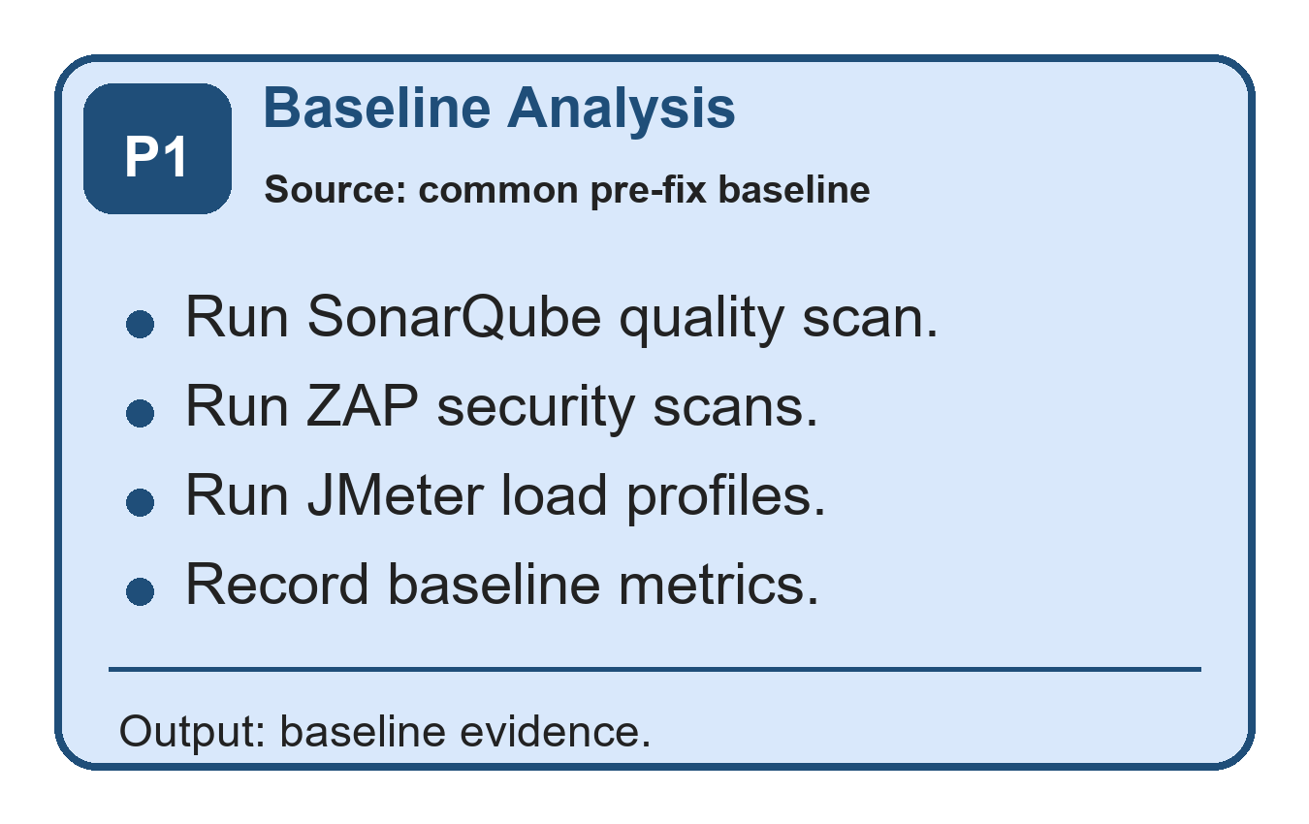
Figure 3.1. Phase 1 - Baseline analysis workflow.
Phase 1: Baseline Analysis
Initial security, performance, and code-quality testing is conducted on the financial accounting ASP.NET Core RESTful API. Its endpoints cover authentication, chart of accounts, journal entries, accounting periods, financial reports, and audit logs. SonarQube analyzes source-code quality, OWASP ZAP runs baseline and authenticated API security scans, and Apache JMeter runs load, soak, and spike profiles at 50, 100, and 500 concurrent users. Measurements from the common baseline branch provide the reference for evaluating subsequent changes.
The evaluation API uses a multi-tier architecture comprising API, BAL/Services, MODEL/Entities, and Tests. It has role-based access control for Admin, FinanceManager, User, and Auditor roles, JWT authentication, and comprehensive audit logging.
Workflow | Representative route | Example use
Accounts | GET /accounts | List the chart of accounts
Journal entries | POST /journal-entries | Create a balanced journal entry
Bulk journals | POST /journal-entries/bulk | Create a validated batch with finance-role authorization
Reports | GET /reports/trial-balance | Generate a trial-balance report
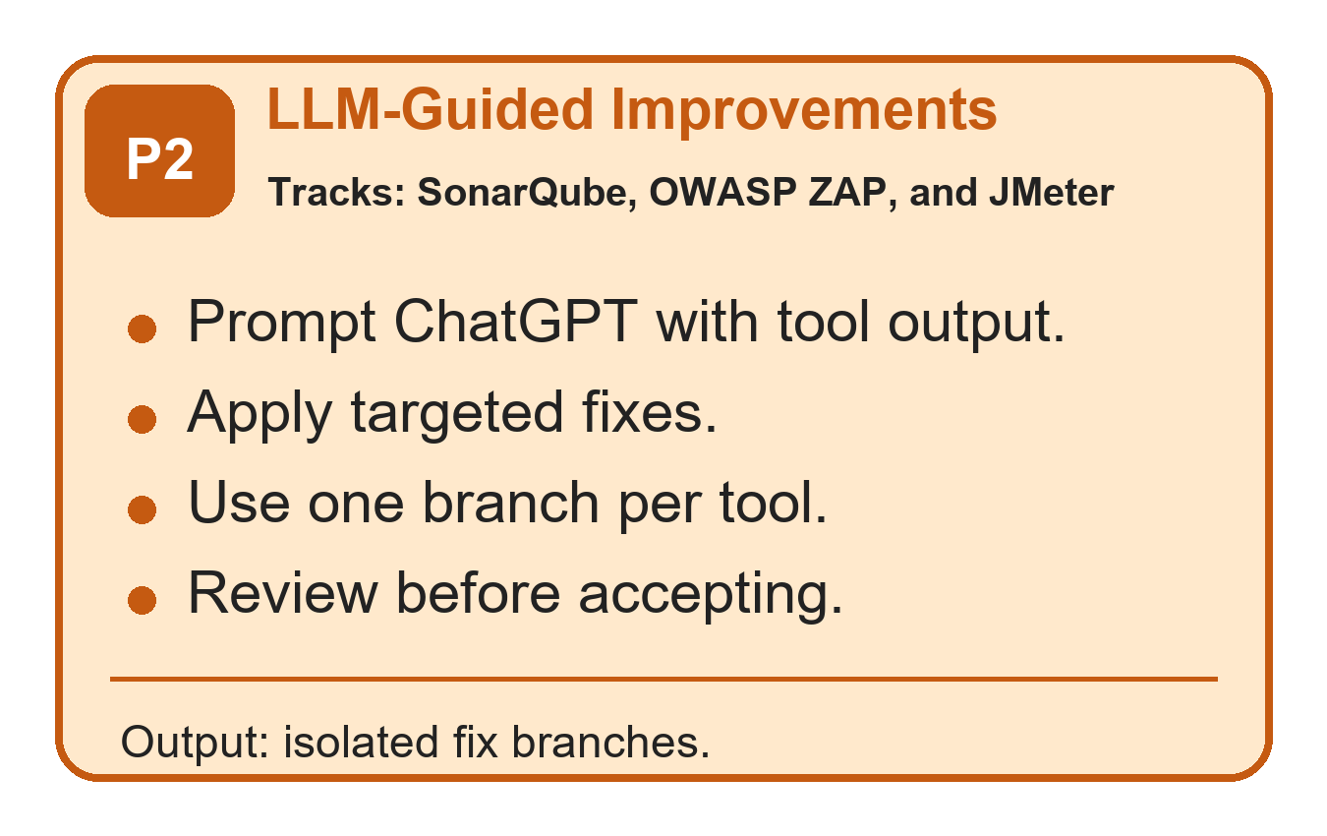
Figure 3.2. Phase 2 - LLM-guided improvements workflow.
Phase 2: ChatGPT-Generated Improvements
ChatGPT (Codex 5.4), accessed through OpenAI’s Codex coding environment, receives tool findings, relevant code snippets, and expected constraints before suggesting candidate fixes. Its guidance includes parameterized queries to prevent SQL injection, more efficient loops, and secure session management. A human reviewer applies each candidate on a dedicated branch, runs dotnet test, and measures it again with the same tool used at baseline. The recommendation is evaluated against its target metric and regression tests rather than accepted automatically.
For the security example, write endpoints such as POST /journal-entries and POST /journal-entries/bulk must prevent untrusted input from changing database-query behavior or bypassing authorization. The candidate guidance preserves Entity Framework parameterization, validates DTO input, rejects unauthorized roles, and protects write operations with JWT authentication and role policies.
Table 3.3. API endpoint coverage used for side-by-side security and performance evidence.
Category | Representative endpoints | Evidence source | Reviewer relevance
Authentication | /api/auth/register /api/auth/login  /api/auth/me | ZAP authenticated scan, API smoke coverage | Role-aware access and token-protected flows
Users | /api/users  /api/users/{id} /api/users/{id}/status | ZAP authenticated scan | Administrative user management
Accounts | /api/accounts /api/accounts/{id}  /api/accounts/{id}/ledger | JMeter core and complex profiles | Ledger browsing and account-level reporting
Journal entries | /api/journalentries /api/journalentries/{id} /api/journalentries/post | JMeter bulk and query profiles | High-volume transaction workflow
Periods | /api/periods, /api/periods/{periodId}/close | API smoke coverage | Accounting period setup and close controls
Reports | /api/reports/trial-balance /api/reports/profit-loss /api/reports/balance-sheet | JMeter complex, soak, and spike profiles | Performance-critical financial reporting
Audit logs | /api/auditlogs | ZAP authenticated scan and manual role checks | Traceability for sensitive accounting actions
For the performance example, slow p95 latency on GET /reports/trial-balance, GET /reports/profit-loss, GET /reports/balance-sheet, and GET /reports/account-ledger during soak and spike workloads motivates a caching proposal. The illustrative recommendation is to cache frequently requested report results in memory for ten minutes. Table 3.4 then records selected SonarQube code-quality remediation evidence.
Table 3.4. SonarQube code-quality remediation evidence by rule, file, and fix.
Rule or area | File | Before | After | Status
S107 | JournalEntriesController.cs | Controller action used eight query parameters. | Introduced JournalEntryQueryDto and passed one query model to the service. | Code smell removed
S2325 | ServiceManager.cs | Private helper did not access instance state. | Converted helper to static. | Code smell removed
S3267/S6602 | JournalEntryService.cs | Loops and LINQ operations were less maintainable. | Rewrote selected loops and lookup calls with clearer collection operations. | Code smell removed
S6966 | Program.cs | Application startup used blocking Run. | Changed startup to await app.RunAsync(). | Code smell removed
Fresh summary | C# project | 17 unique issues; 17 legacy Code Smells. | 0 issues; Quality Gate OK. | Closed
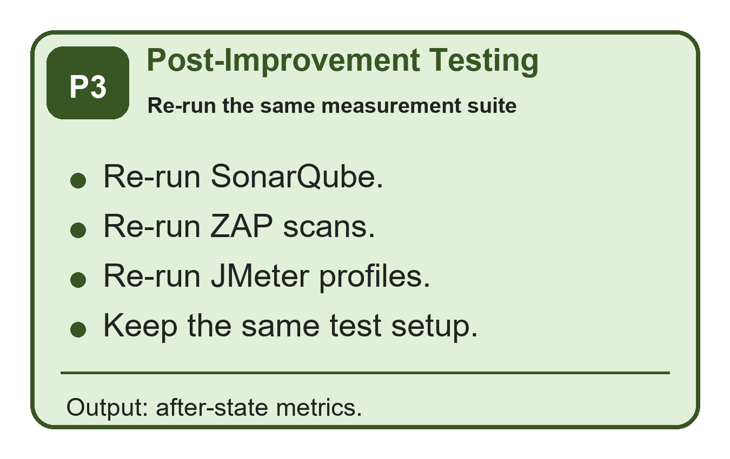
Figure 3.3. Phase 3 - Post-improvement testing workflow.
Phase 3: Post-Improvement Testing
After candidate changes are implemented on separate branches, the same tools and configurations are used for another round of testing. SonarQube rechecks code quality, OWASP ZAP repeats baseline and authenticated API scans across the endpoint groups on its remediation branch, and JMeter repeats the 50-, 100-, and 500-user load tests together with soak and spike profiles on its remediation branch. Security, performance, and code-quality measurements are then compared with the common baseline branch.
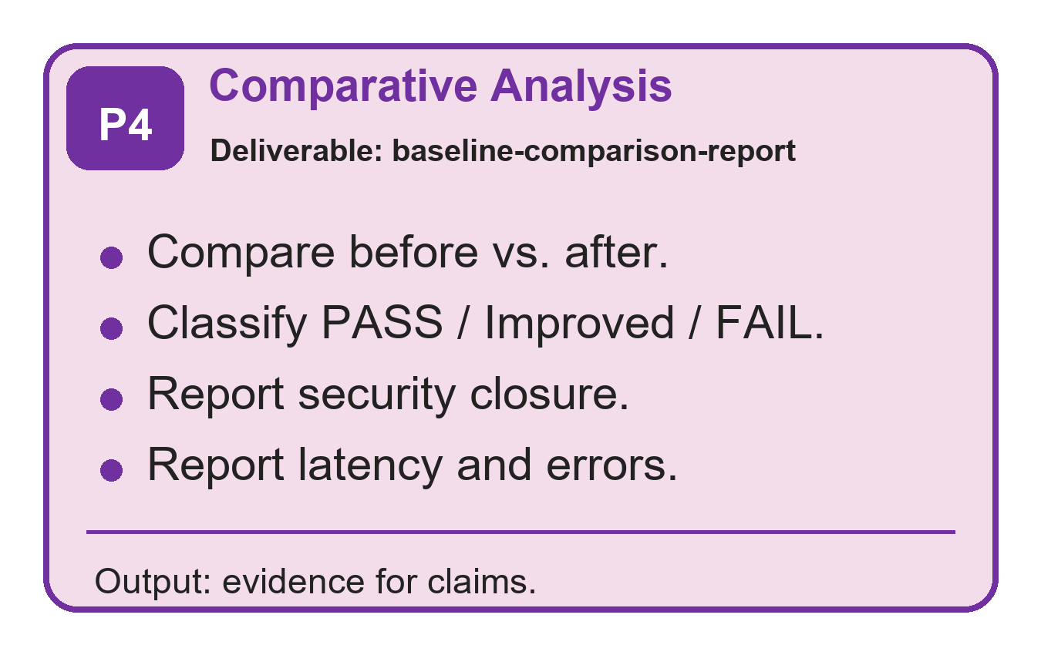
Figure 3.4. Phase 4 - Comparative analysis and reporting workflow.
Phase 4: Comparative Analysis and Reporting
Finally, results from the common baseline branch are compared with the SonarQube, OWASP ZAP, and JMeter remediation branches to judge the effect of each ChatGPT-guided change. The comparison considers security findings, performance metrics, and code-quality outcomes, including acceptance targets that were not met. Appendices A–N provide the environment, exact branch and commit provenance, curated source-code listings, reproduction automation, dashboards, result traceability, and limitations in this full report.
Table 3.5. OWASP ZAP before-and-after security evidence.
Scan | Severity | Before -> After | Vulnerability class | Fix applied
Passive baseline scan | Medium | 3 -> 0 | Security-header and browser-facing configuration alerts. | Header middleware and Swagger hardening cleared the raw Medium alerts.
Passive baseline scan | Low | 6 -> 0 | Missing hardening and isolation headers. | Added and consistently applied response-security headers.
Authenticated API scan | Medium | 1 -> 1 | HTTP Only Site (CWE-311) on the local HTTP test transport. | Disclosed as a residual environment observation; not reported as cleared.
Authenticated API scan | Low | 3 -> 0 | Authenticated endpoint hardening findings. | Same middleware path protects authenticated API responses.
Configured gate | Result | PASS_CONFIGURED_RULES -> PASS_CONFIGURED_RULES | Configured business-endpoint rule set. | Gate passed, but raw Medium transport observation remains visible.
Table 3.6. JMeter before-and-after performance profile comparison.
Profile | Metric | Baseline | After fixes | Change | Status
p50 | Total p95 response time | 33.00 ms | 199.90 ms | +505.8% | Regression
p100 | Total p95 response time | 255.90 ms | 1146.90 ms | +348.2% | FAIL
p500 | Total p95 response time | 106.00 ms | 1547.95 ms | +1360.3% | FAIL
soak | Total p95 response time | 443.95 ms | 171.00 ms | -61.5% | Improved
spike | Total p95 response time | 33401.75 ms | 4730.85 ms | -85.8% | Improved
Core gate | Threshold result | PASS | FAIL | p100 and p500 exceeded thresholds | NOT ACHIEVED
Table 3.7. Selected before-and-after code evidence linked to reviewer comments.
Example | Before branch | Before code | After branch | After code | Reason
SonarQube maintainability | common baseline branch | public async Task<IActionResult> GetPaged(DateTime? from, DateTime? to, string? status, int? accountId, string? search, int page = 1, int pageSize = 20, string? sort = "entryDate_desc") | SonarQube remediation branch | public async Task<IActionResult> GetPaged([FromQuery] JournalEntryQueryDto query) | Replaced eight query parameters with one DTO, directly addressing S107.
ZAP security headers | common baseline branch | app.UseSwagger(); app.UseSwaggerUI(); ... app.UseMiddleware<SecurityHeadersMiddleware>(); | OWASP ZAP remediation branch | app.UseMiddleware<SecurityHeadersMiddleware>(); ... if (enableSwaggerDocument) app.UseSwagger(); if (enableSwaggerUi) app.UseSwaggerUI(); | Ensures Swagger/OpenAPI responses receive the same hardening headers and separates the UI switch from the JSON document.
JMeter report performance | common baseline branch | await _context.Reports.AddAsync(report); await _context.SaveChangesAsync(); | JMeter remediation branch | await _auditLogService.WriteAsync(actorUserId, "GENERATE_REPORT", "Reports", $"{reportType}:{periodId}", ipAddress, new { reportType, periodId, items = items.Count }); | Removed report snapshot write amplification from read-heavy report generation.

3.1.2 Selected Source-Code Evidence
The following excerpts are real source-code evidence from the compared Git branches. They are intentionally selected examples rather than full-file listings, because the purpose is to show how the measured SonarQube, ZAP, and JMeter improvements map back to concrete code changes.
Source-code evidence A: SonarQube maintainability fix in API/Controllers/JournalEntriesController.cs.
Before: common baseline branch
[HttpGet]
public async Task<IActionResult> GetPaged(
[FromQuery] DateTime? from,
[FromQuery] DateTime? to,
[FromQuery] string? status,
[FromQuery] int? accountId,
[FromQuery] string? search,
[FromQuery] int page = 1,
[FromQuery] int pageSize = 20,
[FromQuery] string? sort = "entryDate_desc")
{
var result = await _journalEntryService.GetPagedAsync(from, to, status, accountId, search, page, pageSize, sort);
return Ok(result);
}

After: SonarQube remediation branch
[HttpGet]
public async Task<IActionResult> GetPaged([FromQuery] JournalEntryQueryDto query)
{
var result = await _journalEntryService.GetPagedAsync(query);
return Ok(result);
}

This excerpt addresses the SonarQube maintainability issue by replacing a long query-parameter list with a single JournalEntryQueryDto request model.
Source-code evidence B: OWASP ZAP security-header fix in API/Program.cs.
Before: common baseline branch
var enableSwagger = app.Environment.IsDevelopment() || appSettings.EnableSwaggerInProduction;
if (enableSwagger)
{
app.UseSwagger();
app.UseSwaggerUI();
}

app.UseMiddleware<CorrelationIdMiddleware>();
app.UseMiddleware<GlobalExceptionMiddleware>();
app.UseMiddleware<SecurityHeadersMiddleware>();

After: OWASP ZAP remediation branch
app.UseMiddleware<CorrelationIdMiddleware>();
app.UseMiddleware<GlobalExceptionMiddleware>();
app.UseMiddleware<SecurityHeadersMiddleware>();

var enableSwaggerDocument = app.Environment.IsDevelopment() || appSettings.EnableSwaggerInProduction;
var enableSwaggerUi = enableSwaggerDocument && appSettings.EnableSwaggerUi;
if (enableSwaggerDocument)
{
app.UseSwagger();
}

if (enableSwaggerUi)
{
app.UseSwaggerUI();
}

This excerpt shows that the security-header middleware was moved before Swagger/OpenAPI middleware, so diagnostic responses receive the same hardening headers as API responses.
Source-code evidence C: JMeter performance fix in BAL/Services/FinancialReportService.cs.

Before: common baseline branch
private async Task PersistReportAsync(
string reportType,
int periodId,
Guid actorUserId,
string? ipAddress,
List<ReportItemDto> items)
{
var report = new FinancialReport
{
ReportType = reportType,
PeriodId = periodId,
GeneratedByUserId = actorUserId,
GeneratedAt = DateTime.UtcNow
};

foreach (var item in items)
{
report.ReportItems.Add(new FinancialReportItem
{
AccountId = item.AccountId,
DebitTotal = decimal.Round(item.DebitTotal, 2),
CreditTotal = decimal.Round(item.CreditTotal, 2),
Balance = decimal.Round(item.Balance, 2)
});
}

await _context.Reports.AddAsync(report);
await _context.SaveChangesAsync();
}

After: JMeter remediation branch
public async Task<AccountLedgerPayload> GetAccountLedgerPayloadAsync(int accountId, int periodId, Guid actorUserId, string? ipAddress)
{
var period = await GetPeriodOrThrowAsync(periodId);
var account = await _context.ChartOfAccounts.AsNoTracking().FirstOrDefaultAsync(x => x.AccountId == accountId);

var payload = await _accountLedgerCache.GetOrCreatePayloadAsync(
accountId,
periodId,
account.AccountType,
period.StartDate,
period.EndDate,
() => BuildAccountLedgerPayloadAsync(accountId, period, account));

await PersistReportAsync("Ledger", periodId, actorUserId, ipAddress, new List<ReportItemDto> { ... });
return payload;
}

private async Task PersistReportAsync(string reportType, int periodId, Guid actorUserId, string? ipAddress, List<ReportItemDto> items)
{
await _auditLogService.WriteAsync(
actorUserId,
"GENERATE_REPORT",
"Reports",
$"{reportType}:{periodId}",
ipAddress,
new { reportType, periodId, items = items.Count });
}

This excerpt shows the core performance change: report generation no longer persists full report snapshots during read-heavy paths, and account-ledger output can be served from the new cache-backed payload path while preserving audit logging.

3.1.3 Prompt-Template Evidence and Reproducibility
The remediation prompts used the same three-part structure across SonarQube, OWASP ZAP, and JMeter findings. This makes the LLM interaction auditable: the tool report states the measurable problem, the code excerpt bounds the editable context, and the instruction constrains the model to a minimal patch that must be re-tested.
Table 3.8. Prompt-template traceability used in remediation runs.
Prompt component | Content used in this study | Purpose
Context | Native tool finding: SonarQube rule id, ZAP alert metadata, or JMeter endpoint latency profile. | Anchors the model to a measured defect or hotspot.
Code excerpt | Smallest affected controller, service, middleware, configuration, or test block. | Prevents broad rewrites and keeps the proposed patch reviewable.
Instruction | Propose a minimal patch that keeps existing tests green, avoids new dependencies unless justified, and states how to re-measure the result. | Turns the LLM output into an auditable repair proposal rather than an accepted change.

3.1.4 Human-Effort Traceability
The following table records how much human intervention was required before a candidate fix was accepted. The important point is that ChatGPT supplied advice, but the acceptance gate was the developer review plus the same measurement tool that produced the original findings.
Table 3.9. Human-effort traceability for accepted remediation fixes.
Fix class | Evidence branch | LLM rounds | Human intervention | Acceptance evidence
SonarQube controller DTO refactor | SonarQube remediation branch | 1 | Reviewed route compatibility and service-layer signature. | Fresh issues reduced from 17 to 0; Quality Gate remained OK.
Security headers and Swagger hardening | OWASP ZAP remediation branch | 1-2 | Moved middleware order, split Swagger document/UI switches, reviewed package upgrade. | Configured gate passed; raw API HTTP Only Site Medium remained.
ARM/camelCase analyzer cleanup | SonarQube remediation branch | 2-3 | Manually corrected provider-specific conventions after initial model output was insufficient. | Fresh remediation scan reported 0 issues.
Report-performance remediation | JMeter remediation branch | 1-2 | Reviewed cache/audit tradeoff and removed read-path report snapshot writes. | Fresh p100 and p500 p95 exceeded thresholds; core gate failed.
Stress-profile interpretation | JMeter remediation branch | Human review | Separated aggregate totals from endpoint-level and core-threshold behavior. | Soak and spike aggregate p95 improved, but this did not offset the failed core gate.

3.2 Dataset Description and Preparation
This study does not use production customer records or a public financial dataset. The data used in the tests is a repo-seeded financial accounting test dataset generated by scripts/phase4/seed-test-data.ps1 and loaded into the local SQL Server Financial database. This makes the dataset repeatable and auditable from the repository while avoiding confidentiality risk.
The seed configuration is deterministic in its parameters and naming patterns, including PeriodId 202601, 120 chart-of-account records, 30,000 journal entries, and at least 5,000 posted entries. Runtime-generated values such as GUID user IDs, password salts and hashes, timestamps, and identity values may differ between database runs, so the examples below show representative records based on the repo seed rules rather than private production rows.
Table 3.10. Repo-seeded test-data configuration.
Seed item | Repo-backed value | Purpose in the study
Script | scripts/phase4/seed-test-data.ps1 | Source of the repeatable test-data generation process
Database target | SQL Server database: Financial | Same local database target used for security and performance tests
Accounting period | PeriodId 202601; 2026-01-01 to 2026-12-31 | Period-sensitive report endpoints use this range
Accounts | AccountCount = 120 | Ensures all five account types are available for ledger and report paths
Journal entries | JournalEntryCount = 30,000 | Creates enough volume for load, soak, and spike tests
Posted entries | MinimumPostedEntries = 5,000 | Ensures report endpoints have posted transactions to aggregate
Admin credential | Local demo administrator credential (value omitted) | Used by JMeter and ZAP scripts for authenticated test setup

The dataset is used to test API behavior, not to make claims about real financial performance. Its purpose is to exercise authentication, authorization, accounting-period logic, balanced journal entries, financial-report aggregation, and audit logging under repeatable security and load-test conditions.
Table 3.11. Seeded entity coverage for the API behavior under test.
Entity | Repo-backed seeded or generated data | How it is produced | API behavior tested
Roles | Admin, User, Auditor, FinanceManager | Inserted if missing | RBAC and authenticated API scans
Users | Admin user plus probe users created by test scripts | Upserted or created with GUID UserId | Login, role-boundary, and audit-log tests
ChartOfAccounts | A/L/E/R/X account-code prefixes; Asset, Liability, Equity, Revenue, Expense | Generated until target account count is reached | Ledger and financial-report calculations
AccountingPeriods | PeriodId 202601 | Inserted or reset to open state | Trial balance, profit/loss, balance sheet, account ledger
JournalEntries | SEED-P and SEED-D reference numbers | Generated as posted and draft entries | Posting, bulk, report, and performance paths
JournalEntryLines | Balanced debit and credit lines | Generated for every seeded journal entry | Double-entry accounting validation
AuditLogs | LOGIN, CREATE_USER, CREATE_ACCOUNT, POST_ENTRY, GENERATE_REPORT, etc. | Written by application services during tests | Traceability and Auditor role checks

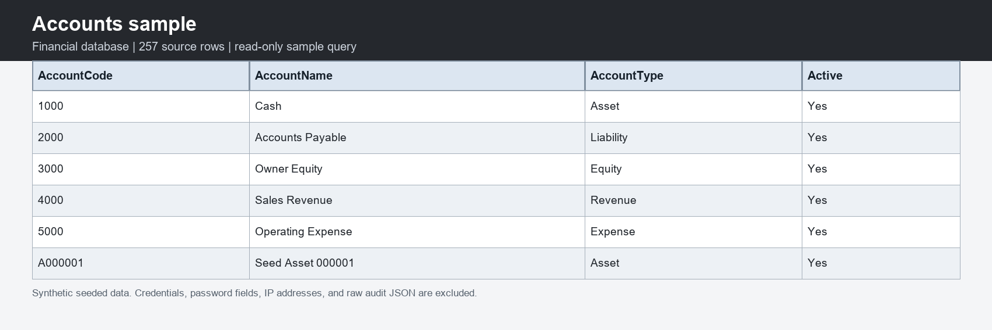
Figure 3.5. Representative chart-of-accounts rows from the live seeded database.
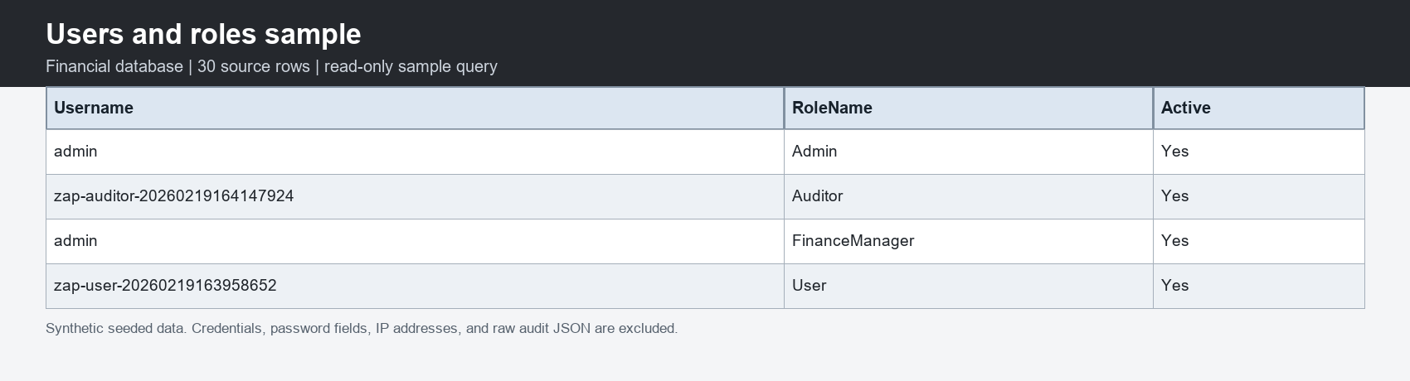
Figure 3.6. Representative users and role assignments from the live seeded database.
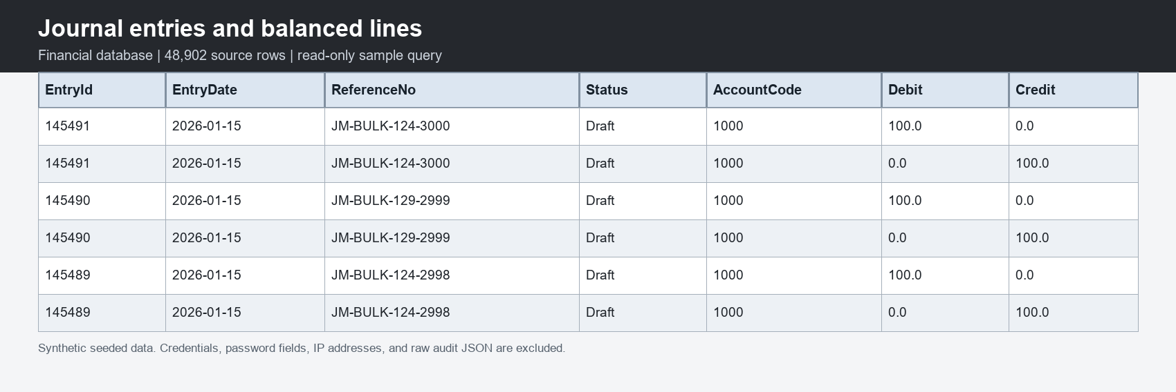
Figure 3.7. Representative journal entries and balanced debit-credit lines.
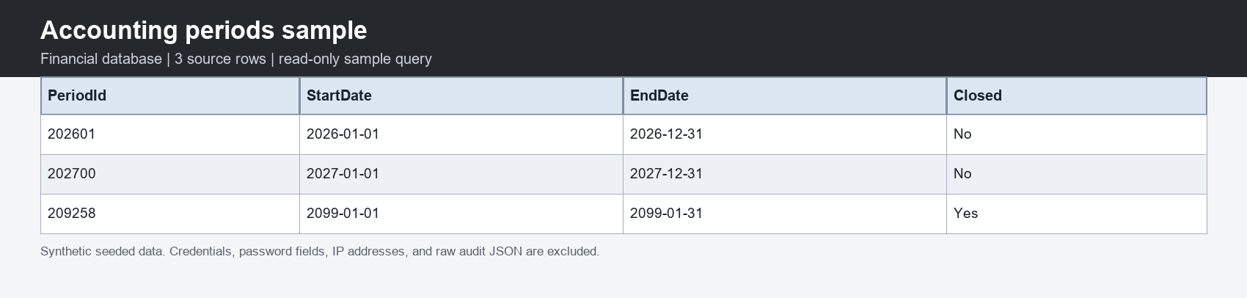
Figure 3.8. Representative accounting-period rows from the live seeded database.
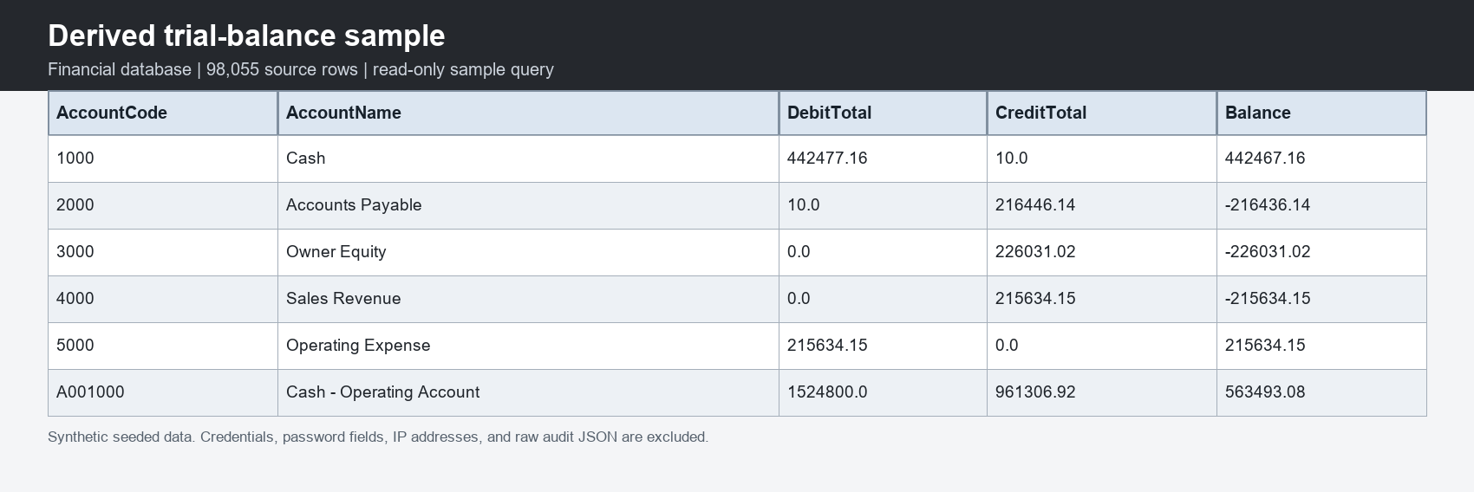
Figure 3.9. Trial-balance sample derived from posted journal-entry lines.
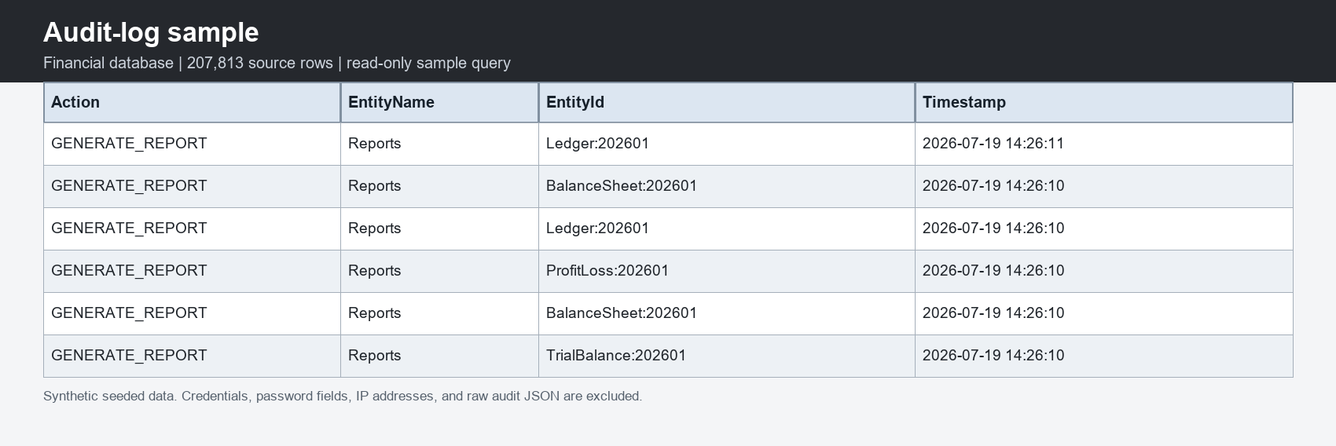
Figure 3.10. Representative audit-log rows from report-generation workflows.
Therefore, the study evaluates the financial accounting API and its code paths using repeatable repo-backed test data. The dataset is realistic enough to trigger the same endpoint behavior as financial records, but it is not real customer data and should not be interpreted as a production financial dataset. The database schema and deterministic seed implementation are reproduced in Appendix H.

3.3 Model and Tool Selection
This section explains the three evaluation tools in plain language because each tool answers a different question. SonarQube asks whether the source code contains maintainability, reliability, or security concerns; OWASP ZAP asks how the running API behaves when examined like an external security tester; and Apache JMeter asks whether the API continues responding acceptably when many requests arrive together. ChatGPT (Codex 5.4) is the improvement advisor, while the three independent tools provide the measurements used to accept or reject its recommendations.
SonarQube works like an automated code reviewer: it examines source code without requiring a committee member to read every file and reports possible bugs, security weaknesses, maintainability problems called code smells, duplicated code, and test coverage. A SonarQube issue is a warning that requires interpretation, not automatic proof that the application has failed. In this study, the .NET scanner examines the API, service, model, repository, and test projects, and the result is accepted only when the remediation branch reaches the defined Quality Gate without hiding changes in coverage or complexity. Because research has shown that static-analysis warnings do not always correspond to real defects (Lenarduzzi et al., 2020), the SonarQube result is interpreted together with ZAP and JMeter. The actual before-and-after implementation is reproduced in Appendix E, the dashboards are Figures L.1-L.4, and the result mapping is in Appendix M.
OWASP ZAP works like an automated security tester positioned outside the application. Its passive scan observes pages and responses for missing headers or unsafe configuration, while its authenticated API scan signs in and exercises endpoints described by the OpenAPI document. Alerts are labelled High, Medium, Low, or Informational so that serious findings can be separated from observations. In this study, the configured gate passed, but one raw Medium HTTP Only Site observation remained because the local test used HTTP rather than production TLS; therefore the report does not claim that every raw Medium alert disappeared. The hardening code is reproduced in Appendix F, the scan dashboards are Figures L.5-L.8, and the result mapping is in Appendix M.
Apache JMeter works like a controlled crowd of users sending requests to the API at the same time. It records response time, throughput, and errors for p50, p100, p500, soak, and spike profiles. The p95 value means that 95 out of every 100 measured requests completed at or below that time; a lower p95 is normally better. Soak testing checks sustained activity, while spike testing checks a sudden burst. The fresh remediation run improved the soak and spike aggregate p95 values but failed the core p100 and p500 thresholds, so the performance outcome is reported as Not Achieved for the core criterion. The performance implementation is reproduced in Appendix G, the dashboards are Figures L.9-L.18, and the result mapping is in Appendix M.
Branch roles in plain language. baseline-v0.1 is the frozen pre-remediation baseline: it represents the code before the evaluated ChatGPT-guided changes. The branches baseline-sonarqube-v1, baseline-zap-v1, and baseline-jmeter-v1 are the first improvement versions for static quality, security, and performance respectively; each contains only the changes relevant to its evaluation so that one type of fix cannot distort another tool's comparison. The codex/thesis-reproducibility-v1 branch contains evidence automation and report support, not an additional improvement result. The suffixes v0.1 and v1 therefore identify controlled versions, while the exact commit IDs in Appendix A identify the immutable source actually tested.

3.4 Implementation of ChatGPT-Guided Improvements
After baseline testing, ChatGPT (Codex 5.4) is used to generate improvement suggestions. Key areas of focus include:
- Security Enhancements
ChatGPT offers guidance on preventing SQL injection by implementing parameterized queries, managing session data securely, and sanitizing inputs. Example Adjustments: Integrating secure authentication protocols, using encryption for sensitive data, and adjusting HTTP headers to prevent common attacks like cross-site scripting (XSS).
- Performance Optimizations
ChatGPT suggestions for performance optimization may include improvements to data handling, optimizing API response time by limiting unnecessary queries, and using caching mechanisms for frequently accessed resources. Example Adjustments: Refining data-fetching algorithms, implementing pagination, and managing connection pooling.

3.5 Testing Phases
The same financial accounting API undergoes two testing phases: initial testing on common baseline branch and post-improvement testing on the relevant improvement branch. The study does not compare many unrelated APIs; instead, it evaluates seven endpoint groups inside one API so that the before-and-after results are attributable to controlled changes.
- Baseline Testing: The initial state of the financial accounting API is tested for security (ZAP baseline + API scan), performance (JMeter load/soak/spike), and code quality (SonarQube). Results are captured on the common baseline branch. The exact baseline ref and commit are recorded in Appendix A.
- Post-Improvement Testing: After implementing ChatGPT’s improvements on dedicated branches (SonarQube remediation branch, OWASP ZAP remediation branch, JMeter remediation branch), each branch is re-tested with the same tool and configuration to assess the efficacy of the changes. All issues and fixes are documented in per-tool fix tracking documents. The automated tests are reproduced in Appendix I, and the exact-ref verification workflow is reproduced in Appendix K.

3.6 How is it different from others research?
- Focus on ChatGPT: Unlike studies that compare multiple AI tools, this work focuses on ChatGPT (Codex 5.4) as an improvement advisor for one ASP.NET Core RESTful API. The depth comes from measuring one API across security, performance, and code quality rather than from comparing many models superficially.
- Combination of Security and Performance Testing: This study integrates both security (OWASP ZAP) and performance (Apache JMeter) testing in a single workflow, which is less commonly addressed together in similar research.
- Realistic API Test Data: The study uses seeded and generated financial accounting records to simulate realistic accounting operations without using live customer data. The evaluation target is the API behavior and codebase, not a public financial dataset.
- Production-Complexity API Surface: The report focuses on one API with multiple endpoint categories, role-based access control, bulk journal-entry operations, report generation, and audit logging. This provides enough complexity to test whether ChatGPT-guided changes hold across different API responsibilities.

3.7 Security Evaluation Plan
The security evaluation plan focuses on using OWASP ZAP for comprehensive testing.
- Vulnerability Scanning: OWASP ZAP performs both baseline (passive) and authenticated API (active) scans across all endpoints: /auth, /accounts, /journal-entries, /periods, /reports, and /audit-logs. Focus areas include injection flaws, broken authentication, missing security headers (CSP, X-Content-Type-Options, CORS), and vulnerable dependencies.
- Authentication and Authorization Testing: OWASP ZAP authenticated API scan is used to test role-based access control (Admin, FinanceManager, User, Auditor roles) and JWT authentication. Unauthorized access attempts against protected endpoints (e.g., POST /accounts, POST /periods/{id}/close, DELETE /journal-entries/{id}) verify the robustness of the API’s access control.
- Comparison of Pre- and Post-Improvement Results: Security test results from common baseline branch and OWASP ZAP remediation branches are compared, analyzing how ChatGPT (Codex 5.4)’s recommendations mitigated identified vulnerabilities. Alert counts are compared by severity level (High, Medium, Low, Informational).

3.8 Performance Evaluation Plan
Performance testing is conducted with Apache JMeter to simulate multiple concurrent users accessing the API.
- Response Time and Throughput: Apache JMeter measures response times (average, p95, p99) and throughput for each API endpoint under load profiles of 50, 100, and 500 concurrent users, plus soak (sustained load) and spike (burst) test profiles.
- Resource Utilization: CPU and memory usage are tracked during load tests. Error rates are monitored to identify endpoints that fail under stress.
- Comparison of Performance Metrics: Results from common baseline branch and JMeter remediation branches are compared to determine the impact of ChatGPT (Codex 5.4)’s suggestions on performance, focusing on improvements in response times, error rate reduction, throughput gains, and stability under sustained and spike load conditions.

3.9 Code Quality Evaluation Plan
Code quality is assessed using SonarQube, focusing on key metrics such as code smells, maintainability, and cyclomatic complexity.
- Baseline Analysis: The initial codebase on common baseline branch is scanned with SonarQube (via dotnet-sonarscanner) to identify code smells, potential bugs, security vulnerabilities, and security hotspots across all five modules (API, BAL, MODEL, REPOSITORY, Tests).
- Post-Improvement Analysis: After applying ChatGPT (Codex 5.4)’s recommendations on SonarQube remediation branch, SonarQube is run again with the same configuration to evaluate improvements. This second analysis identifies reductions in bugs, code smells, security vulnerabilities, and security hotspots. Quality gate status is compared.
- Clean Code Principles: Changes are analyzed based on adherence to clean code principles like simplicity, readability, and minimized dependencies. To mitigate the known limitation that not every SonarQube rule correlates with real defects (Lenarduzzi et al., 2020), quality-gate conclusions are cross-referenced with the ZAP and JMeter outcomes on their respective branches, so that a SonarQube improvement is only claimed when at least one other independent measurement is consistent with it.

Chapter 4: Results and Discussion

4.1 Evaluation Criteria and Decision Rules
Decision rule in plain language. Each improvement is judged against a rule chosen before interpreting the outcome. Achieved means the target was met without a material regression; Partially Achieved means some measurable benefit occurred but an important condition remained; and Not Achieved means the primary target failed. This prevents a visually positive dashboard or one improved number from being presented as success when another required measure became worse.
- Security Metrics: The security of the API is evaluated with OWASP ZAP baseline and authenticated API scans. The endpoint groups tested include /auth, /accounts, /journal-entries, /periods, /reports, and /audit-logs. Findings are compared before and after improvement by severity level (High, Medium, Low, Informational) and by vulnerability class, including missing security headers, vulnerable dependency exposure, authentication behavior, authorization behavior, SQL injection exposure, and sensitive-data-in-URL observations.
- Performance Metrics: Performance is evaluated with Apache JMeter against the same endpoint groups under p50, p100, p500, soak, and spike profiles. Metrics include average response time, p95 latency, p99 latency in milliseconds, throughput in transactions per second, error rate percentage, soak drift percentage, and spike recovery drift percentage.
- Code Quality Metrics: Code quality is evaluated with SonarQube across the API, BAL, MODEL, REPOSITORY, and Tests modules. Metrics include Bugs, Vulnerabilities, Code Smells, Security Hotspots, Quality Gate status, coverage percentage, duplicated-line density, cyclomatic complexity indicators, and specific issue/rule IDs before and after the ChatGPT-guided branch.
Table 4.1. Evaluation criteria used to judge full-report remediation success.
Evaluation area | Measure | Acceptance target | Result | Supporting evidence
Static analysis | SonarQube fresh issues and Quality Gate | No retained blocker/critical issues after fixes; preserve Quality Gate OK | 17 unique issues reduced to 0; Quality Gate OK; coverage 74.4% -> 74.3% | Appendix E; Figures L.1-L.4; Appendix M
Security | OWASP ZAP raw alerts and configured gate | Clear actionable configured-rule alerts and disclose residual observations | Configured gate passed; passive M3/L6 -> M0/L0; API M1/L3 -> M1/L0 | Appendix F; Figures L.5-L.8; Appendix M
Performance | JMeter p95, throughput, error rate, and gate | p50/p100/p500 pass with no material latency regression | Remediation core gate FAIL; p100 and p500 exceeded thresholds | Appendix G; Figures L.9-L.18; Appendices K and M
Maintainability | Representative before/after code evidence | Selected code smells resolved with traceable branch evidence | DTO, middleware-order, and report-persistence examples documented | Listings E.1-E.2; Appendices E-G

Supporting evidence is identified in the final column of Table 4.1. Appendix A records the exact branch and commit provenance, while Appendix N presents the cross-cutting limitations that apply to all four evaluation areas.
Explanation: Figure (4.1) summarizes the evaluation criteria and shows that each dimension is measured twice: once on common baseline branch and once on the matching post-improvement branch.

4.2 Code-Quality Outcome
How to read the code-quality evidence. SonarQube acts as an automated reviewer. Total issues count distinct warnings, while the newer Reliability, Security, and Maintainability impacts describe why an issue matters and may overlap. Coverage is the percentage of executable code exercised by tests, duplicated-line density indicates repeated code, and the Quality Gate is SonarQube's overall pass/fail decision. The report therefore considers both issue closure and changes in these control metrics rather than treating a lower issue count alone as proof of better software.
Observed fresh SonarQube result: 17 unique baseline issues decreased to 0. Under the legacy type metrics, Bugs stayed at 0, Vulnerabilities stayed at 0, Code Smells decreased from 17 to 0, and Security Hotspots stayed at 0. Under MQR impact classification, the baseline issues carried 2 Reliability, 1 Security, and 16 Maintainability impacts; these overlapping impact counts all fell to 0 after remediation. The Quality Gate remained OK, coverage changed from 74.4% to 74.3%, and duplicated-line density remained 0.0%.
Table 4.2. SonarQube before-and-after quality metrics.
Metric | Baseline | After fixes | Interpretation
Total unique issues | 17 | 0 | All fresh baseline issues closed
Code smells (legacy type) | 17 | 0 | Legacy issue-type count
Bugs (legacy type) | 0 | 0 | No legacy BUG-type issues
Vulnerabilities (legacy type) | 0 | 0 | No legacy VULNERABILITY-type issues
Reliability impacts (MQR)* | 2 | 0 | Overlapping software-quality impact
Security impacts (MQR)* | 1 | 0 | Overlapping software-quality impact
Maintainability impacts (MQR)* | 16 | 0 | Overlapping software-quality impact
Security hotspots | 0 | 0 | No hotspots reported
Coverage | 74.4% | 74.3% | Decreased by 0.1 percentage points
Duplicated lines | 0.0% | 0.0% | No change
Cyclomatic complexity | 886 | 889 | Increased by 3
Cognitive complexity | 165 | 165 | No change
Quality Gate | OK | OK | Remained OK
As shown in Table 4.2, all 17 unique fresh baseline issues were closed. Coverage decreased slightly by 0.1 percentage points and cyclomatic complexity increased by 3, so those controls are reported as small regressions rather than described as unchanged. The MQR Reliability, Security, and Maintainability impact counts overlap and therefore do not sum to the 17 unique issues.
Table 4.3. Maintainability-focused code-quality comparison.
Area | Before | After | Effect
Controller parameter complexity | Long JournalEntriesController action signature | JournalEntryQueryDto request model | Improves readability and future extension
Startup lifecycle | Blocking app.Run() | await app.RunAsync() | Matches asynchronous ASP.NET Core hosting pattern
Constants and repeated literals | Repeated journal-entry values in service logic | Named constants | Reduces magic strings and repeated values
Infrastructure templates | ARM expressions flagged by analyzer | Explicit template functions and safer defaults | Cleaner deployment artifacts
The comparison in Table 4.3 links representative maintainability problems to the implemented structural changes and their expected engineering effect.
The fresh SonarQube result remains the cleanest closure case because all 17 unique issues moved to 0 and the Quality Gate remained OK. However, the evidence does not support saying every control metric was unchanged: coverage moved from 74.4% to 74.3% and cyclomatic complexity moved from 886 to 889. The most important maintainability change remains the replacement of the long controller parameter list with a request DTO.
Outcome judgment: Achieved with minor control-metric regressions. The fresh scan reduced 17 unique issues and 17 legacy Code Smells to 0, while the Quality Gate remained OK and duplicated-line density remained 0.0%. Coverage decreased from 74.4% to 74.3%, and cyclomatic complexity increased from 886 to 889, so these controls are reported as small regressions rather than described as unchanged. The before-and-after code is shown in Listings E.1-E.2 of Appendix E, the supporting dashboards are Figures L.1-L.4, the claim-to-evidence mapping is in Appendix M, and the interpretation limits are in Appendix N.

4.3 Security Outcome
How to read the security evidence. ZAP examines the running API rather than only reading its source. High, Medium, and Low alerts indicate potential security risk, while Informational alerts describe observations that do not automatically fail the gate. The passive scan checks ordinary responses and browser-facing configuration; the authenticated API scan signs in and exercises protected endpoints. A remaining HTTP Only Site alert means the local reproduction used HTTP, not that a new application-code vulnerability was introduced.
Observed fresh authenticated API scan result: High alerts stayed at 0, Medium alerts stayed at 1, Low alerts decreased from 3 to 0, and Informational alerts stayed at 5. The remaining Medium alert is HTTP Only Site (CWE-311) on the local HTTP test transport. It is disclosed as a raw scanner observation and was not counted as cleared.
Observed fresh passive-scan result: High alerts stayed at 0, Medium alerts decreased from 3 to 0, Low alerts decreased from 6 to 0, and Informational alerts changed from 3 to 4. The configured-rule gate passed on both branches.
The fresh ZAP evidence shows effective header and configuration hardening, but it does not support a claim that every raw Medium alert was eliminated. The passive scan cleared all Medium and Low alerts, and the authenticated API scan cleared all Low alerts. One HTTP Only Site Medium observation remained because the local reproduction used HTTP rather than a production TLS endpoint.
Outcome judgment: Partially Achieved in raw-alert terms and Achieved for the configured gate. The passive scan improved from Medium 3 / Low 6 to Medium 0 / Low 0; the authenticated API scan improved from Medium 1 / Low 3 to Medium 1 / Low 0. Because one raw Medium HTTP Only Site observation remained, the report does not claim zero raw Medium alerts. The security-header and pipeline changes are shown in Listings F.1-F.2 of Appendix F, the supporting dashboards are Figures L.5-L.8, the claim-to-evidence mapping is in Appendix M, and the interpretation limits are in Appendix N.

4.4 Performance Outcome
How to read the performance evidence. JMeter sends controlled workloads to the API and measures latency, throughput, and errors. The p95 latency is the time below which 95% of measured requests completed, so lower is normally better. Throughput is the number of completed transactions per second, and error rate is the proportion of failed requests. The core p50, p100, and p500 profiles determine the primary gate; soak and spike profiles provide additional evidence about sustained and sudden load but cannot override a failed core gate.
Observed fresh stress-profile result: soak total p95 decreased from 443.95 ms to 171.0 ms and spike total p95 decreased from 33401.75 ms to 4730.85 ms. Spike error rate also decreased from 0.4688% to 0.00%. These aggregate improvements are reported separately from the failed core gate and do not override it.
Observed fresh JMeter core result: p50 total p95 increased from 33.0 ms to 199.9 ms, p100 increased from 255.9 ms to 1146.9 ms, and p500 increased from 106.0 ms to 1547.95 ms. Error rate remained 0.00% for the three core profiles, but the remediation gate failed because p100 exceeded 500 ms and p500 exceeded 1200 ms.
Table 4.4. Performance hotspot comparison for reviewer-visible report endpoints.
Endpoint | Profile metric | Baseline | After fixes | Fresh interpretation
GET /reports/account-ledger | Soak p95 | 741.95 ms | 3825.70 ms | Regression under the fresh sustained-load run
GET /reports/account-ledger | Spike p95 | 50288.30 ms | 12910.20 ms | Improved under spike, but remained the slowest report endpoint
GET /reports/trial-balance | Spike p95 | 31142.45 ms | 2797.70 ms | Large spike-profile improvement
GET /reports/profit-loss | Spike p95 | 31487.90 ms | 2342.75 ms | Large spike-profile improvement
GET /reports/balance-sheet | Spike p95 | 32732.65 ms | 2554.90 ms | Large spike-profile improvement
POST /journal-entries/bulk | Spike p95 | 12734.75 ms | 2544.10 ms | Large spike-profile improvement
The fresh endpoint evidence in Table 4.4 shows that spike-profile report endpoints improved substantially, but account-ledger soak p95 regressed. Endpoint improvements under one workload therefore cannot be generalized to the failed p100 and p500 core profiles.
The fresh JMeter results are mixed. Soak and spike aggregate p95 improved, and spike errors fell to 0%, but p50, p100, and p500 aggregate p95 all worsened. Because the pre-registered core gate failed, the report treats the current performance remediation as unsuccessful for the core criterion rather than carrying forward the earlier historical success claim.
Outcome judgment: Not Achieved for the core performance criterion and Partially Achieved for stress-profile behavior. The remediation core gate failed because p100 p95 was 1146.9 ms against a 500 ms threshold and p500 p95 was 1547.95 ms against a 1200 ms threshold. Soak total p95 improved from 443.95 ms to 171.0 ms, spike total p95 improved from 33401.75 ms to 4730.85 ms, and spike error rate fell from 0.4688% to 0.00%; these stress improvements do not compensate for the failed core gate. The implementation is shown in Listings G.1-G.3 of Appendix G, the execution controls are in Appendix K, the dashboards are Figures L.9-L.18, the traceability table is in Appendix M, and the limitations are in Appendix N.

4.5 Overall Assessment and Trade-offs
Table 4.5. Overall outcome and closure matrix.
Tool | Fresh baseline evidence | Fresh after-fix evidence | Closure status
SonarQube | 17 unique issues; coverage 74.4% | 0 issues; coverage 74.3%; gate OK | Achieved with minor metric regressions
ZAP passive scan | 3 Medium, 6 Low | 0 Medium, 0 Low | Achieved
ZAP authenticated API | 1 Medium, 3 Low | 1 Medium, 0 Low | Configured gate passed; raw Medium remains
JMeter core profiles | p95: 33 / 255.9 / 106 ms | p95: 199.9 / 1146.9 / 1547.95 ms | Not Achieved; remediation gate FAIL
JMeter stress profiles | Soak 443.95 ms; spike 33401.75 ms | Soak 171 ms; spike 4730.85 ms | Partially Achieved
The closure matrix in Table 4.5 applies the decision rules consistently across static analysis, security scanning, and performance testing.

Overall, the fresh evidence is mixed. The code-quality criterion was achieved with small coverage and complexity regressions. The ZAP configured gate was achieved, but one raw Medium HTTP-only transport observation remained. The JMeter core performance criterion was not achieved, although soak and spike aggregate behavior improved. The defensible conclusion is therefore that ChatGPT-guided remediation was effective for the measured static-analysis findings and selected security hardening, but performance benefits were not reproducible across the fresh core profiles. Appendix M summarizes the complete result chain, while Appendix N explains why these findings must not be generalized beyond this application and reproduction environment.

4.6 Web Application Evidence for Current APIs
A React and Vite web application was added as a live validation artifact for the current ASP.NET Core financial accounting APIs. The application runs at http://localhost:5173 and connects to the API at http://localhost:5296, matching the CORS origins already configured in the backend. It demonstrates JWT login, role-aware navigation, account balances, expandable journal-entry debit and credit lines, accounting periods, reports, audit logs, user administration, and a research-evidence dashboard.
The local seed process creates four demo accounts for reproducible role testing: admin, finance-manager, normal-user, and auditor-user, using local-only demo credentials whose values are omitted from this report. The screenshots below were captured after seeding the local SQL Server database and logging in through the web application, so they validate the user-visible path rather than only the API response layer. The supporting code is reproduced in Appendices B-D, I, and J: Appendices B-D contain the server-side authentication, accounting, and audit implementations; Appendix I contains the automated role tests; and Appendix J contains the React/API integration.
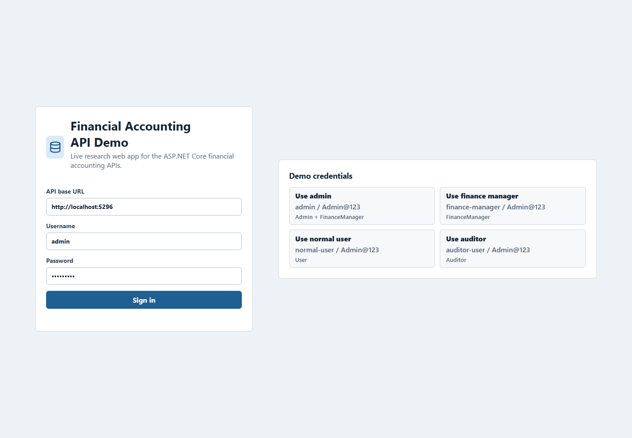
Figure 4.1. Web application login screen with demo role credentials.

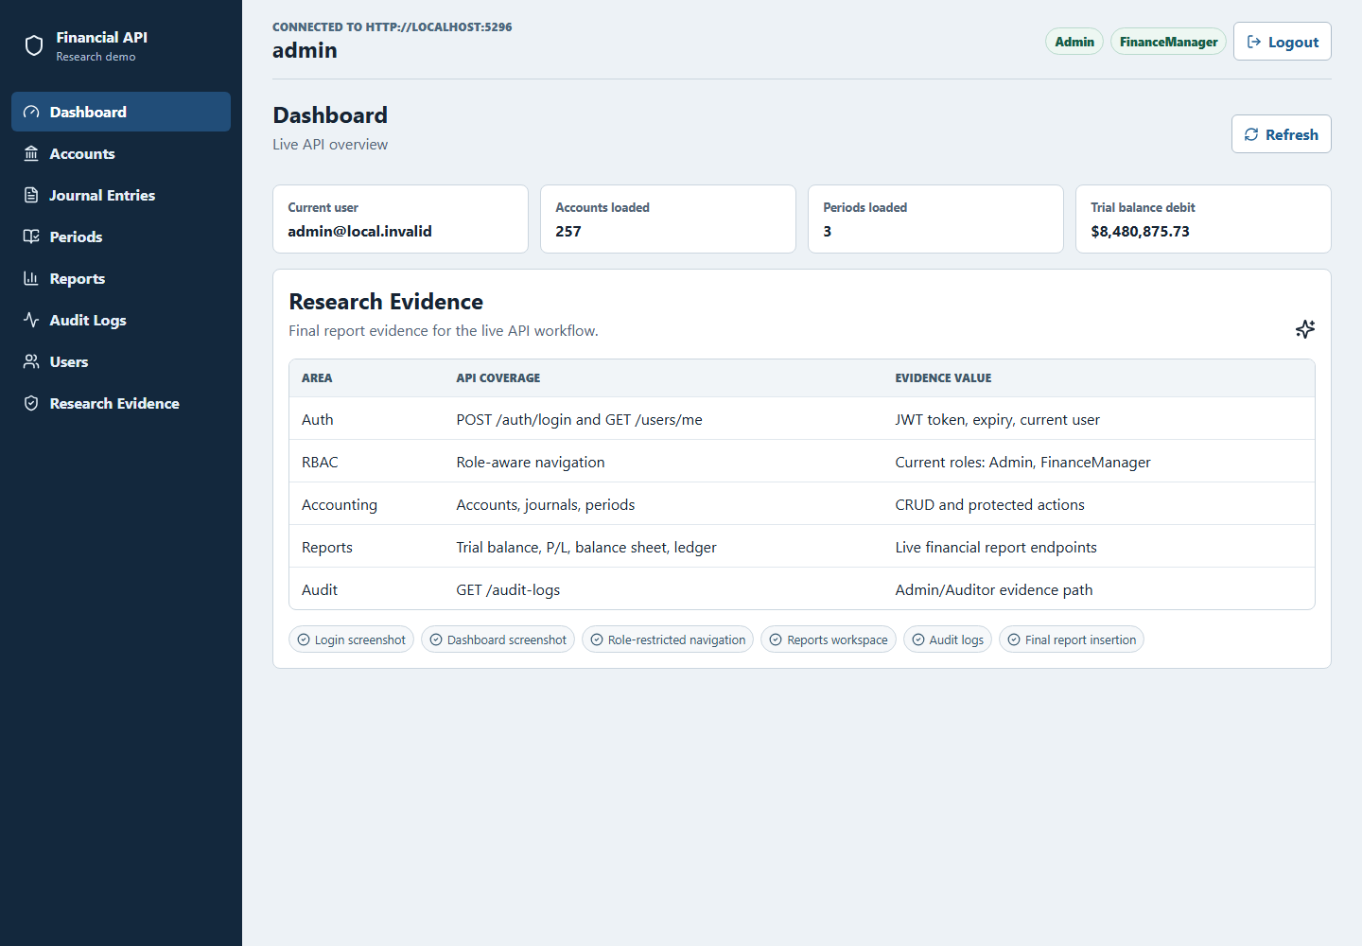
Figure 4.2. Admin dashboard showing live API counts and report summary.

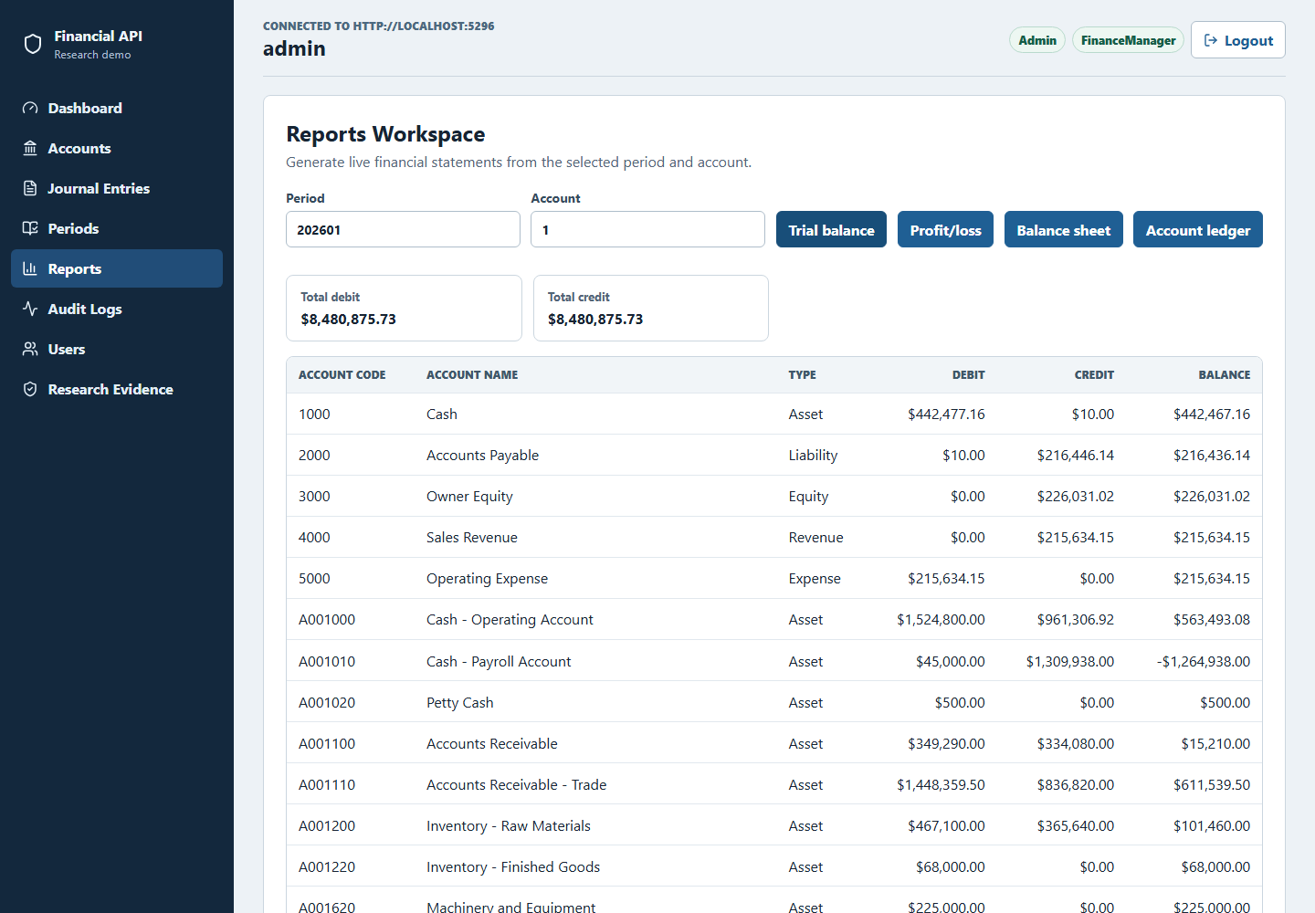
Figure 4.3. Trial balance report generated from the live reports API.

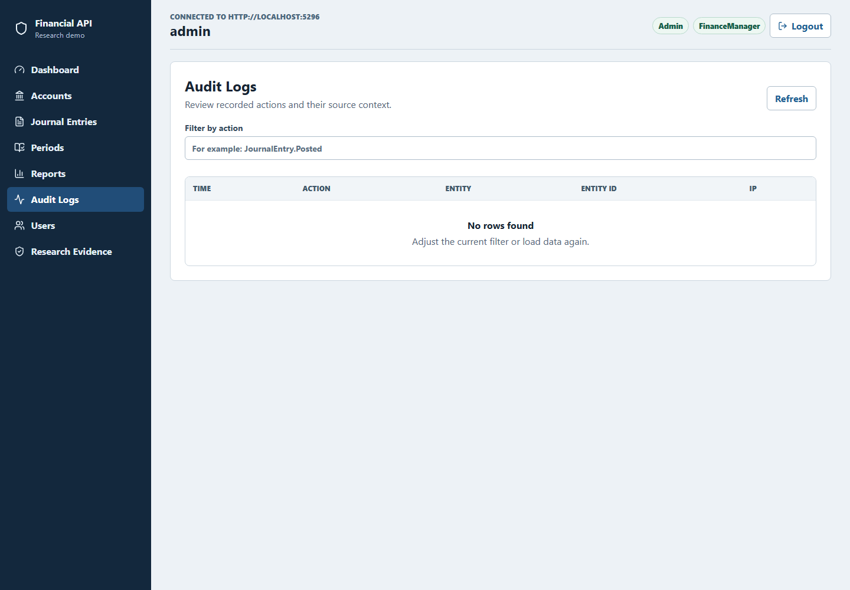
Figure 4.4. Audit-log screen available to Admin and Auditor roles.

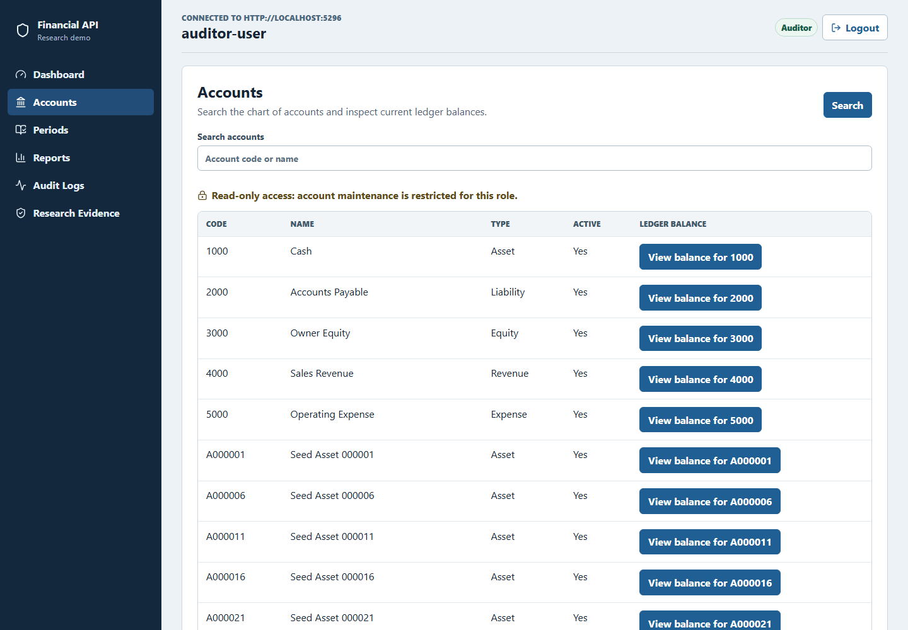
Figure 4.5. Auditor role view with restricted navigation.

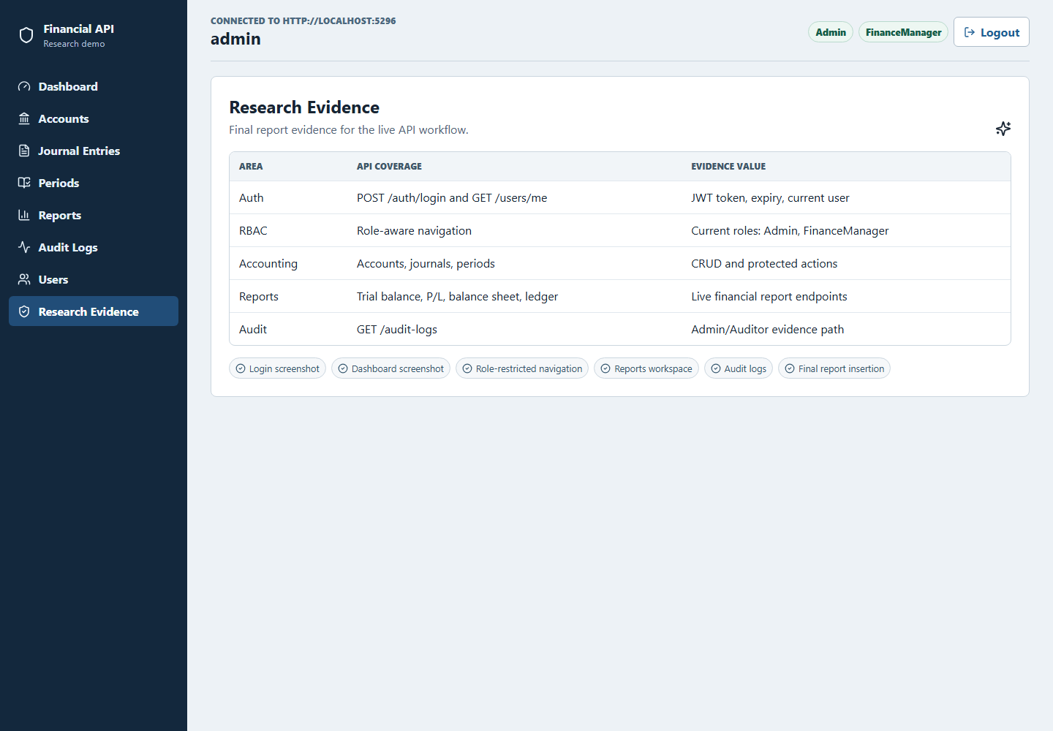
Figure 4.6. Research-evidence page mapping screens to API coverage.

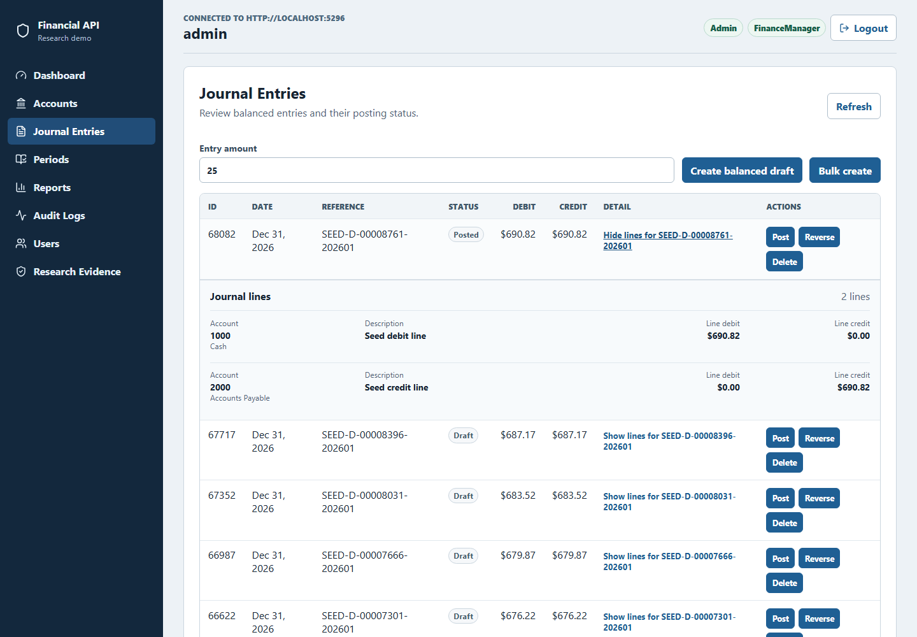
Figure 4.7. Expanded journal-entry lines showing account-level debit and credit evidence.

Chapter 5: Conclusion
This full report presented a systematic, branch-based evaluation of ChatGPT (Codex 5.4) as an improvement advisor for a financial accounting ASP.NET Core RESTful API. The work moved beyond the planning stage by executing the baseline measurement, applying selected ChatGPT-guided fixes on isolated branches, and comparing the measured outcomes across security, performance, and code quality.

5.1 Summary of the Completed Study
The study evaluated one production-complexity RESTful API with endpoint groups for authentication, users, accounts, journal entries, accounting periods, reports, and audit logs. Baseline results were captured on common baseline branch. Post-improvement results were captured on SonarQube remediation branch, OWASP ZAP remediation branch, and JMeter remediation branch. This branch structure made it possible to attribute each measured change to one improvement stream.

5.2 Main Findings
Fresh reproduction showed that the SonarQube branch reduced 17 unique issues to 0 while the Quality Gate remained OK; coverage changed from 74.4% to 74.3%. The OWASP ZAP configured gate passed: the passive scan cleared 3 Medium and 6 Low alerts, while the authenticated API scan retained one Medium HTTP Only Site observation and cleared all 3 Low alerts. The JMeter remediation branch did not reproduce the earlier core-profile improvements: p50 p95 increased from 33.0 ms to 199.9 ms, p100 from 255.9 ms to 1146.9 ms, and p500 from 106.0 ms to 1547.95 ms, causing the core gate to fail. Soak and spike aggregate p95 improved, but the performance conclusion remains Not Achieved for the core criterion.

5.3 Contributions
The report contributes empirical evidence that ChatGPT can be useful as an advisor when its suggestions are constrained by existing code, applied on isolated branches, and validated with repeatable tools. It also contributes a reusable evaluation framework combining SonarQube, OWASP ZAP, Apache JMeter, dotnet test, and branch-based before/after comparison for RESTful API improvement studies.

5.4 Limitations and Future Work
The findings are limited to one ASP.NET Core API, one language (C#), one database-backed financial accounting domain, one AI assistant configuration, and one fresh reproduction per evidence branch. Tool versions, host load, database state, and workload composition can materially change measured values. The fresh JMeter run demonstrates this limitation directly: stress aggregates improved while core p95 thresholds failed. Repeated runs with controlled host utilization and confidence intervals are required before claiming general performance improvement. Historical measurements remain in the appendices for provenance, but Chapters 4 and 5 use the September 22, 2026 fresh reproduction as the current result. Future work should compare multiple LLMs, repeat each measurement, and test production-like HTTPS deployment so the remaining ZAP HTTP Only Site observation can be evaluated under the intended transport.

REFERENCES
Chen, E., Huang, R., Chen, H.-S., Tseng, Y.-H., & Li, L.-Y. (2023). GPTutor: A ChatGPT-powered programming tool for code explanation [Preprint]. arXiv. https://doi.org/10.48550/arXiv.2305.01863
Fajkovic, E., & Rundberg, E. (2023). The impact of AI-generated code on web development: A comparative study of ChatGPT and GitHub Copilot [Bachelor's thesis, Blekinge Institute of Technology]. DiVA. https://www.diva-portal.org/smash/record.jsf?pid=diva2:1769082
Flores, C. P., Jr., & Monreal, R. N. (2024). Evaluation of common security vulnerabilities of state universities and colleges websites based on OWASP. Journal of Electrical Systems, 20(5s), 1396-1404. https://doi.org/10.52783/jes.2471
Hou, X., Zhao, Y., Liu, Y., Yang, Z., Wang, K., Li, L., Luo, X., Lo, D., Grundy, J., & Wang, H. (2024). Large language models for software engineering: A systematic literature review. ACM Transactions on Software Engineering and Methodology, 33(8), Article 220, 1-79. https://doi.org/10.1145/3695988
Khoury, R., Avila, A. R., Brunelle, J., & Camara, B. M. (2023). How secure is code generated by ChatGPT? In 2023 IEEE International Conference on Systems, Man, and Cybernetics (SMC) (pp. 2445-2451). IEEE. https://doi.org/10.1109/SMC53992.2023.10394237
Lenarduzzi, V., Lomio, F., Huttunen, H., & Taibi, D. (2020). Are SonarQube rules inducing bugs? In 2020 IEEE 27th International Conference on Software Analysis, Evolution and Reengineering (SANER) (pp. 501-511). IEEE. https://doi.org/10.1109/SANER48275.2020.9054821
Mousavi, Z., Islam, C., Moore, K., Abuadbba, A., & Babar, M. A. (2024). An investigation into misuse of Java security APIs by large language models. In Proceedings of the 19th ACM Asia Conference on Computer and Communications Security (pp. 1299-1315). ACM. https://doi.org/10.1145/3634737.3661134
Özpolat, Z., Yıldırım, Ö., & Karabatak, M. (2023). Artificial intelligence-based tools in software development processes: Application of ChatGPT. European Journal of Technic, 13(2). https://doi.org/10.36222/ejt.1330631
Pearce, H., Ahmad, B., Tan, B., Dolan-Gavitt, B., & Karri, R. (2022). Asleep at the keyboard? Assessing the security of GitHub Copilot's code contributions. In 2022 IEEE Symposium on Security and Privacy (SP) (pp. 754-768). IEEE. https://doi.org/10.1109/SP46214.2022.9833571
Peng, S., Kalliamvakou, E., Cihon, P., & Demirer, M. (2023). The impact of AI on developer productivity: Evidence from GitHub Copilot [Preprint]. arXiv. https://doi.org/10.48550/arXiv.2302.06590
Ságodi, Z., Siket, I., & Ferenc, R. (2024). Methodology for code synthesis evaluation of LLMs presented by a case study of ChatGPT and Copilot. IEEE Access, 12, 72303-72316. https://doi.org/10.1109/ACCESS.2024.3403858
Sandoval, G., Pearce, H., Nys, T., Karri, R., Garg, S., & Dolan-Gavitt, B. (2023). Lost at C: A user study on the security implications of large language model code assistants. In 32nd USENIX Security Symposium (USENIX Security 23) (pp. 2205-2222). USENIX Association. https://www.usenix.org/conference/usenixsecurity23/presentation/sandoval
Szabó, Z., & Bilicki, V. (2023). A new approach to web application security: Utilizing GPT language models for source code inspection. Future Internet, 15(10), Article 326. https://doi.org/10.3390/fi15100326
Yetiştiren, B., Özsoy, I., Ayerdem, M., & Tüzün, E. (2023). Evaluating the code quality of AI-assisted code generation tools: An empirical study on GitHub Copilot, Amazon CodeWhisperer, and ChatGPT [Preprint]. arXiv. https://doi.org/10.48550/arXiv.2304.10778
Zhang, N., Zou, Y., Xia, X., Huang, Q., Lo, D., & Li, S. (2023). Web APIs: Features, issues, and expectations - A large-scale empirical study of Web APIs from two publicly accessible registries using Stack Overflow and a user survey. IEEE Transactions on Software Engineering, 49(2), 498-528. https://doi.org/10.1109/TSE.2022.3154769

APPENDICES
These appendices are self-contained. They reproduce the essential implementation excerpts, explanations, commands, dashboards, and result provenance required to assess the study. The repository remains the authoritative complete source, but no external Markdown appendix is required to understand the evidence presented here.

Appendix A - Environment and Repository Provenance
The study evaluates ChatGPT (Codex 5.4) against one ASP.NET Core financial-accounting API using branch-isolated baseline and remediation evidence. Exact refs prevent later branch movement from changing the evaluated source.
Evidence role | Reference | Exact commit | Purpose
Baseline | origin/baseline-v0.1 | 7a0469d9401a3061941b44fcd46b3beca1c9c729 | Common pre-remediation source
SonarQube remediation | origin/baseline-sonarqube-v1 | a2279bcbdc20751529335cf72f8baac1bc6f994b | Static-analysis changes
ZAP remediation | origin/baseline-zap-v1 | 5f3bd3ccd9e0d460f52cac6a8a0d5fdceff1ce3d | Security-hardening changes
JMeter remediation | origin/baseline-jmeter-v1 | 78b08b62570dcf6fe436354e8e6b770ab2074445 | Performance changes
Reproducibility package | origin/codex/thesis-reproducibility-v1 | efa19cea58c7746f88d1efd83fa34719673d1881 | Evidence automation and dashboard capture

- Platform: Windows 11; PowerShell; .NET 8; Node.js/npm; local SQL Server; Docker for SonarQube, OWASP ZAP, and JMeter.
Dataset: 120 accounts; 30,000 journal entries; at least 5,000 posted entries; accounting period 202601.
Fresh reproduction date: September 22, 2026. Historical values are retained only for comparison and provenance.

Appendix B - Authentication, JWT, and RBAC Source Code

B.1 JWT Authentication Configuration
Purpose. Configures JWT bearer validation at the API boundary so issuer, audience, signing key, and token lifetime are checked by ASP.NET Core.
Source. Remediated authentication registration; file API/Program.cs; branch origin/baseline-sonarqube-v1; commit a2279bcb; lines 77-104.
77 .AddAuthentication(options =>
78 {
79 options.DefaultAuthenticateScheme = JwtBearerDefaults.AuthenticationScheme;
80 options.DefaultChallengeScheme = JwtBearerDefaults.AuthenticationScheme;
81 options.DefaultScheme = JwtBearerDefaults.AuthenticationScheme;
82 })
83 .AddJwtBearer(options =>
84 {
85 options.SaveToken = true;
86 options.RequireHttpsMetadata = !builder.Environment.IsDevelopment();
87 options.TokenValidationParameters = new TokenValidationParameters
88 {
89 ValidateIssuerSigningKey = true,
90 IssuerSigningKey = signingKey,
91 ValidateLifetime = true,
92 ValidateIssuer = true,
93 ValidateAudience = true,
94 ValidIssuer = appSettings.JwtIssuer,
95 ValidAudience = appSettings.JwtAudience,
96 ClockSkew = TimeSpan.FromMinutes(1)
97 };
98 });
99
100 builder.Services.AddAuthorization();
101
102 builder.Services.AddSwaggerGen(options =>
103 {
104 options.SwaggerDoc("v1", new OpenApiInfo { Title = "Financial Accounting API",
Version = "v1" });
Verification. Related evidence: authenticated API scans, role-aware browser demonstration, and token unit tests.

B.2 Controller-Level Role Enforcement
Purpose. Requires authentication for the journal-entry controller and narrows posting and reversal operations to Admin and FinanceManager roles.
Source. Controller and draft-creation authorization; file API/Controllers/JournalEntriesController.cs; branch origin/baseline-sonarqube-v1; commit a2279bcb; lines 9-32.
9 [ApiController]
10 [Route("journal-entries")]
11 [Authorize]
12 public class JournalEntriesController : ControllerBase
13 {
14 private readonly IJournalEntryService _journalEntryService;
15
16 public JournalEntriesController(IJournalEntryService journalEntryService)
17 {
18 _journalEntryService = journalEntryService;
19 }
20
21 [Authorize(Roles = "Admin,User,FinanceManager")]
22 [HttpPost]
23 public async Task<IActionResult> Create([FromBody]
CreateJournalEntryRequestDto request)
24 {
25 var actorId = UserClaimsHelper.GetUserId(User);
26 if (!actorId.HasValue)
27 {
28 return Unauthorized();
29 }
30
31 var result = await _journalEntryService.CreateDraftAsync(request,
actorId.Value, HttpContext.Connection.RemoteIpAddress?.ToString());
32 return CreatedAtAction(nameof(GetById), new { id = result.JournalEntryId
}, result);
Source. Posting authorization and actor propagation; file API/Controllers/JournalEntriesController.cs; branch origin/baseline-sonarqube-v1; commit a2279bcb; lines 68-87.
68 [Authorize(Roles = "Admin,FinanceManager")]
69 [HttpPost("{id:long}/post")]
70 public async Task<IActionResult> Post([FromRoute] long id)
71 {
72 var actorId = UserClaimsHelper.GetUserId(User);
73 if (!actorId.HasValue)
74 {
75 return Unauthorized();
76 }
77
78 var posted = await _journalEntryService.PostAsync(id, actorId.Value,
HttpContext.Connection.RemoteIpAddress?.ToString());
79 if (!posted)
80 {
81 return Problem(
82 statusCode: StatusCodes.Status404NotFound,
83 title: "Journal entry not found",
84 detail: "Draft journal entry was not found.");
85 }
86
87 return NoContent();
Verification. Related evidence: RBAC integration matrix and browser role-restriction workflow.

Appendix C - Journal-Entry Accounting Source Code

C.1 Balanced Journal-Entry Posting
Purpose. Prevents posting into a closed period, enforces debit-credit equality to two decimal places, persists the state transition, and records the actor and totals.
Source. Posting invariant and audit write; file BAL/Services/JournalEntryService.cs; branch origin/baseline-sonarqube-v1; commit a2279bcb; lines 198-240.
198 public async Task<bool> PostAsync(long journalEntryId, Guid actorUserId,
string? ipAddress)
199 {
200 var entry = await _context.JournalEntries
201 .Include(x => x.Lines)
202 .FirstOrDefaultAsync(x => x.JournalEntryId == journalEntryId);
203
204 if (entry == null || !string.Equals(entry.Status, DraftStatus,
StringComparison.OrdinalIgnoreCase))
205 {
206 return false;
207 }
208
209 var period = await GetPeriodForDateAsync(entry.EntryDate);
210 if (period != null && period.IsClosed)
211 {
212 throw new InvalidOperationException("Cannot post journal entry in a
closed accounting period.");
213 }
214
215 var debitTotal = entry.Lines.Sum(x => x.Debit);
216 var creditTotal = entry.Lines.Sum(x => x.Credit);
217 if (decimal.Round(debitTotal, 2) != decimal.Round(creditTotal, 2) ||
debitTotal <= 0m)
218 {
219 throw new InvalidOperationException("Journal entry must be balanced
before posting.");
220 }
221
222 entry.Status = PostedStatus;
223 entry.PostedAt = DateTime.UtcNow;
224
225 await _context.SaveChangesAsync();
226
227 if (period != null)
228 {
229 await RefreshLedgerBalancesForPeriodAsync(period.PeriodId);
230 }
231
232 await _auditLogService.WriteAsync(
233 actorUserId,
234 "POST_ENTRY",
235 JournalEntriesEntityName,
236 journalEntryId.ToString(),
237 ipAddress,
238 new { debitTotal, creditTotal });
239
240 return true;
Verification. Related evidence: posted-entry seed data, journal-line browser evidence, and audit-log output.

C.2 Journal-Entry Reversal
Purpose. Creates a reversing draft by swapping debit and credit values, prevents duplicate reversal, and writes the resulting relationship to the audit trail.
Source. Reversal workflow; file BAL/Services/JournalEntryService.cs; branch origin/baseline-sonarqube-v1; commit a2279bcb; lines 243-310.
243 public async Task<long> ReverseAsync(long journalEntryId, Guid actorUserId,
string? ipAddress)
244 {
245 var original = await _context.JournalEntries
246 .Include(x => x.Lines)
247 .FirstOrDefaultAsync(x => x.JournalEntryId == journalEntryId);
248
249 if (original == null)
250 {
251 throw new InvalidOperationException("Journal entry was not found.");
252 }
253
254 if (!string.Equals(original.Status, PostedStatus,
StringComparison.OrdinalIgnoreCase))
255 {
256 throw new InvalidOperationException("Only posted journal entries can
be reversed.");
257 }
258
259 if (original.ReversedAt.HasValue)
260 {
261 throw new InvalidOperationException("This journal entry has already
been reversed.");
262 }
263
264 var period = await GetPeriodForDateAsync(original.EntryDate);
265 if (period != null && period.IsClosed)
266 {
267 throw new InvalidOperationException("Cannot reverse entry in a
closed accounting period.");
268 }
269
270 var reversal = new JournalEntry
271 {
272 EntryDate = original.EntryDate,
273 Description = $"Reversal of #{original.JournalEntryId}:
{original.Description}",
274 ReferenceNo = string.IsNullOrWhiteSpace(original.ReferenceNo) ?
$"REV-{original.JournalEntryId}" :
$"REV-{original.ReferenceNo}",
275 Status = PostedStatus,
276 CreatedByUserId = actorUserId,
277 CreatedAt = DateTime.UtcNow,
278 PostedAt = DateTime.UtcNow
279 };
280
281 foreach (var line in original.Lines)
282 {
283 reversal.Lines.Add(new JournalEntryLine
284 {
285 AccountId = line.AccountId,
286 LineDescription = line.LineDescription,
287 Debit = line.Credit,
288 Credit = line.Debit
289 });
290 }
291
292 original.Status = ReversedStatus;
293 original.ReversedAt = DateTime.UtcNow;
294
295 await _context.JournalEntries.AddAsync(reversal);
296 await _context.SaveChangesAsync();
297
298 if (period != null)
299 {
300 await RefreshLedgerBalancesForPeriodAsync(period.PeriodId);
301 }
302
303 await _auditLogService.WriteAsync(
304 actorUserId,
305 "REVERSE_ENTRY",
306 JournalEntriesEntityName,
307 journalEntryId.ToString(),
308 ipAddress,
309 new { reversingEntryId = reversal.JournalEntryId });
310
Verification. Related evidence: journal-entry service behavior and double-entry database constraints.

Appendix D - Audit Logging and Traceability Source Code

D.1 Structured Audit-Log Writer
Purpose. Serializes structured details and records the user, action, entity, identifier, timestamp, and network address for sensitive operations.
Source. Audit service; file BAL/Services/AuditLogService.cs; branch origin/baseline-sonarqube-v1; commit a2279bcb; lines 10-45.
10 internal class AuditLogService : IAuditLogService
11 {
12 private readonly DataContext _context;
13
14 public AuditLogService(DataContext context)
15 {
16 _context = context;
17 }
18
19 public async Task WriteAsync(Guid? userId, string action, string?
entityName, string? entityId, string? ipAddress, object? details = null)
20 {
21 var model = new AuditLog
22 {
23 UserId = userId,
24 Action = action,
25 EntityName = entityName,
26 EntityId = entityId,
27 IpAddress = ipAddress,
28 DetailsJson = details == null ? null :
JsonSerializer.Serialize(details),
29 Timestamp = DateTime.UtcNow
30 };
31
32 await _context.AuditLogs.AddAsync(model);
33 await _context.SaveChangesAsync();
34 }
35
36 public async Task<PagedResultDto<AuditLogResponseDto>> GetPagedAsync(
37 DateTime? from,
38 DateTime? to,
39 Guid? userId,
40 string? action,
41 int page,
42 int pageSize)
43 {
44 page = page < 1 ? 1 : page;
45 pageSize = pageSize < 1 ? 50 : pageSize;
Verification. Related evidence: audit-log API/browser screenshots and GENERATE_REPORT/POST_ENTRY audit records.

D.2 Auditor-Role Read Boundary
Purpose. Restricts audit-log retrieval to Admin and Auditor roles while keeping filtering and paging in the service layer.
Source. Audit-log controller; file API/Controllers/AuditLogsController.cs; branch origin/baseline-sonarqube-v1; commit a2279bcb; lines 7-32.
7 [ApiController]
8 [Route("audit-logs")]
9 [Authorize(Roles = "Admin,Auditor")]
10 public class AuditLogsController : ControllerBase
11 {
12 private readonly IAuditLogService _auditLogService;
13
14 public AuditLogsController(IAuditLogService auditLogService)
15 {
16 _auditLogService = auditLogService;
17 }
18
19 [HttpGet]
20 public async Task<IActionResult> GetAuditLogs(
21 [FromQuery] DateTime? from,
22 [FromQuery] DateTime? to,
23 [FromQuery] Guid? userId,
24 [FromQuery] string? action,
25 [FromQuery] int page = 1,
26 [FromQuery] int pageSize = 50)
27 {
28 var result = await _auditLogService.GetPagedAsync(from, to, userId,
action, page, pageSize);
29 return Ok(result);
30 }
31 }
32 }
Verification. Related evidence: auditor navigation screenshot and RBAC matrix.

Appendix E - SonarQube Remediation Source Code

E.1 S107 Controller-Parameter Remediation
Purpose. Replaces eight query parameters with one request DTO, directly addressing the SonarQube S107 maintainability finding without changing the route.
Source. Before: long action signature; file API/Controllers/JournalEntriesController.cs; branch origin/baseline-v0.1; commit 7a0469d9; lines 61-74.
61 [HttpGet]
62 public async Task<IActionResult> GetPaged(
63 [FromQuery] DateTime? from,
64 [FromQuery] DateTime? to,
65 [FromQuery] string? status,
66 [FromQuery] int? accountId,
67 [FromQuery] string? search,
68 [FromQuery] int page = 1,
69 [FromQuery] int pageSize = 20,
70 [FromQuery] string? sort = "entryDate_desc")
71 {
72 var result = await _journalEntryService.GetPagedAsync(from, to, status,
accountId, search, page, pageSize, sort);
73 return Ok(result);
74 }
Source. After: DTO-bound action; file API/Controllers/JournalEntriesController.cs; branch origin/baseline-sonarqube-v1; commit a2279bcb; lines 61-67.
61 [HttpGet]
62 public async Task<IActionResult> GetPaged([FromQuery] JournalEntryQueryDto
query)
63 {
64 var result = await _journalEntryService.GetPagedAsync(query);
65 return Ok(result);
66 }
67
Source. Query DTO; file MODEL/DTOs/FinancialAccountingDTOs.cs; branch origin/baseline-sonarqube-v1; commit a2279bcb; lines 148-166.
148 public class JournalEntryQueryDto
149 {
150 public DateTime? From { get; set; }
151 public DateTime? To { get; set; }
152 public string? Status { get; set; }
153 public int? AccountId { get; set; }
154 public string? Search { get; set; }
155 public int Page { get; set; } = 1;
156 public int PageSize { get; set; } = 20;
157 public string? Sort { get; set; } = "entryDate_desc";
158 }
159
160 public class JournalEntryLineResponseDto
161 {
162 public long JournalEntryLineId { get; set; }
163 public int AccountId { get; set; }
164 public string AccountCode { get; set; } = string.Empty;
165 public string AccountName { get; set; } = string.Empty;
166 public string? LineDescription { get; set; }
Verification. Fresh SonarQube result: 17 unique issues reduced to 0; Quality Gate remained OK.

E.2 S6966 Asynchronous Host Shutdown
Purpose. Uses await app.RunAsync() instead of the blocking host call identified by the analyzer.
Source. Before: blocking host call; file API/Program.cs; branch origin/baseline-v0.1; commit 7a0469d9; lines 176-188.
176
177 if (enableSwagger)
178 {
179 app.MapGet("/", () => Results.Redirect("/swagger")).ExcludeFromDescription();
180 }
181 else
182 {
183 app.MapGet("/", () =>
Results.Redirect("/health/live")).ExcludeFromDescription();
184 }
185
186 app.MapFallback(() => Results.NotFound()).ExcludeFromDescription();
187 app.MapControllers();
188 app.Run();
Source. After: asynchronous host call; file API/Program.cs; branch origin/baseline-sonarqube-v1; commit a2279bcb; lines 180-190.
180 }
181 else
182 {
183 app.MapGet("/", () =>
Results.Redirect("/health/live")).ExcludeFromDescription();
184 }
185
186 app.MapFallback(() => Results.NotFound()).ExcludeFromDescription();
187 app.MapControllers();
188 await app.RunAsync();
189
190 public partial class Program
Verification. Fresh remediation scan reported zero remaining issues.

Appendix F - OWASP ZAP Security-Hardening Source Code

F.1 Response Security-Headers Middleware
Purpose. Applies CSP, framing, MIME-sniffing, permissions, and cross-origin policies immediately before each response is sent.
Source. Security-header middleware; file API/Middleware/SecurityHeadersMiddleware.cs; branch origin/baseline-zap-v1; commit 5f3bd3cc; lines 17-63.
17 public async Task InvokeAsync(HttpContext context)
18 {
19 if (_options.Enabled)
20 {
21 context.Response.OnStarting(() =>
22 {
23 SetHeaderIfMissing(context, "Content-Security-Policy",
GetContentSecurityPolicy(context.Request.Path));
24 SetHeaderIfMissing(context, "X-Frame-Options",
_options.XFrameOptions);
25 SetHeaderIfMissing(context, "X-Content-Type-Options",
_options.XContentTypeOptions);
26 SetHeaderIfMissing(context, "Permissions-Policy",
_options.PermissionsPolicy);
27 SetHeaderIfMissing(context, "Cross-Origin-Opener-Policy",
_options.CrossOriginOpenerPolicy);
28 SetHeaderIfMissing(context, "Cross-Origin-Embedder-Policy",
_options.CrossOriginEmbedderPolicy);
29 SetHeaderIfMissing(context, "Cross-Origin-Resource-Policy",
_options.CrossOriginResourcePolicy);
30 return Task.CompletedTask;
31 });
32 }
33
34 await _next(context);
35 }
36
37 private string GetContentSecurityPolicy(PathString requestPath)
38 {
39 return IsSwaggerUiRequest(requestPath)
40 ? _options.SwaggerContentSecurityPolicy
41 : _options.ContentSecurityPolicy;
42 }
43
44 private static bool IsSwaggerUiRequest(PathString requestPath)
45 {
46 if (!requestPath.StartsWithSegments("/swagger", out var remainingPath))
47 {
48 return false;
49 }
50
51 return remainingPath == PathString.Empty
52 || remainingPath == "/"
53 || remainingPath == "/index.html"
54 || remainingPath.Value?.EndsWith(".js",
StringComparison.OrdinalIgnoreCase) == true
55 || remainingPath.Value?.EndsWith(".css",
StringComparison.OrdinalIgnoreCase) == true
56 || remainingPath.Value?.EndsWith(".png",
StringComparison.OrdinalIgnoreCase) == true;
57 }
58
59 private static void SetHeaderIfMissing(HttpContext context, string
headerName, string headerValue)
60 {
61 if (!string.IsNullOrWhiteSpace(headerValue) &&
!context.Response.Headers.ContainsKey(headerName))
62 {
63 context.Response.Headers[headerName] = headerValue;
Verification. Fresh passive ZAP scan: Medium 3 to 0 and Low 6 to 0.

F.2 Middleware Ordering and Swagger Exposure
Purpose. Places response hardening before Swagger/OpenAPI and separates the Swagger document switch from the browser UI switch.
Source. Before: baseline pipeline; file API/Program.cs; branch origin/baseline-v0.1; commit 7a0469d9; lines 135-166.
135 });
136
137 var app = builder.Build();
138
139 using (var scope = app.Services.CreateScope())
140 {
141 var roleSeeder =
scope.ServiceProvider.GetRequiredService<FinancialRoleStartupSeeder>();
142 await roleSeeder.SeedAsync();
143 }
144
145 var enableSwagger = app.Environment.IsDevelopment() ||
appSettings.EnableSwaggerInProduction;
146 if (enableSwagger)
147 {
148 app.UseSwagger();
149 app.UseSwaggerUI();
150 }
151
152 app.UseMiddleware<CorrelationIdMiddleware>();
153 app.UseMiddleware<GlobalExceptionMiddleware>();
154 app.UseMiddleware<SecurityHeadersMiddleware>();
155
156 app.UseHttpsRedirection();
157 app.UseCors("AppCors");
158 app.UseCookiePolicy(new CookiePolicyOptions
159 {
160 HttpOnly = Microsoft.AspNetCore.CookiePolicy.HttpOnlyPolicy.Always,
161 Secure = CookieSecurePolicy.Always,
162 MinimumSameSitePolicy = Microsoft.AspNetCore.Http.SameSiteMode.Lax
163 });
164 app.UseAuthentication();
165 app.UseAuthorization();
166
Source. After: hardened pipeline; file API/Program.cs; branch origin/baseline-zap-v1; commit 5f3bd3cc; lines 135-166.
135 {
136 var roleSeeder =
scope.ServiceProvider.GetRequiredService<FinancialRoleStartupSeeder>();
137 await roleSeeder.SeedAsync();
138 }
139
140 app.UseMiddleware<CorrelationIdMiddleware>();
141 app.UseMiddleware<GlobalExceptionMiddleware>();
142 app.UseMiddleware<SecurityHeadersMiddleware>();
143
144 var enableSwaggerDocument = app.Environment.IsDevelopment() ||
appSettings.EnableSwaggerInProduction;
145 var enableSwaggerUi = enableSwaggerDocument && appSettings.EnableSwaggerUi;
146 if (enableSwaggerDocument)
147 {
148 app.UseSwagger();
149 }
150
151 if (enableSwaggerUi)
152 {
153 app.UseSwaggerUI();
154 }
155
156 app.UseHttpsRedirection();
157 app.UseCors("AppCors");
158 app.UseCookiePolicy(new CookiePolicyOptions
159 {
160 HttpOnly = Microsoft.AspNetCore.CookiePolicy.HttpOnlyPolicy.Always,
161 Secure = CookieSecurePolicy.Always,
162 MinimumSameSitePolicy = Microsoft.AspNetCore.Http.SameSiteMode.Lax
163 });
164 app.UseAuthentication();
165 app.UseAuthorization();
166
Verification. Configured ZAP rules passed; one raw HTTP Only Site Medium observation remains disclosed for local HTTP transport.

Appendix G - JMeter Performance and Query-Optimization Source Code

G.1 Concurrency-Safe Account-Ledger Cache
Purpose. Uses a concurrent dictionary and Lazy<Task<T>> so simultaneous requests share one in-flight calculation and failed entries can be retried.
Source. Cache implementation; file BAL/Shared/AccountLedgerCache.cs; branch origin/baseline-jmeter-v1; commit 78b08b62; lines 8-37.
8 public sealed class AccountLedgerCache : IAccountLedgerCache
9 {
10 private readonly ConcurrentDictionary<string,
Lazy<Task<AccountLedgerSnapshot>>> _entries = new();
11 private readonly ConcurrentDictionary<string,
Lazy<Task<AccountLedgerPayload>>> _payloads = new();
12
13 public async Task<AccountLedgerSnapshot> GetOrCreateAsync(
14 int accountId,
15 int periodId,
16 string accountType,
17 DateTime startDate,
18 DateTime endDate,
19 Func<Task<AccountLedgerSnapshot>> factory)
20 {
21 var key = BuildKey(accountId, periodId, accountType, startDate,
endDate);
22 var lazy = _entries.GetOrAdd(
23 key,
24 _ => new Lazy<Task<AccountLedgerSnapshot>>(factory,
LazyThreadSafetyMode.ExecutionAndPublication));
25
26 try
27 {
28 return await lazy.Value;
29 }
30 catch
31 {
32 _entries.TryRemove(new KeyValuePair<string,
Lazy<Task<AccountLedgerSnapshot>>>(key, lazy));
33 throw;
34 }
35 }
36
37 public void Invalidate(int accountId, int periodId)
Verification. Fresh performance evidence is mixed: spike improved, account-ledger soak regressed, and the core gate failed.

G.2 Read-Only Ledger Query and Running Balance
Purpose. Aggregates the opening balance in SQL, retrieves the period lines without tracking, and computes a deterministic running balance.
Source. Ledger payload query; file BAL/Services/FinancialReportService.cs; branch origin/baseline-jmeter-v1; commit 78b08b62; lines 154-215.
154 private async Task<AccountLedgerPayload> BuildAccountLedgerPayloadAsync(int
accountId, AccountingPeriod period, ChartOfAccount account)
155 {
156 var openingSums = await (
157 from entry in _context.JournalEntries
158 join line in _context.JournalEntryLines on entry.JournalEntryId
equals line.JournalEntryId
159 where entry.Status == "Posted" &&
160 line.AccountId == accountId &&
161 entry.EntryDate < period.StartDate
162 group line by 1
163 into grouped
164 select new
165 {
166 DebitTotal = grouped.Sum(x => (double)x.Debit),
167 CreditTotal = grouped.Sum(x => (double)x.Credit)
168 })
169 .FirstOrDefaultAsync();
170
171 var openingBalance = NormalizeBalance(
172 account.AccountType,
173 decimal.Round(Convert.ToDecimal(openingSums?.DebitTotal ?? 0d), 2),
174 decimal.Round(Convert.ToDecimal(openingSums?.CreditTotal ?? 0d),
2));
175
176 var lines = await (
177 from entry in _context.JournalEntries.AsNoTracking()
178 join line in _context.JournalEntryLines.AsNoTracking() on
entry.JournalEntryId equals line.JournalEntryId
179 where entry.Status == "Posted" &&
180 line.AccountId == accountId &&
181 entry.EntryDate >= period.StartDate &&
182 entry.EntryDate <= period.EndDate
183 orderby entry.EntryDate, entry.JournalEntryId,
line.JournalEntryLineId
184 select new
185 {
186 entry.EntryDate,
187 entry.JournalEntryId,
188 entry.ReferenceNo,
189 EntryDescription = entry.Description,
190 line.LineDescription,
191 line.Debit,
192 line.Credit
193 })
194 .ToListAsync();
195
196 var runningBalance = openingBalance;
197 var ledgerLines = new List<AccountLedgerLineDto>(lines.Count);
198 foreach (var line in lines)
199 {
200 runningBalance += NormalizeBalance(account.AccountType, line.Debit,
line.Credit);
201 ledgerLines.Add(new AccountLedgerLineDto
202 {
203 EntryDate = line.EntryDate,
204 JournalEntryId = line.JournalEntryId,
205 ReferenceNo = line.ReferenceNo,
206 EntryDescription = line.EntryDescription,
207 LineDescription = line.LineDescription,
208 Debit = line.Debit,
209 Credit = line.Credit,
210 RunningBalance = runningBalance
211 });
212 }
213
214 var debitTotal = ledgerLines.Sum(x => x.Debit);
215 var creditTotal = ledgerLines.Sum(x => x.Credit);
Verification. Table 4.4 reports the fresh endpoint-level soak and spike behavior rather than assuming universal improvement.

G.3 Idempotent SQL Server Performance Indexes
Purpose. Creates the composite indexes required by report and journal-entry access paths only when SQL Server is the active provider.
Source. Index startup component; file BAL/Shared/SqlServerPerformanceIndexStartup.cs; branch origin/baseline-jmeter-v1; commit 78b08b62; lines 1-53.
1 using Microsoft.EntityFrameworkCore;
2 using MODEL;
3
4 namespace BAL.Shared
5 {
6 public sealed class SqlServerPerformanceIndexStartup
7 {
8 private readonly DataContext _context;
9
10 public SqlServerPerformanceIndexStartup(DataContext context)
11 {
12 _context = context;
13 }
14
15 public async Task EnsureAsync(CancellationToken cancellationToken = default)
16 {
17 if (!_context.Database.IsSqlServer())
18 {
19 return;
20 }
21
22 const string sql = """
23 IF OBJECT_ID(N'[dbo].[JournalEntries]', N'U') IS NOT NULL
24 AND NOT EXISTS (
25 SELECT 1
26 FROM sys.indexes
27 WHERE name =
N'IX_JournalEntries_Status_EntryDate_JournalEntryId'
28 AND object_id = OBJECT_ID(N'[dbo].[JournalEntries]')
29 )
30 BEGIN
31 CREATE NONCLUSTERED INDEX
[IX_JournalEntries_Status_EntryDate_JournalEntryId]
32 ON [dbo].[JournalEntries] ([Status], [EntryDate],
[JournalEntryId])
33 INCLUDE ([ReferenceNo], [Description]);
34 END;
35
36 IF OBJECT_ID(N'[dbo].[JournalEntryLines]', N'U') IS NOT NULL
37 AND NOT EXISTS (
38 SELECT 1
39 FROM sys.indexes
40 WHERE name =
N'IX_JournalEntryLines_AccountId_JournalEntryId_JournalEntryLineId'
41 AND object_id = OBJECT_ID(N'[dbo].[JournalEntryLines]')
42 )
43 BEGIN
44 CREATE NONCLUSTERED INDEX
[IX_JournalEntryLines_AccountId_JournalEntryId_JournalEntryLineId]
45 ON [dbo].[JournalEntryLines] ([AccountId], [JournalEntryId],
[JournalEntryLineId])
46 INCLUDE ([Debit], [Credit], [LineDescription]);
47 END;
48 """;
49
50 await _context.Database.ExecuteSqlRawAsync(sql, cancellationToken);
51 }
52 }
53 }
Verification. Related evidence: deterministic database initialization and JMeter branch provenance.

Appendix H - Database Schema and Deterministic Seed Source Code

H.1 Deterministic Dataset Parameters
Purpose. Pins the accounting period and dataset sizes while intentionally omitting credential values from the thesis listing.
Source. Seed profile without credential parameters; file scripts/phase4/seed-test-data.ps1; branch origin/baseline-v0.1; commit 7a0469d9; lines 1-2, 5-10, 13-27.
1 param(
2 [string]$ConnectionString,
// ... unrelated lines omitted ...
5 [int]$PeriodId = 202601,
6 [string]$PeriodStart = "2026-01-01",
7 [string]$PeriodEnd = "2026-12-31",
8 [int]$AccountCount = 120,
9 [int]$JournalEntryCount = 30000,
10 [int]$MinimumPostedEntries = 5000
// ... unrelated lines omitted ...
13 $ErrorActionPreference = "Stop"
14
15 if ([string]::IsNullOrWhiteSpace($ConnectionString)) {
16 $appSettingsPath = Join-Path $PSScriptRoot "..\..\API\appsettings.json"
17 $fullAppSettingsPath = [System.IO.Path]::GetFullPath($appSettingsPath)
18 if (-not (Test-Path $fullAppSettingsPath)) {
19 throw "ConnectionString was not provided and appsettings was not found:
$fullAppSettingsPath"
20 }
21
22 $json = Get-Content -Path $fullAppSettingsPath -Raw | ConvertFrom-Json
23 $ConnectionString = $json.AppSettings.ConnectionStrings
24 if ([string]::IsNullOrWhiteSpace($ConnectionString)) {
25 throw "ConnectionString was not provided and AppSettings.ConnectionStrings
is empty."
26 }
27 }
Verification. Fresh runs used 120 accounts, 30,000 journal entries, and at least 5,000 posted entries.

H.2 Double-Entry Schema Constraints and Indexes
Purpose. Defines journal headers and lines, enforces one-sided debit/credit values, and indexes the transaction access paths.
Source. Journal schema; file Document/sql/financial_accounting_schema.sql; branch origin/baseline-v0.1; commit 7a0469d9; lines 363-424.
363 IF OBJECT_ID(N'dbo.JournalEntries', N'U') IS NULL
364 BEGIN
365 CREATE TABLE dbo.JournalEntries
366 (
367 JournalEntryId bigint IDENTITY(1,1) NOT NULL CONSTRAINT PK_JournalEntries
PRIMARY KEY,
368 EntryDate date NOT NULL,
369 Description nvarchar(500) NULL,
370 ReferenceNo nvarchar(100) NULL,
371 Status nvarchar(20) NOT NULL CONSTRAINT DF_JournalEntries_Status DEFAULT
(N'Draft'),
372 CreatedByUserId uniqueidentifier NOT NULL,
373 CreatedAt datetime2 NOT NULL CONSTRAINT DF_JournalEntries_CreatedAt DEFAULT
SYSUTCDATETIME(),
374 PostedAt datetime2 NULL,
375 ReversedAt datetime2 NULL,
376 CONSTRAINT FK_JournalEntries_Users FOREIGN KEY (CreatedByUserId) REFERENCES
dbo.Users(UserId)
377 );
378 END;
379 GO
380
381 IF NOT EXISTS (SELECT 1 FROM sys.indexes WHERE object_id =
OBJECT_ID(N'dbo.JournalEntries') AND name = N'IX_JournalEntries_EntryDate')
382 BEGIN
383 CREATE INDEX IX_JournalEntries_EntryDate ON dbo.JournalEntries(EntryDate);
384 END;
385 GO
386
387 IF NOT EXISTS (SELECT 1 FROM sys.indexes WHERE object_id =
OBJECT_ID(N'dbo.JournalEntries') AND name = N'IX_JournalEntries_ReferenceNo')
388 BEGIN
389 CREATE INDEX IX_JournalEntries_ReferenceNo ON dbo.JournalEntries(ReferenceNo);
390 END;
391 GO
392
393 IF NOT EXISTS (SELECT 1 FROM sys.indexes WHERE object_id =
OBJECT_ID(N'dbo.JournalEntries') AND name = N'IX_JournalEntries_Status')
394 BEGIN
395 CREATE INDEX IX_JournalEntries_Status ON dbo.JournalEntries(Status);
396 END;
397 GO
398
399 IF OBJECT_ID(N'dbo.JournalEntryLines', N'U') IS NULL
400 BEGIN
401 CREATE TABLE dbo.JournalEntryLines
402 (
403 JournalEntryLineId bigint IDENTITY(1,1) NOT NULL CONSTRAINT
PK_JournalEntryLines PRIMARY KEY,
404 JournalEntryId bigint NOT NULL,
405 AccountId int NOT NULL,
406 LineDescription nvarchar(500) NULL,
407 Debit decimal(18,2) NOT NULL CONSTRAINT DF_JournalEntryLines_Debit DEFAULT
(0),
408 Credit decimal(18,2) NOT NULL CONSTRAINT DF_JournalEntryLines_Credit DEFAULT
(0),
409 CONSTRAINT FK_JournalEntryLines_JournalEntries FOREIGN KEY (JournalEntryId)
REFERENCES dbo.JournalEntries(JournalEntryId) ON DELETE CASCADE,
410 CONSTRAINT FK_JournalEntryLines_ChartOfAccounts FOREIGN KEY (AccountId)
REFERENCES dbo.ChartOfAccounts(AccountId),
411 CONSTRAINT CK_JournalEntryLines_DebitCredit CHECK ((Debit >= 0 AND Credit >=
0) AND ((CASE WHEN Debit > 0 THEN 1 ELSE 0 END + CASE WHEN Credit > 0
THEN 1 ELSE 0 END) = 1))
412 );
413 END;
414 GO
415
416 IF NOT EXISTS (SELECT 1 FROM sys.indexes WHERE object_id =
OBJECT_ID(N'dbo.JournalEntryLines') AND name =
N'IX_JournalEntryLines_JournalEntryId')
417 BEGIN
418 CREATE INDEX IX_JournalEntryLines_JournalEntryId ON
dbo.JournalEntryLines(JournalEntryId);
419 END;
420 GO
421
422 IF NOT EXISTS (SELECT 1 FROM sys.indexes WHERE object_id =
OBJECT_ID(N'dbo.JournalEntryLines') AND name =
N'IX_JournalEntryLines_AccountId')
423 BEGIN
424 CREATE INDEX IX_JournalEntryLines_AccountId ON dbo.JournalEntryLines(AccountId);
Verification. Related evidence: balanced journal lines and report-generation database records.

Appendix I - Automated Test Source Code

I.1 Role-by-Endpoint Integration Matrix
Purpose. Generates test cases across every protected endpoint and role, authenticates the caller, and asserts the expected HTTP status.
Source. RBAC matrix test; file tests/FinancialAccounting.IntegrationTests/RbacMatrixTests.cs; branch origin/baseline-v0.1; commit 7a0469d9; lines 23-71.
23 public static IEnumerable<object[]> Cases()
24 {
25 foreach (var endpoint in ExpectedStatusMatrix.EndpointRoleStatus.Keys)
26 {
27 foreach (var role in Roles)
28 {
29 yield return new object[] { endpoint, role };
30 }
31 }
32 }
33
34 [Theory]
35 [MemberData(nameof(Cases))]
36 public async Task EndpointRoleMatrix_MatchesExpectedStatus(string endpointKey,
string role)
37 {
38 await ApplyRoleAsync(role);
39
40 using var response = await SendAsync(endpointKey, role);
41 var expectedStatus =
ExpectedStatusMatrix.EndpointRoleStatus[endpointKey][role];
42
43 var actual = (int)response.StatusCode;
44 if (endpointKey == "POST /periods/{id}/close" && (role == "Admin" || role ==
"FinanceManager"))
45 {
46 new[] { 204, 404 }.Should().Contain(actual);
47 return;
48 }
49
50 actual.Should().Be(expectedStatus, $"endpoint '{endpointKey}' role '{role}'
should map to expected status");
51 }
52
53 private async Task ApplyRoleAsync(string role)
54 {
55 _client.ClearAuth();
56 if (role == "Anonymous")
57 {
58 return;
59 }
60
61 var token = role switch
62 {
63 "Admin" => await _tokens.GetAdminTokenAsync(),
64 "FinanceManager" => await _tokens.GetFinanceManagerTokenAsync(),
65 "User" => await _tokens.GetUserTokenAsync(),
66 "Auditor" => await _tokens.GetAuditorTokenAsync(),
67 _ => throw new InvalidOperationException($"Unknown role {role}")
68 };
69
70 _client.SetBearer(token);
71 }
Verification. The matrix covers Admin, FinanceManager, User, Auditor, and Anonymous callers.

I.2 Security and Performance Configuration Defaults Test
Purpose. Locks down the expected security-header defaults and the p50/p500 gate thresholds used by the application configuration.
Source. Configuration defaults test; file tests/FinancialAccounting.UnitTests/AppSettingsTests.cs; branch origin/baseline-v0.1; commit 7a0469d9; lines 7-19.
7 public class AppSettingsTests
8 {
9 [Fact]
10 public void Defaults_ShouldProvideSecurityAndPerformanceOptions()
11 {
12 var settings = new AppSettings();
13
14 settings.SecurityHeaders.Should().NotBeNull();
15 settings.SecurityHeaders.Enabled.Should().BeTrue();
16 settings.PerformanceGates.Should().NotBeNull();
17 settings.PerformanceGates.Profile50.MaxErrorPct.Should().Be(0.5);
18 settings.PerformanceGates.Profile500.MaxP95Ms.Should().Be(1200);
19 }
Verification. Related evidence: fresh JMeter remediation failure against the configured p100 and p500 thresholds.

Appendix J - React Web Application and API Integration Source Code

J.1 Authenticated API Client
Purpose. Adds the bearer token only when present, centralizes JSON headers and error parsing, and keeps the API base URL configurable.
Source. API request implementation; file WEB/src/lib/api.ts; branch origin/codex/thesis-reproducibility-v1; commit efa19cea; lines 238-270.
238 export class ApiClient {
239 private readonly baseUrl: string;
240 private readonly getToken: () => string | null;
241 private readonly fetchImpl: FetchLike;
242
243 constructor(baseUrl: string, getToken: () => string | null, fetchImpl: FetchLike =
globalThis.fetch.bind(globalThis)) {
244 this.baseUrl = baseUrl.replace(/\/$/, "");
245 this.getToken = getToken;
246 this.fetchImpl = fetchImpl;
247 }
248
249 private async request<T>(path: string, init: RequestInit = {}): Promise<T> {
250 const token = this.getToken();
251 const headers: Record<string, string> = {
252 Accept: "application/json",
253 ...(init.headers as Record<string, string> | undefined),
254 };
255 if (init.body && !headers["Content-Type"]) {
256 headers["Content-Type"] = "application/json";
257 }
258 if (token) {
259 headers.Authorization = `Bearer ${token}`;
260 }
261
262 const response = await this.fetchImpl(`${this.baseUrl}${path}`, { ...init,
headers });
263 const body = await parseResponse(response);
264 if (!response.ok) {
265 throw new ApiError(response.status, resolveMessage(body, response.statusText),
body);
266 }
267 return body as T;
268 }
269
270 getHealth(): Promise<string> {
Verification. Related evidence: browser login, report, audit-log, and journal-line demonstrations.

J.2 Role-Aware Navigation and Mutation Rules
Purpose. Maps server roles to visible routes and mutation permissions so the user interface mirrors, but does not replace, server-side authorization.
Source. Client permission map; file WEB/src/lib/permissions.ts; branch origin/codex/thesis-reproducibility-v1; commit efa19cea; lines 13-56.
13 export type Role = "Admin" | "FinanceManager" | "User" | "Auditor";
14
15 export type NavItem = {
16 path: string;
17 label: string;
18 roles: Role[];
19 icon: ComponentType<{ size?: number }>;
20 };
21
22 export const navigation: NavItem[] = [
23 { path: "/dashboard", label: "Dashboard", roles: ["Admin", "FinanceManager",
"User", "Auditor"], icon: Gauge },
24 { path: "/accounts", label: "Accounts", roles: ["Admin", "FinanceManager", "User",
"Auditor"], icon: Landmark },
25 { path: "/journal-entries", label: "Journal Entries", roles: ["Admin",
"FinanceManager", "User"], icon: FileText },
26 { path: "/periods", label: "Periods", roles: ["Admin", "FinanceManager", "User",
"Auditor"], icon: BookOpenCheck },
27 { path: "/reports", label: "Reports", roles: ["Admin", "FinanceManager",
"Auditor"], icon: BarChart3 },
28 { path: "/audit-logs", label: "Audit Logs", roles: ["Admin", "Auditor"], icon:
Activity },
29 { path: "/users", label: "Users", roles: ["Admin"], icon: Users },
30 { path: "/research-evidence", label: "Research Evidence", roles: ["Admin",
"FinanceManager", "User", "Auditor"], icon: ShieldCheck },
31 ];
32
33 export function hasAnyRole(userRoles: string[], allowedRoles: Role[]): boolean {
34 return allowedRoles.some((role) => userRoles.includes(role));
35 }
36
37 export function getAllowedNavigation(userRoles: string[]): NavItem[] {
38 return navigation.filter((item) => hasAnyRole(userRoles, item.roles));
39 }
40
41 export function canAccessRoute(userRoles: string[], routePath: string): boolean {
42 const navItem = navigation.find((item) => item.path === routePath);
43 return navItem ? hasAnyRole(userRoles, navItem.roles) : true;
44 }
45
46 export function canMutate(userRoles: string[], area: "accounts" | "journals" |
"periods" | "users"): boolean {
47 if (area === "users" || area === "accounts") {
48 return userRoles.includes("Admin");
49 }
50
51 if (area === "periods") {
52 return userRoles.includes("Admin") || userRoles.includes("FinanceManager");
53 }
54
55 return userRoles.includes("Admin") || userRoles.includes("FinanceManager") ||
userRoles.includes("User");
56 }
Verification. Related evidence: Admin and Auditor browser screenshots plus server-side RBAC tests.

Appendix K - Reproduction and Evidence-Automation Source Code

K.1 Exact-Commit Research Verification
Purpose. Rejects the wrong commit or a dirty measurement checkout, binds runtime evidence to the live process, and dispatches only the tool appropriate to the evidence role.
Source. Research verification guardrails; file scripts/thesis/Invoke-ResearchVerification.ps1; branch origin/codex/thesis-reproducibility-v1; commit efa19cea; lines 1-75.
1 [CmdletBinding()]
2 param(
3 [Parameter(Mandatory = $true)]
4 [ValidateSet('baseline', 'sonarqube-remediation', 'zap-remediation',
'jmeter-remediation')]
5 [string]$Role,
6 [Parameter(Mandatory = $true)][string]$WorkingDirectory,
7 [Parameter(Mandatory =
$true)][ValidatePattern('^[0-9a-fA-F]{40}$')][string]$ExpectedCommit,
8 [string]$Phase4Root,
9 [string]$OutputDirectory = 'docs/appendix/verification-runs/research',
10 [string]$BaseUrl = 'http://localhost:5296',
11 [string]$OpenApiUrl = 'http://localhost:5296/swagger/v1/swagger.json',
12 [string]$Username = 'admin',
13 [string]$Password = '',
14 [int]$PeriodId = 202601,
15 [int]$AccountId = 1,
16 [string]$RuntimeEvidencePath,
17 [switch]$AllowDirty,
18 [switch]$ReturnFailureRecord,
19 [switch]$DryRun
20 )
21
22 $ErrorActionPreference = 'Stop'
23 Import-Module (Join-Path $PSScriptRoot 'Thesis.Common.psm1') -Force
24 Import-Module (Join-Path $PSScriptRoot 'Thesis.Research.psm1') -Force
25 $canonicalRoot = Get-ThesisRepositoryRoot -StartPath $PSScriptRoot
26 $workingDirectoryFull = [System.IO.Path]::GetFullPath($WorkingDirectory)
27 if (-not (Test-Path -LiteralPath $workingDirectoryFull)) { throw "Working directory
does not exist: $workingDirectoryFull" }
28 $actualCommit = (& git -C $workingDirectoryFull rev-parse HEAD).Trim()
29 if ($LASTEXITCODE -ne 0) { throw "Unable to resolve Git commit in the working
directory." }
30 if ($actualCommit -ne $ExpectedCommit.ToLowerInvariant()) {
31 throw "Expected $ExpectedCommit but found $actualCommit."
32 }
33 $dirtyEntries = @(& git -C $workingDirectoryFull status --porcelain
--untracked-files=all)
34 if ($dirtyEntries.Count -gt 0 -and -not $AllowDirty) { throw 'Measurement checkout
must be clean.' }
35
36 if ([string]::IsNullOrWhiteSpace($Phase4Root)) {
37 $Phase4Root = Join-Path $workingDirectoryFull 'scripts/phase4'
38 }
39 $phase4RootFull = [System.IO.Path]::GetFullPath($Phase4Root)
40 $outputDirectoryFull = if ([System.IO.Path]::IsPathRooted($OutputDirectory)) {
41 [System.IO.Path]::GetFullPath($OutputDirectory)
42 } else {
43 [System.IO.Path]::GetFullPath((Join-Path $canonicalRoot $OutputDirectory))
44 }
45 $runId = Get-Date -Format 'yyyyMMdd-HHmmssfff'
46 $commitPrefix = $actualCommit.Substring(0, 8)
47 $sonarKeys = @{
48 baseline = 'financial-accounting-thesis-baseline-v01'
49 'sonarqube-remediation' = 'financial-accounting-thesis-sonarqube-v1'
50 'zap-remediation' = 'financial-accounting-thesis-zap-v1'
51 'jmeter-remediation' = 'financial-accounting-thesis-jmeter-v1'
52 }
53 $usesSonar = $Role -in @('baseline', 'sonarqube-remediation')
54 $usesZap = $Role -in @('baseline', 'zap-remediation')
55 $usesJMeter = $Role -in @('baseline', 'jmeter-remediation')
56 $runtimeEvidence = $null
57 if ($usesZap -or $usesJMeter) {
58 if ([string]::IsNullOrWhiteSpace($RuntimeEvidencePath) -or -not (Test-Path
-LiteralPath $RuntimeEvidencePath)) {
59 throw 'Runtime evidence is required for ZAP and JMeter measurement roles.'
60 }
61 $runtimeEvidence = Get-Content -LiteralPath $RuntimeEvidencePath -Raw |
ConvertFrom-Json
62 $null = Test-RuntimeEvidence -Evidence $runtimeEvidence -ExpectedCommit
$actualCommit -ExpectedBaseUrl $BaseUrl -ExpectedWorkingDirectory
$workingDirectoryFull
63 }
64
65 $result = [pscustomobject]@{
66 SchemaVersion = 1
67 RunId = $runId
68 Role = $Role
69 Commit = $actualCommit
70 EvidenceClassification = 'fresh-reproduction'
71 Status = if ($DryRun) { 'DRY_RUN' } else { 'PENDING' }
72 Failure = $null
73 Docker = [pscustomobject]@{ Status = if ($DryRun) { 'DRY_RUN' } else { 'PENDING'
}; ServerVersion = $null }
74 Sonar = [pscustomobject]@{
75 Status = if ($usesSonar) { if ($DryRun) { 'DRY_RUN' } else { 'PENDING' } }
else { 'NOT_APPLICABLE' }
Verification. The thesis-script suite verifies exact-ref, clean-checkout, runtime-evidence, and failure-propagation behavior.

K.2 Environment and Tool Readiness Checks
Purpose. Checks required files and tools, treats Docker as optional in Fast mode, and blocks Full mode when the research-tool environment is unavailable.
Source. Environment audit; file scripts/thesis/Test-ThesisEnvironment.ps1; branch origin/codex/thesis-reproducibility-v1; commit efa19cea; lines 1-25, 44-70.
1 [CmdletBinding()]
2 param(
3 [ValidateSet('Fast', 'Demo', 'Full')]
4 [string]$Mode = 'Fast',
5 [string]$OutputPath
6 )
7
8 $ErrorActionPreference = 'Stop'
9 $modulePath = Join-Path $PSScriptRoot 'Thesis.Common.psm1'
10 Import-Module $modulePath -Force
11
12 $repositoryRoot = Get-ThesisRepositoryRoot -StartPath $PSScriptRoot
13 $git = Get-GitProvenance -WorkingDirectory $repositoryRoot
14 $blockingReasons = New-Object System.Collections.Generic.List[string]
15
16 function Get-CommandVersion {
17 param([string]$Name, [string[]]$Arguments)
18
19 $command = Get-Command $Name -ErrorAction SilentlyContinue
20 if (-not $command) {
21 return [pscustomobject]@{ Present = $false; Version = $null; Path = $null }
22 }
23
24 $result = Invoke-ThesisCommand -FilePath $command.Source -ArgumentList
$Arguments -WorkingDirectory $repositoryRoot
25 [pscustomobject]@{
// ... unrelated lines omitted ...
44 $blockingReasons.Add("$($requiredCommand.Name) is unavailable.")
45 }
46 }
47
48 $dockerCommand = Get-Command docker -ErrorAction SilentlyContinue
49 $dockerClientVersion = $null
50 $dockerServerVersion = $null
51 $dockerServerAvailable = $false
52 if ($dockerCommand) {
53 $clientProbe = Invoke-ThesisCommand -FilePath $dockerCommand.Source
-ArgumentList @('version', '--format', '{{.Client.Version}}')
-WorkingDirectory $repositoryRoot
54 if ($clientProbe.ExitCode -eq 0) { $dockerClientVersion = ($clientProbe.Output
-join ' ').Trim() }
55 $serverProbe = Invoke-ThesisCommand -FilePath $dockerCommand.Source
-ArgumentList @('version', '--format', '{{.Server.Version}}')
-WorkingDirectory $repositoryRoot
56 if ($serverProbe.ExitCode -eq 0 -and -not
[string]::IsNullOrWhiteSpace(($serverProbe.Output -join ''))) {
57 $dockerServerAvailable = $true
58 $dockerServerVersion = ($serverProbe.Output -join ' ').Trim()
59 }
60 }
61
62 $docker = [pscustomobject]@{
63 ClientPresent = $null -ne $dockerCommand
64 ClientVersion = $dockerClientVersion
65 ServerAvailable = $dockerServerAvailable
66 ServerVersion = $dockerServerVersion
67 }
68
69 $sqlServices = @(Get-Service -ErrorAction SilentlyContinue | Where-Object { $_.Name
-match '^MSSQL' } | ForEach-Object {
70 [pscustomobject]@{ Name = $_.Name; Status = [string]$_.Status }
Verification. The thesis-script suite verifies Fast/Full mode behavior and portable run records.

K.3 Reproduction Command Sequence
The following commands execute the self-contained fast verification and local demonstration workflow. Secrets are supplied through process-local environment variables and are not printed in this report.
.\scripts\thesis\Test-ThesisEnvironment.ps1 -Mode Fast
.\scripts\thesis\Initialize-ThesisDatabase.ps1
.\scripts\thesis\Invoke-ThesisVerification.ps1 -Mode Fast
.\scripts\thesis\Invoke-ThesisDemo.ps1 -KeepRunning
.\scripts\thesis\New-DashboardCaptureCases.ps1 -OutputPath
'.tmp/dashboard-cases.json'
$env:THESIS_DASHBOARD_CASES = '.tmp/dashboard-cases.json'
npm run capture:appendix --prefix WEB

Appendix L - SonarQube, OWASP ZAP, and JMeter Dashboards

L.1 SonarQube baseline overview
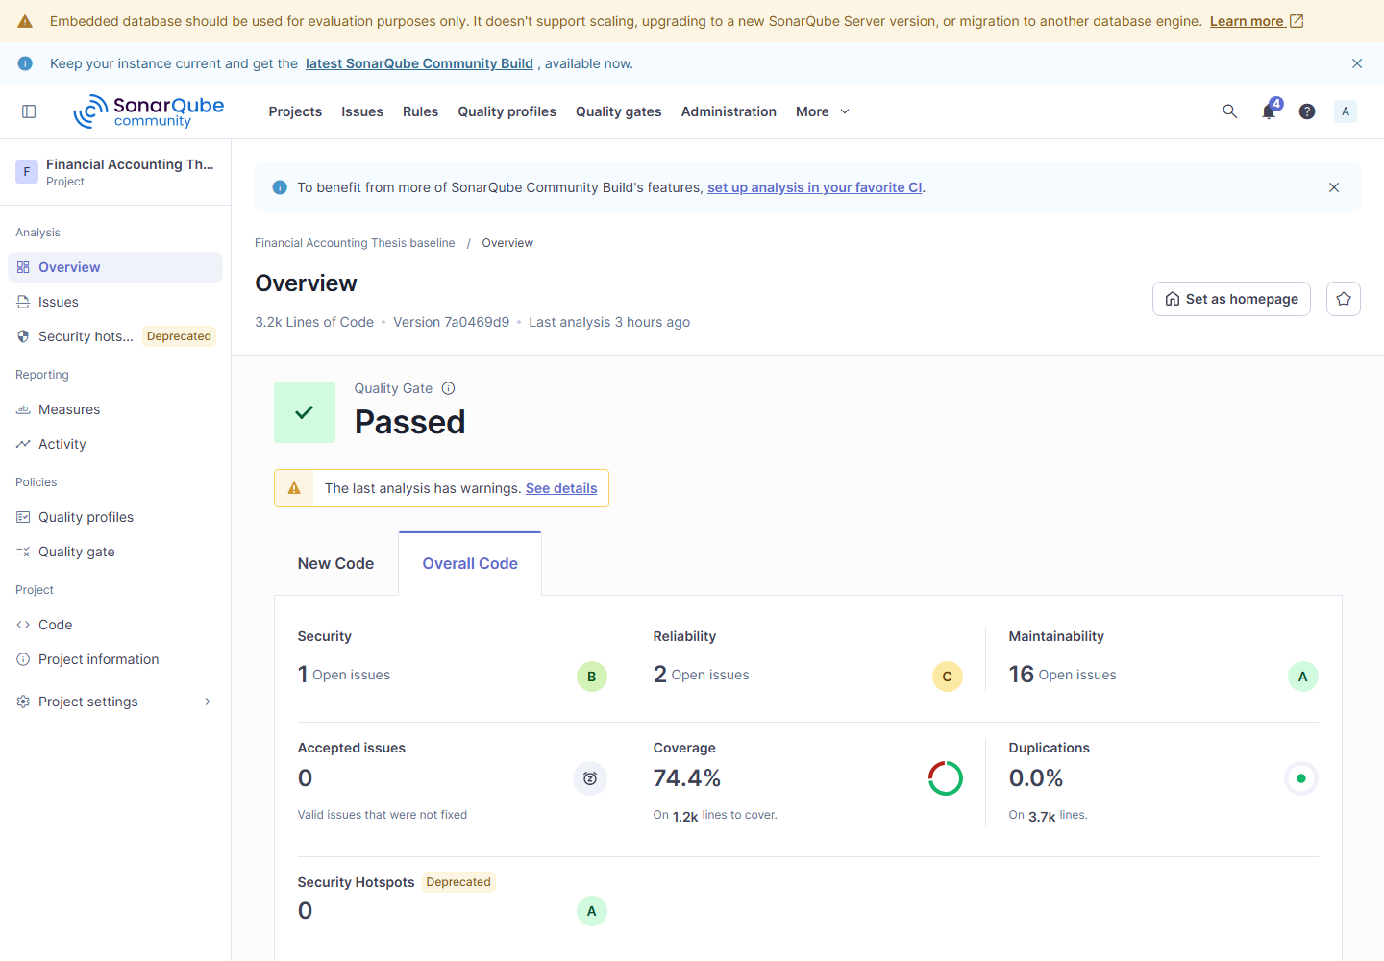
Figure L.1. SonarQube baseline overview dashboard.
Classification: fresh-reproduction; role: baseline; branch: origin/baseline-v0.1; commit: 7a0469d9; run: 20260922-183352; tool version: 26.7.0.124771; machine-readable source: docs/appendix/verification-runs/research/sonar/baseline/summary.json.

L.2 SonarQube baseline issues
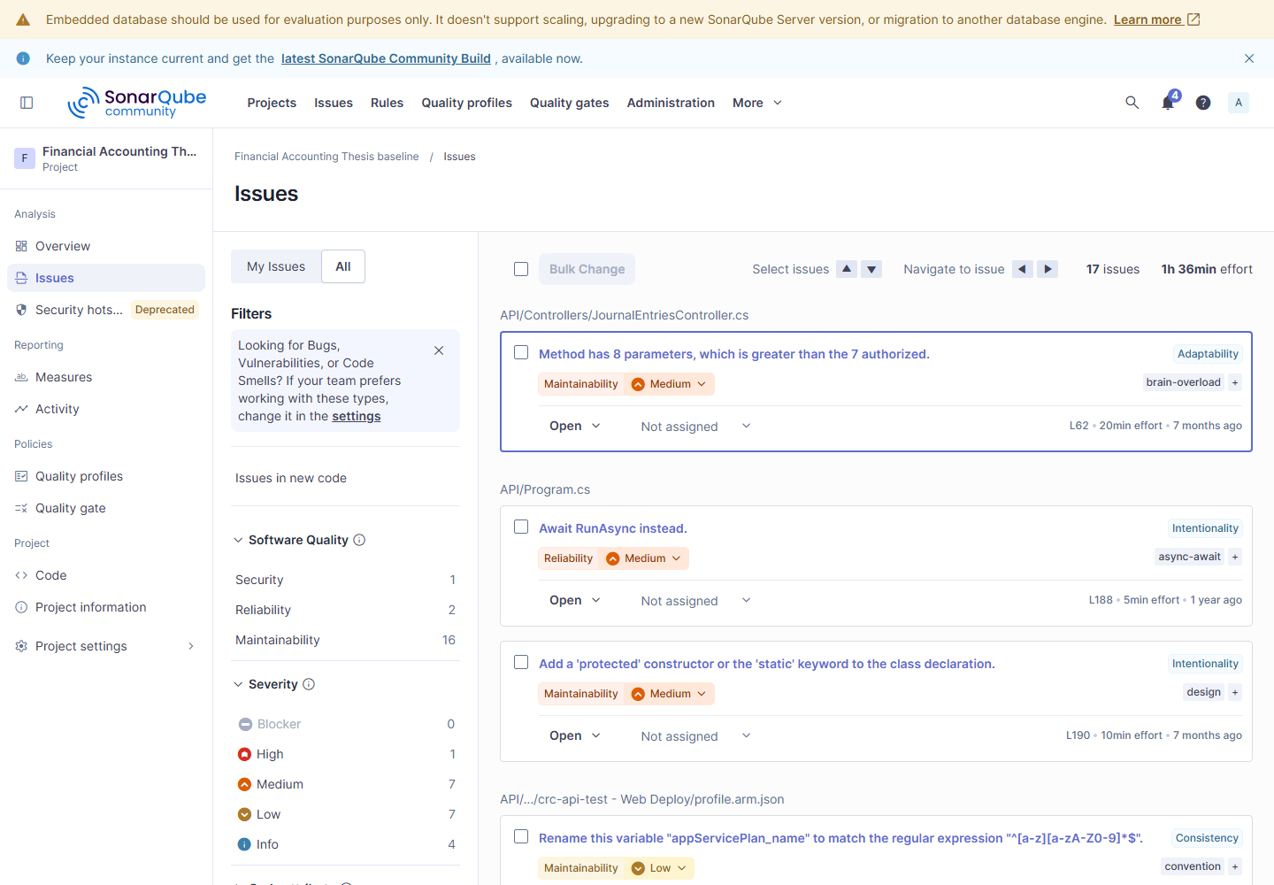
Figure L.2. SonarQube baseline issues dashboard.
Classification: fresh-reproduction; role: baseline; branch: origin/baseline-v0.1; commit: 7a0469d9; run: 20260922-183352; tool version: 26.7.0.124771; machine-readable source: docs/appendix/verification-runs/research/sonar/baseline/summary.json.

L.3 SonarQube remediation overview
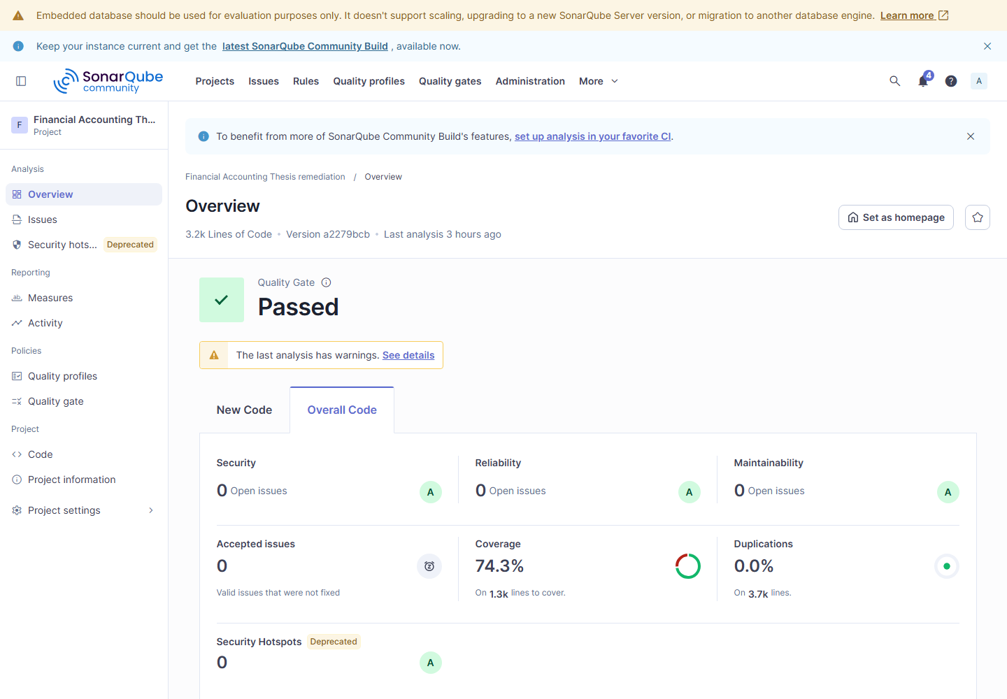
Figure L.3. SonarQube remediation overview dashboard.
Classification: fresh-reproduction; role: remediation; branch: origin/baseline-sonarqube-v1; commit: a2279bcb; run: 20260922-183352; tool version: 26.7.0.124771; machine-readable source: docs/appendix/verification-runs/research/sonar/remediation/summary.json.

L.4 SonarQube remediation issues
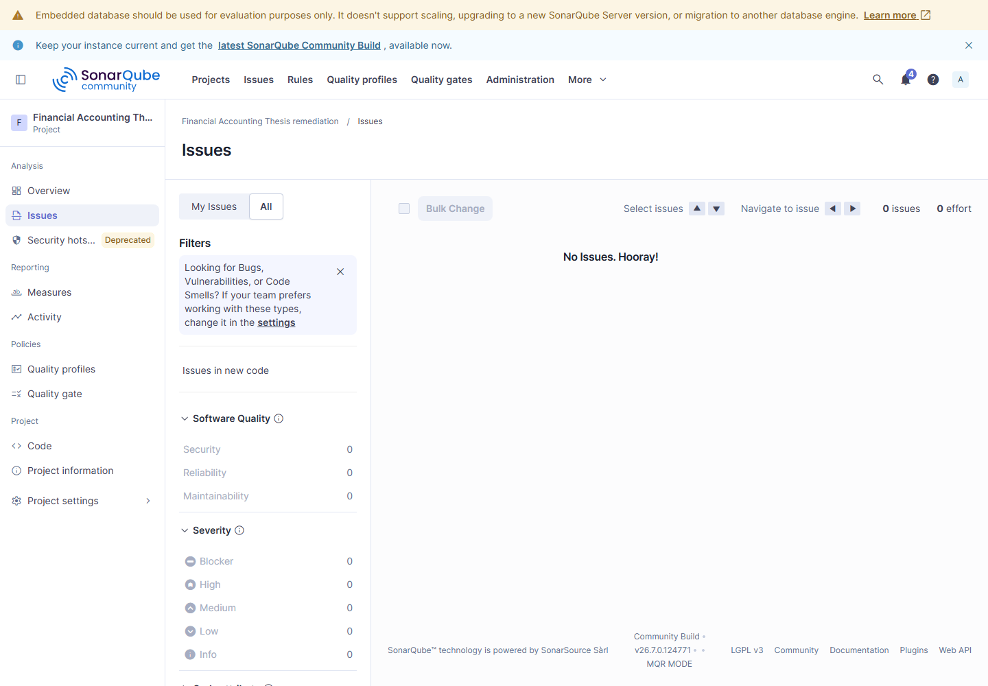
Figure L.4. SonarQube remediation issues dashboard.
Classification: fresh-reproduction; role: remediation; branch: origin/baseline-sonarqube-v1; commit: a2279bcb; run: 20260922-183352; tool version: 26.7.0.124771; machine-readable source: docs/appendix/verification-runs/research/sonar/remediation/summary.json.

L.5 OWASP ZAP passive baseline before remediation
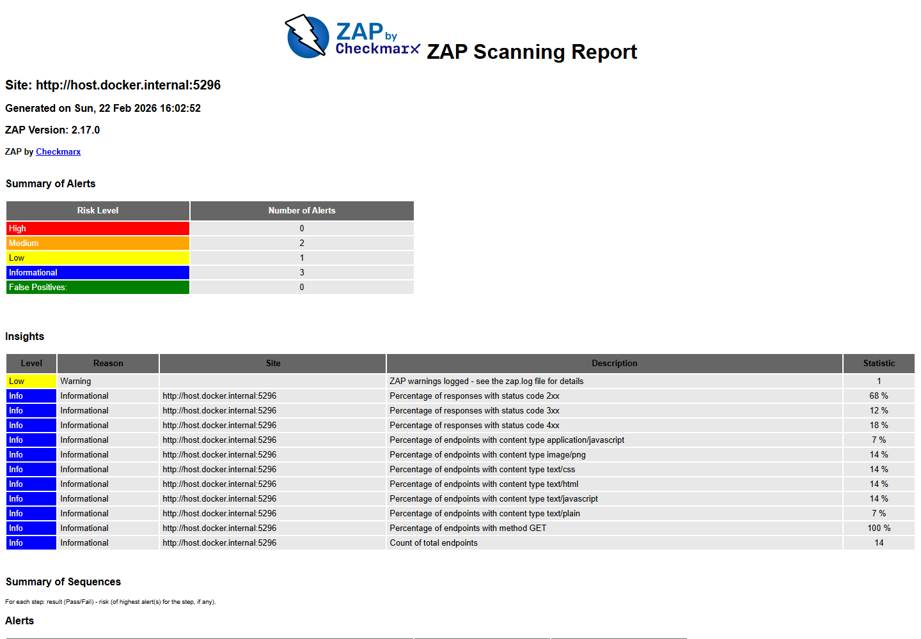
Figure L.5. OWASP ZAP passive baseline before remediation dashboard.
Classification: rendered-historical; role: baseline; branch: origin/baseline-v0.1; commit: 7a0469d9; run: 20260222-230133; tool version: 2.17.0; machine-readable source: Document/security/zap-baseline-20260222-230133.json.

L.6 OWASP ZAP passive baseline after remediation
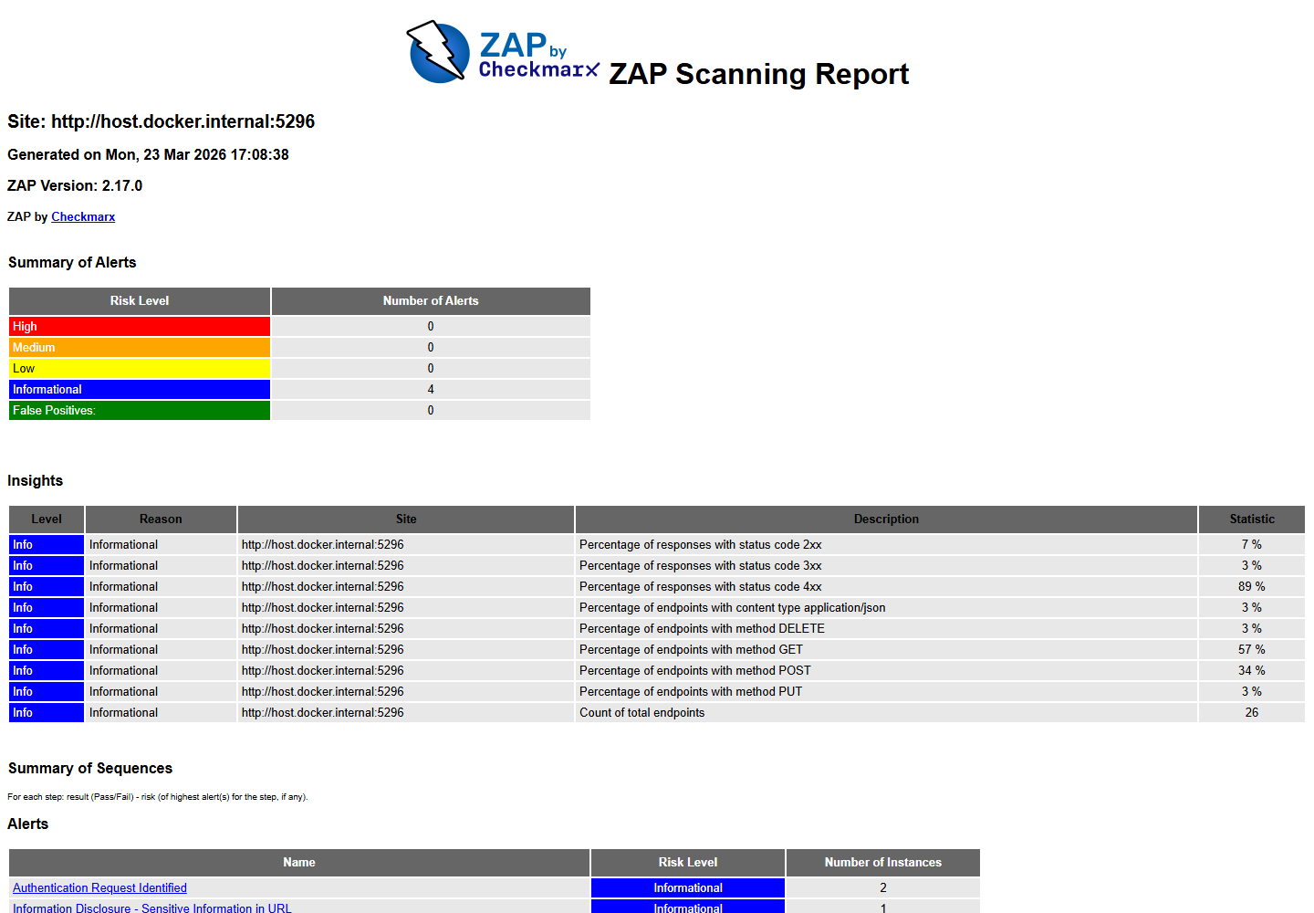
Figure L.6. OWASP ZAP passive baseline after remediation dashboard.
Classification: rendered-historical; role: remediation; branch: origin/baseline-zap-v1; commit: 5f3bd3cc; run: 20260324-000724; tool version: 2.17.0; machine-readable source: Document/security/zap-baseline-20260324-000724.json.

L.7 OWASP ZAP authenticated API before remediation
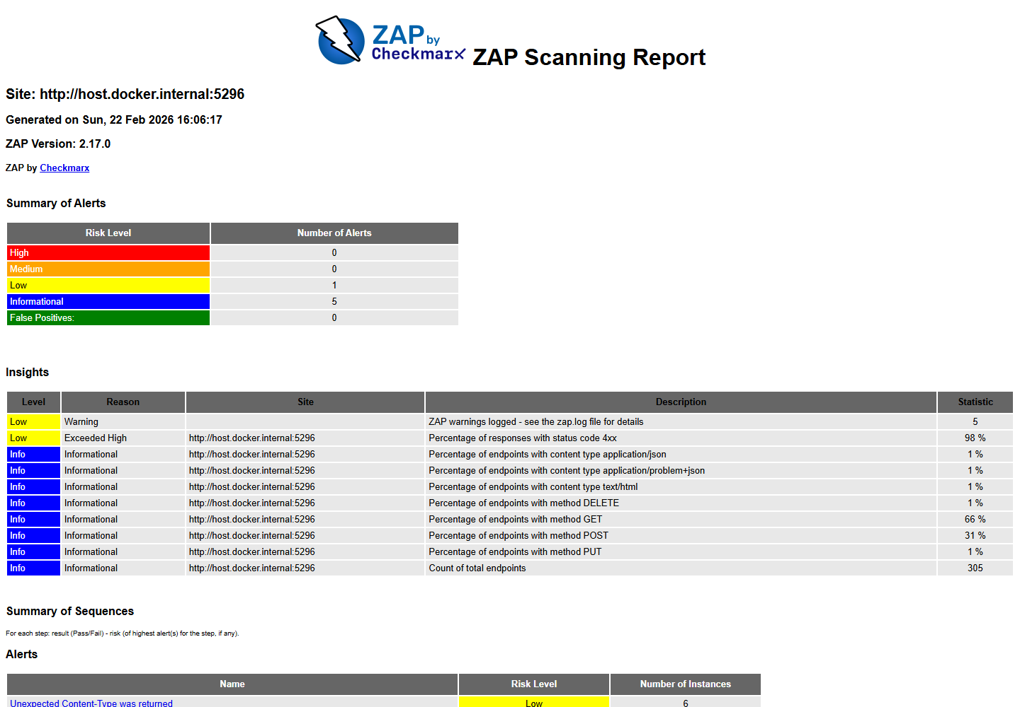
Figure L.7. OWASP ZAP authenticated API before remediation dashboard.
Classification: rendered-historical; role: baseline; branch: origin/baseline-v0.1; commit: 7a0469d9; run: 20260222-230133; tool version: 2.17.0; machine-readable source: Document/security/zap-api-20260222-230133.json.

L.8 OWASP ZAP authenticated API after remediation
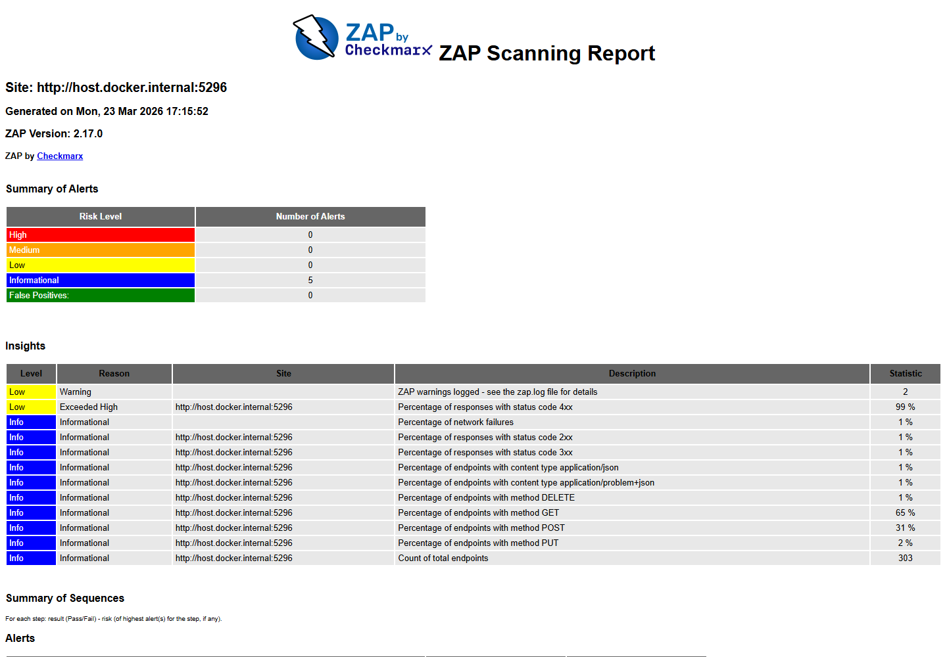
Figure L.8. OWASP ZAP authenticated API after remediation dashboard.
Classification: rendered-historical; role: remediation; branch: origin/baseline-zap-v1; commit: 5f3bd3cc; run: 20260324-000856; tool version: 2.17.0; machine-readable source: Document/security/zap-api-20260324-000856.json.

L.9 Apache JMeter baseline p50
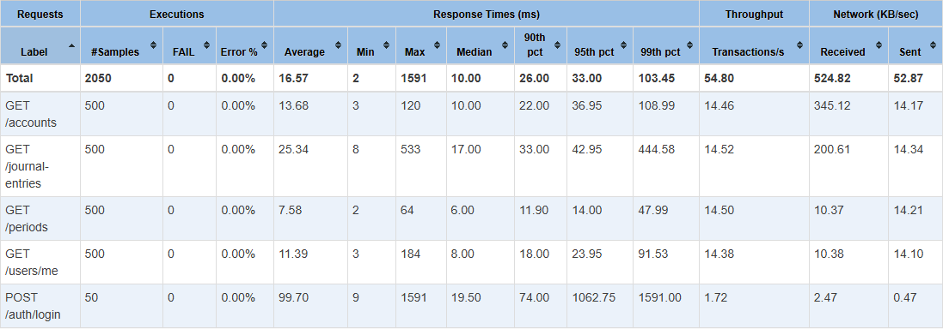
Figure L.9. Apache JMeter baseline p50 dashboard.
Classification: fresh-reproduction; role: baseline; branch: origin/baseline-v0.1; commit: 7a0469d9; run: baseline-20260922-192730; tool version: 5.5; machine-readable source: docs/appendix/verification-runs/research/jmeter/baseline/report-baseline-20260922-192730-p50/statistics.json.

L.10 Apache JMeter baseline p100
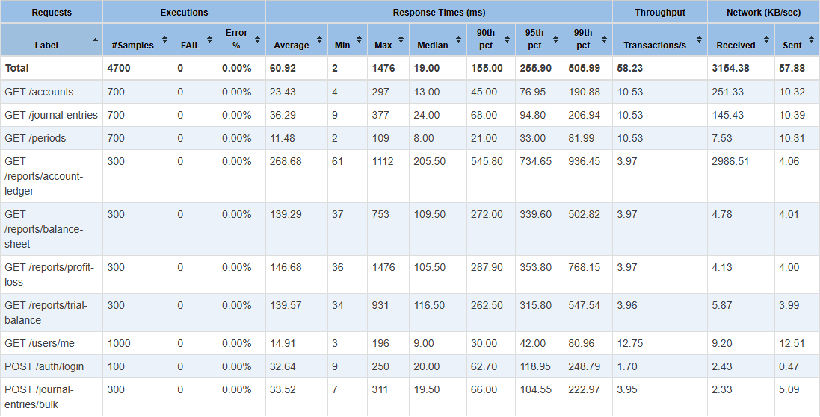
Figure L.10. Apache JMeter baseline p100 dashboard.
Classification: fresh-reproduction; role: baseline; branch: origin/baseline-v0.1; commit: 7a0469d9; run: baseline-20260922-192730; tool version: 5.5; machine-readable source: docs/appendix/verification-runs/research/jmeter/baseline/report-baseline-20260922-192730-p100/statistics.json.

L.11 Apache JMeter baseline p500
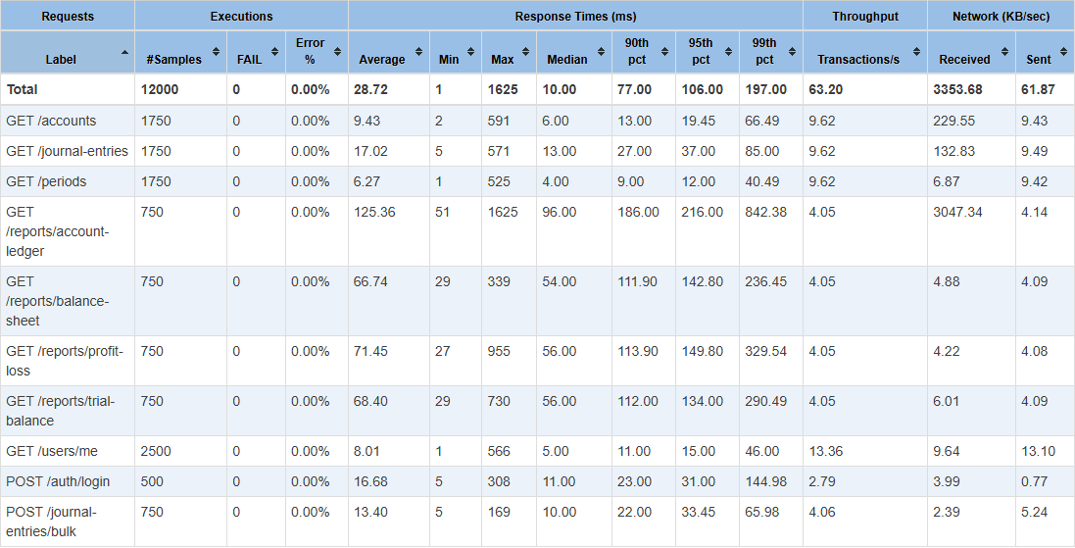
Figure L.11. Apache JMeter baseline p500 dashboard.
Classification: fresh-reproduction; role: baseline; branch: origin/baseline-v0.1; commit: 7a0469d9; run: baseline-20260922-192730; tool version: 5.5; machine-readable source: docs/appendix/verification-runs/research/jmeter/baseline/report-baseline-20260922-192730-p500/statistics.json.

L.12 Apache JMeter baseline soak
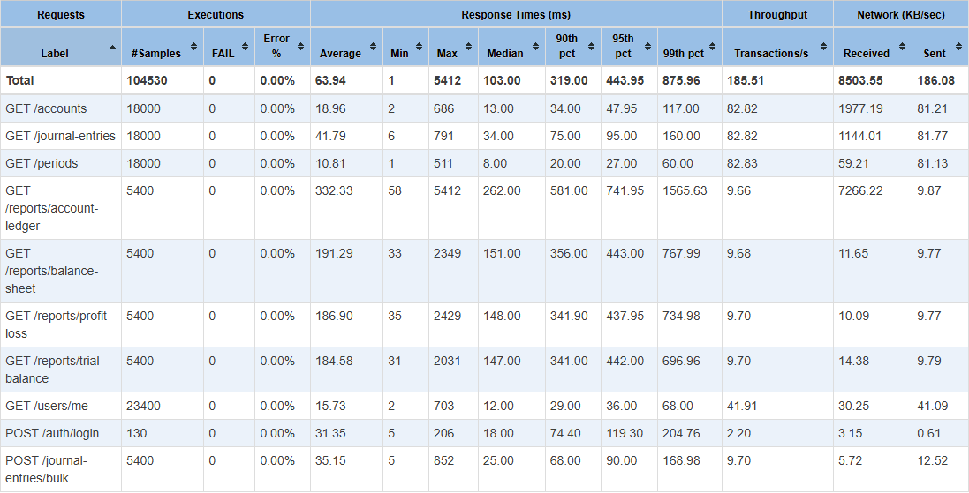
Figure L.12. Apache JMeter baseline soak dashboard.
Classification: fresh-reproduction; role: baseline; branch: origin/baseline-v0.1; commit: 7a0469d9; run: baseline-20260922-192730; tool version: 5.5; machine-readable source: docs/appendix/verification-runs/research/jmeter/baseline/report-baseline-20260922-192730-soak/statistics.json.

L.13 Apache JMeter baseline spike
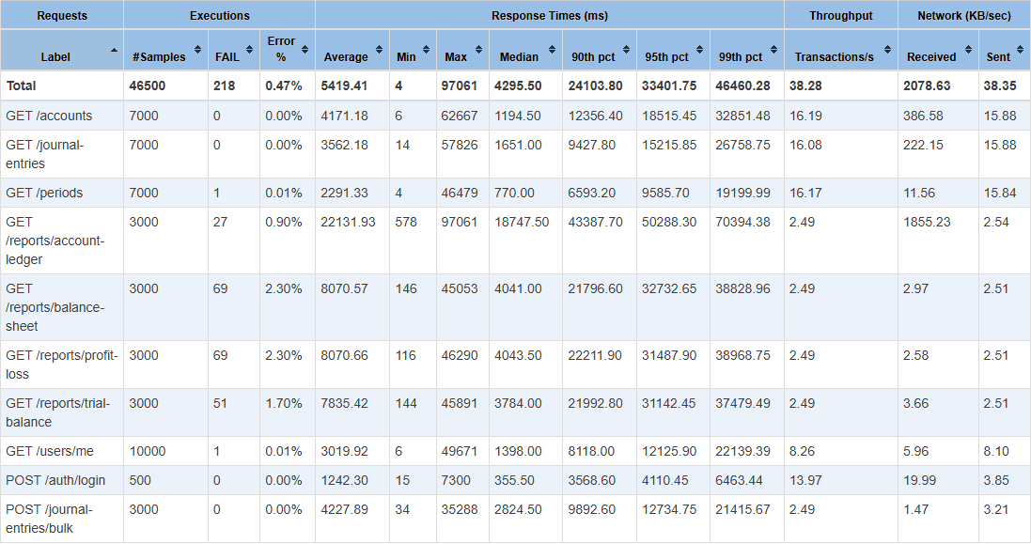
Figure L.13. Apache JMeter baseline spike dashboard.
Classification: fresh-reproduction; role: baseline; branch: origin/baseline-v0.1; commit: 7a0469d9; run: baseline-20260922-192730; tool version: 5.5; machine-readable source: docs/appendix/verification-runs/research/jmeter/baseline/report-baseline-20260922-192730-spike/statistics.json.

L.14 Apache JMeter remediation p50
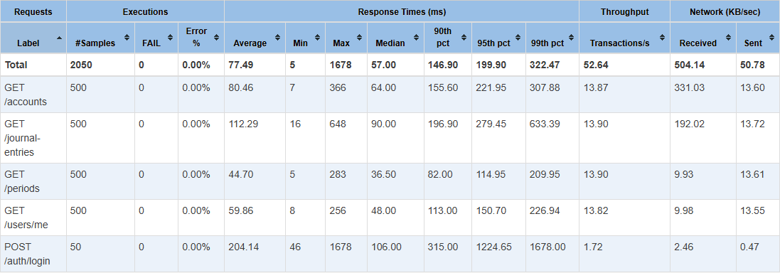
Figure L.14. Apache JMeter remediation p50 dashboard.
Classification: fresh-reproduction; role: remediation; branch: origin/baseline-jmeter-v1; commit: 78b08b62; run: remediation-20260922-200712; tool version: 5.5; machine-readable source: docs/appendix/verification-runs/research/jmeter/remediation/report-remediation-20260922-200712-p50/statistics.json.

L.15 Apache JMeter remediation p100
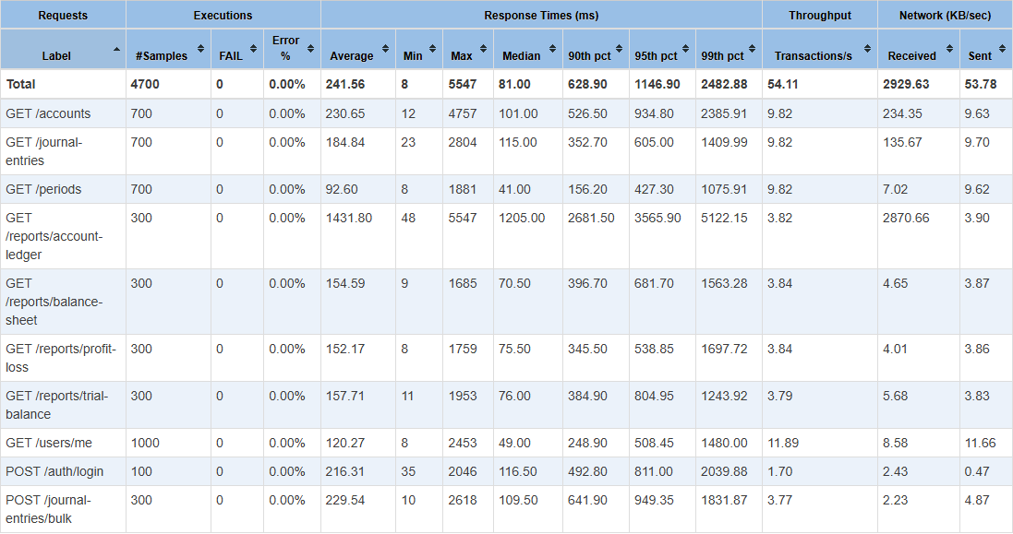
Figure L.15. Apache JMeter remediation p100 dashboard.
Classification: fresh-reproduction; role: remediation; branch: origin/baseline-jmeter-v1; commit: 78b08b62; run: remediation-20260922-200712; tool version: 5.5; machine-readable source: docs/appendix/verification-runs/research/jmeter/remediation/report-remediation-20260922-200712-p100/statistics.json.

L.16 Apache JMeter remediation p500
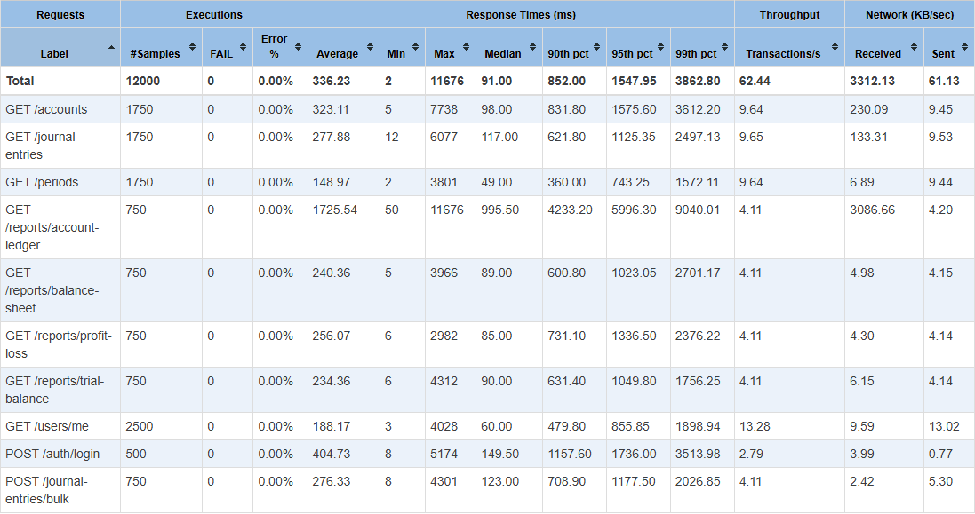
Figure L.16. Apache JMeter remediation p500 dashboard.
Classification: fresh-reproduction; role: remediation; branch: origin/baseline-jmeter-v1; commit: 78b08b62; run: remediation-20260922-200712; tool version: 5.5; machine-readable source: docs/appendix/verification-runs/research/jmeter/remediation/report-remediation-20260922-200712-p500/statistics.json.

L.17 Apache JMeter remediation soak
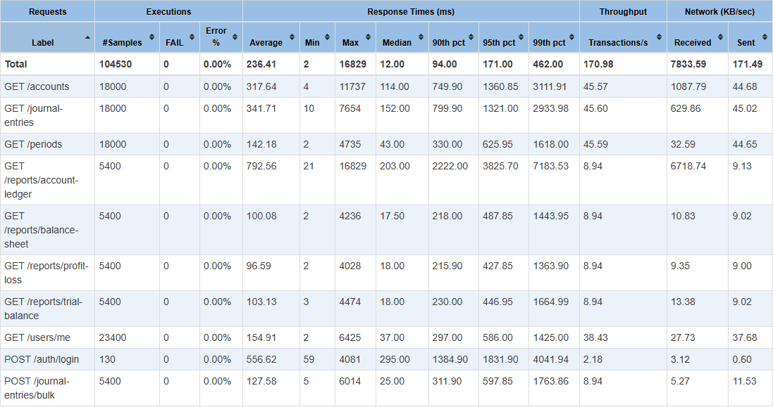
Figure L.17. Apache JMeter remediation soak dashboard.
Classification: fresh-reproduction; role: remediation; branch: origin/baseline-jmeter-v1; commit: 78b08b62; run: remediation-20260922-200712; tool version: 5.5; machine-readable source: docs/appendix/verification-runs/research/jmeter/remediation/report-remediation-20260922-200712-soak/statistics.json.

L.18 Apache JMeter remediation spike
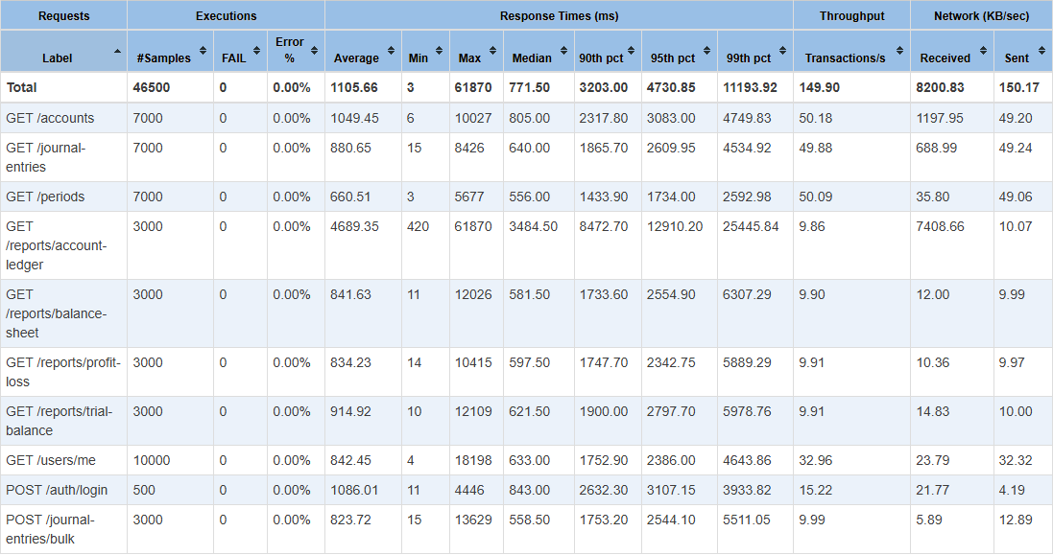
Figure L.18. Apache JMeter remediation spike dashboard.
Classification: fresh-reproduction; role: remediation; branch: origin/baseline-jmeter-v1; commit: 78b08b62; run: remediation-20260922-200712; tool version: 5.5; machine-readable source: docs/appendix/verification-runs/research/jmeter/remediation/report-remediation-20260922-200712-spike/statistics.json.

Appendix M - Result Traceability
Current conclusions use the fresh September 22 reproduction. Historical measurements are retained in the comparison column so the evolution of the study remains auditable.
Tool | Current fresh result | Historical comparison | Machine-readable evidence
SonarQube | 17 unique issues to 0; coverage 74.4% to 74.3%; gates OK/OK | 28 retained findings to 0; coverage reported as 74.3% | docs/appendix/verification-runs/research/sonar/*
OWASP ZAP | Passive M3/L6 to M0/L0; API M1/L3 to M1/L0; configured gate passed | Earlier scans reported all gated Medium/Low alerts cleared | docs/appendix/verification-runs/research/zap/*
Apache JMeter | Core gate FAIL; p50 33 to 199.9 ms; p100 255.9 to 1146.9 ms; p500 106 to 1547.95 ms; soak/spike aggregates improved | Earlier run reported core and stress p95 improvements | docs/appendix/verification-runs/research/jmeter/*
Application demonstration | API health, frontend smoke, and browser role workflow PASS | Role-aware React client added as a validation artifact | docs/appendix/verification-runs/demo-*.json

Appendix N - Limitations and Complete Source Index
- The study covers one ASP.NET Core application, one dataset profile, one AI assistant configuration, and one fresh measurement run per evidence branch.
- SonarQube MQR Reliability, Security, and Maintainability impacts overlap and must not be added together as unique issues.
- The fresh authenticated ZAP scan retains one raw Medium HTTP Only Site observation because the local reproduction uses HTTP instead of a production TLS endpoint.
- The fresh JMeter remediation core gate fails even though soak and spike aggregate p95 improve; this prevents a general performance-improvement claim.
- Tool versions, host load, database state, and workload composition can change results. Repeated controlled runs and confidence intervals are future work.
- The listings below are deliberately curated. The complete repository at the pinned commits remains authoritative for files not reproduced in full.
Listing and purpose | File | Branch/ref | Commit
B.1 - JWT Authentication Configuration | API/Program.cs | origin/baseline-sonarqube-v1 | a2279bcb
B.2 - Controller-Level Role Enforcement | API/Controllers/JournalEntriesController.cs | origin/baseline-sonarqube-v1 | a2279bcb
C.1 - Balanced Journal-Entry Posting | BAL/Services/JournalEntryService.cs | origin/baseline-sonarqube-v1 | a2279bcb
C.2 - Journal-Entry Reversal | BAL/Services/JournalEntryService.cs | origin/baseline-sonarqube-v1 | a2279bcb
D.1 - Structured Audit-Log Writer | BAL/Services/AuditLogService.cs | origin/baseline-sonarqube-v1 | a2279bcb
D.2 - Auditor-Role Read Boundary | API/Controllers/AuditLogsController.cs | origin/baseline-sonarqube-v1 | a2279bcb
E.1 - S107 Controller-Parameter Remediation | API/Controllers/JournalEntriesController.cs | origin/baseline-v0.1 | 7a0469d9
E.1 - S107 Controller-Parameter Remediation | API/Controllers/JournalEntriesController.cs | origin/baseline-sonarqube-v1 | a2279bcb
E.1 - S107 Controller-Parameter Remediation | MODEL/DTOs/FinancialAccountingDTOs.cs | origin/baseline-sonarqube-v1 | a2279bcb
E.2 - S6966 Asynchronous Host Shutdown | API/Program.cs | origin/baseline-v0.1 | 7a0469d9
E.2 - S6966 Asynchronous Host Shutdown | API/Program.cs | origin/baseline-sonarqube-v1 | a2279bcb
F.1 - Response Security-Headers Middleware | API/Middleware/SecurityHeadersMiddleware.cs | origin/baseline-zap-v1 | 5f3bd3cc
F.2 - Middleware Ordering and Swagger Exposure | API/Program.cs | origin/baseline-v0.1 | 7a0469d9
F.2 - Middleware Ordering and Swagger Exposure | API/Program.cs | origin/baseline-zap-v1 | 5f3bd3cc
G.1 - Concurrency-Safe Account-Ledger Cache | BAL/Shared/AccountLedgerCache.cs | origin/baseline-jmeter-v1 | 78b08b62
G.2 - Read-Only Ledger Query and Running Balance | BAL/Services/FinancialReportService.cs | origin/baseline-jmeter-v1 | 78b08b62
G.3 - Idempotent SQL Server Performance Indexes | BAL/Shared/SqlServerPerformanceIndexStartup.cs | origin/baseline-jmeter-v1 | 78b08b62
H.1 - Deterministic Dataset Parameters | scripts/phase4/seed-test-data.ps1 | origin/baseline-v0.1 | 7a0469d9
H.2 - Double-Entry Schema Constraints and Indexes | Document/sql/financial_accounting_schema.sql | origin/baseline-v0.1 | 7a0469d9
I.1 - Role-by-Endpoint Integration Matrix | tests/FinancialAccounting.IntegrationTests/RbacMatrixTests.cs | origin/baseline-v0.1 | 7a0469d9
I.2 - Security and Performance Configuration Defaults Test | tests/FinancialAccounting.UnitTests/AppSettingsTests.cs | origin/baseline-v0.1 | 7a0469d9
J.1 - Authenticated API Client | WEB/src/lib/api.ts | origin/codex/thesis-reproducibility-v1 | efa19cea
J.2 - Role-Aware Navigation and Mutation Rules | WEB/src/lib/permissions.ts | origin/codex/thesis-reproducibility-v1 | efa19cea
K.1 - Exact-Commit Research Verification | scripts/thesis/Invoke-ResearchVerification.ps1 | origin/codex/thesis-reproducibility-v1 | efa19cea
K.2 - Environment and Tool Readiness Checks | scripts/thesis/Test-ThesisEnvironment.ps1 | origin/codex/thesis-reproducibility-v1 | efa19cea

