Wordpress環境作成メモー
作業記録
1. Vmware esxi update
Target ip : 192.168.1.22
Update 詳細：version 6.0 ⇨ 6.7

2. テスト用仮想マシン作成
Target ip : 192.168.1.205
OS: Centos 7
ID: root / user
PW: https://docs.google.com/spreadsheets/d/1p_1yQffS9S1Bwz-rSfZjap82tf661QCYt-LPAKvPFRU/edit#gid=0
3. Wordpress 設置
WordPress => APM (Apache + PHP + Mysql) 基盤にされています。
準備事項
※この作業では、各バージョン互換性を気をつけながら進んでください
WordPress ⇨ APM (Apache + PHP + Mysql) 基盤にされています。
Apache ⇨ Apache/2.4.6 (CentOS)
PHP ⇨ PHP 7.1.33
Mysql ⇨5.7.29

[Command]
yum -y update
yum -y install httpd ⇨ Apache 設置
systemctl start httpd ⇨ Apache 実行
systemctl enable httpd ⇨ システム始める際、Apacheが実行可能
firewall-cmd --add-service=http --permanent
firewall-cmd --add-service=https --permanent
firewall-cmd --reload
yum install wget
wget http://rpms.remirepo.net/enterprise/remi-release-7.rpm
⇨ PHP 設置
(yum --enablerepo=extras install epel-release)
rpm -Uvh remi-release-7.rpm ⇨ 解放できない場合、上のコマンドを試して下さい。
yum install yum-utils -y
yum-config-manager --enable remi-php71
yum install -y httpd mysql-server php php-mysql php-gd php-ldap php-imap
reboot ⇨ 設定更新後、ブラウザで画面が見れない場合再起動してください！
wget http://dev.mysql.com/get/mysql57-community-release-el7-7.noarch.rpm ⇨ MySQL設置
yum localinstall mysql57-community-release-el7-7.noarch.rpm
yum repolist enabled | grep "mysql.*-community.*"
yum install mysql-community-server mysql mysql-libs mysql-devel mysql-server
systemctl start mysqld.service ⇨ MySQL実行
systemctl enable mysqld.service
sudo grep 'temporary password' /var/log/mysqld.log
⇨ default パスワード確認
mysql_secure_installation⇨ Secure 環境設定
cd /var/www/html
wget https://wordpress.org/latest.tar.gz
wget https://wordpress.org/latest.tar.gz
tar -zxvf latest.tar.gz
cp /var/www/html/wordpress/wp-config-sample.php /var/www/html/wordpress/wp-config.php
mkdir -p /var/www/html/wordpress/wp-content/uploads
sudo chown -R apache:apache /var/www/html/wordpress/
mysql -u root -p ⇨ ここからはDB作成です。
[user@localhost html]$ mysql -u root -p
Enter password:
Welcome to the MySQL monitor. Commands end with ; or \g.
Your MySQL connection id is 5
Server version: 5.7.29 MySQL Community Server (GPL)

Copyright (c) 2000, 2020, Oracle and/or its affiliates. All rights reserved.

Oracle is a registered trademark of Oracle Corporation and/or its
affiliates. Other names may be trademarks of their respective
owners.

Type 'help;' or '\h' for help. Type '\c' to clear the current input statement.

mysql> create databases;
ERROR 1064 (42000): You have an error in your SQL syntax; check the manual that corresponds to your MySQL server version for the right syntax to use near 'databases' at line 1
mysql> create database wordpress;
Query OK, 1 row affected (0.00 sec)

mysql> show databases;
+--------------------+
| Database |
+--------------------+
| information_schema |
| mysql |
| performance_schema |
| sys |
| wordpress |
+--------------------+
5 rows in set (0.00 sec)

mysql> grant all privileges on wordpress.* to root@localhost identified by 'ezgkZeC_;95K';
Query OK, 0 rows affected, 1 warning (0.01 sec)

mysql> flush privileges;
Query OK, 0 rows affected (0.00 sec)

mysql> exit
Bye

vi /var/www/html/wordpress/wp-config.php ⇨mysql と wordpress連動作業
vi /wp-config.php
※この場所で次の内容を修正して保存してください。
#/var/www/html/wordpress/wp-config.php
// ** MySQL settings - You can get this info from your web host ** //
/** The name of the database for WordPress */
define('DB_NAME', 'wordpress');
/** MySQL database username */
define('DB_USER', 'root');
/** MySQL database password */
define('DB_PASSWORD', 'mysqlより作ったパスワード入力');

/** MySQL hostname */
define('DB_HOST', 'localhost');

/** Database Charset to use in creating database tables. */
define('DB_CHARSET', 'utf8');

/** The Database Collate type. Don't change this if in doubt. */
define('DB_COLLATE', '');
:wq

再起動してください。

http:// IP address /wordpress に接続してWordpress の次の画面が出るか確認
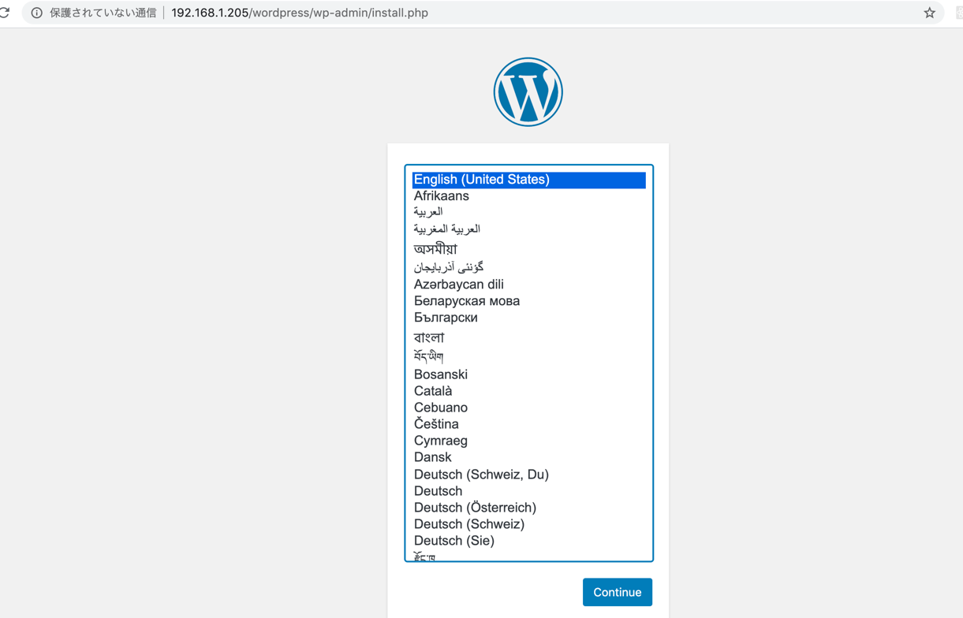
IDとパスワード新しく登録します。
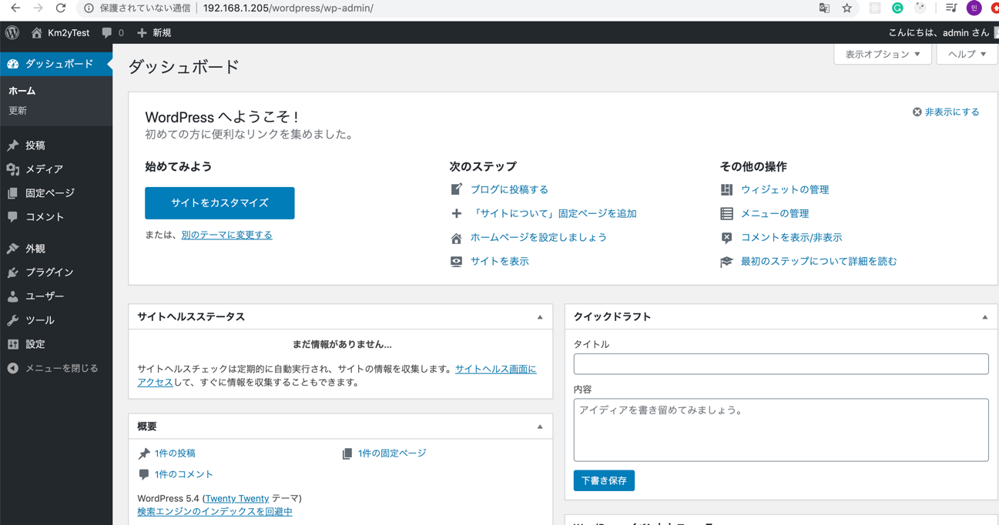
Access wordpress URL : http://192.168.1.205/wordpress

