San Andres, Princess April R. Intelligent System  
BSCS31A

**Damaged Items Report System**

Damaged Items Report System is a Python program that enables the PDMians to report defective or damaged items/furniture in their designated classrooms and facilities. It is done by inputting needed data into the program where they will be asked what is the damaged item, where that damaged item is located, its description, and the name of the informant. This information will be stored in a workbook, along with the date it was reported and the status of the report whether it was pending, followed-up, or fixed.

1. **Algorithms Used**

This program used two algorithms: **Data Collection and Report Generation & Logging Algorithm.** Data Collection was used to collect the needed data from the informants about the damaged items they have reported. This includes the collection of the item name, item location, damage description, name of the informant, and the date it was reported. With the Logging Algorithm, these collected data were stored in a database (workbook), where all logged entries were generated as a status report using the Report Generation Algorithm.

1. **Syntax**

**Import Libraries**

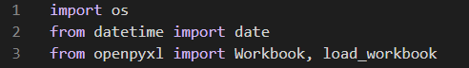

*import os* was imported so the program will be able to interact with the operating system like creating files (workbook), since my program uses a database in handling the data. *from datetime import date* was imported to store or record the report was submitted. *from openpyxl import Workbook, load_workbook*, then, was used to read and write excel files connected to the program.

**Declarations of List and Excel File**



*damage_reports = []* is list variable that holds reports. Content will come from the users’ inputs. *excel_file = “damaged_items_reports.xlsx”* is an excel file/ the workbook where reports were stored permanently.

**Function for Saving a Single Report to Excel**

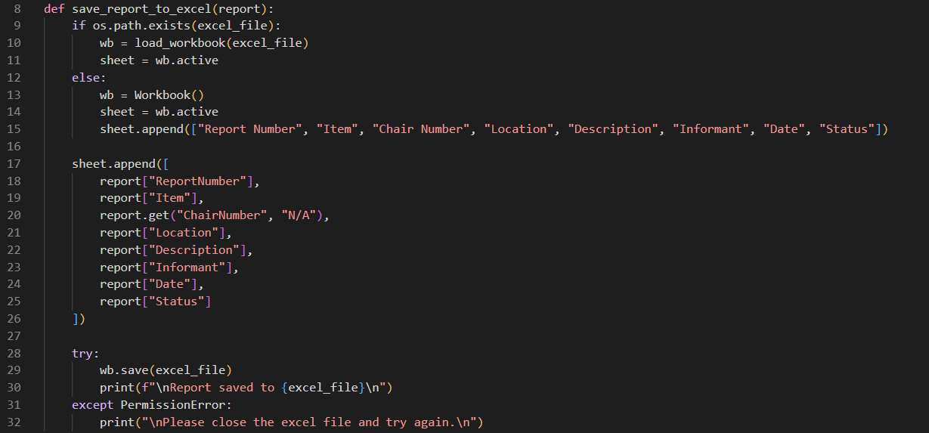

*save_report_to_excel(report)* saves each report to Excel. The if-else statement opens a condition that determines whether there is an existing excel file or not. If yes, then the excel file will be accessed. Else, a new excel file will be created, as well as a header row named “Report Number”, “Item”, “Chair Number”, “Location”, “Description”, “Informant”. “Date”, and “Status”. Once the program receives a new report from the user, a new row will be created using *sheet.append* and fill the empty cells according to their inputs. The *try-except* then helps prevent the program from crashing if the excel file is open in another tab by giving a warning to the user.

**Function for Reporting a Damaged Item**

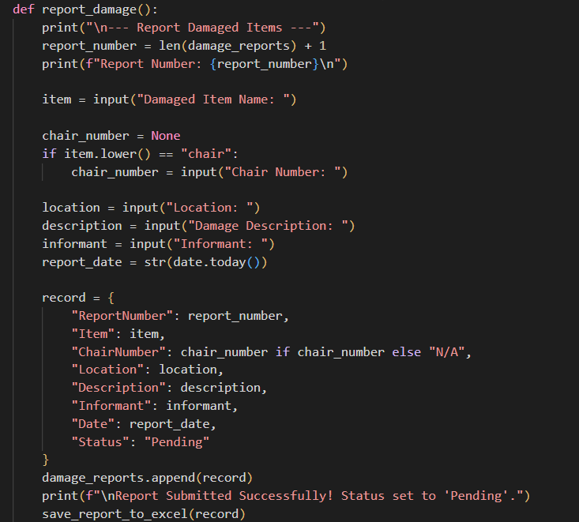

Using *report_damage()*, the users are able to input details about their reporting damaged items. *report_number = len(damage_reports) + 1*

**Function for Viewing Reports**

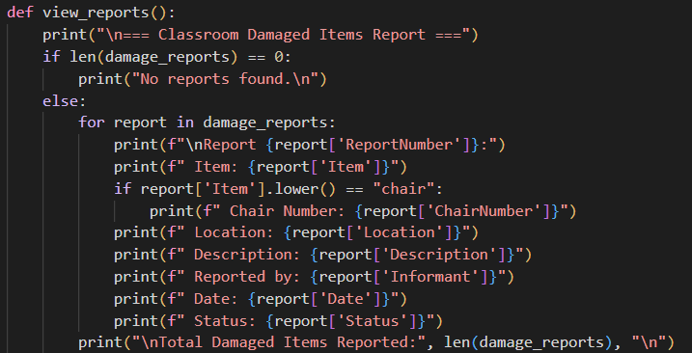

**Function for Updating Report Status**

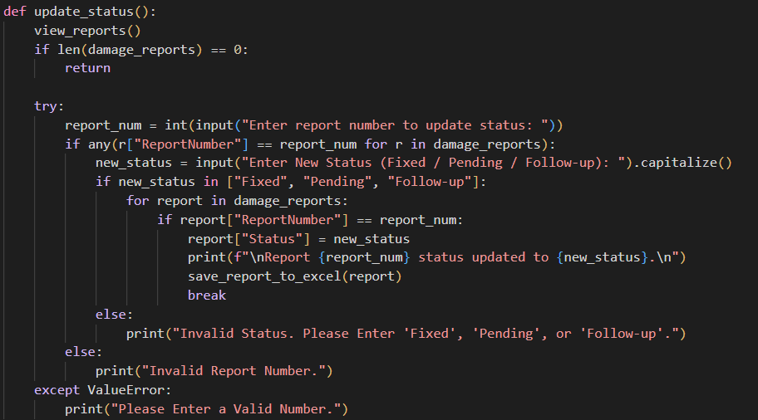

**Main Function**

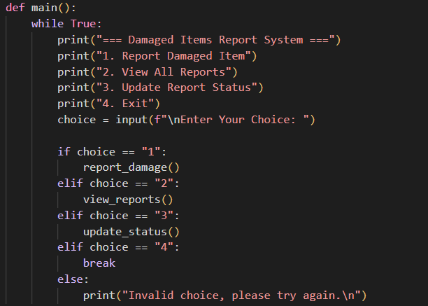

**Program Execution**



1. **Output**