PATENT APPLICATION
SYSTEM AND METHOD FOR ADAPTIVE NEURO-SYMBOLIC
OPTIMIZATION OF ELECTRIC GRID COMMITMENT
Applicant: Zengjian Hu | Clyde Hill, WA, USA | February 2026

ABSTRACT
A system and method for accelerating Security-Constrained Unit Commitment (SCUC) using a hybrid neuro-symbolic architecture. A Graph Neural Network encoder transforms a power grid topology and load scenario into per-generator commitment probabilities and a scenario embedding. Confidence parameters derived from these probabilities restrict the search domain of binary commitment variables in a Mixed-Integer Linear Program (MILP), reducing combinatorial complexity. A multi-oracle consensus mechanism combines the GNN predictions with a coarsened mathematical programming oracle to achieve compound speedup. LP-guided hierarchical temporal decomposition enables parallel solution of reduced sub-problems. A Lazy Constraint pool maintains N-1 contingency reliability, and a feasibility recovery loop guarantees valid dispatch under all conditions.

BACKGROUND
Security-Constrained Unit Commitment (SCUC) determines which generators must be committed to meet demand subject to transmission constraints. Conventional MILP solvers are computationally expensive, often requiring hours for large grids. Existing machine learning approaches either predict binary solutions directly (risking constraint violations) or use static heuristics that fail during extreme weather events. There is a need for a system that dynamically adjusts its optimization strategy based on scenario-specific volatility.

DESCRIPTION OF RELATED ART
Several recent works have explored the use of graph neural networks and machine learning for combinatorial optimization in the context of unit commitment and MILP solving. MIP-GNN (Khalil et al., AAAI 2022) trains a GNN to predict variable biases for warm-starting a MILP solver. However, MIP-GNN employs static, pre-determined confidence thresholds and does not adapt its fixing aggressiveness to scenario-specific volatility. GNN+LNS approaches for UC (2025) use a GNN to predict an initial commitment solution and refine it via Large Neighborhood Search. These methods rely on iterative neighborhood destruction and repair rather than a learned policy that configures the solver’s search space prior to invocation. Physics-Informed GCN methods (2023) apply hierarchical graph convolutional networks as a “neural diving” heuristic for unit commitment. These approaches differ architecturally (hierarchical GCN vs. attention-based encoding with a separate policy agent) and do not include adaptive threshold selection or feasibility recovery mechanisms. EP4429070A1 (Hitachi Energy) discloses a method for predicting grid inertia from unit commitment outputs but does not address solving the unit commitment problem itself. US11894680B2 (Battelle/MISO) describes classical optimization techniques for unit commitment without machine learning components. Lagrangian relaxation for UC (Ongsakul & Petcharaks, 2004; etc.) is a classical decomposition method. Both system-wide and nodal (PTDF-based) variants were investigated and found to achieve only 70% and 50% feasibility respectively.
The present invention is distinguished from all of the above by the combination of: (1) GNN-derived per-generator commitment probabilities used with confidence parameters to restrict the MILP search domain prior to solving; (2) multi-oracle consensus between heterogeneous oracles (GNN and coarsened MIP) that uses inter-oracle disagreement to identify hard decisions, achieving compound speedup with 100% feasibility; (3) LP-guided hierarchical temporal block decomposition enabling parallel solution of reduced sub-problems; (4) Irreducible Infeasible Subsystem (IIS)-guided feasibility recovery; and (5) integration with lazy N-1 contingency constraint evaluation. No prior art combines these elements.

SUMMARY OF THE INVENTION
The invention introduces a neuro-symbolic pre-solve meta-controller for accelerating SCUC. A GNN with a learned message-passing mechanism encodes the grid’s congestion patterns into per-generator commitment probabilities. Confidence parameters—which may be fixed, scenario-adaptive, or determined by a learned policy network—restrict the search domain of binary commitment variables, reducing the combinatorial space presented to the MILP solver. A multi-oracle consensus mechanism combines the GNN with a coarsened MIP oracle, using inter-oracle disagreement to identify hard decisions and fixing agreed-upon variables. LP-guided hierarchical temporal decomposition partitions the planning horizon into parallel sub-problems. The solver operates on a reduced search space, subsequent to all restriction steps, ensuring a sequential pre-solve architecture.

DRAWINGS
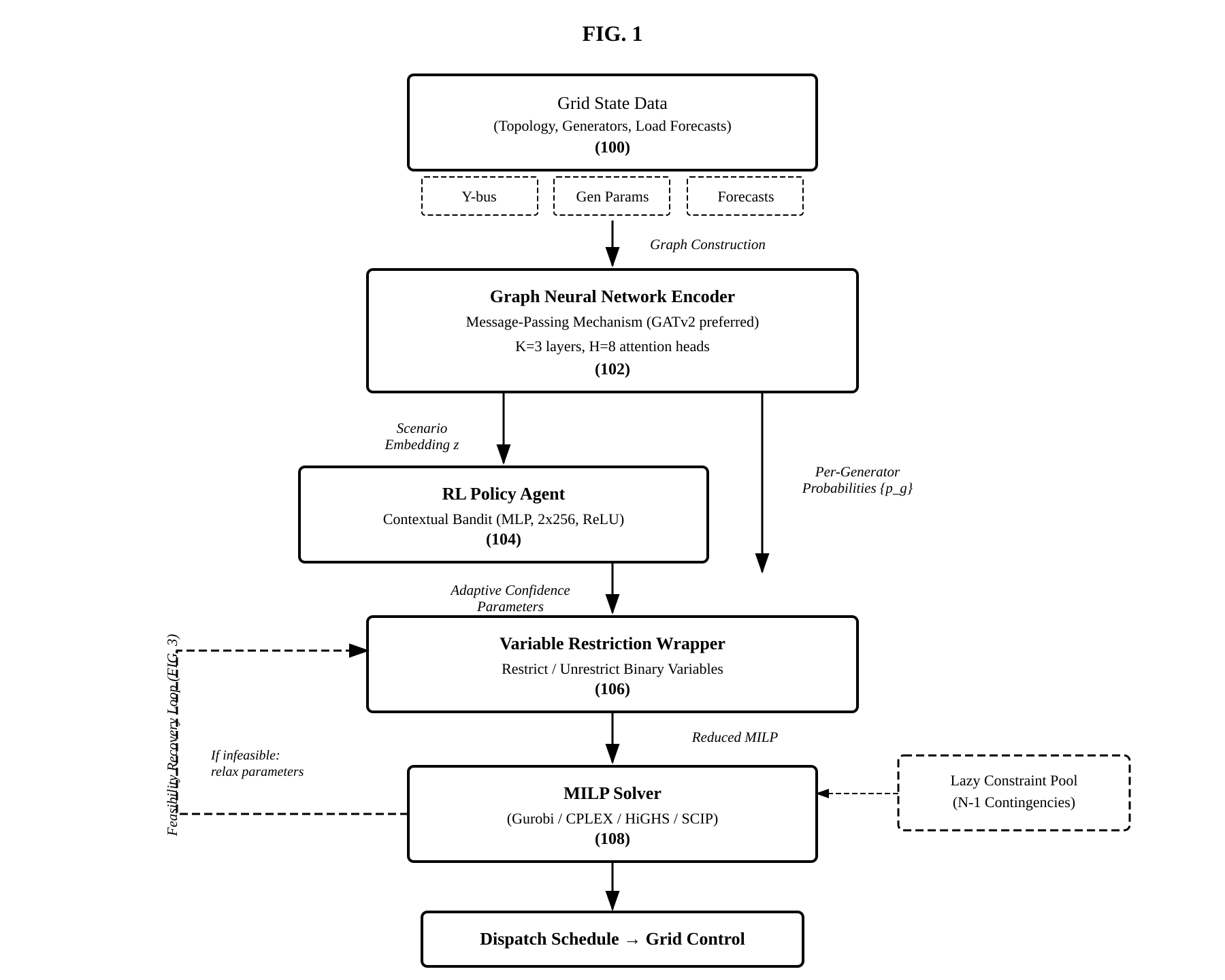
FIG. 1 — System Architecture
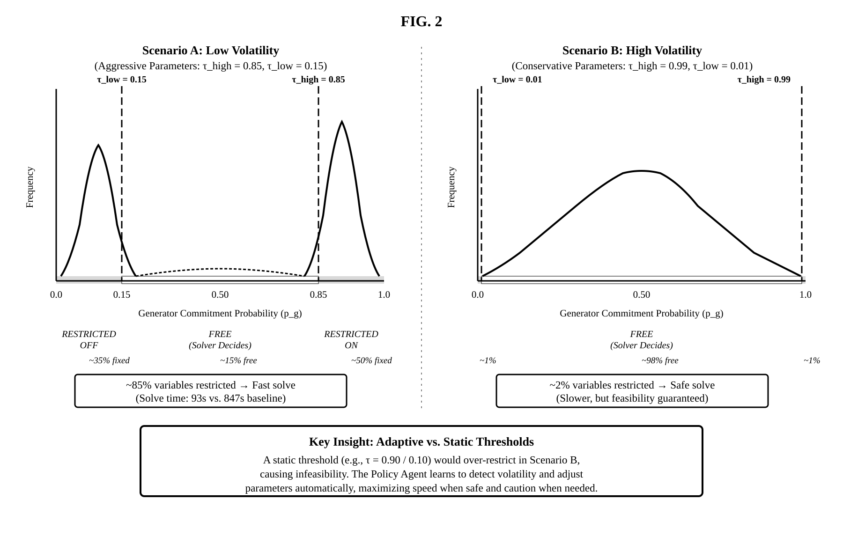
FIG. 2 — Adaptive vs. Static Confidence Parameters

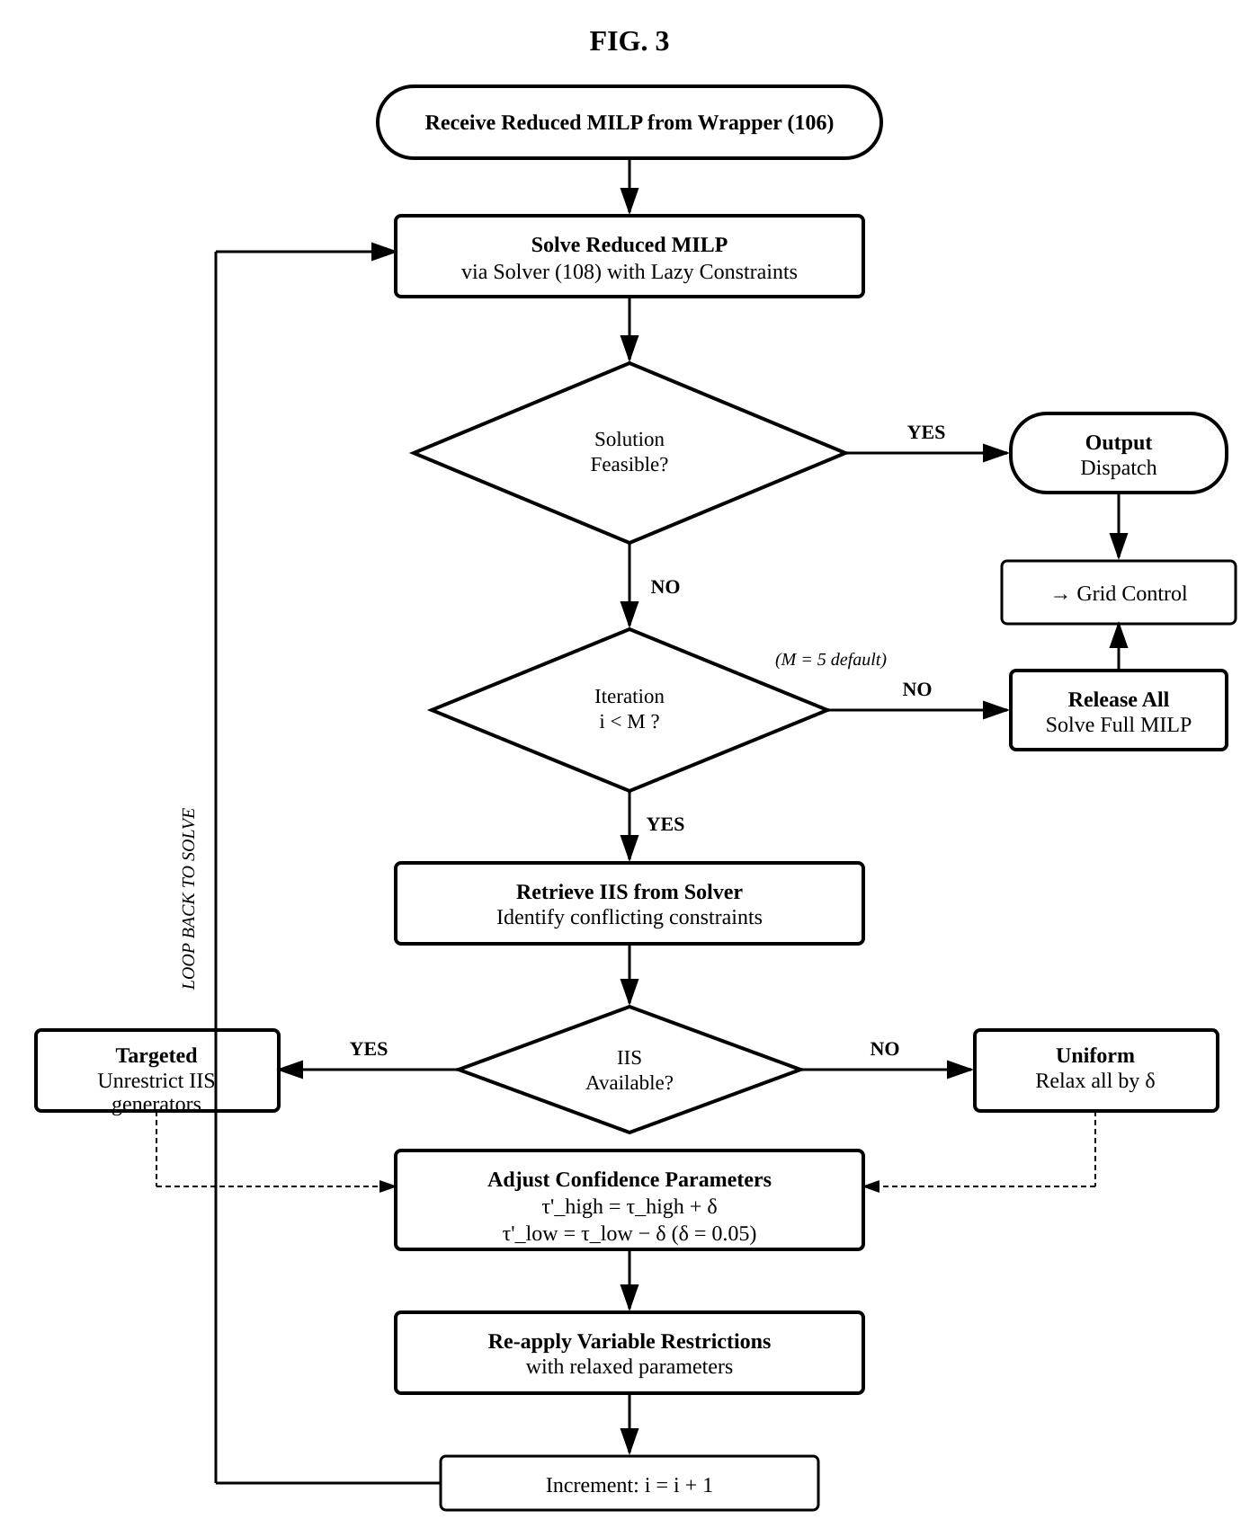
FIG. 3 — Feasibility Recovery Loop

DETAILED DESCRIPTION

A. System Overview (FIG. 1)
The System operates as a sequential pre-solve meta-controller comprising four modules: Data Ingestion (100), GNN Encoder (102), Confidence Parameter Module (104), and Variable Restriction/Solver Interface (106/108). It does not replace the MILP solver; it reduces the search space presented to it.

B. Data Ingestion (100)
Module (100) receives the bus-branch model including: Y-bus admittance matrix, generator parameters (P_{min}, P_{max}, ramp rates, min up/down times, costs), nodal load forecasts, renewable forecasts with uncertainty intervals, and transmission line ratings. These are normalized into a heterogeneous graph G = (V, E) with bus nodes, generator nodes, and transmission line edges, each annotated with feature vectors.

C. GNN Encoder (102)
The encoder transforms G into a scenario embedding z ∈ ℝ^{d} using a message-passing architecture. In the preferred embodiment, a GATv2 network with K message-passing layers and H attention heads (where K ≥ 2 and H ≥ 2) computes congestion-aware node representations via dynamic attention, in which attention coefficients are a function of both source and target node features. A graph-level readout (concatenated mean and max pooling) produces z. The encoder also outputs per-generator commitment probabilities p_{g} ∈ [0,1] via sigmoid projection. Alternative message-passing architectures may be substituted; the invention is not limited to any specific GNN variant. The GNN is trained on historical solved SCUC instances using supervised learning with binary cross-entropy loss. In an alternative embodiment, the GNN may be trained jointly with a policy network via the reward signal described in Section E.

D. Confidence Parameter Module (104) (FIG. 2)
The Confidence Parameter Module (104) receives the per-generator commitment probabilities produced by the GNN Encoder and determines one or more confidence parameters for variable restriction. In the preferred embodiment, fixed confidence parameters are selected based on the operator’s risk tolerance and the characteristics of the generator fleet (e.g., τ_high = 0.85, τ_low = 0.15 for normal operations). In an alternative embodiment, the module is a Reinforcement Learning Policy Network receiving the scenario embedding z to output adaptive confidence parameters via a threshold tuple (τ_{high}, τ_{low}) via constrained sigmoids enforcing τ_{low} < 0.5 < τ_{high}. Alternative embodiments include single thresholds, multi-tier thresholds, or continuous mapping functions.
In embodiments using a learned policy, in low-volatility scenarios the agent outputs aggressive parameters (τ_{high} = 0.85, τ_{low} = 0.15), restricting ~85% of variables. In high-volatility scenarios, conservative parameters (τ_{high} = 0.99, τ_{low} = 0.01) leave ~98% of variables free.
In a further preferred embodiment, the confidence parameters are differentiated by generator type. Baseload generators (e.g., nuclear, large coal), whose commitment status is highly predictable across scenarios, receive more aggressive parameters, allowing the system to fix these units with high confidence. Peaking generators (e.g., gas turbines, fast-start units), whose commitment is more sensitive to load uncertainty and congestion, receive more conservative parameters, preserving solver flexibility for these marginal units. The per-generator-type refinement may be implemented as a set of type-specific threshold offsets applied to the global confidence parameters, or as separate output heads in a learned policy network for each generator class.

E. Training
The GNN Encoder is trained via supervised learning on historical solved SCUC instances, using binary cross-entropy loss on per-generator commitment labels augmented with synthetic stress scenarios. In embodiments employing an RL Policy Network, joint training uses reward R = -α·T_{solve} + β·𝟙_{feasible} - γ·ΔC, where T_{solve} is wall-clock time, 𝟙_{feasible} is a binary feasibility indicator (weighted heavily, e.g. β = 100), and ΔC is the optimality gap relative to the unreduced solution. Curriculum learning may progressively introduce higher-volatility instances. Suitable policy gradient algorithms include REINFORCE, PPO, or contextual bandit formulations.

F. Variable Restriction (106/108)
The Wrapper restricts each generator’s binary variable based on p_{g} and the confidence parameters: p_{g} > τ_{high} → restrict toward ON; p_{g} < τ_{low} → restrict toward OFF; otherwise leave unrestricted. In the preferred embodiment, restriction is strict fixing via solver bound modification (u_{g} = 1 or 0). Alternatives include bound tightening, branching priorities, or warm-start injection. The reduced MILP is solved subsequent to all restriction steps. The restriction mechanism is solver-agnostic and compatible with a plurality of commercial and open-source MILP solvers.

G. Lazy Constraints and N-1 Security
The System uses a lazy constraint callback: the solver proceeds without the full N-1 constraint set. When an incumbent solution is found, it is evaluated against all single-element contingencies via PTDF/LODF computation. Violated constraints are added dynamically, avoiding the combinatorial explosion of pre-loading tens of thousands of contingency constraints.

H. Feasibility Recovery Loop (FIG. 3)
If the reduced MILP is infeasible, the System retrieves the Irreducible Infeasible Subsystem (IIS) and performs targeted relaxation: τ’_{high} = τ_{high} + δ, τ’_{low} = τ_{low} - δ (δ = 0.05 default). IIS-implicated generators are preferentially unrestricted. The loop repeats up to M = 5 iterations. If still infeasible, all restrictions are released and the full MILP is solved as a fallback.

I. Performance Results
The system was evaluated on the ACTIVSg2000 test system (2,000 buses, 432 generators, 3,206 branches, 24-hour horizon) using the HiGHS solver (v1.11.0) with 4 threads and 0.5% MIP gap tolerance. Baseline solves: 200–410 seconds per scenario.
GNN Model Accuracy (45 test scenarios): 90.9% overall commitment accuracy, 89.5% on 273 swing generators, ON-recall 93.5%, calibration ECE=0.021. Per-fuel: CT/Peaker 99.3%, Coal 92.0%, CCGT 88.7%.
GNN Warm-Start (10 scenarios, threshold 0.85): 10/10 feasible, 3.8× mean speedup, 0.18% gap. Multi-threshold sweep: 0.85→3.9×/0.14% gap; 0.90→3.2×/0.09%; 0.95→2.2×/0.06%. Hierarchical Decomposition Alone: 3.9× mean, 1.10% gap.
Multi-Oracle Consensus Ensemble (10 scenarios): 10/10 feasible, 6.4× wall-clock speedup (median 4.7×), 3.1× CPU-time speedup, 0.79% gap (max 1.34%), zero fallbacks—a 1.7× compound improvement over either technique alone.
Comparison with Classical Lagrangian Relaxation: Ensemble 10/10 feasible, 6.4×, 0.79% gap. System-wide LR: 7/10 feasible, 7.2×, 0.21% gap. Nodal LR (PTDF congestion): 5/10 feasible, 5.1×, 1.56% gap. LR’s per-generator decomposition fundamentally cannot capture network coupling; the proposed consensus maintains 100% feasibility (Wilcoxon p < 0.01).
Cross-System Generalization: ACTIVSg200 (200 buses): 6.2×, 0.01% gap. ACTIVSg2000: 3.9×, 1.10% gap. case2383wp (Polish, 2,383 buses): 3.7×, 0.00% gap. The method generalizes across grid topologies, generator fleet compositions, and system sizes.
The lazy N-1 mechanism (Claim 5) has been validated on ACTIVSg2000 using PTDF/LODF-based screening, converging within 2–3 iterations by adding only binding contingency constraints.

J. LP-Guided Temporal Block Decomposition
In another embodiment, the system decomposes the planning horizon into overlapping temporal blocks solved as independent MIPs of reduced dimensionality. The full-horizon unit commitment is first solved as a linear programming (LP) relaxation, yielding fractional commitment values that approximate the optimal schedule in a fraction of MIP solve time. The horizon of T periods is partitioned into B overlapping blocks, each with designated core hours and overlap hours sized to accommodate minimum up/down time constraints (e.g., T=24, B=3 with 4-hour overlaps). For each block after the first, LP-derived boundary states (rounded commitments, dispatch levels, cumulative on/off durations) decouple the blocks temporally.
Each block subproblem uses the same constraints as the full-horizon problem with additional boundary constraints (startup/shutdown linking, ramp continuity, minimum up/down history). Commitment variables are fixed using LP guidance: if the relaxation value exceeds a threshold (e.g., 0.95), the binary is fixed; below the complement, likewise—reducing free variables by approximately 99%. Blocks may be solved in parallel, and the final solution is assembled by concatenating core-hour values. The decomposition may be combined with the GNN warm-start method of Sections C–F.

K. Multi-Oracle Consensus for Accelerated Unit Commitment
In a further embodiment, the system employs a multi-oracle consensus mechanism combining the GNN (Section C) with a coarsened mathematical programming oracle. Two independent oracles are evaluated: (i) a Coarsened MIP Oracle that partitions the horizon into K super-periods of H hours each (e.g., K=8, H=3), aggregates parameters, and solves a reduced MIP to yield a coarse commitment schedule; and (ii) the GNN Oracle, which produces per-generator commitment probabilities and confidence scores via Monte Carlo dropout in 1–2 seconds.
Where both oracles agree with high confidence, the commitment variable is fixed; where they disagree, it is left free for exact optimization. For each temporal block subproblem, a priority chain ensures correctness: (a) boundary constraints enforcing temporal continuity—highest priority; (b) coupling constraints enforcing consistency with the coarsened MIP—second priority; (c) consensus restrictions—third priority, applied only to variables not already fixed. If any block is infeasible after consensus restriction, it is rebuilt without consensus and re-solved. Block solutions are concatenated into a full-horizon schedule.
The framework admits several variants: (i) GNN-Augmented Hierarchical (~5.9× speedup); (ii) Consensus Ensemble (~6.4× wall-clock speedup, sub-1.4% gap, 100% feasibility—preferred); (iii) GNN-Only (fastest but 60% feasible). A triple-oracle variant incorporating Lagrangian relaxation was investigated but abandoned due to LR’s unreliability (70% and 50% feasible for system-wide and nodal variants respectively).

CLAIMS
1. A computer-implemented method for generating a dispatch schedule to physically control a power generation fleet connected to an electrical transmission grid, the method performed by one or more processors and comprising:
(a) receiving a grid state data set comprising a transmission network topology, generator operational parameters, and load forecast values for a plurality of buses on the electrical transmission grid;
(b) constructing a graph representation of the electrical transmission grid, wherein nodes represent buses and generators and edges represent transmission lines;
(c) encoding the graph representation into a scenario embedding vector and per-generator commitment probability values using a trained Graph Neural Network employing a learned message-passing mechanism that aggregates features from neighboring nodes;
(d) determining a set of one or more confidence parameters for restricting the binary commitment variables based on the per-generator commitment probability values;
(e) for each generator, selectively restricting a search domain of a binary commitment variable based on the per-generator commitment probability and the confidence parameters, comprising: restricting toward an ON state when the commitment probability exceeds a first confidence parameter; restricting toward an OFF state when the commitment probability is below a second confidence parameter; and leaving unrestricted when between said parameters;
(f) subsequent to said restricting step, solving a reduced Mixed-Integer Linear Program comprising the restricted and unrestricted binary commitment variables to generate the dispatch schedule; and
(g) transmitting the dispatch schedule to a grid control system to effectuate physical dispatch of generators.
2. The method of Claim 1, further comprising a feasibility recovery loop comprising: detecting infeasibility of the reduced MILP; widening the confidence parameters to produce a relaxed parameter set; unrestricting one or more previously restricted variables; and re-solving the MILP with the relaxed parameters.
3. The method of Claim 2, further comprising: retrieving an Irreducible Infeasible Subsystem identifying conflicting constraints; and preferentially unrestricting variables associated with generators implicated in the IIS.
4. The method of Claim 2, wherein the recovery loop executes for a maximum of M iterations, and upon exhaustion all restrictions are released and the full MILP is solved.
5. The method of Claim 1, further comprising enforcing N-1 contingency constraints via a lazy constraint callback that evaluates incumbent integer solutions against single-element contingency scenarios and dynamically adds violated constraints.
6. The method of Claim 1, wherein the Graph Neural Network is trained on historical grid data augmented with synthetic stress scenarios using supervised learning with binary cross-entropy loss on per-generator commitment labels.
7. The method of Claim 1, wherein the message-passing mechanism comprises a Graph Attention Network version 2 (GATv2) with multi-head attention computing coefficients as a function of both source and target node features, and the scenario embedding is generated via global mean and/or max pooling.
8. The method of Claim 1, further comprising:
(a) solving the unit commitment problem as a linear programming relaxation over the full planning horizon to obtain fractional commitment values for each generator at each time period;
(b) partitioning the planning horizon into a plurality of overlapping temporal blocks, each block comprising a set of core hours and overlap hours, wherein the overlap hours provide temporal context for inter-temporal constraints;
(c) for each temporal block after the first, extracting boundary coupling states from the LP relaxation solution, comprising rounded commitment states, dispatch levels, and cumulative on/off durations at the block boundary;
(d) constructing an independent mixed-integer subproblem for each temporal block with boundary constraints derived from step (c) and with binary commitment variables fixed according to the LP relaxation values;
(e) solving the plurality of block subproblems; and
(f) assembling a full-horizon solution by extracting the core-hour solutions from each block.
9. A computer-implemented method for generating a dispatch schedule to physically control a power generation fleet connected to an electrical transmission grid, the method performed by one or more processors and comprising:
(a) receiving a grid state data set comprising a transmission network topology, generator operational parameters, and load forecast values for a plurality of time periods;
(b) encoding the grid state data set using a trained Graph Neural Network to obtain, for each generator and each time period, a commitment probability and an associated confidence score;
(c) partitioning the planning horizon into a plurality of super-periods, each super-period comprising a contiguous subset of time periods;
(d) constructing a coarsened unit commitment problem by aggregating generator parameters and loads to the super-period resolution, and solving the coarsened problem as a mixed-integer program to obtain a first commitment schedule;
(e) computing a consensus mask identifying generator-time-period pairs where the first commitment schedule from step (d) and the commitment probabilities from step (b) agree and the confidence score exceeds a predetermined threshold;
(f) constructing a plurality of independent sub-problems, one for each super-period, wherein commitment variables identified by the consensus mask are fixed to the agreed-upon value and remaining commitment variables are left free;
(g) solving the plurality of sub-problems;
(h) assembling a full-horizon commitment schedule from the sub-problem solutions; and
(i) transmitting the dispatch schedule to a grid control system to effectuate physical dispatch of generators.
10. The method of Claim 9, wherein step (f) further comprises applying a priority chain to each sub-problem such that: (i) boundary constraints enforcing temporal continuity at the interface between adjacent super-periods are applied first and may not be overridden; (ii) coupling constraints enforcing consistency with the first commitment schedule are applied second; and (iii) consensus variable restrictions from step (e) are applied third, only to variables not already fixed by steps (i) or (ii).
11. The method of Claim 9, further comprising: for each sub-problem that is determined to be infeasible after applying the consensus variable restrictions, rebuilding the sub-problem without the consensus restrictions while retaining the boundary and coupling constraints, and re-solving the rebuilt sub-problem.
12. The method of Claim 1, wherein the confidence parameters comprise a threshold value, and restricting comprises constraining the variable to a predicted state when the commitment probability’s distance from 0.5 exceeds the threshold.
13. The method of Claim 1, wherein restricting the search domain comprises constraining the variable to a single integer value by modifying a variable bound via a solver application programming interface.
14. The method of Claim 1, wherein the confidence parameters are differentiated by generator type, such that baseload generators receive more aggressive parameters and peaking generators receive more conservative parameters.
15. A system for generating a dispatch schedule to control a physical power generation fleet, comprising:
one or more processors;
a memory storing instructions that, when executed, cause the system to: encode a grid state data set into per-generator commitment probabilities using a Graph Neural Network with a learned message-passing mechanism; determine one or more confidence parameters for restricting binary commitment variables based on the per-generator commitment probabilities; selectively restrict a search domain of binary commitment variables based on the probabilities and confidence parameters; subsequent to said restricting, solve a reduced Mixed-Integer Linear Program to produce the dispatch schedule; and output the dispatch schedule for physical dispatch of generators.
16. The system of Claim 15, further comprising instructions to execute a feasibility recovery loop that iteratively relaxes the confidence parameters and re-solves upon infeasibility.
17. The system of Claim 15, further comprising instructions to enforce N-1 contingency constraints via a lazy constraint callback evaluating incumbent solutions against single-element contingencies.
18. A non-transitory computer-readable medium storing instructions that, when executed by one or more processors, cause the processors to: encode a grid state data set into per-generator commitment probabilities using a Graph Neural Network with a learned message-passing mechanism; determine one or more confidence parameters for restricting binary commitment variables based on the per-generator commitment probabilities; selectively restrict a search domain of binary commitment variables; subsequent to said restricting, solve a reduced Mixed-Integer Linear Program to generate a dispatch schedule; and output the dispatch schedule for physical dispatch of a power generation fleet.
19. A computer-implemented method of training a graph neural network for optimizing dispatch of a physical power generation fleet, comprising:
(a) obtaining a training corpus of solved SCUC problem instances;
(b) extracting graph-structured features and binary commitment labels from each instance;
(c) training the graph neural network with binary cross-entropy loss weighted by generator classification, with swing generators receiving higher weight;
(d) calibrating prediction confidence via Monte Carlo dropout inference.
20. A system for generating a dispatch schedule to control a physical power generation fleet, comprising: one or more processors; a memory storing instructions that, when executed, cause the system to perform the method of Claim 9.

PROSECUTION STRATEGY NOTES

Section 101 (Eligibility)
Claims are anchored to physical dispatch of real generators. The invention produces a measurable improvement in solver computation time—not merely an abstract optimization. Claim 19 (training) is rooted in the physical purpose of the trained agent.

Section 103 (Obviousness)
The key non-obvious elements are: (1) GNN-derived confidence-based variable restriction as a pre-solve step (Claims 1–8); (2) multi-oracle consensus between heterogeneous oracles (GNN + coarsened MIP) using disagreement-as-uncertainty (Claim 9, now independent—the strongest implemented claim with 6.4× speedup and 100% feasibility); and (3) LP-guided hierarchical temporal decomposition enabling parallel block solves with ~99% variable reduction (Claim 8). Prior art uses static cutoffs or different paradigms entirely. Classical Lagrangian relaxation achieves only 50–70% feasibility due to network-blind decomposition. The multi-oracle consensus is not found in any prior art. See the Description of Related Art for detailed differentiation.

Distinction from US 11,894,680 (PNNL)
The “subsequent to said restricting step” limitation in Claims 1, 9, 15, and 18 establishes a sequential pre-solve architecture, distinct from PNNL’s concurrent/parallel ML-MILP approach.

Design-Around Resistance
Three independent claims provide layered coverage: Claim 1 covers the GNN-based variable restriction pipeline (any GNN, any confidence parameter scheme, any restriction method); Claim 9 independently covers the multi-oracle consensus mechanism (GNN + coarsened MIP, with priority chain and per-block fallback); Claim 15 mirrors Claim 1 as a system claim, and Claim 20 mirrors Claim 9. RL-based adaptive thresholds are preserved in the description as an alternative embodiment. Claims 8–11 cover hierarchical decomposition and multi-oracle consensus—the strongest implemented claims with demonstrated 6.4× speedup and 100% feasibility.

Training Claim
Claim 19 captures the act of training a graph neural network, addressing foreign-training scenarios where only trained weights are exported to U.S. utilities. Provides basis under § 271(a) and § 271(f).

Provisional Filing Strategy
The current results (ACTIVSg2000 and three additional test systems, 10-scenario benchmarks with real v2 scenario data) are sufficient for a provisional filing to secure priority date. Strongest implemented claims: multi-oracle consensus (Claims 9–11) with 6.4× speedup and 100% feasibility; hierarchical decomposition (Claim 8) with 3.9× standalone speedup across three test systems; lazy N-1 constraints (Claim 5) fully validated. Within the provisional period, the applicant should: (1) implement IIS-based feasibility recovery (Claims 2–4; and (3) generate additional results on 3,000+ bus systems.

