Twitter Client Application
Software Design Description

Version 1.0 ● 31-March-2013
JALAJ MINDA

Approver Name | Title | Signature | Date

Contents
Section 1. Overview 1
1.1 Purpose 1
1.2 Scope 1
Section 2. System Architecture 2
Section 3. Class Diagram 2
Section 4. Sequence Diagrams and Descriptions 4
4.1 Sequence Diagram for Login Use Case 4
4.2 Sequence Diagram for Registration Use Case 5
4.3 Sequence Diagram for creating favorite list Use Case 6
4.4 Sequence Diagram for view timeline of user in favorite list Use Case 7
4.5 Sequence Diagram for trending a topic at twitter Use Case 8
4.6 Sequence Diagram for searching tweets based on hash tag Use Case 9
4.7 Sequence Diagram for finding relation between 2 twitter user Use Case 10
4.8 Sequence Diagram for searching tweets of a user based on date Use Case 11
Section 5. Activity Diagram 12
5.1 Activity Diagram for Login 12
5.2 Activity Diagram for registration 13
5.3 Activity Diagram for creating a favorite list 14
5.4 Activity Diagram for viewing timeline of a user in favorite list 15
5.5 Activity Diagram for trending a topic on twitter 16
5.6 Activity Diagram for searching tweets based on hash tag 17
5.7 Activity Diagram for searching tweets of a user based on date 18
5.8 Activity Diagram for finding relation between two twitter user accounts 19
Section 6. State Chart Diagram 20
Section 7. Data Design 20
7.1 ER Diagram 20
7.2 Table layout 21
Section 8. Data Flow Diagrams 23
8.1 Level 0 DFD 23
8.2 Level 1 DFD 24
8.3 Level 2 DFD – USER Registration 25
8.4 Level 2 DFD – View timeline of favorite user 26
8.5 Level 2 DFD – View tweets for a user based on date 27
8.6 Level 2 DFD – View tweets based on hash tag 28
8.7 Level 2 DFD – Trend a topic 29
8.8 Level 2 DFD – find relationship between two user account 30
Section 9. Detailed Module Description 31
9.1 Login 31
9.2 Rgistration 32
9.3 Create favorite list 33
9.4 View timeline of favorite use 35
9.5 Search tweet based on hash tag 36
9.6 Search tweet of user based on date 37
9.7 Trend a topic 38
9.8 Find relation between 2 twitter users 39
Section 10. User Interface Design 40
10.1 User Interface Screen for User Login 40
10.2 User Interface Screen for New User Registration 41
10.3 User Interface Screen for Home Page 42
10.4 User Interface Screen for view favorite users timeline 43
10.5 User Interface Screen for viewing tweets based on hash tag 44
10.6 User Interface Screen for view tweets based on date 45
10.7 User Interface Screen for view Trending a topic 46
10.8 User Interface Screen for viewing relation between 2 user accounts 47
Section 11. Requirements Traceability Matrix 48
Requirement ID 49
Design Component 49
Section 12. References 50
Section 13. Glossary 51
Section 14. Revision History 52
Section 15. Appendices 53

Section 1. Overview

1.1 Purpose
The purpose of this Object-Oriented Software Design Description (SDD) document is to describe the overall behavior of Twitter Client Application(TCA). This desktop application’s goal is to enable the user to be able to quickly and easily check, write, and browse their personal Tweets from their current Twitter user account. Not only do we want the application to be a fully functional client but to also be visually appealing, intuitive, and helpful .This document highlights all the necessary diagram which will help both technical and non-technical people, to able to understand the thorough working of the system. Document shows class diagram, sequence diagram, activity diagram, entity relation ,modular description of each use case and user interface

1.2 Scope
The Twitter Client Application will automate the following processes.

- A category named “favorite” will allow individuals to select the most important people of whose tweets he wants to view.
- Automate the process of re tweet to support a trending twitter hash tag.
- Search all latest tweets based on a hash tag.
- Find relationship between two twitter accounts.
- Searching for particular users tweets based on date.

Section 2. System Architecture

Client Application

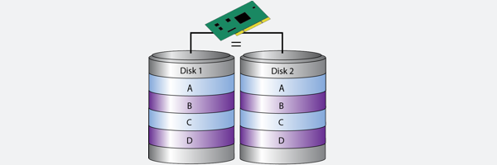

View tweets based on hash tag / screen name

Trend a topic
Find relationship between two accounts
Manage tweets of user based on date
RAID LEVEL 1

Https
Device on which twitter is hosted.

Section 3. Class Diagram

Note: Please complete the class diagrams by filling in the class name, attributes and the operations for all the classes.
The relationships among the classes and cardinality should be mentioned and it should follow UML standards

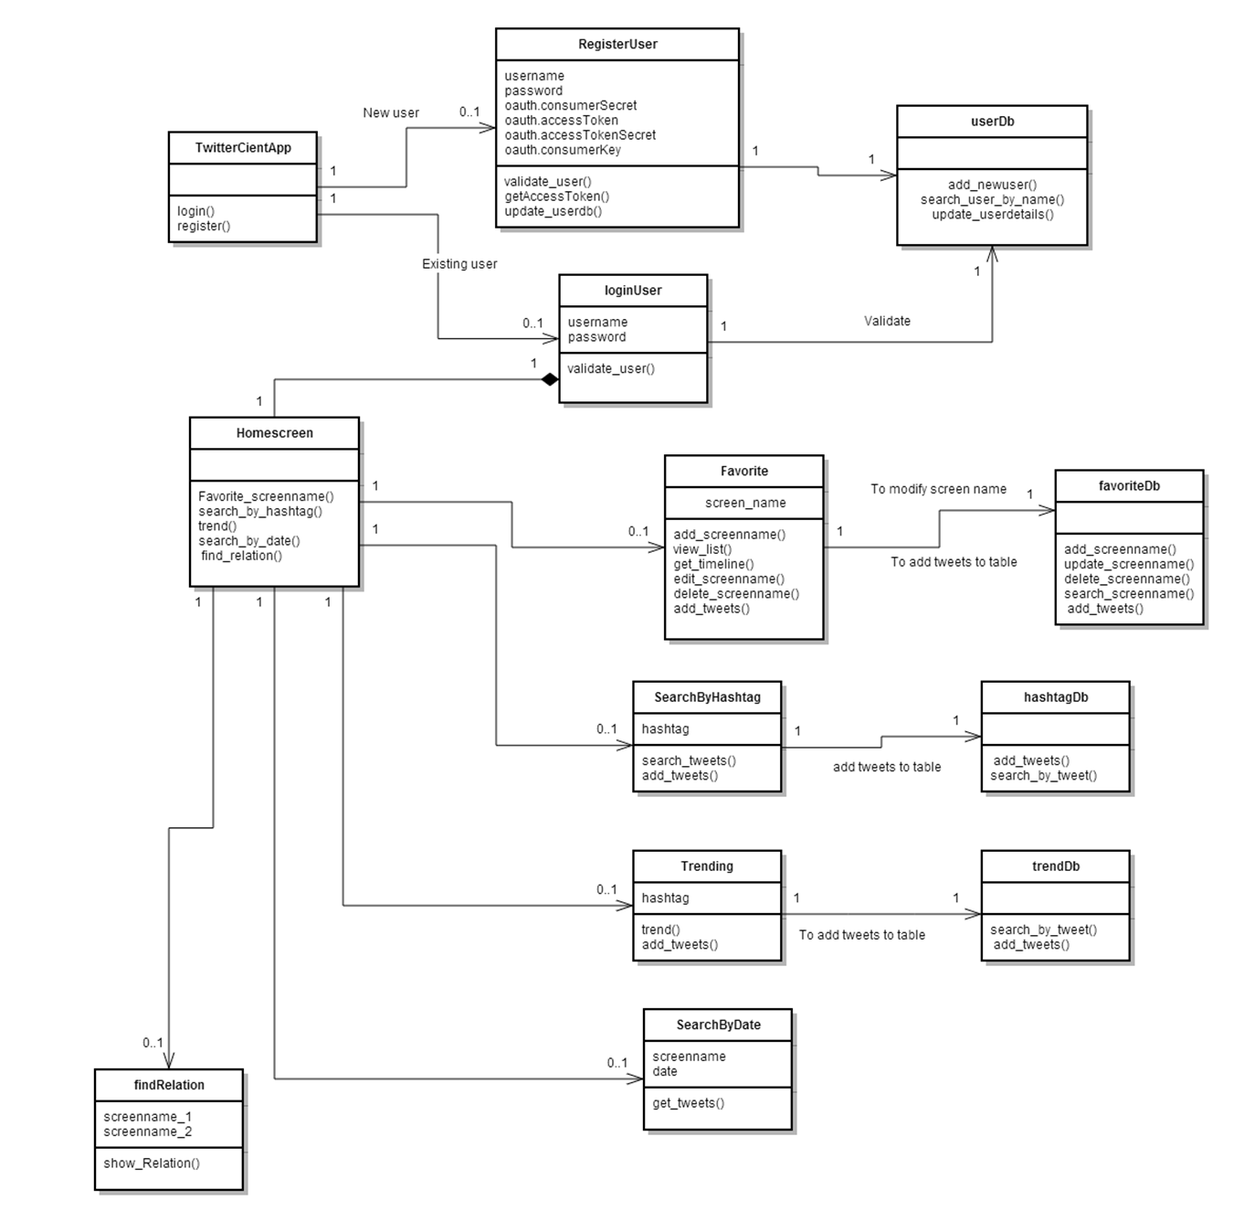

Section 4. Sequence Diagrams and Descriptions

4.1 Sequence Diagram for Login Use Case

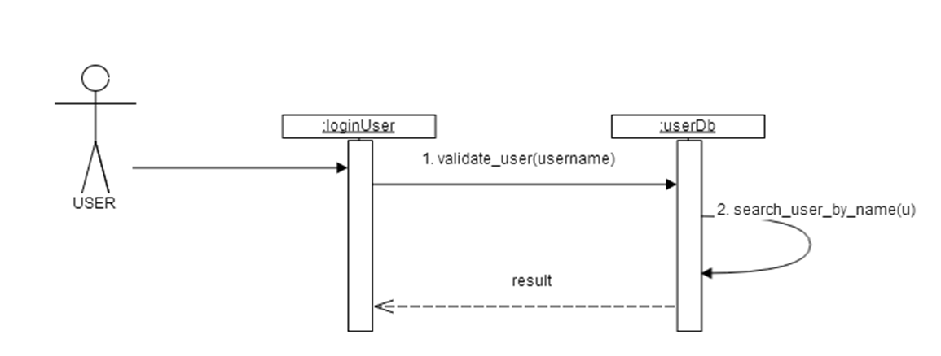

4.2 Sequence Diagram for Registration Use Case

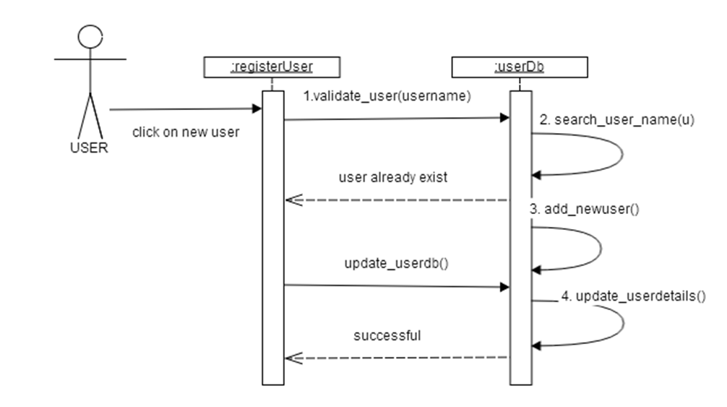

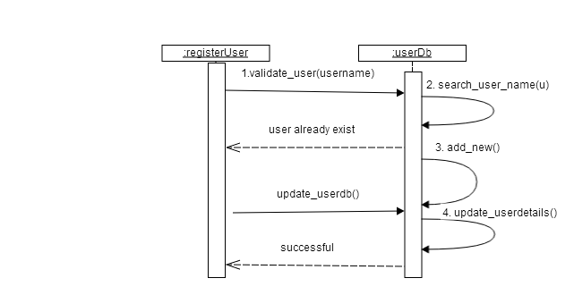

4.3 Sequence Diagram for creating favorite list Use Case

USER
USER

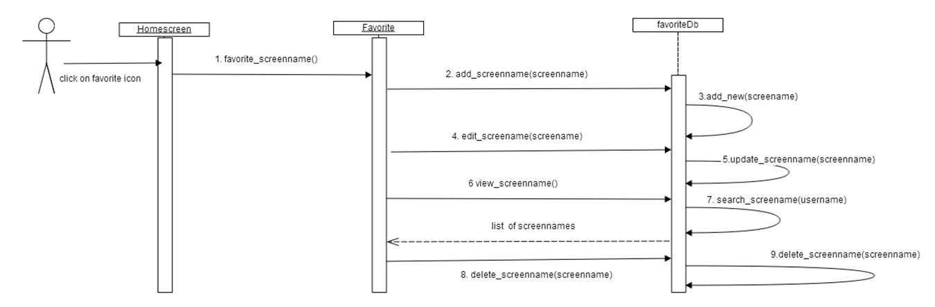

4.4 Sequence Diagram for view timeline of user in favorite list Use Case

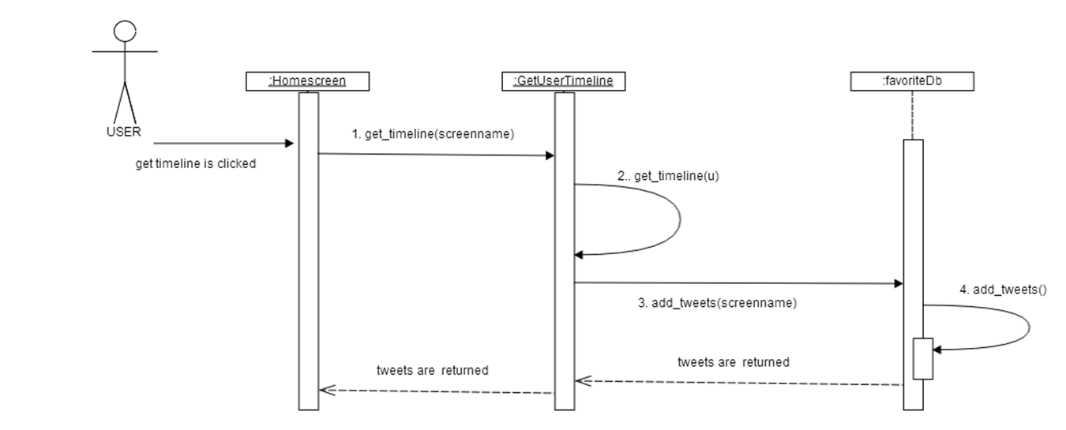

4.5 Sequence Diagram for trending a topic at twitter Use Case

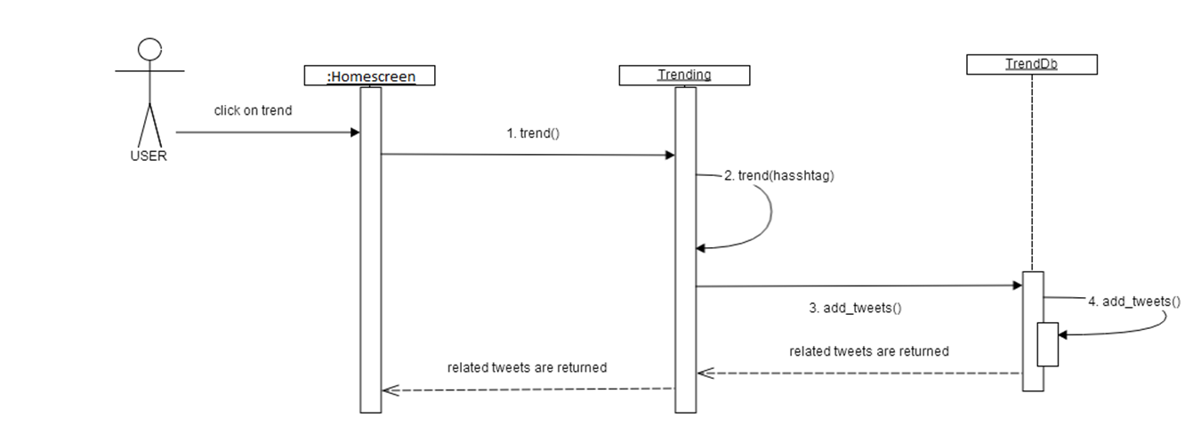

4.6 Sequence Diagram for searching tweets based on hash tag Use Case

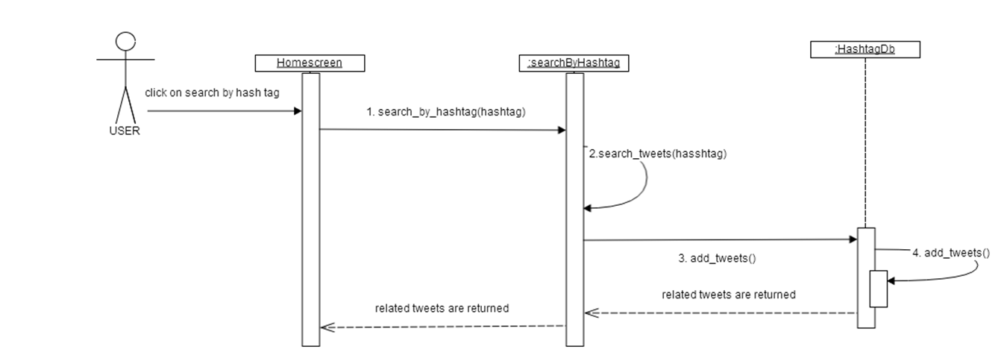

4.7 Sequence Diagram for finding relation between 2 twitter user Use Case

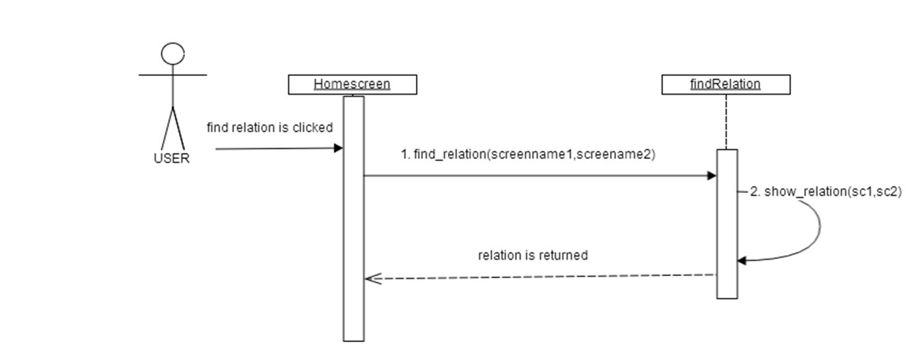

4.8 Sequence Diagram for searching tweets of a user based on date Use Case

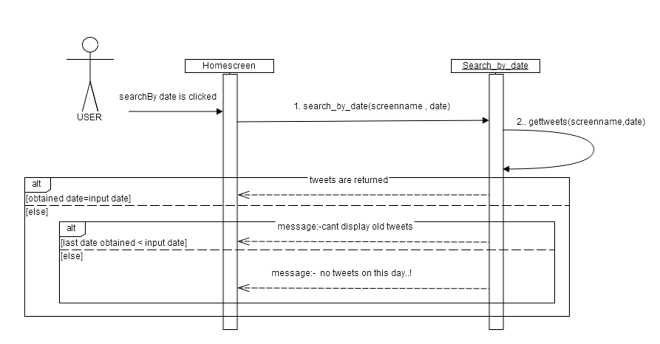

Section 5. Activity Diagram

5.1 Activity Diagram for Login

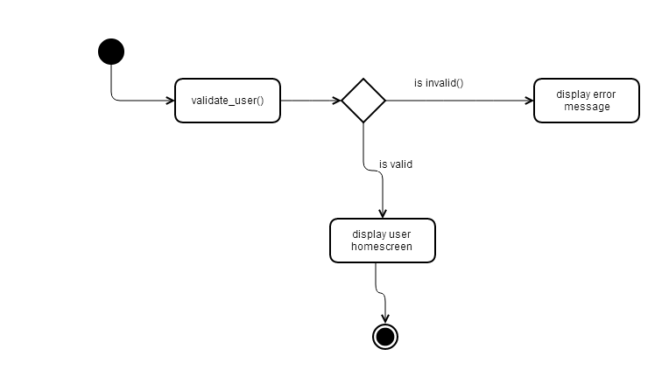

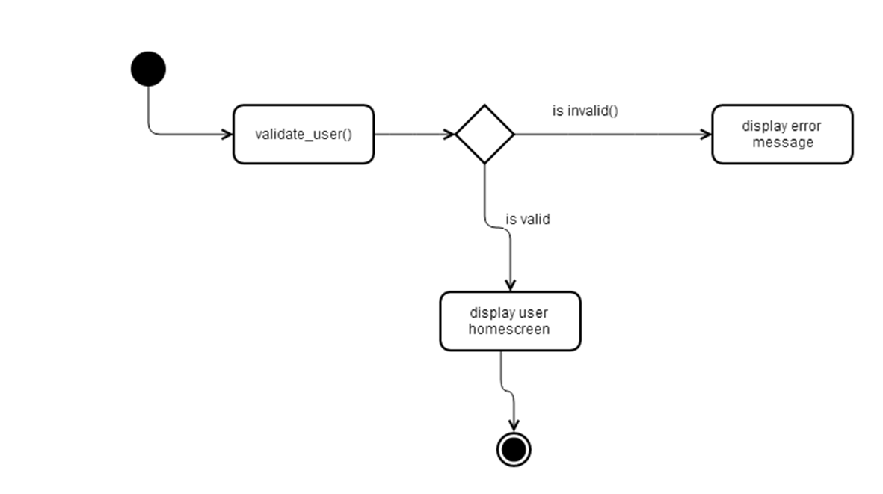

5.2 Activity Diagram for registration

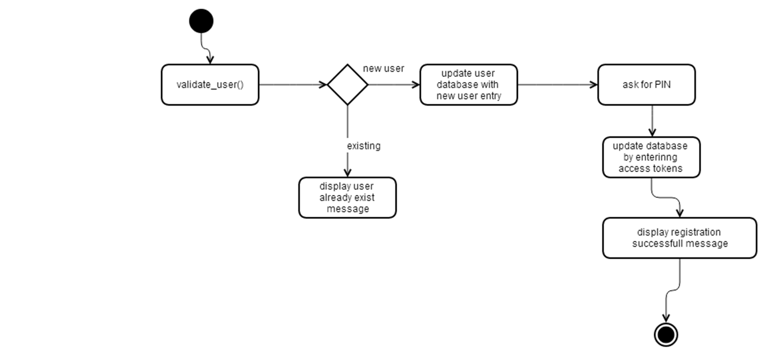

5.3 Activity Diagram for creating a favorite list

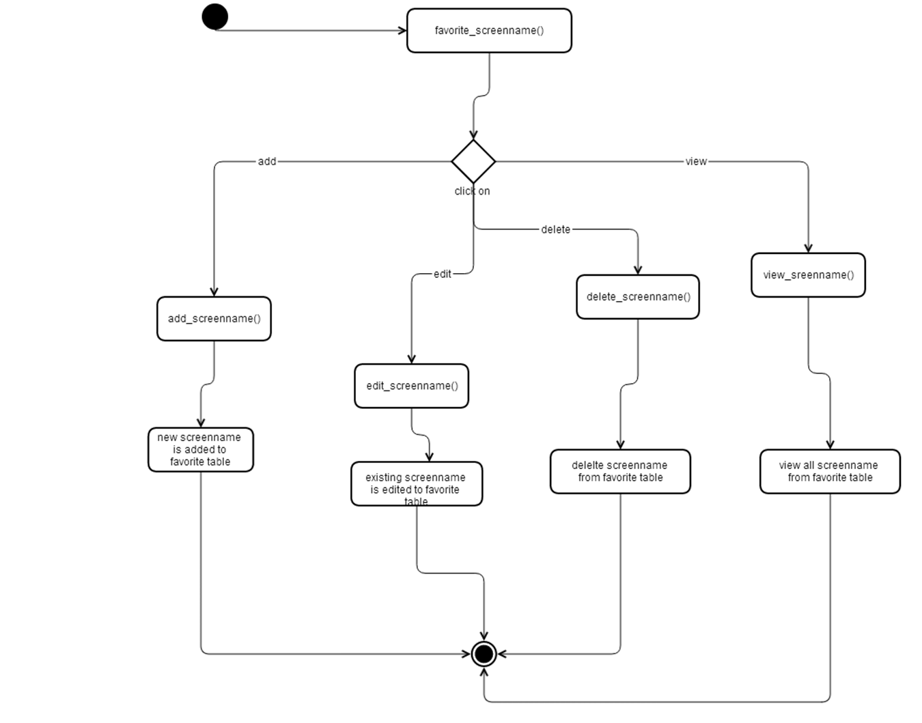

5.4 Activity Diagram for viewing timeline of a user in favorite list

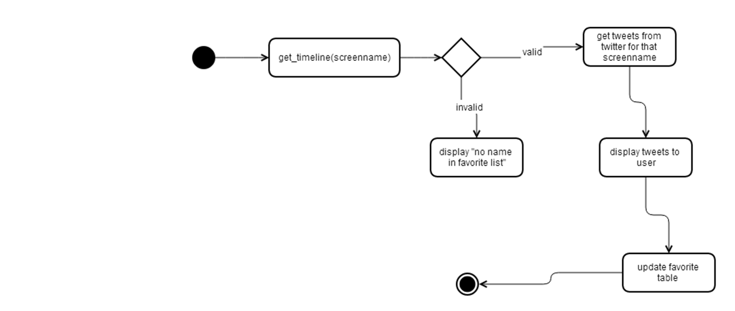

5.5 Activity Diagram for trending a topic on twitter

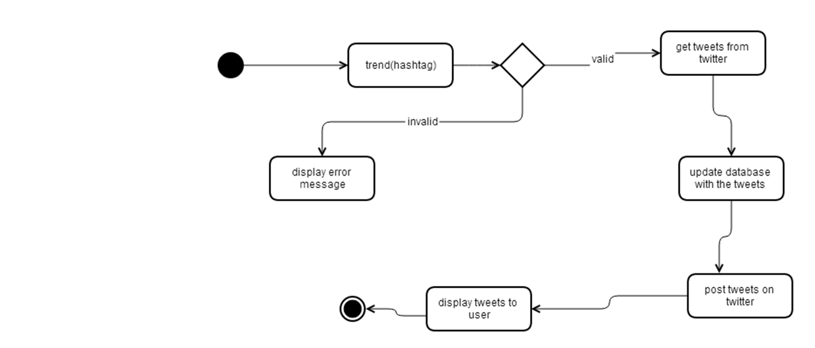

5.6 Activity Diagram for searching tweets based on hash tag

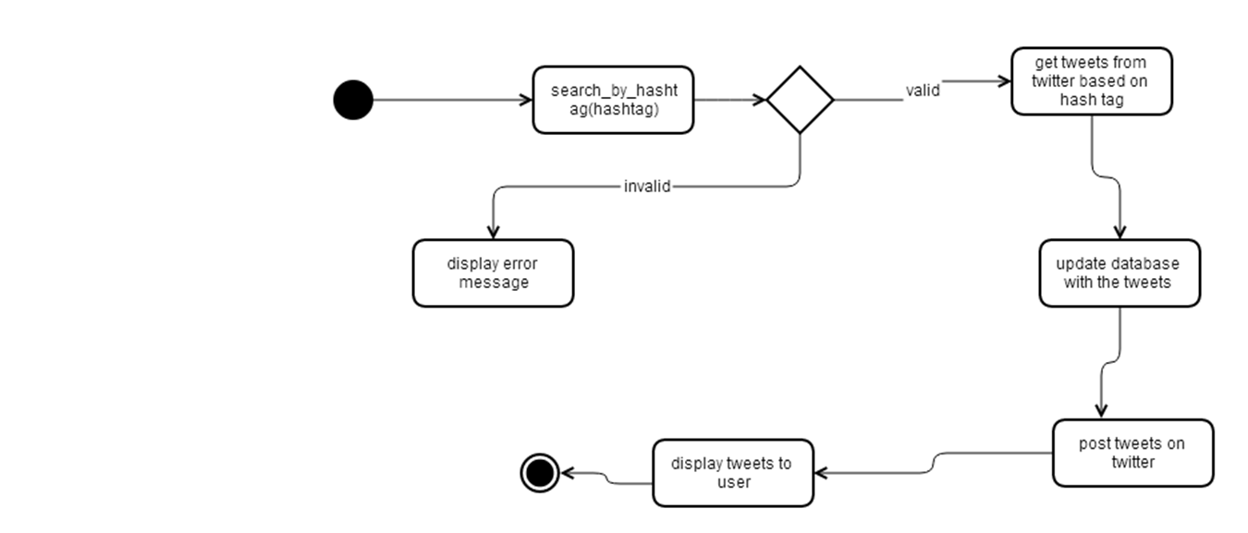

5.7 Activity Diagram for searching tweets of a user based on date

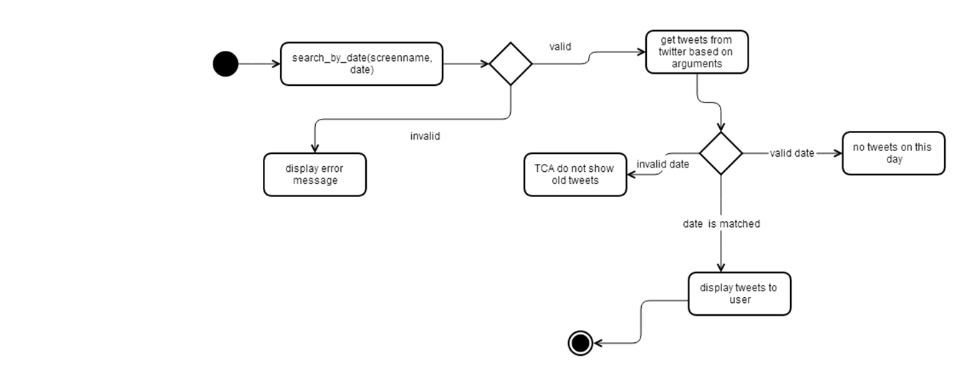

5.8 Activity Diagram for finding relation between two twitter user accounts

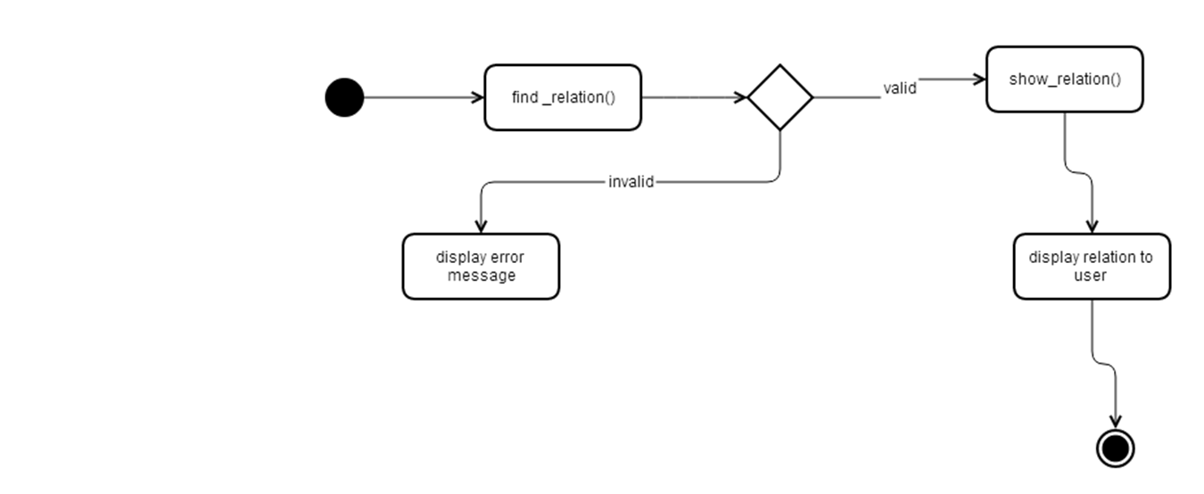

Section 6. State Chart Diagram
Objects will maintain the same state when the system is running, so there is no state diagram for this application.

Section 7. Data Design
Construct the ER diagram for the system using Visio 2007/2010.The ER diagram should reflect the rules of your system.

7.1 ER Diagram

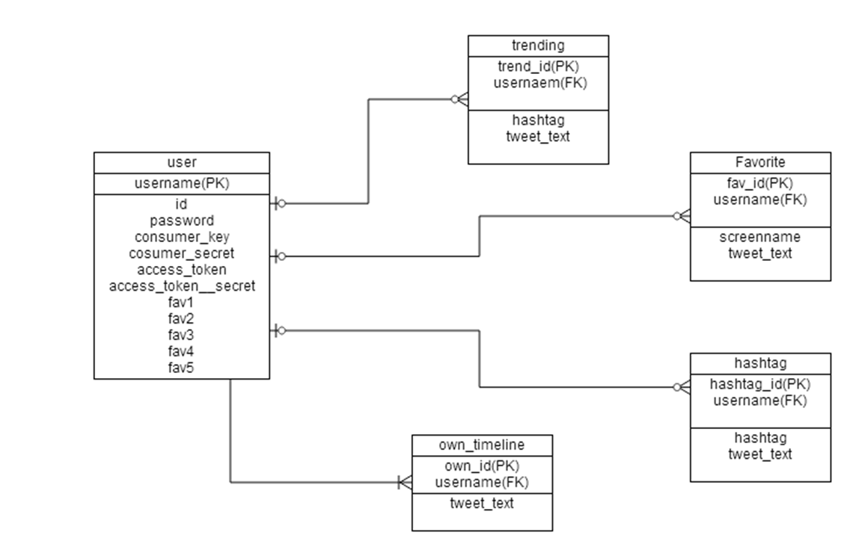

7.2 Table layout
7.2.1. User table
Attribute | Type
Username | Varchar,primary key
Id | Number,auto-increment
Password | Varchar
Consumer_key | text
Consumer_secret | Text
Access_token | Text
Access_token_secret | Text
Fav1 | Varchar
Fav2 | Varchar
Fav3 | Varchar
Fav4 | Varchar
Fav5 | Varchar

7.2.2 Favorite table
Attribute | Type
Fav_Id | Number, primary key
Username | Varchar, Foreign key
Screenname | Varchar
Tweet_text | Text

7.2.3 hashtag table
Attribute | Type
Hashtag_id | Number,primary key
Username | Varchar ,Foreign key
Hashtag | Varchar
Tweet_text | Text
Access_token_secret | Text

7.2.4 Trending table
Attribute | Type
Trend-id | Number,primary keyq
Username | Varchar ,Foreign key
Hashtag | Varchar
Tweet_text | Text

7.2.5 Own_timeline table
Attribute | Type
Own_id | Number,primary keyq
Username | Varchar ,Foreign key
Tweet_text | Text

Section 8. Data Flow Diagrams

8.1 Level 0 DFD

USER
Date, screenname
Screennames for relation
HashTag
RanR
Screennames
Trend topic

0. TCA

Show Relation
Displays relevant tweets

Registration details

8.2 Level 1 DFD

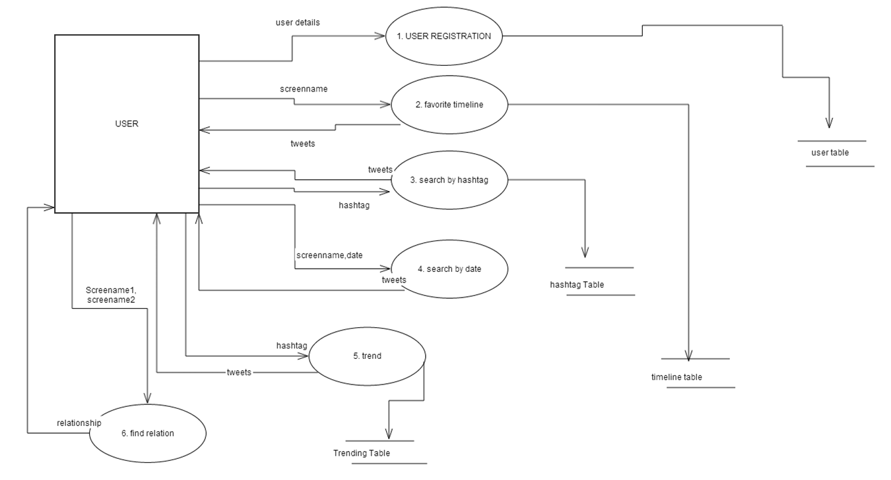

8.3 Level 2 DFD – USER Registration

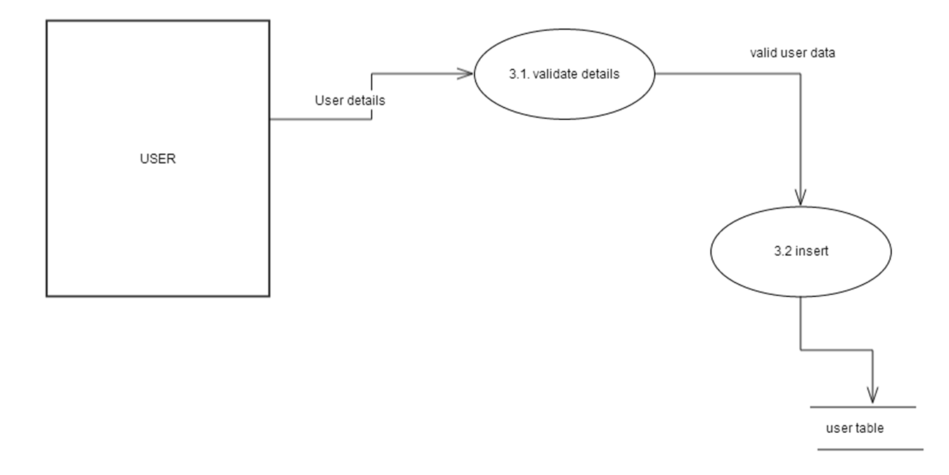

8.4 Level 2 DFD – View timeline of favorite user

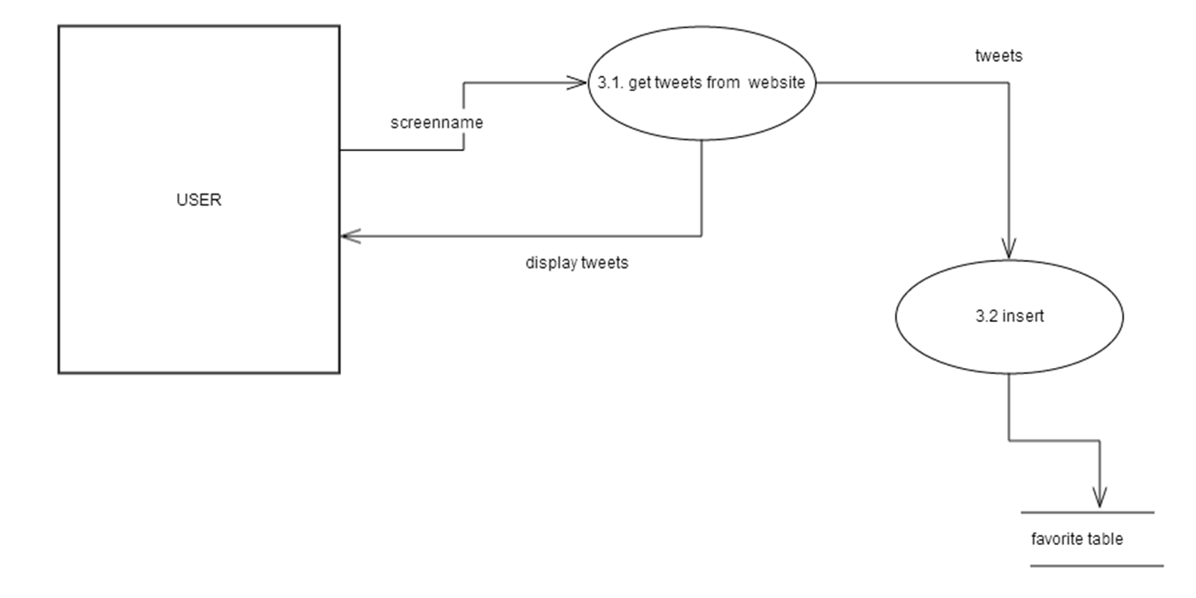

8.5 Level 2 DFD – View tweets for a user based on date

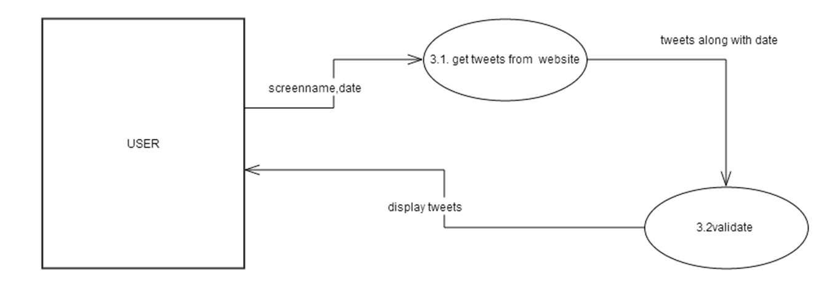

8.6 Level 2 DFD – View tweets based on hash tag

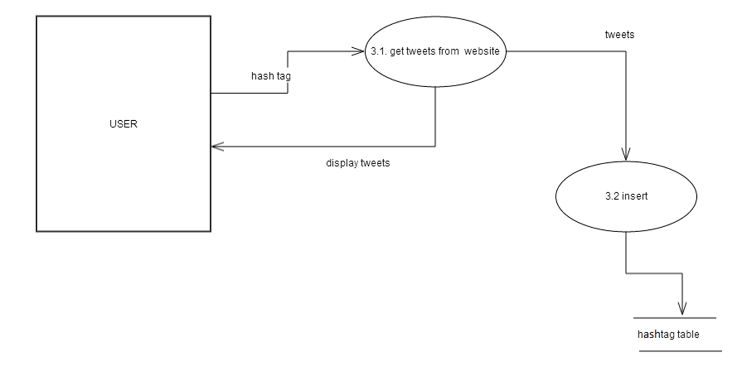

8.7 Level 2 DFD – Trend a topic

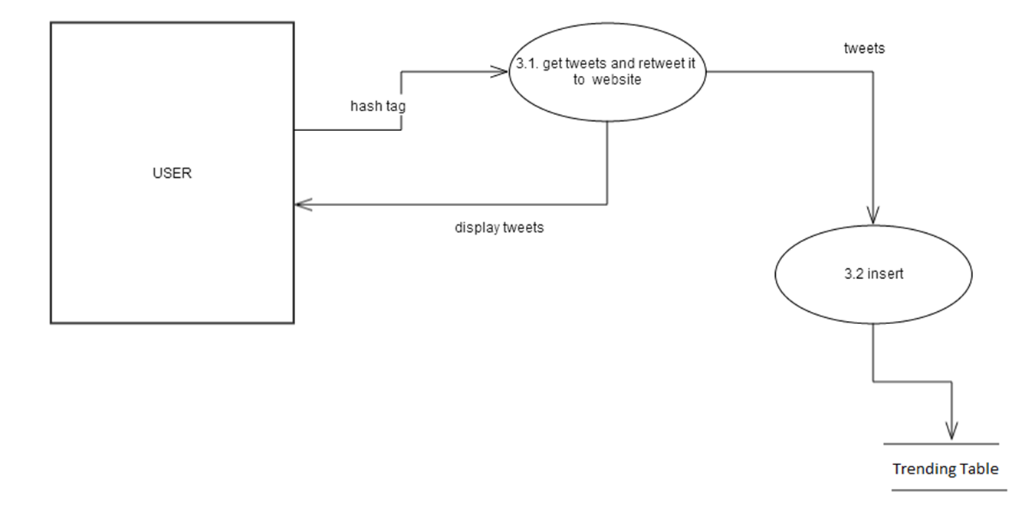

8.8 Level 2 DFD – find relationship between two user account

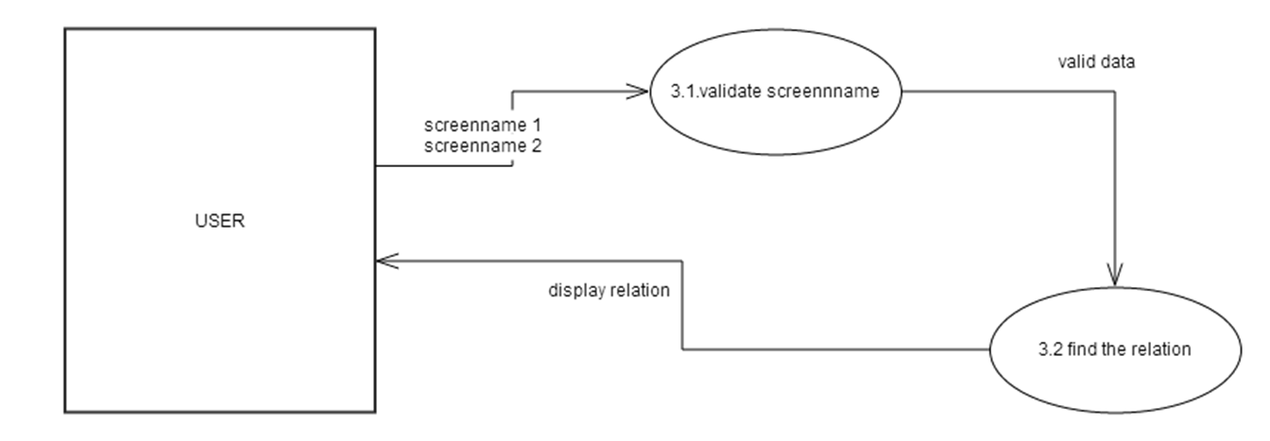

Section 9. Detailed Module Description

9.1 Login
9.1.1 Login Module supports the following functions in the following classes TwitterClientApp, loginUser, userDb
- Validate_user
- Search_user_by_name
9.1.2. Function Description
9.1.2.1. Function Name – Validate_user
9.1.2.2- Input Parameters – Character -username name ,password
9.1.2.3- Output Parameters – Not available
9.1.2.4. Called by Functions –login
9.1.2.5. Calling Functions – Search_user_by_name
9.1.2.6 Process
GET input data
CALL Search_user_by_name (username)
IF ture returned
DISPLAY login successful message and show users homescreen page
ELSE
DISPLAY username already exists.
END-IF
END

9.2 Rgistration
9.2.1. Criminal Management Module supports the following functions of the following classes TwitterClientApp, RegisterUser, userDb

- Validate_user
- Update_userdb
- getAccessToken
- register
9.2.2. Function Description
9.2.2.1. Function Name –register
9.2.2.2- Input Parameters – Character - user name , password , consumer_key, consumer_key_secret
9.2.2.3- Output Parameters – Not available
9.2.2.4. Called by Functions – Nil
9.2.2.5. Calling Functions – Validate_user, update_user_db ,getAccessToken
9.2.2.6 Process
GET input data
CALL Validate_criminal (username)
IF false returned
CALL update_user(username,password,ck1,ck2)
IF UPDATE successful
CALL getAccessToken(consumer_key,consumer_key_secret)
INPUT the PIN number which is displayed after user accepts twitter terms and conditions.
ACCESS TOKENS are received .
CALL update_user(username,accesst1,accesst2)
IF UPDATE successful
DISPLAY successfully registered
ELSE
DISPLAY Registration failed Error Message
END-IF
END

9.3 Create favorite list
9.3.1. Criminal Management Module supports the following functions of the following classes Homescreen, Favorite, favoriteDb.

- favorite_screenname
- add_screenname
- view_list
- edit_screename
- delete_screename

9.3.2. Function Description
9.3.2.1. Function Name – favorite_screenname
9.3.2.2- Input Parameters – Character - screenname
9.3.2.3- Output Parameters – Not available
9.3.2.4. Called by Functions – Nil
9.3.2.5. Calling Functions – add_screenname, view_list, edit_screename, delete_screename

9.3.2.6 Process
GET input data
IF add button clicked
CALL add_screenname (screenname)
IF valid returned
DISPLAY screenname Added Successfully
ELSE
DISPLAY Error while adding .
END-IF
END-IF
IF EDIT button clicked
CALL edit_screenname (screenname)
IF valid returned
DISPLAY screenname EDITED Successfully
ELSE
DISPLAY Error while editing.
END-IF
END-IF
IF delete button clicked
CALL delete_screenname (screenname)
IF valid returned
DISPLAY screenname deleted successfully
ELSE
DISPLAY Error while deletion.
END-IF
END-IF
IF view button clicked
CALL view_list()
DISPLAY list of screennames.
END-IF
END

9.4 View timeline of favorite use
9.4.1 Criminal Management Module supports the following functions of the following classes Homescreen, Favorite, favoriteDb.
- get_timeline
- add_tweets
- search_screenname
9.4.2. Function Description
9.4.2.1. Function Name – get_timeline
9.4.2.2- Input Parameters – Character –screen name
9.4.2.3- Output Parameters – tweets (String)
9.4.2.4. Called by Functions – favorite_screenname
9.4.2.5. Calling Functions – search_screenname, add_tweets
9.4.2.6 Process
GET input data
CALL search_screenname (screenname)
IF valid returned
CALL gettweets()
CALL add_tweets (tweets)

DISPLAY tweets
ELSE
DISPLAY Error Message
END-IF
END

9.5 Search tweet based on hash tag
9.5.1 Search tweet based on hash tag Module supports the following functions of the following classes Homescreen, SearchByHashtag, hashtagDb.
- search_by_hashtag
- search_tweets
- add_tweets
9.5.2. Function Description
9.5.2.1. Function Name – search_by_hashtag
9.5.2.2- Input Parameters – Character –hashtag
9.5.2.3- Output Parameters – tweets (String)
9.5.2.4. Called by Functions – nil
9.5.2.5. Calling Functions – search_tweets, add_tweets
9.5.2.6 Process
GET input data
CALL search_tweets(hashtag)
IF valid
CALL add_tweets (tweets)

DISPLAY tweets
ELSE
DISPLAY Error Message
END-IF
END

9.6 Search tweet of user based on date
9.6.1 Search tweet of user based on date Module supports the following functions of the following classes Homescreen, SearchByDate.
- search_by_date
- get_tweets
9.6.2. Function Description
9.6.2.1. Function Name – search_by_date
9.6.2.2- Input Parameters – Character –screenname, integer input_date
9.6.2.3- Output Parameters – tweets (String)
9.6.2.4. Called by Functions – nil
9.6.2.5. Calling Functions – get_tweets
9.6.2.6 Process
GET input data
CALL get_tweets (screenname)
IF obtained_date==input_date
DISPLAY tweets
ELSE
IF obtained_date > input_date
DISPLAY No Tweets On This day . Error Message
ELSE
DISPLAY Cant Display Old tweets Error Message
END-IF
END-IF
END

9.7 Trend a topic
9.7.1 Trend a topic Module supports the following functions of the following classes Homescreen, Trending, trendDb.
- Trend
- search_tweets
- add_tweets
9.7.2. Function Description
9.7.2.1. Function Name – trend
9.7.2.2- Input Parameters – Character –hashtag
9.7.2.3- Output Parameters – tweets (String)
9.7.2.4. Called by Functions – trend
9.7.2.5. Calling Functions – search_tweets, add_tweets
9.7.2.6 Process
GET input data
CALL search_tweets(hashtag)
IF valid
CALL add_tweets (tweets)

DISPLAY tweets
ELSE
DISPLAY Error Message
END-IF
END

9.8 Find relation between 2 twitter users
9.8.1 Find relation between 2 twitter users Module supports the following functions of the following classes Homescreen, findRelation.
- find_relation
- show_relation
9.8.2. Function Description
9.8.2.1. Function Name – find_relation
9.8.2.2- Input Parameters – Character –screenname1, screenname2
9.8.2.3- Output Parameters – string
9.8.2.4. Called by Functions – nil
9.8.2.5. Calling Functions – show_relation
9.8.2.6 Process
GET input data
CALL show_relation(screenname1,screenname2)
IF following=TRUE
DISPLAY screenname1 is following screenname 2
ELSE
DISPLAY screenname1 is not following screenname 2
END-IF
IF followed_by=TRUE

DISPLAY screenname2 is following screenname 1
ELSE
DISPLAY screenname2 is not following screenname 1
END-IF
END

Section 10. User Interface Design

10.1 User Interface Screen for User Login

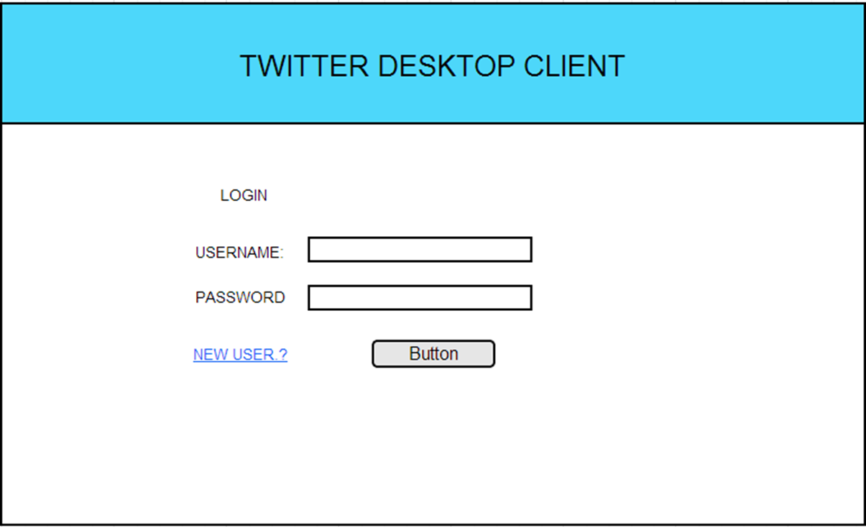

10.2 User Interface Screen for New User Registration

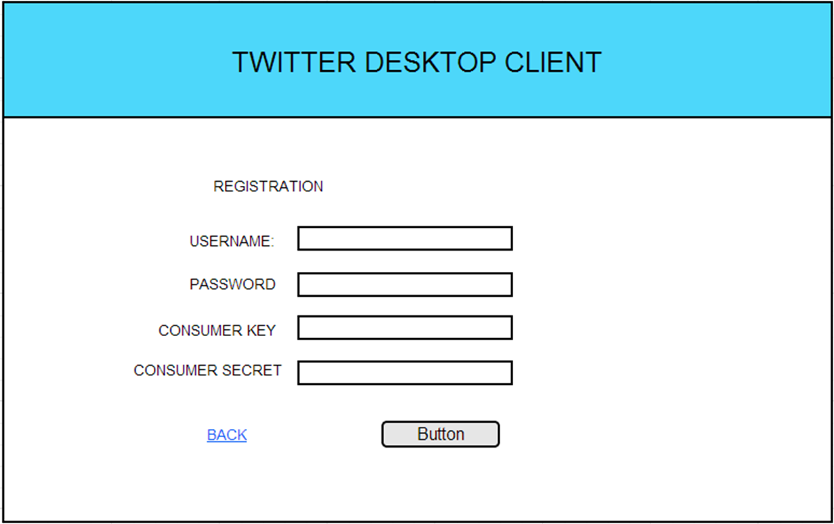

10.3 User Interface Screen for Home Page

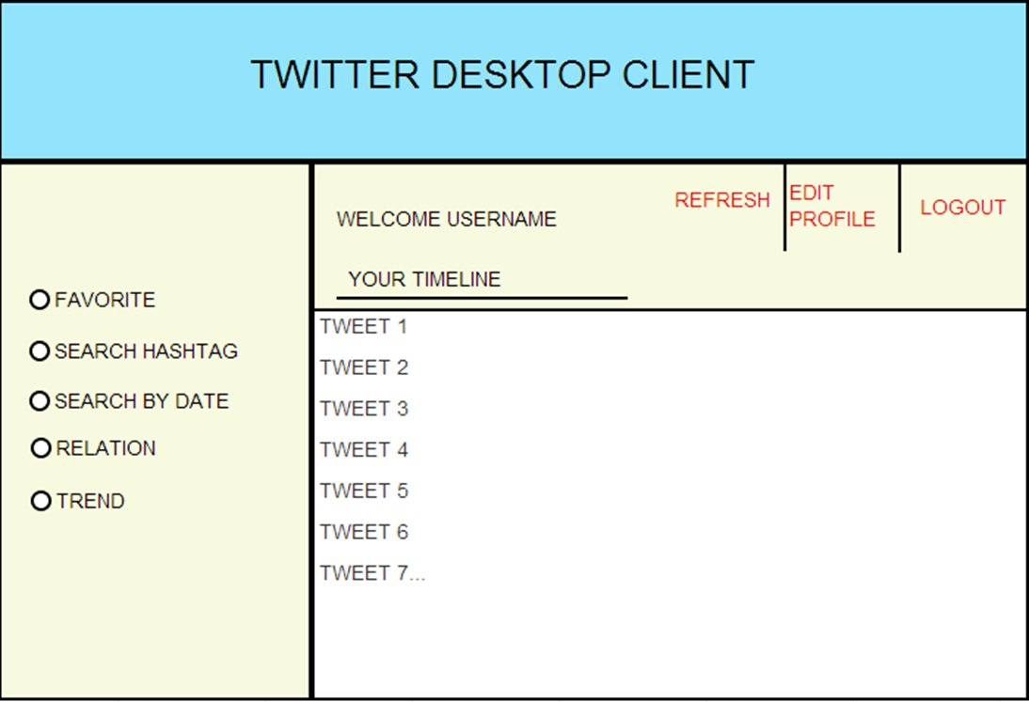

10.4 User Interface Screen for view favorite users timeline

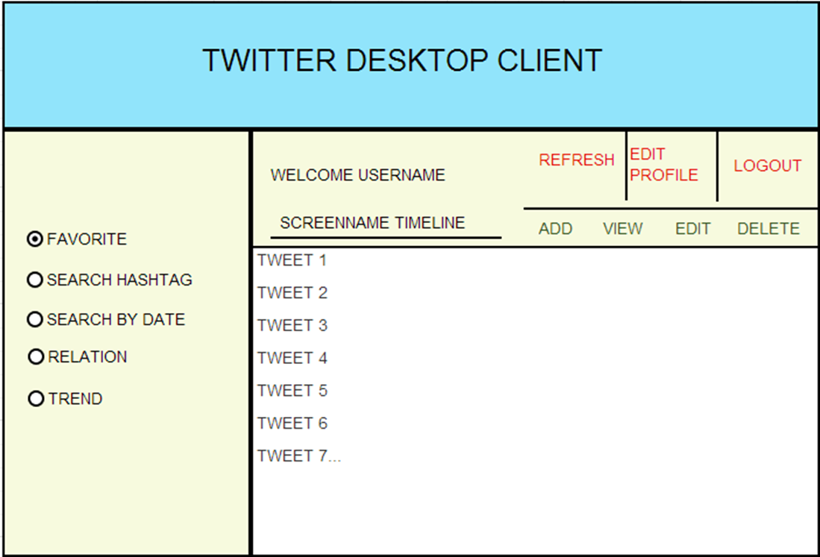

10.5 User Interface Screen for viewing tweets based on hash tag

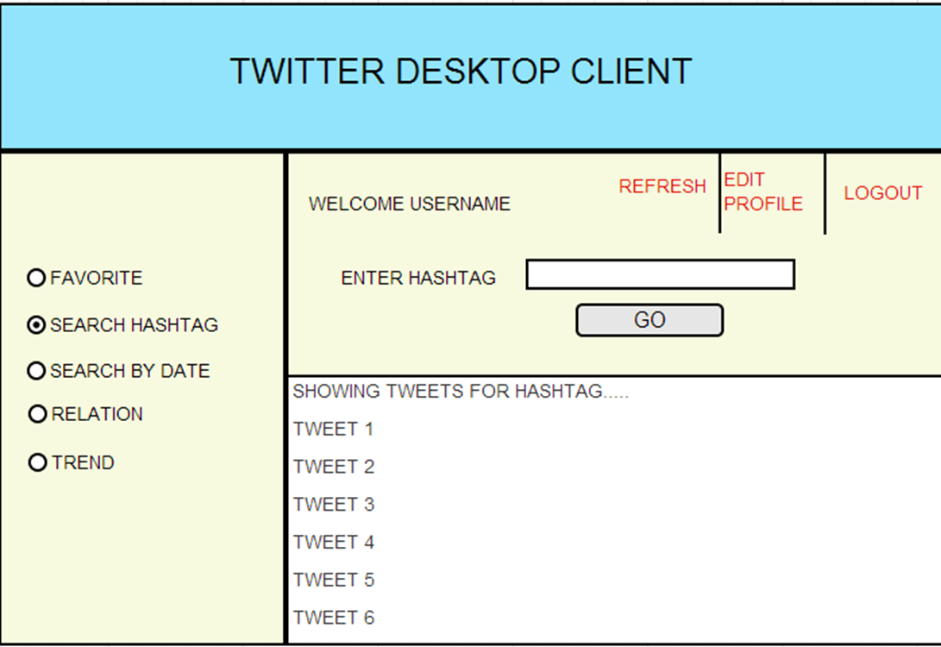

10.6 User Interface Screen for view tweets based on date

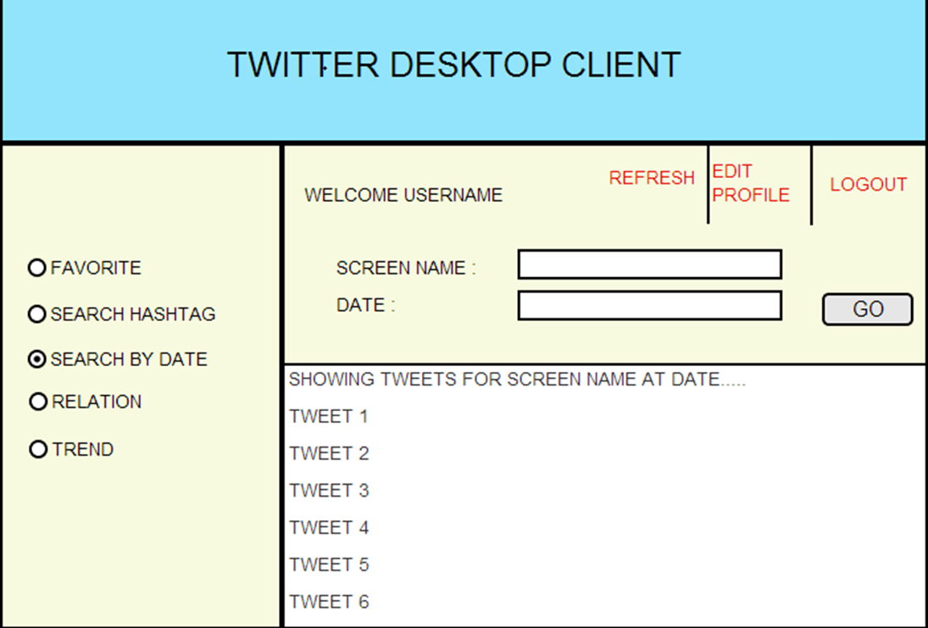

10.7 User Interface Screen for view Trending a topic

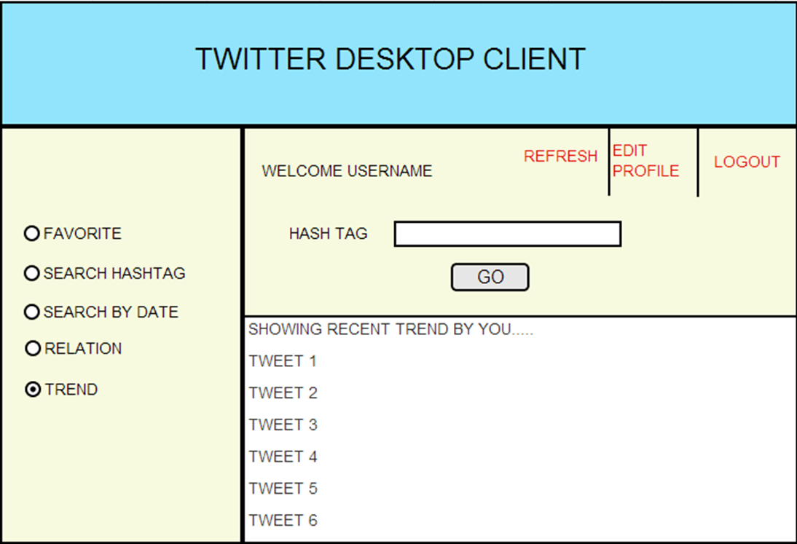

10.8 User Interface Screen for viewing relation between 2 user accounts

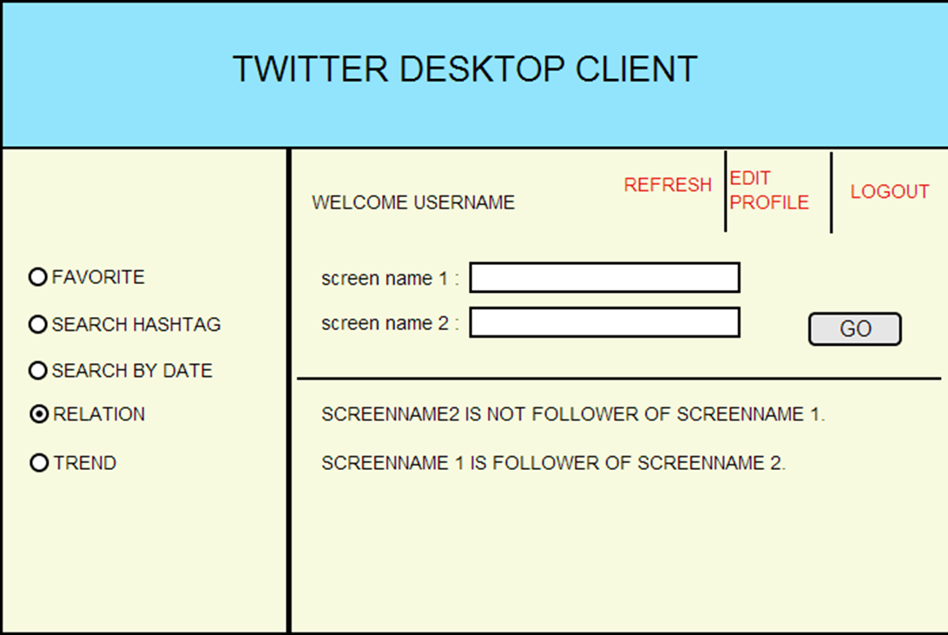

Section 11. Requirements Traceability Matrix
Provide reference to the location of the Requirements Traceability Matrix that indicates traceabilty from the system requirements documented in the System Requirements Specification (SRS) to the design elements documented in the System Design Description (SyDD), the design elements documented in the SyDD to the software requirements documented in the SRS, and the software requirements documented in the SRS to the design elements documented in the Software Design Description (SDD).

Requirement ID | Design Component
6.2.1 | 4.2, 5.2, 7.2.1, 8.3 , 9.2, 10.2
6.2.2 | 4.1, 5.1, 7.2.1, 9.1, 10.1
6.2.3 | 4.3 ,4.4 , 5.3 ,5.4 ,7.2.2 ,8.4 ,9.3 ,9.4 ,10.4
6.2.4 | 4.7 ,5.8, 8.8, 9.8, 10.8
6.2.5 | 4.8, 8.5, 5.7, 9.6, 10.6
6.2.6 | 4.6, 5.6, 7.2.3, 8.6, 9.5, 10.5
6.2.7 | 4.5, 5.5, 8.7, 9.7, 7.2.4, 10.7

Section 12. References
Provide a list of all documents and other sources of information referenced in the Software Design Description (SDD) and utilized in developing the SDD. Include for each the document number, title, date, and author.
Document No. | Document Title | Date | Author
Version 2.0 | Software Requirements Specification – Criminal Management System | 29-Jan-13 | Satish.C.J

Section 13. Glossary
Define all terms and acronyms required to interpret the Software Design Description properly

Abbreviation | Designation
TCA | Twitter Client Application
Twitter | A social media website that allows users to publicly share short sentences, or Tweets
Tweet | A text string posted by a Twitter user (140 characters or fewer)
ReTweet/trend | The process of re-posting someone else’s tweet on one’s own profile
Follower | One user on Twitter can follow another in order to directly receive their Tweets
SRS | Software Requirements Specification
.

Section 14. Revision History
.
Version | Date | Name | Description

Section 15. Appendices

Twitter4J is an unofficial Java library for the Twitter API.--- http://twitter4j.org/en/index.htm which helps the application get tweets/post tweets on twitter website.

Along with this it is mandatory for every user to associate his/her application with his twitter account and get all the access tokens keys and consumer keys. Along with this user must make sure what access right has been granted for his application. Application will be perform only valid operation which is granted to it based on access rights. New app user can register their app at https://apps.twitter.com/ .

Complete registration process can be referred from the below link http://xmeng.wordpress.com/2011/07/10/how-to-handle-sign-in-with-twitter-using-twitter4j/#comment-23 .

