I

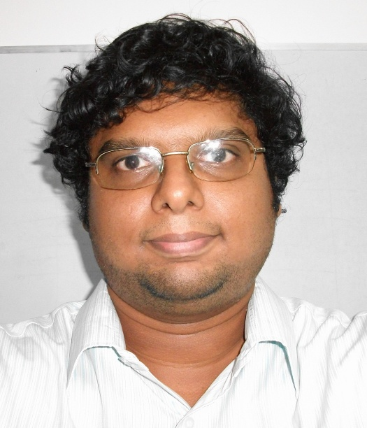
Hi, I am A.K.Karthikeyan, the author of this book. I came across Ruby and found that the language was dazzling. I thought why not write a book for self study and so was created this book.
Currently I am an web programmer, I use Ruby on Rails due to its great innovative features. You can contact me at mindaslab@gmail.com or tweet to @karthik_ak
This book is no match to other Ruby best sellers, this is just an attempt to have a personalized Ruby study material.

Kannan Doss

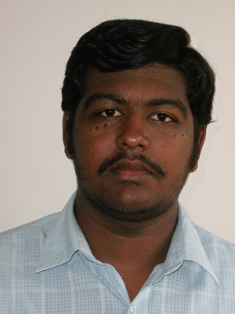
I am very much grateful Kannan Doss who worked in Mind As Lab as a apprentice web developer and a Ruby on Rails Geek for putting sincere efforts to improve the quality of this book. He has proof read the entire book, spotted mistakes he could find, cataloged them and corrected them.
Without him the book wont be a good quality as it is now. I am not saying that this book is superb. But his efforts truly played a decisive role to make this book what it is.
You can contact Kannan at doss.kannan@gmail.com

Jawahar

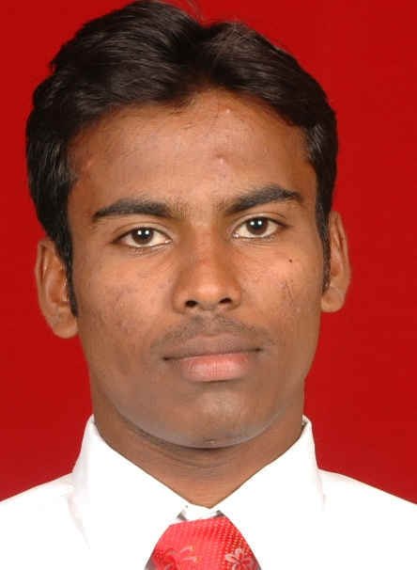
Jawahar trains in Webtoday business, has good management skills. He is also taking part in I Love Ruby (facebook group) propaganda. I am happy that he is contributing his efforts to this book. Jawahar graduated from Satyabama University in the discipline Computer Science Engineering.
You can contact him at: jawahar.cs3@gmail.com

Premchander

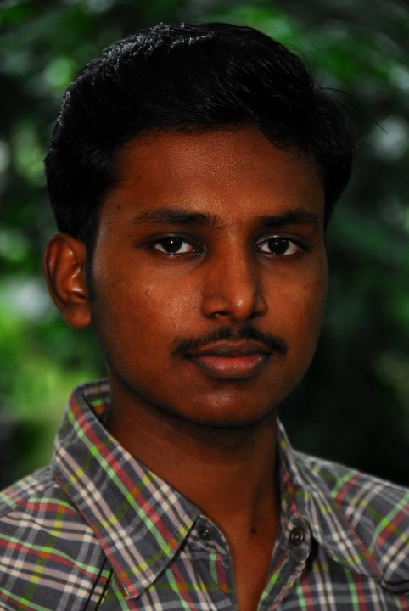
Premchander thinks and works like a scientist. He some how finds right solutions for many problems, and at times some how links Ruby programming with worm-holes and other stuff. He trains in Webtoday Business as a Rails programmer. Prem graduated from Veltch Chennai in the discipline of Electronics and Communication Engineering.
You can contact him at: premcspc@gmail.com

Saidev

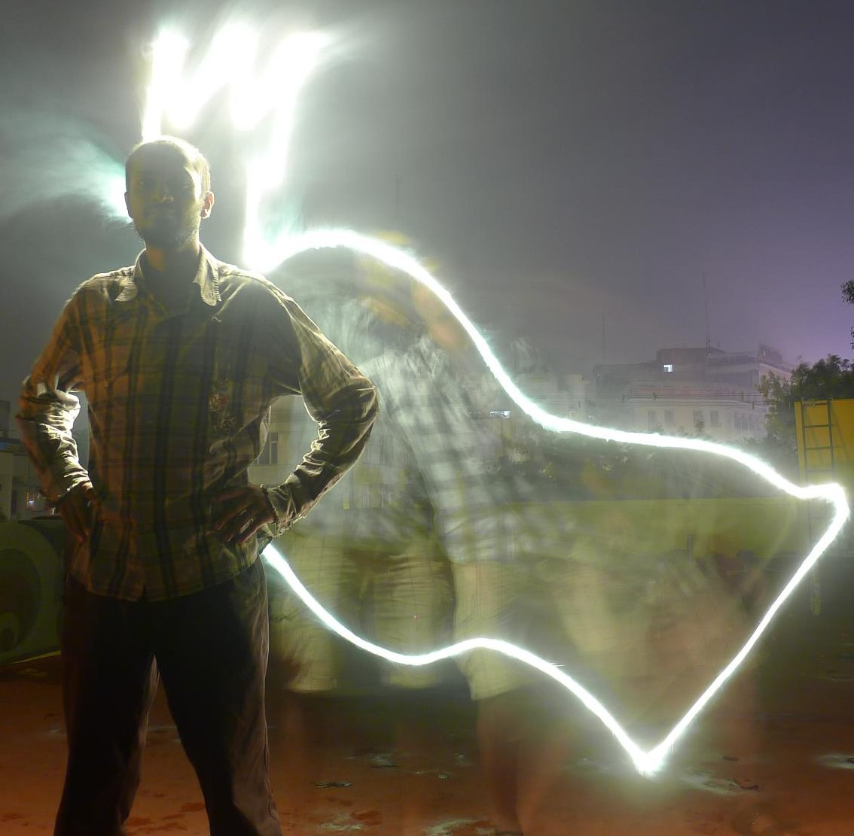
Saidev works in Webtoday Business as a Rails developer. He could become a Ruby and Rails Jedi if he wishes. He graduated from Campus of Guindy Annauniversity in the discipline of Computer Science Engineering and helped to spot many mistakes in this book.
He can be contacted at: sai@webtodaybusiness.com

