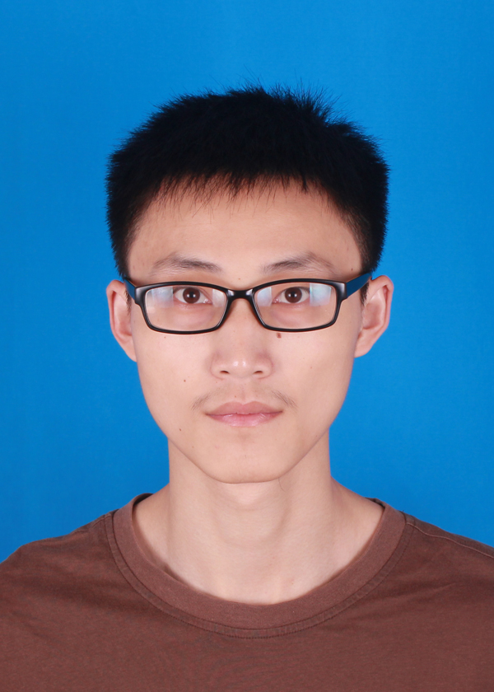 |  | DaWei Min（闵大为）
 |  | 2018's graduates of Zhejiang University
 |  | m920376513@163.com
 |  | （+86）187-9595-0169
EDUCATION
2015.9 - present | Zhejiang University |  | Computer Science & Technology |  |  |  | M.Sc. |  |  | Rank：3/24
 | Huawei Scholarship (second-rate)
 | Miyoshi Graduate (Top 15%), Outstanding Graduate (Top 35%)
2011.9 - 2015.6 | Nanjing University of Science&Technology |  |  | Software Engineering |  |  | B.Eng. |  |  | Rank：1/80
 | National Scholarship, Special Grade Scholarship (Twice), First Grade Scholarship (Twice)
 | Outstanding Graduates, Merit Student (Twice)
PROJECT EXPERIENCE
2015.9 - present | Maintenance & Development of Traffic Simulation Platform |  |  |  |  | Java |  | Indie Developer
The project simulates the traffic behavior of the vehicle on the road. My work is as follows:
1) Read the code (34,000 lines) and repair bugs to maintain the project.
2) Increase the function of the simulation platform, including the simulation of traffic lights, the automatic expansion of the road lane, the optimization of the intersection turning trajectory and so on.
3) Develop a web demo to use the history data of HD capture system to generate the vehicle route.
4) Reconstruct the original project into a number of sub projects, and write a documentation with more than 10,000 words.
2015.9 - 2016.2 | Traffic Congestion Index Project of Ningbo City |  |  |  |  | Java |  | Core Person
 | The project uses the GPS data of more than 20,000 vehicles in Ningbo road transport authority to calculate road congestion. I completed the congestion index calculation module in the project, to achieve the GPS data to the congestion index conversion model.
CONTEST EXPERIENCE
2016.3 - 2016.7 | Alibaba Music Trends Forecast Contest |  |  |  | Geek Award |  |  |  | Captain
 | The contest requires participants to use the first 6 months of broadcast data to predict the next 2 months of broadcast data. In the contest, I am responsible for data cleaning, data smoothing and writing rules. Finally, our team ranked 12 (5476 teams), won the Geek Award and was awarded Alibaba Cloud Certified Big Data Technical Certification (ACP Level).
2016.3 - 2016.5 | Ppdai Data Products Contest |  |  |  | Silver Award |  |  |  | Member
 | The contest requires participants to develop a data public opinion product to help users understand the status of the P2P industry. In the contest, I am responsible for website design, development and deployment. Finally, our team ranked 2, won the Silver Award and got 50,000 yuan bonus.
PERSONAL INFORMATION
English Skill | CET6
Position Applied | Software Engineer (Java preferred)
Self-Evaluation | Take responsibility and have a passion for programming

