Here is the comparison cross the 4 groups in terms of the reported threshold:

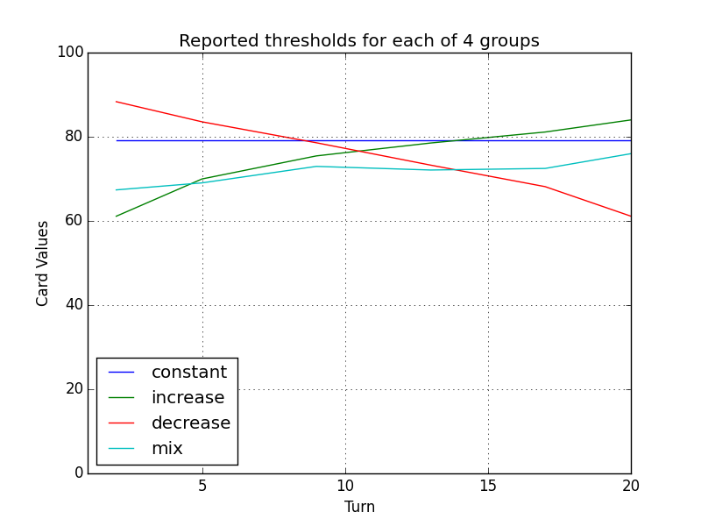

the followings are 4 graphs , each is about plotting all the subjs data in each group of the 4 , and also plotting the mean for each group correspondingly. It is a little bit mess there because of lots of subjs. The MEAN line is colored heavy black line.

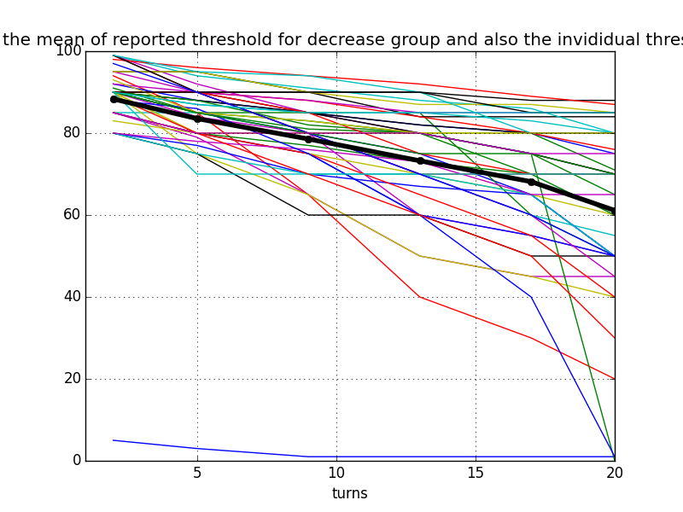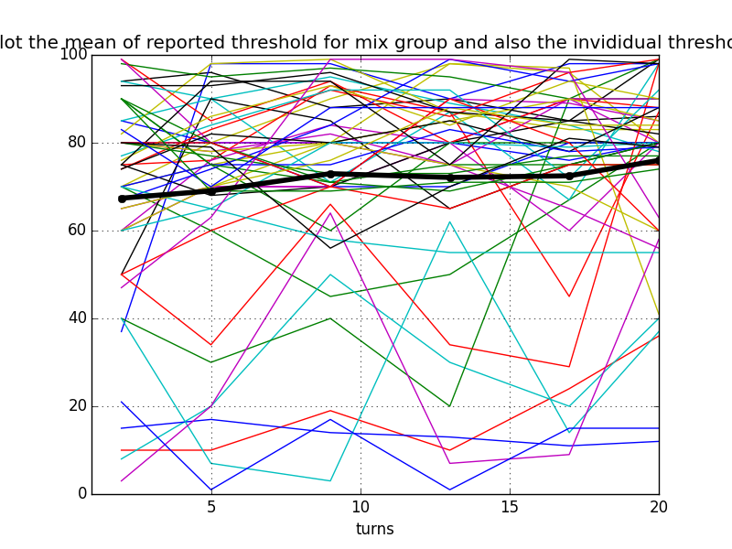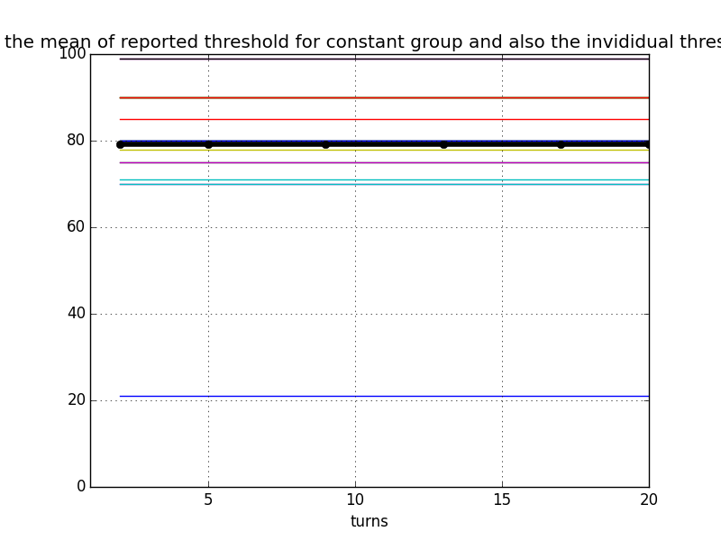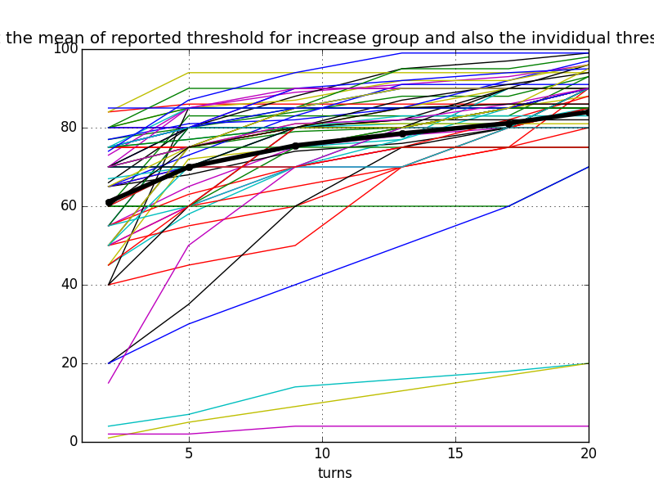

the following are the 4 groups, each is about plotting both the reported threshold and also the modeling threshold based on Model B

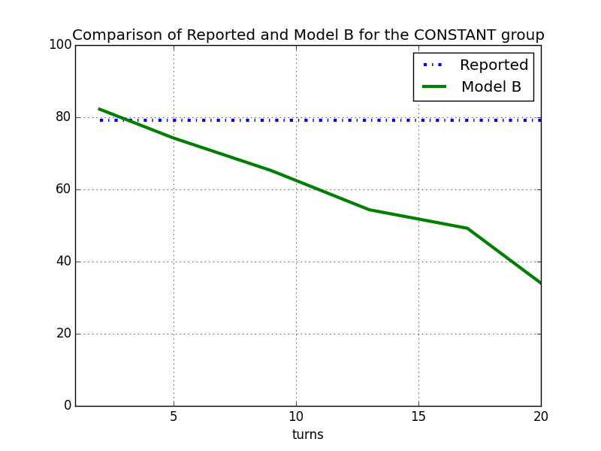

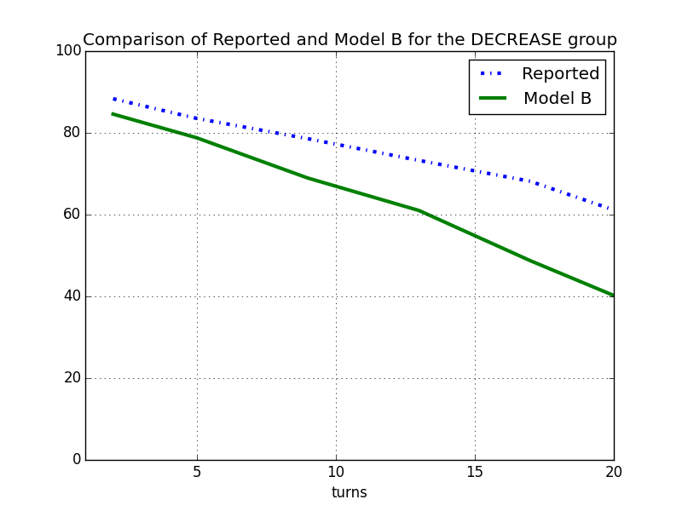

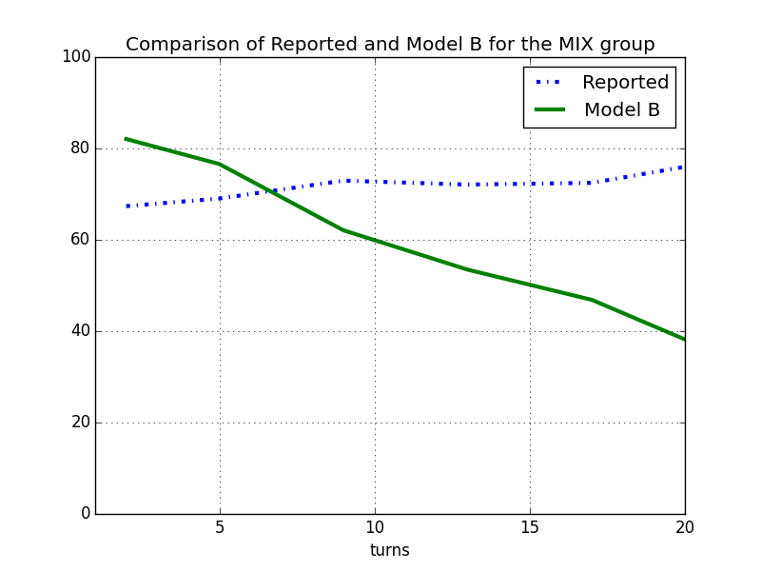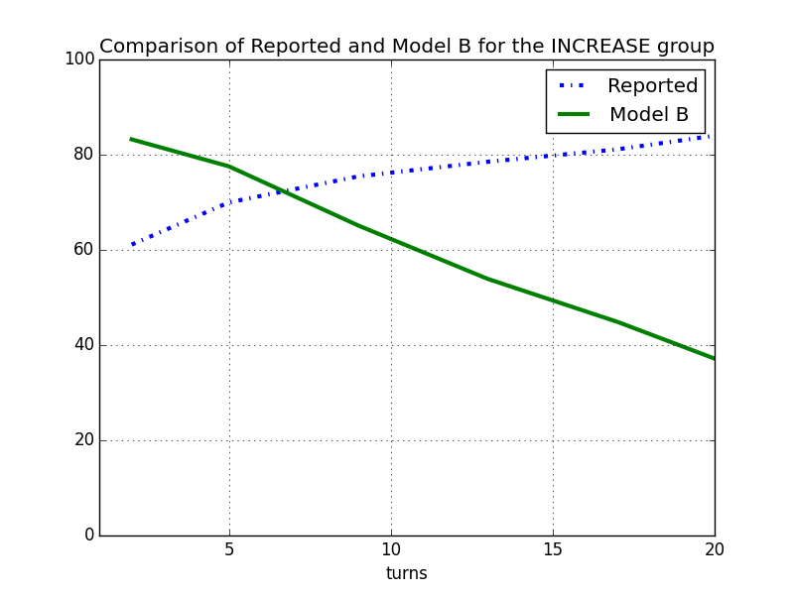

the following are the tables showing the number of subjects each model best fit:

across all the subjects:

an interesting finding is that though secretary model is not the best or the second best, but it fits a substantial amount of subjects the best.

|  |  |
| --- | --- |
| jump | 70 |
| jump_7 | 51 |
| secretary | 40 |
| fix | 13 |
| modelB | 11 |
| random_k | 2 |
| k_step | 1 |

For decrease group:

|  |  |
| --- | --- |
| jump_7 | 18 |
| jump | 12 |
| secretary | 8 |
| modelB | 5 |
| fix | 4 |

For increase group:

|  |  |
| --- | --- |
| jump | 32 |
| secretary | 20 |
| jump_7 | 13 |
| fix | 4 |
| modelB | 2 |

For mix group:

|  |  |
| --- | --- |
| jump | 18 |
| jump_7 | 15 |
| secretary | 8 |
| modelB | 4 |
| fix | 3 |
| random_k | 2 |
| k_step | 1 |

For constant group:

|  |  |
| --- | --- |
| jump | 8 |
| jump_7 | 5 |
| secretary | 4 |
| fix | 2 |

---------------------------------------new results for jumpturn model---------------------------

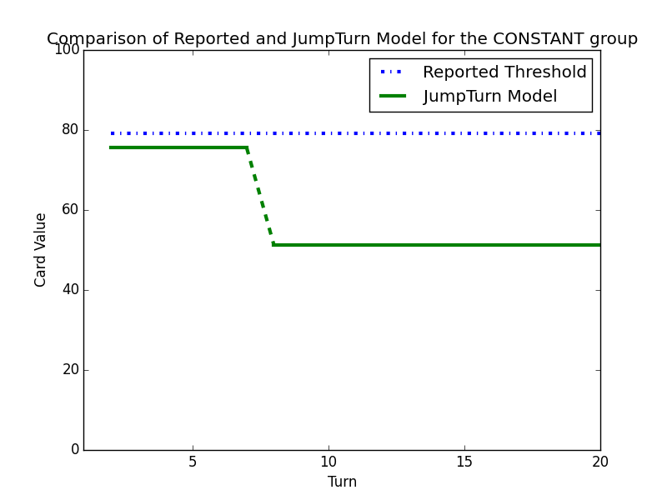

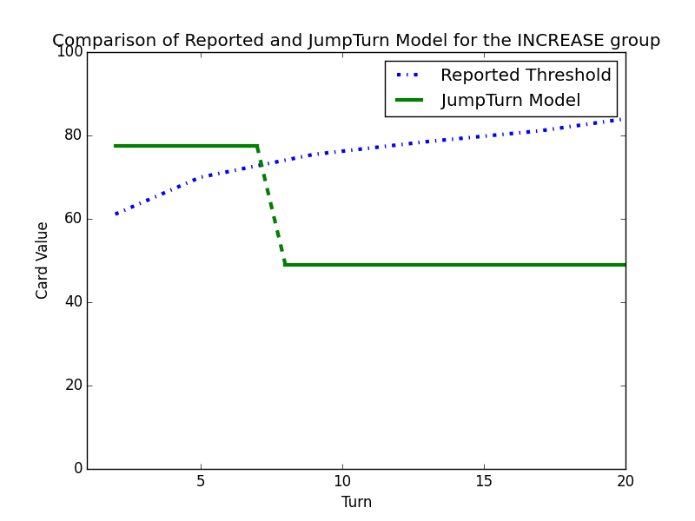

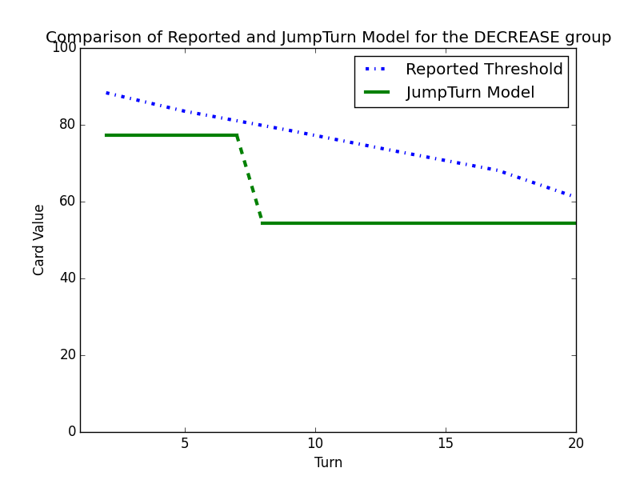

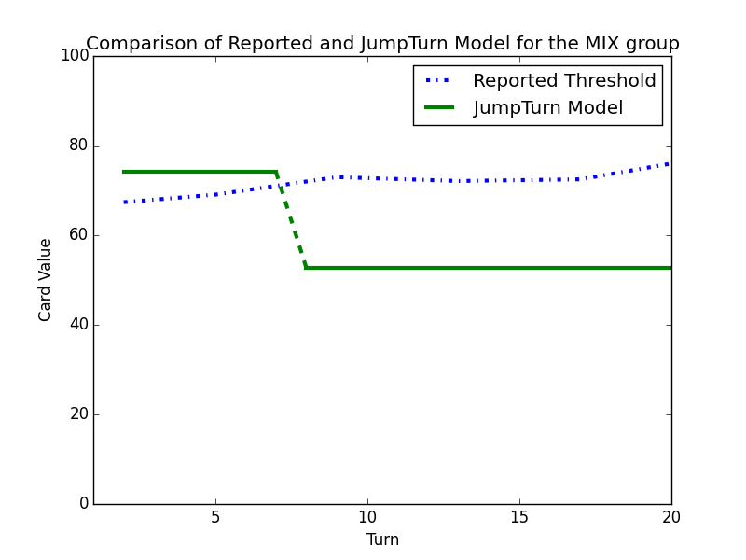

---------------------------------------new results for best models--------------------------

the following are the tables showing the number of subjects each model best fit:

across all the subjects:

an interesting finding is that though secretary model is not the best or the second best, but it fits a substantial amount of subjects the best.

Across all the subjects:

|  |  |
| --- | --- |
| jump | 115 |
| secretary | 42 |
| modelB | 15 |
| fix | 13 |
| random_k | 2 |
| k_step | 1 |
| epi_greedy | 0 |
| successive non-candidate | 0 |

For decrease group:

|  |  |
| --- | --- |
| jump | 26 |
| secretary | 9 |
| modelB | 8 |
| fix | 4 |
| random_k | 0 |
| k_step | 0 |
| epi_greedy | 0 |
| successive non-candidate | 0 |

For increase group:

|  |  |
| --- | --- |
| jump | 45 |
| secretary | 20 |
| fix | 4 |
| modelB | 2 |
| random_k | 0 |
| k_step | 0 |
| epi_greedy | 0 |
| successive non-candidate | 0 |

For mix group:

|  |  |
| --- | --- |
| jump | 31 |
| secretary | 9 |
| modelB | 5 |
| fix | 3 |
| random_k | 2 |
| k_step | 1 |
| epi_greedy | 0 |
| successive non-candidate | 0 |

For constant group:

|  |  |
| --- | --- |
| jump | 13 |
| secretary | 4 |
| fix | 2 |
| modelB | 0 |
| random_k | 0 |
| k_step | 0 |
| epi_greedy | 0 |
| successive non-candidate | 0 |