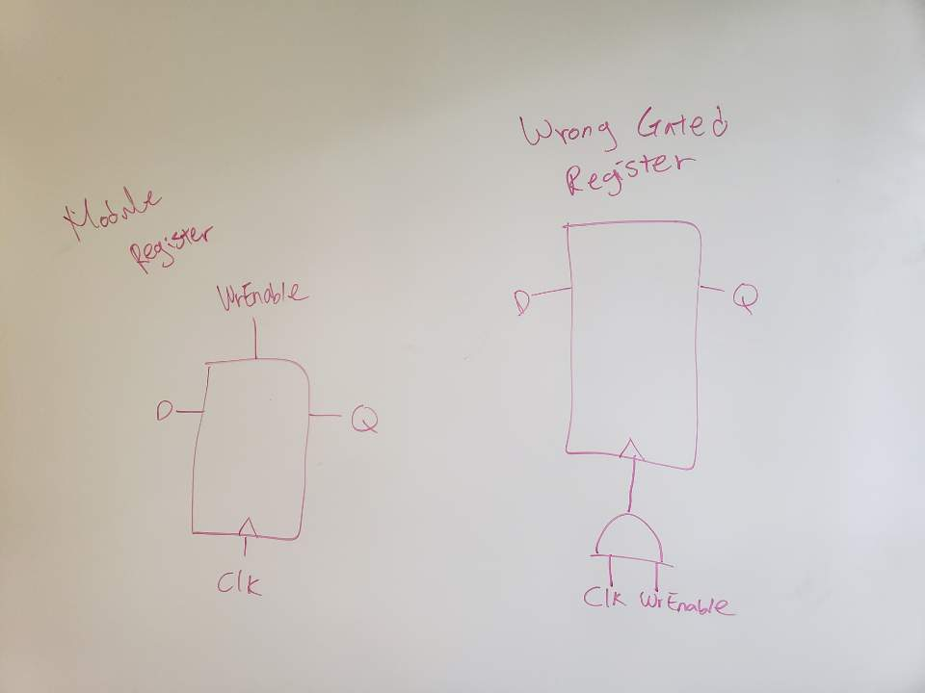
<< Deliverable 1>>
<< Deliverable 6>>

In decoder code, “<<” operator is a shift operator. What the code does is it shifts the enable bit to the magnitude of address bits. For example, if you have an address of 5, you will have an output of “10000”. For another example, if you have an address of 3, you will have an output of “100”. By doing such implementation in decoders, we can see that address is equivalent to the position of enable bit(which is 1).

