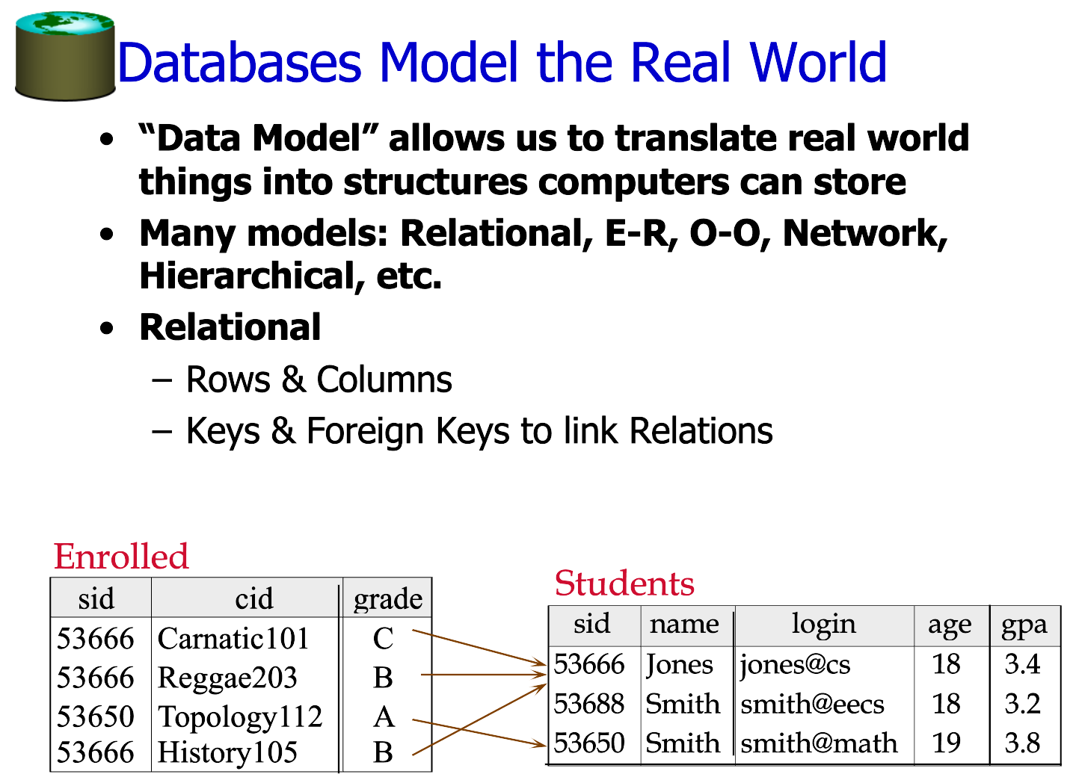

-- STUDENTS TABLE

CREATE TABLE STUDENTS_KUN (
SID NUMERIC(10),
NAME VARCHAR2(50),
LOGIN VARCHAR2(50),
AGE NUMERIC(10),
GPA NUMERIC(10,2),
CONSTRAINT PK_STUDENTS_KUN PRIMARY KEY(SID));

-- ENROLLED TABLE

CREATE TABLE ENROLLED_KUN(
SID NUMERIC(10),
CID VARCHAR2(50),
GRADE VARCHAR2(10),
CONSTRAINT PK_ENROLLED_KUN PRIMARY KEY(CID),
CONSTRAINT FK_ENROLLED_KUN FOREIGN KEY(SID) REFERENCES STUDENTS_KUN(SID));

-- INSERT DATA INTO STUDENT_KUN TABLE

INSERT INTO STUDENTS_KUN VALUES (53666, 'Jones', 'jones@cs',18,3.4);
INSERT INTO STUDENTS_KUN VALUES (53688, 'Smith', 'smith@eecs',18,3.2);
INSERT INTO STUDENTS_KUN VALUES (53650, 'Smith', 'smith@math',19,3.8);

-- TO CHECK THE DATA FROM STUDENTS_KUN

SELECT * FROM STUDENTS_KUN;

-- INSERT DATA INTO ENROLLED_KUN

INSERT INTO ENROLLED_KUN VALUES (53666,'Carnatic101','C');
INSERT INTO ENROLLED_KUN VALUES (53666,'Reggae203','C');
INSERT INTO ENROLLED_KUN VALUES (53650,'Topology112','C');
INSERT INTO ENROLLED_KUN VALUES (53666,'History105','C');

-- TO CHECK THE DATA FROM ENROLLED_KUN

SELECT * FROM ENROLLED_KUN;

