**Optimization of Production in an Industrial Plant**

**Background:** In an industrial plant, several machines are used to manufacture products. Each machine has a limited capacity, and each product requires specific resources (e.g., material, time, energy) for production. The goal is to maximize profits while ensuring that the total consumption of resources (machine time, energy, material, etc.) does not exceed the available resources, and the machines operate within their capacities.

**Problem Setup:**

* We have a set of machines, each with a limited capacity for production.
* There are several products, each requiring a certain amount of machine time, material, and energy to produce.
* The objective is to maximize the profit, which depends on the number of units of each product produced, while respecting the capacity constraints of machines and resource availability.

**Given Data:**

1. **Machine Data:**
   * **Capacity of each machine**: Each machine has a limited number of hours it can operate in a given time period (e.g., 10 hours).
2. **Product Data:**
   * **Profit per unit of each product**: This represents the revenue or profit earned for each unit of a product produced.
   * **Resource consumption**: Each product consumes a certain amount of machine time, material, and energy.
3. **Objective:** Maximize total profit, considering the costs of production and constraints of resources.

**Constraints:**

1. The total machine time required by all products should not exceed the available time for each machine.
2. The total amount of material and energy used by all products should not exceed the available resources.

**Example: Optimization Problem**

Let's assume the following scenario:

* **Machines**:
  + Machine 1: 10 hours available.
  + Machine 2: 12 hours available.
* **Products**:
  + **Product 1**:
    - Profit per unit: $10
    - Time required on Machine 1: 2 hours
    - Time required on Machine 2: 3 hours
    - Material required: 5 units
    - Energy required: 3 units
  + **Product 2**:
    - Profit per unit: $15
    - Time required on Machine 1: 3 hours
    - Time required on Machine 2: 2 hours
    - Material required: 4 units
    - Energy required: 2 units
  + **Product 3**:
    - Profit per unit: $20
    - Time required on Machine 1: 1 hour
    - Time required on Machine 2: 4 hours
    - Material required: 6 units
    - Energy required: 4 units
* **Available Resources**:
  + Material: 50 units
  + Energy: 30 units

**Objective:**

Maximize the total profit by determining the optimal number of units of each product to produce, considering the constraints on machine time, material, and energy.

**Solution Approach:**

We will use **linear programming** (LP) to solve this problem. Here are the steps involved:

1. **Decision Variables**: Let:

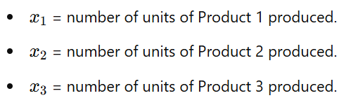

1. **Objective Function**: The objective is to maximize profit. The profit is given by:

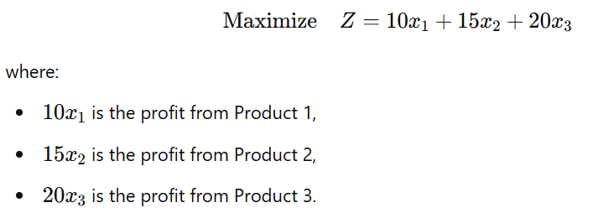

1. **Constraints**:

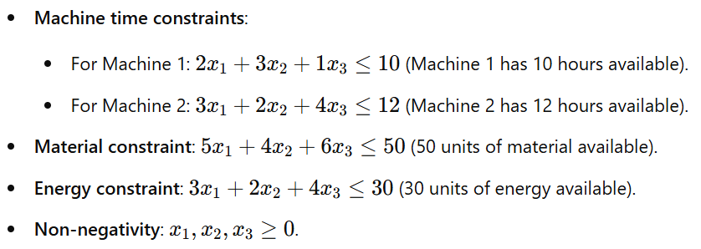

**Problem Statement: Boiler Optimization**

The boiler system needs to optimize coal consumption for generating steam, minimizing operational costs, while satisfying the steam demand and meeting environmental constraints. Specifically, the system needs to generate **10,000 kg/hr of steam** at a pressure of **15 bar**. The energy produced by burning 1 kg of coal is **8,000 kcal**, and the combustion process requires **5 kg of air per kg of coal** and generates **2.5 kg of flue gases per kg of coal**.

The objective is to **minimize the fuel consumption** while ensuring the following constraints are met:

1. **Steam generation requirement**: The boiler must produce 10,000 kg/hr of steam.
2. **Air supply**: For every 1 kg of coal, 5 kg of air is required.
3. **Emissions control**: The system must limit the generation of flue gases.
4. **Energy balance**: The energy produced by coal combustion must meet the energy demand for steam generation.

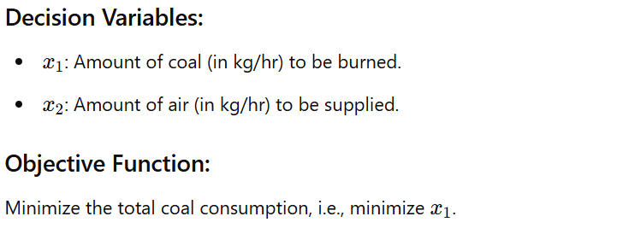

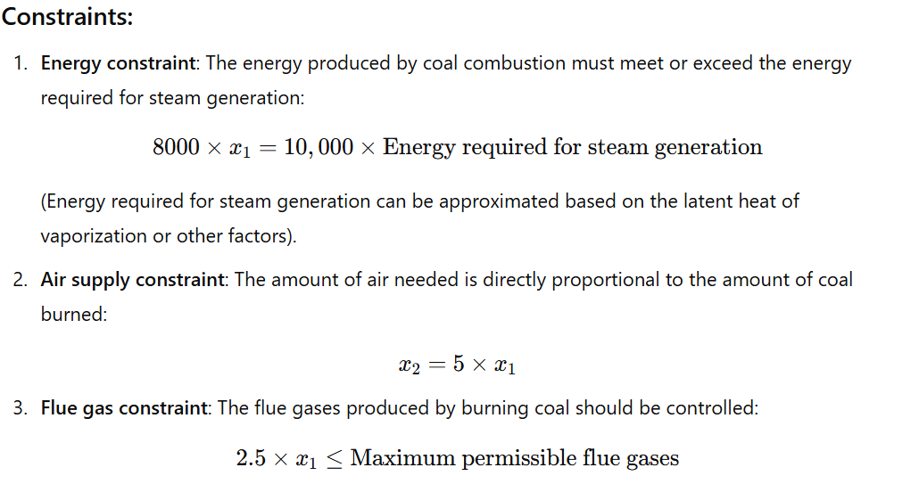

**Solution Approach:**

We will solve the problem using both **linear optimization** (for the simpler part of the problem) and **global optimization** (to handle any complexities such as non-linearity or multiple local optima).

**Linear Optimization Solution (using scipy.optimize.linprog):**

In the linear optimization approach, we will simplify the problem by treating the energy constraint as linear, assuming a direct relationship between coal burned and steam output. We will use linear programming to minimize the amount of coal used, while adhering to the air and flue gas constraints.

See: boiler-linear-optimzation.py

**Global Optimization Solution (using scipy.optimize.differential_evolution):**

In case the problem involves non-linear relationships or more complex constraints, we can use a global optimization method such as **Differential Evolution**, which is a metaheuristic that can handle non-linearity.

See: boiler-multi-optimization.py

**Notes:**

1. **Linear Optimization Solution**:
   * We define the objective function to minimize coal input.
   * The constraints represent the energy balance (coal energy vs. steam requirement), the relationship between coal and air, and the flue gas generation constraint.
   * The linprog function is used to solve this linear optimization problem.
2. **Global Optimization Solution**:
   * In the global optimization approach, we define an objective function that penalizes violating constraints (energy and flue gas limits).
   * The differential_evolution function is used, which is a global optimization method capable of finding a good solution even in the presence of non-linearity or complex constraints.

Boiler System Details:

O2 Dataset:

Here’s a tabular analysis of the features you provided, categorized by their role (Input/Output) and functionality:

| **Feature** | **Input/Output** | **Functionality** |
| --- | --- | --- |
| **Time** | Input | Timestamp for recording data, enabling time-series analysis. |
| **BF GAS FLOW BEFORE FGTV** | Input | Volume of gas flow before the Flue Gas Treatment Vessel (FGTV), affecting combustion. |
| **COAL FLOW TOTAL** | Input | Total coal flow rate to the boiler, used as the primary fuel input. |
| **Main Steam Flow** | Output | Total flow rate of steam generated by the boiler, a key performance metric. |
| **AH INLET FGS OXYGEN CONTENT** | Input | Oxygen content in flue gases at the Air Heater inlet, influencing combustion efficiency. |
| **PRIMARY AIR FLOW** | Input | Flow rate of primary air supplied for coal combustion, critical for air-fuel ratio. |
| **Steam To Fuel Ratio** | Output | Efficiency metric indicating the amount of steam generated per unit of fuel. |
| **GasCV** | Input | Calorific value of the gas used, determining the energy potential of the fuel. |
| **Air to Fuel Ratio** | Input | Ratio of air supplied to fuel burned, critical for achieving optimal combustion. |
| **SEC AIR FLOW B** | Input | Flow rate of secondary air to one section of the boiler, used for combustion stability. |
| **SEC AIR FLOW A** | Input | Flow rate of secondary air to another section of the boiler, balancing combustion. |
| **Bucket** | Input | Categorical feature indicating specific operating conditions or states of the boiler. |
| **O2 Category** | Output | Categorized oxygen levels, reflecting combustion quality or flue gas composition. |

**Observations:**

1. **Inputs** like *coal flow, air flow, and gas calorific value* control the combustion process.
2. **Outputs** like *steam flow, steam-to-fuel ratio, and O2 category* measure the performance of the boiler.
3. Features such as *Air to Fuel Ratio* and *Oxygen Content* are key for optimizing efficiency and minimizing emissions.