TeamsSampleApp: Deployment Steps

# Follow below steps to integrate given Teams app to Microsoft Teams.

(1) Download Sample

(2) Build and run the sample

* Once the repo is cloned, use Visual Studio to open the solution file TeamsSampleApp.sln from the root directory of the sample and click Build Solution from the Build menu. You can run the sample by pressing F5 or choosing Start Debugging from the Debug menu.
* When the app starts, you will see a browser window open with the root of the app launched. You can navigate to the URL [http://localhost:3333](http://localhost:3333%20) to verify that app is loading.

(3) Host the sample app in azure.

* Follow Steps given on <https://docs.microsoft.com/en-us/microsoftteams/platform/get-started/get-started-dotnet-in-azure> to deploy TeamsSampleApp to azure.
* Once deployment is completed Azure app will be opened in browser automatically. Take a note of this URL. It will be used in manifest file of solution.
* Example: Assume we have Azure Web App URL: https://yourteamsapp.ngrok.io

(4) We need unique ID to distinguish our app from others on the Microsoft Teams platform. We get this ID by creating Bot in Teams. Create a bot for Microsoft Teams.

* Refer steps from [https://docs.microsoft.com/en-us/microsoftteams/platform/concepts/bots/bots-create](https://docs.microsoft.com/en-us/microsoftteams/platform/concepts/bots/bots-create%20) to create new bot in Teams.
* Collect APP Id and Password for future reference

(5) Now change APP id in Solution and update Azure Web App URL.

Go to Manifest folder and open manifest.json file. Make changes as below.

* set the value of the "id" property to the AppID returned by BotFramework.

{

"$schema": "https://statics.teams.microsoft.com/sdk/v1.0/manifest/MicrosoftTeams.schema.json",

"manifestVersion": "1.0",

"version": "1.0.0",

"id": " 00000000-0000-0000-0000-000000000000",

"packageName": "com.contoso.helloworld",

"developer": {

"name": "Contoso",

"websiteUrl": "https://www.microsoft.com",

"privacyUrl": "https://www.microsoft.com/privacy",

"termsOfUseUrl": "https://www.microsoft.com/termsofuse"

},

* change the botID value in the bots and the composeExtensions sections.

"bots": [

{

"botId": "00000000-0000-0000-0000-000000000000",

"needsChannelSelector": false,

"isNotificationOnly": false,

"scopes": [

"team",

"personal"

]

}

],

"composeExtensions": [

{

"botId": "00000000-0000-0000-0000-000000000000",

"scopes": [

"personal",

"team"

],

"commands": [

{

"id": "getRandomText",

"description": "Gets some random text and images that you can insert in messages for fun.",

"title": "Get some random text for fun",

"initialRun": true,

"parameters": [

{

"name": "cardTitle",

"description": "Card title to use",

"title": "Card title"

}

]

}

]

}

],

* Change the URLs that point to yourteamsapp.ngrok.io to the URL where the app is hosted (Azure Web App URL). Microsoft Teams will load your app from this location.

"staticTabs": [

{

"entityId": "com.contoso.helloworld.hellotab",

"name": "Hello Tab",

"contentUrl": "https://yourteamsapp.ngrok.io/hello",

"scopes": [

"personal"

]

}

],

"configurableTabs": [

{

"configurationUrl": "https://yourteamsapp.ngrok.io/configure",

"canUpdateConfiguration": true,

"scopes": [

"team"

]

}

],

(6) Add credentials for the bot

* Update web.config within solution folder. Update MicrosoftAppId and MicrosoftAppPassword in following section.

<appSettings>

<add key="webpages:Version" value="3.0.0.0" />

<add key="webpages:Enabled" value="false" />

<add key="ClientValidationEnabled" value="true" />

<add key="UnobtrusiveJavaScriptEnabled" value="true" />

<add key="MicrosoftAppId" value="00000000-0000-0000-0000-000000000000" />

<add key="MicrosoftAppPassword" value="yourBotAppPassword" />

</appSettings>

(7) Rebuild solution file and publish to Azure Web App again.

* Once app is republished to azure web app. Take Zip package (helloworldapp.zip) from bin folder of project solution.
* We need this zip package to be deployed to Microsoft Teams.

(8) Upload Zip Package to Microsoft Teams

* Go to Microsoft teams Store
* Upload Zip -- It Will add your app to Microsoft Team Store for you.
* Refer URL [https://docs.microsoft.com/en-us/microsoftteams/platform/concepts/apps/apps-upload](https://docs.microsoft.com/en-us/microsoftteams/platform/concepts/apps/apps-upload%20) for more details about Upload Package to Microsoft Teams.

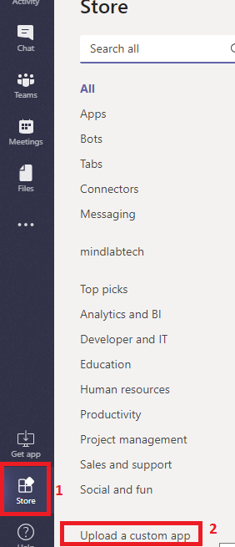

(9) Install TeamsSampleApp to your Microsoft Teams.

* Go to Store in your Teams. Add App from app section.

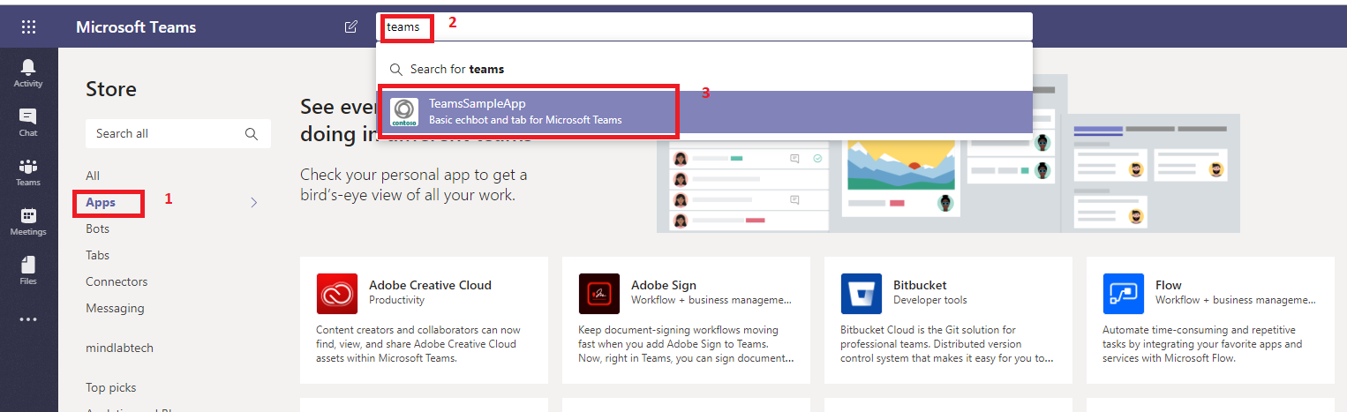

* Select Appropriate Teams and Install app.

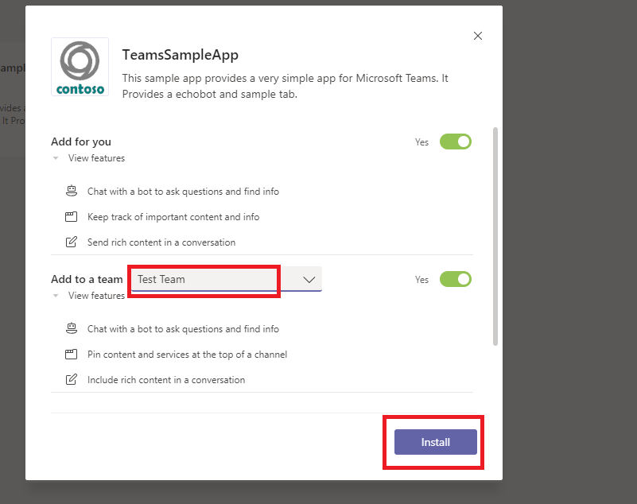

(10) Once we installed TeamsSample app, we can find new chatbot in chat section as below.

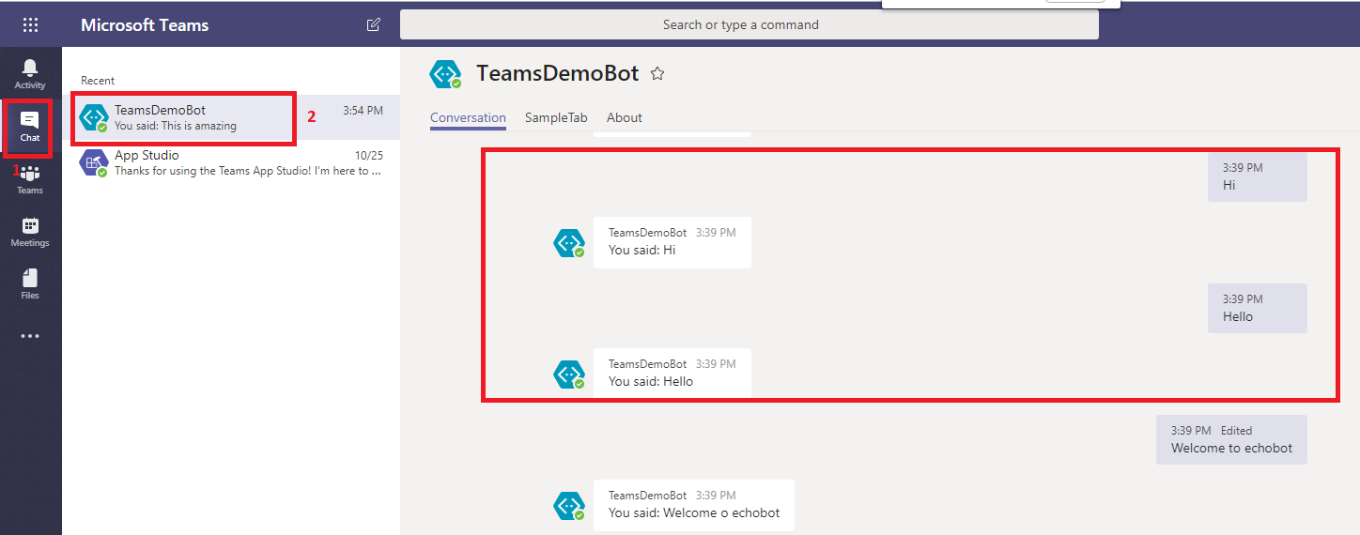

(11) Add Sample tab in your teams.

Go to Teams section and add tab from TeamsSampleApp.

