**DAS** ASSIGNMENT 1

LAB 1

TOP 40  
SERIES FROM IMDB

**___**

SABARI K

2340154

# AIM

To see the total number of episodes in top 40 series ,

Top rated series

Least rated series

## ALGORITHM

USE

SUM, COUNT, AVERAGE, MIN, MAX

## OUTPUT

WE CAN SEE THE EXPECTED OUTPUT

## SCREENSHOTS

### OUTPUT

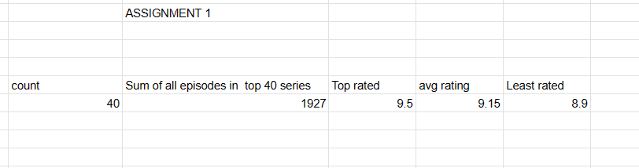

### DATASET

