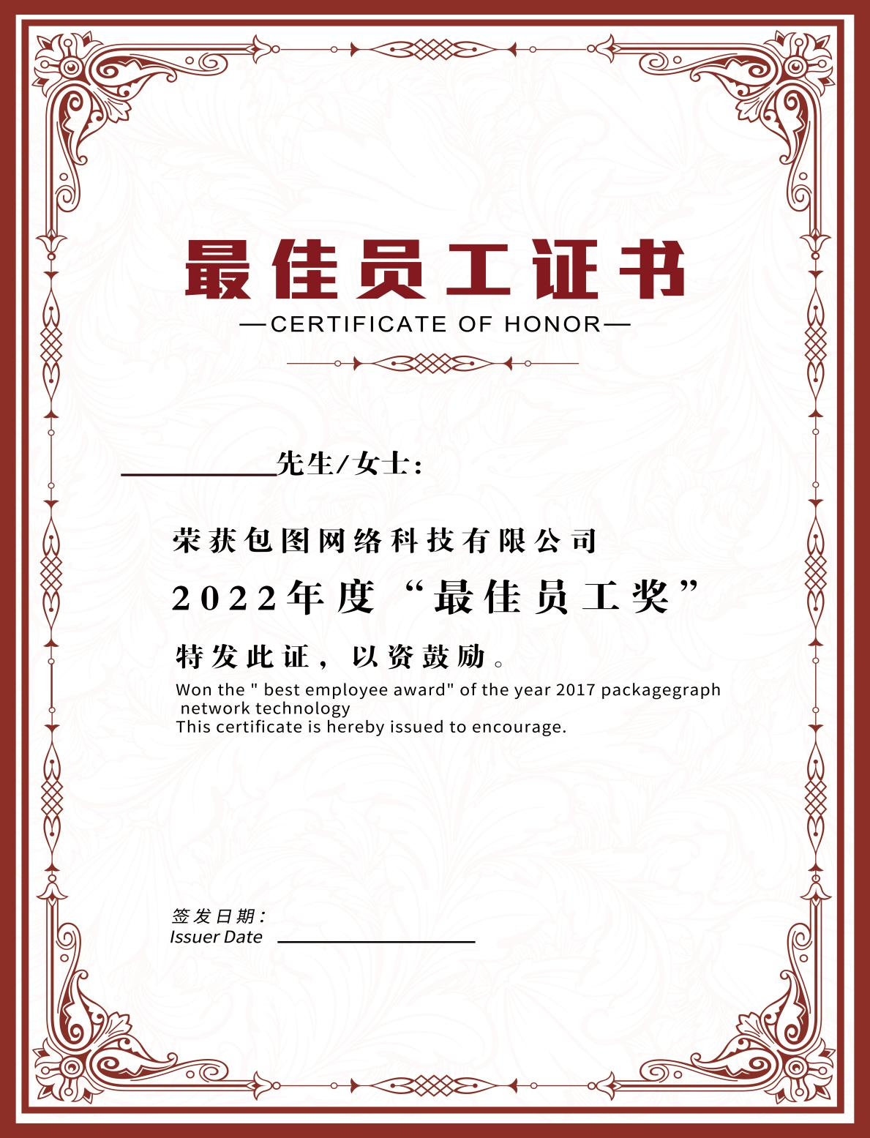

* *

${CERT_AUTHORITY}

${START_TIME}

**${USER_NAME}**