# GoldMine: Contacts Service using Restful Web API

## Source Controll:

<https://github.com/mindsqual/ContactsApi>

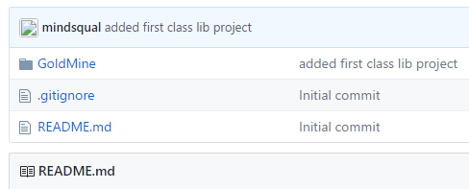

## Visual Studio: using 2015 Pro

## Projects within solution:

### Database Projects- ‘GoldMineDb’

I am pretty sure that what I did was genearate a EF model from the existing Adventureworks 2014 full DB. I only used the Person schema. Then I used EF to produce a database. I would need to review this but it isn’t hard to do and would

<https://msdn.microsoft.com/en-us/library/hh272677(v=vs.103).aspx>

**Used existing project which I think was generated from the existing database.**

### Web API

### Common

## Specific MSDN Topics:

### ORM:

#### Entity Framework: I used EF to generate the database, the Author of book used NHibernate therefore I used what he had in place. I might switch to EF time permitting…

#### NHibernate

#### Dapper

### SSDT

### Web API

### IoC and Dependency injection: using NJect(that’s what Jamie K. used in book.

## References