**Give-AID**

**Installation Guide**

**Installation Guide Document**

**06-2024**

**Introduce**

This document details the necessary settings to run the Give-AID website source.

**Applicable object**

This document is intended for professionals and judges to install, test, and grade projects.

**Install and run**

**System requirements for SQL Server 2019:**

**Operating System: Windows 10 (or supported Windows Server versions)**

**CPU: Minimum 1.4 GHz or faster**

**RAM: Minimum 2 GB (recommended 4 GB or more)**

**Hard Disk Cache: Minimum 6 GB (recommended 10 GB or more)**

**Hard Drive: Minimum 10 GB of free space**

**Graphics: Display with a resolution of 800x600 or higher**

**System requirements for Visual Studio 2019:**

**Operating System: Windows 10 (version 1507 or later), Windows Server 2016 (version 1607 or later)**

**CPU: Minimum 1.8 GHz or faster**

**RAM: Minimum 2 GB (recommended 8 GB or more)**

**Hard Disk Cache: Minimum 20 GB (recommended 50 GB or more)**

**Hard Drive: Minimum 8 GB of free space**

**Graphics: Display with a resolution of 1366x768 or higher**

After downloading, you'll get a folder like this

Figure 1.Project Compression File

Proceed to unzip the folder and you'll get this

Figure 2.File when compressed after

Open it and you'll get 4 folders

Figure 3.Folder inside Project

Open the folder "Database"

Figure 4. sql file for DB

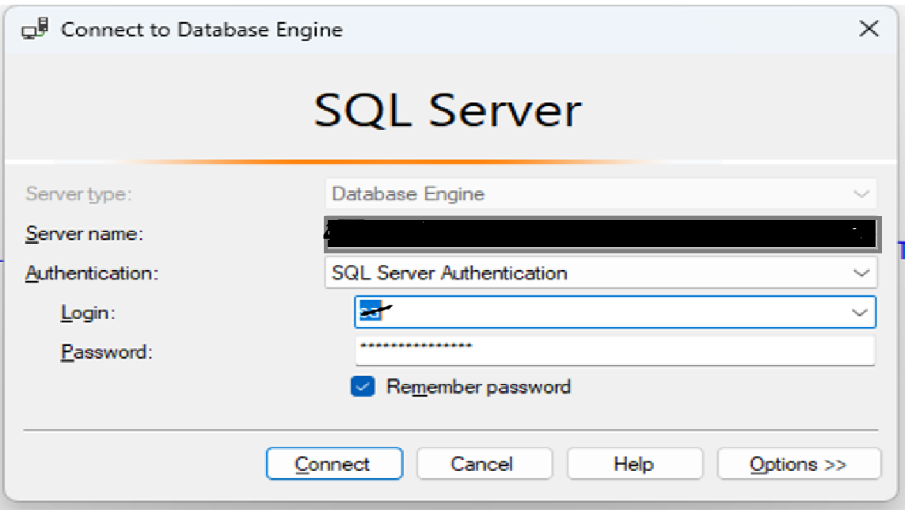Double click to run "GiveAID.sql" with SSMS or right click and choose "Open with SSMS".

Figure 5. The user's SQL Server gateway

Proceed to log into your database

Press "Ctrl + A" to choose all and "F5" to run file or click here to run "GiveAID.sql"

Figure 6. Run sql query button

Reload your database and you'll get this

Figure 7. Once the data has been successfully created

Now, comeback to "File Explorer". Unzip "source.zip". Follow the path "source\\GiveAID". Open "GiveAID.sln" in Visual Studio

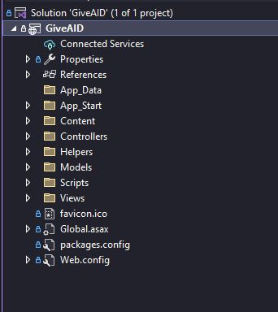Figure 8. Run the file solution to get Project

Open "Web.config". Scroll down and find "<connectionStrings>"

Figure 9. Modify the information in the web.config

Enter your database information. Includes "data source = your server name", "user id = your login" and "password = your password".

After that. Press "Ctrl + S" to save.

Now press here to run Project

Figure 10. Button to run solution

**ADMIN ACCOUNT**

**USERNAME:** admin

**PASSWORD:** 123

**Thanks for reading.**