CollectorCoin

Company : CollectorCoin, A Subsidiary of DLM Group, Inc.
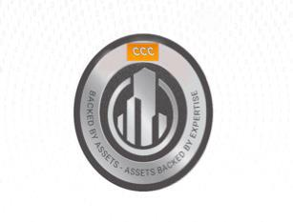

CollectorCoin(CC) is an innovative new tokenization method that uses the value of “hard assets”, such as collector cars, as the core of its monetary worth. CC is essentially a crowd-funded hard assets investment platform. Big and small-time investors can, using the security that the Ethereum blockchain provides, buy stakes in collector projects, such as the restoration of collector cars. Because the blockchain provides an immutable record of ownership, CC allows investors of any size to buy into collector projects and reap rewards proportionate to their investments down the line. Investing in projects such as the restoration of collector cars is daunting, has a very high barrier to entry, and is often incredibly inefficient. However, using CC’s new blockchain system in place, virtually anyone with a computer and a small sum of money will be able to diversify investments into the restoration of collector cars. DLM Group, Inc. is a holding company that provides services to the collector car market. It currently manages the online Cadillac Database for the Cadillac LaSalle Club and the Cadillac LaSalle Museum and Research Center, which attracts a community of more than 7,000 members.
CollectorCoin

Proposal: CollectorCoin(CC) for Collector Car Market

Background and Current Conjecture:

- The collector car market is very adhoc as no platform currently brings collectors, dealers, service providers together to provide a frictionless way of conducting discovery, buy/sell transactions and payments.

- CCC intends to tokenize CollectorCar investment via blockchain. The CC strategy is to compile a portfolio of several cars with a view to flip, lease, restore, manage and resell them. This portfolio is being referred to as the CC CorePool. CC will also set up the CC Opportunity Pool, where collector car investment projects will be presented to investors so that they may vote on acquisition via token allocation. The platform is designed to serve two different kinds of users. First, there are the investors who wish to invest their cryptocurrency capital into tokens that enable them to participate in the platform’s collector car projects. Secondly, there are Marketplace participants and service providers who interact with the platform to provide Services like Restoration, Auction and Trading etc.

- CCC is an Ethereum-based ERC 20 token that powers CCC's economic system. Token holders will benefit from the profits made by the Core Pool as well as the profits that come from the CCC platform-as-a-service.

- CC is a decentralized, global platform dedicated to crowdfunding the world’s best collector car opportunities. Using blockchain technology, the CCC platform allows car experts to present unique projects, tokenize them, and offer them as curated investment opportunities. From rental cars to new developments, tokenized investments will be governed by an escrow-backed trust,
CollectorCoin

Previous Phase:

The following business and technical summary of the phase 1 of project:

Business:

DLM Group, Inc. | Collector Coin (CC)
DLM Group, Inc. | ITP Summer 2018
 | Professor: Dr. JC Franchitti Project Managers: Bobby Singh & Helen Ng
 | Team Members: Ann Malavet, Kedar Gangopadhyay & Jason Chang


Company Description


- DLM Group, Inc. (“DLM”) is a holding company providing services to the collector market

- Provides digital solutions for the collector car market and manages newcadillacdatabase.org for the Cadillac LaSalle Club and its associated Museum and Research Center

  - A community of > 7,000 members worldwide who collectively own 18,000+ collectible automobiles

- The digital solutions provided by DLM include asset-backed restoration, trading, and proxy financing

 | Business Architecture | Value Achieved
 | Coin holders | Coin traders
Restorers |  | • Offers investors the ability to acquire
Restorers |  | tokens in curated and vetted collectibles
 |  | projects
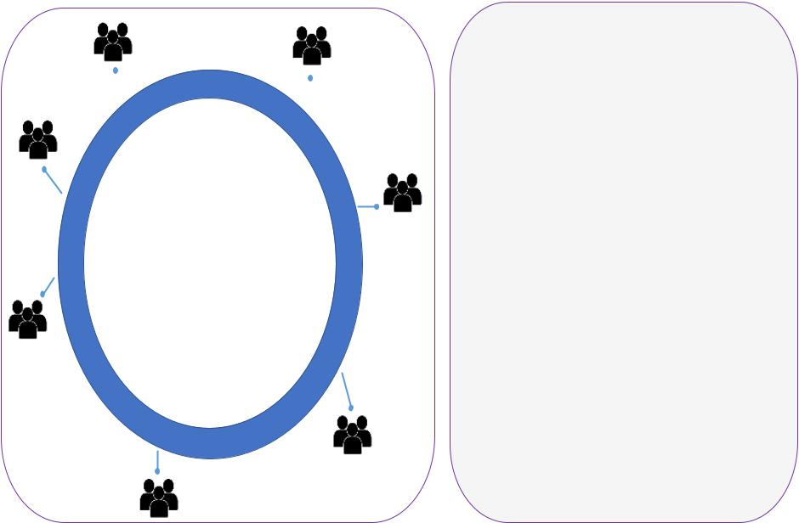

• Creates liquidity in tokens that are tradeable within a marketplace and in
Asset crypto exchanges
buyers
• Creates ability to project finance

restorations in a decentralized and
anonymous manner

Portfolio | • Increase rates of appreciation in certain
investors | • Increase rates of appreciation in certain
investors | collectible items

Asset
_{DLM} sellers

Project Objectives


- Objectives achieved via an ecosystem of CC token holders

Restore
Trade assets

coins
Buy/sell assets in
marketplace
Hold coins for
capital _{ETH-}
appreciation _{based}
CC token
Invest in
Vote on asset- _{portfolio of}
^{related} projects
matters
Pay
transaction
fees

Business Solution: A Coin Platform
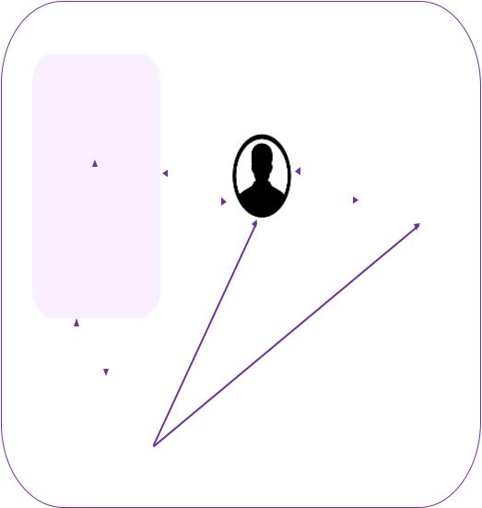

 | Asset Managers
 | Investment Manager
 | (assembles/manages
 | tokenized project portfolios) |  |  |  |  |  |  |  |  |  |  |  |  |  |  |  |  |  |  |  |  |  |  |  |  |  |  |  |  |  |  |  |  | Third-Party
 |  |  |  |  |  |  | Ownership % |  |  |  |  |  |  |  |  |  |  |  |  |  |  |  |  |  |  |  |  |  |  | CC coin
 |  |  |  |  |  |  |  |  |  |  |  |  |  |  |  |  |  |  |  |  |  |  |  |  |  |  |  |  |  |  |  |  |  | Crypto Exchanges
 |  |  | Restore |  |  |  |  |  |  |  |  |  |  |  |  |  |  |  |  |  |  |  |  |  |  |  |  |  |  |  |  |  |  | Crypto Exchanges
 |  |  | projects |  |  |  | CC coin |  |  |  |  |  |  |  |  |  |  |  |  |  |  |  |  |  |  |  |  |  |  | ETH |  |  |  | (Coinbase, Luno, etc.)
 | Operational Manager
 | (select/vet/manage assets)
 |  |  |  |  |  |  |  |  |  |  |  |  |  |  |  | n |  | s |  |  |  |  |  |  |  |  |  |  |  | s
 |  |  |  |  |  |  |  |  |  |  |  |  |  |  |  |  |  |  |  |  |  |  |  |  |  |  |  |  |  | in
 |  |  |  |  |  |  |  |  |  |  |  |  |  |  |  |  |  |  |  |  |  |  |  |  |  |  |  |  | o
 |  |  |  |  |  |  |  |  |  |  |  |  | t | u |  |  |  |  |  |  |  |  |  |  |  |  |  |  | c
 |  |  |  |  |  |  |  |  |  |  |  |  | t |  |  |  |  |  |  |  |  |  |  |  |  |  |  |  | C
 |  |  |  |  |  |  |  |  |  |  |  | e | t |  |  |  |  |  |  |  |  |  |  |  |  |  |  | C
 |  |  |  |  |  |  |  |  |  |  | r | e |  |  |  |  |  |  |  |  |  |  |  |  |  |  | k
 |  |  |  |  |  |  |  |  |  |  | r |  |  |  |  |  |  |  |  |  |  |  |  |  |  |  | c
 |  |  |  |  |  |  |  |  |  | y |  |  |  |  |  |  |  |  |  |  |  |  |  |  |  | a
 |  |  |  |  |  |  |  |  |  | y |  |  |  |  |  |  |  |  |  |  |  |  |  | y
 |  |  |  |  |  |  |  | P | a |  |  |  |  |  |  |  |  |  |  |  |  |  | u |  | b
 |  |  |  |  |  |  |  | P |  |  |  |  |  |  |  |  |  |  |  |  |  | b
 |  |  |  |  |  |  |  | P |  |  |  |  |  |  |  |  |  |  |  |  |  | /
Management |  |  |  | Coin appreciation |  |  |  |  |  |  |  |  |  |  |  |  |  |  | Is | e
 |  |  |  |  |  |  |  |  |  |  |  |  |  |  |  |  |  |  | u
 |  |  |  |  |  |  |  |  |  |  |  |  |  |  |  |  |  |  | s
fees
 | Platform Manager
 |  | DLM Group
 | (market maker in CC coins)

Next Steps


- Operational:

  - Consider which types of auctions to pursue

  - Think about physical delivery of assets

- Financial:

  - Structure option terms (buyback) for the original asset owner

  - Set minimum investment criteria

  - Plan for ICO

- Legal:

  - Analyze ongoing laws related to SEC and exchanges

CollectorCoin

Technical:
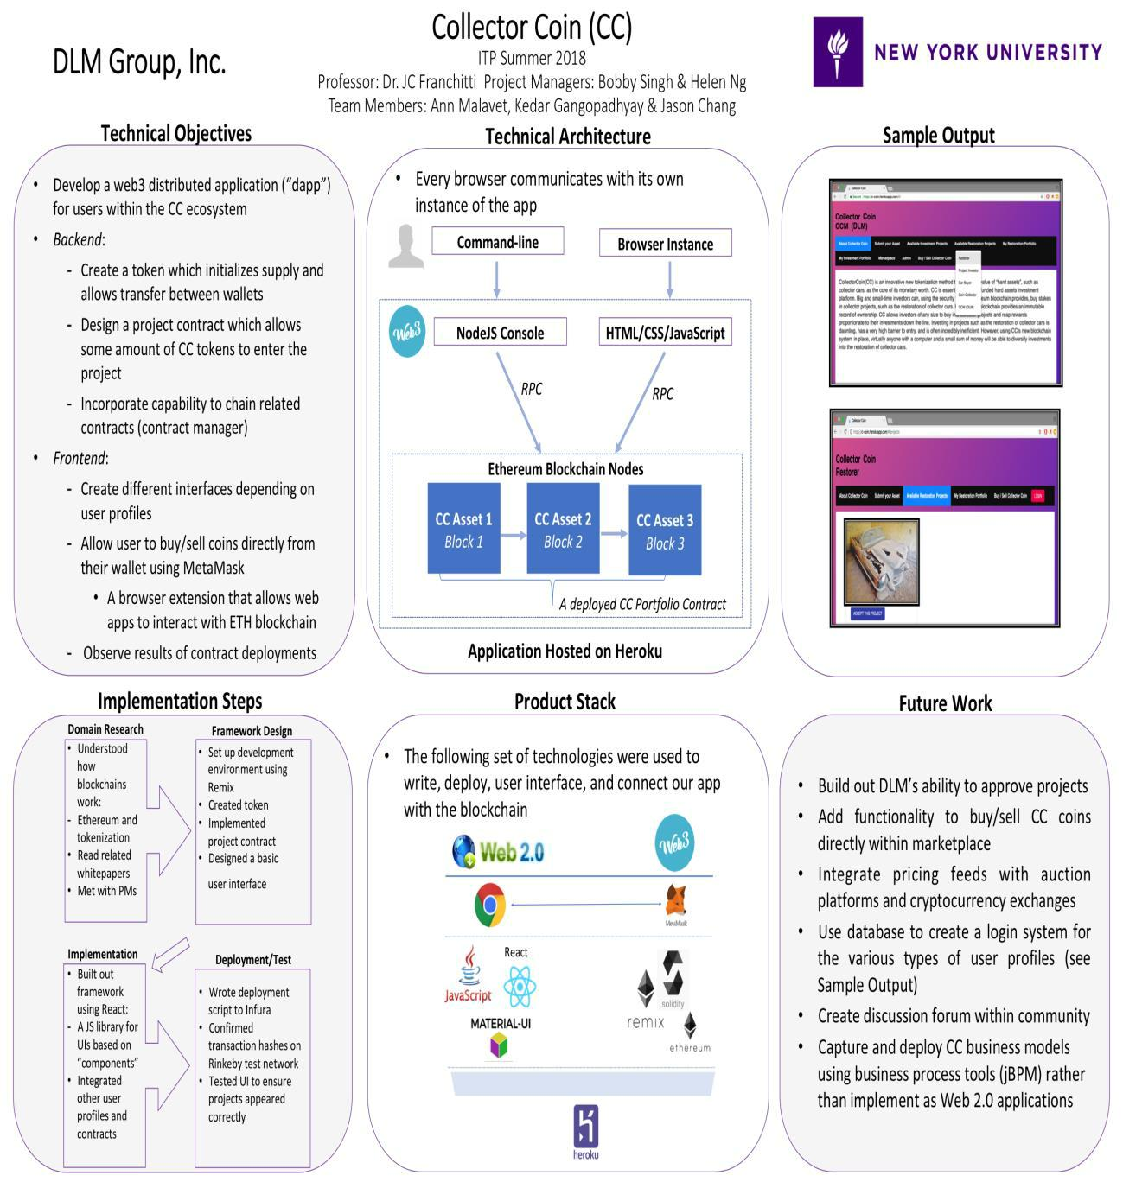
CollectorCoin

Phase II scope:

The platform MVP will be implemented using the Ethereum platform and Web 3.0 technology. Any Web technology stack may be used to implement the CC Web site and Marketplace platform.

- Develop a CollectorCoin Website that includes User login and Profiles based on Roles

- Integrate with Cadillac Database for Displaying Car information

- Integrate with a Wallet application based on User Login Authentication

- Ability to Buy/ Sell Collector Coins

- Develop Services like – Buy Car, Restore Car, Auction, My portfolio – Investments, Projects

Skills required:

- Familiarity with Web site development, web crawling engines, object oriented programming, and Ethereum platform.

Company Web Site: (to be created as part of the project)

https://www.CollectorCoin.cc

Contacts:

Bobby Singh

Chief Product Officer

Phone: (917) 207-0914

Email: bobby.singh@tupel.tech

References:

- Model Projects

- https://bitcar.io

  - https://realisto.io

- Guides:

  - https://blockgeeks.com/guides/

