Homework 3

## Question 1

### 1.1 Graphical representation

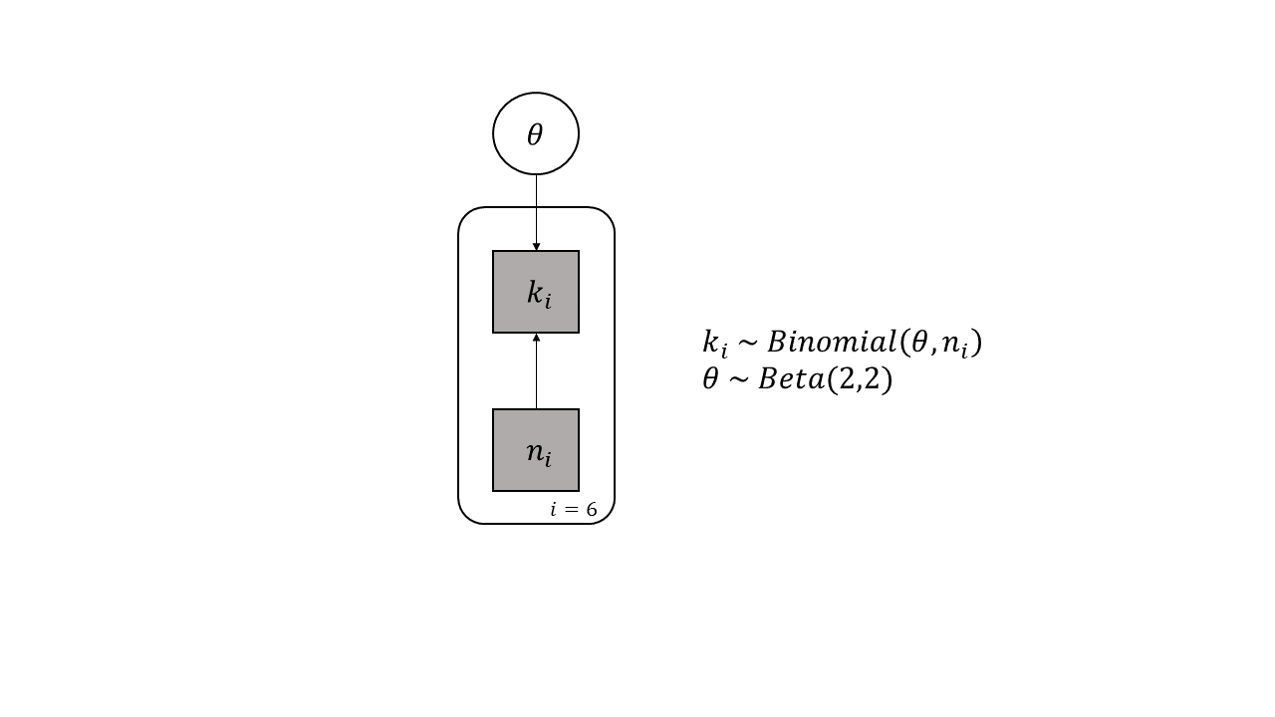

### 1.2 Posterior distribution of theta

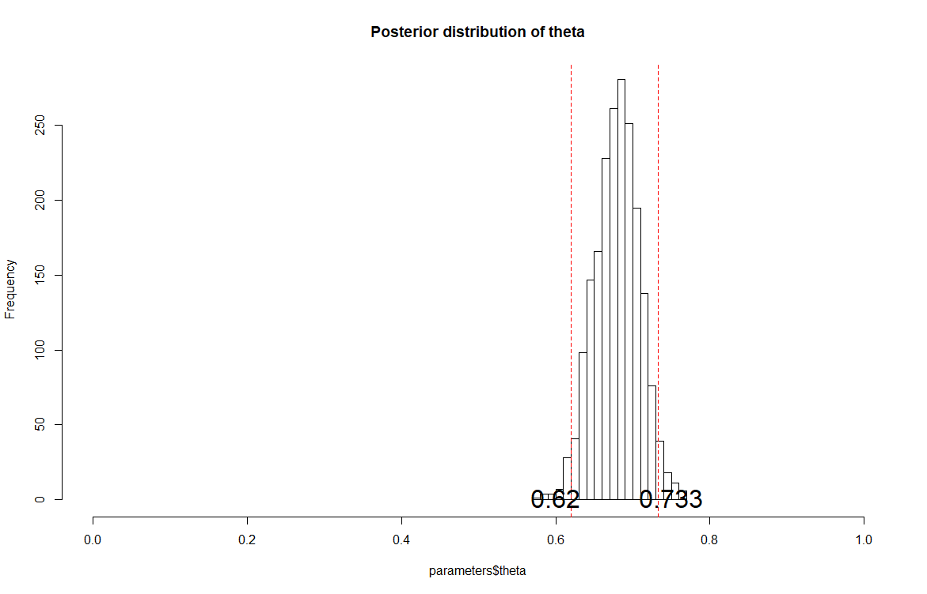

## Question 2

### 2.1 Posterior distributions of parameters

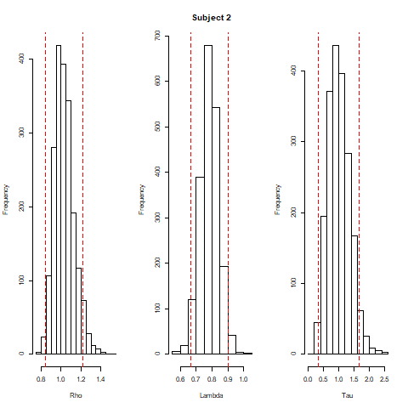 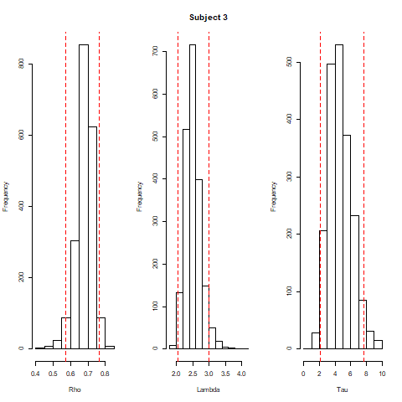

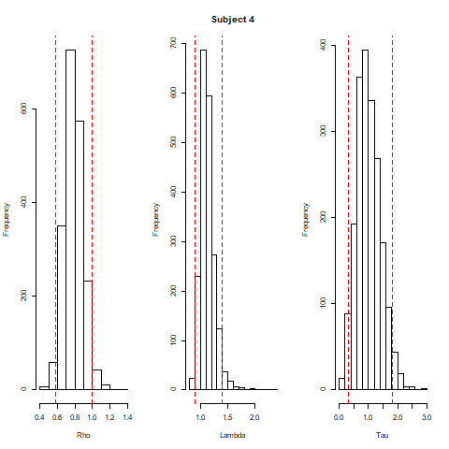 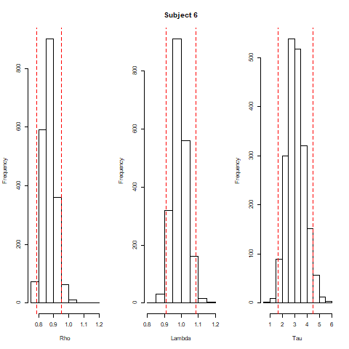

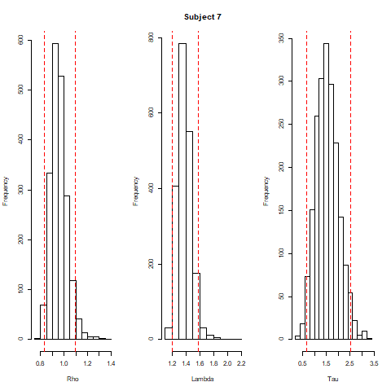

### 2.2 Posterior mean of parameters

|  |  |  |  |
| --- | --- | --- | --- |
|  | Rho | Lambda | Tau |
| Subject 2 | 1.032 | 0.7840 | 1.0050 |
| Subject 3 | 0.680 | 2.5150 | 4.6460 |
| Subject 4 | 0.786 | 1.1290 | 1.0130 |
| Subject 6 | 0.870 | 0.9890 | 3.0940 |
| Subject 7 | 0.957 | 1.3810 | 1.5360 |
| Total | 0.865 | 1.3596 | 2.2588 |

### 

### 2.3 Plot of MLE estimates(x-axis) and posterior mean(y-axis)

