First ten entries in our data set.

|  |  |  |  |  |  |  |
| --- | --- | --- | --- | --- | --- | --- |
|  | ID | SYMBOL | OFRSIZ | OFR | BIDSIZ | BID |
| 2010-01-04 09:30:00 | 98790 | 1003 | 1475 | 423.75 | 1188 | 423.75 |
| 2010-01-04 09:30:00 | 98800 | 1003 | 1483 | 423.75 | 1188 | 423.75 |
| 2010-01-04 09:30:00 | 98810 | 1003 | 1483 | 423.75 | 1197 | 423.75 |
| 2010-01-04 09:30:00 | 98820 | 1003 | 1486 | 423.75 | 1197 | 423.75 |
| 2010-01-04 09:30:00 | 98830 | 1003 | 1486 | 423.75 | 1231 | 423.75 |
| 2010-01-04 09:30:00 | 98840 | 1003 | 1494 | 423.75 | 1231 | 423.75 |
| 2010-01-04 09:30:00 | 98850 | 1003 | 1496 | 423.75 | 1231 | 423.75 |
| 2010-01-04 09:30:00 | 98860 | 1003 | 1510 | 423.75 | 1231 | 423.75 |
| 2010-01-04 09:30:00 | 98870 | 1003 | 1510 | 423.75 | 1233 | 423.75 |
| 2010-01-04 09:30:00 | 98880 | 1003 | 1520 | 423.75 | 1234 | 423.75 |

Notes: ID = CME's trade sequence number, Symbol = Contract expiration year (2010) and month (March), OFRSIZ = Number of contracts at the best offered price, OFR = Best price offered (cents per bushel), BIDSIZ = Number of contracts at the best bid price, BID = Best price bid (cents per bushel).

Notes: This table contains a summary of the correlation results that are presented in figures 1, 2, and 3. Correlations are calculated in for ten minute intervals and for every day of our sample.

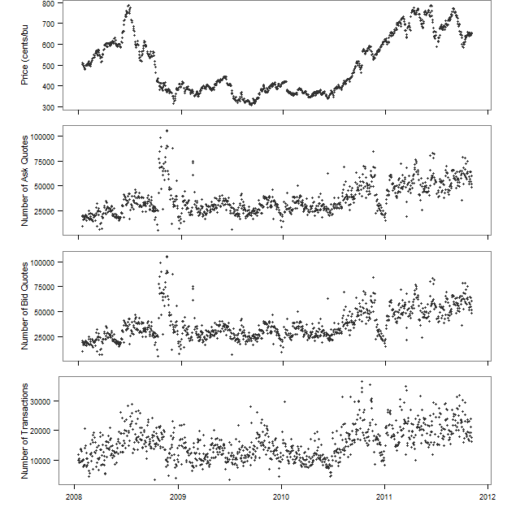

Figure displays data for the corn futures market from 1/14/2008 to 11/04/2011 for the nearby contract. The September contract is excluded due to the possibility of 'old crop' and 'new crop' both being delivered on this contract. To form the continuous nearby series contracts are rolled to the next contract on the 20th of the month prior to the delivery month.

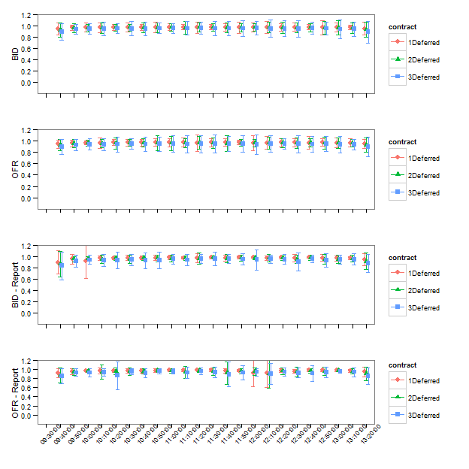

Mean correlations and one standard deviation error bars over all days in the top two plots. Mean correlations and one standard deviation error bars in the bottom two plots.

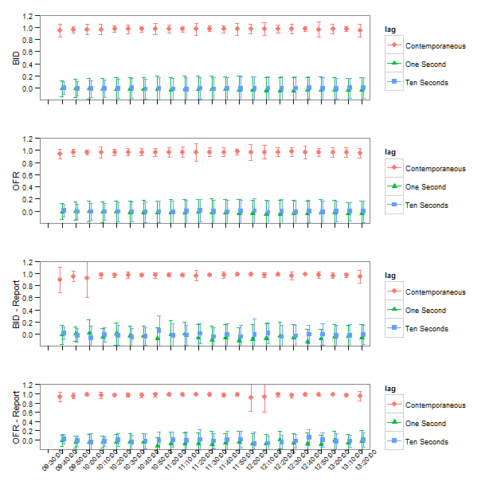

Mean correlations and one standard deviation error bars over all days in the top two plots. Mean correlations and one standard deviation error bars in the bottom two plots.

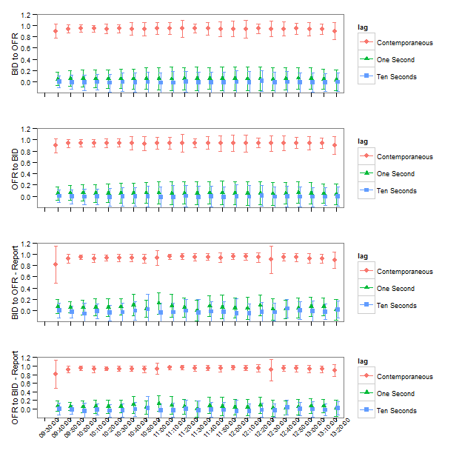

Mean correlations and one standard deviation error bars over all days in the top two plots. Mean correlations and one standard deviation error bars in the bottom two plots. Bid-to-Offer means revisions to the lagged nearby bid were correlated with the first deferred revisions to the offer, and Offer-to-Bid means revisions to the lagged nearby offer were correlated with the first deferred revisions to the bid.