**Nearby and deferred quotes: What they tell us about linkages and adjustments to information**

Mindy Mallory, Philip Garcia, and Teresa Serra

June 08, 2015

# Introduction

There has been recent concern about whether and how the 'Financialization of Commodity Markets' has impacted market efficiency (futures markets as unbiased predictors of future spot prices) and efficacy in the traditional roles of risk mitigation, coordinating production, and coordinating consumption through time (Irwin and Sanders 2011; Cheng and Xiong 2013; Irwin and Sanders 2012; Henderson, Pearson and Wang 2015). Additionally, the recent increase in the production of biofuel from food commodities has created or changed the relationship between food and energy commodities (Serra and Zilberman 2013; Mallory, Irwin and Hayes 2012; Gardebroek and Hernandez 2013; Vacha et al. 2013; Avalos 2014; Trujillo-Barrera et al. 2012).

Both of these issues represent potentially profound shifts in the way commodity markets operate, and the articles cited above have considered their implications. However, how these issues affect trading tick-by-tick and quote-by-quote has not been considered. This is primarily because there is scant market microstructure literature that was developed with the particular characteristics of commodity futures markets in mind.

In this article, we are motivated to develop tools with which we can consider the microstructure implications of important trends like the financialization of commodity futures or links between energy and food commodities, but this is only a modest first step in that direction. Our purpose in this article is to develop initial metrics of information- verses liquidity-based activity in commodity markets. Our hope is that this work will lead to future developments in the microstructure of commodity markets literature.

Even how to develop simple metrics of information- verse liquidity-based activity from standard microstructure models is not obvious because standard models of trading securities are not necessarily directly applicable to commodity futures markets. For example, in commodities futures markets several contracts with different maturities trade in the marketplace, each reacting to information and liquidity based shocks. Each contract reacts differently to information based shocks because there is a cost to store the physical commodity through time. Therefore, an information based shock that is most pertinent to the nearby contract may have a large effect on the nearby futures contract, but a dampened effect in more distant maturing contracts. For example, information about shortages and surpluses in the near-term are mitigated in distant contracts by the assumption that high (low) prices today will ration (encourage) consumption and therefore mitigate price effects. Further, each contract maturity attracts different levels of liquidity. Generally liquidity decreases as more distant contracts are considered except that commodities produced once per year - corn, for example - are harvested in the fall and the 'new crop contract' with a December maturity routinely attracts more volume than the May or July contract even when the May or July contract expires sooner.

The metrics we develop in this article on liquidity and transmission of information are based on insights we combined from the sequential trading models on single securities, index futures based on a basket of securities, and some of the features of commodity futures markets described in the preceding paragraph. Using the standard sequential trading result that quote revisions only occur if liquidity providers have updated their beliefs about the value of the security after observing order flows, the correlation between quote revisions in nearby and deferred contracts can be used to measure information-based activity, and correlations between revisions of the time lagged nearby and deferred maturity can be used to measure the speed at which information is transmitted among the different futures maturities. This metric is sensible in commodity futures markets but not in a market for a single security because futures markets have multiple maturity contracts that should respond to information in a very similar and predictable way.

We find within one second information has been fully transmitted from nearby to deferred contract maturities. Without a model explicitley realting these correlations to primitives of a sequential trading model, we cannot interpret much about the size of the correlations, but the speed of information transfer is impressive and perhaps surprising. Future reserach would develop a sequential trading model for commodity futures markets where more insights about model primitives could be gleaned.

The remainder of the article is organized as follows. First we provide a background of the sequential trading and index futures microstructure literature and describe the conceptual framework that motivates our interpretation of correlations of quote revisions as a metric of information-based activity. Next we describe the data and report the results of our analysis. Finally, we make some concluding remarks.

# Background

The literature on how information affects liquidity in securities markets is long and rich.[1] Bagehot (1971) is regarded as the first to demonstrate that a BAS arises when asymmetric information is present even if inventory and transactions costs are assumed to be zero. Copeland and Galai (1983) built upon Bagehot's work by assuming that the proportion of informed traders in the market was $π$. Knowing this the market maker adjusts his quoted bids and offers to maximize expected profit. Copeland and Galai's model, however, did not account for the fact that the trades themselves could reveal information about whether or not traders were informed. Glosten and Milgrom (1985) formalized this concept and developed a model where the market maker adjusts his beliefs based on the trades that occur. The market maker knows that at least some of the traders are informed so sell orders revise the market maker's belief downward about the value of the security and buy orders revise his belief upward. They show that the spread is increasing in the proportion of informed traders, and there is a point at which too many informed traders require the market maker to set the spread so wide that trade does not occur and the market halts (an example of the famous "Market for Lemons" described by Akerlof (1970)).

Easley and O’Hara (1987) and Easley and O’Hara (1992) incorporate trade size and its effect to a model similar to Glosten and Milgrom. A market maker must set breakeven bid and offer quotes knowing that he faces a certain proportion of informed traders who only trade if they receive a signal that an information event has occurred and a certain proportion of uninformed traders who do not receive an information signal but occasionally need to trade for liquidity reasons. Both informed and uninformed traders can choose between a large and small block trading size. This model setup leads to two types of equilibria: a separating equilibrium where informed traders only trade in large quantities and a pooling equilibria where informed traders may trade both large and small quantities. This model setup of information uncertainty and asymmetric information leads to the market maker updating his beliefs about the value of the security (and therefore his quotes) based on the order flow he observes in the market. For example, in a separating equilibrium a large trading block causes the market maker to revise upward his expectation that an information event has occurred (since informed traders do not transact at small sizes). This results in a trade off for the informed trader. Transact at 'good' price with one large lot, or transact with several small lots at 'good', but worsening, prices as the market maker learns slowly from the informed traders' one sided order flow.

Hasbrouck (2006) provides and excellent overview of how Easley, Hvidkjaer and O’Hara (2002) and Easley, Kiefer and O’Hara (1997) use the Easley and O'Hara models of informed trading to develop a measure of the probability of informed trading (PIN). This measure, though, is estimated solely based on the sequence of order arrivals, where a trade is labeled as buyer initiated if the trade occurs above the midpoint of the quoted spread and seller initiated if the trade occurs below the midpoint of the quoted spread. Numerous studies have documented that there may be problems with downward bias in the estimated PIN (Yan and Zhang 2012; Vega 2006; Boehmer, Grammig and Theissen 2007) and estimating information based trading in this way ignores some aspects of futures markets discussed above that are not present in securities markets. For these reasons we seek an alternative to the PIN measure of information based trading in commodity futures.

To the best of our knowledge there are no market microstructure models that explicitly take into account the features of commodity futures markets. The closest models come from work on index futures that cover a basket of securities. Most prominent is the work by Kumar and Seppi (1994) who assume *N* different non-dividend paying securities and an index futures contract on a buy-and-hold portfolio of a subset of these stocks. In Kumar and Seppi's model, specialists in the cash market observe a signal, and floor traders of the futures index observe a signal about the value of the index but not the individual securities. A key feature they build into the model is a lag in the information transmittal between the cash and futures markets because specialists only observe order flows from their own market, and not the other. This lag in information transmittal allows for arbitrageurs, who possess faster telecommunication technologies, to learn from transactions in both markets and make profitable trades in the cash and futures markets. In common futures market parlance, these 'arbitrageurs' are analogous to spread traders who trade in both nearby and deferred contracts hoping to profit on relative price movements.

There are some important distinctions between the arbitrageurs as imagined in the Kumar and Seppi model and spread traders in a futures market. Namely, the basis between a composite of cash security prices and the price of a futures index of the same basket should behave in very predictable ways (the basis, in theory, should only vary with interest rates and expected changes in dividend yields if information is symmetric). In contrast, the spread between the price of two commodity futures contracts with different maturities depends on many more uncertain structural variables: domestic and international consumption, exchange rates, production or distribution bottlenecks, and weather among other things. The arbitrageurs in Kumar and Seppi's model need only to wait for others in the marketplace to learn to profit. The futures market spread trader entertains much more risk in betting on relative price changes between to futures maturities.

However, Kumar and Seppi's model yields two empirical predictions that provide insight. Their Proposition 1 states that it may not be optimal for the arbitrageur to hold a perfectly offsetting position. Because there is a time lag over which the specialists learn about realized market signals in the other market, it may be optimal for the arbitrageur to hold a net long or net short position in the cash or index futures market. As noted above, the commodity futures market is even noisier and so this proposition may hold for commodity futures as well. Next, their proposition two states that the correlation between arbitrageurs' stock and futures orders is negative, meaning if they are long the in the cash basket of securities they are likely to be short the basket of index futures, or vice versa. If arbitrageurs only made perfectly offsetting orders in the cash and futures markets, this would trivially be a perfect negative correlation. What this behavior means for bids, offers, and relative transaction prices in the cash and futures market is unclear because the arbitrageurs' activities could cause the cash and futures prices to come together or cause them to diverge.

In the next section we draw insights from the sequential trading models described above to generate some empirical predictions about the correlations between revisions to bids and offers of nearby and deferred maturity commodity futures contracts.

# Conceptual Framework

In this section we develop a conceptual framework for how the role of liquidity-based activity verses information-based activity should affect quote revisions in a commodity futures market. There is no published formal market microstructure theory of commodity futures markets, but we can use insights from the Easley and O'Hara and Kumar and Seppi models described above, along with features of commodity futures markets to generate some empirical predictions about the correlations between revisions to quotes in the nearby and deferred maturity commodity futures contracts.

First, consider an absence of information. In the Easley and O'Hara sequential trader models, the market maker revises his quotes only when he updates his belief that the value of the security has changed. Therefore, we interpret no changes in revisions to bids (offers) as indicative of no information having arrived to the market. Any transactions that occur at these prices, the market maker believes were conducted by uninformed traders demanding liquidity.

Conversely, when we observe revisions to the bid or offer, we can infer that the market maker from the Easley and O'Hara models has updated his beliefs about information arrival to the market based on past order flows. These revisions to the bid and offer we interpret as indicative of information having arrived to the market.

Now we discuss features of futures markets that we can utilize when considering revisions to nearby and deferred contract quotes. First, in actively traded commodity futures markets there is no market maker, but there are entities who activley supply liquidity to the market under a variety of motives. Since the Easley and O'Hara models consider a competitive market maker, it is irrelevant whether there is one one market maker in the traditional sense or a large number of liquidity providers 'making markets'. Second, when the market makers revise their beliefs that an information event has arrived to the market, they know it affects futures contracts of all maturities (Similar to Kumar and Seppi, one can think of futures contracts of all maturities as a single factor model cite) so quotes must be revised in all contracts.

This should induce a high degree of correlation between bid and offer revisions when an information event arrives. Further, one market maker would revise bids and offers on futures contracts of all maturities at the same time the instant they updated beliefs about an information event having occurred. As a practical matter with many entities making markets in the futures contracts, it is not clear that this updating will happen in all maturities simultaneously. Therefore, it is of interest to measure correlation contemporaneously and at increasing time lags of the nearby to determine how quickly beliefs are updated in deferred maturities relative to the nearby.

# Data

The data used in this analysis comes from the CME Group's Top of Book (BBO) database for corn futures contracts from 1/4/2010-11/4/2011. The data contains the best bid, bid volume, best offer, offer volume, last trade price, and last trade volume of the order book for each active futures contract, time-stamped to the second. For those familiar with the CME Group's Time & Sales database, the BBO contains the Time & Sales data as well as information about the best bids and offers on the top of the limit order book.

The data are time-stamped to the second, but trades and updates to the top of the book routinely occur more rapidly than once per second. This results in several updates to the top of the book displaying the same time stamp. This requires us to either aggregate to the second, or to simulate sub-second time stamps (Hasbrouck 2015; Wang 2014). Since we calculate correlations between updates to the top-of-the book for several contract maturities, simulation would need to preserve (at least) the order in which updates arrived to each respective contract to be useful. Since preserving the order in which updates to the top of the book is impossible, we aggregate to the second instead.

Further, we exclude days on which there was a limit price move in any of the contracts, since when prices are locked at the limit, calculating correlations is impossible (Dates deleted due to limit price moves and the corresponding information events, if known, are as follows: 1/12/2010, revision to a Crop Production report; 3/31/2011, Prospective Plantings report; 6/30/2011, Planted Acres report; 10/8/2010, World Agricultural Supply and Demand Estimates (WASDE); and 12/9/2010, WASDE). Also, we exclude 4/5/2010, because there was an unusually high number of revisions to the best bid and best offer. Since we were not able to process all of the data for this day in a reasonable amount of computing time, we drop this day from our sample. Additionally, 7/5/2011 was an unusually light trading day after the Fourth of July holiday and resulted in no data for the third to mature contract.

Table 1 shows the first ten entries to our data after manipulating the raw BBO data set from CME Group to display the entire top of the book on one line with the appropriate time stamp. The first column is the time-stamp, the second column is the trade sequence number, which the CME Group gives to individual trades to identify separate orders that arrive on the same second. The third column, SYMBOL, identifies which futures maturity the observation represents. In this case, 1003 stands for March 2010, with the first two characters representing the year and the second two characters representing the month.

For each date in our sample, we define the first to mature (nearby), one, two, and three contracts deferred. To avoid undesirable delivery month effects, we roll these definitions at the end of the month prior to contract maturity (For example, on March 1st the May futures contract is considered the nearby as opposed to the March futures contract, and so forth).

# Analysis

Our analysis considers the correlation of revisions to nearby contract bids (offers) with one, two, and three deferred contract bids (offers), respectively. We described in the Conceptual Framework section that when information arrives to the market, it usually will affect the entire forward curve in the same direction. In other words, information that raises the best bid (offer) in the nearby contract, should usually raise the best bid (offer) in the deferred contracts as well. Linkages between the nearby and deferred contracts can be measured with simple correlations without making the distributional assumptions required by a more intricate econometric model. Given the high frequency and irregularly spaced nature of the data, such distributional assumptions are often problematic (cite).

We have two primary objectives in this study: 1) calculate the strength of correlations between the order books of the nearby and deferred contracts, and 2) measure (or bound) the time it takes for information to be transmitted from nearby to deferred contracts. To measure the first, we calculate contemporaneous correlations between the log changes of the bid (offer) in the nearby and the deferred contracts. Then, to measure the second we calculate the correlation between time lagged log changes of the bid (offer) of the nearby with log changes of the bid of the deferred contracts. We lag the nearby by one second and ten seconds. The time lagged correlations provide a measure of how long it takes for information to be transmitted from nearby to the deferred contracts. The logic is that if we observe contemporaneous correlation between the nearby and deferred contracts, we can search for the time lag at which we observe the correlation disappearing. We conclude that information has been fully transmitted when the time lagged nearby and deferred contract order book revisions become uncorrelated.

Since the corn futures contract experiences non-uniform trading volume throughout the day, there may be time of day effects in the strength and rate at which information is transmitted through the futures market. To measure how the correlations change throughout the trading day, we divide the day into ten minute intervals and calculate correlations between the nearby and the deferred contract bids (offers) for each interval. This allows us to detect if there are any discernible patterns to the correlations over the trading day. Further, since we calculate one correlation per bin per day we also recover a whole distribution of the correlations for each time interval.

## USDA Announcement Days

On USDA report announcement days there is often a significant amount of information that market participants receive at the same time, causing large price fluctuations and larger than usual trading volumes. Therefore, in our analysis we also separate out days on which major USDA reports are released and calculate the same correlations described above. During our sample period, the USDA reports we include were released at 8:30 am CST, before the day trading session began.

## Treatment of Zero Changes

We mentioned above that it is common to have multiple revisions to the order book on the same second (and consequently receive the same time-stamp in the data). The converse is also true, however. It is also common for a number of seconds to transpire before the top of the order book is revised. This results in our variables, log changes in best bid (offer), containing many zeros. How these zeros are distributed between the contracts is related to the concepts of liquidity-based activity verses information-based activity discussed in the conceptual framework above.

To fix ideas consider the case where we intend to calculate the contemporaneous correlation between the nearby and the deferred contracts. There are four possibilities for the presence of zeros. On any time stamp one of four situations may be operative: 1) neither the nearby nor the deferred has a zero log change in the bid (offer), 2) either the nearby or the deferred has a zero log change in the bid (offer), but not both, or 3) both the nearby and the deferred have a zero log change in the bid (offer).

Based on the definition of liquidity-based activity and information-based activity in the conceptual framework from above, we present a case for interpreting (1) as information-based activity, (2) liquidity-based activity, and (3) liquidity based activity.[2]

The intuition is that if both the nearby and deferred contracts experience a revision in the same direction, they are likely responding to the the arrival of information to the marketplace, and best bids (offers) adjusted accordingly. This is in contrast to the case where one of the two contracts experienced a revision and the other contract had no change. If one contract experienced a revision in the best bid (offer) and the other did not, it is likely that the revision resulted from a liquidity based order in an effort to exit their position.

If this intuition is correct, it is informative to consider only time-stamps for which both contracts experienced a revision - that is isolating what we are referring to as information-based activity. In the next section we will present results based on all data in our sample and the sub-sample where only the time-stamps for which both contracts experienced a non-zero revision to the top of the book are included as separate cases.

# Results

In this section we present a series of charts that display the calculations described in the preceding section. First we present all the correlation charts calculated contemporaneously: full sample, information-based activity only, USDA report days only. Then we present correlation charts calculated at one and ten second time lags of the nearby contract for the full sample, information-based activity only, and USDA report days only.

For each set of figures, panel A is produced with correlations between log changes to the bid in the nearby and log changes to the bid in the deferred. Panel B is produced with the same way as panel A, but offers are used. Correlations are calculated over ten minute intervals starting at 9:30am Central Standard Time, the beginning of the daytime trading session for CBOT corn futures. One correlation is is calculated per day per ten minute bin, so for every ten minute bin we recover a distribution of correlations. The dots represent the mean of the distribution and the bars represent one standard deviation.

## Contemporaneous Correlation

In figure 1 contemporaneous correlation between the nearby and one, two, and three deferred maturity contracts are displayed. Correlations between both the nearby bid and deferred bids in panel A and nearby offers and deferred offers in panel B seem to have fairly stable means beginning around 0.6 at the start of the trading day and falling slightly to around 0.5 as trading progresses. Both means and one standard deviation error bars seem to exhibit a fairly constant and stable relationship over the trading day; there is no obvious trend up or down in the mean correlations as trading progresses.

It is interesting that the distribution of correlations between the nearby and deferred contract bids are at such similar levels, hovering between 0.5 and 0.6. Also, the correlation between nearby and two contracts deferred is highest, nearby and three contracts deferred is next highest, and the nearby and one contract deferred is lowest, across all ten minute intervals. This result is puzzling. We expected either a random ranking among correlations with the different deferreds or that the highest correlations would result from the nearest to mature contracts.

## Contemporaneous Correlation - Information-Based Activity Only

In figure 2 we see a very different pattern of correlation when we perform the calculations based only on time-stamps where both the nearby and deferred maturity experience non-zero revisions to the best bid (panel A) or offer (panel B). When we focus on what we are calling information-based activity, the correlations between the nearby and deferred best bids (offers) basically go to one.

This implies that in the event both contracts experience revisions to their respective limit order books, they are revised in lockstep. While some of this correlation is artificially induced due to the tick structure of price changes in this market (prices move in 0.25 cent increments.), not all of it can be attributed to that. Additionally, we since our data is only time-stamped to the second, we may be missing nuance that would be captured with data time stamped to the millisecond. However, we contend that the result further supports interpreting this activity as information based, even considering that the market has 0.25 cent tick structure and the data is time stamped to the second.

## Contemporaneous Correlation on USDA Report Days

Figure 3, is exactly analogous to figure 1 except that it focuses on USDA report days. We see a remarkably similar depiction compared to figure 1, in that the correlations hover between 0.5 and 0.6 throughout the trading day. There is visibly more variation in the means of these distributions, resulting from the small sample of report days we average over, but the one standard deviation error bars are similar to that generated by the full sample.

If there had been a difference in the pattern of correlations on USDA report days, one would have expected the first ten minutes of trading to display the largest effect. Contrary to this, however, there does not seem to be any discernible effect of USDA report releases on the market open, or in any other time bin. Two primary causes are suspected: 1) Since we removed days where the report release corresponded to limit price moves, we systematically removed report days where the most important information was conferred on the market. It is possible that the remaining days corresponded to USDA reports that contained relatively less relevant market information, or they contained information market participants widely expected beforehand. 2) Since USDA reports were released prior to the market open during this time period, the information may have already been fully incorporated by market participants by the time the market opened, resulting in no discernible difference in the pattern of correlations in the first (and subsequent) time bins.

## Contemporaneous Correlation - USDA Report Days and Information-Based Activity Only

Figure 4 is analogous to figure 2 except that it focuses on USDA report days. Again, this figure is very similar to its full sample counterpart, correlations between the nearby and deferred are nearly one throughout the trading day. Like in figure 3, we observe more variation due to the small sample of USDA report days relative to the full sample.

## Contemporaneous and Time-lagged Correlations

An important contribution of this analysis is to provide a measure of the speed at which information is transmitted from the nearby to the deferred contracts. To measure this, we lag the nearby series of log changes in the bid (offer) and calculate the correlation with the deferred bids (offers). This allows us to determine the length of time it takes for information to be fully transmitted to the deferred contracts. The assumption here is that the length of time it takes for the revisions to the top of the nearby limit order book to become uncorrelated with revisions to the top of the deferred limit order books is the length of time it takes for information to be transmitted between the two markets.

Figure 5 contains the correlations between the nearby and one deferred contracts. The graph shows the contemporaneous correlation from figure 1 as a reference, and correlations generated by lagging the nearby by one second and ten seconds respectively. Here we expected to see a clear pattern of decreased correlation as we increased the length of the lag in the nearby. However, we see that the correlation drops to zero with a lag of one second, which in this data set is the shortest time lag possible.[3]

There are two possible explanations for this. First, it is possible that there is a clear and decreasing correlation between lags of the nearby and the deferreds, but it can only be observed on mili- or micro-second time stamps. Then, when aggregating to the nearest second, we only observe contemporaneous correlation, but zero correlation even at the shortest possible time delay.

This would also occur if linkages between the nearby and deferred contracts were immediately enforced by spread traders. Surely the spread trade is an important component that keeps nearby and deferred contracts linked in economically meaningful ways. Spread trading does not really explain this phenomenon, however, because a spread trade is entered as a bid (offer) in the nearby and a offer (bid) in the deferred contract. Until now, we have been measuring correlations bib-to-bid and offer-to-offer between the nearby and deferred contracts.

In figure 6 we generate a figure analogous to figure 1 in that it calculates the contemporaneous correlations between the nearby and deferred revisions to the top of the book. Figure 6, however, calculates the correlation between revisions to the nearby by bid with the deferred offer in panel A, and nearby offer with deferred bid in panel B. Here, as in figure 1 we see correlations hovering between 0.5 and 0.6. Perhaps the only distingishable characteristic of this figure compared to figure 1 is that the unexpected ordering of correlations highest to lowest as 2, 1, and 3 deferred that is present in figure 1 is no longer evident. The correlations of the nearby with the different deferred maturities is noticeably tighter in the bid-to-offer and offer-to-bid correlations.

# Conclusions

In this paper we glean insights from the sequential trading market microstructure literature to generate metrics of informed versus liquidity trading in commodity futures markets. Sequential trading models allow liquidity providers to learn about the existence of information arrivals and their directional implications for security prices. From these models we infer that market makers detected no new market information if we observe no changes to the best bid or best offer in the limit order book. This is because in sequential trading models, the market maker learns about the probability of an information event from trader order flows and revises his breakeven bids and offers accordingly.

We use simple corrleations between revisions to the best bid (offer) in the limit order book as our metric of information-based activity in the market. Our results for CBOT corn indicate that the mean contemporaneous correleation between the nearby and all deffered contracts considered was between 0.5 and 0.6 throughout the trading day. When we measured the correlation using information based activity only, we found the mean correlation between the nearby and all deferred contracts wan nearly 1, indicating that when information arrives to the market, liquidity providers in contracts of all maturities revise their quotes in lockstep.

To measure the speed of information transfer from nearby to deferred maturities, we lagged the nearby by one and ten second respectively and computed correlations in revisions to the best bid (offer) with deferred contracts. We found that even at a one second lag, the shortest time lag possible with this data set, the correlation between revisions to the best bid and best offer dropped to zero. This indicates that by one second, any information that arrived to the market had been fully incorporated in all contract maturities.

These results indicate that we can probably learn much from trades and quotes data about how many informed traders there are in a marketplace, but it is clear that much additional work in this area is needed. We borrowed from the sequential trading in securities literature, but future research is needed to develop sequential trading models specific to commodity futures markets. Then one would likely recover measures in information-based trading that relate to primitive structural parameters of the trading model, rather than simple correlations we relied upon here.

# Tables

Table 1: First ten entries in our data set.

|  |  |  |  |  |  |  |
| --- | --- | --- | --- | --- | --- | --- |
|  | EX | SYMBOL | OFRSIZ | OFR | BIDSIZ | BID |
| 2010-01-04 09:30:00 | 98790 | 1003 | 1475 | 423.75 | 1188 | 423.75 |
| 2010-01-04 09:30:00 | 98800 | 1003 | 1483 | 423.75 | 1188 | 423.75 |
| 2010-01-04 09:30:00 | 98810 | 1003 | 1483 | 423.75 | 1197 | 423.75 |
| 2010-01-04 09:30:00 | 98820 | 1003 | 1486 | 423.75 | 1197 | 423.75 |
| 2010-01-04 09:30:00 | 98830 | 1003 | 1486 | 423.75 | 1231 | 423.75 |
| 2010-01-04 09:30:00 | 98840 | 1003 | 1494 | 423.75 | 1231 | 423.75 |
| 2010-01-04 09:30:00 | 98850 | 1003 | 1496 | 423.75 | 1231 | 423.75 |
| 2010-01-04 09:30:00 | 98860 | 1003 | 1510 | 423.75 | 1231 | 423.75 |
| 2010-01-04 09:30:00 | 98870 | 1003 | 1510 | 423.75 | 1233 | 423.75 |
| 2010-01-04 09:30:00 | 98880 | 1003 | 1520 | 423.75 | 1234 | 423.75 |

# 

# Figures

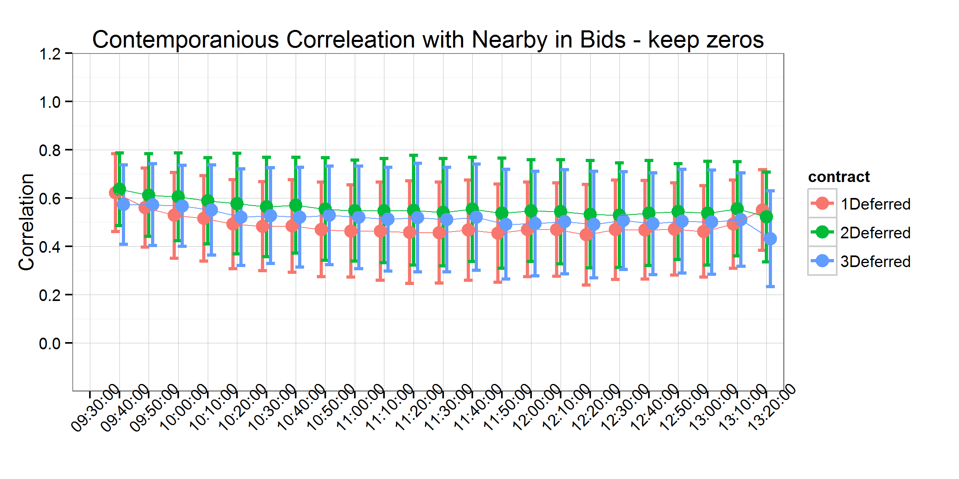

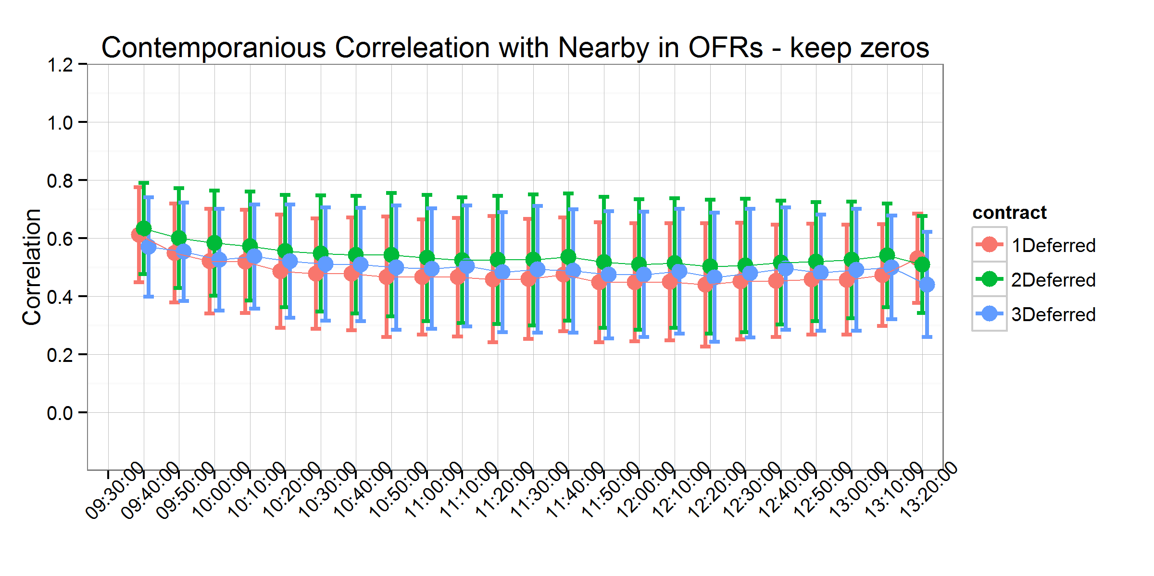

Figure 1. Contemporaneous Correlation with Nearby - Keep Zeros

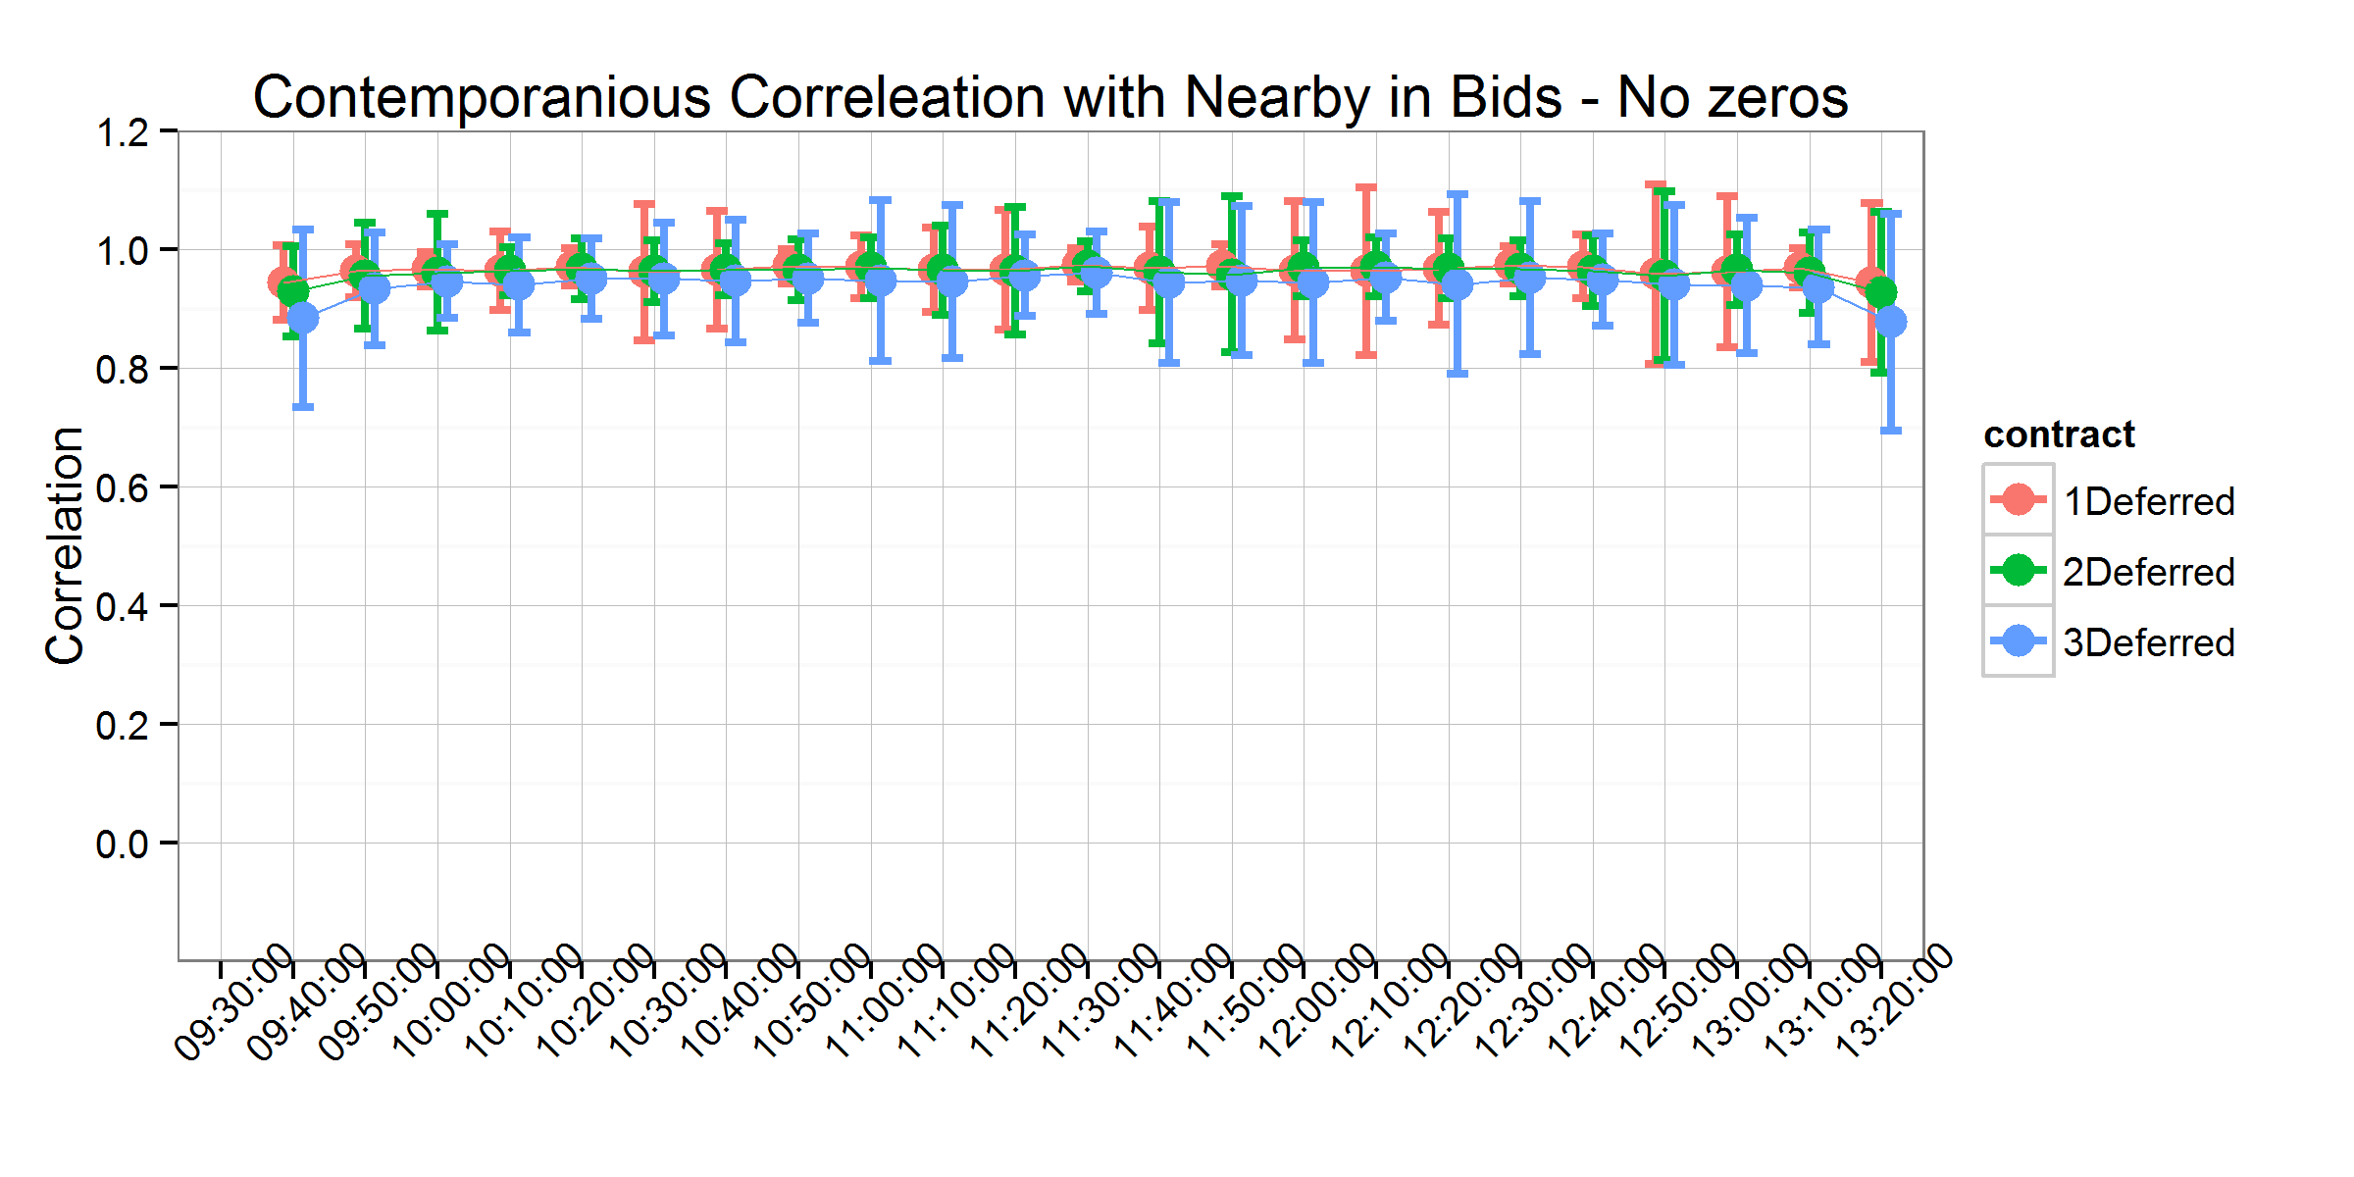

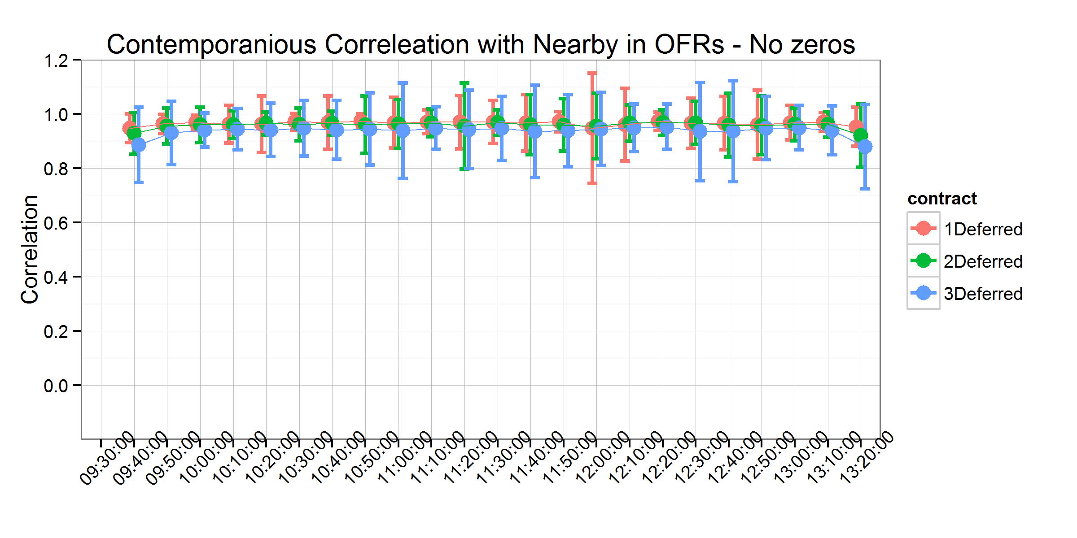

Figure 2. Contemporaneous Correlation with Nearby - No Zeros

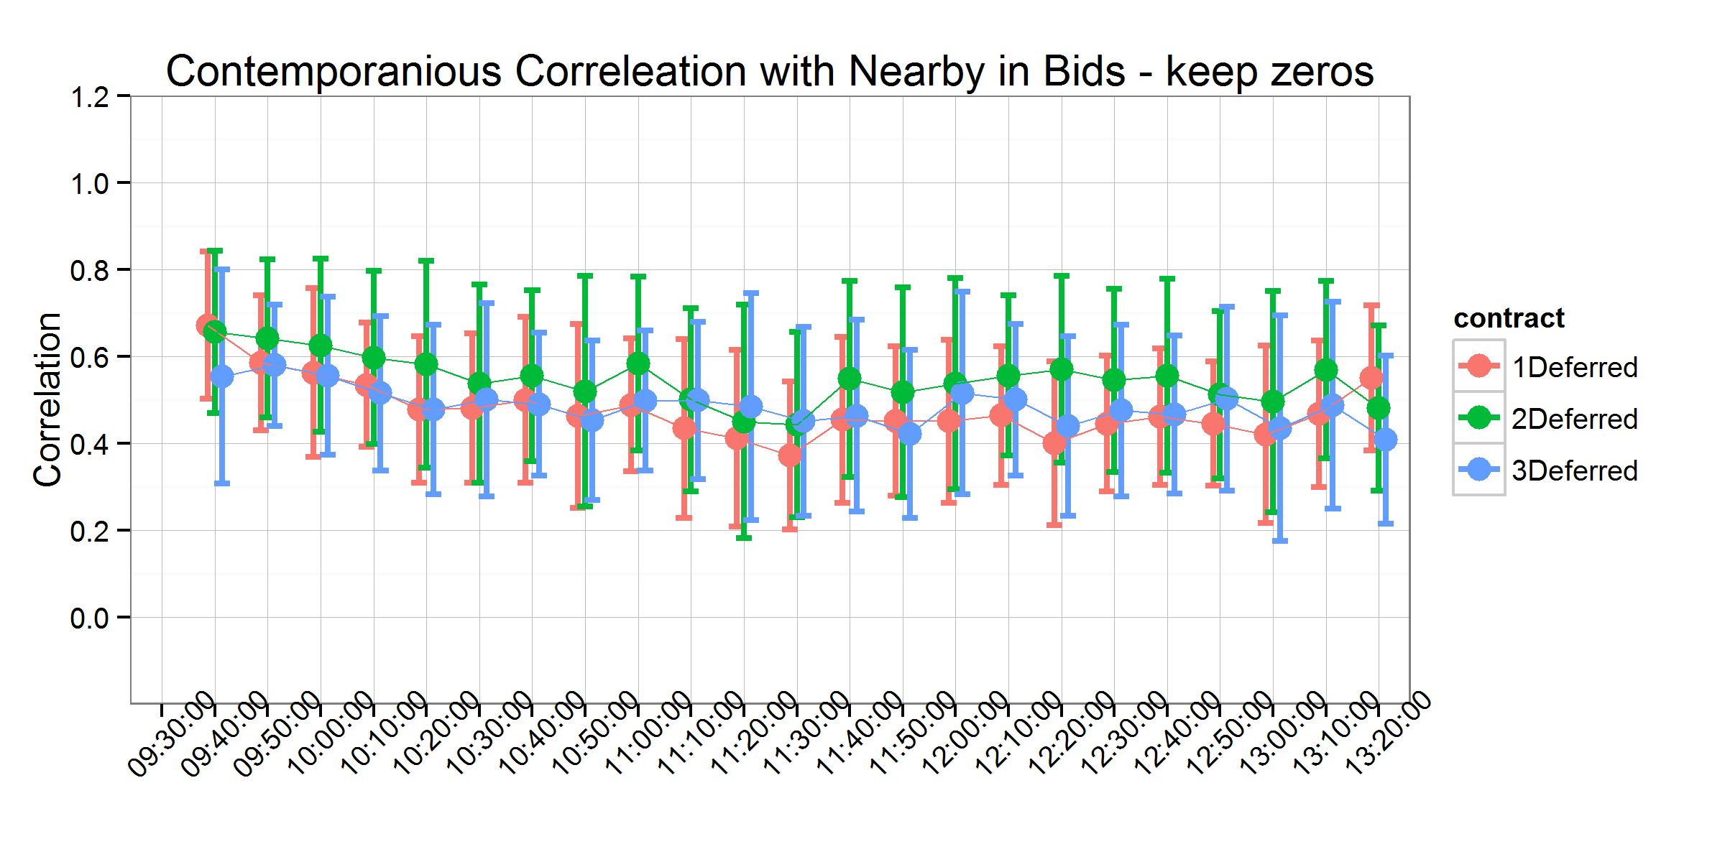

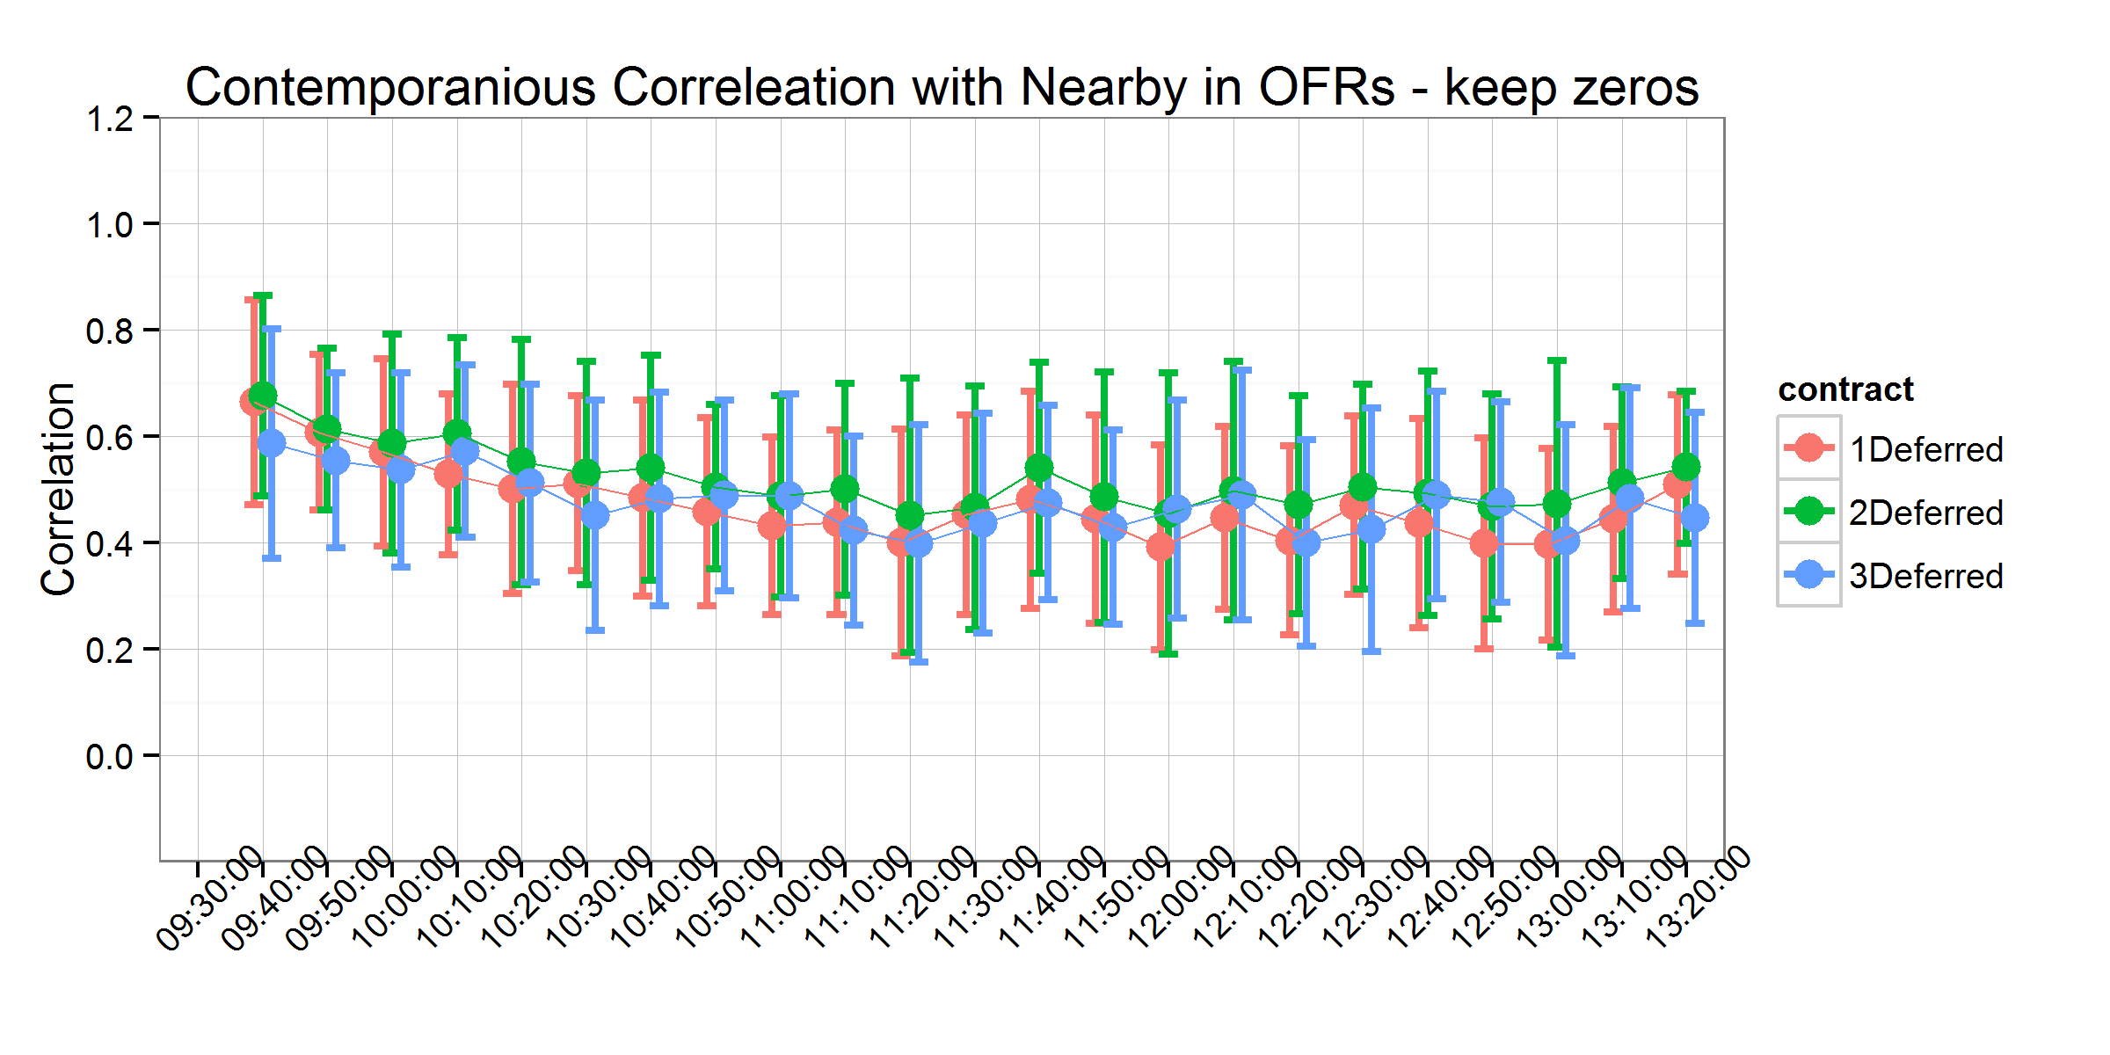

Figure 3. Contemporaneous Correlation with Nearby on USDA Report Days - Keep Zeros

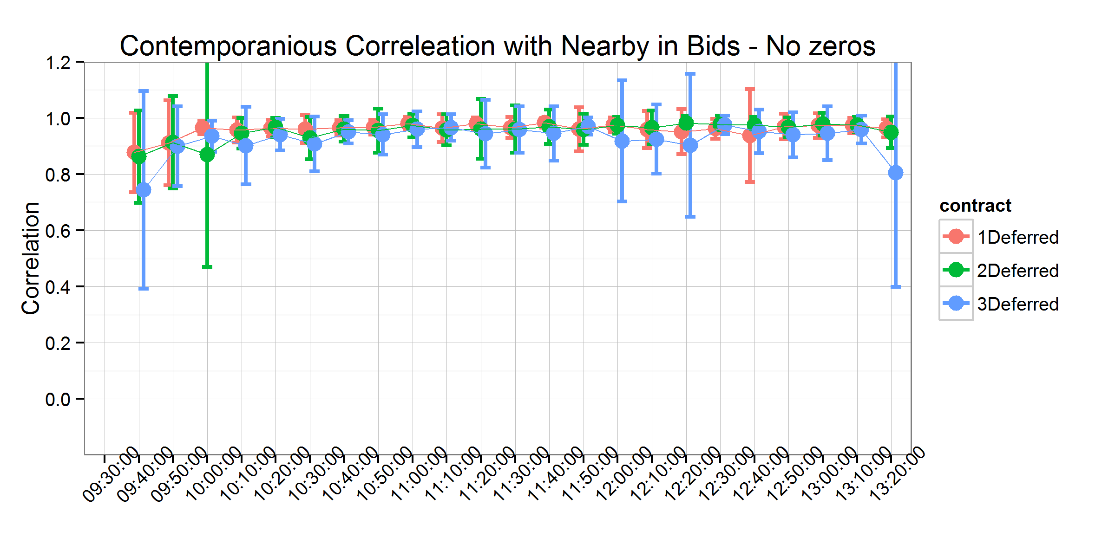

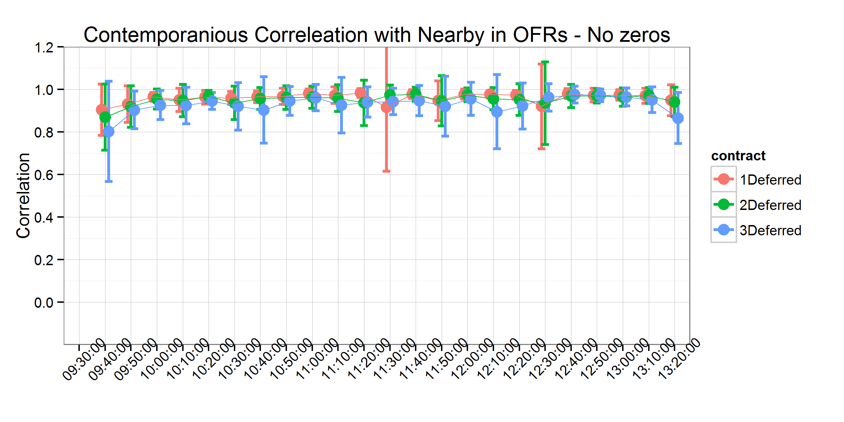

Figure 4. Contemporaneous Correlation with Nearby on USDA Report Days - No Zeros

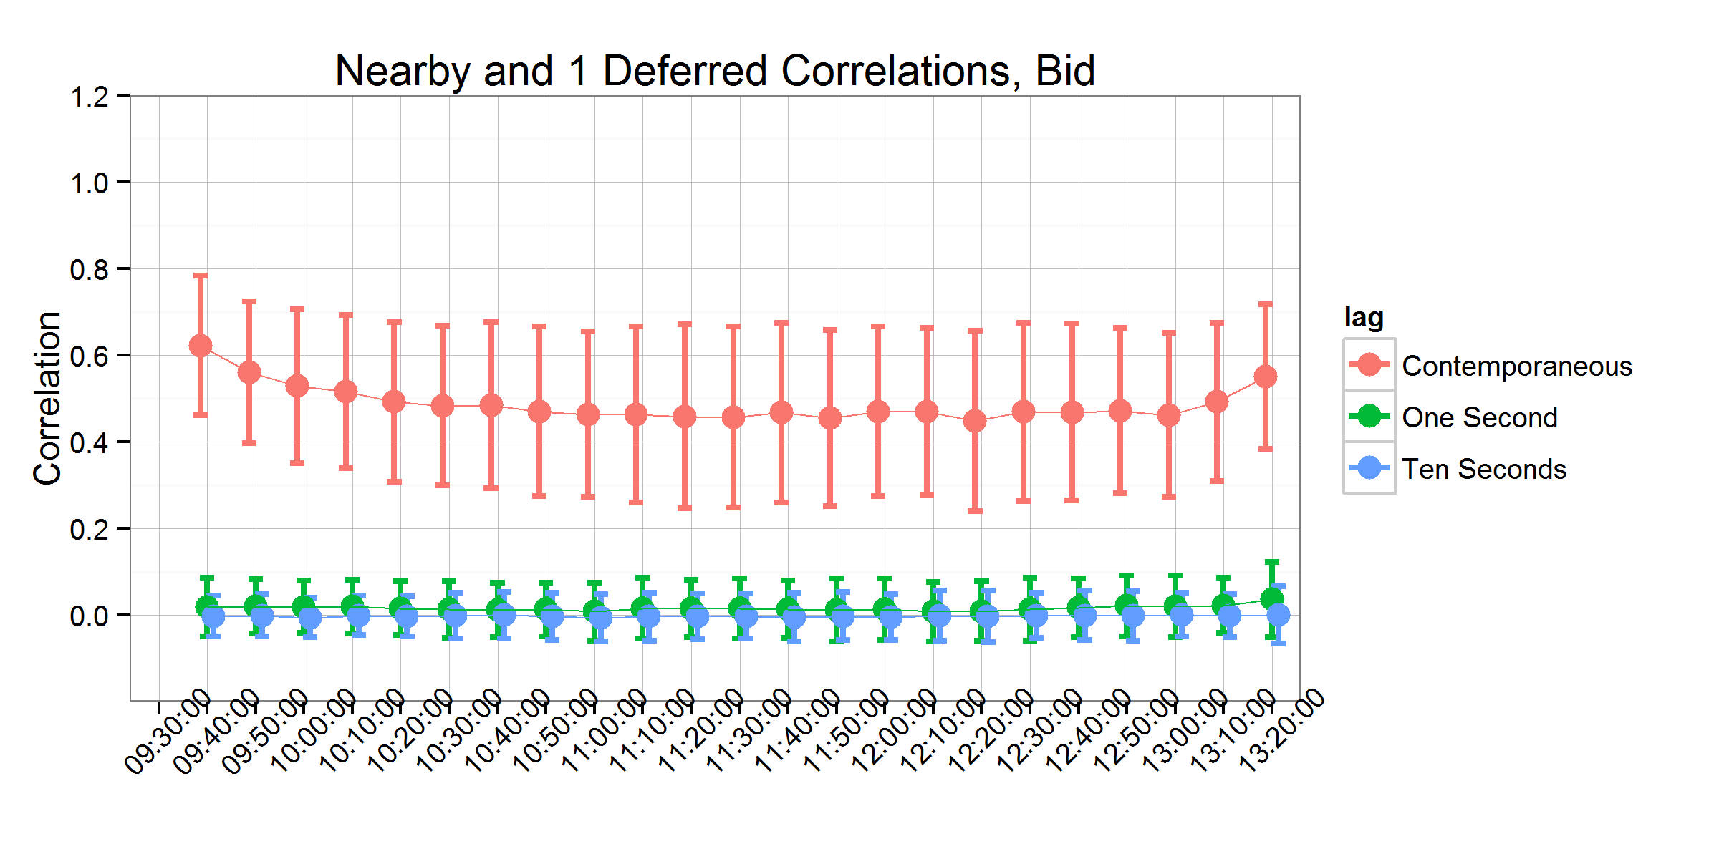

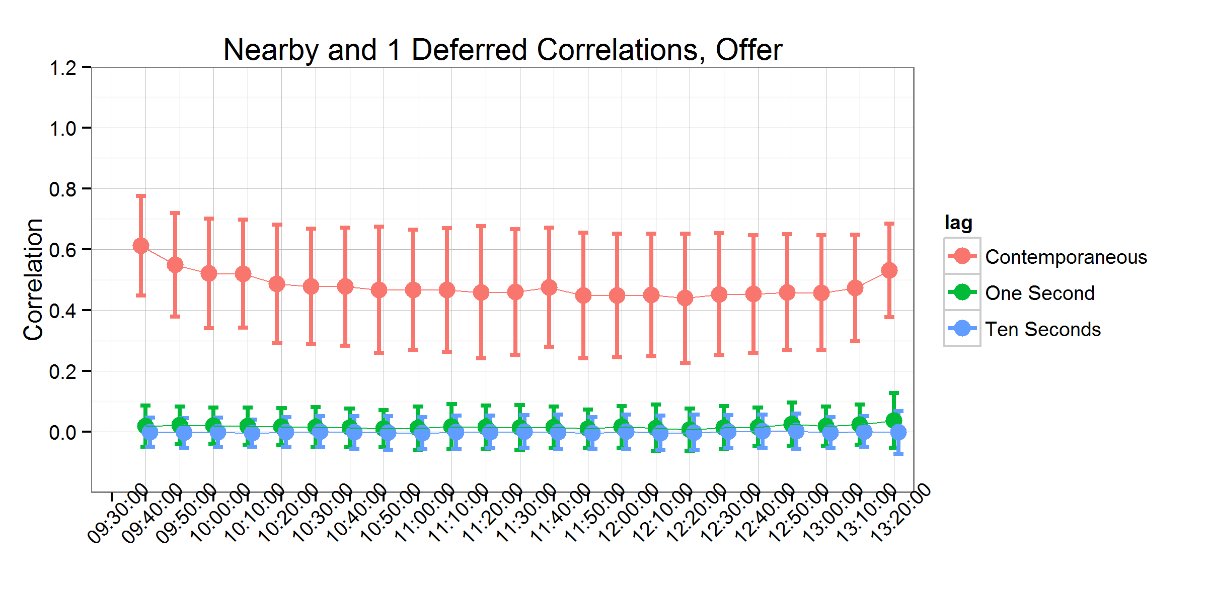

Figure 5. Contemporaneous and Time-lagged Correlations between the Nearby and One-deferred Contract

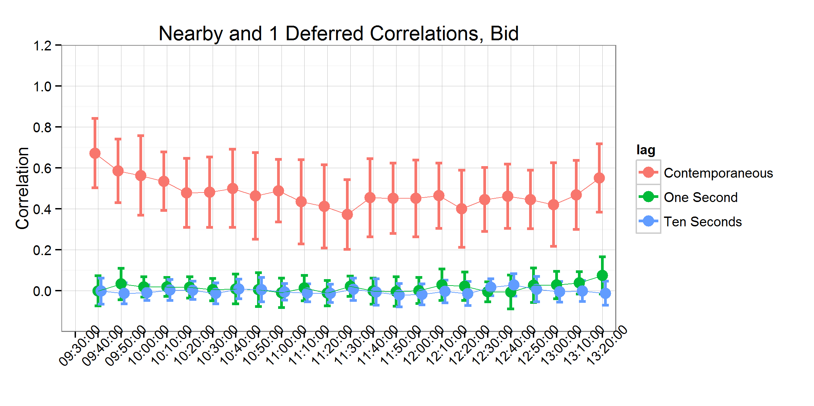

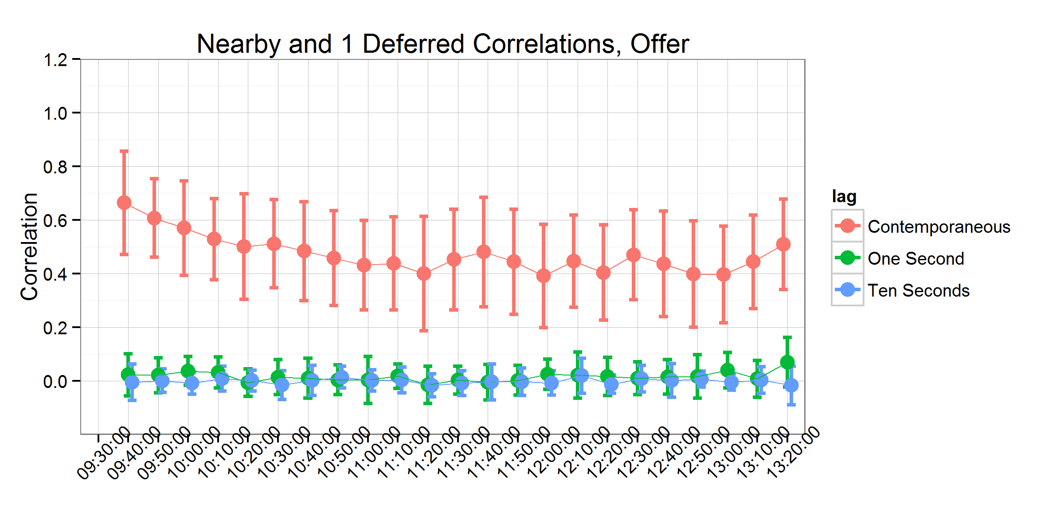

Figure 6. Contemporaneous and Time-lagged Correlations between the Nearby and One-deferred Contract on USDA Report Days

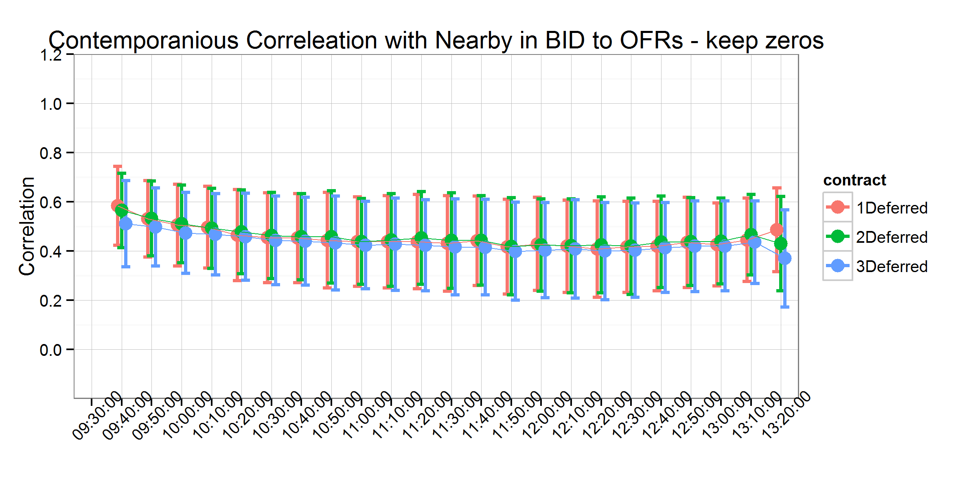

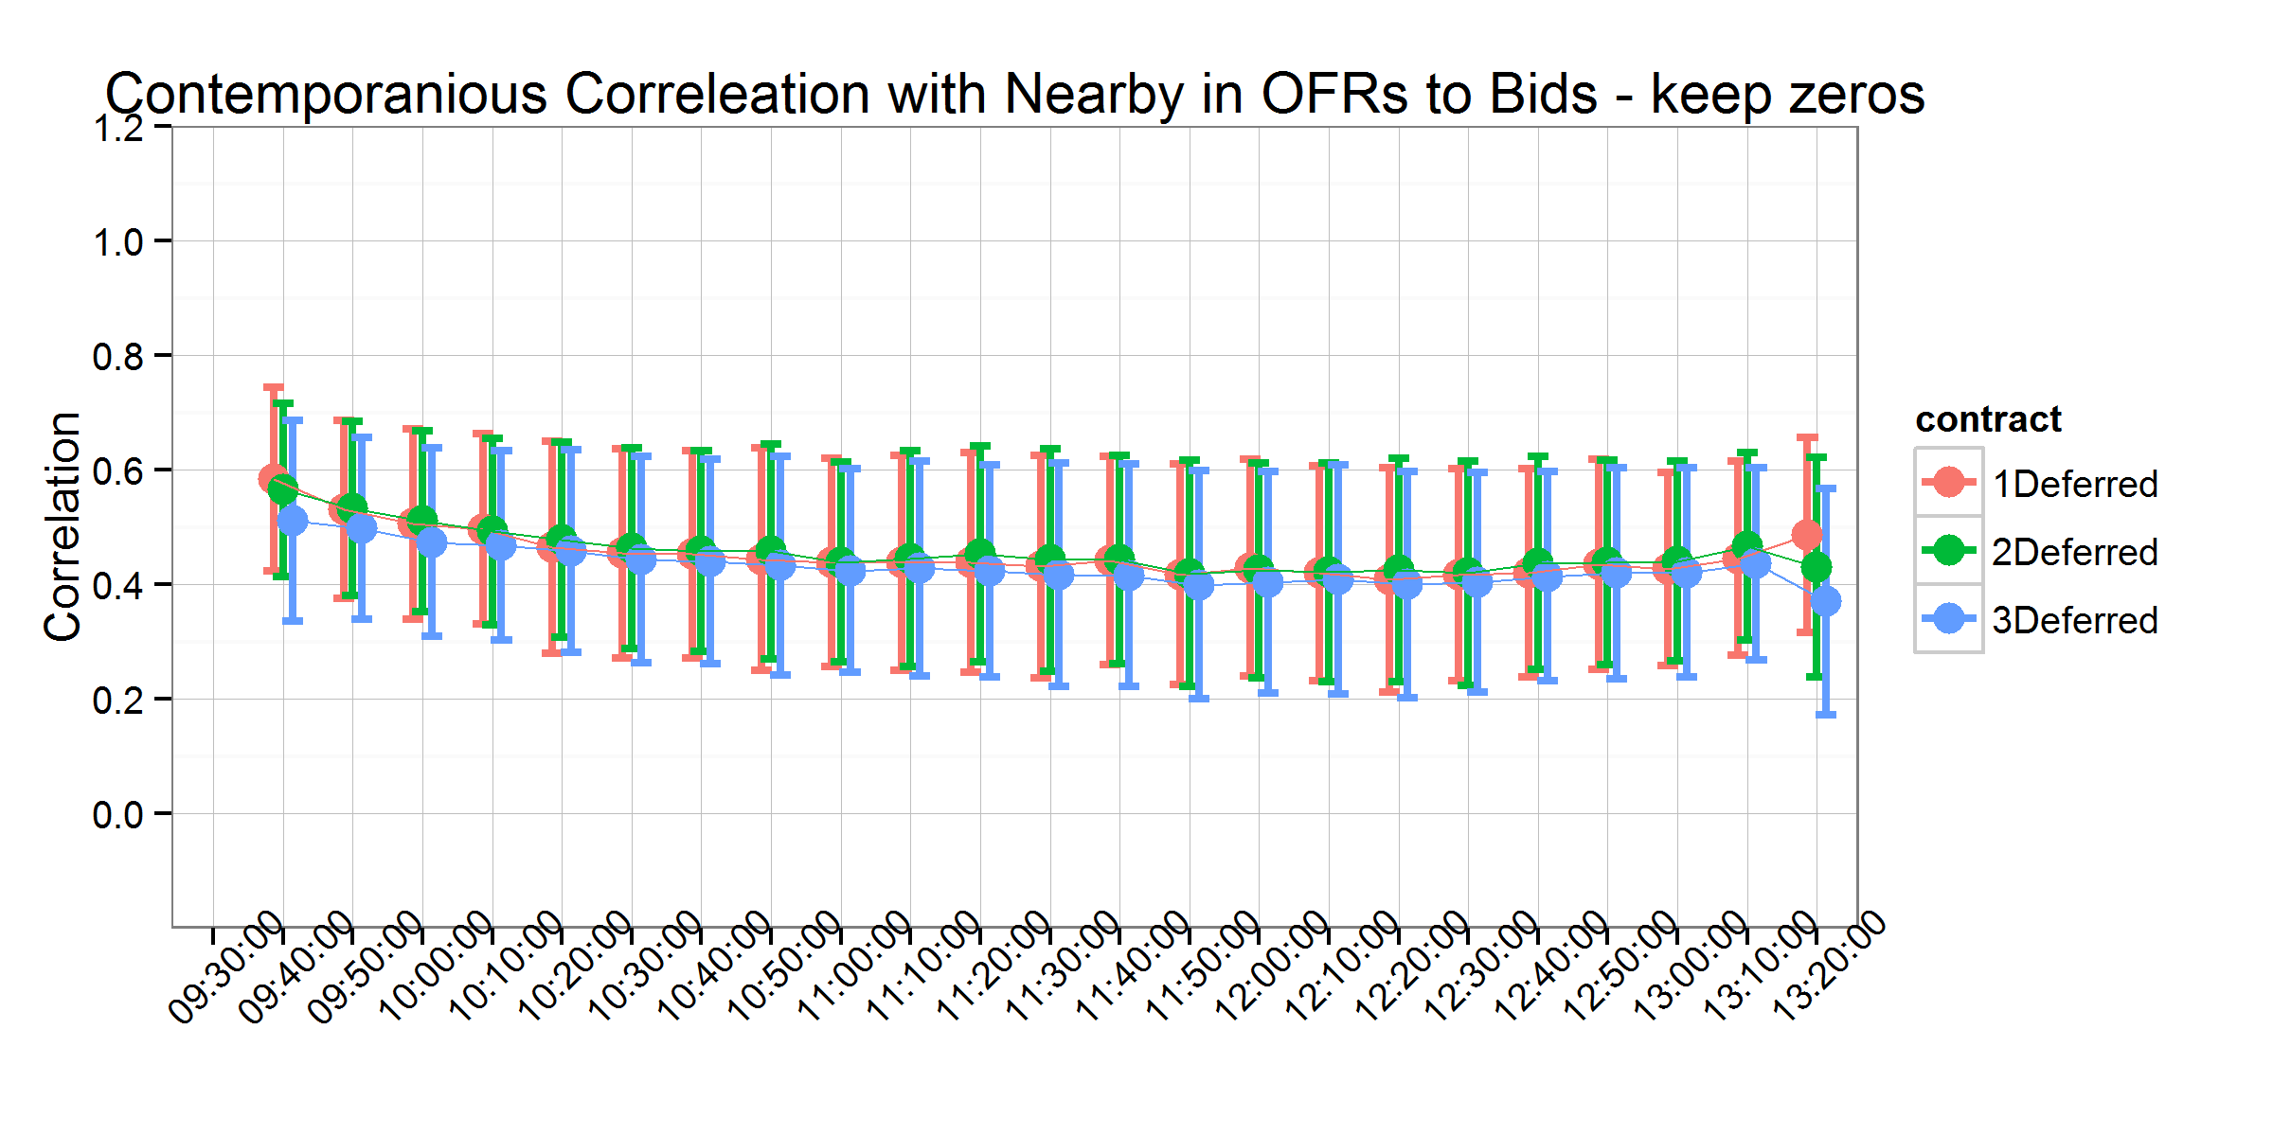

Figure 7. Contemporaneous Correlations with Nearby Bid-to-Ask and Ask-to-Bid - Keep Zeros

# References

Akerlof, G.A. 1970. “The market for‘ lemons’: Quality uncertainty and the market mechanism.” *The Quarterly Journal of Economics* 84(3):488–500.

Avalos, F. 2014. “Do oil prices drive food prices? The tale of a structural break.” *Journal of International Money and Finance* 42(0):253–271. Available at: <http://www.sciencedirect.com/science/article/pii/S0261560613001162>.

Bagehot, W. 1971. “The only game in town.” *Financial Analysts Journal* 27(2):12–14.

Boehmer, E., J. Grammig, and E. Theissen. 2007. “Estimating the probability of informed trading-does trade misclassification matter?” *Journal of Financial Markets* 10(1):26–47. Available at: <http://www.scopus.com/inward/record.url?eid=2-s2.0-33846279422&partnerID=40&md5=864042ba646f1d94703dccc526ad2da8>.

Cheng, I.-H., and W. Xiong. 2013. “The financialization of commodity markets.” Working paper series No. 19642, National Bureau of Economic Research. Available at: <http://www.nber.org/papers/w19642>.

Copeland, T.E., and D. Galai. 1983. “Information effects on the bid-ask spread.” *The Journal of Finance* 38(5):1457–1469.

Easley, D., and M. O’Hara. 1987. “Price, trade size, and information in securities markets.” *Journal of Financial economics* 19(1):69–90.

Easley, D., and M. O’Hara. 1992. “Time and the process of security price adjustment.” *The Journal of Finance* 47(2):577–605.

Easley, D., S. Hvidkjaer, and M. O’Hara. 2002. “Is information risk a determinant of asset returns?” *The Journal of Finance* 57(5):2185–2221.

Easley, D., N.M. Kiefer, and M. O’Hara. 1997. “One day in the life of a very common stock.” *Review of Financial Studies* 10(3):805–835.

Gardebroek, C., and M.A. Hernandez. 2013. “Do energy prices stimulate food price volatility? Examining volatility transmission between {uS} oil, ethanol and corn markets.” *Energy Economics* 40(0):119–129. Available at: <http://www.sciencedirect.com/science/article/pii/S0140988313001266>.

Glosten, L.R., and P.R. Milgrom. 1985. “Bid, ask and transaction prices in a specialist market with heterogeneously informed traders.” *Journal of Financial Economics* 14(1):71–100.

Hasbrouck, J. 2006. *Empirical market microstructure: The institutions, economics, and econometrics of securities trading*. Oxford University Press.

Hasbrouck, J. 2015. “High frequency quoting: Short-term volatility in bids and offers.” New York University. Available at: [http://ssrn.com/abstract=2237499](%20http://ssrn.com/abstract=2237499%20).

Henderson, B.J., N.D. Pearson, and L. Wang. 2015. “New evidence on the financialization of commodity markets.” *Review of Financial Studies* 28(5):1285–1311. Available at: <http://rfs.oxfordjournals.org/content/28/5/1285.abstract>.

Irwin, S.H., and D.R. Sanders. 2011. “Index funds, financialization, and commodity futures markets.” *Applied Economic Perspectives and Policy* 33(1):1–31. Available at: <http://aepp.oxfordjournals.org/content/33/1/1.abstract>.

Irwin, S.H., and D.R. Sanders. 2012. “Testing the masters hypothesis in commodity futures markets.” *Energy Economics* 34(1):256–269. Available at: <http://www.sciencedirect.com/science/article/pii/S0140988311002362>.

Kumar, P., and D.J. Seppi. 1994. “Information and index arbitrage.” *Journal of Business* 67(4):481–509.

Mallory, M.L., S.H. Irwin, and D.J. Hayes. 2012. “How market efficiency and the theory of storage link corn and ethanol markets.” *Energy Economics* 34(6):2157–2166. Available at: <http://www.sciencedirect.com/science/article/pii/S0140988312000552>.

O’Hara, M. 1995. *Market microstructure theory*. Blackwell Cambridge, MA.

Serra, T., and D. Zilberman. 2013. “Biofuel-related price transmission literature: A review.” *Energy Economics* 37(0):141–151. Available at: <http://www.sciencedirect.com/science/article/pii/S0140988313000388>.

Trujillo-Barrera, A., M. Mallory, P. Garcia, and others. 2012. “Volatility spillovers in uS crude oil, ethanol, and corn futures markets.” *Journal of Agricultural and Resource Economics* 37(2):247.

Vacha, L., K. Janda, L. Kristoufek, and D. Zilberman. 2013. “Time–frequency dynamics of biofuel–fuel–food system.” *Energy Economics* 40(0):233–241. Available at: <http://www.sciencedirect.com/science/article/pii/S0140988313001424>.

Vega, C. 2006. “Stock price reaction to public and private information.” *Journal of Financial Economics* 82(1):103–133. Available at: <http://www.scopus.com/inward/record.url?eid=2-s2.0-33748041619&partnerID=40&md5=1eb71f6d3df8978c80f959991cfc4348>.

Wang, X. 2014. *Price volatility and liquidity cost in grain futures markets*. PhD thesis. University of Illinois.

Yan, Y., and S. Zhang. 2012. “An improved estimation method and empirical properties of the probability of informed trading.” *Journal of Banking & Finance* 36(2):454–467. Available at: <http://www.sciencedirect.com/science/article/pii/S0378426611002433>.

1. The interested reader can refer to O’Hara (1995) for an excellent and detailed overview of the evolution of this literature.
2. In the third case, no activity at all is observed in the quoted prices, but quoted quantities may have changed do to new limit orders arriving, limit orders being cancelled, or market orders arriving taking some of the quoted quantities off the book. This is indicative of liquidity-based activity as well.
3. We generated this figure for USDA report days only. Similar to our result before, it is basically the same as figure 5 with more variation due to the small sample.