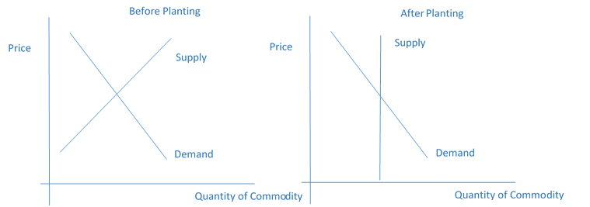

Supply

Demand

Quantity of Commodity

Price

Supply

Demand

Quantity of Commodity

Price

Before Planting

After Planting