# Add an Instructor, TA, or Grader to My Course

**NOTE:** *The people you add to your D2L Brightspace course must have completed* [*FERPA certification*](https://www.purdue.edu/registrar/FERPA/certification.html)*.*

* **Login** to D2L Brightspace and **open** the course you would like to add people to.
* From the course navigation bar, **click** **Classlist**.



* **Click Add Participants** and **select** **Add existing users** from the drop-down.

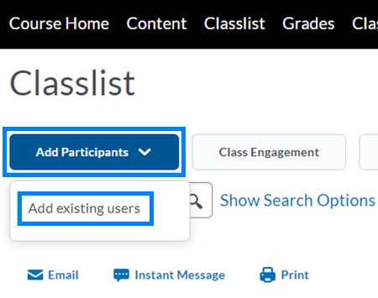

* **Click** within the **Search For** textbox and **enter** the First Name, Last Name, or Purdue Career Account username of the person you would like to add to the course. Then **click** the **Search** icon.

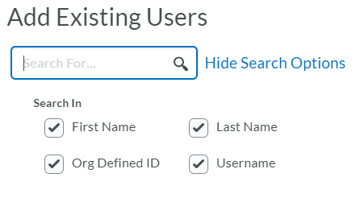

* From the search results, **check** the box next to the individual you would like to add to your course. To the far right, **click Select a Role** and **select** the role this person should have from the drop-down.

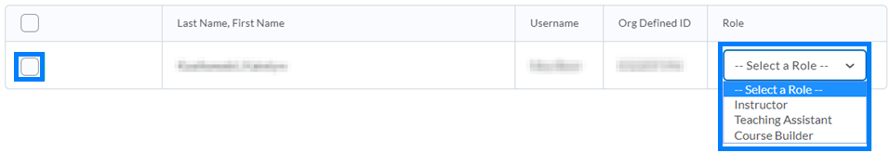

* **Click** the **Enroll Selected Users** option at the bottom of the screen.

