PROJECT REPORT

PHANTOM SECURE MESSAGING SYSTEM

By
VISHNUPRIYAN V
(Reg.No:2428K0331)

Guided by
Ms.M.Premavathi M.C.A.,M.phil.,
Assistant Professor of Computer Science, Bharathidasan College of Arts And Science, Erode.

PG & RESEARCH DEPARTMENT OF COMPUTER SCIENCE BHARATHIDASAN COLLEGE OF ARTS AND SCIENCE
(An Autonomous College Affiliated to Bharathiar University, Coimbatore)
ERODE - 638 116.

NOVEMBER 2026

PHANTOM SECURE MESSAGING SYSTEM

VISHNUPRIYAN V
(Reg.No:2428K0331)

Bonafide work done by

Project submitted in partial fulfillment of the requirements for the award of Bachelor of Computer Science(Artificial Intelligence and Data Science) of Bharathidasan College of Arts and Science affiliated to Bharathiar University, Coimbatore-46.

SIGNATURE OF THE GUIDE SIGNATURE OF THE HOD

Submitted for the Viva-Voce examination held on:

INTERNAL EXAMINER EXTERNAL EXAMINER

DECLARATION

I hereby declare that project work entitled “PHANTOM SECURE MESSAGING SYSTEM” done at Bharathidasan College of Arts & Science, Erode submitted to Bharathiar University in partial fulfillment of requirements for the award of Bachelor of Computer Science(Artificial Intelligence and Data Science) is a record of original and independent work done by me during the period 2024-2026 under the guidance and supervision of Ms.M.Premavathi MCA., M.Phil., Assistant Professor of Computer Science and it has not been submitted for the award of any other degree, diploma, fellowship, or any other similar title to any candidate of any other university.

Place: Erode Date:

Signature of the Candidate

VISHNUPRIYAN V
(Reg.No:2428K0331)

ACKNOWLEDGEMENT

I express my profound gratitude to our Secretary Mr.NKKP.NAREN RAAJA for allowing me to undertake this project work. I express my sincere thanks to Dr.P.VANATHI, Principal, Bharathidasan College of Arts And Science, Erode for having given me this fine opportunity to do the project. I wish to express my deep gratitude to Ms.M.Premavathi M.C.A.,M.phil., Assistant Professor of Computer Science, Bharathidasan College of Arts And Science, Erode for his valuable guidance and support throughout the project work.
I am extremely happy to thank our Bharathidasan College of Arts And Science Management. I also thank all the staff members of Computer Science Department who extended their help to complete my project work successfully. I am also thankful to the computer lab programmers for their kind co-operation. I wish to thank my colleagues who gave me full encouragement and support.

Last but not the least, I proudly thank and express my gratefulness to all my friends for the kind help rendered by them. I extend my heartfelt gratitude to my parents.

VISHNUPRIYAN V

 | TITLE | PAGE NO
 | ACKNOWLEDGMENT | i
 | SYNOPSIS | ii
1 | INTRODUCTION | 7
 | 1.1 ABOUT THE PROJECT | 7
 | 1.2 SYSTEM SPECIFICATION | 7
 | 1.2.1 HARDWARE CONFIGURATION | 7
 | 1.2.2 SOFTWARE SPECIFICATION | 7
 | 1.2.3 SOFTWARE DESCRIPTION | 8
2 | SYSTEM STUDY | 12
 | 2.1 EXISTING SYSTEM | 12
 | 2.1.1 DRAWBACKS OF EXISTING SYSTEM | 12
 | 2.2 PROPOSED SYSTEM | 12
 | 2.2.1 OBJECTIVE OF THE PROPOSED SYSTEM | 12
3 | SYSTEM DESIGN AND DEVELOPMENT | 13
 | 3.1 FILE DESIGN | 13
 | 3.2 INPUT DESIGN | 13
 | 3.3 OUTPUT DESIGN | 14
 | 3.4 DATABASE DESIGN | 15
 | 3.5 SYSTEM DEVELOPMENT | 16
 | 3.5.1 MODULE DESCRIPTIONS | 16
4 | TESTING AND IMPLEMENTATION | 18
5 | CONCLUSION | 20
 | SCOPE FOR FUTURE ENHANCEMENT | 20
 | BIBLIOGRAPHY | 21
 | APPENDICES | 22
 | A. DATA FLOW DIAGRAM | 22
 | B. TABLE STRUCTURE | 23
 | C. SAMPLE CODING | 25
 | D. SAMPLE SCREEN SHOT | 29
PHANTOM SECURE MESSAGING SYSTEM

ABSTRACT
Phantom is a computerized application designed to provide secure and real-time messaging between users. In traditional unencrypted messaging systems, conversations are maintained insecurely, which is vulnerable to eavesdropping and data breaches. This system aims to automate the end-to-end encryption process and provide accurate and organized secure data management.
The system allows users to register profiles, manage cryptographic prekey bundles, send end-to-end encrypted messages, and manage friend requests automatically. By maintaining digital encrypted records, the system reduces privacy risks and improves accuracy in message delivery. It also helps users maintain secure communications through offline queueing and real-time WebSocket connections.
Overall, the Phantom Secure Messaging System improves privacy, saves time, and supports secure communication. The system is suitable for personal and enterprise secure messaging and can be further enhanced with advanced group chats and real-time voice monitoring features.
Frontend Technologies:
Kotlin – Programming Language
Jetpack Compose – UI Design
Android SDK - Functionality
Backend Technologies:
Node.js/Express
Database: Room (Local) / In-memory/File-based JSON (Server)

CHAPTER 1
INTRODUCTION
1.1 ABOUT THE PROJECT
The Phantom Secure Messaging System is an Android-based application developed to automate and efficiently manage the daily activities of secure communication, particularly focusing on profile management, end-to-end encrypted messaging, and friend operations.
In many traditional messaging apps, communication records and message details are maintained unencrypted on servers. This traditional method often leads to data breaches, loss of privacy, duplication of records, and difficulty in ensuring message integrity. Unsecured systems also consume more effort to manually encrypt.
To overcome these issues, this project proposes a computerized system that maintains accurate and organized records of
Daily secure communications
Cryptographic key bundles
Available connections
Friend details
Message transactions
Offline queue reports
The system automatically updates connections whenever messages are sent or received. It generates offline queues for disconnected users and provides detailed mechanisms such as real-time WebSocket delivery and key bundle management. This helps the users make better communication decisions.

1.2 SYSTEM SPECIFICATION
1.2.1 HARDWARE CONFIGURATION
Processor: Snapdragon / Intel Core i3 or equivalent
RAM: 4 GB
Storage: 64 GB internal storage or equivalent HDD
Screen: 6-inch Touch Screen Monitor
Input: Virtual Keyboard
1.2.2 SOFTWARE SPECIFICATION
Operating System: Android 7.0+ (API 24+) / Server: Windows 10/11 or Linux
Frontend: Kotlin, Jetpack Compose
Backend: Node.js, Express, Socket.io
1.2.3 SOFTWARE DESCRIPTION

FEATURES OF KOTLIN / NODE.JS
Kotlin and Node.js are widely used technologies for developing modern applications. Kotlin is a cross-platform, statically typed, general-purpose programming language with type inference, widely used for Android development. Node.js is an open-source, cross-platform, back-end JavaScript runtime environment that executes JavaScript code outside a web browser.
Node.js works on the server side and processes the data using WebSockets and REST APIs before sending the output to the client. Kotlin is used to create the layout and structure of the mobile pages. Node.js can easily interact with databases or file systems to store and retrieve information.
Node.js is an open-source scripting language and it is widely used across the world for backend development. It is simple, flexible, efficient, and platform independent. Due to these advantages, Kotlin and Node.js are commonly used together for developing full-stack applications.

Some important features of Kotlin / Node.js are given below:
Simple
Kotlin and Node.js are very simple and easy to use compared to other programming languages. The syntax is easy to understand, which makes it popular among developers for building real-time applications.
Asynchronous
Node.js is an asynchronous event-driven JavaScript runtime. It does not wait for API responses before execution. The Node.js code is executed directly on the server and the output is sent to the user's device via WebSockets.
Faster
Node.js is faster than many other server-side technologies such as ASP and JSP in certain real-time web application environments due to its V8 engine.
Open Source
Both are open-source software, which means they are free to use and distribute.
Developers do not need to pay any license fee for using them.
Platform Independent
Node.js programs can run on different platforms such as Windows, Linux, Unix, and macOS. This makes it flexible and widely supported.
Type Safe
Kotlin is statically typed and provides null safety. It prevents null pointer exceptions during execution based on the type system.
Error Reporting
Both provide built-in error reporting features that help developers identify warnings and errors in the program during development.
Real-Time Access Monitoring
Node.js (with Socket.io) allows developers to monitor and log user access and WebSocket connections, which helps in tracking user activities.
Loosely Typed Language (JS)
Node.js supports JavaScript variables without explicitly declaring their data type. The data type is automatically determined during execution based on the value assigned.
Uses of Kotlin / Node.js
Kotlin and Node.js are widely used for developing mobile applications and dynamic backends. Node.js mainly works on the server side and interacts with databases or file systems.
Some common uses are:
Creating dynamic mobile interfaces
Interacting with web servers and WebSockets
Connecting applications with databases such as SQLite and Room
Interacting with the operating system file system
Implementing business logic in real-time applications
Encrypting data (End-to-end encryption)
Handling sockets and session variables
Generating UI output to the screen
Sending and receiving encrypted messages
Creating login and authentication systems
Managing database records such as add, delete, and update operation
Why Use Kotlin / Node.js
Node.js runs on different platforms such as Windows, Linux, and Unix.
It works efficiently on the server side for I/O heavy operations.
Node.js is compatible with many web servers and reverse proxies.
Kotlin can be easily integrated with Android SDK.
They are widely used for developing secure web and mobile applications.
It can be easily embedded within mobile application code.
It is widely used for developing secure real-time messaging applications.
Room Database / SQLite
SQLite is a Relational Database Management System (RDBMS) used for storing and managing data in a structured format on mobile devices. It is widely used in mobile applications as a fast and reliable local database system.
SQLite stores data in the form of tables consisting of rows and columns. These tables can store different types of information such as user profiles, encrypted messages, friend details, and cryptographic keys.
For example, in the Phantom Secure Messaging System, SQLite (via Room) can store information such as message ID, encrypted content, sender ID, recipient ID, and timestamps.
Room provides an abstraction layer over SQLite to allow fluent database access while harnessing the full power of SQLite. Room scripts send queries to the SQLite database and retrieve the required information which is then displayed in the app interface.

Installation Guide to Use Node.js
Node.js can be downloaded from the official website. There are also several package managers like npm that allow users to easily configure Node.js projects.

Some popular tools include:
npm (Node Package Manager)
Android Studio
VS Code
Postman (API Testing)
These tools provide an easy interface to manage dependencies and configure development environments.
In this project, Android Studio and VS Code are used because they are easy to install and configure. Android Studio includes the Android SDK and Kotlin support in a single package which makes it convenient for mobile development.
Android Studio
Android Studio is a free and open-source IDE that provides a local development environment for building Android applications. It includes several components such as
Kotlin Compiler
Gradle Build System
Android Emulator
Layout Inspector
Android Studio allows developers to build and test mobile applications on their local computer using the emulator. It provides an easy way to test and develop Kotlin and Jetpack Compose based mobile applications.

Features of Room / SQLite
Room provides many powerful features for managing local databases efficiently.
Some of the important features are:
Compile-time verification of SQL queries
Convenience annotations that minimize boilerplate code
Streamlined database migration paths
Testability and integration with LiveData and Coroutines
Triggers for automatic database operations
Information Schema for database metadata
SQL mode options to control runtime behavior
Transactions with save points
ACID compliance for reliable transactions
Full-text indexing and searching.

CHAPTER 2
SYSTEM STUDY AND ANALYSIS
2.1 EXISTING SYSTEM
In the existing system, messaging activities are carried out with unencrypted or centrally controlled servers. All the details related to daily messages, user data, customer information, and transactions are recorded using plain text databases. This method requires more trust in the central server and consumes a lot of privacy.
In the insecure system, operations such as encrypting messages are done loosely or not at all, which may lead to data interception. Searching for secure previous records is very difficult, as all the data is stored in vulnerable plain text. There is also a high risk of data loss due to server compromise or improper maintenance of security.

2.1.1 DRAWBACKS OF EXISTING SYSTEM:
All records are maintained insecurely using plain text tables
Interception of messages may occur frequently
Data breaches are possible due to server hacks or misplacement of records
Time-consuming process for verifying authenticity
Difficult to track secure keys accurately
End-to-end encryption cannot be managed easily
Managing large amounts of secure data is not efficient

2.2 PROPOSED SYSTEM
The proposed system is a computerized Phantom Secure Messaging System developed to manage end-to-end encryption, user connections, and messaging activities in secure networks. In the existing system, message records and connection details are maintained insecurely using centralized plain text databases. This process leads to privacy loss, interception, and difficulty in maintaining secure communications.

2.2.1 OBJECTIVE OF THE PROPOSED SYSTEM
To avoid interception of data and reduce privacy risks.
To provide an easy and efficient way to manage secure messages accurately and securely.
To generate encrypted communication channels for privacy purposes.
The system is flexible and easy to use.
CHAPTER 3
SYSTEM DESIGN AND DEVELOPMENT
3.1 FILE DESIGN
This system contains different screens for performing various operations related to secure messaging management. Screens and components are created for displaying and managing the information about messages, friends, keys, and connection details.
The system also contains interactive elements as part of the user interface to perform operations such as adding friends, updating profiles, sending messages, and viewing chats.
Navigation-driven programming makes the system very easy to access and operate. Using navigation graphs, the user can easily navigate through the different modules of the system.

The system contains the following screens:
Profile Setup
Chat List
Friend Requests
Messaging Screen

3.2 INPUT DESIGN
Input Design is one of the most important phases in the operation of a computerized system. A large number of problems in a system are usually caused by poor input design and improper data entry methods. Input data is considered as the lifeblood of a system and must be carefully designed and analyzed.
The main objectives of input design are:
To provide a cost-effective method of data entry
To achieve the highest possible level of accuracy
To ensure that the input is easy to understand for the user

System analysis determines the following input design details such as what data should be entered, what input medium should be used, how the data should be arranged or coded, and how validation checks should be applied to detect errors.
Input data may be raw data entered directly by the user or it may come from another system or subsystem. Input design covers all phases from initial data creation to actual data entry into the system.
The design of input involves identifying the required data, defining the characteristics of each data item, preparing the data for processing, and ensuring data accuracy.
Input forms used in this system include:
Profile Entry
Message Entry
Friend Request Entry
Key Generation Entry

3.3 OUTPUT DESIGN
Output design refers to the results and information generated by the system. For many users, the output is the main reason for developing the system and the basis for evaluating the usefulness of the application.
The objective of the system is reflected in the outputs it generates. Output may appear in different forms such as reports, screen displays, printed forms, or graphical representations. Outputs may also vary based on their content, frequency, timing, and format.
Users depend on the outputs generated by the system to make decisions. Therefore, outputs must be accurate, timely, and appropriate in terms of content and format.

The output design contains the following reports:
Profile Display
Chat History Display
Connection Status Display
Offline Queue Report
Secure Key Verification Report
When designing outputs, system analysts must determine what information should be presented, whether the information should be displayed on the screen or printed, and how the output should be distributed to users.
External outputs are those that are sent outside the organization and require special attention because they represent the image of the organization.
Internal outputs are those used within the organization and must be carefully designed since they serve as the main interface between the user and the system.

3.4 DATABASE DESIGN

A table is a collection of related data about a specific topic. For example, a table can contain data about user profiles, messages, friend requests, or cryptographic keys.
Tables organize data into columns (fields) and rows (records). The database is the storage medium where the data entered by the user is stored and processed. The system retrieves data from the database to generate useful information for the user.
While designing the database, the required data is identified and divided into different tables based on their purpose. Relationships between tables are also defined to ensure proper data organization.
Sample records are entered to verify the database structure and ensure that the system produces correct results.
Profile Table
User_ID
Username
Display_Name

Messages Table
Message_ID
Sender_ID
Recipient_ID
Encrypted_Content
Timestamp

Friend Requests Table
Request_ID
From_User_ID
To_User_ID
Timestamp

Prekey Bundles Table
User_ID
Signed_Prekey
Signature
One_Time_Prekeys

3.5 SYSTEM DEVELOPMENT
System development involves designing and implementing the system using appropriate programming languages and database management tools. In this project, the Phantom Secure Messaging System is developed using Kotlin, Jetpack Compose, Node.js, and SQLite (Room).
The system is designed in a modular structure so that each module performs a specific function. This modular approach makes the system easy to understand, maintain, and update.
3.5.1 MODULE DESCRIPTIONS
The system consists of the following modules:
Server Administration
Connection Management
Messaging Management
Friend Management
Cryptography Management
Server Administration
In this module, the relay server manages the connections. The server can manage all the sockets related to clients, offline queues, and profile data.
The server can perform operations such as:
Storing offline messages
Routing live messages
Delivering friend requests
Serving prekey bundles
The server can also view connection logs such as active sockets, authentication events, and message routing details.
Connection Management
In this module, users can connect to the relay server using WebSockets. The system records the active socket ID each time and stores the information in memory. This module helps the app track online status and receive real-time packets.
Messaging Management
This module is used to record and send encrypted messages. Users can enter details such as friend name, and message content. The system automatically encrypts and transmits via Socket.io. This module helps maintain secure chat records locally.
Friend Management
This module stores friend information such as user ID, username, and public keys. The system maintains friend records for future reference and encryption tracking. Users can add new friends, accept requests, or view existing friend details.
Cryptography Management
This module generates different types of keys based on the Signal protocol or similar E2EE protocols. Examples of operations include:
Generating Identity Keys
Signing Prekeys

CHAPTER 4
SYSTEM TESTING AND IMPLEMENTATION
SYSTEM TESTING
System testing is one of the most important phases in software development. It is
used to verify whether the developed system works correctly according to the requirements. Testing ensures that the software is free from errors and performs efficiently.
System testing involves different verification, validation, and testing activities to ensure that the system functions properly.
VERIFICATION
Verification is the process of checking whether the system is developed according to the specified design and requirements. It ensures that the system is consistent, complete, and correctly implemented during each stage of development.
VALIDATION
Validation is the process of evaluating the final software system to ensure that it satisfies the user requirements and performs the intended tasks effectively.
TESTING
Testing is the process of executing the software with different sets of sample input data to ensure that the program produces the correct output. It helps identify errors and ensures that the system functions properly.
Several testing methods are used to confirm that the system is ready for implementation.
Testing Steps
Unit Testing
Integration Testing
User Acceptance Testing
Security Testing

UNIT TESTING
Unit testing focuses on verifying the smallest unit of the software, such as individual modules or functions. Each module is tested independently to ensure that it performs its intended function correctly.
This testing was carried out during the programming stage to ensure that every module of the system works properly.
INTEGRATION TESTING
Integration testing is performed after all modules are developed and combined together. This testing checks whether different modules work together correctly without any errors. The outputs generated by the system were verified according to the system design specifications.
The integration testing phase confirmed that all modules are working together efficiently.
USER ACCEPTANCE TESTING
User Acceptance Testing (UAT) is performed to ensure that the system meets the expectations and requirements of the users.
During this phase, users interact with the system and verify whether it performs the required operations such as entering profile data, managing secure messages, and generating keys. Any necessary changes are made based on user feedback to improve the system.
SECURITY TESTING
Security testing ensures that the system is protected from unauthorized access. Only authenticated clients with valid cryptographic keys are allowed to decrypt the messages.
This testing verifies that sensitive information such as message contents, private keys, and user details are properly protected with end-to-end encryption.

SYSTEM IMPLEMENTATION
System implementation is the final stage in the development process where the system is installed and made available for use by the users.
After completing the development and testing phases, the Phantom Secure Messaging System is installed on the mobile devices used by the users.
Initially, the system is tested using sample accounts to verify that all modules are functioning correctly. Once the results are verified and approved by the users, real-time messaging is executed in the system.
During the implementation phase, users are trained to use the system effectively. Proper instructions are provided to help them understand how to enter profile data, manage friends, and verify security keys.
The new computerized system replaces the insecure messaging system and provides better accuracy, privacy, and data management.

5.CHAPTER
CONCLUSION AND FUTURE ENHANCEMENT
5.1 CONCLUSION
All the objectives of the Phantom Secure Messaging System have been successfully implemented. The system was tested thoroughly and was found to work efficiently. This system helps in managing secure communication, profile details, message records, and friend information in an organized manner. The system has been developed in such a way that it is flexible to add additional features in the future if required.

The project work became successful because of the following reasons:
The users can save their privacy and maintain confidentiality after implementing this system.
Modification and maintenance can be done easily because the software is flexible.
A large amount of data such as encrypted messages, contact records, and profile information can be stored and retrieved easily.
Speed and accuracy are maintained in managing secure connections.
Data is encrypted in a proper and organized format.
Various operations such as key generation, socket routing, and offline queuing can be performed easily.
The system eliminates unencrypted record keeping.
Data processing is faster and more secure compared to plaintext methods.
5.2 SCOPE FOR FUTURE ENHANCEMENT

In today’s competitive digital environment, it is very important to use secure systems to manage communication efficiently. The Phantom Secure Messaging System helps users manage private records, friend details, and encrypted information easily. In the future, this system can be enhanced to support group chats and voice/video calls, allowing customers to communicate securely in larger settings anytime, anywhere.
This system can be further improved by adding features such as multi-device support, so users can sync encrypted data across multiple devices. The system can also include self-destructing messages, which helps users maintain ephemeral communications instantly.

BIBLIOGRAPHY

TEXT BOOKS REFERRED
Kotlin in Action – Dmitry Jemerov and Svetlana Isakova.
Node.js Design Patterns – Mario Casciaro and Luciano Mammino.
Android Programming: The Big Nerd Ranch Guide – Bill Phillips.
Practical Cryptography – Niels Ferguson and Bruce Schneier.
Database Management Systems – G.K. Gupta.
A Philosophy of Software Design – John Ousterhout.
The Art of Software Testing – Glenford J. Myers, Corey Sandler, and Tom Badgett.
Software Testing – Ron Patton, 2nd Edition, 2005.

WEBSITES REFERRED
Kotlin Documentation – https://kotlinlang.org/docs/home.html
Android Developers – https://developer.android.com/
Node.js Documentation – https://nodejs.org/en/docs/
Socket.IO Documentation – https://socket.io/docs/

APPENDICES
A. DATA FLOW DIAGRAM

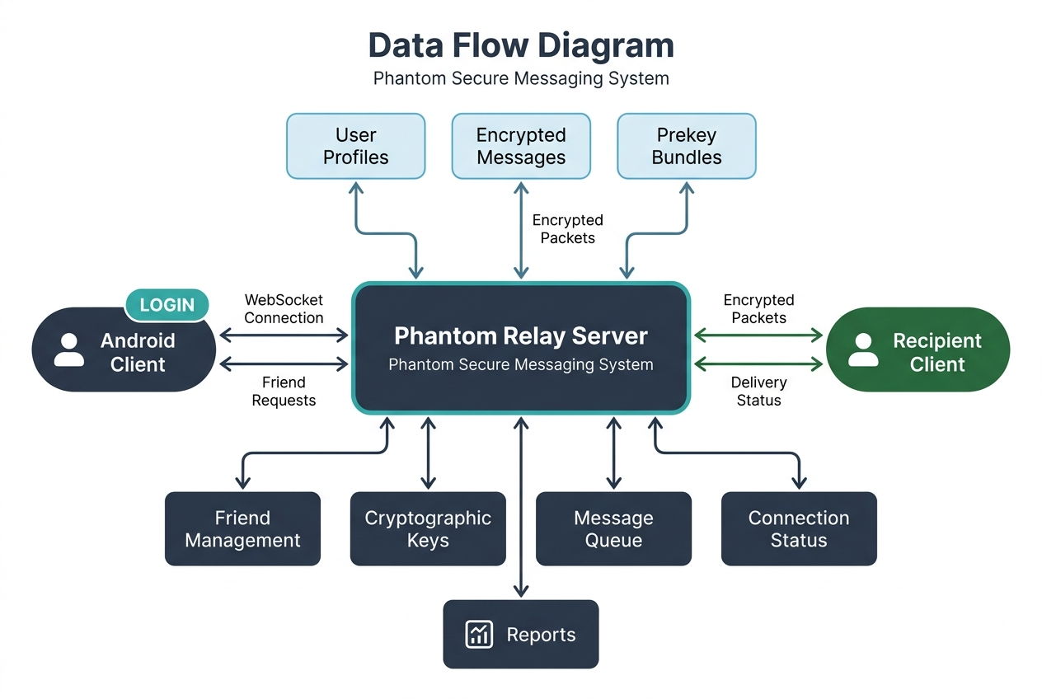

B. TABLE STRUCTURE

1. Profile Table
This table stores user profile information locally and on the server.

Field Name | Data Type | Description
user_id | VARCHAR | Unique user identifier
username | VARCHAR | User's chosen name
display_name | VARCHAR | User's display name
avatar_style | VARCHAR | User's avatar config
identity_public_key | VARCHAR | Public Identity Key for E2EE

2. Messages Table
This table stores information about encrypted messages locally.

Field Name | Data Type | Description
message_id | INT | Unique ID of the message
sender_id | VARCHAR | ID of the sender
recipient_id | VARCHAR | ID of the recipient
encrypted_content | TEXT | Ciphertext of the message
timestamp | DATE | Time when sent/received

3. Friend Requests Table
This table stores the pending friend requests on the server.

Field Name | Data Type | Description
request_id | INT | Unique ID for request
from_user_id | VARCHAR | ID of sender
to_user_id | VARCHAR | ID of recipient
timestamp | DATE | Time when request was made

4. Prekey Bundles Table
This table maintains cryptographic key bundles for E2EE.
Field Name | Data Type | Description
user_id | VARCHAR | Unique ID of the user
signed_prekey | VARCHAR | Signed public prekey
signature | VARCHAR | Digital signature of the prekey
one_time_prekeys | JSON | Array of one-time prekeys

5. Friends Table
This table stores friend relationships and public keys.

Field Name | Data Type | Description
friend_id | VARCHAR | Unique ID of the friend
username | VARCHAR | Friend's username
display_name | VARCHAR | Friend's display name
identity_public_key | VARCHAR | Friend's public key for E2EE

6. Offline Queue Table
This table keeps track of messages queued for offline users.

Field Name | Data Type | Description
queue_id | INT | Unique ID of the queued message
recipient_id | VARCHAR | ID of the offline recipient
encrypted_packet | TEXT | Encrypted message packet stored for delivery

SAMPLE CODING

const express = require('express');
const http = require('http');
const { Server } = require('socket.io');
const cors = require('cors');

const app = express();
const server = http.createServer(app);
const io = new Server(server, {
cors: {
origin: "*",
methods: ["GET", "POST"]
}
});

io.on('connection', (socket) => {
console.log(`Client connected: ${socket.id}`);

socket.on('authenticate', (userId) => {
console.log(`User ${userId} authenticated`);
});

socket.on('send_message', (packetInput) => {
let packet = packetInput;
if (typeof packetInput === 'string') {
packet = JSON.parse(packetInput);
}
console.log(`Routing packet from ${packet.senderUserId} to ${packet.recipientUserId}`);
});
});

server.listen(3000, () => {
console.log(`Phantom Relay Server running on port 3000`);
});

SAMPLE SCREENSHOTS:

1. Profile Setup Screen

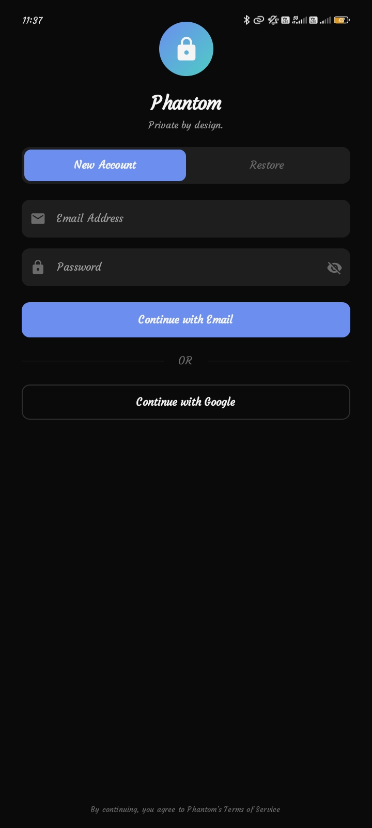

2. Chat List Screen

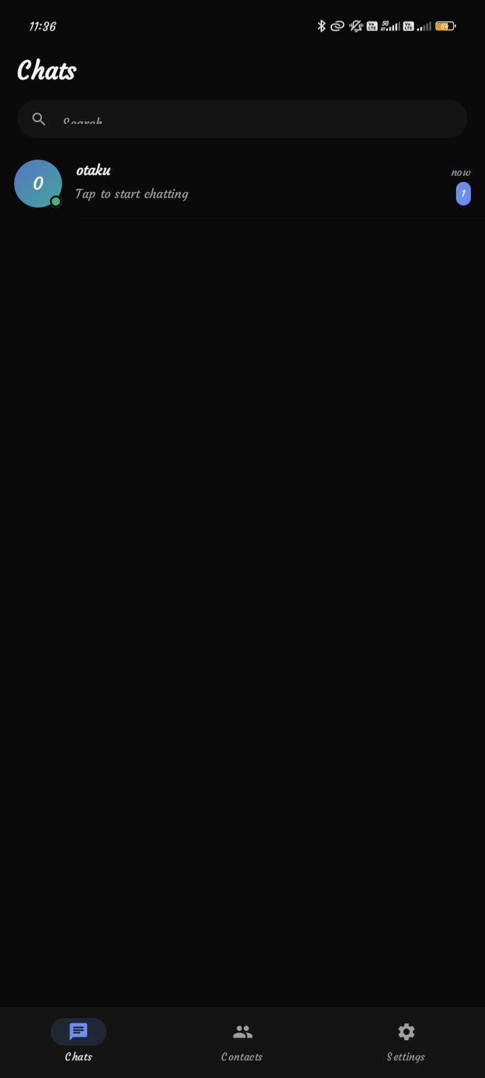

3. Messaging Screen

