**Name:** Chan Ming En Minern

**Matric No.:** A0164749N

**Github repo:** <https://github.com/minernchan/OTOTassignmentB>

**B1 – Running the API locally:**

1. Fork the repository from the given link above
2. Navigate to the root directory of the repository in the command line.
3. Run “node index” on the command line, and the application should start running on localhost at port 8080.
4. Open Postman and navigate to localhost:8080/api/messages
5. You can use the GET request at localhost:8080/api/messages to retrieve the entire list of messages submitted.  
   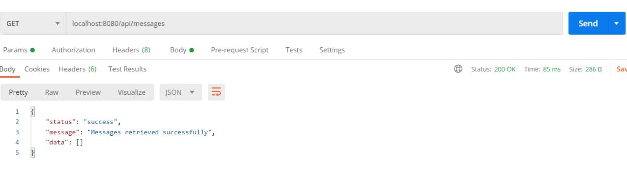  
     
     
   You can also use the POST request to submit a new message by filling in the x-www-form-urlencoded table in the body tab.  
   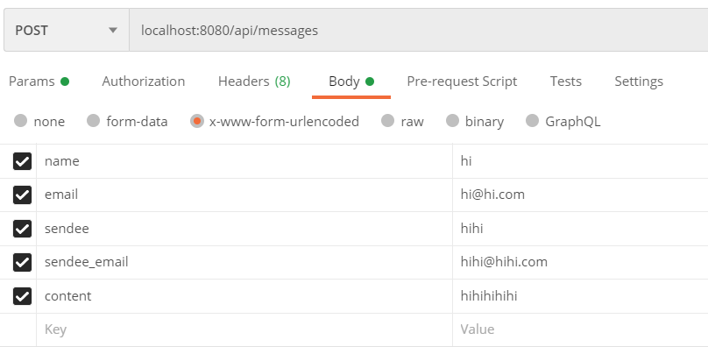
6. The GET, PUT, and DELETE API calls can be requested at the url for each individual message. The message id is automatically generated, and can be found at GET localhost:8080/api/messages after a message has been successfully posted.  
     
     
     
   GET localhost:8080/api/messages/:messageid 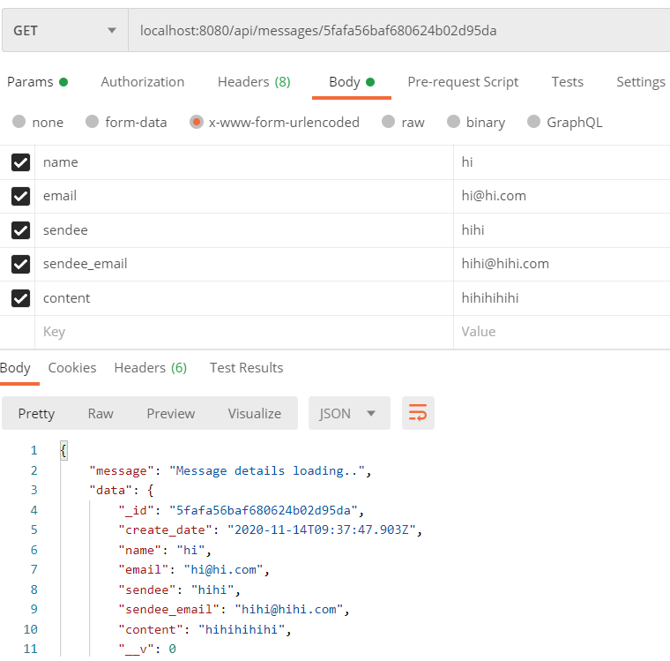  
     
   PUT localhost:8080/api/messages/:messageid  
   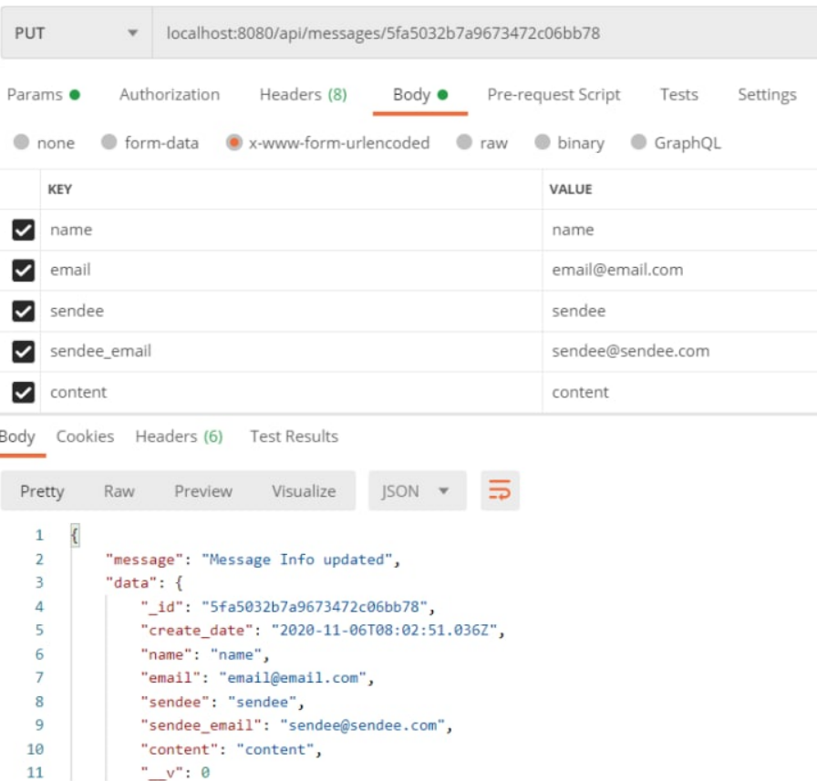  
     
     
   DELETE localhost:8080/api/messages/:messageid  
   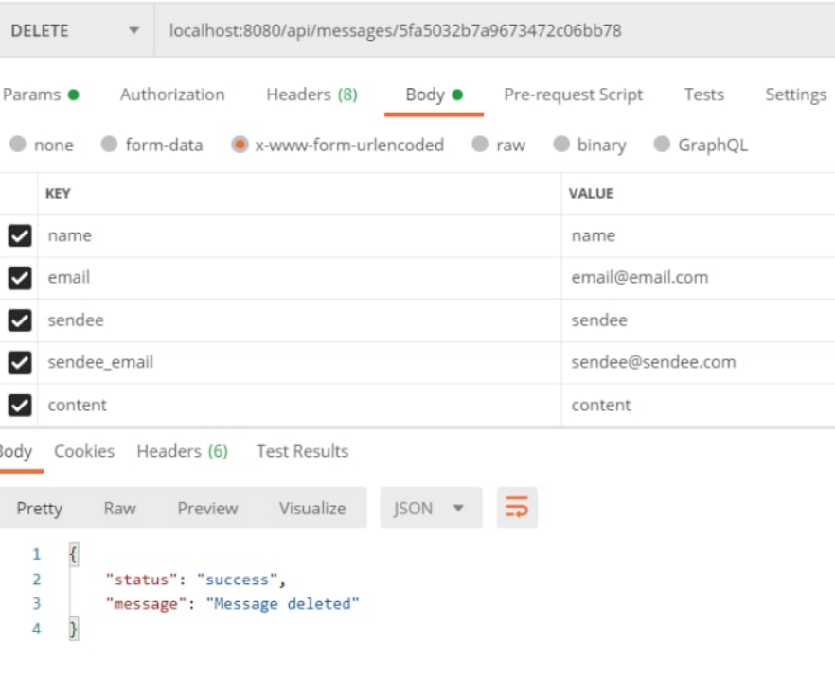

**B1 – Running the API on deployed endpoint (Heroku)**

1. The application was deployed to <https://mighty-springs-25535.herokuapp.com/api/messages> by using Heroku. Since, it has to started from my device, I can only say I followed the steps in this guide <https://medium.com/make-school/how-to-deploy-your-node-js-mongodb-app-to-the-web-using-heroku-63d4bccf2675> to deploy my application to a Heroku endpoint. After configuring the necessary files, I ran “heroku open” to launch the application.
2. GET https://mighty-springs-25535.herokuapp.com/api/messages  
   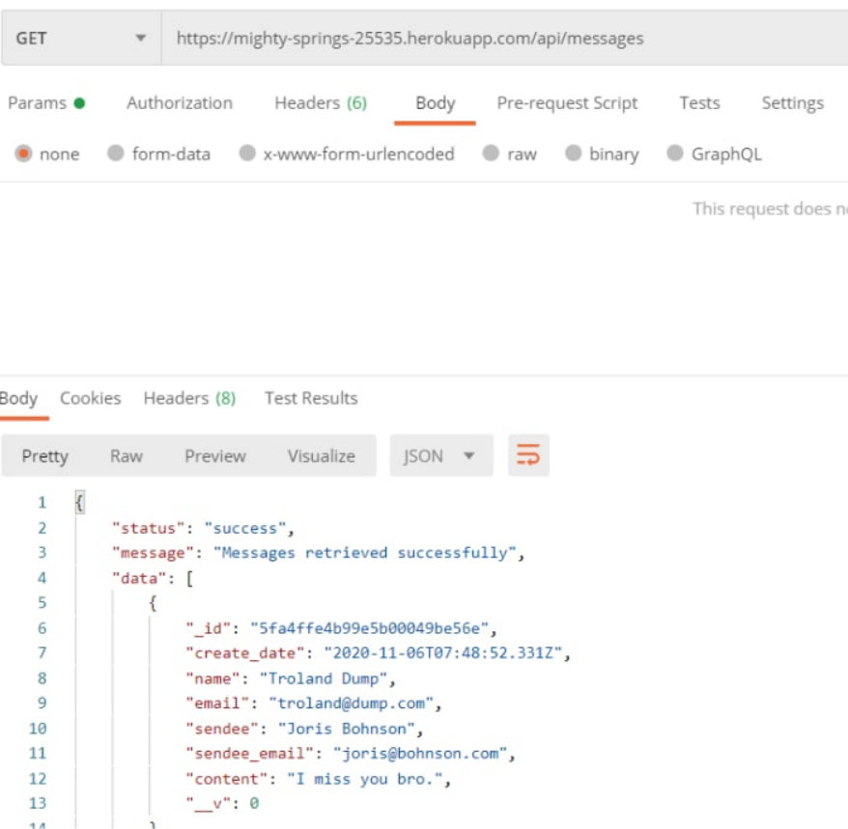  
     
   POST https://mighty-springs-25535.herokuapp.com/api/messages  
   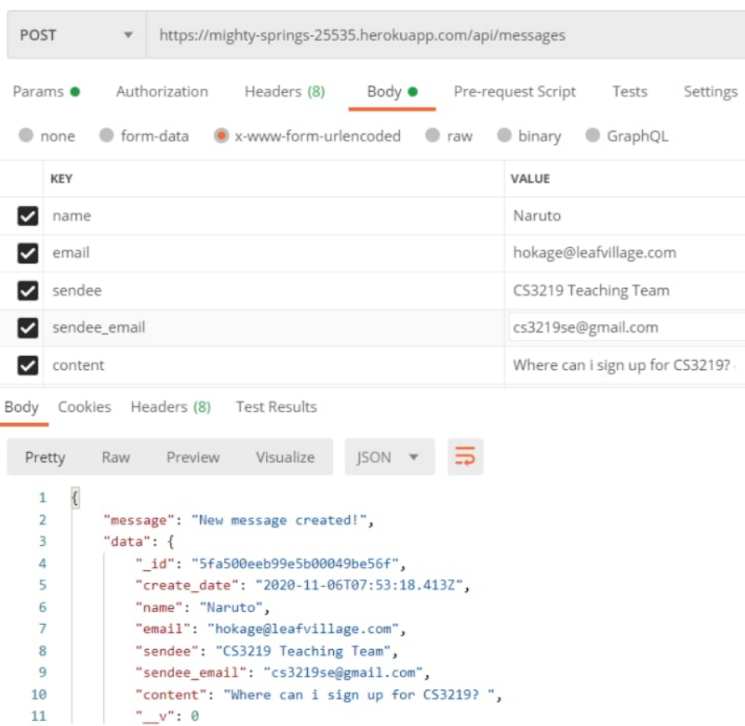  
   GET https://mighty-springs-25535.herokuapp.com/api/messages/:messageid  
   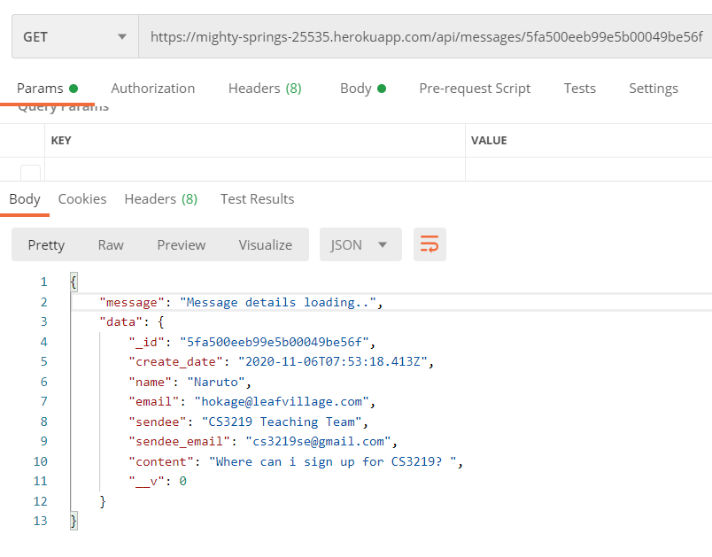  
     
   PUT https://mighty-springs-25535.herokuapp.com/api/messages/:messageid  
   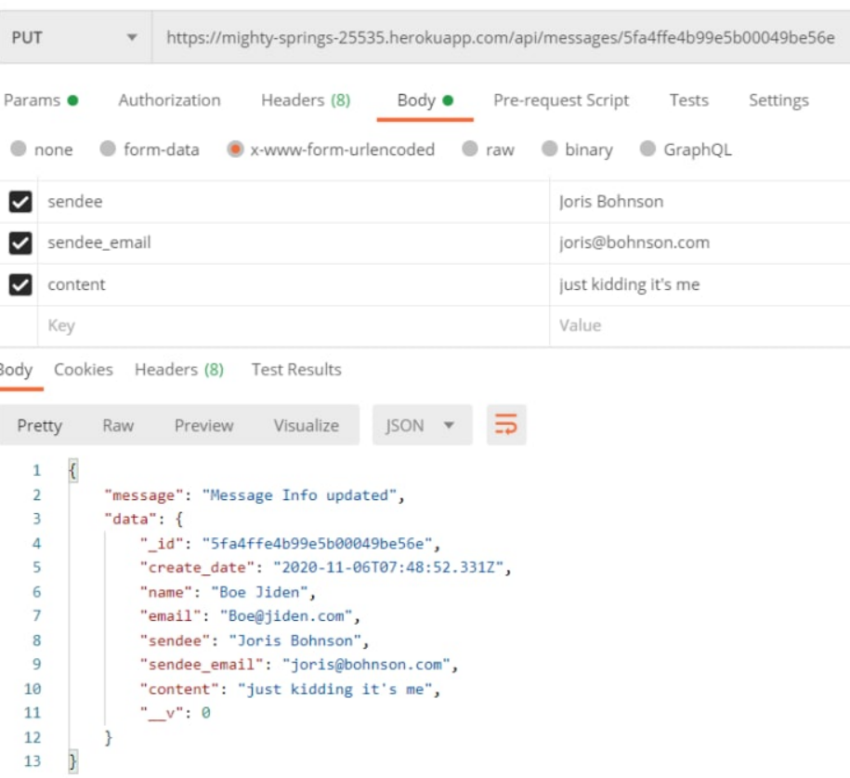  
     
     
     
     
     
     
   DELETE https://mighty-springs-25535.herokuapp.com/api/messages/:messageid   
   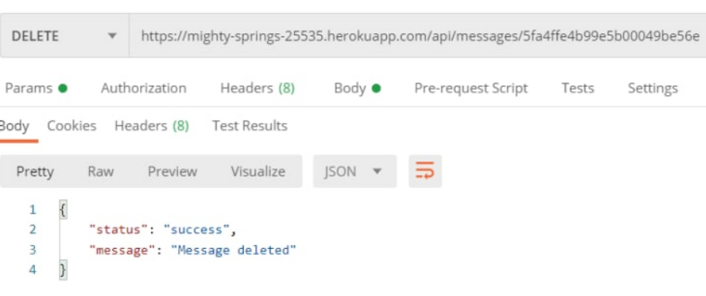

**B2 – Run tests locally**

The tests were written and stored inside the test.js file inside the tests folder. The tests consists of:

1. Retrieving all messages
2. Adding a new message
3. Retrieving a single message
4. Editing a single message
5. Deleting a single message

Other tests that were intended to be added and used but had problems that I could not resolve, namely the error below:

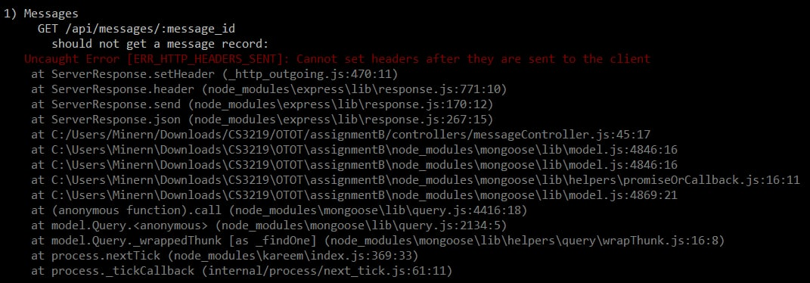

1. Adding a new message that is missing a required field should not be successful.
2. Retrieving/Editing/Deleting a message with an invalid message id should not be successful.

The tests were run with the command “npm run test” locally.

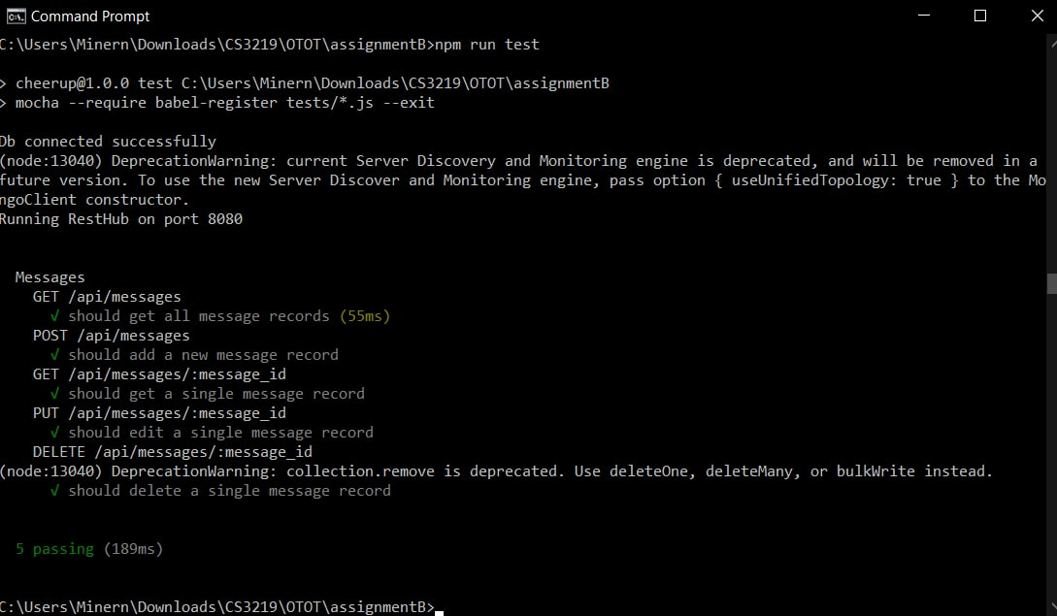

**B2 – Running the tests via travis**

1. Linked GitHub account to Travis CI, and created a .travis.yml file with the configurations to automate testing.  
   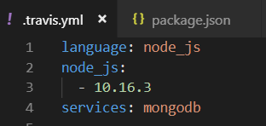
2. Stage, commit and push any changes to my GitHub repository, then Travis CI should automatically run the test cases from my test.js file.  
   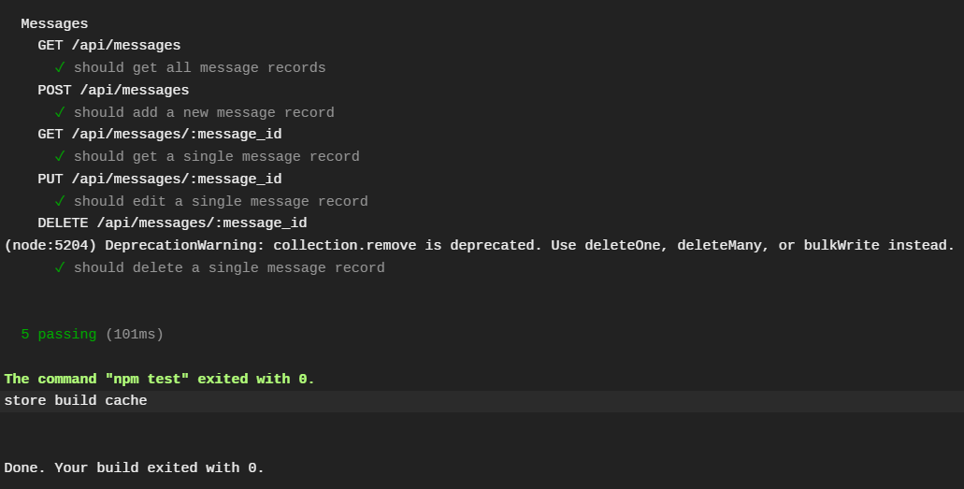  
   <https://travis-ci.org/github/minernchan/OTOTassignmentB/builds/742601107>