Plugin *UserTakeOver*

Documentation

¨

|  |  |
| --- | --- |
| Date of Release: | 21.11.2014 |
| Document-Version: | 1.3 |
| Plugin-Version | 1.0.0 and above |
| Author: | Martin Studer, studer + raimann ag |

|  |  |  |
| --- | --- | --- |
| Version | Author | Changes |
| 1.0 | Martin Studer | Created |
| 1.1 | Fabian Schmid | Updated Installation-Docu |
| 1.2 | Stefan Wanzenried | Updates to install instructions |
| 1.3 | Benjamin Seglias | Add the requirements section |
| 4.1.1 | Thibeau Fuhrer | Add brief explanation about groups |

Table of contents

1 Introduction 4

2 Requirements 5

3 Groups 7

4 Installation 8

# Introduction

The UserTakeOver-Plugin gives you the possibility to take over the view of another ILIAS User.

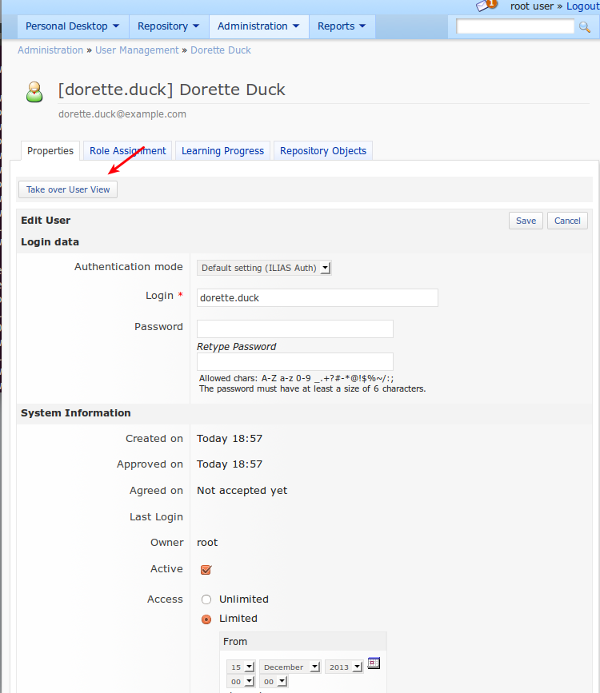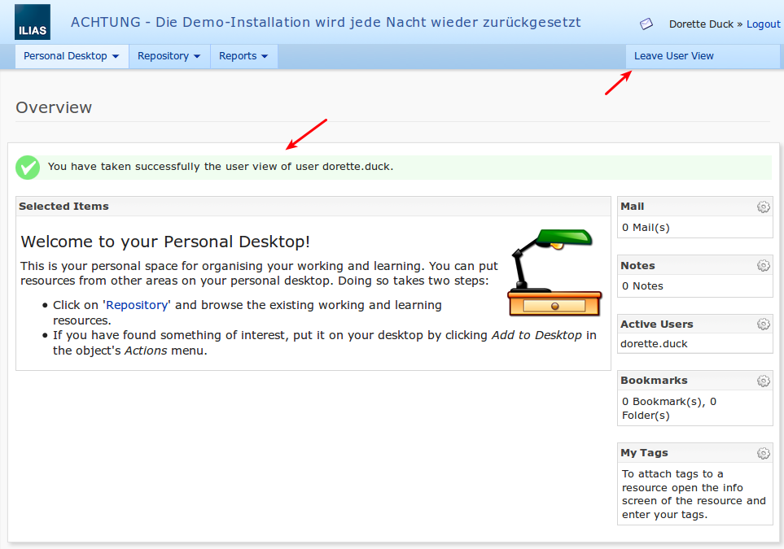

# Requirements

In order to leave a user view the user you took over has to be member of a global role which has the administration permission “Search: User can use the global search in ILIAS”. If the user you took over isn’t in a global role who has the mentioned privilege you have to log out and log in again with a user who is allowed to use global search in order to reuse the UserTakeOver Plugin.

Therefore, we recommend giving the global user role the administration permission “Search: User can use the global search in ILIAS”.

Go to Administration>Roles and click on User Title.

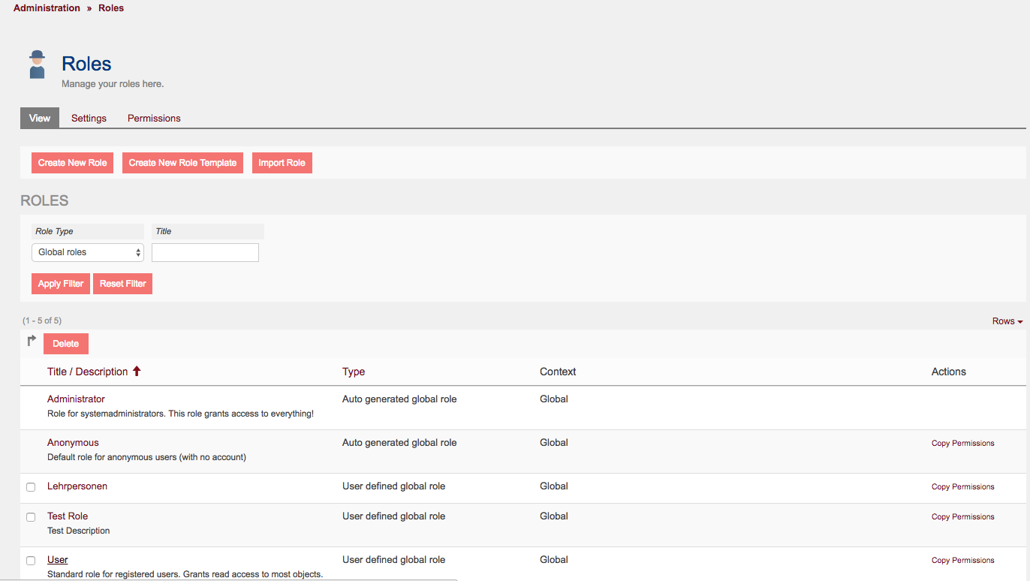

Afterwards you have to switch to the subtab “Administration Permissions”.

Under this subtab enable the checkbox “Search: User can use the global search in ILIAS”.

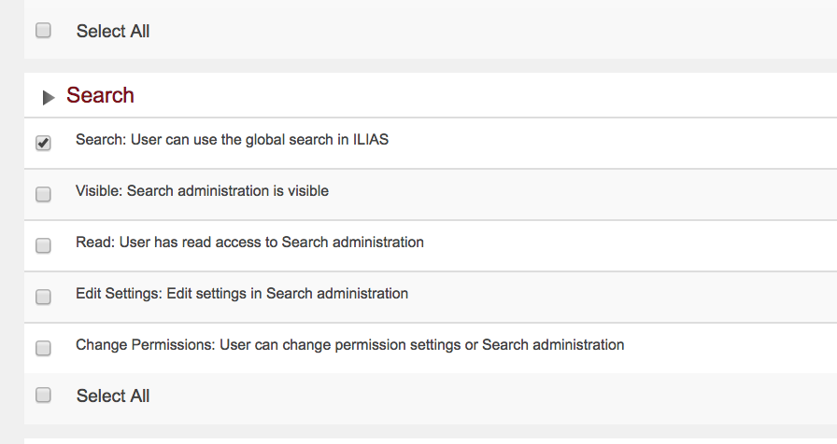

Finally click on the save button.

# Groups

You can create plugin-internal groups in the configuration of this plugin. These groups can be used to restrict access to the impersonate-search and -functionality. We currently differentiate between two kinds of groups:

* **Member-based**\*: when creating or editing a group, the “Restrict to group members” option can be enabled to restrict the impersonate-search and -functionality to members of this group. This means, if user A and B are in the same group, they can only find and impersonate each other.
* **Role-based**: when creating or editing a group, the “Restrict to global roles” option can be enabled to restrict the impersonate-search and -functionality to all users who are assigned to the selected global roles. This means, if user A (regardless of his role) is assigned to a group which restricted access to the global role X, he can only find and impersonate users who are assigned to the global role X.

These two kinds of groups can also be combined (by enabling both options), so the access will be restricted to the members of the group but also to the configured global roles.

*\* When using member-based groups, please be aware that administrators can be impersonated by users with lower access if they the option “Allow impersonation of Admins” in the plugin configuration was enabled.*

# Installation

Start at your ILIAS root directory

mkdir -p Customizing/global/plugins/Services/UIComponent/UserInterfaceHook/   
cd Customizing/global/plugins/Services/UIComponent/UserInterfaceHook/   
git clone https://github.com/studer-raimann/UserTakeOver.git

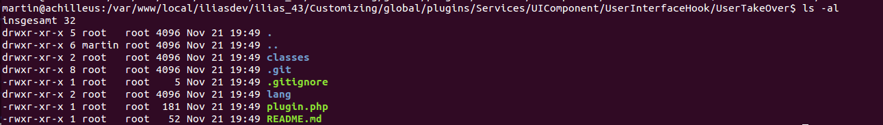Figure 1: Example Directory Structure

Log into ILIAS as an administrator and navigate to „Administration > Plugins“. Update and activate the plugin „UserTakeOver“. You should now be able to take over the user view of any user. You can do this by opening the edit view of any user under „Administration > User Management“, then clicking the button „Take over User View“ in the toolbar.