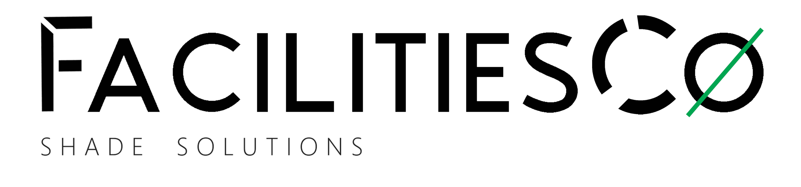
DESIGN | CREATE | INNOVATE | MAINTAIN
PROPOSAL
[ CLIENT LOGO ]

Prepared For: [CLIENT / COMPANY NAME]
Attention: [CONTACT PERSON]
Site: [SITE NAME / ADDRESS]
Date: [DATE]

Prepared by Minette Liebenberg
minette@facilitiesco.com · 083 378 5122

SCOPE OF WORK
Everything we do is considered, directed through strategy and concept — structures, netting and cable specified to fit your site, not off-the-shelf.
SITE DETAILS
Site / Area: [e.g. Directors Parking]
Structure Colour: [COLOUR]
Netting Colour: [COLOUR]
Netting Size: [SINGLE / DOUBLE / TRIPLE]
Dimensions: [WIDTH x LENGTH]
PROJECT TIMELINE
Phase | Description | Duration
1. Site Inspection | Measurements taken, structures assessed | [ ]
2. Quotation | Formal quote issued for sign-off | [ ]
3. Order Confirmation | Signed quotation + deposit received | [ ]
4. Fabrication | Steelwork and netting prepared to spec | [ ]
5. Installation | On-site installation and tensioning | [ ]
6. Final Inspection | Sign-off with site contact | [ ]

WHAT IS EXPECTED FROM YOU
- A deposit of 65% is required on confirmation of order, 35% balance on completion
- Confirmation of order is a signed quotation and deposit sent to FacilitiesCo
- The price on the quotation is all-inclusive — VAT is not applicable
- Site access arranged for inspection, installation, and final sign-off

SITE INSPECTION
Area: [SITE / AREA NAME]
📷  Photo 1 | 📷  Photo 2 | 📷  Photo 3 | 📷  Photo 4
📷  Photo 5 | 📷  Photo 6 | 📷  Photo 7 | 📷  Photo 8

NET REPLACEMENT
Description | Quantity
Two Car Nets (Double) | [ ]
Three Car Nets (Triple) | [ ]

PAINTING REQUIREMENTS
Painting Level | Number of Structures
Light | [ ]
Medium | [ ]
Full | [ ]

MATERIAL NOTES
- Netting Type: 80% UV Block ☐ 90% UV Block ☐
- Colour: [COLOUR] · All nets secured with galvanised fixings
- Tensioned to fit per structure spec, using 5mm 6x19 fibre core galvanised cable

ADDITIONAL SITE PHOTOS
Optional -- delete this page if 8 photos were enough. Duplicate the grid below (copy a row, paste) for more than 16 in total.
📷  Photo 1 | 📷  Photo 2 | 📷  Photo 3 | 📷  Photo 4
📷  Photo 5 | 📷  Photo 6 | 📷  Photo 7 | 📷  Photo 8

TECHNICAL SPECIFICATIONS
STRUCTURAL STEEL
- Cantilever — Anchor Poles: 152mm / 165mm round tubing (3mm wall thickness)
- Cantilever — Main Frame: 50mm / 57mm round tubing (2mm wall thickness)
- Four Post — Anchor Poles: 76mm / 101mm round tubing (3mm wall thickness)
- Four Post — Main Frame: 50mm round tubing (2mm wall thickness)
- Foundations: 600mm–800mm deep pole planting, secured with ready-mix concrete
- Designed for high wind conditions (120–140 km/h when correctly installed)
SHADE NETTING
- Knittex Z25 UV-stabilised shade netting
- High durability and tear resistance, wide range of colours available
CABLE TENSIONING SYSTEM (CERTIFIED)
- 5mm 6x19 Fibre Core Galvanised Steel Cable, secured with Crosby clamps
- Breaking Load: 13.6 kN (≈ 1,385 kg) · Tested Breaking Load: 14.3 kN
STITCHING & THREAD — COATS DABOND AWF
- Bonded, twisted continuous filament polyester thread with a PFC-free anti-wick finish
- Blocks water migrating through stitched seams for genuinely water-repellent stitching
- Excellent bleach, mildew and rot resistance for long-term outdoor exposure
- Tex 80 (5,700 cN) for standard seams, Tex 135 (9,310 cN) for heavy-duty seams

WHY INVEST IN SHADE STRUCTURES
Protection
Protect yourself and valuable assets from UV sun rays and hail.
Warranty
8-year manufacturer's warranty on shade netting, guaranteed against defective materials and workmanship.
Flexible Design
Structures can be adjoined, back-to-back, side-by-side, or built to custom shapes and sizes.
Wide Application
Residential parking bays, outdoor entertaining areas, playgrounds, nurseries and gardening venues.
Sustainability
Re-netting and repairs to existing structures and netting extend service life without a full rebuild.
Structure Choice
Four options to suit the site: Standard Four-Post, Semi-Cantilevered, Full Cantilevered, or Shade Sails.
Build Quality
All-steel construction on the framework, with netting made to measure for each individual structure.
After-Sales
Complete after-sales service and support for the life of the structure.

TYPES OF STRUCTURES
FOUR POST / STANDARD
Four steel posts anchor the structure, one on each corner. Four hoops complete the structural element, rolled to create a dome effect. Suits any parking or outdoor area needing shade — over playgrounds, pools, grandstands, picnic areas and campsites.
Size | Dimensions
Single | 3m x 5m
Double | 5m x 5m
Triple | 7.5m x 5m

CANTILEVER
The structure extends from a wall or post, to which it must be firmly attached — substantial engineering and proper load calculations for a genuinely dramatic effect. Two upright columns at the back allow total access when turning into the bay.
Size | Dimensions
Single | 3m x 5m
Double | 5m x 5m
Triple | 7.5m x 5m

SHADE SAIL
Tensioned fabric stretched between fixing points — wall brackets, poles, or a combination of both. A flexible option for irregular areas where a post-and-hoop structure isn't practical.

OUR CLIENTS
A few of the businesses we've worked with:
 | 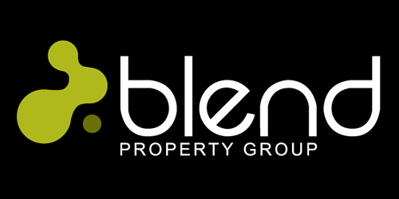 | 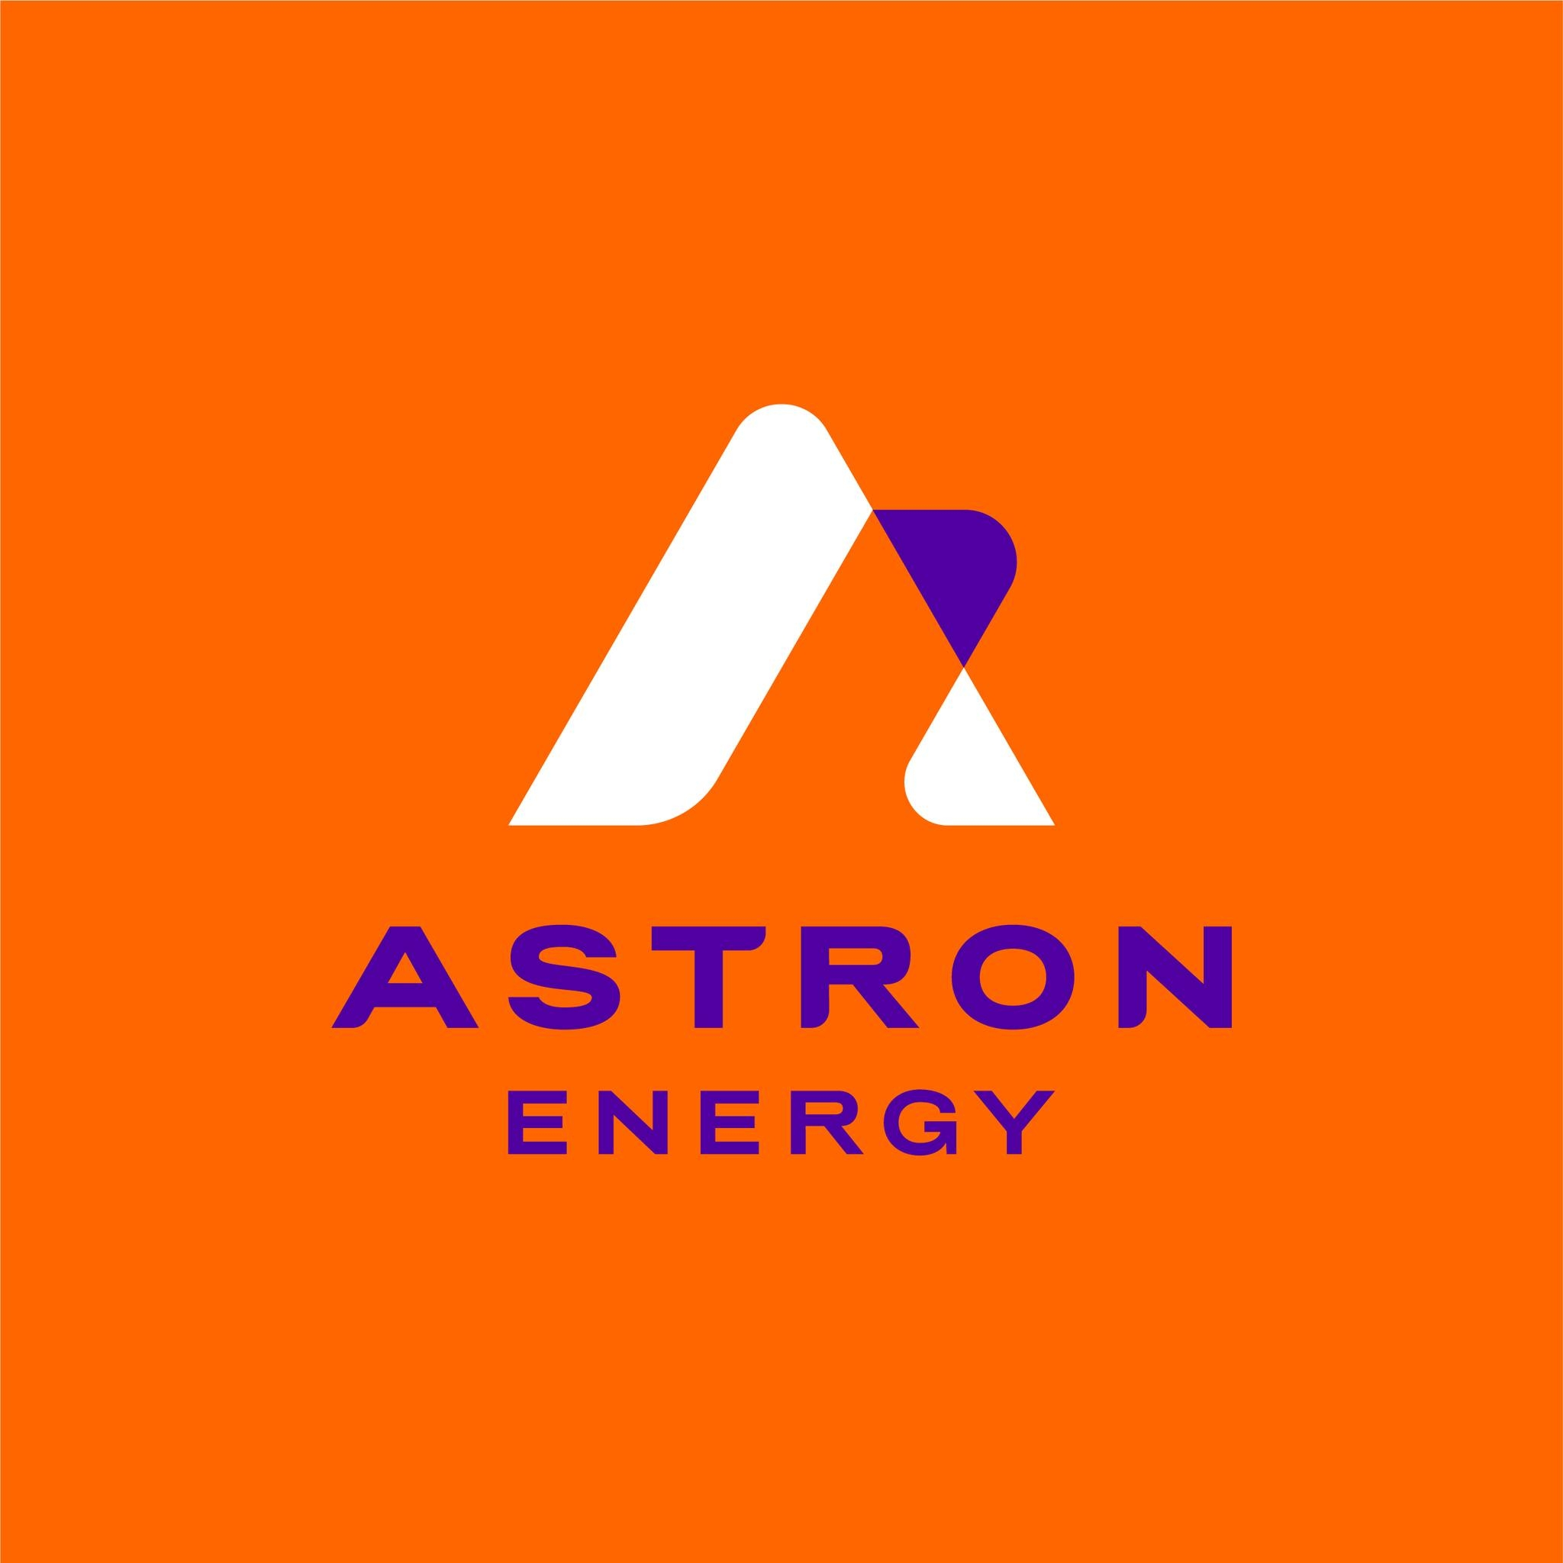
 | Digistics | BDO
DSV | CoSpace | Rebosis Property Fund
Ascension Properties | Saint Gobain | Tarloy Properties
Insimbi Alloy | The Cavaleros Property Group | Little Porcupine Schools

Thank You for the Opportunity

Minette Liebenberg
Director, Shade Solutions by FacilitiesCo
minette@facilitiesco.com · 083 378 5122
sales@facilitiesco.com · 010 015 0532



🌐 www.facilitiesco.com · @facilitiesco

