EZ80P QUICK START GUIDE

The EZ80P is a hobbyist's computer PCB based around a Spartan3 XC3S200 FPGA, 50MHz
EZ80 CPU and three 512KB 10ns SRAMs. It was designed by Phil Ruston 2010-2011.

The default FPGA architecture is called AMOEBA ("Another of My Original Eight Bit
Architectures") and the default OS is called PROSE ("Phil's Rudimentary Operating
System Experiment"). Everything is open source and can be freely distributed.

Project archive: http://ez80p.svn.sourceforge.net

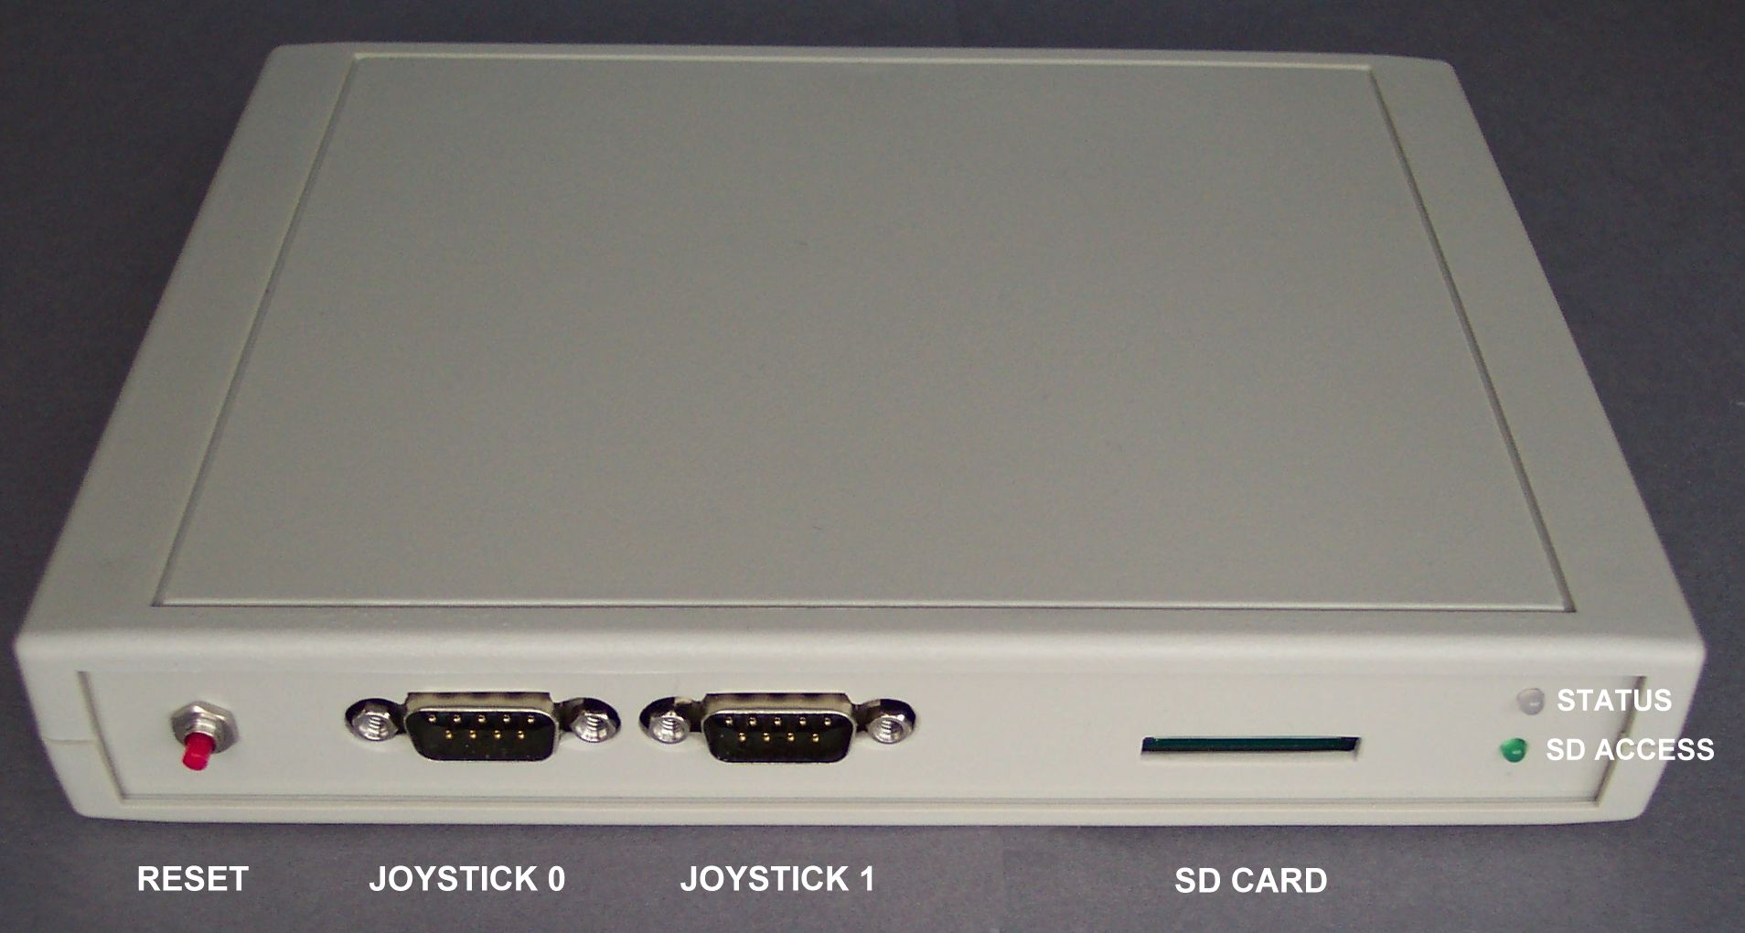

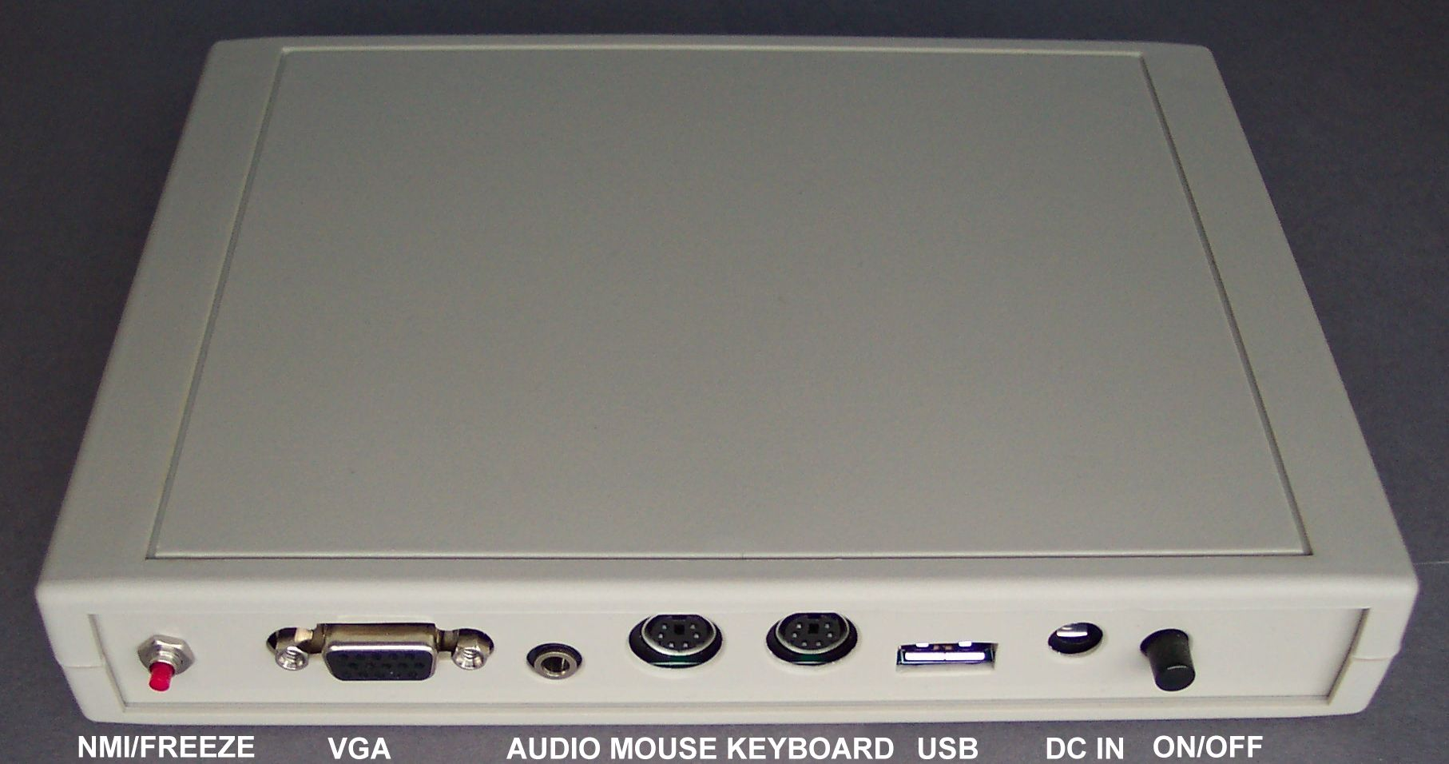

Power:

Use a 7.5v or 9v DC regulated PSU with a 2.1mm jack. The PSU should be capable
of supplying around 600mA or more.

Buttons:

The main power button is the black latching push switch at the back next to the DC jack.
The red button on the front left is a reset switch and the one on the right at the back is connected to spare IO#1 (in AMOEBA/PROSE this is used as a NMI program freezer input.)

SD Card:

The SD card should be a known brand for compatibility and FAT16 formatted. (In case of problems, format the card in the EZ80P with the command: "FORMAT SD_CARD PROSE")

USB Port / Serial comms:

The EZ80P uses a FT232RL USB-to-serial bridge chip for communications which requires
a driver on the host PC - this is provided in the PC_apps/USB related/VCOM_drivers
folder (Linux, Mac, WinXP/Win7). The driver creates a virtual com port on the PC
so the PC sees the EZ80P as a standard serial device.

Suggested first-time start up procedure:

1. Go to ez80p.svn.sourceforge.net and click "Download GNU tarball"
2. Extract the files from the archive to a convenient folder on your PC.
3. Connect power, USB cable, keyboard and monitor to EZ80P and other end of USB cable to PC.
4. Press the EZ80P power switch (the PC should detect the FT232RL USB chip)
5. Point the "Found new hardware" wizard at the folder "PC_apps/USB related/VCOM drivers"
6. Follow the prompts to install the driver.
7. Switch off the EZ80P
8. Format an SD card to FAT16 and copy the contents of the project folder "SD_Card" to it.
9. Insert SD card in EZ80P.
10. Power on EZ80P - the Operating System (PROSE) should load up.

A list of internal commands is displayed when you type "?" (return). Programs on the SD card can be loaded by entering their filename (the .EZP extension does not need to supplied). Files can be sent to and from PROSE using the PC-based "Serial Link" program supplied in the project's "PC Apps" folder (see commands RX and TX)

Development software:

Ideally, use ZDS II available free from zilog.com - Info on how to start coding in assembly and C is in the documentation.

For full documentation see the project folder: Docs/

