EZ80P QUICK START GUIDE

The EZ80P is a hobbyist's computer PCB based around a Spartan3 XC3S200 FPGA, 50MHz
EZ80 CPU and three 512KB 10ns SRAMs. It was designed by Phil Ruston 2010-2011.

The default FPGA architecture is called AMOEBA (Another of My Original Eight Bit
Architectures) and the default OS is called PROSE (Phil's Rudimentary Operating
System Experiment). Everything is open source and can be freely distributed.

Project archive: http://sourceforge.net/projects/ez80p/files/
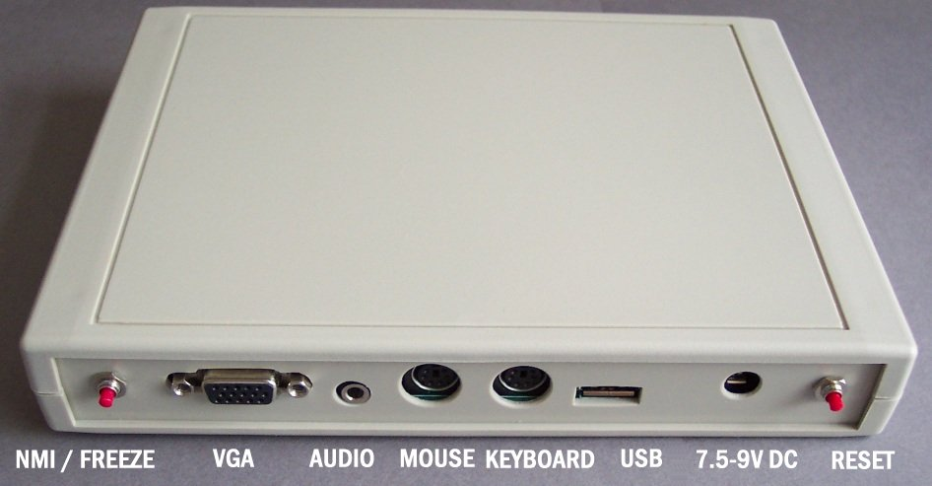
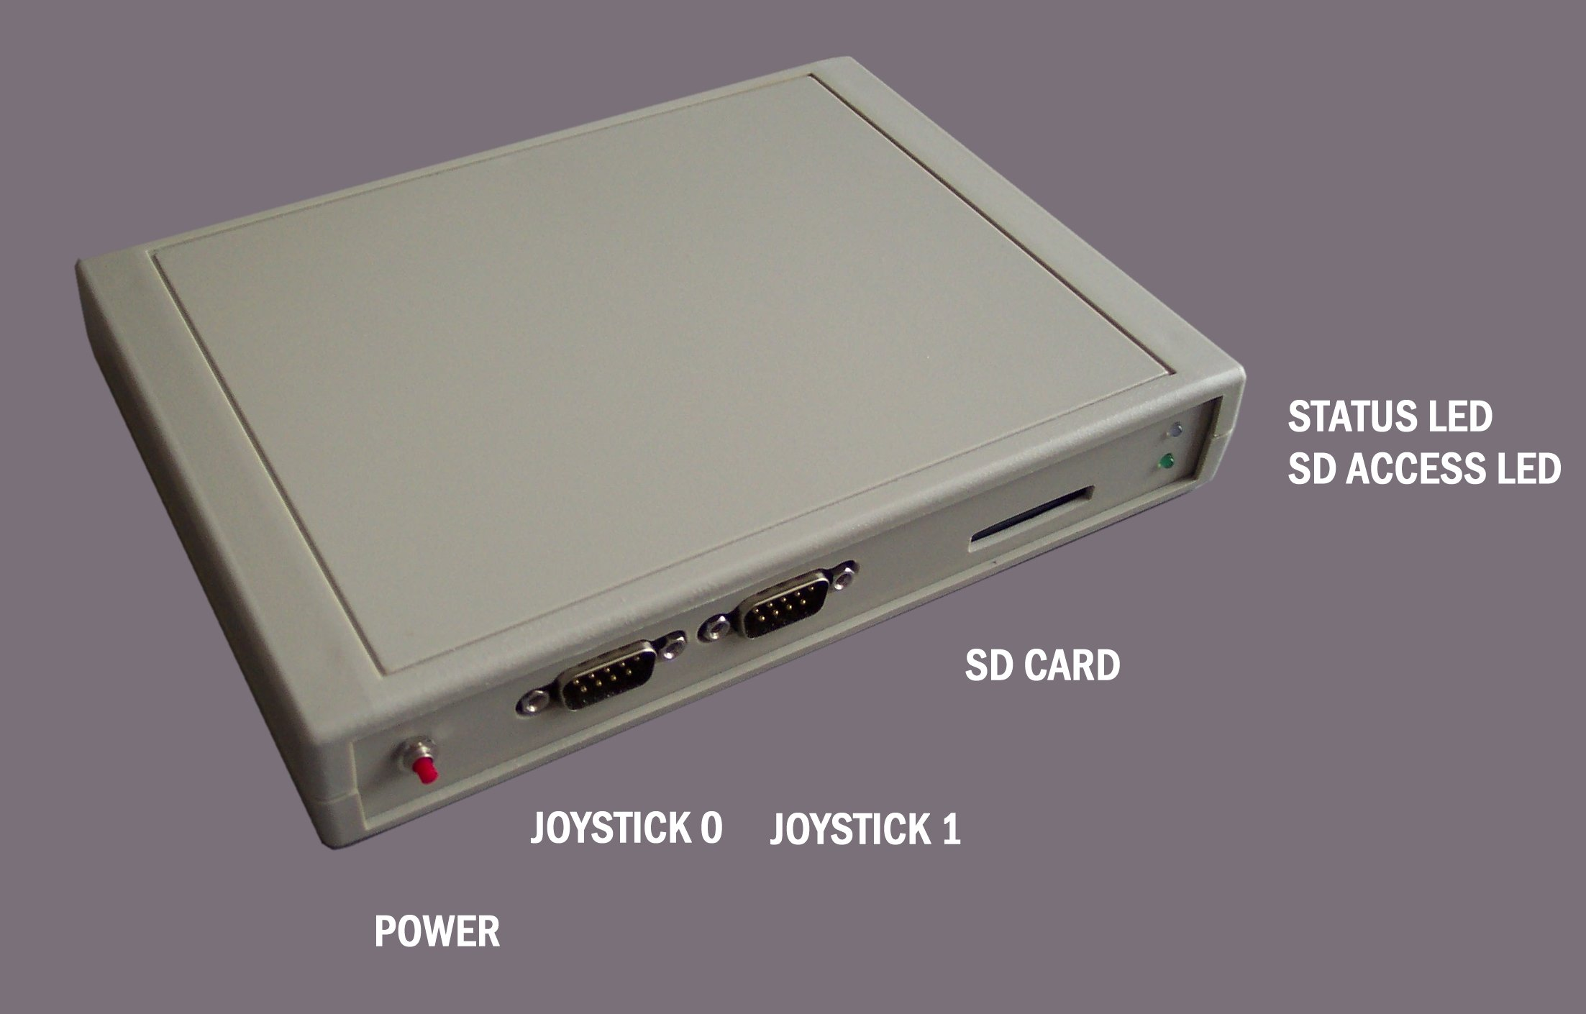

Power:

Use a 7.5v or 9v DC regulated PSU with a 2.1mm jack. The PSU should be capable
of supplying around 600mA or more.

Buttons:

The front button on the left is soft-power (hold for half a second for power on/off) The left back button is a system reset, the right back button is connected to spare IO#1, in AMOEBA/PROSE this is used as a NMI program freezer input.
SD Card:

The SD card should be FAT16 formatted. Copy the contents of the project's "SD card"
folder to the card.

Mouse:

Mouse should be a older native PS/2 type mouse (2 or 3 buttons) without scroll-wheel (MS Intellimouse scroll-wheel mouse may work).

USB Port / Serial comms:

The EZ80P uses a FT232RL USB-to-serial bridge chip for communications which requires
a driver on the host PC - this is provided in the PC_apps/USB related/VCOM_drivers
folder (Linux, Mac, WinXP/Win7). The driver creates a virtual com port on the PC
so the PC sees the EZ80P as a standard serial device.

Windows USB driver installation:

The first time you connect the eZ80P to the PC, the new hardware wizard appears.
Just point the installer at the appropriate driver folder and it should install and
make a new virtual com port ("USB Serial Port COMx" in device manager.)

Files are sent to and from PROSE using the PC-based "Serial Link" program supplied
and the commands "RX" and "TX" under PROSE.

Development software:

Ideally, use ZDS II available free from Zilog. Info on how to proceed is in the documentation.

For full documentation see the project folder: Documentation/

