**QUEST INTERNATIONAL UNIVERSITY**

**PERAK**

**FACULTY OF SCIENCES AND TECHNOLOGY**

**Bachelor of Computer Science (Hons)**

**BCS3225 Introduction Artificial Intelligence**

**Gaming Gear Recommendation Mobile App by using Machine Learning**

**FINAL ASSESSMENT TECHNICAL REPORT**

PREPARED BY:

**TAN ZHONG MING (QIUP-201804-002120)**

SUBMISSION DATE:

**23 OCTOBER 2020**

**TABLE OF CONTENTS**

ACKNOWLEDGEMENT 1

ABSTRACT 2

PRELIMINARY PAGE 2

List of abbreviations 2

List of Tables 3

List of Figures 4

INTRODUCTION 5

1.1 Background 5

1.2 Problem Statement 8

1.2.1 Choosing the gaming gear manually 8

1.2.2 Inaccurate to search a gaming gear 8

1.2.3 Long searching and exploring time to find a suitable gaming gear 8

1.3 Objectives 9

1.3.1 Automate the process to choose the gaming gear 9

1.3.2 Improve the accuracy to search a gaming gear 9

1.3.3 Reduce the long searching process and exploring time to find a suitable gaming gear 9

1.4 Comparison 10

1.5 Scope 10

1.6 Benefits and Significance 12

1.7 System Overview 13

1.8 Constraint & Limitation 14

1.8.1 Mobile Platform 14

2 LITERATURE REVIEW 15

2.1 Literature on Intelligent Agent 15

2.1.1 Imaged-Based Fashion Product Recommendation with Deep Learning 15

2.1.2 Product Recommendations Using Data Mining And Machine Learning Algorithm 17

2.2 Literature on related technology, development platforms and tools 19

2.2.1 Flutter 19

2.2.2 Using Machine Learning on Compute Engine to Make Product Recommendations 20

2.3 Literature review on the similar technology 23

2.3.1 Perzonalization 23

2.3.2 Adoric 23

2.3.3 Recombee 24

3 RESEARCH TECHNOLOGY 25

3.1 Methodology 25

3.1.1 Organization Structure, Role and Responsibility 26

3.1.2 Definition 27

3.2 Planning 29

3.2.1 WBS 29

3.2.2 Gantt Chart 29

3.2.3 Deliverables 29

3.3 Hardware Requirement 30

3.3.1 Minimum Requirement 30

3.3.2 Development and Deployment Environment 30

3.4 Software Requirement 31

3.4.1 Functional Requirement 31

3.4.2 Non-functional Requirement 32

3.4.3 User requirement 32

3.4.4 Minimum Requirement 33

3.5 SOFTWARE DESIGN 34

3.5.1 Framework 34

3.5.2 Architecture 35

3.5.3 User Interface 44

4 IMPLEMENTATION 62

4.1 Testing 62

4.2 Output Analysis 62

5 CONCLUSION 63

5.1 Finding & limitations 63

5.2 Contribution 63

5.3 Summary 63

5.4 Future Enhancement 63

REFERENCES 64

APPENDICES 65

**Error! Hyperlink reference not valid.Error! Hyperlink reference not valid.Error! Hyperlink reference not valid.Error! Hyperlink reference not valid.Error! Hyperlink reference not valid.Error! Hyperlink reference not valid.Error! Hyperlink reference not valid.Error! Hyperlink reference not valid.Error! Hyperlink reference not valid.Error! Hyperlink reference not valid.Error! Hyperlink reference not valid.Error! Hyperlink reference not valid.Error! Hyperlink reference not valid.Error! Hyperlink reference not valid.Error! Hyperlink reference not valid.Error! Hyperlink reference not valid.Error! Hyperlink reference not valid.Error! Hyperlink reference not valid.Error! Hyperlink reference not valid.Error! Hyperlink reference not valid.Error! Hyperlink reference not valid.Error! Hyperlink reference not valid.Error! Hyperlink reference not valid.Error! Hyperlink reference not valid.Error! Hyperlink reference not valid.Error! Hyperlink reference not valid.Error! Hyperlink reference not valid.Error! Hyperlink reference not valid.Error! Hyperlink reference not valid.Error! Hyperlink reference not valid.Error! Hyperlink reference not valid.Error! Hyperlink reference not valid.Error! Hyperlink reference not valid.Error! Hyperlink reference not valid.Error! Hyperlink reference not valid.Error! Hyperlink reference not valid.Error! Hyperlink reference not valid.Error! Hyperlink reference not valid.Error! Hyperlink reference not valid.Error! Hyperlink reference not valid.Error! Hyperlink reference not valid.Error! Hyperlink reference not valid.Error! Hyperlink reference not valid.Error! Hyperlink reference not valid.Error! Hyperlink reference not valid.Error! Hyperlink reference not valid.Error! Hyperlink reference not valid.Error! Hyperlink reference not valid.Error! Hyperlink reference not valid.Error! Hyperlink reference not valid.Error! Hyperlink reference not valid.Error! Hyperlink reference not valid.Error! Hyperlink reference not valid.Error! Hyperlink reference not valid.Error! Hyperlink reference not valid.Error! Hyperlink reference not valid.Error! Hyperlink reference not valid.**

# ACKNOWLEDGEMENT

First and foremost, I would like to give a heart full of appreciation to my lecturer, Dr. Lee Lam Hong for his encouragement and continuous support throughout this project as well as his guidance and feedback on reviewed reports.

I would also like to thank to my classmate Ms. Low Hwei Li, Ms. Chin Yoke Nien, Mr. Fong Jia Hui, Mr. Ho Jin Heng, Mr Lee Jian Sheng, Ms Reshmi Ravandran for sharing their knowledge to me and navigate me through certain complication.

Last but not least, I would like to thank my classmates and course mates for always being there for me and providing a positive vibe.

A million thank you is not enough for me to express the appreciation for all the help I have received.

# ABSTRACT

The gaming industry is growing at a speed that we cannot imagine. The gaming industry bring a lot benefit and income to many country and city. It is more popular than other traditional sport such as F1, basketball, football. This project is to study the suitable gaming gear for a user and develop a system which able to recommend the gaming gear to gamer or casual user. This project is trying to solve the issues when the customer choosing the suitable gaming gear. This project also focusses on the user without any prior knowledge. Apart from that, this project is aimed to automate the process for choosing gaming gear and improve the accuracy, reduce the searching time for customer. The long searching time is caused by the current shopping website have too many choice and customer can be easily affected by the promoted product. This project also aimed to remove the recommendation from a salesman to avoid any personal bias. The domain of this project is keyboard. The proposed system able to provide a recommendation base on few answers from customer.

# PRELIMINARY PAGE

## List of abbreviations

|  |  |  |
| --- | --- | --- |
| No. | Term | Description |
|  | API | Application Programming Interface |
|  | CNN | Convolutional Neural Network |
|  | TKL | Ten Keyless |
|  | k-NN | k-nearest-neighbor |
|  | CF | Collaborative Filtering |
|  | SVM | Support Vector Machine |
|  | TV | Television |
|  | iOS | iPhone Operating System |
|  | UI | User interface |
|  | RAM | Random Access Memory |
|  | OS | Operating System |
|  | ROM | Read-only memory |
|  | GPU | Graphic Processing Unit |
|  | CPU | Central Processing Unit |
|  | REQ | Requirement |

## List of Tables

Table 1 Comparison of Traditional Method and Proposed Plant Monitoring App 6

Table 10 Role and Responsibilities in Scrum 14

Table 11 Minimum Hardware Requirement 19

Table 12 Development and Deployment Environment 20

Table 13 Non-functional Requirement 21

Table 14 User Requirement 22

Table 15 Minimum software requirement 23

Table 16 Requirement Traceability List 31

## List of Figures

Figure 2.2 Etornam Susu's Flutter Logo. Retrieved October 14, 2020 from Medium Daily website:https://medium.com/@EtornamSunu/getting-started-with-flutter-web-19acbb3fefc1 15

Figure 3.1 - Scrum Model. Adapted from "Nutcache", 21

Figure 3.2 Organization Structure for Scrum 22

Figure 3.3 User Story. Adapted from "Mountain Goat Software", by Mike Cohn, 24

Figure 3.21 UI - Home Screen 40

Figure 3.22 UI - Import Screen 40

**Error! Hyperlink reference not valid.Error! Hyperlink reference not valid.Error! Hyperlink reference not valid.Error! Hyperlink reference not valid.Error! Hyperlink reference not valid.Error! Hyperlink reference not valid.Error! Hyperlink reference not valid.Error! Hyperlink reference not valid.Error! Hyperlink reference not valid.Error! Hyperlink reference not valid.Error! Hyperlink reference not valid.Error! Hyperlink reference not valid.Error! Hyperlink reference not valid.Error! Hyperlink reference not valid.Error! Hyperlink reference not valid.Error! Hyperlink reference not valid.Error! Hyperlink reference not valid.Error! Hyperlink reference not valid.Error! Hyperlink reference not valid.Error! Hyperlink reference not valid.Error! Hyperlink reference not valid.Error! Hyperlink reference not valid.Error! Hyperlink reference not valid.Error! Hyperlink reference not valid.Error! Hyperlink reference not valid.Error! Hyperlink reference not valid.**

## INTRODUCTION

## Background

Gaming industry is the most important innovative and important sector in an information era. Gaming industry bring the most impact in short amount of time. It is not only an entertainment sector only. It included professional competitive gaming, broadcasting, endorsement and more. Nowadays gaming industry provided the most immersive and amazing entertainment experience for more than two billion around the globe. In 1970 and 1980’s, they just starting to play with the joystick to compete the highest score in Pac-Man. The gaming industry have at least 200 billion USD value in today. There is no one expected the exploded of gaming industry. Today people able to sit at the couch and watch the best e-sport athlete in the world competing on the stage. For example, Twitch, Mixer, HuYa, DouYu and etc.

The gaming industry is a sport activity. It has stadium that full with fans, world-class athlete, broadcasting tv, engaging commentators and more. The e-sport more focus to compete with their opponent by using careful designed strategy, statistical analysis, fast reaction time and more. There is million of people watching the live show and screaming for the opportunity to compete the champion.

The streaming platform such as Twitch, YouTube Gaming, Dou Yu, Hu Ya, Bilibili provided an opportunity for a normal people or even disabled people to prove their ability. They have the chance to gain million of fans and income. The streaming also become very popular and common nowadays. Twitch, YouTube Gaming, Mixer and Facebook Gaming generated total of 13 billion watched hours in 2019. For example, Tyler “Ninja” Blevins earn more than 10 million dollars with only streaming and endorsement. E-sport just start to growth, now gaming industry is ready to compete with other technology area. Gaming is special not only because of the immersive and entertaining, it also includes the inclusive and expansive as well. These characteristics make it become the world most popular activity. (builtin, n.d.)

The gaming industry generated 159 billion dollars in 2020 due to the Covid 19. Newzoo predict the gaming industry will generate more then $200 billion revenue in 2023. As a comparison the revenue that generated by Disney reduced by 50% and took a $1.4 billion loss last quarter. The movie industry lost around $10 billion in 2020 due to Covid 19. Wijam’s data show the mobile game able to generate $72.2 billion in 2020, it increases around 13.3% compare to 2019. (MEDIA, 2020)

Tencent’s total generated RMB 100 billion in the first season of 2020. Tencent generated RMB 37.28 billion in the first season of 2020 from only online game. The online game includes King of Glory, Clash of Clans, PUBG Mobile and etc. (CISION PRNewswire, 2020)

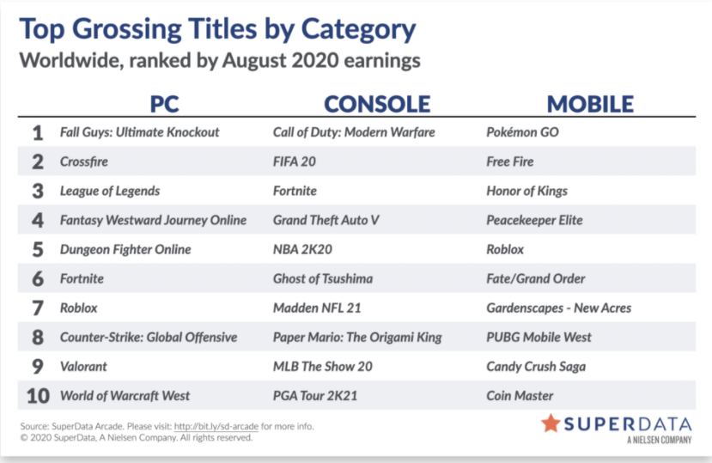

Super Data Research released the most earning game in August 2020. In August 2020, digital game earned around $82.2 billion and growth 13% from the same time span in the last year. Super Data Research claimed the gaming revenue have an exploding growth since April 2020 due to Covid19 lockdown policy. Fall Guys: Ultimate Knockout has the highest earning since launch of any PC game which are $185 Million. (Staff, 2020)

The purpose of this project is aimed to develop an app which able to recommend the most suitable keyboard for the user. This able help for those gamers and the people without any experience in gaming industry to find their gaming gear as fast as possible. The image that collected will use to train a supervised machine learning model. The user will choose the most preferred three keyboard at the beginning then these pictures will send to the machine learning model for prediction process. The algorithm will analyse the input and understand the picture then suggest a more suitable keyboard.

## Problem Statement

### Choosing the gaming gear manually

The choose a suitable gaming gear required a lot of effort. It needs some electronic and physical knowledge to choose the right mechanical switch. For example, it required to do a lot of research on different branding and different key switch to understand the purpose of design and their feeling. Mouse also involved big amount of sensor, branding and concept between different company. Customer need to do a lot research on a single product.

### Inaccurate to search a gaming gear

Sometime the computer store does not provide the gaming gear that suitable for customer. They may advice the customer go for alternative choice. But alternative choice may not suitable for him. The salesman in the shop will have limited knowledge or unconscious bias to suggest a gaming gear to customer. Next is the sales man have commination issues with the customer, this will make some misunderstanding and lead to wrong decision.

### Long searching and exploring time to find a suitable gaming gear

Customer need to spend a lot of time to study the knowledge that required for each gaming gear. For example, the structure of the mechanical switch on the keyboard, the pressure required, sound and etc. Apart from that, the type of sensor for a mouse also play a big role. For example, laser sensor and optical sensor perform very different on different surface.

## Objectives

### Automate the process to choose the gaming gear

This app will automate the process to chose a gaming gear. To choose a gaming gear required a lot of research and knowledge. This can minimum the knowledge required and reducing the time required to choose a more suitable gaming gear on the market by automate the searching and exploring process.

### Improve the accuracy to search a gaming gear

Machine learning model able to provide a bias free analysis process and maintain neutral mind. Apart from that, this able to solve the issues of inadequate knowledge of customer and suggest the most prefer gaming gear. This can avoid the customer affected by the salesman that may lead to wrong decision.

### Reduce the long searching process and exploring time to find a suitable gaming gear

This mobile app able to help customer to make decision in short amount of time. It able to reduce the long search process and exploring time to find a suitable gaming gear by asking few questions. This mobile app able to suggest the gaming gear that most suitable for the customer based on the personal preferences that learned by machine learning model.

## Comparison

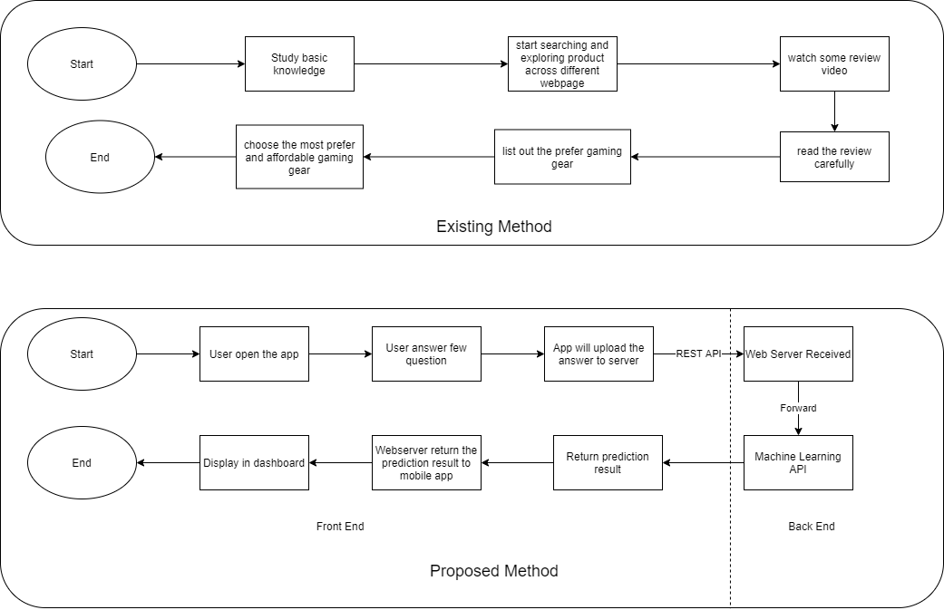

The proposed method replaces the salesman by using machine learning model. This can solve the bias issues that caused by the salesman. The traditional method salesman will use their pass experience to suggest a product to a customer. This may add some bias to some particular product. This app able to maintain neutral to suggest a product to the customer. This mobile app able to help customer to get the most suitable gaming gear with the help of the machine learning model.

## Scope

Domain

The domain will focus on keyboard. They keyboard can be classify in to different category from few perspectives. The keyboard have different type of layout which include Full Size Keyboard (100%), Ten keyless (TKL, 87-88%), Compact (75%), 65%, Super Compact (60%) and Split Columnar Staggered. Apart from that, the mechanical keyboard also included mechanical switches from different branding, color, actuation force, and sound signature. Mechanical switches manufacture includes Cherry Mx, Kailh, Razer, Logitech, GX SteelSeries QS1, Cooler Master, Bloody, Gateron and more. This project only will analyze from the perspective of type of mechanical switches such as Linear Red, Linear Black, Clicky Blue, Tactile Brown, Romer G and Optical switch. Next is the design of the keyboard, nowadays low-profile keyboard getting more attention. This project will include low profile keyboard and not low-profile keyboard. The keyboard feature also very important for user, it include macro key, media key, function key, lightning and etc. This project will only include is it include backlighting.

Project Scope

1. Perform pre-processing techniques to data set to improve the number of sample and quality of it
2. Train a custom model by using TensorFlow
3. Develop a Flask API to forward the image to TensorFlow API and return the prediction result.
4. Develop an apps which capable to send a sequence of answer and send to Google TensorFlow API for further processing.

User Scope

1. This system is aimed to help the customer with limited knowledge and experience.
2. This system also aimed for a general customer which include student, office worker, professional gamer.

System Scope

1. A function to ask user a sequence of question
2. A function uploads a sequence of answer to webserver automatically
3. A function to validate the user input
4. A function to identify the returned result
5. A function to show the recommendation and information of possible product.

## Benefits and Significance

This project will improve the process for customer to find a suitable keyboard for their preferences. This project will develop an android application to automate the manual process of selecting gaming gear.

The table below shows the comparison between the existing method and proposed Gaming Gear Recommendation Mobile App.

|  |  |  |
| --- | --- | --- |
|  | Traditional Method | Proposed Plant Monitoring App |
| Process | Do a lot of review, rating, shopping, research on a single product | Open app and answer a sequence of question |
| Accuracy | Low | High |
| Process time | Slow | Fast |
| Human involvement | High | Low |
| Knowledge Base | Limited | High |
| Bias | High | Low |

Table Comparison of Traditional Method and Proposed Plant Monitoring App

The proposed method will significantly improve the process and process time for customer to select their gaming gear. Apart from that, the proposed method will improve the accuracy to select a gaming gear. Machine learning model will introduce to automate and improve recommendation and classification process.

## System Overview

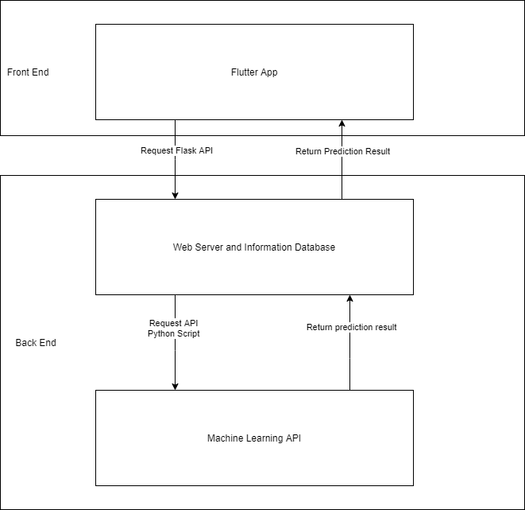

The proposed mobile apps allow user to take few questions and upload the answer to the webserver and forward to Machine Learning API to perform prediction task. The mobile app will request the services by sending a sequence of answer to a webserver through Flask API. Then the webserver will forward to the Machine Learning API to perform prediction process by using python script. The Machine Learning API able to classify the customer preferences and return to the webserver. Web server able return the prediction result from Machine Learning API and forward to the mobile app and display the result.

## Constraint & Limitation

### Mobile Platform

#### Processing power

The machine learning task is hard to run on mobile devices due to its limited processing power. Mobile devices are providing mobile services which allowed user still connected when they move around. Run a machine learning task on the mobile devices will consume a lot of battery life and reduce mobility because the user cannot move around during the execution time.

#### Connectivity

Mobile devices are a handheld device which provides a high mobility computing device for a user. High mobility may cause internet disruption, so it is hard to run a cloud computing on a server through mobile devices due to unstable connectivity of mobile devices.

# LITERATURE REVIEW

## Literature on Intelligent Agent

### Imaged-Based Fashion Product Recommendation with Deep Learning

Author: Hessel Tuinhof, Clemens Pirker, and Markus Haltmeier

DOI: <https://doi.org/10.1007/978-3-030-13709-0_40>

This will able to increase the benefit that generated by an organization. To promote a suitable product in ecommerce that will increase the buying chance for a customer. Apart from that, promote too many products at once will decrease the buying possibility. Based on previous research a recommendation engine able to help customer to make better decision and reduce amount of work in searching. This able to help the customer to find out the most suitable price range. One of the ways to study the preferences of customer is through specific questioning in customer survey. But the answer from customer may not always right. So, this project followed a different direction to extract the customer’s preferences from existing information. This project is focus on fashion product and developed a framework that able return a ranked recommendation list by only single input image.

The system proposed by author divided into two stage. First, they train a Convolutional Neural Network (CNN) to solve specific image classification problem. The trained CNN will use as a feature extraction tool. The feature that extracted by CNN serve as an input for the ranking system. Image provided a lot of visual-aware feature such as edges and colour blobs. Deep learning provides a technique to compose several convolutional layers to extract higher-level feature.

Collaborative Filtering (CF) and Content-based filtering is two main approaches in product recommendation. CF heavily relies on historical user-item interaction. Content-based filtering is a technique that used to relate the user profiles and item description. The author claimed neural collaborative filtering framework is a recent deep learning approach in product recommendation. It is widely use in CF methods. Apart from that, CNN is very successful in object detection and segmentation.

They use an open online dataset called Fashion1. They design a labeling questionnaire on CrowdFlower2 to gain the high-quality ground-truth labels for category type and texture attributes. A picture only allows maximum 5 human to label. To become a valid label at least need 3 human operators agree with it. They classify the type of clothes into few categories which are blouse, dress, shorts, skirt, top, pullover, pants, T-shirt and shirt. The texture of the clothes divided into plaid, plain, graphic, spotted and striped.

The proposed system uses a trained CNN as a feature extraction tools and k-nearest-neighbor (k-NN) as a ranking system. They choose AlexNet and batchnormalised inception (BN-Inception) framework in this project. They take AlexNet as a baseline. The AlexNet is form by 8 layers and BN-Inception is form by 34 layers. Both framework use 224x224 image as the input. AlexNet contain a normalization layer after the ReLU activation, this can improve the generalization ability of the network. BN-Inception is the extension of the GooLeNet. It allows deeper and wider CNN by mapping the output of a layer into several layer at once.

They use the concept of transfer learning to solve the small dataset issues. They pretrain a classification models on a larger data set called DeepFashion Attribute. It contain 289222 garment images. They minimize the stochastic gradient decent in AlexNet. They train the classification model with batch size of 64, regularization parameter λ is 0.0005, momentum is 0.9 and learning rate is 0.01. They implement the ADAM algorithm in BN-Inception with batch size of 32, λ is 0 and learning rate is 0.001. they train the final BN-Inception by minimizing the Fashion dataset, added L2-regularization with λ = 0.001 and reduce the batch size to 16.

In conclusion, they proposed a simple, visual-aware and data-driven recommendation system for fashion product image. The proposed two stage method which are using CNN to extract the feature and use as the similarity recommendation input. This able to implement in ecommerce and allow user to upload a specific fashion image to provide the similarity recommendation services. This can be easily expanded to colour classification task, or gender classification training. The author requires to do further investigation on music recommendation based on raw music data. Fashion product recommendation system is based on an end-to-end deep learning model. The hybrid approach such as combining image-based and content-based should take into consideration and it is important to evaluate the customer impact of the image-based recommendation system. (Hessel Tuinhof, Clemens Pirker, Markus Haltmeier, 2019)

### Product Recommendations Using Data Mining And Machine Learning Algorithm

Author: Kaveri Roy, Aditi Choudhary, and J. Jayapradha

Link: [Click here](https://www.researchgate.net/publication/333564440_Product_recommendations_using_data_mining_and_machine_learning_algorithms/citations)

Collaborative Filtering (CF) is an earlier system that purposely design to predict the customer interest to recommend user based on a particular query context. CF algorithm will find the similarity between each item based on the user’s feedback. CF has a problem in a smaller data set due to the data sparsity problem. This problem is caused by the large amount of item in the system. The answer that requested by new user will affected by other user choice. In this system, Support Vector Machine (SVM) is implemented with fuzzy decision to improve the effectiveness compare to CF. The fuzzy decision is SVM is used to deal with uncertainty and imprecise measurement.

They proposed a recommendation system which include k-nutrient algorithm, SVM algorithm, and Random Forest to increase the efficiency of their recommendation system. K-nutrient algorithm recommend the food product based on a nutrient database that available online. SVM is a supervise machine learning model which purposely design to solve the classification problem. It is suitable to use in smaller dataset to solve the data sparsity problem. Random forest is an ensemble learning method by creating a multitude decision tree during the training time and outputting the class. In this paper, they compared SVM and Random Forest. SVM show a better performance compare to Random Forest.

In the proposed system, user required to register a user profile and specify the health issues at the first time visited the website. The information that registered by user and the ingredient dataset will stored in a database. The training algorithm will pass the available data set to the recommendation engine to predict and recommend the food product based on user’s heath diseases. The user’s health issues are the main consideration in this project when the system recommending the food product.

They classify the recommendation level into few categories which are “Highly Recommended”, “Recommended”, “Least Recommended” and “Avoid”. They use 60% of data set to train the model and 40% for verification purpose. The included fuzzy threshold to capture the notion that the content is high but not as high as the fixed value. The “Highly Recommended” food product will have value 1, “Recommended” is between 0 to 1, “Least Recommended” will have value of 0 and -1 is for “Avoid”. If the recommended product is not in the highly recommended list, the system will choose the next best food product such as “Recommended” until “Avoid”. User able to select the most benefit product base on their health condition by using SVM machine learning.

Based on the data shown in this paper, SVM perform better than Random Forest. This is because Random Forest required large amount of decision tree. The execution time for SVM is 1.38 second but Random Forest is 2.388 second. SVM provided average 88.77% of accuracy among the diseases but Random Forest only provided 68.07% of accuracy to predict the diseases. So SVM is recommended in this project to provide user a more accurate recommendation.

In conclusion, the earlier system implements CF algorithm but it facing data sparsity problem. They proposed a feasible algorithm called k-nutrient. This algorithm work well to recommended the food product. Apart from that, the SVM is perform better than Random Forest base on few perspectives which are efficiency, accuracy and time complexity. Their future plan is to study the impact of size of data. (A. Choudhary, 2017)

## Literature on related technology, development platforms and tools

### Flutter

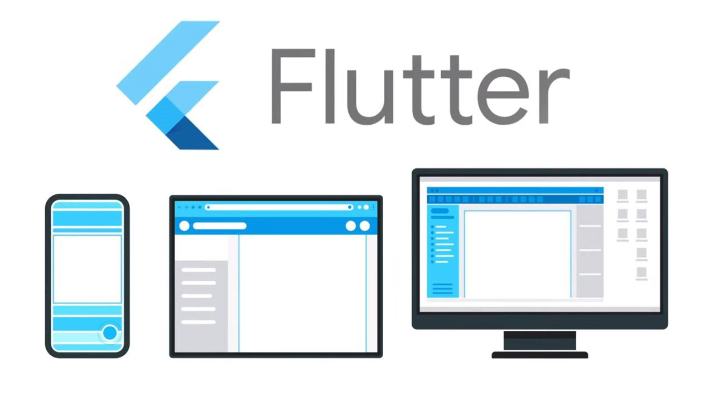

Figure 2.2 Etornam Susu's Flutter Logo. Retrieved October 14, 2020 from Medium Daily website:https://medium.com/@EtornamSunu/getting-started-with-flutter-web-19acbb3fefc1

Flutter is a Google’s UI kit which will compile the application for mobile, web and desktop natively. Flutter is a learn once use anywhere concept. Flutter solved the issues when the developer has to launch an application in two different platforms such as Android and iOS. The traditional method to launch an application in two different platform developer must learn the two programming languages which supported by two different platforms. Apart from that, Flutter also solved the issues caused by different screen size for different mobile devices such as iPad, Android smartphone, iPhone, a screen on refrigerator, touch wall, TV Box and more. (Flutter, 2020)

Flutter is an open source framework which widely used by many companies to develop cross-platform mobile apps such as Alibaba, Google Ads, Reflectly, Birch Finance, Hamilton Musical and more. It includes a popular and killer feature which are hot reloading. The developer able to preview the changed code without recompiling the apps and install again to the emulator, Android phone or iOS phone. This will increase the productivity by reducing the time for debugging and fixing the UI. Apart from that, Flutter include Built-in widget to reducing the development time. This allow developer to reuse simple widget to build a more complex UI. Flutter also provided a theme called Material Design. This will make sure the iOS and Android apps have the same flavour. Flutter also provided Cupertino which is iOS style design. (Gurwani, 2018)

Flutter does not compile to Android or iOS directly. Instead it using multiple render engine which built on C++ and Flutter than built on dart. It is similar to game engine; the game does not allocate its framework instead the functionality is provided by the game engine. Although flutter have a limited library but flutter able to reduce the development team by 40%. Apart from that, the cost to develop a flutter apps are cheaper compared to develop both native apps for Android and iOS. Flutter did provided widget, so the developer no need to code it from scratch so developer can more focus on feature rather than the underlying engine. Author suggest to use flutter to develop an apps when the time and budget is limited. (Kuprenko, 2020)

### Using Machine Learning on Compute Engine to Make Product Recommendations

Google Cloud provided a solution for a developer to build a scalable, efficient and effective relevant product recommendations services for an online store. E-commerce competition is fierce now. This service allowed developer to build a basic recommendation engine environment. The system can scale base on the workload and performance we need with the help of Google Cloud.

Base on Google Cloud’s documentation, the system should able to learn from the user to collect their personal preferences and taste to provide meaningful recommendation. If we enable system retrain periodically, it can provide a better result by including other’s user input. This solution able to learn from the user activity to solve the limited knowledge on your user.

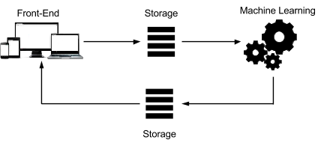

This solution required a scalable front end to record the data based on the user interactions. Next, a permanent storage is required and it can access by machine learning platform. We need to load the data into permanent storage. It may include few steps such as data import and export. A machine learning platform is essential to allow user analyse existing data and content to provide a relevant recommendation. Storage can use based on the timeliness requirement for recommendations.

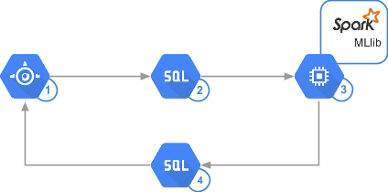

Google Cloud provided few solutions for computing power which are App Engine, Cloud SQL and Apache Spark that running on App engine using Data proc. App engine have the ability to process ten thousand of queries per seconds and with minimum management effort. App engine able to deploy our code in a second. Cloud SQL provided expandability to 32 core virtual machine and up to 208 GB of RAM. We can expand our storage to 10TB with 30IOPS per GB. Cloud SQL is able access directly from Spark. Spark MLlib provided amazing performance which capable to process million of rating in a minute. These advantages allow user to run the algorithm more frequently and decrease the round trips to disk as much as possible by using RAM. This solution also provided Compute Engine to host the analysis infrastructure.



The solution provided by Google Cloud include few steps such as collecting the data, storing the data, analysis the data and provide recommendation. The recommendation engine able to collect user activity data based on their behavior and input. The most significant down side is hard to analyse and filtering out the logs that is less interest. It is recommended to refer implementation of Fluentd and BigQuery to analyse to log in real time. Some data is harder to collect such as write a review. This able to provide a more accurate result when study the user preferences. But some user will not write a review base on some reason.

Next is storing the data. The more data that feed in to the system, the more accurate result we will get. Any recommendation project has the possibility to become a Bigdata project. It is suggested to use NoSQL database or a standard SQL database to store the data. The selection of database is depends on the ease of implementation and the way of capturing user data.

It is important to understand the requirement of the application in designing phase. It includes the filtering approach and understanding the timeliness. It required more immediate and nimble type of analysis when user is viewing the product. A Realtime system able to process the data at the moment that data is created. Batch analysis is required to perform analysis task periodically. This required significant amount of data to make it work.

Filtering data contain three approach which are content-based, cluster and collaborative. Content-based is a popular way to recommend a similar product. It will recommend the product based on the similarity of attributes that view or like by user. Cluster will recommend the product based on the similarity only without any knowledge of user. Collaborative provide the recommendation services base on the rating matrix or interaction matrix.

We need to divide the data set into few sections which are training set, validating set and testing set. Training set is the data that use to train the machine learning model which may include the user rating. Validating set is use to verify the accuracy of the machine learning model. Testing set contain the data that use to evaluate the trained model. It is equivalent running the test in the real world. The lower the root-mean-square error (RMSE) mean the better the model. At the end of this website, Google’s suggest a few practical codes for machine learning and implementation by using MySQL client. (Google Cloud, 2020)

## Literature review on the similar technology

### Perzonalization

Personalization provide an AI solution to deliver a personalized shopping experience shopping experience. It will recommend the product base on predicted taste and unique taste. It advertises able to boost sales up to 15%, convert more visitor and reduce site abandonment. It able recommend the product based on the similarity and the type of the product. It provided few features such as Related Product, Brand Filtered Products, History Aware Products, Keyword Filtered Products and Up/Cross Sell. Up/Cross sells able to increase the profit margin by recommending the product at higher price that matched the customer’s preferences. The selling point for this system is the able to make prediction in real time and friend-like advice. Apart from that, they also providing some feature that is useful for seller such as product recommendation services, personalized emails, performance tracking, campaign banner lists, automated emails, mobile API. (Perzonalization, n.d.)

### Adoric

Adoric is a company that providing a recommendation services for personalized product. They implement Adoric’s algorithm to provide recommendation service based on the data from the Google Analytics. It able to import the catalog by insert the Facebook or google catalog feed link to Adoric. Another feature is it able connect to Google Analytics to access the data. Basically, they providing a web hosting service for ecommerce with the implementation of the AI solution. They also providing professionally designed template for user to choose to setup their ecommerce website. Avishay Assaf is the e-commerce manager at gade.co.il, he wrote a positive review. He said “Adoric has a lot of tools tailored for e-commerce business. They are quite advanced and efficient.” The director of CRM and Marketing Technologies at groo.co.li, Hagai Yaffe said Adoric allow them to deliver perosalized messages to each visitor in simple, easy and fast way. Adoric makes it easy to set up campaign design for their online store with their brand design. (Adoric, 2020)

### Recombee

Recombee provide Recommender as a service. It is a API which easy to integrate with the ecommerce website with powerful admin user interface. The developer able to do integration by using several ways which are server side integration, client and server side integration by using java script, client side integration and product feed by using JavaScript. It will send the interaction of the user as the input to the recommender engine. It supports JavaScript, python, ruby, java, php, C#, Node.js and REST to send the detail view. The detail view will send to Recombee when the user views the detail of the item. Apart from that, Recombee also will receive the detail of user purchase activity for further analysis. There is some additional feature for developer to add on such as get recommendation, manage item in catalog, send item values, personalized search and more. I registered the account, they did separate the production database and development database. Daniel Uhm is the product manager at Slickdeals, he commented the Recombee able to handle their very specific use care and providing recommendation with a highly volatile inventory of user’s generated content. It increases 70% of product and page view and 30% clickthrough. (Recombee, 2020)

# RESEARCH TECHNOLOGY

## Methodology

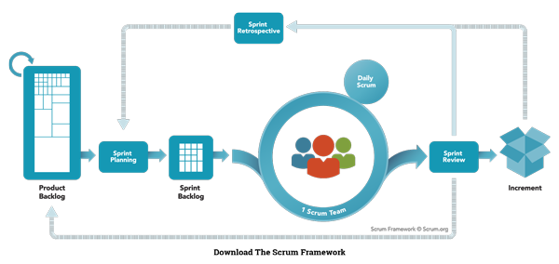

Figure 3.1 - Scrum Model. Adapted from "Nutcache",

retrieved from https://www.nutcache.com/blog/leverage-scrum-to-manage-your-projects/

A scrum model (agile) is implemented in this project. Agile is an iterative approach for software development. The software is developed and delivered to customers in increments. Agile has the flexibility to accommodate frequent changes in the design. Scrum is one of the agile process frameworks which include product owner, scrum master, and development team. Scrum breaks the task into goals that can be completed within the timeboxed iteration, which call sprint. This is a lightweight. Iterative and incremental approach. The sprints should not longer than one month. The development team is self-organized, and responsible convert the backlog into an actual system. Eight members of the development team are required in this project. Product owner representing stakeholders and the voice of the customer. Only 1 product owner is required in this project to maximizing the value delivered by the development team. Scrum Master is responsible for ensuring the Scrum framework is followed and acts as a buffer between the team and any distracting influences. Each team required a scrum master, in this project, there is two development team which are Team A, and Team B. Scrum also included sprint planning, daily scrum, sprint review, sprint retrospective, backlog refinement, cancelling a sprint. These will be implemented in this project. (Fernandes, 2015) (scrum.org, n.d.)

### Organization Structure, Role and Responsibility

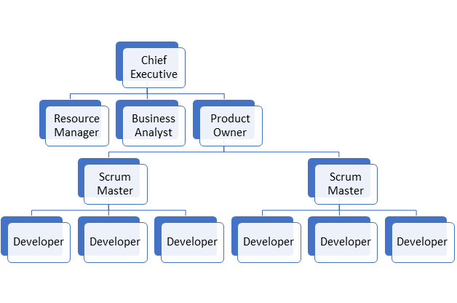

Figure 3.2 Organization Structure for Scrum

|  |  |
| --- | --- |
| **Role** | **Responsibilities** |
| Chief Executive | Manage the management board and communicating with shareholders, government entities and customer, Make |
| Resource Manager | Manage the resources efficiently and maximize productivity such as manage staff, administer payroll and etc. |
| Business Analyst | Analysing the business requires flexibility, responsiveness, creativity, innovative thinking, acceptance of change and a dependence on individuals and interactions. |
| Product Owner | Manages the Product Backlog optimizes the value of the product |
| Scrum Master | Manages the scrum process and remove impediments |
| Developer | Self-organize team even there is no Scrum Master and turn the Product Backlog into increments of potentially releasable functionality |

Table 10 Role and Responsibilities in Scrum

### Definition

Scrum events are defined as the following:

1. **Sprint:**A time-boxed mini project which less than 4 weeks, at the end for each sprint should deliver a releasable product or feature, Sprints include the planning, design, development and testing phase. Each sprint can assign to a synchronized team.
2. **Sprint planning:** A planning stage before the sprint began. Each backlog is prioritizing and review the requirement (product backlog) and created an order list for a particular sprint. Analyze the feasibility for each requirement and features finish at a particular time.
3. **Daily Scrum:**A meeting that held every day morning and takes less than 5 minutes. The scrum master will coordinate the team and discuss their daily goal and achievement. The obstacle also will be discussed in the meeting to seek help from another team. An unclear goal can make the team focus on their daily tasks and increase productivity.
4. **Sprint review:**An informal meeting establishes at the end of the sprint. The increment (product backlog) will be demonstrating to the end-user if any improvement or changes will execute in the next sprint.
5. **Sprint retrospective:**A formal meeting that gathers all the scrum and reviews the sprint. Each sprint will be review in this stage, which included the factor that makes the sprint or goal fail, way to improve the sprint, and etc. Then continue next sprint.

Scrum artifacts are defined as the following:

1. **Story:**Describe what users need to solve their problems. It describes the functionality and the features of the system which is also known as user stories. For example, login, pay and update profile.

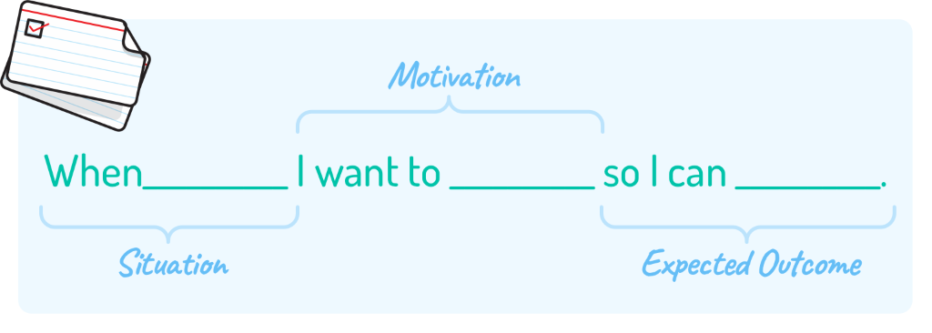

Figure 3.3 User Story. Adapted from "Mountain Goat Software", by Mike Cohn,

retrieved from http://www.mountaingoatsoftware.com/blog/job-stories-offer-a-viable-alternative-to-user-stories/feed

1. **Product Backlog**: An ordered list of the requirement for the product or features of the system. Product backlog includes all the requirements of the systems or features such as users can pay via credit card. A product backlog is never complete because product backlog will evolve throughout the entire development process. A product backlog is dynamic and frequently changes to fulfil the requirement of the product and what the product needed to be competitive. Adding detail, estimate, and order to items in the product backlog call product backlog refinement.  (Fernandes, 2015)
2. **Tasks:**A decomposed of a product backlog. Task refine the product backlog and the requirement of the product or features of the system.

## Planning

### WBS

Refer to WBS.pdf

### Gantt Chart

Refer to GanttChart.pdf

### Deliverables

|  |  |  |
| --- | --- | --- |
| **Deliverables** | **Phase** | **Date** |
| Proposal | Analysis Phase (Planning) | 15/10/2020 |
| Documentation (Chapter 1 to 4)  UI Design | Analysis Phase (Planning – Define Scope) | 16/10/2020 |
| Collect User Preferences Data  Documentation for Data  Train Machine Learning Model  Verified accuracy of machine learning model | Sprint 1 | 17/10/2020 |
| UI design for mobile app  Create Flask API  Connect mobile app to backend | Sprint 2 | 19/10/2020 |
| UI design and Connect to Backend Product information  Documentation for Implementation each stage | Sprint 3 | 21/10/2020 |
| Input the price range selector  Enhancement and Debug  Final documentation  Final prototype | Sprint 4 | 22/10/2020 |

## Hardware Requirement

### Minimum Requirement

|  |  |
| --- | --- |
| Hardware | Specification |
| Computer | RAM: 4GB minimum, 8GB recommended  Hard disk: 4GB of available disk space  Resolution: 1280 x 800 minimum  OS: Windows 7 (64bit) or later |
| Smartphone | ROM: 1GB available  RAM: 2GB  OS: Android 6.0 (Marshmallow) or iOS 8  Or newer  -Have camera  -Have good internet connection |

Table 11 Minimum Hardware Requirement

The minimum requirement for Android is Jelly Bean but preferred Android 6.0. According to (Mobile & Tablet Android Version Market Share Worldwide, 2020), there is only 8.72% people using android 6.0 and 37.4% of people using Android 9.0. So, the test platform will start with Android 6.0 since that is the minimum requirement. The minimum requirement to support flutter is iOS 8 or newer.

### Development and Deployment Environment

|  |  |
| --- | --- |
| Hardware | Specification |
| Laptop | Model: Acer E15 575G-55Z3  OS: Windows 10  RAM: 8GB  GPU: Nvidia GeForce 940MX  Processor: Intel i5-7200u  Addon:  SSD 480GB  HDD 1TB |
| Smartphone | Model: Oppo A57 (CPH1701)  Display: 720 x 1280 pixels  Platform: Android 6 (Marshmallow)  OS: ColorOS3  Chipset: Qualcomm MSM8940 Snapdragon 435 (28 nm)  CPU: Octa-core 1.4 GHz Cortex-A53  GPU: Adreno 505  Main camera: 13 MP, f/2.2, PDAF, 1080p@30fps  Internal Storage: 32GB 3GB RAM |

Table 12 Development and Deployment Environment

Hardware play essential role to increase the productivity. The laptop or PC is required in this project with at least Intel i5 7th generation or above processor and at least with 4GB RAM. For the development phase, a good camera is essential to capture the high-quality image. The camera should equip with at least 48MP sensor or above.

## Software Requirement

### Functional Requirement

##### System should able to ask few question

##### System should able to upload the answer to webserver

##### System should able to display the prediction result

##### System should able to promote product

### Non-functional Requirement

|  |  |
| --- | --- |
| Performance | 1. System shall not take more than 1 minutes to reboot 2. System shall not require large memory space 3. System shall able to return the prediction result in 2 minutes |
| Usability | 1. System shall able to resubmit the answer and did not related to previous answer 2. Each function should have brief description 3. System should able to suggest the gaming gear 4. System should able to promote the gaming gear |
| Reliability | 1. Mean time to failure of system must more than 1 crash / 10000 use 2. The system should able to upload the answer continuously 3. The system should available for 24 hours |
| Operational | 1. System must operate in Android platform 2. System must interact with touch screen |

Table 13 Non-functional Requirement

### User requirement

|  |  |
| --- | --- |
| App  [USR_REQ_01] | 1. User need to answer a sequence of question [USR_REQ_01_01] 2. User need to get recommendation from server [USR_REQ_01_02] 3. User need to dashboard to display the result [USR_REQ_01_03] 4. User need to see the product information [USR_REQ_01_04] |
| Server  [USR_REQ_02] | 1. User need it available 24 hours nonstop [USR_REQ_02_01] 2. User need it stable for 24 hours [USR_REQ_02_02] |

### Minimum Requirement

|  |  |
| --- | --- |
| Android (target platform) | * Android SDK API equal or more then 23 * Android 6.0 or above |
| Operating System | * Windows 7 or above |
| Framework | * Dart 2.10.1 or above * Flutter 1.22.1 or above |

## SOFTWARE DESIGN

### Framework

#### High System work flow



The proposed method is a mobile app which able to suggest a gaming gear for customer. The user will open an app to answer a sequence of question and upload to the webserver through REST API (Flask). Then the server will implement python script to forward the input to the Machine Learning API to perform prediction process. After that, the Machine Learning API will return the highest possible result to the server and forward to the app. At the end, the app will display the gaming gear in dashboard.

### Architecture

#### Use Case Diagram

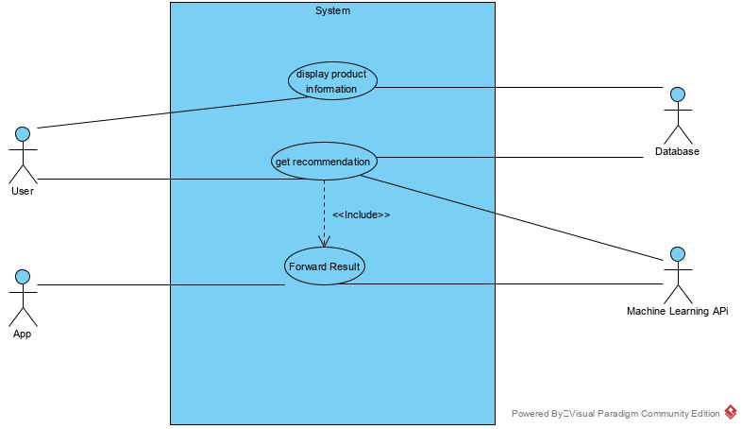

#### Use Case Report

|  |  |
| --- | --- |
| Use Case ID |  |
| Use Case Name | Display product information |
| Description | User looking the product information |
| Pre-condition | User pressed the product item |
| Post-condition | Display Menu |
| Basic Flow | 1. Select item from product list **[SRS_REQ_01_01]** 2. System process [E1] 3. Display menu [A1] **[SRS_REQ_01_02]** 4. User case end |
| Alternative Flow | 1. Home page **[SRS_REQ_01_03]**    1. Press <Home page> button    2. System process    3. User case end |
| Exceptional Flow | 1. Invalid image    1. Display error message **[SRS_REQ_01_04]**    2. Proceed B1    3. User case end |

|  |  |
| --- | --- |
| Use Case ID |  |
| Use Case Name | Get recommendation |
| Description | User ask for a recommendation for gaming gear |
| Pre-condition | Display Menu |
| Post-condition | Display Menu |
| Basic Flow | 1. Select <Get Recommendation> [A1] [A2] **[SRS_REQ_02_01]** 2. System process 3. Display Menu [A3] **[SRS_REQ_02_02]** 4. System process [E1] 5. Display Menu **[SRS_REQ_02_03]** 6. User case end |
| Alternative Flow | 1. Select <home page> **[SRS_REQ_02_04]**    1. Press <Home page> button    2. System process    3. User case end 2. Select <cancel> **[SRS_REQ_02_05]**    1. Press <cancel> button    2. System process    3. User case end |
| Exceptional Flow | 1. Invalid answer    1. Display error message **[SRS_REQ_02_06]**    2. Proceed B1    3. User case end |

|  |  |
| --- | --- |
| Use Case ID |  |
| Use Case Name | Forward result |
| Description | Server forward result to mobile app |
| Pre-condition | A valid answer |
| Post-condition | Display Menu |
| Basic Flow | 1. Receiving Request **[SRS_REQ_03_01]** 2. System process [E1] [E2] 3. Return result **[SRS_REQ_03_02]** 4. User case end |
| Alternative Flow |  |
| Exceptional Flow | 1. Invalid Format    1. Set error message **[SRS_REQ_03_03]**    2. Proceed B5    3. User case end 2. Invalid Response    1. Set error message **[SRS_REQ_03_04]**    2. Proceed B5    3. User case end |

#### Requirement Traceability List

|  |  |  |
| --- | --- | --- |
| No. | Requirement ID | Description |
|  | SRS_REQ_01_01 | Select item from product list |
|  | SRS_REQ_01_02 | Display menu |
|  | SRS_REQ_01_03 | Home page |
|  | SRS_REQ_01_04 | Display error message |
|  | SRS_REQ_02_01 | Select <Get Recommendation> |
|  | SRS_REQ_02_02 | Display Menu |
|  | SRS_REQ_02_03 | Display Menu |
|  | SRS_REQ_02_04 | Select <home page> |
|  | SRS_REQ_02_05 | Press <cancel> button |
|  | SRS_REQ_02_06 | Display error message |
|  | SRS_REQ_03_01 | Receiving Request |
|  | SRS_REQ_03_02 | Return result |
|  | SRS_REQ_03_03 | Set Error Message |
|  | SRS_REQ_03_04 | Set Error Message |

#### Activity Diagram

Get Recommendation

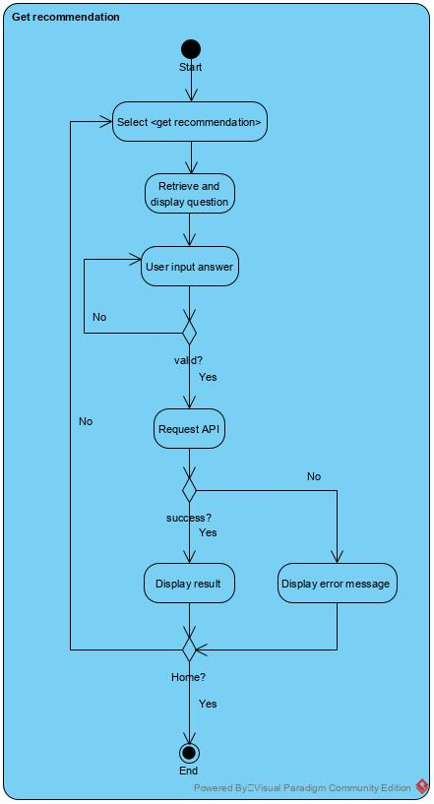

Display Product Information

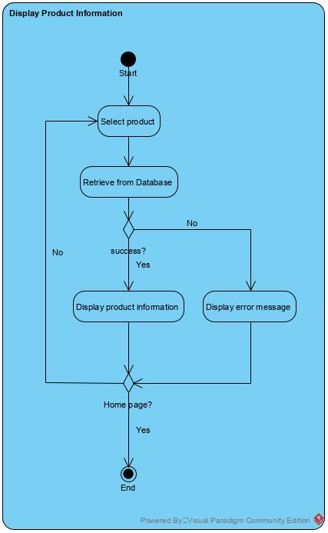

Forward Result

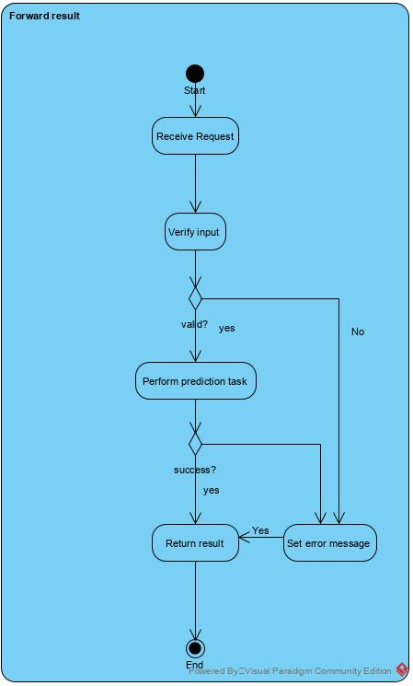

#### Deployment Diagram

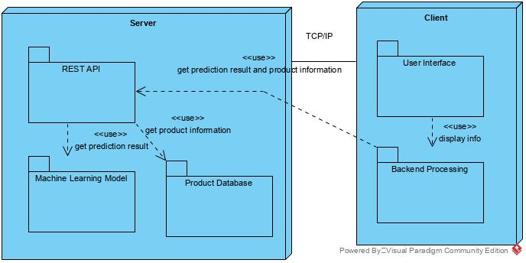

### User Interface

Home

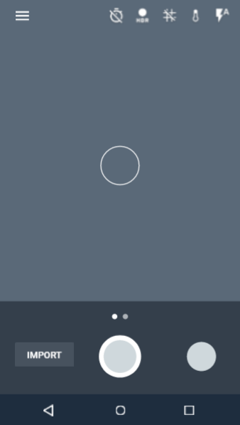

Figure 3.21 UI - Home Screen

Import

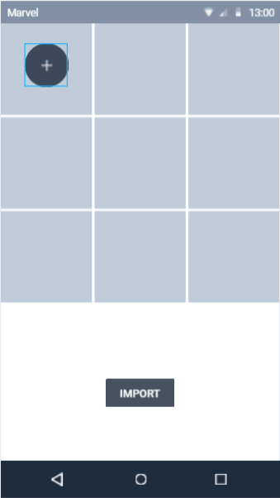

Figure 3.22 UI - Import Screen

# IMPLEMENTATION

## Testing

## Output Analysis

# CONCLUSION

## Finding & limitations

## Contribution

## Summary

## Future Enhancement

# REFERENCES

A. Choudhary, J. J. (2017). Product recommendations using data mining and machine learning algorithms. *ARPN Journal of Engineering and Applied Sciences*, 5475-5483.

*Adoric*. (2020). Retrieved from Personalized product recommendations: https://adoric.com/solutions/recommendations?utm_source=Google_search_ppc&utm_medium=Google_search_text&utm_campaign=recommendations&gclid=CjwKCAjwiaX8BRBZEiwAQQxGxwDY_srGbSObky1Lx-2RWIsdH_SAcmwrKzBpxVtd8aKjAK2PMKA4qhoCaa4QAvD_BwE

*builtin*. (n.d.). Retrieved from What is Gaming?: https://builtin.com/gaming

*CISION PRNewswire*. (2020, May 13). Retrieved from Tencent Announces 2020 First Quarter Results: https://www.prnewswire.com/news-releases/tencent-announces-2020-first-quarter-results-301058417.html

Fernandes, E. A. (2015, Jan 21). *Scrum explained*. Retrieved May 2020, from Code Project: https://www.codeproject.com/Articles/704720/Scrum-explained

*Flutter*. (2020). Retrieved from Flutter: https://flutter.dev/

*Google Cloud*. (2020, June 22). Retrieved from Using Machine Learning on Compute Engine to Make Product Recommendations: https://cloud.google.com/solutions/recommendations-using-machine-learning-on-compute-engine

Gurwani, M. S. (2018, October 14). *10 Amazing Apps Built Using Flutter Framework*. Retrieved from daffodilsw: https://insights.daffodilsw.com/blog/10-amazing-apps-built-using-flutter-framework

Hessel Tuinhof, Clemens Pirker, Markus Haltmeier. (2019, February 14). Image-Based Fashion Product. *International Conference on Machine Learning, Optimization, and Data Science*, 472-481. doi:https://doi.org/10.1007/978-3-030-13709-0_40

Kuprenko, V. (2020, April 22). *Google Flutter Review – Why Mobile App Developers Love Flutter*. Retrieved from freeCodeCamp: https://www.freecodecamp.org/news/why-mobile-apps-makers-are-in-love-with-flutter/

MEDIA, F. L. (2020, May 12). *Reuters*. Retrieved from Report: Gaming revenue to top $159B in 2020: https://www.reuters.com/article/esports-business-gaming-revenues-idUSFLM8jkJMl

*Mobile & Tablet Android Version Market Share Worldwide*. (2020). Retrieved 7 5, 2020, from statcounter: https://gs.statcounter.com/android-version-market-share/mobile-tablet/worldwide

*Perzonalization*. (n.d.). Retrieved from Personalized Product Recommendations: https://www.perzonalization.com/ecommerce-personalization-products/personalized-product-recommendations/?gclid=CjwKCAjwiaX8BRBZEiwAQQxGx2vQK07Dz-mNOs2OCIBFwiNWOXLTyBM4RDs53GPnN91qQlUbt_qVFRoC-9EQAvD_BwE#1502981335816-1f83aded-1be4

*Recombee*. (2020). Retrieved from Artificial Intelligence Powered Recommender as a Service: https://www.recombee.com/

scrum.org. (n.d.). *What is a Product Backlog?* Retrieved May 2020, from Scrum.org: https://www.scrum.org/resources/what-is-a-product-backlog

Staff, S. (2020, September 23). *SuperData*. Retrieved from Worldwide digital games market: August 2020: https://www.superdataresearch.com/blog/worldwide-digital-games-market

# APPENDICES

1. Appendix A – WBS
2. Appendix B – Gantt Chart
3. Appendix C – Network Diagram