Self-Driving Car Assignment 2: Probability Bayesian

312512005 黃名諄

Exercises 2

Suppose we live at a place where days are either sunny, cloudy, or rainy. The weather

transition function is a Markov chain with the following transition table:

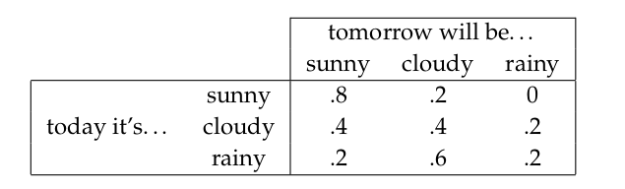(a) Suppose Day 1 is a sunny day. What is the probability of the following sequence of days:

Day2 = cloudy,Day3 = cloudy, Day4 = rainy?

Ans:

day1(sunny) to day2(cloudy) : 0.2

day2(cloudy) to day3(cloudy) : 0.4

day3(cloudy) to day4(rainy) : 0.2

1* 0.2* 0.4* 0.2 = 0.016

(b)Write a simulator that can randomly generate sequences of “weathers” from this state transition

function.

Ans:

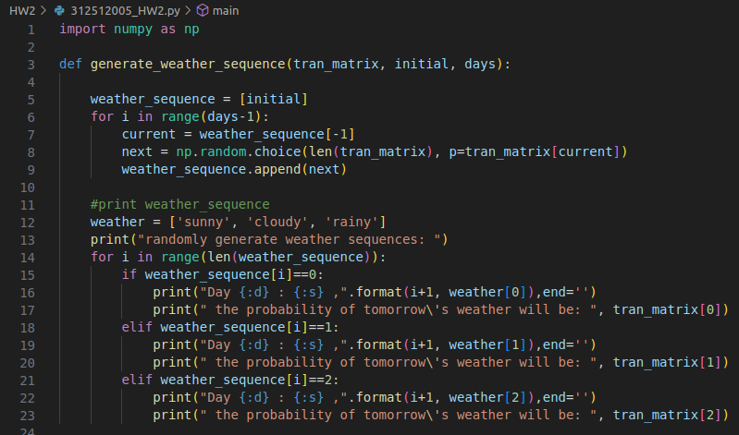

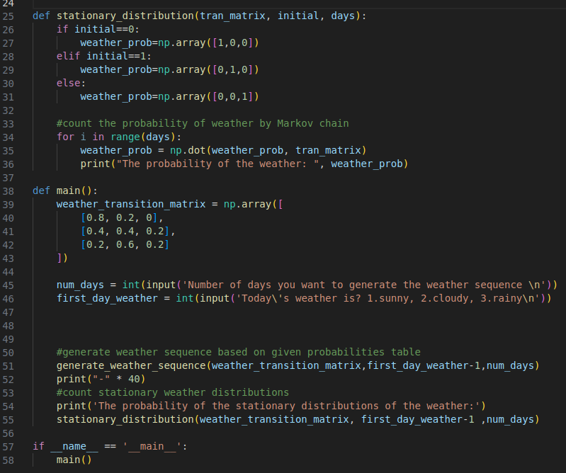

demo result:

1. number of days = 10, today(day1) is sunny

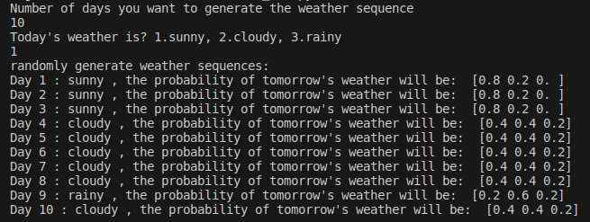

1. number of days = 10, today(day1) is cloudy

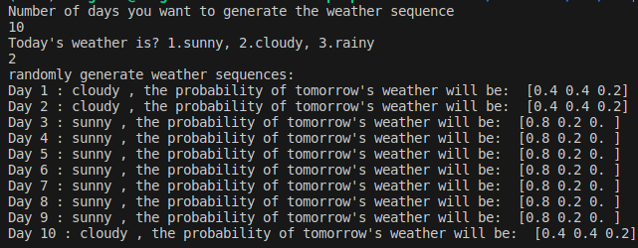

1. number of days = 10, today(day1) is rainy

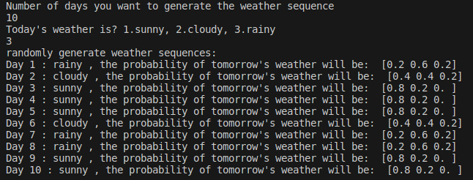

(c)Use your simulator to determine the stationary distribution of this Markov chain. The stationary

distribution measures the probability that a random day will be sunny, cloudy, or rainy.

Ans:

1. number of days = 10, today(day1) is sunny

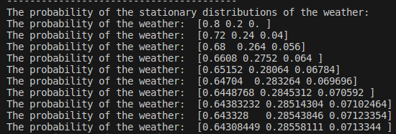

1. 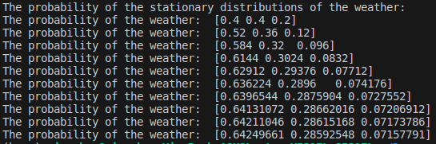number of days = 10, today(day1) is cloudy
2. number of days = 10, today(day1) is rainy

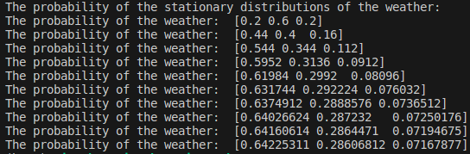

(d)Can you devise a closed-form solution to calculating the stationary distribution based on the state

transition matrix above?

Ans:

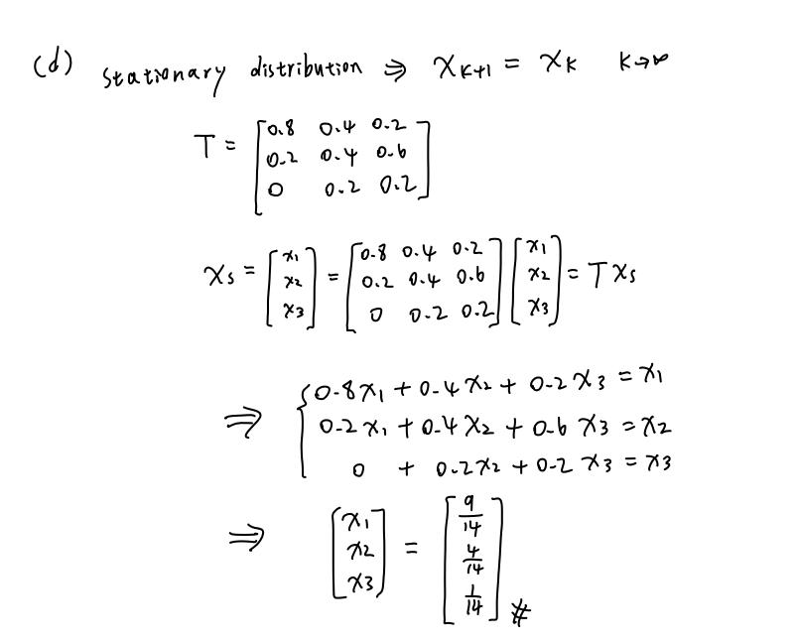

(e) What is the entropy of the stationary distribution?

Ans:

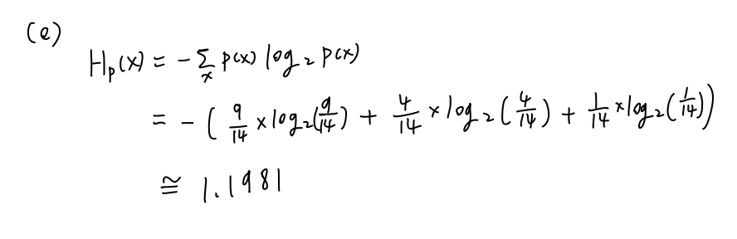

(f)Using Bayes rule, compute the probability table of yesterday’s weather given today’s weather. (It

is okay to provide the probabilities numerically, and it is also okay to rely on results from

previous questions in this exercise.)

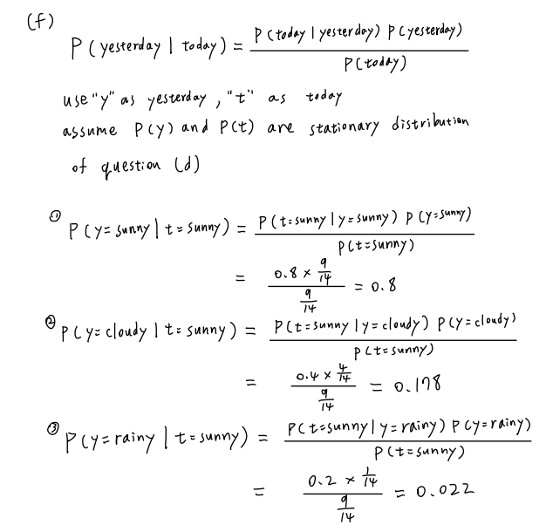Ans:

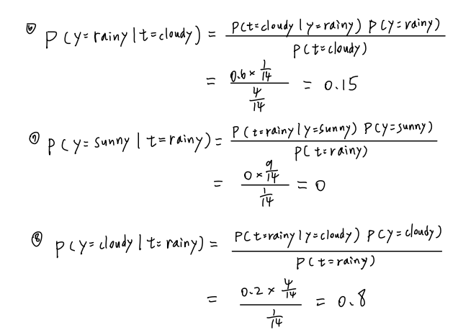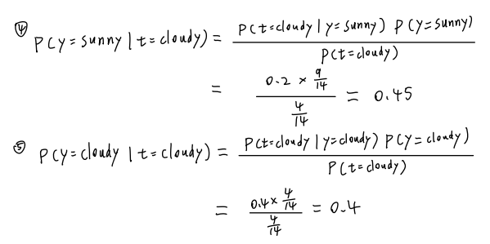

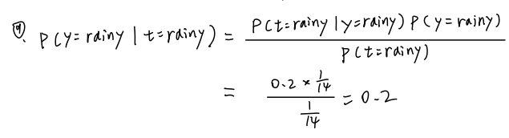

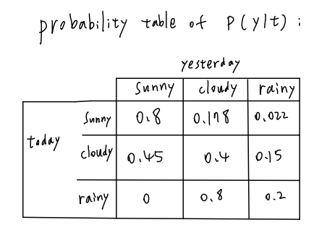

(g)Suppose we added seasons to our model. The state transition function above would only apply to

the Summer, whereas different ones would apply to Winter, Spring, and Fall. Would this violate

the Markov property of this process? Explain your answer.

Ans:

The Markov property dictates that the future state of the system depends solely on its current state. We can view it as a Markov chain that is different depends on the season(time varying).Therefore, it do not violate Markov assumption because future state of the system still depends on its current state only just within each different season.

Furthermore, we can incorporate the season as a state variable into the transition matrix for consideration. Use it to count the transition probability:

Exercises 3

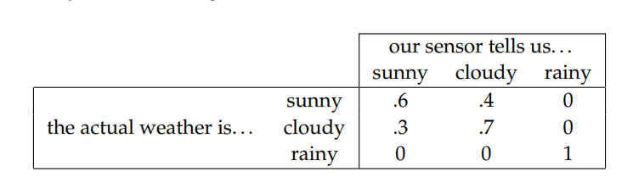Suppose that we cannot observe the weather directly, but instead rely on a sensor. The problem is that our sensor is noisy. Its measurements are governed by the following measurement model:

1. Suppose Day 1 is sunny (this is known for a fact), and in the subsequent four days our sensor observes cloudy, cloudy, rainy, sunny. What is the probability that Day 5 is indeed sunny as predicted by our sensor?

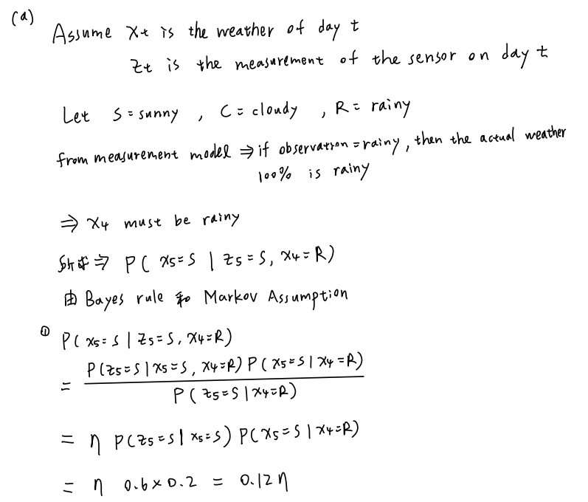Ans:

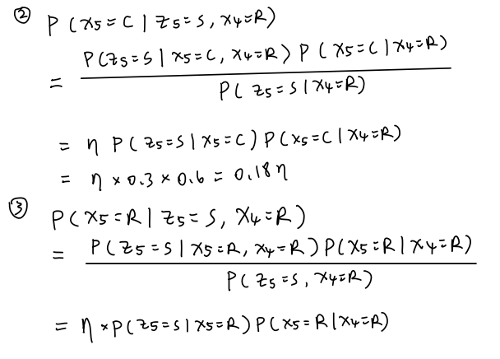

1. 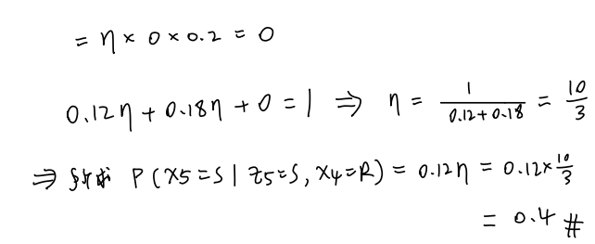Once again, suppose Day 1 is known to be sunny. At Days 2 through 4, the sensor measures sunny, sunny, rainy. For each of the Days 2 through 4, what is the most likely weather on that day? Answer the question in two ways: one in which only the data available to the day in question is used, and one in hindsight, where data from future days is also available.

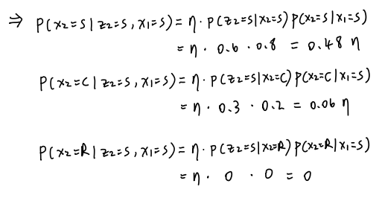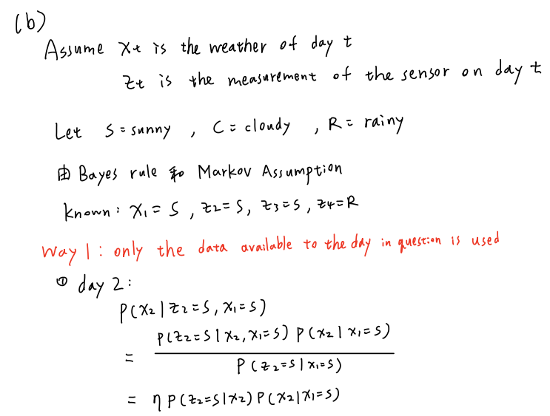

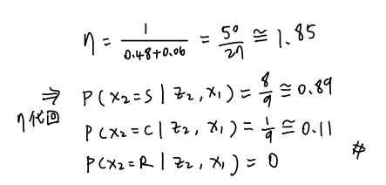

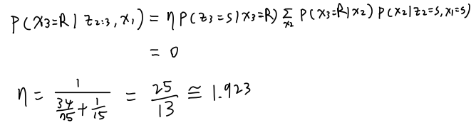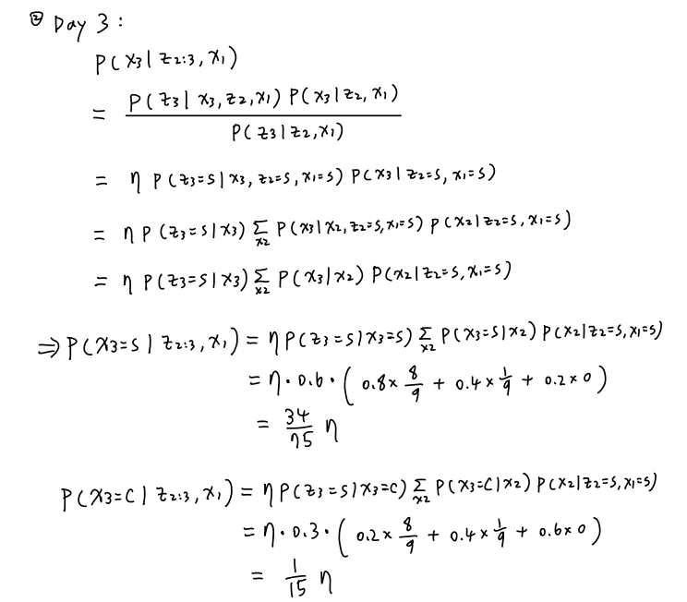

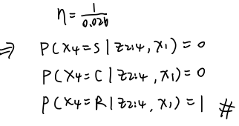

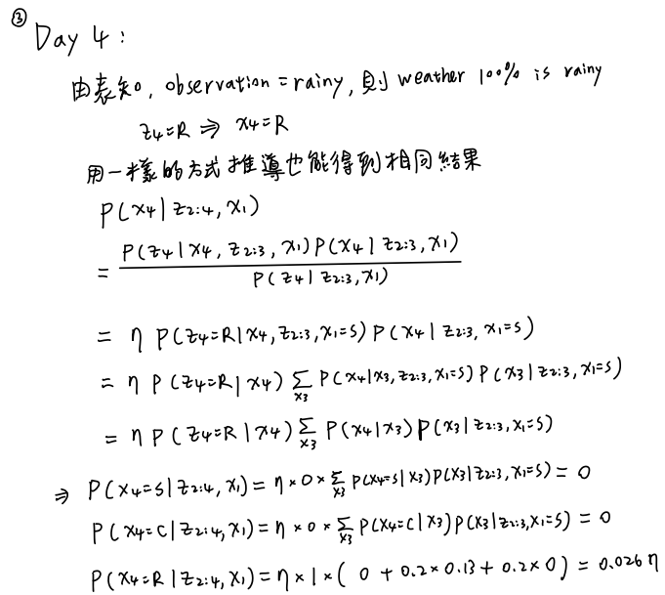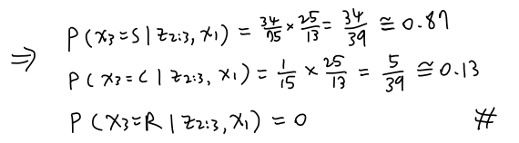

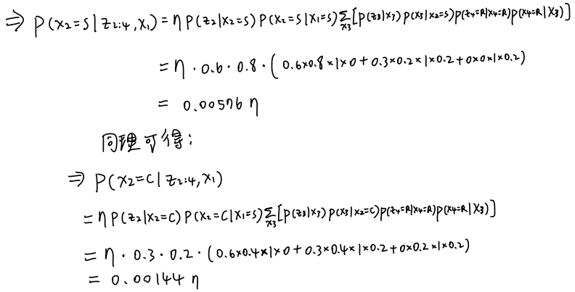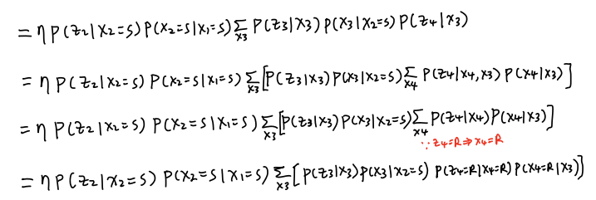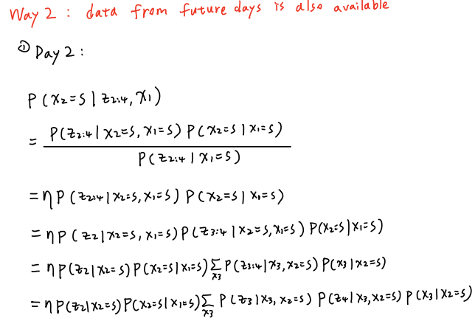

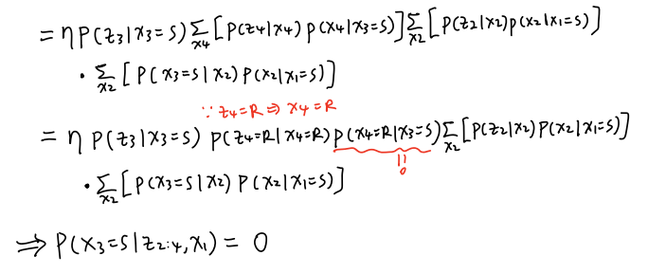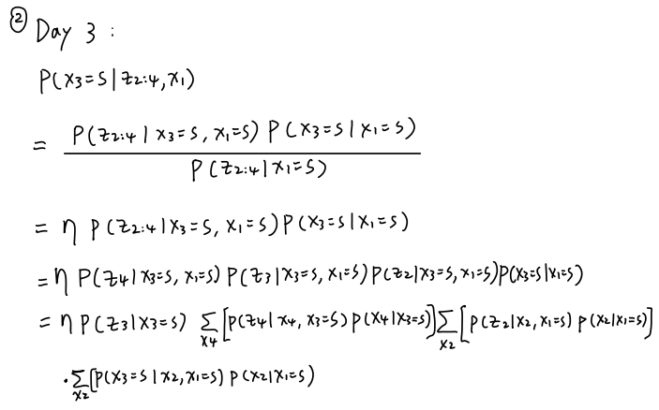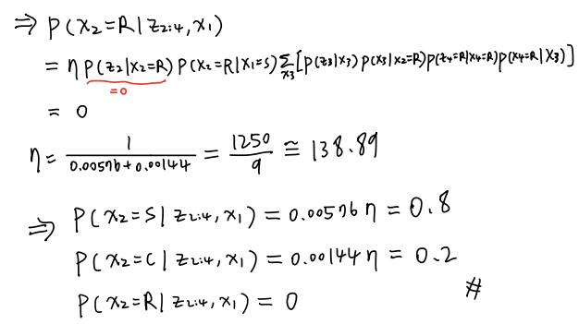

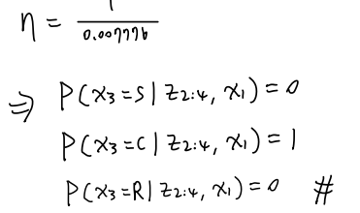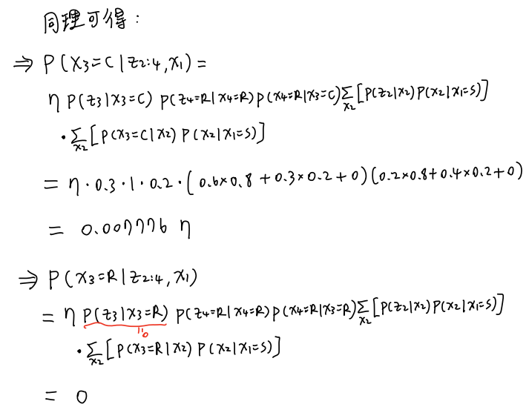

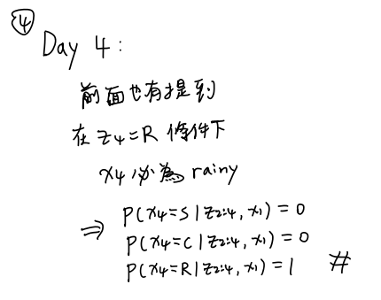

1. Consider the same situation (Day 1 is sunny, the measurements for Days 2, 3, and 4 are sunny, sunny, rainy). What is the most likely sequence of weather for Days 2 through 4? What is the probability of this most likely sequence?

Ans:

* 1. Use way1 method:

most likely sequence: Day 1 is sunny, Day 2 is sunny, Day 3 is sunny, Day 4 is rainy

probability of this sequence:

3

* 1. Use way2 method:

most likely sequence: Day 1 is sunny, Day 2 is sunny, Day 3 is cloudy, Day 4 is rainy

probability of this sequence: