Self-Driving Car Assignment 2: Probability Bayesian
312512005 黃名諄

Exercises 2
Suppose we live at a place where days are either sunny, cloudy, or rainy. The weather
transition function is a Markov chain with the following transition table:
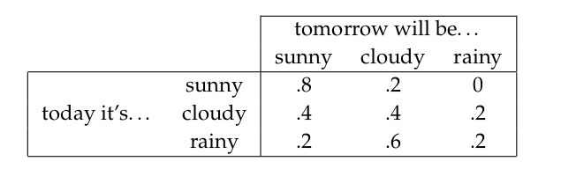
(a) Suppose Day 1 is a sunny day. What is the probability of the following sequence of days:
Day2 = cloudy,Day3 = cloudy, Day4 = rainy?

Ans:
day1(sunny) to day2(cloudy) : 0.2
day2(cloudy) to day3(cloudy) : 0.4
day3(cloudy) to day4(rainy) : 0.2
1* 0.2* 0.4* 0.2 = 0.016

(b)Write a simulator that can randomly generate sequences of “weathers”from this state transition
function.

Ans:
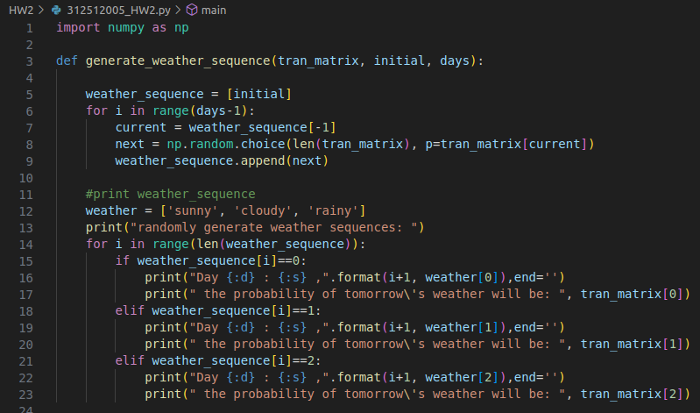
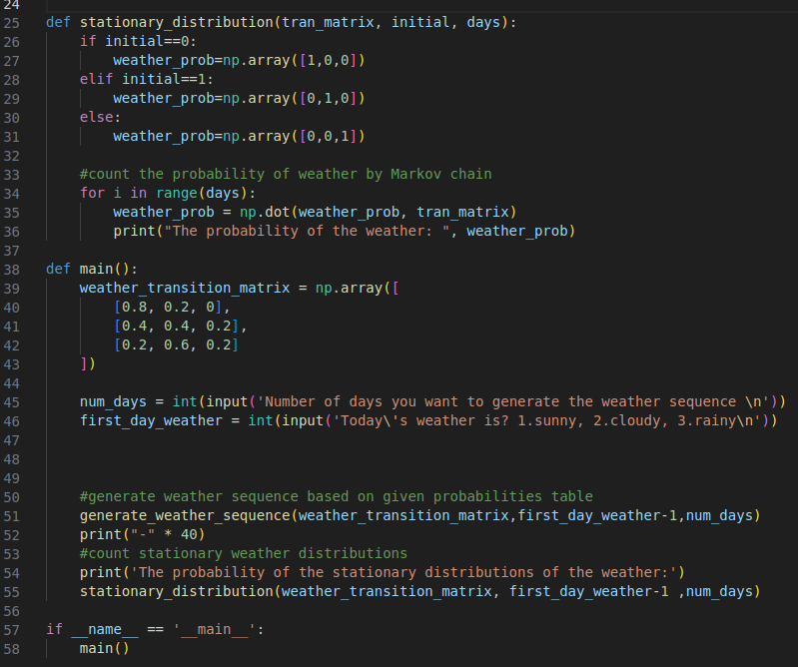

demo result:

- number of days = 10, today is sunny

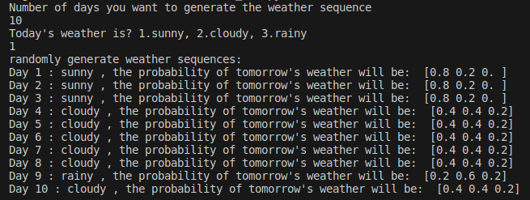

- number of days = 10, today is cloudy
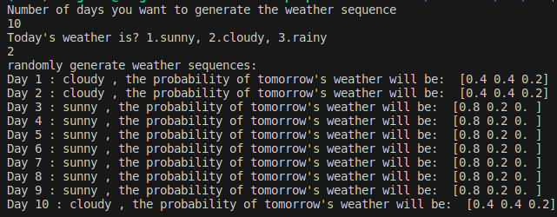
- number of days = 10, today is rainy

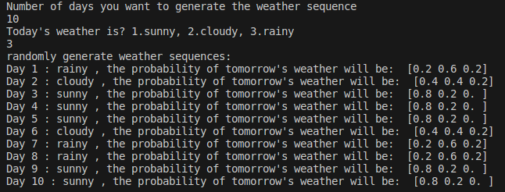

(c)Use your simulator to determine the stationary distribution of this Markov chain. The stationary
distribution measures the probability that a random day will be sunny, cloudy, or rainy.

Ans:
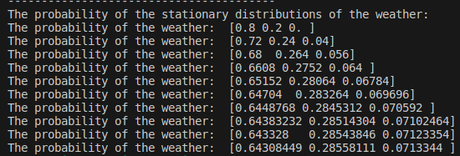
- number of days = 10, today is sunny

- number of days = 10, today is cloudy
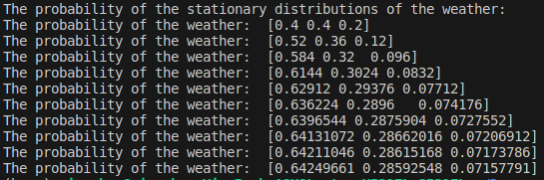
- number of days = 10, today is rainy
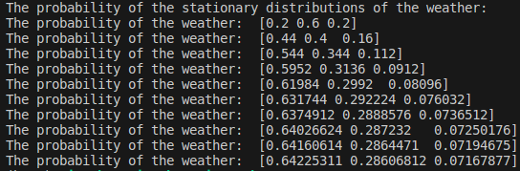

(d)Can you devise a closed-form solution to calculating the stationary distribution based on the state
transition matrix above?

Ans:
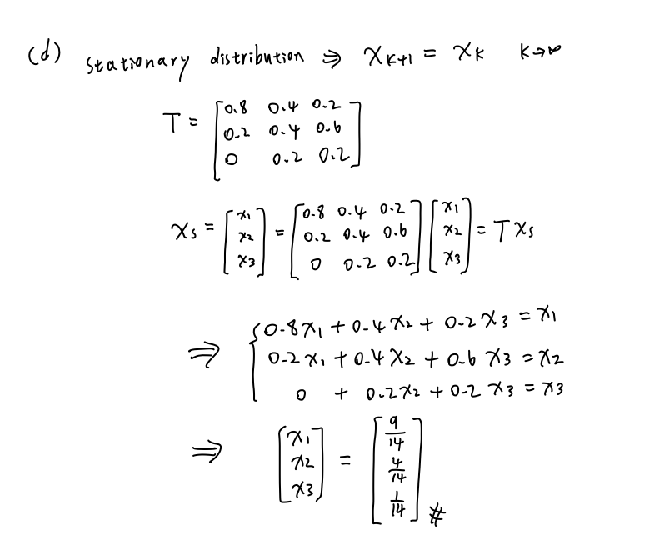

(e) What is the entropy of the stationary distribution?

Ans:

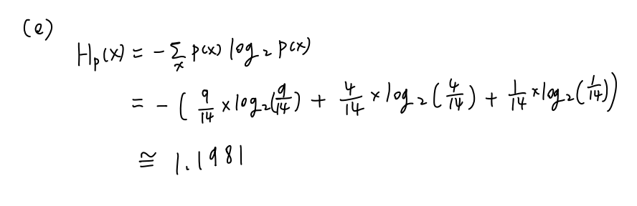

(f) Using Bayes rule, compute the probability table of yesterday’s weather given today’s weather. (It is okay to provide the probabilities numerically, and it is also okay to rely on results from previous questions in this exercise.)

(g)Suppose we added seasons to our model. The state transition function above would only apply to the Summer, whereas different ones would apply to Winter, Spring, and Fall. Would this violate the Markov property of this process? Explain your answer.

Ans:
I believe it would violate the Markov property. The Markov property dictates that the future state of the system depends solely on its current state. However, if we consider a state transition function that is specific to each season, the transition probabilities would be affected by additional information related to the current season. This would mean that the future state not only depends on the current state but also on the specific season, thereby violating the Markov property.

