Supplementary
Supplementary Figures
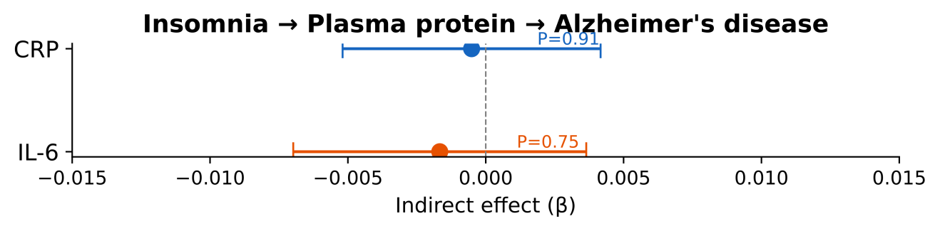
Supplementary Figure 3A: insomnia → plasma CRP/IL-6 → AD forest
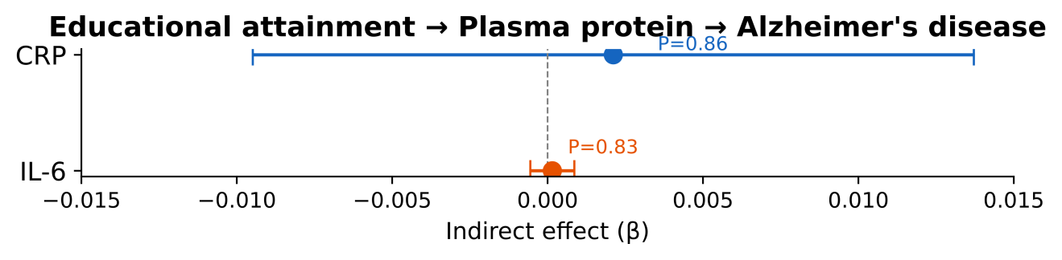
Supplementary Figure 3B: education → CRP/IL-6 → AD (exposure substitution)
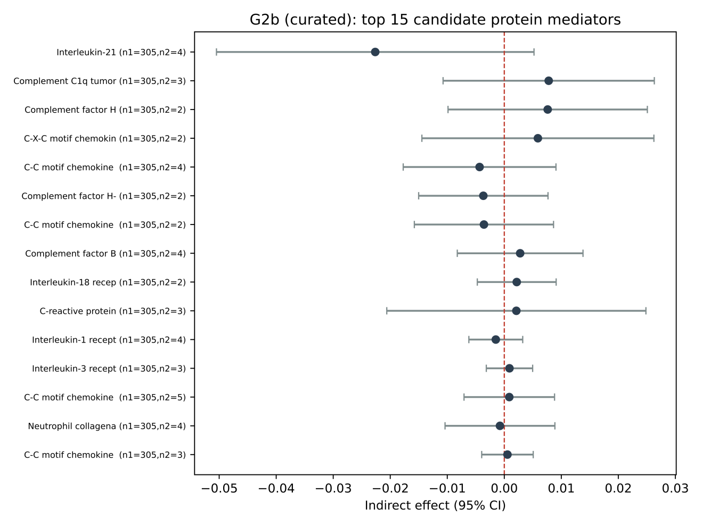
Supplementary Figure 3C: G2b 36-protein screen volcano and top-15 forest
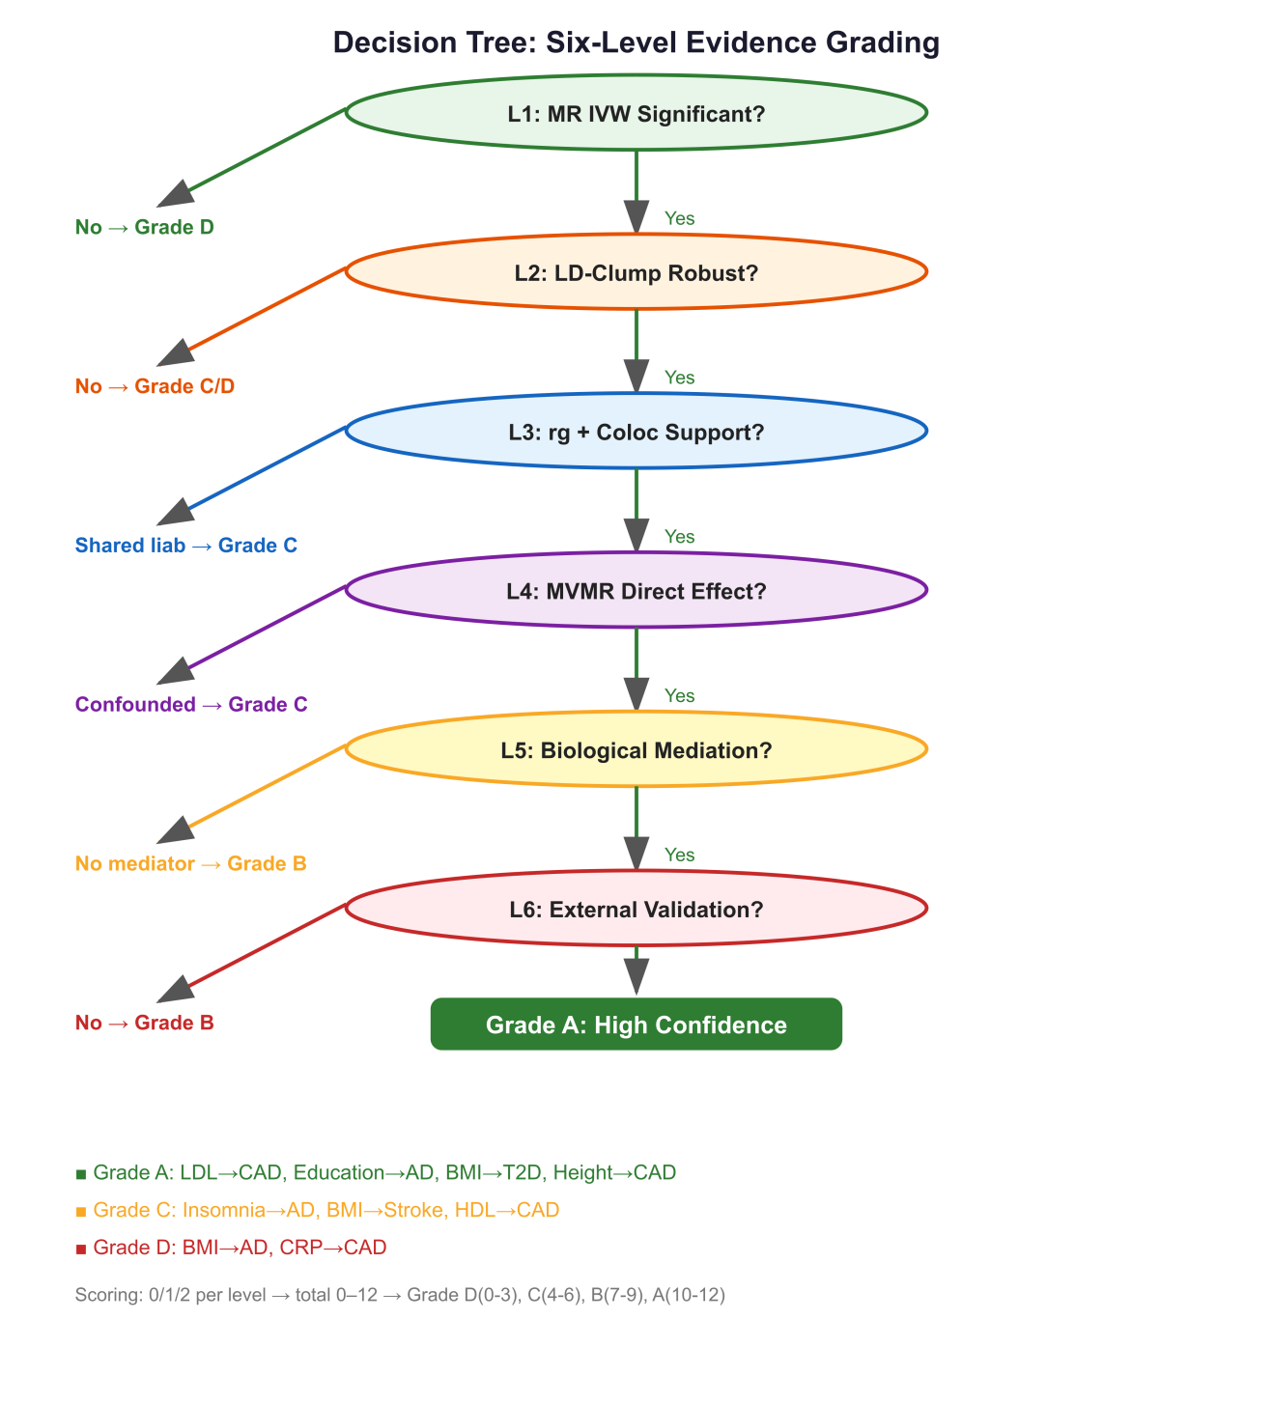
Supplementary Figure 4: Decision-tree flowchart for applying the six-level evidence-grading framework to any polygenic exposure–outcome pair. Encodes the practical algorithm: MR IVW significant → LD-clump robust → CAUSE/MRlap consistent → coloc rg architecture → MVMR direct effect → biological mediation → external validation → assign Grade A/B/C/D.
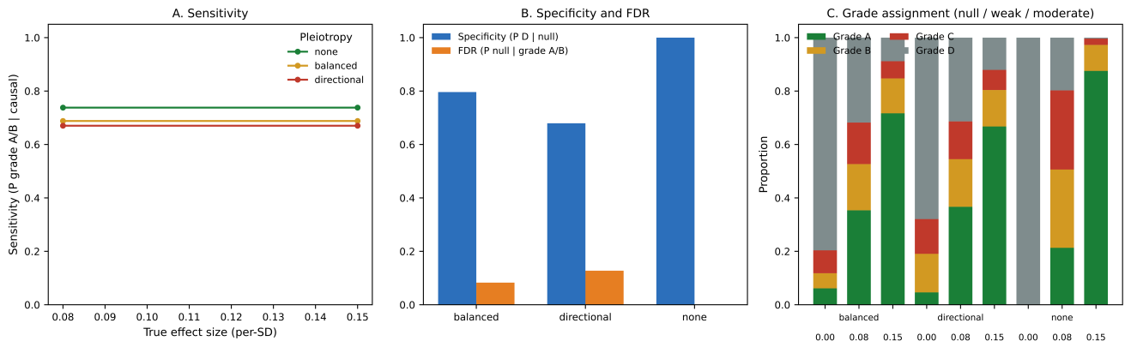
Supplementary Figure 5: Simulation operating characteristics. Panel A: sensitivity vs effect size, by pleiotropy regime. Panel B: specificity and FDR by pleiotropy. Panel C: grade assignment distribution across null / weak / moderate effect × pleiotropy conditions.

Supplementary Tables
Supplementary Table S1: Complete colocalization results (129 loci)
Supplementary Table S2: Instrument sensitivity (unclumped vs. clumped, 4 methods)
Supplementary Table S3: Complete MVMR/UVMR results matrix (27 rows)
Supplementary Table S4: Educational attainment PheWAS (4 outcomes × 4 methods)
Supplementary Table S5: STROBE-MR checklist
Supplementary Table S6: Exploratory height→AD analysis: 382 instruments (F = 78.4), IVW β = −0.107 (P = 0.002), MR-Egger β = −0.071 (P = 0.44), WM β = −0.089 (P = 0.063), Cochran Q = 431 (P = 5 × ¹⁰⁻⁵). Interpreted as directional pleiotropy; not used as a formal negative control.
Supplementary Table S7: Twelve-case expanded validation cohort (LDL→CAD, Education→AD, BMI→T2D, Height→CAD, Insomnia→AD, BMI→Stroke, HDL→CAD, Depression→AD, Education→T2D, CRP→CAD, BMI→AD, T2D→AD) with full per-level 0–2 scoring, cumulative 0–12 total, F-statistics, IVW/WM/Egger estimates, and domain annotation. Available as CSV and Markdown in the Supplementary materials.
Supplementary Table S8: Simulation operating characteristics across the LD-concentration × pleiotropy × sample-overlap × effect-size scenario grid (43,200 replicates; seed 20260804). Per-scenario CSV with sensitivity, specificity, FDR, and grade distribution; marginal summary by pleiotropy and effect size. Underlies Supplementary Fig. 5.
Supplementary Notes
Supplementary Note 1: Threshold-sensitivity analysis of the A/B/C/D grade boundaries. Tests strict (+1), lenient (−1), and extreme-strict configurations; no case changes by more than one grade across any scenario.
Supplementary Note 2: Cross-ancestry (East Asian) reinforcement of Level 6. Four East Asian checks: education→T2D (BBJ; IVW β = −0.145, P = 0.012 — significant replication), T2D→AD (GARD; β = +0.006, P = 0.93 — null concordance), education→stroke (BBJ; β = −0.008, P = 0.87 — underpowered null), education→AD (GARD; β = −0.029, P = 0.85 — directional consistency). No framework-assigned direction contradicted in EAS.
Supplementary Note 3: EAS depression replication feasibility. Documents why a formal East Asian depression→AD replication is currently infeasible: the EAS clinical-MD stratum of the largest multi-ancestry MDD GWAS (Meng et al. 2024) contains no genome-wide-significant variants, and the sole EAS AD outcome (GARD, 2,919 cases) covers only 2 of 6 multi-ancestry MDD loci; an exploratory two-instrument direction check is reported for transparency and does not affect the Depression→AD grade.

