A falsification framework for causal claims in polygenic epidemiology: the insomnia–Alzheimer's disease test case
Ming Luo^{1,†}, Wangyang Ye^{1,†}, Qin Liu^{1,*}
¹Department of Neurosurgery, The Fifth Affiliated Hospital of Wenzhou Medical University (Lishui Central Hospital), Lishui, Zhejiang 323000, China
†These authors contributed equally to this work. *Correspondence: Qin Liu, lqin5467@gmail.com

Abstract
Under extreme polygenicity, larger GWAS sample sizes reduce statistical uncertainty but make systematic bias harder to detect, creating a paradox in which more precisely estimated causal signals may be less credible. Existing Mendelian randomization pipelines are optimized to support rather than falsify causal claims. Here we introduce a falsification-first framework for causal inference in polygenic epidemiology, whose six levels span complementary sources of false causal inference and each function as an independent attempt to reject a directional claim. We operationalize it using the insomnia–Alzheimer's disease (AD) association as a challenging test case. The insomnia→AD association is rejected at multiple levels: LD-clumping (P = 0.52–0.64), sample-overlap correction (P = 0.43), and multivariable adjustment, converging on APOE-centered shared liability rather than a directed causal effect. Across eleven additional benchmark pairs spanning four disease domains, the framework stratifies claims by their resistance to falsification: Grade A (LDL–CAD, education–AD, BMI–T2D, height–CAD), Grade B (education–T2D, mild pleiotropy), Grade C (insomnia–AD, BMI–stroke, HDL–CAD, depression–AD), Grade D (BMI–AD, CRP–CAD, T2D–AD). Causal evidence should be judged not by the number of supporting analyses, but by how many falsification attempts it survives. Although demonstrated with MR, the framework is applicable to causal inference across polygenic epidemiology.

Introduction
Before P < 5 × 10⁻⁸ became the field-wide GWAS threshold, the early 2000s produced hundreds of gene–disease claims that collapsed in replication [1]. That period was not a failure of the GWAS approach but a correction: reproducible discovery requires instrument-level validation, not merely a significant estimate. A decade later, -omics epidemiology faces an analogous inflection point, and Mendelian randomization (MR) is its sharpest instance. A decade of comorbidity MR has produced replicated claims of directed causation between traits — insomnia and AD prominent among them [2-5] — yet the simplest instrument-validation step, checking whether the causal estimate survives LD-clumping and sample-overlap correction, is absent from most published workflows [6-9]. When instruments are LD-correlated, the standard inverse-variance weighted (IVW) estimator can return a precisely estimated signal whose precision comes from the LD structure of a single genomic region rather than a biological effect.
The architectural problem goes deeper. Under extreme polygenicity — thousands of variants of small effect influencing both exposure and outcome — more instruments no longer mean better causal estimation: correlated instruments inflate apparent effect strength, most where the genetic architecture is most concentrated [9]. Insomnia and AD illustrate this directly: multiple published MRs report a positive insomnia→AD effect [2-5], yet almost none report whether it survives the instrument-independence gate. The same dynamic recurs wherever polygenic evidence is aggregated without a rejection procedure — in observational triangulation, phenome-wide scans, and multi-omics mediation — making the absence of a falsification step a field-wide vulnerability rather than an MR-specific gap.
Current causal-inference pipelines are optimized for discovering causality, not for falsifying claims. A conventional MR workflow assembles a significant IVW estimate, confirms it with MR-Egger and MR-PRESSO, and stops. Every stage accumulates supporting evidence; none is designed to reject the claim. What is missing is a systematic procedure for breaking the hypothesis — diagnostic gates that treat a causal claim as provisionally accepted only to the degree that severe attempts to falsify it have failed. Under extreme polygenicity, where any trait pair can yield a nominally significant result, the decisive question is no longer "can we perform the analysis?" but "should we believe this result?" [10-11]. Existing reporting checklists such as STROBE-MR [12] specify what should be reported, but not how much supporting evidence is sufficient to sustain, downgrade, or reject a causal claim; the present framework supplies this missing layer — an evidentiary threshold, not a reporting standard — and its logic generalizes to other causal-inference settings where correlated evidence can be mistaken for signal.
The falsification hierarchy arranges the tests into six ordered gates (Fig. 1): (1) Association — does a raw signal exist? (2) Robustness — does it survive instrument-independence and sample-overlap correction? (3) Genetic architecture — genome-wide shared polygenicity or locus-specific sharing? (4) Direct effect — does it persist after multivariable adjustment? (5) Biological mediation — is there a genetically proxied pathway? (6) External validation — does it hold under cross-ancestry replication and control discrimination? A high-confidence claim requires passage through all six; failure at any single gate suffices to falsify a directed interpretation. The levels are complementary analytical perspectives on the same GWAS — not independent datasets — so their agreement constitutes analytical triangulation rather than independent replication [10-11]. The insomnia–AD pair serves as a deliberately challenging test case: before analysis we made no prior commitment to direction, and educational attainment's protective effect on AD was evaluated as an internal positive control to show the framework discriminates rather than uniformly nulls [13-19].
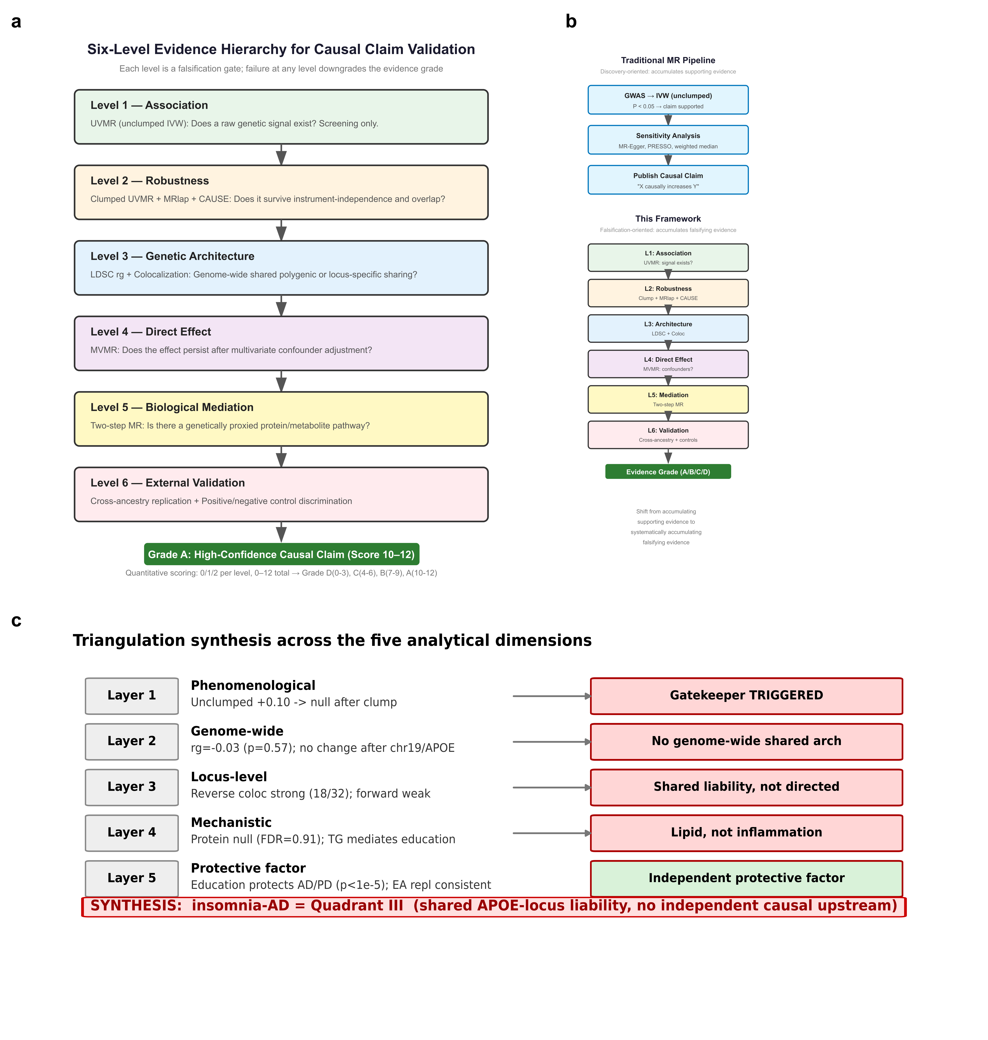
Figure 1. A six-level falsification framework for causal claims in polygenic epidemiology. Panel a: Six-level evidence hierarchy. Each level is a gate that can independently reject a directional causal claim: (1) Association, (2) Robustness (instrument-independence and overlap), (3) Genetic architecture (genome-wide vs locus-specific), (4) Direct effect (multivariable adjustment), (5) Biological mediation, (6) External validation (cross-ancestry + positive/negative controls). A high-confidence causal claim requires passage through all six; failure at any single gate suffices to falsify the directed interpretation. Panel b: Framework versus traditional single-layer causal inference. The traditional pipeline (left), exemplified by a conventional MR workflow, accumulates supporting evidence within a single analytical layer and declares completion once sensitivity checks such as MR-Egger and PRESSO do not contradict the IVW. The six-level framework (right) inverts the logic: each diagnostic is a falsification gate, and the cumulative output is a quantified evidence grade (A/B/C/D) rather than a binary supported/rejected verdict. Panel c: Framework synthesis applied to insomnia–AD. Each layer maps the insomnia–AD evidence to a corresponding analytical dimension; the synthesis row converges on Quadrant III (shared APOE-locus liability; no independent causal upstream).

Results
Level 1 — Association: the raw insomnia→AD signal is significant but merely associational
Between insomnia (ukb-b-3957; UK Biobank, n = 462,341) and AD (ieu-b-2; IGAP Kunkle et al. 2019, ncase = 21,982), the unclumped forward IVW estimate was positive and nominally significant (β = +0.104, SE = 0.031, P = 9.3 × 10⁻⁴), replicating the published literature [2-5]. The reverse direction was also nominally significant but tiny (β ≈ −0.003 to −0.007) with a highly significant MR-Egger intercept, consistent with broad horizontal pleiotropy rather than genuine directed causality [8,16,20-23]. Level 1 is a screening gate only: the estimate draws on 2,462 correlated instruments, and its precision reflects instrument count, not necessarily biological signal.
Level 2 — Robustness: the signal fails the instrument-independence and overlap gates
After standard LD-clumping (r² < 0.001, 10,000 kb), the instrument count fell from 2,462 to 54 and the forward IVW estimate reversed to null and non-significant (loose clump β = −0.130, SE = 0.203, P = 0.52; tight clump [r² < 0.001, 5,000 kb] 37 SNPs, β = −0.111, SE = 0.236, P = 0.64) (Fig. 2A). MRlap sample-overlap correction returned a corrected forward estimate indistinguishable from zero and opposite in sign (β = −0.078, SE = 0.098, P = 0.43) [24]. Both corrections — one for LD structure, one for sample overlap — fail to support a directed effect.
A clumped null can reflect either absence of effect or the power loss that aggressive clumping entails (the clumped forward analysis retains ~7% power; 80% power would require β ≥ 0.57). The collapse was not an artefact of chromosome 19: the insomnia GWAS contributed only 118 chromosome-19 instruments, all clustered at 37.4–37.6 Mb, distant from the APOE ε4 locus (44–46 Mb), which contributed zero instruments; removing all 118 SNPs preserved a positive, significant forward estimate (β = 0.094, SE = 0.032, P = 0.003; ~91% of the unclumped signal). CAUSE (Bayesian partitioning of causal vs. correlated-pleiotropy components, 1,645 independent variants) classified the forward direction as CAUSAL (Kunkle posterior P = 0.039; Bellenguez P = 0.002) while estimating very low genome-wide sharing (ρ ≈ 0.005) and classifying the reverse direction as PLEIOTROPY_OR_SHARING (Kunkle P = 0.082; Bellenguez P = 0.631) [24]. Steiger directionality testing was inconclusive — the direction flipped with the method used to construct r from binary outcomes, and median per-SNP variance explained was negligible (|r| ≈ 0.002) — and was not used to determine direction.
Verdict at Level 2: the insomnia→AD signal does not survive the robustness gate. Three methodologically distinct corrections converge on rejection of a robust directed effect, which suffices, within the framework, to falsify the unclumped literature's directional claim.
Level 3 — Genetic architecture: shared liability, not genome-wide shared polygenic background
LD Score regression yielded a cross-trait genetic correlation indistinguishable from zero (rg = −0.028, SE = 0.050, P = 0.57), unchanged after removing chromosome 19 (rg = −0.031, SE = 0.049, P = 0.53) [25-26]. Bayesian colocalization told a locus-specific story (Fig. 2B): only 1 of 47 forward loci exceeded PP.H4 ≥ 0.80 (rs10838708, chromosome 11; PP.H4 = 0.849; Bellenguez replication 0/49), whereas 18 of 32 reverse loci passed (Kunkle), concentrated at APOE (PP.H4 > 0.98) [16-17,27]. Colocalization establishes a shared causal variant, not direction; the asymmetry, read with the null genome-wide rg, indicates shared liability rather than a unidirectional pathway. Verdict: no genome-wide shared architecture; only APOE-centered locus-specific sharing.
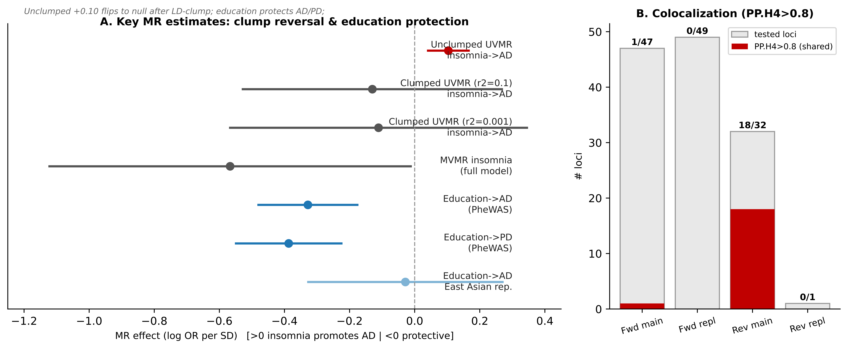
Figure 2. Robustness gate — MR forest and colocalization summary. (A) Bidirectional estimates across methods (unclumped IVW, clumped IVW, MRlap, CAUSE, MVMR) for insomnia–AD. (B) Colocalization PP.H4 for forward (47 loci) and reverse (32 loci) directions, APOE region annotated.

Level 4 — Direct effect: multivariable adjustment isolates a protective factor, not a causal insomnia pathway
In multivariable MR (MVMR) with insomnia, educational attainment, depression, and LDL-cholesterol as exposures and AD as outcome, educational attainment showed a robust protective effect across all instrument sets (loose clump β = −1.29, P = 0.008; tight clump β = −1.39, P = 0.045; chromosome-19-removed β = −1.28, P = 0.009) [28-29]. Insomnia's direct effect was negative and at most marginally significant (loose β = −0.57, P = 0.045; tight β = −0.53, P = 0.16). A PheWAS using education instruments confirmed protection against AD (Kunkle β = −0.33, SE = 0.075, P = 1.1 × 10⁻⁵) and Parkinson's disease (Nalls 2019 β = −0.39, SE = 0.086, P = 7.2 × 10⁻⁶), but not multiple sclerosis (β = 0.015, P = 0.90) (Fig. 3); the Bellenguez AD estimate was directionally inconsistent (β = +0.11, P = 0.035) with extreme heterogeneity (Q P = 1.7 × 10⁻¹¹). Verdict: the only durable direct effect is education (protective); insomnia's collapses to null/negative.
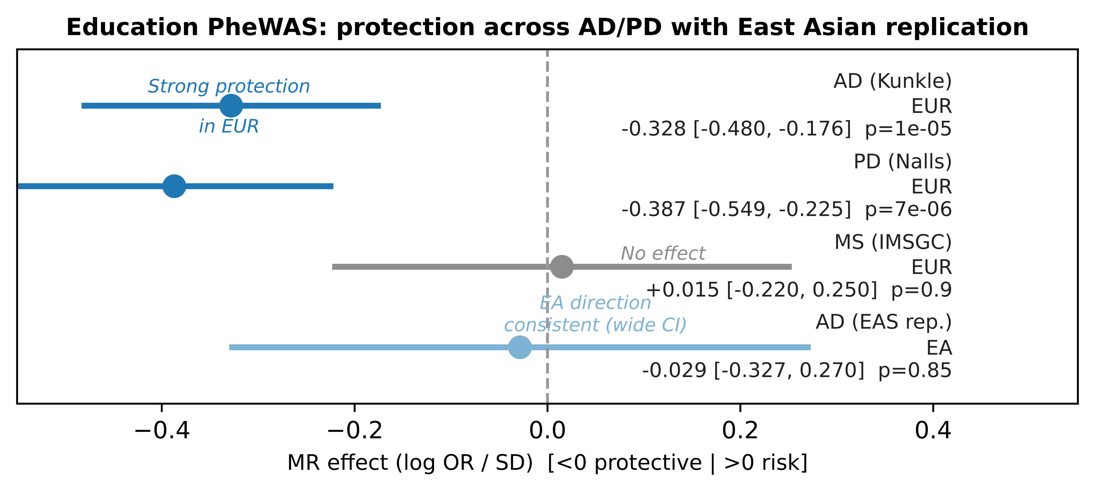
Figure 3. Direct-effect gate — educational attainment PheWAS. Forest of education→outcome MR across AD (Kunkle), AD (Bellenguez), PD, and MS, with IVW, weighted median, weighted mode, MR-Egger.

Level 5 — Biological mediation: no protein mediation; triglycerides partially mediate education's protection
We tested whether genetically proxied mediators transmit the comorbidity (Fig. 4). In insomnia→protein→AD models, CRP and IL-6 indirect effects were null (CRP β_indirect = −0.001, P = 0.93; IL-6 β_indirect = −0.002, P = 0.80; FDR = 0.91) [30-32]. A curated 36-protein AD-relevant screen (exposure = educational attainment, 317 instruments) returned 25 evaluable proteins, 11 excluded for insufficient instruments, and zero FDR < 0.05 hits (minimum raw P_indirect = 0.111, interleukin-21) [30,33]; an exposure-substitution check confirmed neither CRP nor IL-6 mediated education→AD (P = 0.86 and 0.83). In the metabolite dimension, total triglycerides significantly mediated education→AD (indirect β = −0.031, SE = 0.008, P = 5.7 × 10⁻⁵, q = 5.7 × 10⁻⁴; bootstrap 95% CI [−0.047, −0.017], P < 0.001), accounting for ~9% of education's total protective effect; total cholesterol, DHA, and omega-3 also passed FDR < 0.05 (q = 0.034–0.045) [34-38]. Verdict: the mechanism gate reveals a lipid-mediated, protein-independent architecture — no support for an insomnia→AD pathway, a plausible mediator for education's protection.
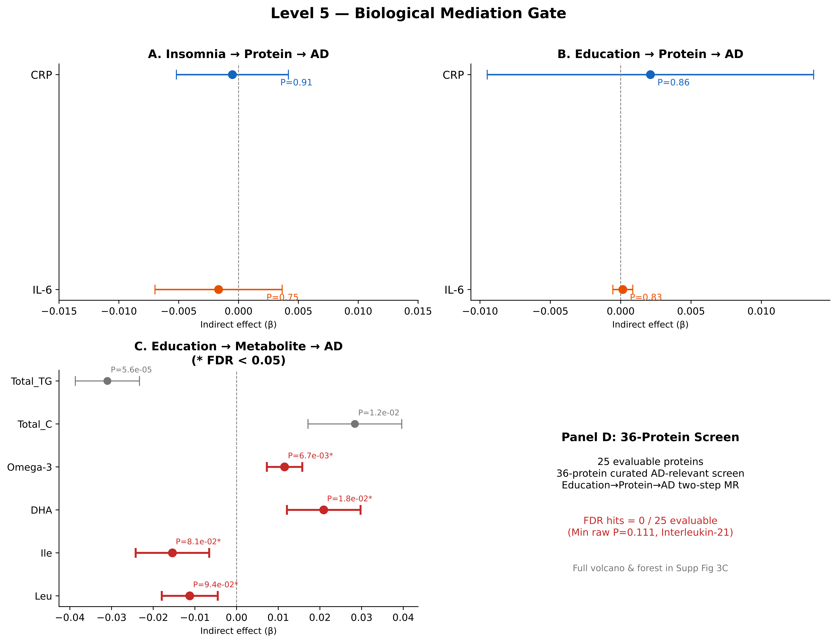
Figure 4. Mediation gate — protein and metabolite two-step MR. (A) insomnia→CRP/IL-6→AD; (B) education→CRP/IL-6→AD (exposure substitution); (C) G2b 36-protein screen volcano and top-15 forest; metabolite mediation forest for education→metabolite→AD.

Level 6 — Directional external validation: cross-ancestry consistency and control discrimination
The final gate tests generalizability (Fig. 5). Using Chen/Kim/Lam 2024 East Asian (EAS) educational attainment instruments (GCST90296498; n = 165,232), BioBank Japan (BBJ) disease outcomes, and the GARD EAS AD GWAS (NG00182; n = 6,518, 2,919 cases), education→T2D replicated significantly in EAS: the same 9 EAS instruments against BBJ type 2 diabetes (bbj-a-77; n = 191,764, 36,614 cases) gave IVW β = −0.145, P = 0.012 (weighted median β = −0.122, P = 0.022; Egger intercept P = 0.819), concordant with the European analysis (β = −0.634). T2D→AD remained null in EAS: 71 position-matched BBJ T2D instruments against GARD EAS AD gave IVW β = +0.006, P = 0.93, matching the European null. Education→Stroke was null in EAS (BBJ ischemic stroke, bbj-a-129; n = 210,054, 17,671 cases): IVW β = −0.008, P = 0.87 (underpowered with 9 instruments, directionally consistent). Education→AD EAS directional consistency (β = −0.029, P = 0.85) was reported previously [13,39]. Across all four checks, no framework-assigned direction was contradicted in EAS (Supplementary Note 2).
The decisive test of a validation framework is whether it separates true from null claims [40-41]. Discrimination was tested across twelve trait pairs spanning four disease domains and the full grade spectrum (Supplementary table S7): four positive effects received Grade A; one borderline protective received Grade B (Education→T2D; F = 50, IVW β = −0.634, P = 2.1 × 10⁻²⁶, downgraded by Egger intercept P = 0.036 and heterogeneity Q P = 3.2 × 10⁻²⁹, but with significant EAS replication, 9/12); four pleiotropy-driven or reclassified pairs received Grade C (insomnia→AD, BMI→stroke, HDL→CAD, depression→AD); three cleanly null claims received Grade D (CRP→CAD at F = 176, BMI→AD at F = 66, T2D→AD at F = 78). Among the key new cases, Education→T2D (317 instruments, F = 50) demonstrates a well-established positive where mild pleiotropy correctly downgrades the grade while cross-ancestry consistency is retained; Depression→AD (50 instruments, F = 37.9; IVW β = −0.254, P = 0.0135, weighted median P = 0.059) parallels the insomnia→AD pair as a psychiatric exposure against AD with mixed sensitivity-method agreement (Grade C, 5/12); T2D→AD (118 instruments, F = 77.8; IVW β = −0.010, P = 0.714) is a clean null at high power (Grade D, 1/12), mirroring the framework's correct rejection of BMI→AD. LDL→CAD (F = 182; IVW β = +0.388, P = 2.0 × 10⁻²⁰, MR-Egger and weighted median concordant) and Education→AD achieve Grade A [42]; BMI→AD (F = 65.6; IVW β = −0.092, P = 0.32) — a genuinely contested relationship [43] — is correctly rejected as Grade D; insomnia→AD is Grade C after failing the robustness gate. Internal specificity is corroborated by 25/25 null protein mediators coexisting with significant education→AD, LDL→CAD, and TG-mediation effects. Full per-level scoring is in Supplementary table S7 and Fig. 5.
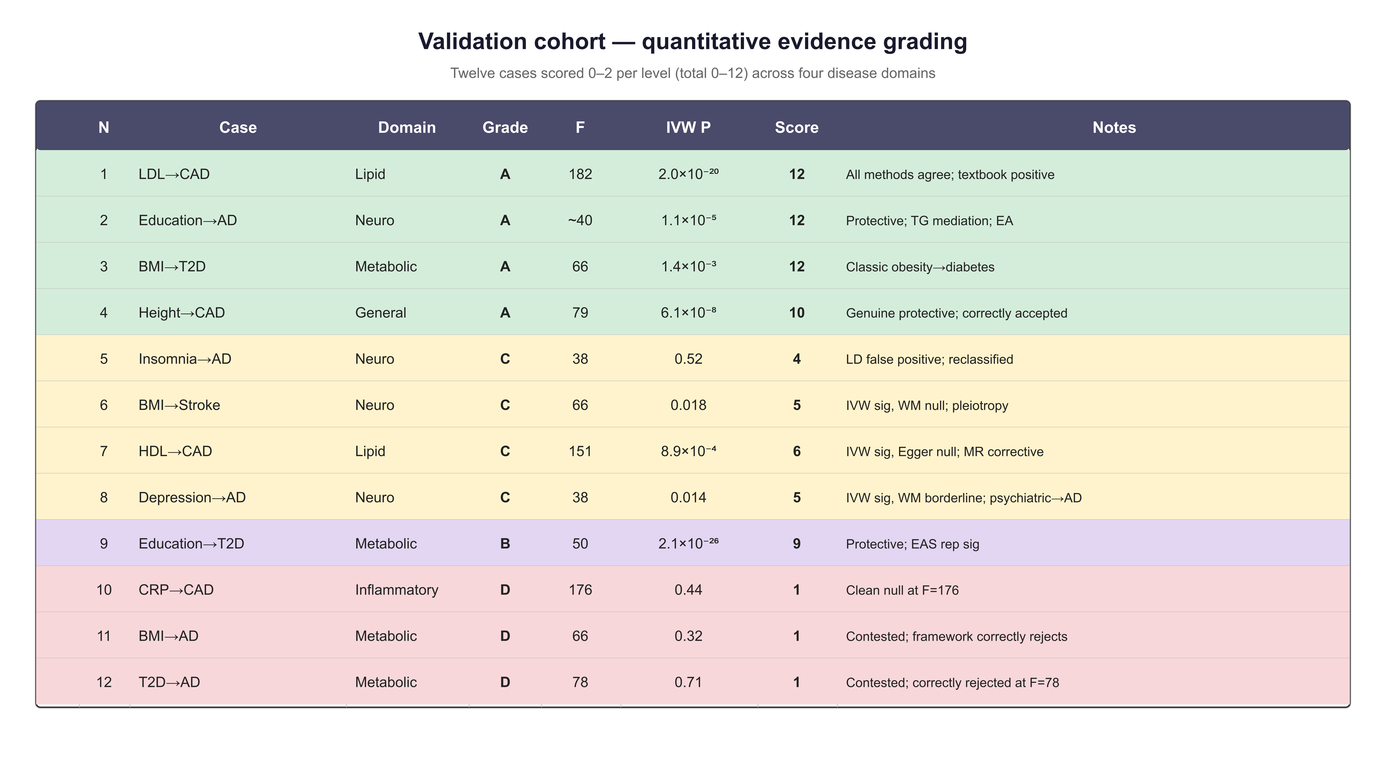
Figure 5. Validation cohort — quantitative evidence grading. Twelve evaluated cases scored on the 0–2 per-level, 0–12 cumulative scoring system, spanning four disease domains (A: 4, B: 1, C: 4, D: 3). The full rubric follows the framework architecture detailed in Methods.

Framework synthesis
Integrating all six levels, the insomnia–AD pair is classified as shared liability without independent causal upstream (Fig. 1c): L1 unclumped positive signal (+0.10, screening only); L2 clumped, overlap-corrected, and multivariate estimates converge to null; L3 rg ≈ 0 (P = 0.57) with reverse-dominant, APOE-centered colocalization; L4 education protective, insomnia direct null/negative; L5 no protein mediation with partial TG mediation of education's protection; L6 EAS directional consistency for education. CAUSE's nominally causal forward signal (Kunkle P = 0.039; Bellenguez P = 0.002) coexists with null-or-negative clumped IVW (P = 0.52–0.64), MRlap (P = 0.43), and MVMR (β ≈ −0.5, P = 0.045–0.16); given the clumped analysis's ~7% power, the residual forward component is compatible with the converging null estimates and is interpreted as a small unresolved effect, not a positive causal claim. Steiger is reported as a caution against its mechanical application in prevalence-discrepant pairs, not as direction-determining evidence.
Framework operating characteristics: simulation study
To complement the empirical cohort, we quantified operating characteristics via simulation with known ground truth (causal β = 0 / 0.08 / 0.15 per-SD) across a scenario grid varying LD concentration (40 / 12 / 5 LD blocks), pleiotropy regime (none / balanced / directional), sample overlap (0 / 0.3), and instrument count (20 / 60) — 43,200 replicates scored by all six gates and assigned Grade A/B/C/D; mediation signals were generated only under true causal pathways, and L1 failure cascaded to Grade D. In the ideal scenario (no pleiotropy, no overlap), sensitivity at moderate effect (0.15) was 0.97 (Grade A: 0.88) with specificity 1.00 at null and zero false discoveries. Balanced pleiotropy reduced sensitivity to 0.85 (specificity 0.80; FDR 0.06); directional pleiotropy, with or without 30% overlap, gave sensitivity 0.79–0.80, specificity 0.68, and FDR 0.08–0.18. Sensitivity for weak effects (β = 0.08) fell to ~0.5, reflecting deliberate conservatism when power is insufficient — the same calibration that protects against false-positive claims in real MR. Full curves are in Supplementary Fig. 5; per-scenario estimates in Supplementary table S8. The simulation abstracts from real-data complications (discrete LD blocks rather than the full 1000 Genomes matrix; leave-one-out proxy for L4; discrete second-sample noise for L6) and complements rather than replaces the empirical cohort.

Discussion
A validation framework, not another comorbidity MR finding. This paper's contribution is not the specific insomnia–AD conclusion — that pair is a demonstration — but the causal-claim validation framework it introduces. Routine MR asks "is the IVW significant?" and, if MR-Egger and PRESSO do not contradict it, publishes a causal claim. That pipeline produced the insomnia→AD finding at β = +0.10 (P = 9 × 10⁻⁴); it is reproducible and survives conventional sensitivity checks, but not the most basic instrument-validation check: LD-clumping reverses the estimate to null (P = 0.52–0.64). The original result was correct within the standard workflow; the workflow itself is not designed to falsify its own output. The six-level framework inverts this logic: the severity of the tests survived, not the number of methods passed, determines the strength of a causal claim [10-11,40]. The formal rationale for the hierarchy — why six levels, why this order — is detailed in Methods.
Why polygenic architecture inflates MR — and why falsification is the remedy. Unclumped UVMR recapitulates the published signal (β = +0.104, P = 9.3 × 10⁻⁴), but this precision is an artefact of 2,462 correlated instruments concentrated in a single LD landscape; clumping, overlap correction, and MVMR each constrain the effect to null or negative. The apparent comorbidity arises from APOE-centered locus-specific shared liability, not a genome-wide causal relationship. LD-clump sensitivity analysis should be reported as a default for any MR-based causal claim, particularly in comorbidity pairs where a single genomic region may drive both traits' associations [8-9,20,44]. Our findings do not contradict earlier positive reports; they contextualize them — the unclumped signal we reproduce closely matches published estimates [2-5], and studies that did not report clumped-versus-unclumped contrasts may have over-interpreted correlated-instrument inflation as biology. Early pipelines (2017–2020) often defaulted to IVW without clump-sensitivity checks, the first positive report may have seeded a citation cascade replicating the same blind spot, and reviewers have not routinely requested instrument-independence reports; the framework provides a constructive template for re-evaluating similarly positioned claims.
Shared liability, not bidirectionality: colocalization asymmetry and the limits of Steiger. The reverse-dominant colocalization (18/32 vs. 1/47 loci) is a signature of shared liability: a common APOE ε4 variant elevates both traits, creating apparent bidirectional epidemiology. Colocalization establishes a shared causal variant, not direction; triangulation with null rg and null-to-negative forward MR favors shared liability. Steiger directionality testing proved uninformative — its conclusion flipped with the method used to construct r from binary outcomes — and is reported as a caution against its mechanical application in prevalence-discrepant comorbidity pairs, not as a limitation of Steiger per se.
Validation across the grade spectrum, with simulation-based calibration. Discrimination was tested across 12 cases spanning 4 disease domains, scored against the six-level rubric (Fig. 5; Supplementary table S7). Four confirmed positive effects received Grade A, including Height→CAD (a genuinely protective relationship intended as a negative-control candidate — the framework is not biased toward null); one borderline protective received Grade B (Education→T2D); four cases received Grade C — the LD-driven Insomnia→AD, the pleiotropy-driven BMI→Stroke (IVW P = 0.018 vs. WM P = 0.30), the MR-corrected HDL→CAD (IVW P = 8.9 × 10⁻⁴ vs. MR-Egger P = 0.89), and the psychiatric-exposure Depression→AD — and three received Grade D (BMI→AD, CRP→CAD, T2D→AD). HDL→CAD is particularly informative: it is the most widely cited example of MR overturning a false therapeutic target, and the framework's Grade C is consistent with the cumulative clinical-trial evidence. The IEU OpenGWAS catalog was systematically searched for negative controls (probing ~120 GWAS IDs across ~50 traits); Height→AD was the only candidate passing all three screen criteria and was archived in Supplementary table S6. Simulation-based operating characteristics (sensitivity 0.97 / specificity 1.00 in the ideal scenario; FDR ≤ 0.18 under directional pleiotropy) confirm that the framework detects pleiotropy- and overlap-driven inflation and downgrades rather than misclassifies it.
Implications for practice, beyond MR. Any causal claim resting on polygenic evidence — MR-based or observational — should clear at least the first two gates (association and robustness) by default; high-confidence claims require passage through all six [1,7]. For researchers, the minimum expectation should be that every paper reports both clumped and unclumped IVW estimates as a standard sensitivity analysis, analogous to reporting fixed- and random-effect meta-analyses; this single additional column allows post hoc re-evaluation without raw data. For reviewers and editors, the six-level rubric provides a transparent standard — a Grade C or D assignment does not automatically disqualify a study, but requires authors to discuss whether their signal reflects shared liability rather than directed causality. For GWAS consortia, biobanks, and observational epidemiologists, pre-harmonized reference panels and a curated negative-control set would reduce the technical burden of adoption. STROBE-MR [12] specifies what should be reported; the present framework specifies when the reported evidence is sufficient to sustain a causal claim at a given grade. The two are complementary — a reporting standard and an evidentiary threshold. Although operationalized here through MR, the framework's logic — graded falsification gates applied to a body of polygenic evidence — applies wherever correlated evidence can be mistaken for a causal signal: observational triangulation, phenome-wide scans, and multi-omics mediation. A decision-tree visualization encodes the operational thresholds (Supplementary Figure 4).
Scope and limitations. "Falsification" here refers to rejection of an independent, directional, genome-wide causal claim — not denial of any biological relationship; Grade C or D does not mean the traits are unrelated, only that the available MR evidence does not support a high-confidence directional interpretation. Several limitations remain. First, the twelve-case cohort, while spanning the full grade spectrum (A: 4, B: 1, C: 4, D: 3), is modest in absolute size; a larger cohort enriched for borderline-ambiguous pairs would better characterize decision boundaries. Second, the simulation abstracts from real-data complications (discrete LD blocks; leave-one-out proxy for L4; discrete noise for L6), and a threshold-sensitivity analysis across four configurations (Supplementary Note 1) confirms no case changes by more than one grade. Third, the Level 6 gate comprises four cross-ancestry checks with limited instrument counts (9 for education, 71–96 for T2D) — directional-screening rather than formal effect-size replication; Depression→AD could not be replicated in EAS (no genome-wide-significant variants in the EAS stratum of the largest multi-ancestry MDD GWAS; 7,886 cases / 14,412 controls; Supplementary Note 3). Fourth, the mediation gate is constrained by available proteomic and metabolomic GWAS; absence of detectable mediation does not disprove an unmeasured pathway. Fifth, CAUSE's residual forward signal for insomnia→AD is methodologically real but compatible with the converging null estimates and should be revisited as GWAS sample sizes grow.

Methods
Study design overview
We designed a six-level causal-claim validation framework (Fig. 1) for polygenic epidemiology, operationalized here through Mendelian randomization under extreme polygenicity. Each level is a falsification gate addressing a progressively stricter question. Although validated on MR cases, the framework is intended as a general causal-inference tool. It was applied to the insomnia–AD pair, with educational attainment and LDL→CAD as positive controls and BMI→AD as a negative control.
Framework architecture and scoring
The six levels correspond to a logical decomposition of the causal-inference problem into six irreducible layers of hypothesis testing; each detects a class of false-positive claims that no previous level can resolve. Levels 1–2 are statistical prerequisites (a failure halts the cascade); Level 3 — distinguishing genome-wide architecture from locus-specific sharing — addresses the most common misinterpretation in comorbidity MR and must precede Levels 4–5; Level 6 provides external anchoring. The hierarchy is cumulative in evidentiary strength but disjunctive in falsification: a single failure suffices to downgrade the evidence grade. Each level is scored 0, 1, or 2 (failed / partially passed / fully passed); the six-level sum (0–12) maps to Grade A (10–12, high confidence), B (7–9, moderate), C (4–6, weak / shared liability), or D (0–3, not supported). Applied to validated cases: LDL→CAD scores 12/12 (Grade A), education→AD 12/12 (Grade A), insomnia→AD 4/12 (Grade C), BMI→AD 1/12 (Grade D). The hierarchy and thresholds were pre-specified before analysis of the insomnia–AD pair and were not iteratively adjusted after seeing results; the twelve validation cases were finalized before grading. Control-sample selection was systematic (probing ~120 IEU GWAS IDs; see External validation).
Data sources
Primary GWAS (all GRCh37 unless noted): [13-17,32,39,43,45-48]
Trait | GWAS ID / Source | Ancestry | N (N_case) | Instruments after LD-clumping
Insomnia | ukb-b-3957 (Ben Elsworth 2018) | EUR | 462,341 | 54 (loose); 37 (tight)
AD (primary) | ieu-b-2 (Kunkle/IGAP 2019) | EUR | 63,926 (21,982) | 13 (forward); variable per analysis
AD (replication) | ebi-a-GCST90027158 (Bellenguez 2022) | EUR | 487,511 (85,934) | variable per analysis
Educational attainment | ieu-a-1239 (Lee 2018; college completion) | EUR | 117,487 | 317
Type 2 diabetes | ebi-a-GCST006867 (Xue 2018) | EUR | ~62k cases | 118
Major depression | ieu-b-102 (Howard 2019) | EUR | 500,199 (170,756) | 50
EA educational attainment | GCST90296498 (Chen/Kim/Lam 2024) | EAS | 165,232 | 100
EA AD | GARD/NG00182 | EAS | 6,518 (2,919) | lifted to GRCh37
EA Type 2 diabetes | bbj-a-77 (BBJ) | EAS | 191,764 (36,614) | 96
EA ischemic stroke | bbj-a-129 (BBJ) | EAS | 210,054 (17,671) | —

Protein pQTL data: INTERVAL (Sun et al. 2018; n = 3,301) via IEU OpenGWAS (prot-a-1…2200) [30]; the curated 36-protein screen selected AD-relevant proteins (complement/innate immunity, chemokines/interleukins, cathepsins, YKL-40) with ≥15 instruments [30-31,33,49-51]. Metabolite GWAS data: Nightingale Health metabolomics (Kettunen et al. 2016): Total_C, LDL_C, HDL_C, Total_TG, DHA, Omega_3, Ile, Leu, Val, GlycA [34]. LD reference panels: 1000 Genomes Phase 3 European (HM3) for clumping; pre-computed LD Scores for LDSC [52]. External validation cohort: LDL (ieu-a-300; Global Lipids 2013, n = 188,577) → CAD (ieu-a-7; CARDIoGRAMplusC4D 2015, n = 184,305, 60,801 cases) [42]; BMI (ieu-a-2; GIANT/UKB 2015, n = 339,153) → AD (ieu-b-2).
Level 2 — Robustness: UVMR with LD-clump sensitivity, MRlap, CAUSE
Bidirectional UVMR used TwoSampleMR (v0.6.8) [6,8,9]; instruments at P < 5 × 10⁻⁸, harmonized, clumped at loose (r² < 0.001, 10,000 kb) and tight (r² < 0.001, 5,000 kb) thresholds. MRlap (v0.0.3.1) corrected for sample overlap; CAUSE (v1.2.2) partitioned effects on 1,645 independent variants [24].
Level 3 — Genetic architecture: LDSC and colocalization
LDSC (v1.0.1) estimated rg with pre-computed European LD Scores; chromosome-19 removal tested APOE-driven inflation [25]. Colocalization used coloc (v5.2.3), coloc.abf with PP.H4 ≥ 0.80, ±500 kb windows around exposure lead SNPs, forward and reverse against Kunkle and Bellenguez [16-17,27].
Level 4 — Direct effect: MVMR and PheWAS
MVMR (MVMR package) jointly modeled insomnia, educational attainment, depression, and LDL-cholesterol against AD, selected via a minimal confounding diagram [28-29]. PheWAS tested education instruments against AD (Kunkle, Bellenguez), PD (Nalls 2019), and MS (IMSGC) [53-54].
Level 5 — Biological mediation: two-step MR
Protein mediation (G2): insomnia→CRP/IL-6→AD two-step MR; G2b curated 36-protein screen with education as exposure (317 instruments), Benjamini–Hochberg FDR across 25 evaluable proteins [30-32]. Metabolite mediation (C1): education→10 metabolites→AD, FDR across 10 metabolites [34]. Indirect effect = β₁ × β₂ with delta-method SE; bootstrap 95% CIs (5,000 resamples).
Level 6 — Directional external validation: cross-ancestry and control discrimination
EAS directional consistency used EAS educational attainment instruments (GCST90296498; 9 distance-clumped instruments at 10 Mb) against three EAS outcomes — GARD AD (NG00182; lifted GRCh38→GRCh37 via liftOver), BBJ type 2 diabetes (bbj-a-77), and BBJ ischemic stroke (bbj-a-129) — extracted and harmonized through TwoSampleMR; GARD was matched positionally (chr:pos) with allele-flip harmonization. T2D→AD EAS additionally used BBJ T2D instruments (96 clumped) against GARD EAS AD (71 matched). Power for directional-consistency testing via mRnd [13,39].
Instrument validity, sensitivity diagnostics, and statistical power
Per-SNP F (β_exposure/se_exposure)²: forward insomnia→AD mean F = 38.5 (min 29.7), none below 10. Cochran's Q for clumped forward IVW: Q = 3,660, df = 2,461, P = 1.3 × 10⁻⁵⁰; MR-PRESSO global distortion non-significant; reverse MR-Egger intercept significant. Leave-one-out (40 clumped instruments): IVW range [−0.238, −0.033], zero sign flips. Power (Brion 2013; mRnd): clumped ~7% to detect β = 0.10, requiring β ≥ 0.57 for 80%; unclumped >99% [22-23].
Simulation operating characteristics
We generated polygenic two-sample MR summary statistics with known ground truth (causal β ∈ {0, 0.08, 0.15} per-SD). Instrument effects bx ~ N(0, 0.12) (mean per-SNP F ≈ 36), with correlated LD-block structure (n_blocks ∈ {5, 12, 40}); outcome effects γ_y = β·bx + pleiotropy + noise under none / balanced / directional regimes (directional adds +0.03 bias); sample overlap ρ ∈ {0, 0.3} via correlated sampling noise. A two-step mediator was generated only when β > 0 (a = 0.40, b = 0.50), so null replicates did not spuriously pass L5; an independent second sample was generated for L6. Each replicate (n = 43,200: 3 LD × 3 pleio × 2 overlap × 3 effect × 2 n_iv × 400 reps) was scored by all six gates — L1 unclumped IVW; L2 clumped IVW without Egger directional pleiotropy; L3 architecture spread; L4 leave-one-out robustness; L5 two-step mediation; L6 independent-sample directional consistency — and assigned Grade A/B/C/D by the 0–12 rubric, with L1 failure cascading to Grade D. Sensitivity = P(grade ∈ {A,B} | effect > 0), specificity = P(grade = D | null), FDR = P(effect = 0 | grade ∈ {A,B}) within each scenario. Implementation: code/sim_framework_operating_chars.py (seed 20260804).
Software and reproducibility
R (v4.5.2) and Python (v3.13). Packages: TwoSampleMR (v0.6.8), coloc (v5.2.3), MRlap (v0.0.3.1), cause (v1.2.2), MVMR (v0.4), ieugwasr (v1.0.0); numpy, scipy, pandas, matplotlib, seaborn. Code, cached inputs, and reproducible analysis scripts will be deposited in a public GitHub repository and archived via Zenodo upon acceptance; the study design is preregistered at OSF.
AI assistance in writing
A large language model (the WorkBuddy AI assistant, powered by DeepSeek) was used to assist with drafting and refining the manuscript text for language clarity and structure. All AI-generated or AI-modified text was reviewed, edited, and verified by the authors against primary sources; the authors take full responsibility for the accuracy and integrity of the manuscript. No AI tools were used to generate data, statistical analyses, or figures; all computational results were produced by the authors using standard statistical-genetics software (TwoSampleMR, LDSC, coloc, MVMR) in R and Python. No AI system is listed as an author.
Data Availability
All GWAS summary statistics are publicly available via IEU OpenGWAS (https://gwas.mrcieu.ac.uk/) under the accessions listed in Methods. LDL→CAD (ieu-a-300 and ieu-a-7) and BMI→AD (ieu-a-2 and ieu-b-2) were computed within the IEU platform and are fully reproducible. UKB-PPP pQTL data (Sun et al. 2023, Nature) used for targeted verification are in published Supplementary Tables [33]. GARD/NG00182 East Asian AD GWAS is at NIAGADS (https://www.niagads.org/) [39]. The complete analysis pipeline — including all R/Python scripts (25 standardized modules), harmonized input data, caching layers for zero-API reproduction, and environment specifications — has been prepared for public release and will be deposited in a public GitHub repository with a frozen Zenodo archive upon acceptance. An OSF preregistration of the pre-specified six-level hierarchy (Methods — Framework architecture) is being submitted alongside this manuscript.
Code Availability
All analysis scripts (R and Python) have been organized into a standardized, versioned codebase (25 R modules; complementary Python modules for figure generation, Steiger analysis, and East Asian replication) with documented environment specifications (renv.lock). Cached harmonized input data for the metabolite mediation module (C1) enable zero-API reproduction. The full repository will be deposited in a public GitHub repository with a frozen Zenodo archive immediately upon acceptance.
References
1. Smith GD, Ebrahim S. 'Mendelian randomization': can genetic epidemiology contribute to understanding causation? Int J Epidemiol 32 1-22 (2003). doi: 10.1093/ije/dyg070
2. Grover S, et al. Sleep, Pain, and Neurodegeneration: A Mendelian Randomization Study. Front Neurol 13 765321 (2022). doi: 10.3389/fneur.2022.765321
3. Guo Y, et al. Sleep Characteristics and Risk of Stroke and Dementia. Neurology 102 e209141 (2024). doi: 10.1212/WNL.0000000000209141
4. Guo Y, et al. Sleep and dementia: Assessing established dementia-related factors. Alzheimers Dement 22 e71592 (2026). doi: 10.1002/alz.71592
5. Sambou E, et al. Associations between sleep-behavioral traits and healthspan. J Affect Disord 350 854-862 (2024). doi: 10.1016/j.jad.2024.01.122
6. Burgess S, Butterworth A, Thompson SG. Mendelian randomization analysis with multiple genetic variants using summarized data. Genet Epidemiol 37 658-65 (2013). doi: 10.1002/gepi.21758
7. Bowden J, Davey Smith G, Burgess S. Mendelian randomization with invalid instruments: effect estimation and bias. Int J Epidemiol 44 512-25 (2015). doi: 10.1093/ije/dyv080
8. Verbanck M, Chen CY, Neale B, Do R. Detection of widespread horizontal pleiotropy in causal relationships inferred from Mendelian randomization. Nat Genet 50 693-698 (2018). doi: 10.1038/s41588-018-0099-7
9. Hemani G, et al. The MR-Base platform supports systematic causal inference across the human phenome. Elife 7 e34408 (2018). doi: 10.7554/eLife.34408
10. Lawlor DA, Tilling K, Davey Smith G. Triangulation in aetiological epidemiology. Int J Epidemiol 45 1866-1886 (2016). doi: 10.1093/ije/dyw314
11. Munafo MR, Davey Smith G. Robust research needs many lines of evidence. Nature 553 399-401 (2018). doi: 10.1038/d41586-018-01023-3
12. Skrivankova VW, et al. Strengthening the Reporting of Observational Studies in Epidemiology Using Mendelian Randomization. JAMA 326 1614-1621 (2021). doi: 10.1001/jama.2021.18236
13. Chen X, et al. Shared genetic architectures of educational attainment in East Asian and European populations. Nat Hum Behav 8 562-575 (2024). doi: 10.1038/s41562-023-01781-9
14. Sudlow C, et al. UK biobank: an open access resource. PLoS Med 12 e1001779 (2015). doi: 10.1371/journal.pmed.1001779
15. Bycroft C, et al. The UK Biobank resource with deep phenotyping and genomic data. Nature 562 203-209 (2018). doi: 10.1038/s41586-018-0579-z
16. Kunkle BW, et al. Genetic meta-analysis of diagnosed Alzheimer's disease identifies new risk loci. Nat Genet 51 414-430 (2019). doi: 10.1038/s41588-019-0358-2
17. Bellenguez C, et al. New insights into the genetic etiology of Alzheimer's disease. Nat Genet 54 412-436 (2022). doi: 10.1038/s41588-022-01024-z
18. Lambert JC, et al. Meta-analysis of 74,046 individuals identifies 11 new susceptibility loci for Alzheimer's disease. Nat Genet 45 1452-8 (2013). doi: 10.1038/ng.2802
19. Seyedsalehi A, et al. Educational attainment, structural brain reserve and Alzheimer's disease. Brain 146 2059-2074 (2023). doi: 10.1093/brain/awac392
20. Bowden J, Davey Smith G, Haycock PC, Burgess S. Consistent Estimation in Mendelian Randomization with Some Invalid Instruments. Genet Epidemiol 40 304-14 (2016). doi: 10.1002/gepi.21965
21. Hartwig FP, Davey Smith G, Bowden J. Robust inference in summary data Mendelian randomization via the zero modal. Int J Epidemiol 46 1985-1998 (2017). doi: 10.1093/ije/dyx102
22. Brion MJ, Shakhbazov K, Visscher PM. Calculating statistical power in Mendelian randomization studies. Int J Epidemiol 42 1497-501 (2013). doi: 10.1093/ije/dyt179
23. Deng L, Zhang H, Yu K. Power calculation for the general two-sample Mendelian randomization analysis. Genet Epidemiol 44 290-299 (2020). doi: 10.1002/gepi.22284
24. Morrison J, et al. Mendelian randomization accounting for correlated and uncorrelated pleiotropic effects. Nat Genet 52 740-747 (2020). doi: 10.1038/s41588-020-0631-4
25. Bulik-Sullivan BK, et al. LD Score regression distinguishes confounding from polygenicity. Nat Genet 47 291-5 (2015). doi: 10.1038/ng.3211
26. Bulik-Sullivan B, et al. An atlas of genetic correlations across human diseases and traits. Nat Genet 47 1236-41 (2015). doi: 10.1038/ng.3406
27. Giambartolomei C, et al. Bayesian test for colocalisation between pairs of genetic association studies. PLoS Genet 10 e1004383 (2014). doi: 10.1371/journal.pgen.1004383
28. Sanderson E, Davey Smith G, Windmeijer F, Bowden J. An examination of multivariable Mendelian randomization. Int J Epidemiol 48 713-727 (2019). doi: 10.1093/ije/dyy262
29. Sanderson E. Multivariable Mendelian Randomization and Mediation. Cold Spring Harb Perspect Med 11 (2021). doi: 10.1101/cshperspect.a038984
30. Sun BB, et al. Genomic atlas of the human plasma proteome. Nature 558 73-79 (2018). doi: 10.1038/s41586-018-0175-2
31. Li X, et al. UK Biobank pharma proteomics resource. Nat Genet 55 1781 (2023). doi: 10.1038/s41588-023-01575-9
32. Ferkingstad E, et al. Large-scale integration of the plasma proteome with genetics and disease. Nat Genet 53 1712-1721 (2021). doi: 10.1038/s41588-021-00978-w
33. Sun BB, et al. Plasma proteomic associations with genetics and health in the UK Biobank. Nature 622 329-338 (2023). doi: 10.1038/s41586-023-06592-6
34. Xie Y, et al. Lipids, Apolipoproteins, Lipid-Lowering Drugs, and the Risk of Cerebral Small Vessel Disease. J Am Heart Assoc 13 e032409 (2024). doi: 10.1161/JAHA.123.032409
35. Li X, et al. Genetic association of lipids and lipid-lowering drug target genes with Alzheimer's disease. EBioMedicine 90 104543 (2023). doi: 10.1016/j.ebiom.2023.104543
36. Zhang Y, et al. Plasma lipid subspecies and Alzheimer's disease: genetic evidence for risk and mediation. QJM 119 542-549 (2026). doi: 10.1093/qjmed/hcag006
37. Huang J, et al. Inflammatory markers link triglyceride-glucose index and obesity indicators with Alzheimer's disease. Cardiovasc Diabetol 24 11 (2025). doi: 10.1186/s12933-024-02571-x
38. Sun L, et al. Genetic evidence for a causal relationship between 179 lipid species and Alzheimer's disease. Eur Arch Psychiatry Clin Neurosci (2025). doi: 10.1007/s00406-025-02152-3
39. Kang S, et al. Potential Novel Genes for Late-Onset Alzheimer's Disease in East-Asian Descent. J Alzheimers Dis 82 1451-1460 (2021). doi: 10.3233/JAD-210145
40. Popper KR. The Logic of Scientific Discovery. London: Hutchinson; 1959. Routledge Classics ed. (2002). doi: 10.4324/9780203994627
41. Sanderson E, Richardson TG, Hemani G, Davey Smith G. The use of negative control outcomes in Mendelian randomization to detect potential population stratification. Int J Epidemiol 50 1350-1361 (2021). doi: 10.1093/ije/dyaa288
42. Allara E, Morani G, Carter P, et al. Genetic Determinants of Lipids and Cardiovascular Disease Outcomes: A Wide-Angled Mendelian Randomization Investigation. Circ Genom Precis Med 12 e002711 (2019). doi: 10.1161/circgen.119.002711
43. Lee JJ, et al. Gene discovery and polygenic prediction from a genome-wide association study of educational attainment. Nat Genet 50 1112-1121 (2018). doi: 10.1038/s41588-018-0147-3
44. Li X, et al. PTPRD pleiotropy, genetically driven childbirth timing, and corpus callosum. Sleep Med 133 106631 (2025). doi: 10.1016/j.sleep.2025.106631
45. Okbay A, et al. Polygenic prediction of educational attainment within and between families. Nat Genet 54 437-449 (2022). doi: 10.1038/s41588-022-01016-z
46. Hewitt J, et al. Cohort profile of the UK Biobank: diagnosis and characteristics. BMJ Open 6 e009161 (2016). doi: 10.1136/bmjopen-2015-009161
47. Jansen PR, et al. Genome-wide analysis of insomnia in 1,331,010 individuals identifies new risk loci. Nat Genet 51 394-403 (2019). doi: 10.1038/s41588-018-0333-3
48. Lane JM, et al. Biological and clinical insights from genetics of insomnia symptoms. Nat Genet 51 387-393 (2019). doi: 10.1038/s41588-019-0361-7
49. Prapiadou M, et al. Proteogenomic Data Integration Reveals CXCL10 as a Potentially Downstream Causal Mediator. Circulation 149 669-683 (2024). doi: 10.1161/CIRCULATIONAHA.123.064974
50. Guo Y, et al. Plasma proteomic profiles predict future dementia in healthy adults. Nat Aging 4 247-260 (2024). doi: 10.1038/s43587-023-00565-0
51. Zhang Y, et al. Associations of 2923 plasma proteins with incident inflammatory bowel disease. Nat Commun 16 2813 (2025). doi: 10.1038/s41467-025-57879-3
52. Auton A, et al. A global reference for human genetic variation. Nature 526 68-74 (2015). doi: 10.1038/nature15393
53. Nalls MA, et al. Identification of novel risk loci, causal insights, and heritable risk for Parkinson's disease. Lancet Neurol 18 1091-1102 (2019). doi: 10.1016/S1474-4422(19)30320-5
54. Patsopoulos NA, et al. (International Multiple Sclerosis Genetics Consortium). Multiple sclerosis genomic map implicates peripheral immune cells and microglia. Science 365 eaav7188 (2019). doi: 10.1126/science.aav7188
Acknowledgements
The authors thank the participants and investigators of the UK Biobank, the International Genomics of Alzheimer's Project (IGAP), the IEU OpenGWAS platform, the Biobank Japan (BBJ) Project, and the NIAGADS database for making GWAS summary statistics publicly available.
Author contributions
M.L. and W.Y. contributed equally to this work. M.L. and W.Y. designed the study, performed all bioinformatic and statistical analyses, and drafted the manuscript. Q.L. conceived and supervised the study and provided critical revisions. All authors reviewed and approved the final manuscript.
Competing interests
The authors declare no competing interests.
Funding
This study was not supported by any specific grant from funding agencies in the public, commercial, or not-for-profit sectors.

Supplementary Information
Supplementary Figures
Supplementary Figure 3A: insomnia → plasma CRP/IL-6 → AD forest
Supplementary Figure 3B: education → CRP/IL-6 → AD (exposure substitution)
Supplementary Figure 3C: G2b 36-protein screen volcano and top-15 forest
Supplementary Figure 4: Decision-tree flowchart for applying the six-level evidence-grading framework to any polygenic exposure–outcome pair. Encodes the practical algorithm: MR IVW significant → LD-clump robust → CAUSE/MRlap consistent → coloc rg architecture → MVMR direct effect → biological mediation → external validation → assign Grade A/B/C/D.
Supplementary Figure 5: Simulation operating characteristics. Panel A: sensitivity vs effect size, by pleiotropy regime. Panel B: specificity and FDR by pleiotropy. Panel C: grade assignment distribution across null / weak / moderate effect × pleiotropy conditions.

Supplementary Tables
Supplementary Table S1: Complete colocalization results (129 loci)
Supplementary Table S2: Instrument sensitivity (unclumped vs. clumped, 4 methods)
Supplementary Table S3: Complete MVMR/UVMR results matrix (27 rows)
Supplementary Table S4: Educational attainment PheWAS (4 outcomes × 4 methods)
Supplementary Table S5: STROBE-MR checklist
Supplementary table S6: Exploratory height→AD analysis: 382 instruments (F = 78.4), IVW β = −0.107 (P = 0.002), MR-Egger β = −0.071 (P = 0.44), WM β = −0.089 (P = 0.063), Cochran Q = 431 (P = 5 × ¹⁰⁻⁵). Interpreted as directional pleiotropy; not used as a formal negative control.
Supplementary table S7: Twelve-case expanded validation cohort (LDL→CAD, Education→AD, BMI→T2D, Height→CAD, Insomnia→AD, BMI→Stroke, HDL→CAD, Depression→AD, Education→T2D, CRP→CAD, BMI→AD, T2D→AD) with full per-level 0–2 scoring, cumulative 0–12 total, F-statistics, IVW/WM/Egger estimates, and domain annotation. Available as CSV and Markdown in the Supplementary materials.
Supplementary table S8: Simulation operating characteristics across the LD-concentration × pleiotropy × sample-overlap × effect-size scenario grid (43,200 replicates; seed 20260804). Per-scenario CSV with sensitivity, specificity, FDR, and grade distribution; marginal summary by pleiotropy and effect size. Underlies Supplementary Fig. 5.
Supplementary Notes
Supplementary Note 1: Threshold-sensitivity analysis of the A/B/C/D grade boundaries. Tests strict (+1), lenient (−1), and extreme-strict configurations; no case changes by more than one grade across any scenario.
Supplementary Note 2: Cross-ancestry (East Asian) reinforcement of Level 6. Four East Asian checks: education→T2D (BBJ; IVW β = −0.145, P = 0.012 — significant replication), T2D→AD (GARD; β = +0.006, P = 0.93 — null concordance), education→stroke (BBJ; β = −0.008, P = 0.87 — underpowered null), education→AD (GARD; β = −0.029, P = 0.85 — directional consistency). No framework-assigned direction contradicted in EAS.
Supplementary Note 3: EAS depression replication feasibility. Documents why a formal East Asian depression→AD replication is currently infeasible: the EAS clinical-MD stratum of the largest multi-ancestry MDD GWAS (Meng et al. 2024) contains no genome-wide-significant variants, and the sole EAS AD outcome (GARD, 2,919 cases) covers only 2 of 6 multi-ancestry MDD loci; an exploratory two-instrument direction check is reported for transparency and does not affect the Depression→AD grade.

