Michael Ing October 8, 2020

Hwk 2 – Viterbi and CKY

**2.1 – HMM Decoding**

The completed table of Viterbi probabilities is shown below, with v3(1) = 0.00288, and v3(2) = 0.012544. The corresponding table with ln-based calculations is shown beside it, with v3(1) = -5.84996 and   
v3(2) = -4.37852. The calculations for each are as follows:  
  
A. Normal probabilities:  
For v3(1), I computed $\max\left[\left(0.0448 * P\left(C | H\right)* P\left(C | 3\right)\right), \left(0.048*P\left(C | C\right)*P\left(C | 3\right)\right)\right]=\max\left[\left(0.0448*0.3*0.1\right), \left(0.048*0.6*0.1\right)\right]=0.00288$.   
Computing v3(2) was similar, as $\max\left[\left(0.0448 * P\left(H | H\right)* P\left(H | 3\right)\right), \left(0.048*P\left(H | C\right)*P\left(H | 3\right)\right)\right]=\max\left[\left(0.0448*0.7*0.4\right), \left(0.048*0.4*0.4\right)\right]=0.012544$.  
To compute the end probability, I simply took the max of the two v3 probabilities, as no probabilities for the end state were given. This led me to 0.012544.   
  
B. ln probabilities  
The ln probabilities were relatively simple to compute and track, as all probabilities P were replaced with ln(P) and all multiplications were replaced with additions. For example, v1(2) = 0.8 * 0.4 was replaced with v1(2) = ln(0.8) + ln(0.4) = -1.1394 = ln(0.32). This was repeated for all steps to get the probabilities shown in the table, with “MIN” representing a 0 probaility, culminating with   
v3(2) = ln(0.0448) + ln(0.7) + ln(0.4) = -4.37851 = ln(0.012544). Similarly, v3(end) was calculated by taking the max of the two v3 values.  
  
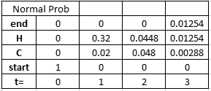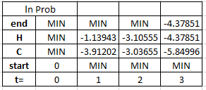  
  
The best path through the HMM that fits the data is: **start -> H -> H -> H -> end**. The backtraces would be drawn as follows:  
-Add a backtrace from end at t=3 to H at t=3.   
-Add a backtrace from H at t=3 to H at t=2.  
-Add a backtrace from C at t=3 to C at t=2.   
-The backtraces from the given diagram would also be included, from H and C at t=2 to H at t=1, and from H and C at t=1 to start at t=0.