M005 I2C Driver Design report

=======================================================================
Last Update | 2008/01/24
Version | REV_00.01
Designer | E230/Betta Lin

Revision History

Version | Date | Owner | Summary
00.01 | 2008/01/24 | Betta | Initial contents

- Introduction
This document intoduce I2C drivers of Linux for MP553 on FPGA REVB. The version of U-boot is 1.1.5 and version of Linux Kernel is Monta Vista 4.0.1. Target functions include external PCM audio codec and external touch screen.
- Architecture

The following describe characteristic of I2C bus controller for MP553.
- The I2C interface for mp553 is used to configure external audio codec/touch screen. Different devices were connected on the same bus, distinguished by different device address. This I2C interface acts as a bus master and is fully programmable by the CPU.
- It supports 8bit and 16bit modes with or without device acknowledge check. It also supports break and continuous read. XX.o, the client device driver that responds to socket events like card insertion and ejection. This also configures the generic device driver (XX.o) with resources like IRQs, I/O base addresses, and memory windows.
- This module has 5 data write buffer, which can provide a fast continues write.

- i2c protocol diagram

Register write:
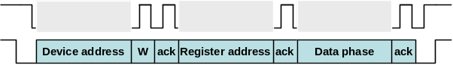

Continuous Register read:
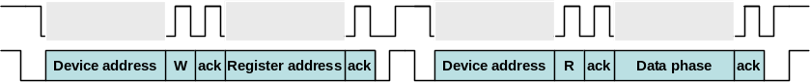

Break Register read:

Device address phase:
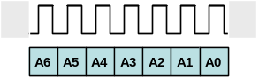

Register address phase:
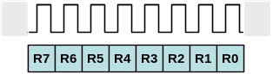

8bit Data phase:
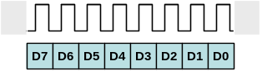

16bit Data phase:
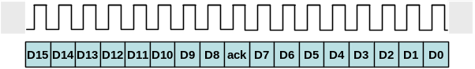
Figure 1-1 I2C Master timing

- Deployment
Souce code path:
(1) Include/asm-arm/arch-mp553/ mp553-i2.h in Linux kernel source code.
(2) arch/arm/mach-mp553/mp553-i2c.c in Linux kernel source code.

- function list
(1) mp553i2c_init() : Initialization of of driver. It will automatically be launched due to module_init (i2c_init) macro.
(2) mp553i2c_read(i2c_config_t info) : Read data by sending i2c command to i2c slave device such as touch screen.
(3) mp553i2c_write(i2c_config_t info) : Write data by sending i2c command to i2c slave device.

- Bugs History

- Reference
[1] “I2C_BUS_SPECIFICATION_3” .
[2] “MP553_DS_20_I2C”

