M005 SDIO Card Driver Design report

=======================================================================
Last Update | 2007/11/08
Version | REV_00.01
Designer | E230/Curtis Yang

Revision History

Version | Date | Owner | Summary
00.01 | 2007/11/08 | Curtis | Initial contents

- Introduction
This document describes the writing of SDIO Card drivers of Linux for MP553 on FPGA REVB. The version of U-boot is 1.1.5 and version of Linux Kernel is Monta Vista 4.0.1. Target functions include memory card and TV Tuner Card.
- Architecture

The following digram illustrates the device driver model of SDIO card adapted by Linux.
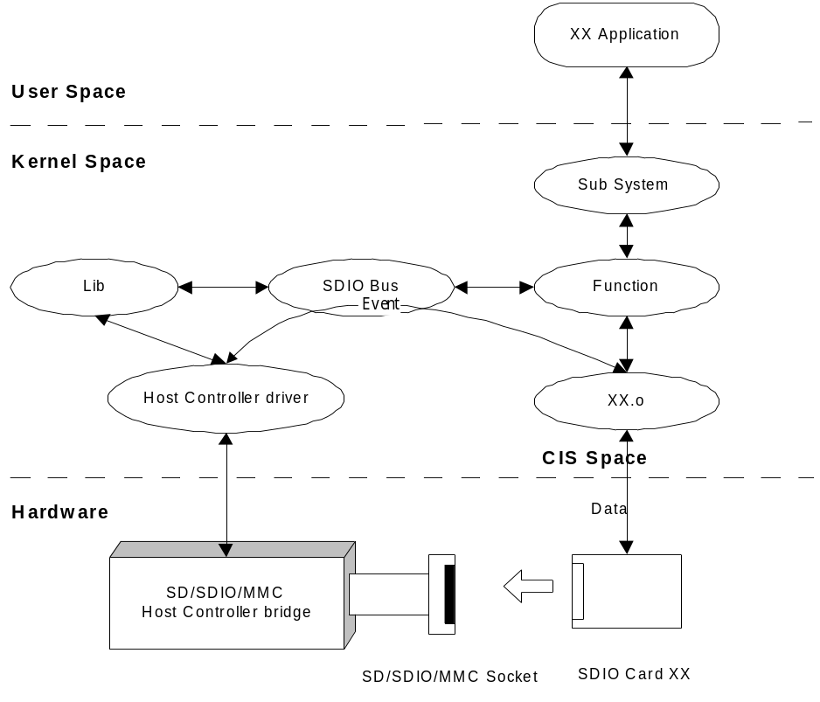

As shown in Figure One, the SDIO Linux layer consists of:
- In initialzing process, By setting the input bitfields, the device driver tells the other parts of the input systems what it is - what events can be generated or accepted by this input device.
- XX.o, the client device driver that responds to socket events like card insertion and ejection. This also configures the generic device driver (XX.o) with resources like IRQs, I/O base addresses, and memory windows.
- Lib module provides utilities to be used by Host Controller driver and Bus.
- The Function module implement the functionality supported by SDIO card on a conceptual level. It aims to separate sw functions from hw implement details.
- The Sub System Modules then provides the whole functionality/application to user space.
- XX Application called from user space tries to access the data of SDIO cards and uses the functionality of inserted SDIO card via the Sub System module.

- Functional Blocks
N/A
- Flow Chart

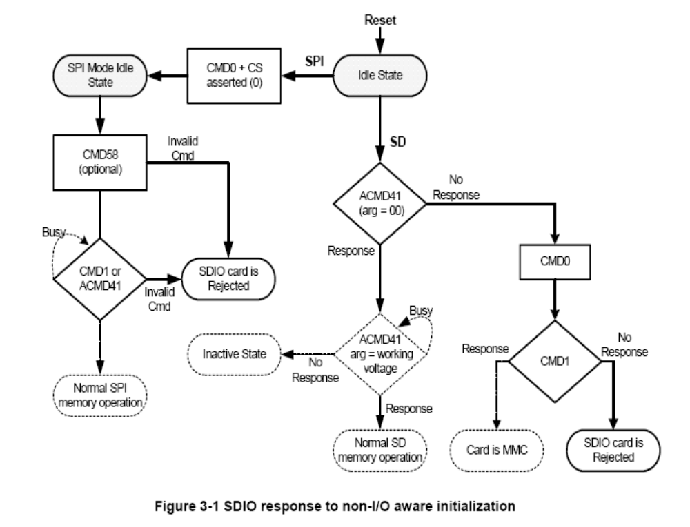
- Module A Functional Description

- Module B Functional Description

- Deployment
Source Files
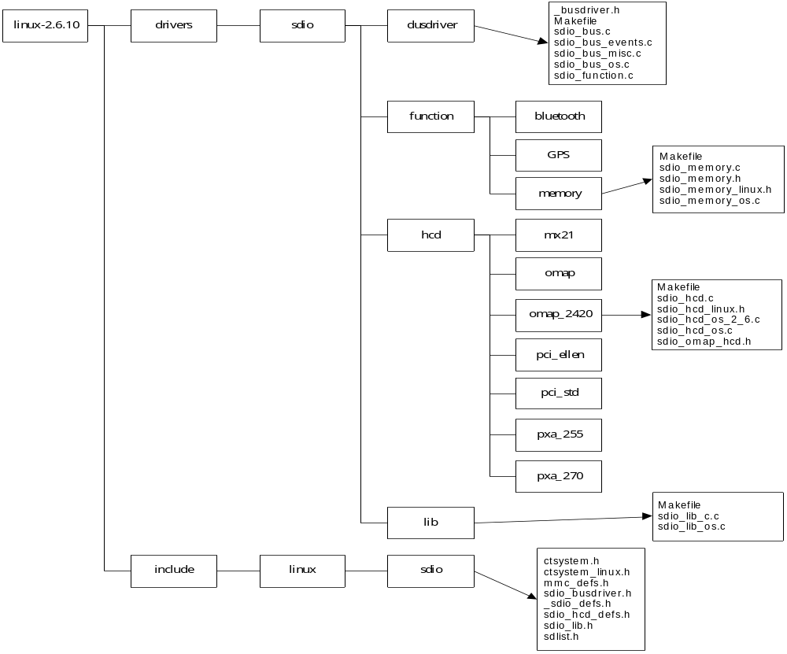
Binary Files
Build Environment and Procedure

- Testing

- Bugs History

- Reference
[1] SD Specifications, Part E1, SDIO Simplified Specification, Version 2.00, February 8 2007.
[2] PC CARD STANDARD, Volume 4, Metaformat Specification.

