- IIS-Bus Interface

26.1 Audio codec interface (I2S)

There are two Audio Codec Interface that handle the data transactions with the external audio codec. Both master and slave modes can be supported.

The following shows the typical digital serial audio data transfer interfaces supported:
Left Justified Audio Interface
In Left Justified mode, the MSB is available on the first rising edge of BCLK following an LRC transition. The other bits up to the LSB are then transmitted in order.
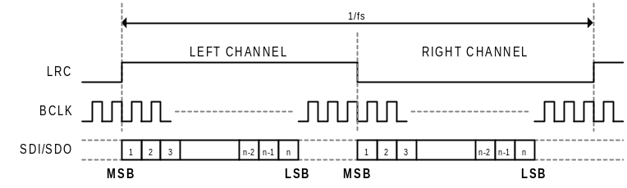
Figure 26-1 Timing diagram for left-justified audio interface
Right Justified Audio Interface
In Right Justified mode, the LSB is available on the last rising of BCLK before a LRC transition. All other are transmitted before (MSB first).
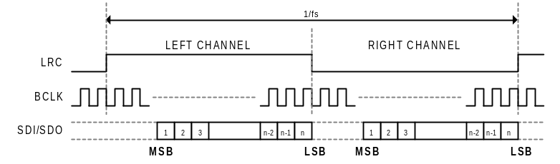
Figure 26-2 Timing diagram for right-justified audio interface

I2S:
In I2S mode, the MSB is available on the second rising edge of BCLK following a LRC transition. The other bits up to the LSB are then transmitted in order.
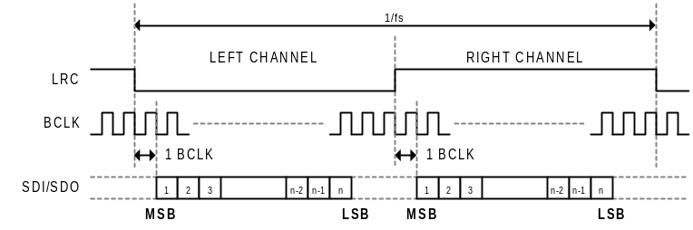
Figure 26-3 Timing diagram for I2S audio interface
PCM Interface:
In PCM interface mode, the left channel MSB is available on the 1st (mode B) or 2nd (mode A) rising edge of BCLK (selected by I2S_DATA_DELAY) following a rising edge of LRC. Right channel data immediately follows left channel data if the audio codec is set as a stereo device. The PCM interface may be configured for Mono mode, where only one channel of data is input or output.

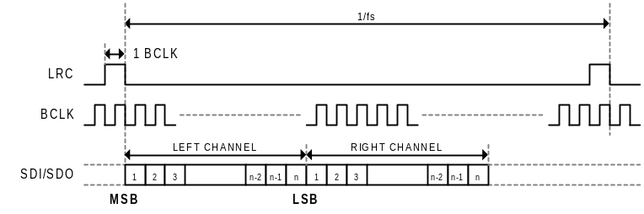
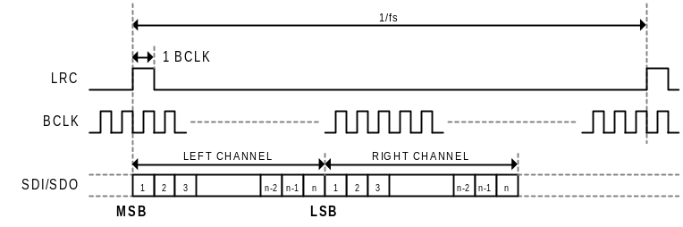
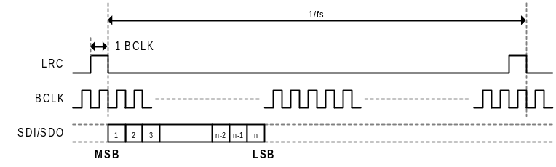
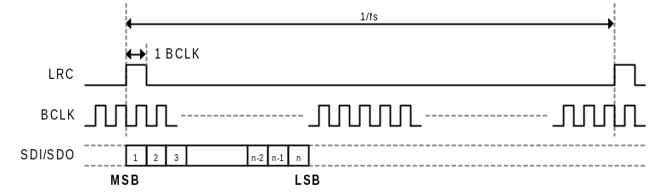
Figure 26-4 Timing diagram for PCM audio interface

26.2 I2S Register

26.2.1 Register Map
Base : 0x0810_0000
Offset | Mnemonic | Description | Type
0x0_0000 | I2S_EN_REG | I2SU enable register | R/W
0x0_0004 | I2S_CLR_REG | I2SU status clear register | R/W
0x0_0008 | I2S_IC_REG | I2SU interrupt cause status register | R
0x0_000c | I2S_IM_REG | I2SU interrupt mask configuration register | R/W
0x0_0010 | I2S_IFCFG_REG | I2SU interface configuration register | R/W
0x0_0014 | I2S_FLEN_REG | I2SU Frame length configuration register | R/W
0x0_0018 | I2S_DATCFG_REG | I2SU PCM data format configuration register | R/W
0x0_001c | I2S_DMAADR_REG | I2SU DMA transfer current address | R
0x0_0020 | I2S_BCLKCFG_REG | I2SU bit clock configuration register | R/W

26.2.2 Register description
- I2SU Enable Register (I2S_EN_REG)
Offset: 0_0000H Type: R/W Default: 0000_0000H

 | 31 | 30 | 29 | 28 | 27 | 26 | 25 | 24
 | Reserved
Default | 0 | 0 | 0 | 0 | 0 | 0 | 0 | 0

 | 23 | 22 | 21 | 20 | 19 | 18 | 17 | 16
 | Reserved
Default | 0 | 0 | 0 | 0 | 0 | 0 | 0 | 0

 | 15 | 14 | 13 | 12 | 11 | 10 | 9 | 8
 | Reserved
Default | 0 | 0 | 0 | 0 | 0 | 0 | 0 | 0

 | 7 | 6 | 5 | 4 | 3 | 2 | 1 | 0
 | Reserved |  |  |  |  |  |  | I2SU_EN
Default | 0 | 0 | 0 | 0 | 0 | 0 | 0 | 0

Bits | Mnemonic | Description
[0] | I2SU_EN | I2SU data transfer enable  = 0b1: transfer enabled  = 0b0: transfer disabled

- I2SU Status Clear Register (I2S_CLR_REG)
Offset: 0_0004H Type: R/W Default: 0000_0000H

 | 31 | 30 | 29 | 28 | 27 | 26 | 25 | 24
 | Reserved
Default | 0 | 0 | 0 | 0 | 0 | 0 | 0 | 0

 | 23 | 22 | 21 | 20 | 19 | 18 | 17 | 16
 | Reserved
Default | 0 | 0 | 0 | 0 | 0 | 0 | 0 | 0

 | 15 | 14 | 13 | 12 | 11 | 10 | 9 | 8
 | Reserved
Default | 0 | 0 | 0 | 0 | 0 | 0 | 0 | 0

 | 7 | 6 | 5 | 4 | 3 | 2 | 1 | 0
 | Reserved |  |  |  |  |  |  | I2S_CLR
Default | 0 | 0 | 0 | 0 | 0 | 0 | 0 | 0

Bits | Mnemonic | Description
[0] | I2S_CLR | I2SU status clear  Write 1 to this bit filed will clear all I2SU’s internal status, including FIFO pointer, DMA transfer address. The status clear operation must be applied, in prior to any new playback/recording section starts.

- I2SU Interrupt Cause Status Register (I2S_IC_REG)
Offset: 0_0008H Type: R/W Default: 0000_0000H

 | 31 | 30 | 29 | 28 | 27 | 26 | 25 | 24
 | Reserved
Default | 0 | 0 | 0 | 0 | 0 | 0 | 0 | 0

 | 23 | 22 | 21 | 20 | 19 | 18 | 17 | 16
 | Reserved
Default | 0 | 0 | 0 | 0 | 0 | 0 | 0 | 0

 | 15 | 14 | 13 | 12 | 11 | 10 | 9 | 8
 | Reserved
Default | 0 | 0 | 0 | 0 | 0 | 0 | 0 | 0

 | 7 | 6 | 5 | 4 | 3 | 2 | 1 | 0
 | Reserved |  |  |  |  |  | I2S_IC_FUR | I2S_IC_FOR
Default | 0 | 0 | 0 | 0 | 0 | 0 | 0 | 0

Bits | Mnemonic | Description
[0] | I2S_IC_FOR | I2SU FIFO overrun occurred
[1] | I2S_IC_FUR | I2SU FIFO underrun occurred
NOTE:
These interrupt cause status will be cleared after writing 0b to corresponding bit field.

- I2SU Interrupt Mask Configuration Register (I2S_IM_REG)
Offset: 0_000CH Type: R/W Default: 0000_0000H

 | 31 | 30 | 29 | 28 | 27 | 26 | 25 | 24
 | Reserved
Default | 0 | 0 | 0 | 0 | 0 | 0 | 0 | 0

 | 23 | 22 | 21 | 20 | 19 | 18 | 17 | 16
 | Reserved
Default | 0 | 0 | 0 | 0 | 0 | 0 | 0 | 0

 | 15 | 14 | 13 | 12 | 11 | 10 | 9 | 8
 | Reserved
Default | 0 | 0 | 0 | 0 | 0 | 0 | 0 | 0

 | 7 | 6 | 5 | 4 | 3 | 2 | 1 | 0
 | Reserved |  |  |  |  |  | I2S_IM_FUR | I2S_IM_FOR
Default | 0 | 0 | 0 | 0 | 0 | 0 | 0 | 0

Bits | Mnemonic | Description
[0] | I2S_IM_FOR | I2SU FIFO overrun interrupt cause mask
[1] | I2S_IM_FUR | I2SU FIFO underrun interrupt cause mask

- I2SU Interface Configuration Register (I2S_IFCFG_REG)
Offset: 0_0010H Type: R/W Default: 0000_0000H

 | 31 | 30 | 29 | 28 | 27 | 26 | 25 | 24
 | Reserved
Default | 0 | 0 | 0 | 0 | 0 | 0 | 0 | 0

 | 23 | 22 | 21 | 20 | 19 | 18 | 17 | 16
 | Reserved
Default | 0 | 0 | 0 | 0 | 0 | 0 | 0 | 0

 | 15 | 14 | 13 | 12 | 11 | 10 | 9 | 8
 | Reserved |  |  |  |  |  | I2S_TR | I2S_MS
Default | 0 | 0 | 0 | 0 | 0 | 0 | 0 | 0

 | 7 | 6 | 5 | 4 | 3 | 2 | 1 | 0
 | Reserved |  | I2S_NON_STOP_FS | I2S_SHORT_FRAME_SYNC | I2S_FRAME_SYNC_POL | I2S_DATA_DELAY | I2S_LEFT_JUST | I2S_STEREO_CODEC
Default | 0 | 0 | 0 | 0 | 0 | 0 | 0 | 0

Bits | Mnemonic | Description
[0] | I2S_STEREO_CODEC | Codec type selection  = 0b0: mono codec is connected.  = 0b1: stereo codec is connected.  NOTE: This bit field is only effective when short frame sync is used.
[1] | I2S_LEFT_JUST | Data justification side selection  = 0b0: right justified.  = 0b1: left justified.
[2] | I2S_DATA_DELAY | Data to frame sync delay configuration  = 0b0: the MSB will appear at the first rising edge of BCLK following an LRCLK transition.  = 0b0: the MSB will appear at the second rising edge of BCLK following an LRCLK transition.
[3] | I2S_FRAME_SYNC_POL | Frame sync polarity selection  = 0b0: left channel’s frame sync polarity is low  = 0b1: left channel’s frame sync polarity is high
[4] | I2S_SHORT_FRAME_SYNC | Frame sync type selection  = 0b0: short frame sync is disabled.  = 0b1: short frame sync is enabled
[5] | I2S_NON_STOP_FS | Non-stop frame sync enable  = 0b0: frame sync will halt toggling in master mode, once FIFO is underrun/overrun.  = 0b1: frame sync will always toggle even if FIFO is underrun or overrun.
[8] | I2S_MS | I2SUoperation mode select  = 0b0: The I2SU is operated in Slave mode, i.e. frame sync provided by external audio codec.  = 0b1: The I2SU is operated in Master mode, i.e. frame sync provided by the I2SU itself.
[9] | I2S_TR | I2SU transfer mode select  = 0b0: The I2SU is operated in receiver mode  = 0b1: The I2SU is operated in transmitter mode.
NOTE:
The following typical digial serial audio data transfer interfaces are supported:
Left Justified Audio Interface
In Left Justified mode, the MSB is available on the first rising edge of BCLK following an LRC transition. The other bits up to the LSB are then transmitted in order. Set I2S_SHORT_FRAME_SYNC = 1’b0, I2S_FRAME_SYNC_POL = 1’b1, I2S_DATA_DELAY = 1’b0, I2S_LEFT_JUST = 1’b1, and I2S_STEREO_CODEC = 1’b1
Right Justified Audio Interface
In Right Justified mode, the LSB is available on the last rising of BCLK before a LRC transition. All other are transmitted before (MSB first). Set I2S_SHORT_FRAME_SYNC = 1’b0, I2S_FRAME_SYNC_POL = 1’b1, I2S_DATA_DELAY = 1’b0, I2S_LEFT_JUST = 1’b0, and I2S_STEREO_CODEC = 1’b1
I2S:
In I2S mode, the MSB is available on the second rising edge of BCLK following a LRC transition . The other bits up to the LSB are then transmitted in order. Set I2S_SHORT_FRAME_SYNC = 1’b0, I2S_FRAME_SYNC_POL = 1’b0, I2S_DATA_DELAY = 1’b1, I2S_LEFT_JUST = 1’b1, I2S_STEREO_CODEC = 1’b1
PCM Interface:
In PCM interface mode, the left channel MSB is avI2Slable on the 1st (mode B) or 2nd (mode A) rising edge of BCLK (selected by I2S_DATA_DELAY) following a rising edge of LRC. Right channel data immediately follows left channel data if audio codec is set as a stereo device (set I2S_STEREO_CODEC as 0b1). The PCM interface may be configured for Mono mode, where only one channel of data is input or output. Set I2S_SHORT_FRAME_SYNC = 1’b1, I2S_FRAME_SYNC_POL = 1’b1, I2S_LEFT_JUST = 1’b1

- I2SU Frame Length Configuration Register (I2S_FLEN _REG)
Offset: 0_0014H Type: R/W Default: 0000_0000H

 | 31 | 30 | 29 | 28 | 27 | 26 | 25 | 24
 | Reserved
Default | 0 | 0 | 0 | 0 | 0 | 0 | 0 | 0

 | 23 | 22 | 21 | 20 | 19 | 18 | 17 | 16
 | Reserved
Default | 0 | 0 | 0 | 0 | 0 | 0 | 0 | 0

 | 15 | 14 | 13 | 12 | 11 | 10 | 9 | 8
 | Reserved |  |  |  |  |  |  | I2S_FRAME_LEN
Default | 0 | 0 | 0 | 0 | 0 | 0 | 0 | 0

 | 7 | 6 | 5 | 4 | 3 | 2 | 1 | 0
 | I2S_FRAME_LEN (cont.)
Default | 0 | 0 | 0 | 0 | 0 | 0 | 0 | 0

Bits | Mnemonic | Description
[8:0] | I2S_FRAME_LEN | Frame period length  0 ~ 511 in bit clock cycle unit.

- I2SU PCM Data Format Configuration Register (I2S_DATCFG_REG)
Offset: 0_0018H Type: R/W Default: 0000_0000H

 | 31 | 30 | 29 | 28 | 27 | 26 | 25 | 24
 | Reserved
Default | 0 | 0 | 0 | 0 | 0 | 0 | 0 | 0

 | 23 | 22 | 21 | 20 | 19 | 18 | 17 | 16
 | I2S_PSU24_LSB
Default | 0 | 0 | 0 | 0 | 0 | 0 | 0 | 0

 | 15 | 14 | 13 | 12 | 11 | 10 | 9 | 8
 | Reserved |  |  |  |  |  | I2S_PCM_WIDTH_
Default | 0 | 0 | 0 | 0 | 0 | 0 | 0 | 0

 | 7 | 6 | 5 | 4 | 3 | 2 | 1 | 0
 | Reserved |  | I2S_STEREO_PCM | I2S_STEREO_CHAN_REV | I2S_MONO_CHAN_SEL | Reserved | I2S_BIG_ENDIAN | I2S_SIGNBIT_INV
Default | 0 | 0 | 0 | 0 | 0 | 0 | 0 | 0

Bits | Mnemonic | Description
[0] | I2S_SIGNBIT_INV | Sign-bit inversion  0b0: sign-bit inversion disabled  0b1: sign-bit inversion enabled  In transmitter mode, the PCM data’s sign-bit is inverse before transmitted to DAC; as in receiver mode, the received PCM data’s sign-bit will be inverse after received from ADC.
[1] | I2S_BIG_ENDIAN | 16-bit PCM data endian select  0b0: 16-bit PCM in little endian format  0b1: 16-bit PCM in big endian format  NOTE: This bit field is only effective for 16-bit PCM data.
[3] | I2S_MONO_CHAN_SEL | Active channel select for stereo source to mono destination  0b0: select left channel’s PCM data as active channel  0b1: select right channel’s PCM data as active channel  NOTE: For transmitter mode, this bit field is only effective for transmitting stereo PCM data to mono DAC; for receiver mode, this bit field is only effective for receiving stereo ADC’s PCM output but stored in mono format.
[4] | I2S_STEREO_CHAN_REV | Stereo PCM data channel reverse  0b0: stereo PCM data channel reverse disabled  0b1: stereo PCM data channel reverse enabled  NOTE: This bit field is only effective for stereo PCM data, i.e. I2S_SD set as 0b1. When stereo audio codec interface is used, the first transferred channel is always assumed as left channel.
[5] | I2S_STEREO_PCM | Stereo PCM data  0b0: the packed PCM data stored in memory is mono format  0b1: the packed PCM data stored in memory is stereo format
[9:8] | I2S_PCM_WIDTH | PCM data bit-width  2b00: 8-bit PCM data  2b01: 16-bit PCM data  2b10: pseudo-24bit PCM data  2b11: 24-bit PCM data
[23:16] | I2S_PSU24_LSB | Only usage for psudo-24bit PCM data mode as the Low Byte.  NOTE: transition data format: 16-bit data+I2S_PSU24_LSB
NOTE:
There are two modes for 24-bit PCM data transition.
- In pseudo-24bit PCM data mode: Audio raw data format is the same with 16-bit mode in storage device. Than, setup one byte special pattern in programming register I2S_PSU24_LSB. The special pattern will follow the original 16-bit data in transition as a complete 24-bit data
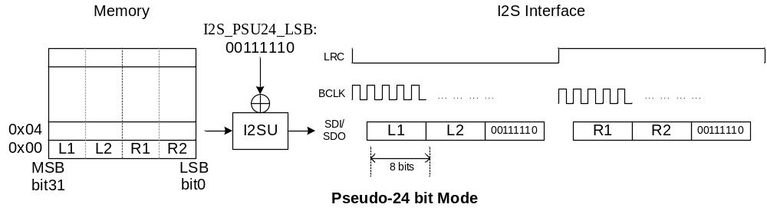
- In 24-bit PCM data mode: A 24-bit audio raw data will store in the most significant three bytes of a double-word. The last byte in double-word will be given any value
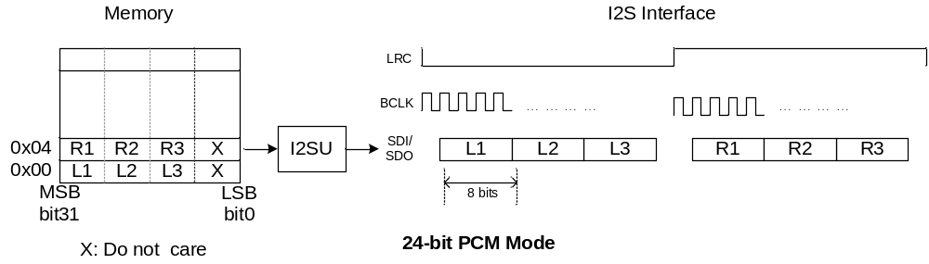

- I2SU DMA Transfer Address (I2S_DMAADR_REG)
Offset: 0_001CH Type: R/W Default: 0000_0000H

 | 31 | 30 | 29 | 28 | 27 | 26 | 25 | 24
 | Reserved
Default | 0 | 0 | 0 | 0 | 0 | 0 | 0 | 0

 | 23 | 22 | 21 | 20 | 19 | 18 | 17 | 16
 | Reserved |  |  |  | I2S_DMAADR
Default | 0 | 0 | 0 | 0 | 0 | 0 | 0 | 0

 | 15 | 14 | 13 | 12 | 11 | 10 | 9 | 8
 | I2S_DMAADR (cont.)
Default | 0 | 0 | 0 | 0 | 0 | 0 | 0 | 0

 | 7 | 6 | 5 | 4 | 3 | 2 | 1 | 0
 | I2S_DMAADR (cont.)
Default | 0 | 0 | 0 | 0 | 0 | 0 | 0 | 0

Bits | Mnemonic | Description
[19:0] | I2S_DMAADR | PCM packed data DMA read/write address in byte address

- I2SU Bit Clock Configuration Register (I2S_BCLKCFG_REG)
Offset: 0_0020H Type: R/W Default: 0000_0000H

 | 31 | 30 | 29 | 28 | 27 | 26 | 25 | 24
 | Reserved
Default | 0 | 0 | 0 | 0 | 0 | 0 | 0 | 0

 | 23 | 22 | 21 | 20 | 19 | 18 | 17 | 16
 | Reserved
Default | 0 | 0 | 0 | 0 | 0 | 0 | 0 | 0

 | 15 | 14 | 13 | 12 | 11 | 10 | 9 | 8
 | Reserved
Default | 0 | 0 | 0 | 0 | 0 | 0 | 0 | 0

 | 7 | 6 | 5 | 4 | 3 | 2 | 1 | 0
 | Reserved |  |  | I2S_BCLK_OE | Reserved |  |  | I2S_BCLK_POL
Default | 0 | 0 | 0 | 0 | 0 | 0 | 0 | 0

Bits | Mnemonic | Description
[0] | I2S_BCLK_POL | Bit clock polarity select  0b0: input serial PCM data (SDI) will be sampled at bit clock rising edge, output serial PCM data (SDO) will transition at bit clock falling edge  0b1: input serial PCM data (SDI) will be sampled at bit clock falling edge, output serial PCM data (SDO) will transition at bit clock rising edge
[4] | I2S_BCLK_OE | Bit clock source select  0b0: the bit clock is provided by external audio codec.  0b1: the bit clock is generated by internal clock generator.

26.3 I2S1 Register

26.3.1 Register map
Base : 0x0810_0000
Offset | Mnemonic | Description | Type
0x1_0000 | I2S1_EN_REG | I2S1U enable register | R/W
0x1_0004 | I2S1_CLR_REG | I2S1U status clear register | R/W
0x1_0008 | I2S1_IC_REG | I2S1U interrupt cause status register | R
0x1_000c | I2S1_IM_REG | I2S1U interrupt mask configuration register | R/W
0x1_0010 | I2S1_IFCFG_REG | I2S1U interface configuration register | R/W
0x1_0014 | I2S1_FLEN_REG | I2S1U Frame length configuration register | R/W
0x1_0018 | I2S1_DATCFG_REG | I2S1U PCM data format configuration register | R/W
0x1_001c | I2S1_DMAADR_REG | I2S1U DMA transfer current address | R
0x1_0020 | I2S1_BCLKCFG_REG | I2S1U bit clock configuration register | R/W

26.3.2 Register description
- I2S1U Enable Register (I2S1_EN_REG)
Offset: 1_0000H Type: R/W Default: 0000_0000H

 | 31 | 30 | 29 | 28 | 27 | 26 | 25 | 24
 | Reserved
Default | 0 | 0 | 0 | 0 | 0 | 0 | 0 | 0

 | 23 | 22 | 21 | 20 | 19 | 18 | 17 | 16
 | Reserved
Default | 0 | 0 | 0 | 0 | 0 | 0 | 0 | 0

 | 15 | 14 | 13 | 12 | 11 | 10 | 9 | 8
 | Reserved
Default | 0 | 0 | 0 | 0 | 0 | 0 | 0 | 0

 | 7 | 6 | 5 | 4 | 3 | 2 | 1 | 0
 | Reserved |  |  |  |  |  |  | I2S1U_EN
Default | 0 | 0 | 0 | 0 | 0 | 0 | 0 | 0

Bits | Mnemonic | Description
[0] | I2S1U_EN | I2S1U data transfer enable  = 0b1: transfer enabled  = 0b0: transfer disabled

- I2S1U Status Clear Register (I2S1_CLR_REG)
Offset: 1_0004H Type: R/W Default: 0000_0000H

 | 31 | 30 | 29 | 28 | 27 | 26 | 25 | 24
 | Reserved
Default | 0 | 0 | 0 | 0 | 0 | 0 | 0 | 0

 | 23 | 22 | 21 | 20 | 19 | 18 | 17 | 16
 | Reserved
Default | 0 | 0 | 0 | 0 | 0 | 0 | 0 | 0

 | 15 | 14 | 13 | 12 | 11 | 10 | 9 | 8
 | Reserved
Default | 0 | 0 | 0 | 0 | 0 | 0 | 0 | 0

 | 7 | 6 | 5 | 4 | 3 | 2 | 1 | 0
 | Reserved |  |  |  |  |  |  | I2S1_CLR
Default | 0 | 0 | 0 | 0 | 0 | 0 | 0 | 0

Bits | Mnemonic | Description
[0] | I2S1_CLR | I2S1U status clear  Write 1 to this bit filed will clear all I2S1U’s internal status, including FIFO pointer, DMA transfer address. The status clear operation must be applied, in prior to any new playback/recording section starts.

- I2S1U Interrupt Cause Status Register (I2S1_IC_REG)
Offset: 1_0008H Type: R/W Default: 0000_0000H

 | 31 | 30 | 29 | 28 | 27 | 26 | 25 | 24
 | Reserved
Default | 0 | 0 | 0 | 0 | 0 | 0 | 0 | 0

 | 23 | 22 | 21 | 20 | 19 | 18 | 17 | 16
 | Reserved
Default | 0 | 0 | 0 | 0 | 0 | 0 | 0 | 0

 | 15 | 14 | 13 | 12 | 11 | 10 | 9 | 8
 | Reserved
Default | 0 | 0 | 0 | 0 | 0 | 0 | 0 | 0

 | 7 | 6 | 5 | 4 | 3 | 2 | 1 | 0
 | Reserved |  |  |  |  |  | I2S1_IC_FUR | I2S1_IC_FOR
Default | 0 | 0 | 0 | 0 | 0 | 0 | 0 | 0

Bits | Mnemonic | Description
[0] | I2S1_IC_FOR | I2S1U FIFO overrun occurred
[1] | I2S1_IC_FUR | I2S1U FIFO underrun occurred
NOTE:
These interrupt cause status will be cleared after writing 0b to corresponding bit field.

- I2S1U Interrupt Mask Configuration Register (I2S1_IM_REG)
Offset: 1_000CH Type: R/W Default: 0000_0000H

 | 31 | 30 | 29 | 28 | 27 | 26 | 25 | 24
 | Reserved
Default | 0 | 0 | 0 | 0 | 0 | 0 | 0 | 0

 | 23 | 22 | 21 | 20 | 19 | 18 | 17 | 16
 | Reserved
Default | 0 | 0 | 0 | 0 | 0 | 0 | 0 | 0

 | 15 | 14 | 13 | 12 | 11 | 10 | 9 | 8
 | Reserved
Default | 0 | 0 | 0 | 0 | 0 | 0 | 0 | 0

 | 7 | 6 | 5 | 4 | 3 | 2 | 1 | 0
 | Reserved |  |  |  |  |  | I2S1_IM_FUR | I2S1_IM_FOR
Default | 0 | 0 | 0 | 0 | 0 | 0 | 0 | 0

Bits | Mnemonic | Description
[0] | I2S1_IM_FOR | I2S1U FIFO overrun interrupt cause mask
[1] | I2S1_IM_FUR | I2S1U FIFO underrun interrupt cause mask

- I2S1U Interface Configuration Register (I2S1_IFCFG_REG)
Offset: 1_0010H Type: R/W Default: 0000_0000H

 | 31 | 30 | 29 | 28 | 27 | 26 | 25 | 24
 | Reserved
Default | 0 | 0 | 0 | 0 | 0 | 0 | 0 | 0

 | 23 | 22 | 21 | 20 | 19 | 18 | 17 | 16
 | Reserved
Default | 0 | 0 | 0 | 0 | 0 | 0 | 0 | 0

 | 15 | 14 | 13 | 12 | 11 | 10 | 9 | 8
 | Reserved |  |  |  |  |  | I2S1_TR | I2S1_MS
Default | 0 | 0 | 0 | 0 | 0 | 0 | 0 | 0

 | 7 | 6 | 5 | 4 | 3 | 2 | 1 | 0
 | Reserved |  | I2S1_NON_STOP_FS | I2S1_SHORT_FRAME_SYNC | I2S1_FRAME_SYNC_POL | I2S1_DATA_DELAY | I2S1_LEFT_JUST | I2S1_STEREO_CODEC
Default | 0 | 0 | 0 | 0 | 0 | 0 | 0 | 0

Bits | Mnemonic | Description
[0] | I2S1_STEREO_CODEC | Codec type selection  = 0b0: mono codec is connected.  = 0b1: stereo codec is connected.  NOTE: This bit field is only effective when short frame sync is used.
[1] | I2S1_LEFT_JUST | Data justification side selection  = 0b0: right justified.  = 0b1: left justified.
[2] | I2S1_DATA_DELAY | Data to frame sync delay configuration  = 0b0: the MSB will appear at the first rising edge of BCLK following an LRCLK transition.  = 0b0: the MSB will appear at the second rising edge of BCLK following an LRCLK transition.
[3] | I2S1_FRAME_SYNC_POL | Frame sync polarity selection  = 0b0: left channel’s frame sync polarity is low  = 0b1: left channel’s frame sync polarity is high
[4] | I2S1_SHORT_FRAME_SYNC | Frame sync type selection  = 0b0: short frame sync is disabled.  = 0b1: short frame sync is enabled
[5] | I2S1_NON_STOP_FS | Non-stop frame sync enable  = 0b0: frame sync will halt toggling in master mode, once FIFO is underrun/overrun.  = 0b1: frame sync will always toggle even if FIFO is underrun or overrun.
[8] | I2S1_MS | I2S1Uoperation mode select  = 0b0: The I2S1U is operated in Slave mode, i.e. frame sync provided by external audio codec.  = 0b1: The I2S1U is operated in Master mode, i.e. frame sync provided by the I2S1U itself.
[9] | I2S1_TR | I2S1U transfer mode select  = 0b0: The I2S1U is operated in receiver mode  = 0b1: The I2S1U is operated in transmitter mode.
NOTE:
Reference to Regieter I2S1_IFCFG_REG (2_0510H).

- I2S1U Frame Length Configuration Register (I2S1_FLEN _REG)
Offset: 1_0014H Type: R/W Default: 0000_0000H

 | 31 | 30 | 29 | 28 | 27 | 26 | 25 | 24
 | Reserved
Default | 0 | 0 | 0 | 0 | 0 | 0 | 0 | 0

 | 23 | 22 | 21 | 20 | 19 | 18 | 17 | 16
 | Reserved
Default | 0 | 0 | 0 | 0 | 0 | 0 | 0 | 0

 | 15 | 14 | 13 | 12 | 11 | 10 | 9 | 8
 | Reserved |  |  |  |  |  |  | I2S1_FRAME_LEN
Default | 0 | 0 | 0 | 0 | 0 | 0 | 0 | 0

 | 7 | 6 | 5 | 4 | 3 | 2 | 1 | 0
 | I2S1_FRAME_LEN (cont.)
Default | 0 | 0 | 0 | 0 | 0 | 0 | 0 | 0

Bits | Mnemonic | Description
[8:0] | I2S1_FRAME_LEN | Frame period length  0 ~ 511 in bit clock cycle unit.

- I2SU PCM Data Format Configuration Register (I2S_DATCFG_REG)
Offset: 1_0018H Type: R/W Default: 0000_0000H

 | 31 | 30 | 29 | 28 | 27 | 26 | 25 | 24
 | Reserved
Default | 0 | 0 | 0 | 0 | 0 | 0 | 0 | 0

 | 23 | 22 | 21 | 20 | 19 | 18 | 17 | 16
 | I2S_PSU24_LSB
Default | 0 | 0 | 0 | 0 | 0 | 0 | 0 | 0

 | 15 | 14 | 13 | 12 | 11 | 10 | 9 | 8
 | Reserved |  |  |  |  |  | I2S_PCM_WIDTH_
Default | 0 | 0 | 0 | 0 | 0 | 0 | 0 | 0

 | 7 | 6 | 5 | 4 | 3 | 2 | 1 | 0
 | Reserved |  | I2S_STEREO_PCM | I2S_STEREO_CHAN_REV | I2S_MONO_CHAN_SEL | Reserved | I2S_BIG_ENDIAN | I2S_SIGNBIT_INV
Default | 0 | 0 | 0 | 0 | 0 | 0 | 0 | 0

Bits | Mnemonic | Description
[0] | I2S_SIGNBIT_INV | Sign-bit inversion  0b0: sign-bit inversion disabled  0b1: sign-bit inversion enabled  In transmitter mode, the PCM data’s sign-bit is inverse before transmitted to DAC; as in receiver mode, the received PCM data’s sign-bit will be inverse after received from ADC.
[1] | I2S_BIG_ENDIAN | 16-bit PCM data endian select  0b0: 16-bit PCM in little endian format  0b1: 16-bit PCM in big endian format  NOTE: This bit field is only effective for 16-bit PCM data.
[3] | I2S_MONO_CHAN_SEL | Active channel select for stereo source to mono destination  0b0: select left channel’s PCM data as active channel  0b1: select right channel’s PCM data as active channel  NOTE: For transmitter mode, this bit field is only effective for transmitting stereo PCM data to mono DAC; for receiver mode, this bit field is only effective for receiving stereo ADC’s PCM output but stored in mono format.
[4] | I2S_STEREO_CHAN_REV | Stereo PCM data channel reverse  0b0: stereo PCM data channel reverse disabled  0b1: stereo PCM data channel reverse enabled  NOTE: This bit field is only effective for stereo PCM data, i.e. I2S_SD set as 0b1. When stereo audio codec interface is used, the first transferred channel is always assumed as left channel.
[5] | I2S_STEREO_PCM | Stereo PCM data  0b0: the packed PCM data stored in memory is mono format  0b1: the packed PCM data stored in memory is stereo format
[9:8] | I2S_PCM_WIDTH | PCM data bit-width  2b00: 8-bit PCM data  2b01: 16-bit PCM data  2b10: pseudo-24bit PCM data  2b11: 24-bit PCM data
[23:16] | I2S_PSU24_LSB | Only usage for psudo-24bit PCM data mode as the Low Byte.  NOTE: transition data format: 16-bit data+I2S_PSU24_LSB

- I2S1U DMA Transfer Address (I2S1_DMAADR_REG)
Offset: 1_001CH Type: R/W Default: 0000_0000H

 | 31 | 30 | 29 | 28 | 27 | 26 | 25 | 24
 | Reserved
Default | 0 | 0 | 0 | 0 | 0 | 0 | 0 | 0

 | 23 | 22 | 21 | 20 | 19 | 18 | 17 | 16
 | Reserved |  |  |  | I2S1_DMAADR
Default | 0 | 0 | 0 | 0 | 0 | 0 | 0 | 0

 | 15 | 14 | 13 | 12 | 11 | 10 | 9 | 8
 | I2S1_DMAADR (cont.)
Default | 0 | 0 | 0 | 0 | 0 | 0 | 0 | 0

 | 7 | 6 | 5 | 4 | 3 | 2 | 1 | 0
 | I2S1_DMAADR (cont.)
Default | 0 | 0 | 0 | 0 | 0 | 0 | 0 | 0

Bits | Mnemonic | Description
[19:0] | I2S1_DMAADR | PCM packed data DMA read/write address in byte address

- I2S1U Bit Clock Configuration Register (I2S1_BCLKCFG_REG)
Offset: 1_0020H Type: R/W Default: 0000_0000H

 | 31 | 30 | 29 | 28 | 27 | 26 | 25 | 24
 | Reserved
Default | 0 | 0 | 0 | 0 | 0 | 0 | 0 | 0

 | 23 | 22 | 21 | 20 | 19 | 18 | 17 | 16
 | Reserved
Default | 0 | 0 | 0 | 0 | 0 | 0 | 0 | 0

 | 15 | 14 | 13 | 12 | 11 | 10 | 9 | 8
 | Reserved |  |  |  |  |  |  | I2S1_DEC_SEL
Default | 0 | 0 | 0 | 0 | 0 | 0 | 0 | 0

 | 7 | 6 | 5 | 4 | 3 | 2 | 1 | 0
 | Reserved |  |  | I2S1_BCLK_OE | Reserved |  |  | I2S1_BCLK_POL
Default | 0 | 0 | 0 | 0 | 0 | 0 | 0 | 0

Bits | Mnemonic | Description
[0] | I2S1_BCLK_POL | Bit clock polarity select  0b0: input serial PCM data (SDI) will be sampled at bit clock rising edge, output serial PCM data (SDO) will transition at bit clock falling edge  0b1: input serial PCM data (SDI) will be sampled at bit clock falling edge, output serial PCM data (SDO) will transition at bit clock rising edge
[4] | I2S1_BCLK_OE | Bit clock source select  0b0: the bit clock is provided by external audio codec.  0b1: the bit clock is generated by internal clock generator.
[8] | I2S1_DEC_SEL | Audio codec selecet  0b0: external audio codec.  0b1: internal audio codec.

