**Connect Power BI to the Registration Database**

1. Install *Npgsql*
2. Download

Go to <https://github.com/npgsql/Npgsql/releases>, download **the first *.msi* file** (latest version).As of Oct 2018, the latest version is v4.0.3.

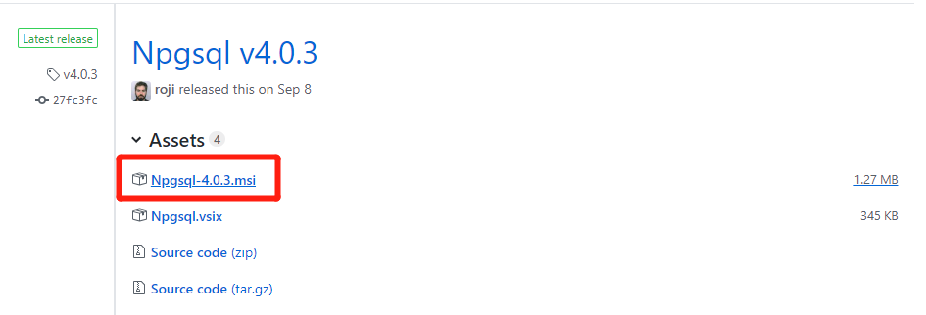

1. Install

**Enable GAC Installation** when you see the window below, by clicking the drop-down arrow and selecting “Will be installed on local hard drive”. Then click *Next* and finish the installation.

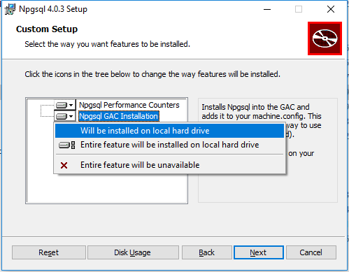

1. Install *psqlODBC*
2. Download

Go to<https://www.postgresql.org/ftp/odbc/versions/msi/>. Scroll down to the bottom of the page to download **the last file** (latest version).

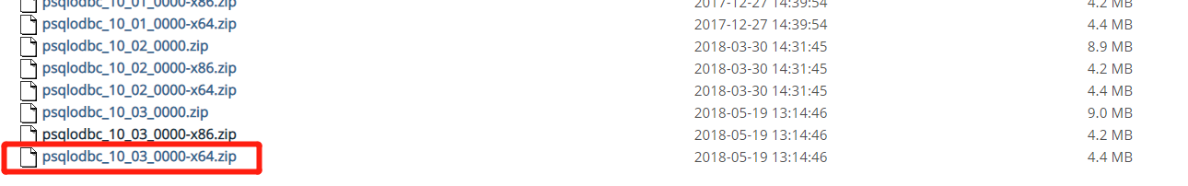

1. Install

**The .msi file** inside the package. No settings need to be changed.

1. Install the certificate
2. Download

Go to <https://www.dropbox.com/s/ia8ckk69m0i9ea0/reporting.api.fusesport_com.crt?dl=0>

**Do NOT double click** the certificate to install it. Please follow the next steps for installation.

1. Type “**mmc.exe**” in the search filed (next to the Start menu on Windows 10, in the Start menu on Windows 7). Press *Enter*.

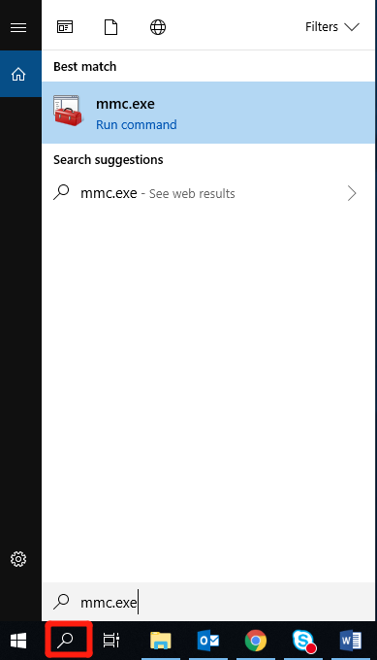

1. Click ***File* -> *Add/Remove Snap-in…***on the top left corner of the pop-up window;

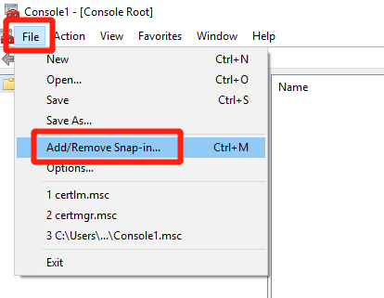

1. Select ***Certificates*** from the list of snap-ins and click ***Add****.*

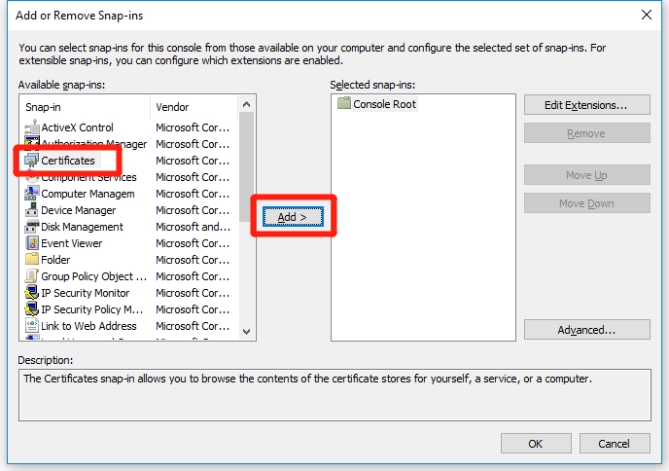

1. Select ***Computer account***, click *Next*.

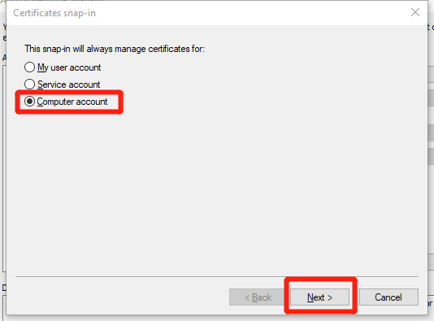

1. Click *Finish*, then *OK*.

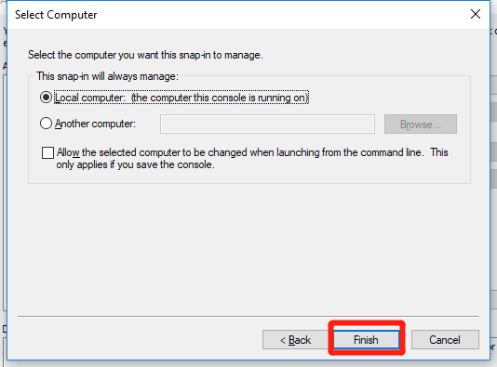

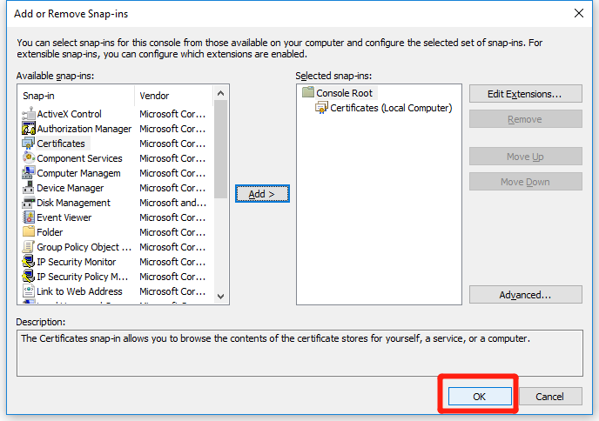

1. Expand *Certificates (Local Computer)* *-> Trusted Root Certification Authorities*. **Right click** on *Certificates*, select *All tasks* -> *Import*…

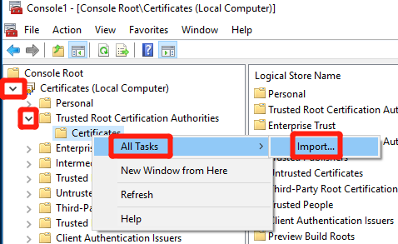

1. Click *Next*, then ***Browse…*** to select the certificate downloaded before, click *Next* until finish installation.

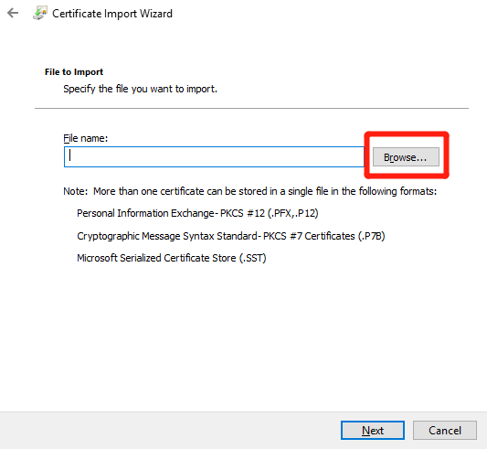

A window will pop up if import is successful.

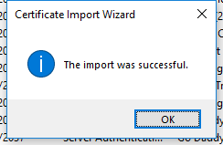

1. Choose ***No***when closing the mmc window

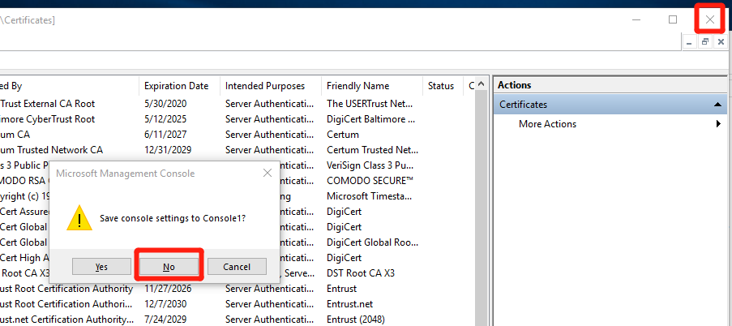

4. Install Microsoft Power BI Desktop using any of the options below: (Skip this step if it is already installed)

* If you have Windows 10, use Microsoft App Store to download and install Power BI Desktop app
* Download and install Microsoft Power BI Desktop from <http://www.microsoft.com/en-us/download/details.aspx?id=45331>

5. Connect PowerBI to the database

1) Launch PowerPI Desktop. Select ***Home* -> *Get Data***in the ribbon

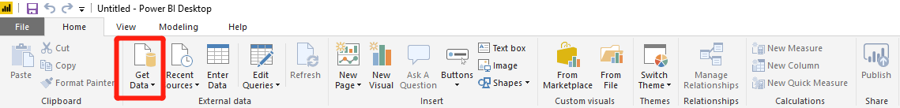

2) Select ***PostgreSQL database***, click *Connect*

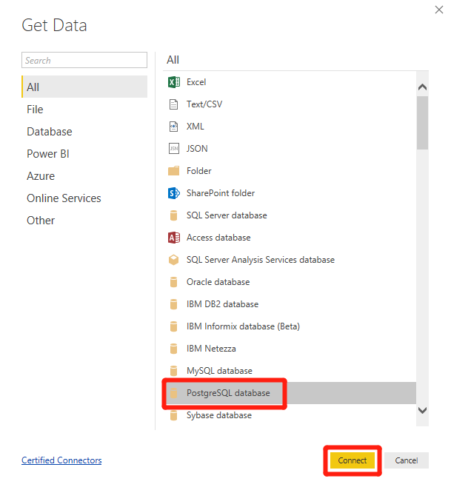

3) Enter the following information and click *OK*

Server: reporting.api.fusesport.com

Database: fuse3

1. Enter the following information, then click *Connect*

User: powerbi

Password: [see email]

1. Select the databases you would like to explore, then click *Load*

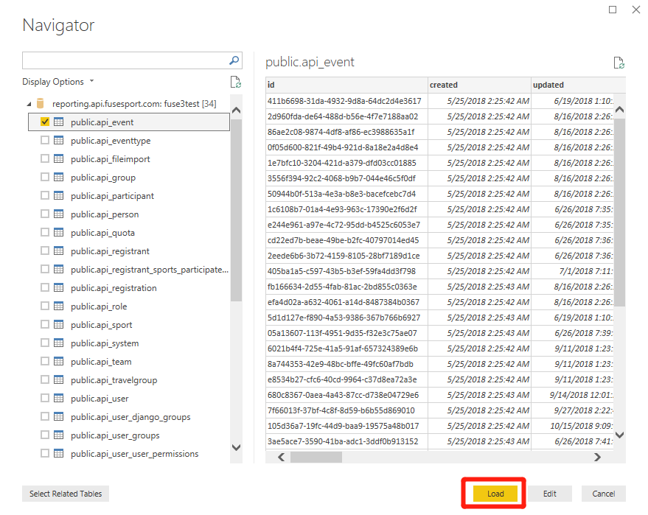

1. Periodically *Refresh* the database to keep updated

