When importing the dataset UNSELECT:

1. trj_id
2. avg_speed
3. osname
4. day
5. month

When creating Automated ML:

1. Select Regression
2. For featurization settings specify the column dtypes:
   1. Avg_bearing: numeric
   2. Day of week: categorical
   3. Is_weekday: categorical
   4. Hour: categorical
   5. Time_group: categorical
   6. Origin_avg_daily_rainfall: numeric
   7. Dest_avg_daily_rainfall: numeric
   8. Origin_lat: numeric
   9. Origin_lng: numeric
   10. Dest_lat: numeric
   11. Dest_lng: numeric
   12. Origin_region: categorical
   13. Origin_subregion: categorical
   14. Dest_region: categorical
   15. Dest_subregion: categorical
   16. Euclid_dist: numeric
3. Select the primary metrics to be ‘normalsed root mean squared error’
4. 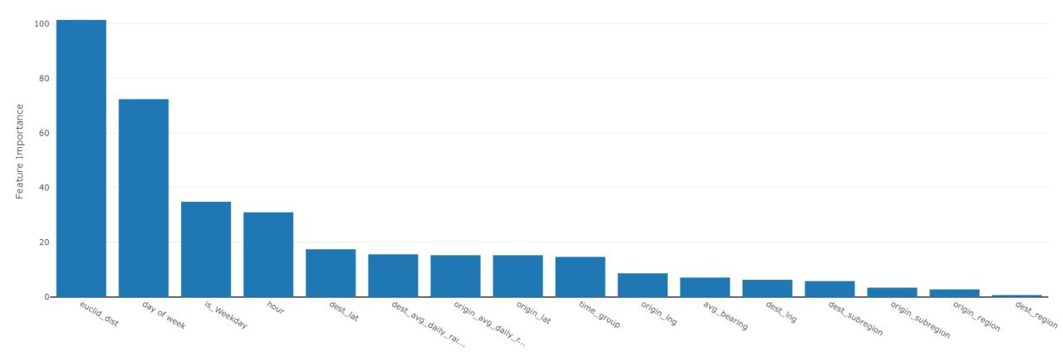Validation: k-fold cross validation = 5

After it has completed, this should be the feature importance ranking, we might exclude the origin and dest region and subregions