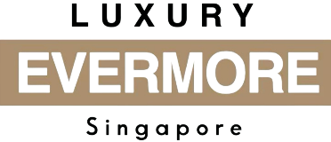
LuxuryEvermore.com
Luxury Evermore Pte Ltd
18-06, 2 Marina Blvd
Singapore 018987
Contact: +65 84023748
Email: contact@luxuryevermore.com
Bill To:

Sales Receipt
Transaction Information
Receipt # | LE-2025-000128
Date | 2025-12-23
Payment Method | PayNow (Paid)
Items Purchased
Image | Item Name | Inclusions | Amount
[Image Placeholder] | Chanel Classic Flap Small (Black Lambskin) | Full set: Box, Dustbag, Card | 9800 SGD

Total Amount Paid: 9800 SGD

Terms of Sale
All sales are final. Items sold are strictly non-refundable and non-exchangeable. By completing the purchase, the buyer confirms acceptance of the item’s condition, authenticity status, and description at the time of sale.
Refunds or disputes will only be considered if the item is conclusively proven to be non-authentic by the brand itself or a mutually agreed, recognized third-party authentication service with a proven track record.

Authorized Signature

This receipt serves as proof of purchase

Thank you for shopping at Luxury Evermore!

