# Efficient estimation of crystal filterability using the discrete element method and the Kozeny-Carman equation

Ming-Chun Fanga, Psalm Josiah Tana, Jeffrey D. Warda[1]

a Department of Chemical Engineering, National Taiwan University, Taipei 10617, Taiwan

# Abstract

A new method is proposed for efficiently predicting filter cake resistance as a function of crystal size distribution, which is useful for the preliminary design of processes where an economic tradeoff is encountered between a crystallization step and a filtration step. In that case it is necessary to estimate the filter cake resistance repeatedly as a function of crystal size distribution for the process design and optimization. The proposed method is validated using published experimental data and illustrated using an integrated crystallization-filtration process of ammonium alum. The results show that for a crystalline product with relatively large crystal size, the overall filter resistance depends strongly on the filter medium resistance. In this case, a decrease in filter cake resistance may have limited effect on the process economics. However, for a crystalline product with a small crystal size, the trade-off between crystallizer design and filter design will become an important issue.

**Keywords:** Pressure filtration, Crystal size distribution, Cake resistance, Discrete Element Method, Simulation

# Introduction

Crystallization is among the most important methods for separation and purification in chemical manufacturing. The driving force for crystal nucleation and growth is the supersaturation, which can be produced by cooling, evaporation or addition of an anti-solvent.1 After crystallization, commonly the crystalline product is separated from the mother liquid using filtration, washing, deliquoring, and drying.2-4 Chang and Ng5 used the adipic acid process as an example to illustrate how crystallization is integrated with other unit operations in a typical chemical process, as shown in Figure 1. KA oil (mixture of cyclohexanol and cyclohexanone) is oxidized with nitric acid to generate adipic acid. The dilute reactor effluent is fed to the concentrator where excess solvent is evaporated to reduce the solution volume and improve the operation of the crystallizer. Because the product purity specification is not achieved after a single crystallization step, a recrystallization step is required. After the recrystallization, the crystalline product is filtered, washed, dewatered, and dried.

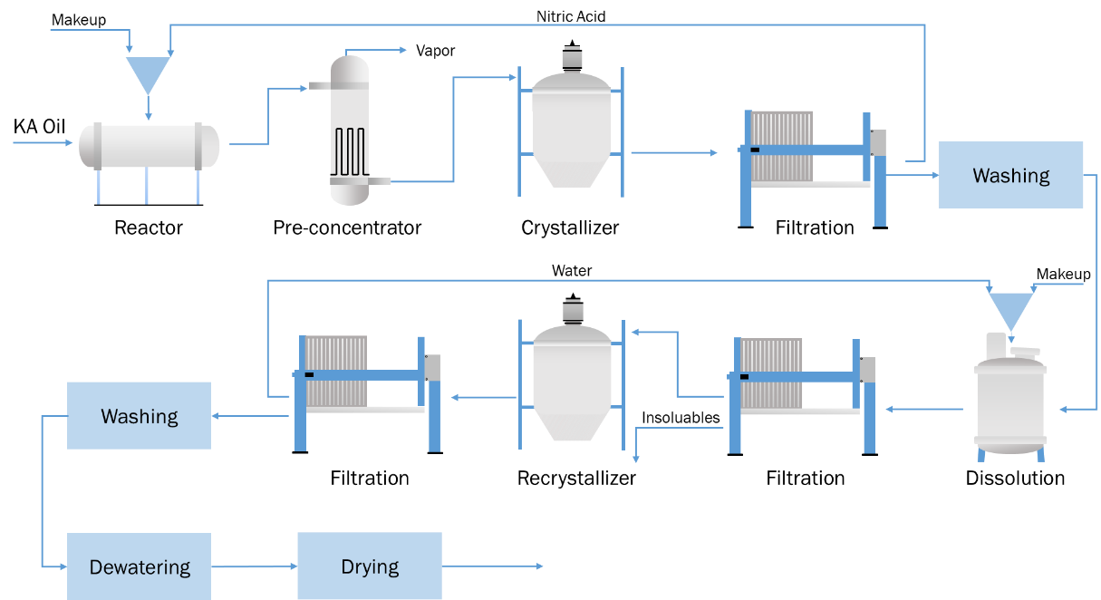

Figure 1. The adipic acid production process flowsheet (after Chang and Ng5).

The performance of downstream processing steps such as filtration, washing or deliquoring are strongly influenced by crystal properties such as the crystal size distribution (CSD) which are determined in the crystallizer.6 Wakeman7 studied the influence of CSD and crystal shape on the operation of filtration, washing, and deliquoring. Wibowo et al2 summarized the potential problems in downstream processing steps that can be caused by the CSD. If the CSD becomes wider or the average crystal size becomes smaller, generally the required filtration area will become larger and the amount of solvent required for washing will become greater, which increases the cost of solvent recovery.

Usually, for a continuous process, there is an economic trade-off between crystallizer design and filter design. If a smaller crystallizer is used, the residence time of the crystals decreases, which decreases the average crystal size. Thus, the crystal filterability will decrease, and a larger filter area is required for the subsequent separation. For batch crystallization, Ward et al8-10 compared the optimal supersaturation trajectory determined for different objective functions. The result shows that the optimal supersaturation trajectory depends heavily on the objective function chosen. There is a trade-off between minimization of nucleated crystal number and volume, which can be represented on a Pareto-Optimal front.9 However, few studies on the relationship between different objective functions and filterability of crystalline product have been published, which makes it difficult to determine the most suitable objective function. Thus, there is a need to develop a filtration model that can predict crystal filterability based on the specified CSD. By combining the filtration model with the crystallization model, the trade-off described previously could be evaluated quantitatively, and overall process design and optimization will be possible.

Traditionally, the crystal filterability is determined experimentally using a constant pressure filtration experiment.11, 12 Perini et al13 estimated the crystal filterability by developing a correlation between filter cake resistance and CSD using partial least square (PLS) regression on experimental data. Because the model is purely empirical, the accuracy of the model depends on the similarity between the crystals studied and the crystals used for the PLS regression. Theoretically, filtration processes can be simulated as liquid flowing through a porous bed driven by a pressure difference. Bourcier et al14 proposed a resistance additivity hypothesis and estimated the cake filterability of non-uniform crystals by integrating the Kozeny-Carman equation with respect to crystal size. They validated this method using experimental data. However, the method still requires the porosity of the crystal cake as an input, which is difficult to predict at the crystallizer design stage. Nagy et al.15 estimated the cake porosity using the method proposed by Ouchiyama and Tanaka,16 which assumes random packing of spherical particle. They simulated a continuous integrated crystallization-filtration processes. However, the particle properties such as density or cohesiveness were not considered when the cake porosity was estimated. Li et al17 simulated filter cake structure using a rigid body dynamic model to investigate the influence of the particle size distribution and particle shape on the cake filterability.

Several researchers have modeled filtration processes by combining computational fluid dynamics (CFD) and the discrete element method (DEM). CFD is used to describe the fluid phase, and DEM is used to describe the solid particles.18 By combining CFD and DEM (CFD-DEM) via a solid/liquid interaction term, fluid-particulate systems such as fluidized beds or filtration processes can be simulated.19 Dong et al20 and D’yachenko and Dueck21 studied the filter cake formation process using DEM. Yue et al22 and Sheng23 studied the filtration process in and on the filter media using CFD-DEM for applications in air filteration. Hund et al24 studied the bridge formation process during the initial stage of filtration using CFD-DEM. Sören and Jürgen25 and Qian et al26 simulated pressure filtration processes using CFD-DEM. The simulation results were compared with experimental data25 and the results of an empirical model26. Deshpande et al27 and Li et al28 studied the factors that influence the performance of pressure filtration such as liquid viscosity, attractive force between particles and particle Reynold’s number using CFD-DEM.

CFD-DEM is a powerful method for studying filtration. However, it also has some limitations. First, it is relatively computationally intensive. According to Li et al28, it takes several hours to finish one simulation of a laboratory scale batch filtration experiment. To simulate the cake filterability of crystalline product having small crystals and a broad CSD, which is usually the case for the crystalline product from a continuous crystallizer, a smaller time step size29 and large number of particles should be used. This will further substantially increase the computation time. Second, CFD-DEM simulation results are sensitive to the CFD cell size.30 The optimal cell size may be difficult to determine when the CSD is broad and no experimental data are available.

Therefore, in this work, a procedure that combines DEM and the Kozeny-Carman equation is proposed to estimate particle filterability. DEM is used to predict the filter cake structure and estimate the cake porosity for a given CSD. Then the Kozeny-Carman equation with the resistance additivity hypothesis proposed by Bourcier et al.14 is used to estimate the filter cake resistance. Thus, the method proposed does not require CFD calculations, only DEM calculations. This substantially reduces the computation time of the proposed method compared to CFD-DEM, and the issue of cell size selection is avoided as well. To demonstrate the application of the model, an integrated crystallization-filtration process for the production of ammonium alum is modelled and analyzed.

The remainder of this article is organized as follows. In Section 2, filtration theory and the discrete element method are introduced. In Section 3, the DEM simulation settings using open-source software LIGGGHTS31-33 are described. The equations used for modelling a rotary-drum filter and a continuous crystallizer are explained. In Section 4, the procedure is validated by comparing simulation results for bimodal PMMA particles with experimental data available in the open literature.14 An integrated crystallization-filtration process of ammonium alum is used as a case study to demonstrate the trade-off between crystallizer design and filter design quantitatively. In Section 5, results are summarized and some limitations of the proposed method are discussed.

# Theory

## Filtration Theory

Filtration is driven by a pressure difference across the filter. The overall pressure drop comprises contributions from the filter medium resistance and the cake resistance as shown in the following equation:34

|  |  |  |
| --- | --- | --- |
|  |  | (1) |

where is the specific cake resistance and is the medium resistance.

The pressure drop across the cake is proportional to the resistance to flow of a liquid through a porous medium. Assume the fluid density is 1000 kg/m3, and the filtrate flowrate is 0.1 cm/s. For the particles whose size is less than 1000 , the particle Reynold’s number during filtration is less than 1 in which case the Kozeny-Carman equation is applicable. Combining Eq. (1) with Kozeny-Carman equation, the specific cake resistance of uniform particles can be estimated using the following equation:14

|  |  |  |
| --- | --- | --- |
|  |  | (2) |

For particles with non-uniform size distribution, Bourcier et al.14 proposed a resistance additivity hypothesis. The cake specific resistance can be estimated by:

|  |  |  |
| --- | --- | --- |
|  |  | (3) |

In the work of Bourcier et al.14, the cake porosity is measured by evaporating the liquid in the wet cake. However, at the preliminary design stage for crystallization-filtration processes, the cake porosity is usually not known. The cake porosity determined from experiments using a laboratory-scale crystallizer may be different from that of the actual process because of differences in the crystallizer type and the residence time. In this work, instead of relying on experiments, the cake structure and porosity are predicted using the discrete element method (DEM). The advantage of this approach is that cake resistance can be efficiently estimated for a given CSD. The crystalline product CSD can be estimated by solving the population balance equation for a given crystallizer design.35 Thus efficient conceptual design and optimization of combined crystallization-filtration processes can he undertaken.

## Discrete Element Method

The discrete element method tracks the movement of every particle in the system by solving the momentum balance equation for translational and rotational motion as shown in the following equations:18

|  |  |
| --- | --- |
|  | (4) |
|  | (5) |

where is the force of contact from particle *j* acting on particle *i*, is the non-contact force of particle *k* acting on particle i, is the interaction force between the particle and the fluid and is the force of gravity.

Zhu et al18 provided a comprehensive introduction to the various forces that are relevant in DEM simulation. In this work, CFD is not coupled with DEM. Thus, the particle-fluid interaction forces such as drag force or pressure gradient force are neglected. The Hertz contact model and Simplified Johnson-Kendall-Roberts (SJKR) model are used to describe the contact force.36, 37 The Hertz contact model accounts for the elasticity force and damping force between particles in the normal and shear directions. The SJKR model describes the cohesive force between particles using the following equation:

|  |  |
| --- | --- |
|  | (6) |

where s is cohesion energy density and is the sphere-sphere contact area.36

Because the cohesiveness of the particles is described by SJKR model, non-contact forces37 including electrostatic forces, liquid bridge forces and van der Waals forces are neglected. The force of gravity is considered in the simulation.

The Hertz contact model and SJKR model require particle deformation information as input.36 The particle deformation is estimated by detection of particle overlap, which is sensitive to the size of the time step used in the simulation. Burns et al29 showed that the size of the time step can influence the numerical stability of the DEM simulation. The upper limit of DEM simulation time step is often taken to be the Rayleigh time step:

|  |  |  |
| --- | --- | --- |
|  |  | (7) |
|  |  | (8) |
|  |  | (9) |

where is the Poisson’s ratio and E is the Young’s modulus.

According to Eq.(7), the Rayleigh time step becomes smaller when the particles become smaller or stiffer (i.e. larger Young’s modulus), and a larger number of time steps will be needed to simulate the same physical time. Thus, the simulation of systems with small particles such as those encountered in crystal filtration will usually require a large computation time.

# Simulation Method

## DEM Software Setting

The DEM simulation is performed using open source software LIGGGHTS 3.8.031-33 running on a desktop computer with an Intel Core i7-10700 (8 cores and 16 threads) and the Linux operating system Ubuntu 20.04.6. The domain geometry of DEM simulation is shown in Figure 2. Cake properties are estimated by simulating a small fraction of the entire filter cake and applying periodic boundary conditions in the x and y directions In DEM simulation, the particles are inserted randomly in the particle insertion region first. When the simulation starts, the particles settle down to form the filter cake. The void fraction of porosity sample region is recorded to check if the cake structure is stable in the simulation. In Figure 2, *L* (here called system dimension) is the length and width of the simulation box. The system dimension is adjusted so that the system is large enough to accommodate the specified number of particles. The system dimension is estimated by assuming the initial void fraction of the particle insertion region is 0.65. For a cake with porosity less than 0.3, the initial void fraction of the particle insertion region is set as 0.6 so that the cake height will be higher than the height of the porosity sampling region. The system dimension used for different simulations in this work is shown in Table 1. The system dimension for the ammonium alum simulations is larger than that of the PMMA simulations because the average crystal size and the total number of particles are larger.

The number of time steps used depends on the time required for the cake structure to stabilize. If the particle settling velocity is constant, systems with larger dimension and a shorter time step require more time steps. For simulations with a sufficient number of time steps, the void fraction trajectory of sample region should be similar to that shown in Figure 3. The initial void fraction is about 0.65 because of the way that the system dimension is determined. During the simulation, particles settle down. Thus, the void fraction in the sample region will decrease and approach a steady state. If the void fraction in the sample region is still decreasing at the end of the simulation, the number of time steps is not enough. The number of time steps should be increased until the cake porosity reaches a steady-state. If the number of particles in sample region is almost the same as the number of particles inserted, the system dimension should be reduced so that the top of the cake is above the top of the sample region.

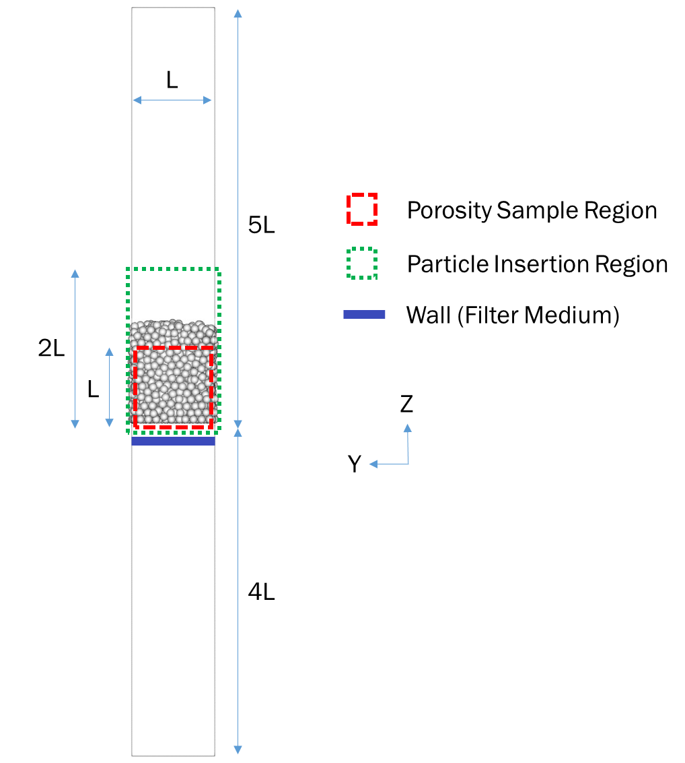

Figure 2. DEM simulation domain geometry

Table 1. System dimension used in DEM simulation

|  |  |  |
| --- | --- | --- |
| System | Particle Number | System Dimension |
| 75/25wt% 20/50 PMMA | 2,000 | 250 |
| 50/50wt% 20/50 PMMA | 2,000 | 282 |
| 25/75wt% 20/50 PMMA | 2,000 | 342 |
| Ammonium alum (residence time=15 min) | 100,000 | 5046 |
| Ammonium alum (residence time=30 min) | 100,000 | 5808 |
| Ammonium alum (residence time=45 min) | 100,000 | 6352 |
| Ammonium alum (residence time=60 min) | 100,000 | 6658 |

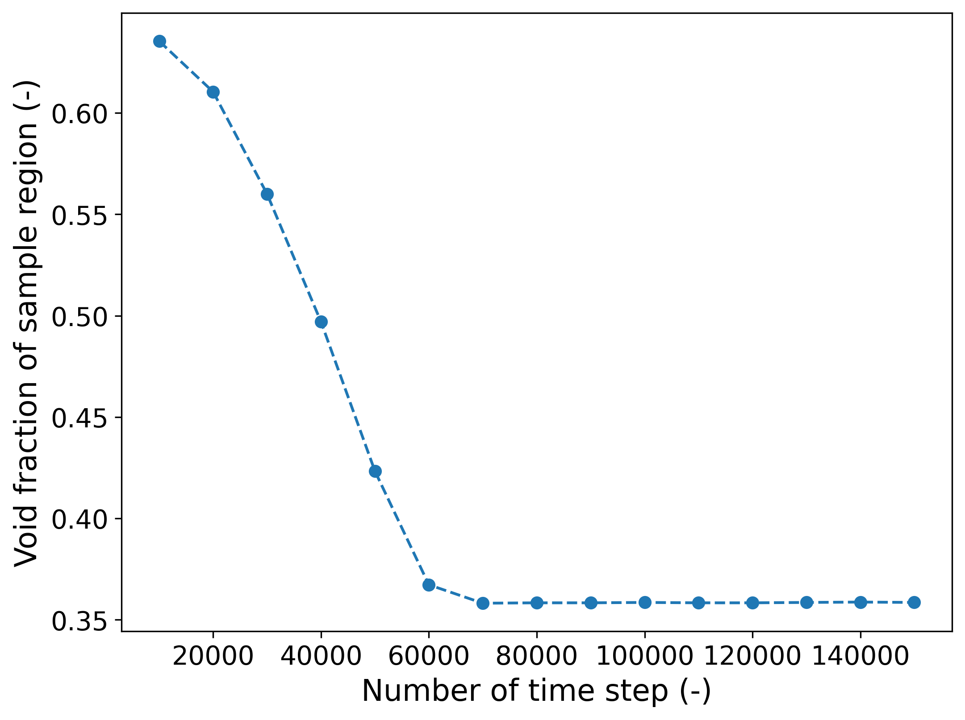

Figure 3. Porosity trajectory during simulation (50/50 wt% 20/50 PMMA)

There are several DEM parameters that should be adjusted based on the specified CSD as shown in Figure 4. Figure 4 shows a typical crystal volume distribution from a continuous crystallizer. When the specified CSD is very broad, the computational burden can be reduced by neglecting very small and very large particles. Small particles necessitate a small time step, and large particles necessitate a subsystem with a large number of particles because the large particles are scarce. Thus, for simulation the CSD should be truncated on the left and right if the original CSD is too broad. The contact detection limit used in this work is the diameter of the largest particle in the specified CSD.

In LIGGGHTS, the size and volume fraction of each particle template should be specified individually. Thus, in this work, the continuous volume population density function from crystallizer simulation is discretized using bins of width 5 and transformed into the volume fraction of each bin. Bins with a volume fraction less than 0.1 vol% (crystals that are smaller than *L*min or larger than *L*max) are neglected as shown in Figure 5. The sum of the volume fraction of all discarded bins is less than 3%. *L*min and *L*max for each simulation are shown in Table 2. The LIGGGHTS script used in this work is available in the GitHub project *Cake_Filterability_Simulator* (<https://github.com/mingchunNTU/Cake_Filterability_Simulator.git>)

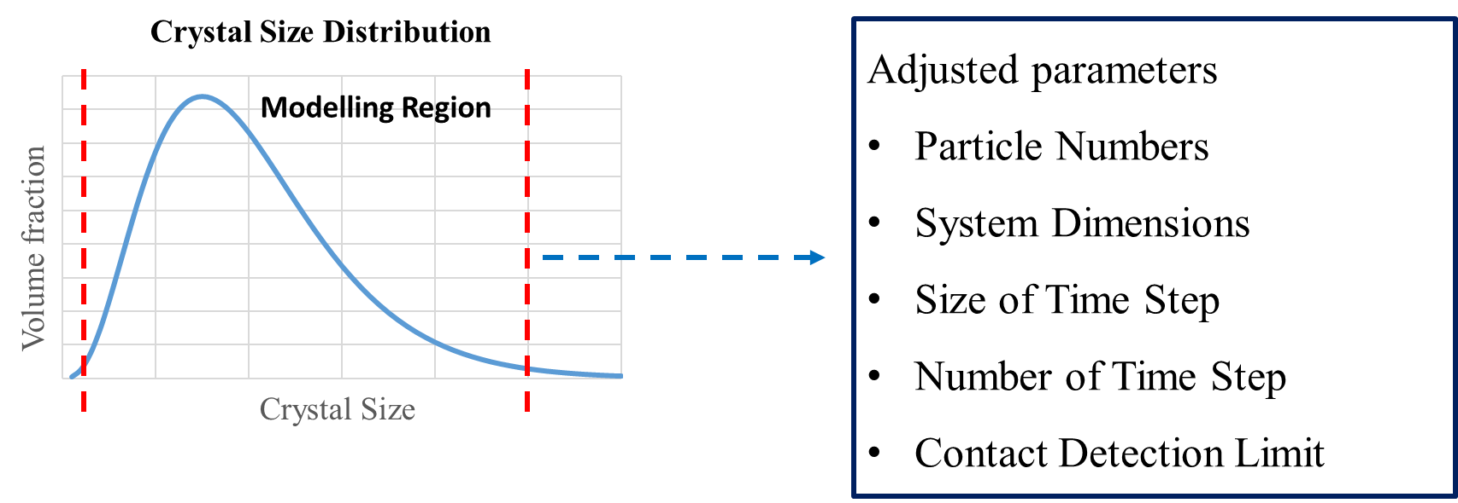

Figure 4. DEM parameters need to be adjusted based on the specified CSD.

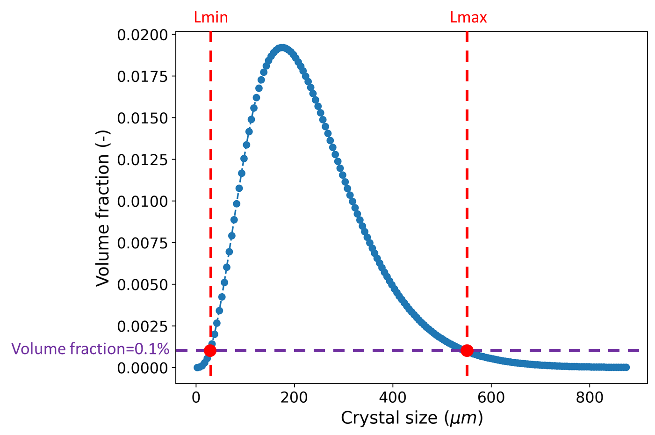

Figure 5. Truncation criteria for a specified CSD

Table 2. Crystal size range (truncation values) used in DEM simulation

|  |  |  |
| --- | --- | --- |
| System | *L*min | *L*max |
| Ammonium alum (residence time=15 min) | 32.5 | 543.3 |
| Ammonium alum (residence time=30 min) | 37.6 | 613.4 |
| Ammonium alum (residence time=45 min) | 42.6 | 653.4 |
| Ammonium alum (residence time=60 min) | 42.5 | 688.2 |

## Simulation of Rotary-Drum Filter

A typical configuration of rotary-drum filter is shown in Figure 6.34 The filter is composed of an outer drum and inner drum. The outer drum is a slotted face covered with a filter medium such as canvas. The inner drum is a solid surface that connects with rotary valves that apply first suction and then air using internal pipes. Part of the filter is immersed in the slurry to perform the filtration. As the drum rotates, the cake accumulates on the outer drum. After the cake leaves the slurry, it is washed and deliquored, and a small amount of air is applied from inside to release the cake from the filter medium. The cake is scrapped from the filter cloth by the doctor blade and routed to the next processing step. The continuous removal of the filter cake allows the rotary-drum filter to operate continuously. The filter area required for processing the specified slurry volume can be estimated by:34

|  |  |
| --- | --- |
|  | (10) |

The slurry concentration MT depends on the crystallizer operation. The specific cake resistance can be estimated using Eq. (3) and DEM simulation. If MT and are known, then the required filter area can be estimated.

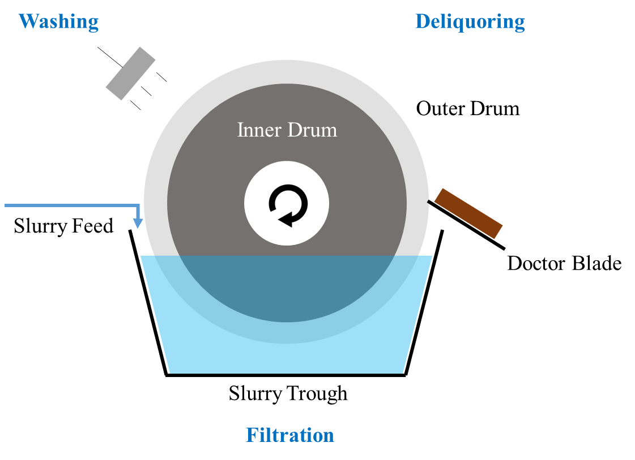

Figure 6. Configuration of rotary-drum filter

## Simulation of a Continuous Crystallizer

A schematic diagram of a continuous crystallizer is shown in Figure 7. Supersaturation in the crystallizer can be generated by cooling, evaporation, reaction precipitation or salting out.38 A well-mixed continuous crystallizer can be modelled as a mixed-suspension, mixed-product-removal (MSMPR) crystallizer.35 The crystal size distribution of an MSMPR crystallizer can be estimated by solving a population balance equation (PBE). As a result, the number population density function *b*(*L*) of the crystalline product can be described by the following equation, where is the nucleation rate, is the crystal growth rate and is the residence time in the crystallizer. The empirical parameters *KR*, *i*, *j* for different crystallization system can be found in the work of Garside and Shah.38

|  |  |
| --- | --- |
|  | (11) |
|  | (12) |
|  | (13) |

By integrating Eq. (11) with respect to crystal mass, the slurry concentration can be expressed using the following equation, where and are the shape factor and density of the crystals. For a crystal system whose physical properties and crystallization kinetics are known, can be determined implicitly from the following equation if the residence time and slurry concentration are specified:

|  |  |
| --- | --- |
|  | (14) |

For a given slurry concentration, the crystal growth rate will decrease if the crystallizer residence time increases. For a crystal system whose growth rate exponent *i* in Eq. (13) is larger than 1, which is usually the case, the nucleation rate will decrease faster than crystal growth rate. Thus, the average crystal size will increase if the crystallizer residence time increases.

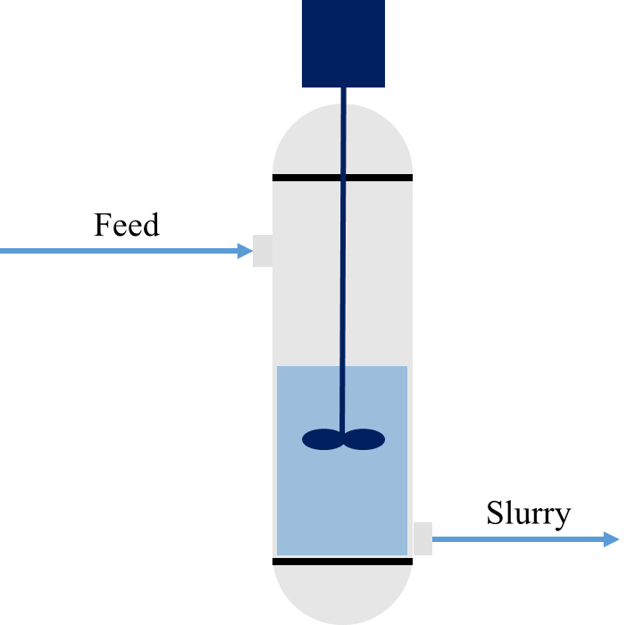

Figure 7. Schematic diagram of a continuous crystallizer

# Result and Discussion

## Model Validation

To validate the resistance additivity hypothesis represented by Eq. (3), Bourcier et al14 compared the measured specific cake resistance with the result determined using Eq.(3) for bimodal (20/50) mixtures of spherical PMMA particles. In the work of Bourcier et al,14 the cake porosity was measured by experiment. In this work, the cake porosity is determined by DEM simulation based on the given PMMA size distribution.

The simulation parameters used for this purpose are shown in Table 3. It was found that if SI units are used in the simulation, the numerical value of the particle volume (in cubic meters) becomes too small, causing a numerical error. Therefore, *micro* units (, , and pg) were used for length, time, and mass, respectively.39 The time step is about 12% of the Rayleigh time step for 20 PMMA particles. The number of time steps is large enough for the cake structure to stabilize. The particle density used in DEM simulations is the density of PMMA. The Young’s modulus is set to the lower limit of LIGGGHTS to increase the Rayleigh time step, which allows a larger time step size to be used. The coefficient of friction is set as 0 to account for the lubrication effect of the filtrate.40 The cohesion energy density is set as 50,000 J/m3 to fit the specific cake resistance of 50/50 wt% 20/50 PMMA. The particle number used is 2000, which is large enough that the estimated porosity is independent of the number of particles used. According to Li et al.28, simulating a filtration system with 1500 particles using CFD-DEM requires about 30 minutes. The computation time for each simulation in Table 4 is about 2 minutes, which is only 7% of the time reported by Li et al.28 Thus using DEM only reduces the computational burden significantly.

The model validation result is shown in Table 4. The error in the specific cake resistance range from 3% to 33%. For 25/75wt% 20/50 PMMA system, the estimated specific cake resistance is 33% larger than the measurement. As shown in Figure 8, the specific cake resistance estimated by Eq. (3) is sensitive to the estimated cake porosity. If the cake resistance is underestimated by 0.03, the specific cake resistance will be overestimated by about 35%, which is the case for 25/75wt% 20/50 PMMA system. Considering the estimated cake porosity may have some error, it’s suggested to use a larger safety factor such as 2 for the simulated specific cake resistance if Eq.(3) is used to estimate the specific cake resistance.

Table 3. Parameters used for model validation

|  |  |  |
| --- | --- | --- |
| Parameters | Value (*SI* unit) | Value (*micro* unit) |
| DEM Setting | | |
| particle number | 2000 | 2000 |
| size of time step | 10-7 s | 0.1 |
| number of time steps | 150,000 | 150,000 |
| settling velocity | 0.01 m/s | 0.01 |
| Particle Properties | | |
| density | 1180 kg/m3 | 1.18 |
| Young’s modulus | 5,000,000 Pa | 5000 |
| Poisson ratio | 0.2 | 0.2 |
| coefficient of restitution | 0.3 | 0.3 |
| coefficient of friction | 0 | 0 |
| cohesion energy density | 50,000 J/m3 | 50 |
| sphericity | 1 | 1 |

Table 4. Model validation result

|  |  |  |  |  |
| --- | --- | --- | --- | --- |
|  | Cake Porosity | | Specific Cake Resistance | |
|  | Measurement | Simulation | Measurement | Simulation |
| 75/25wt% 20/50 | 0.31 | 0.392 | m/kg | m/kg |
| 50/50wt% 20/50 | 0.35 | 0.359 | m/kg | m/kg |
| 25/75wt% 20/50 | 0.38 | 0.358 | m/kg | m/kg |

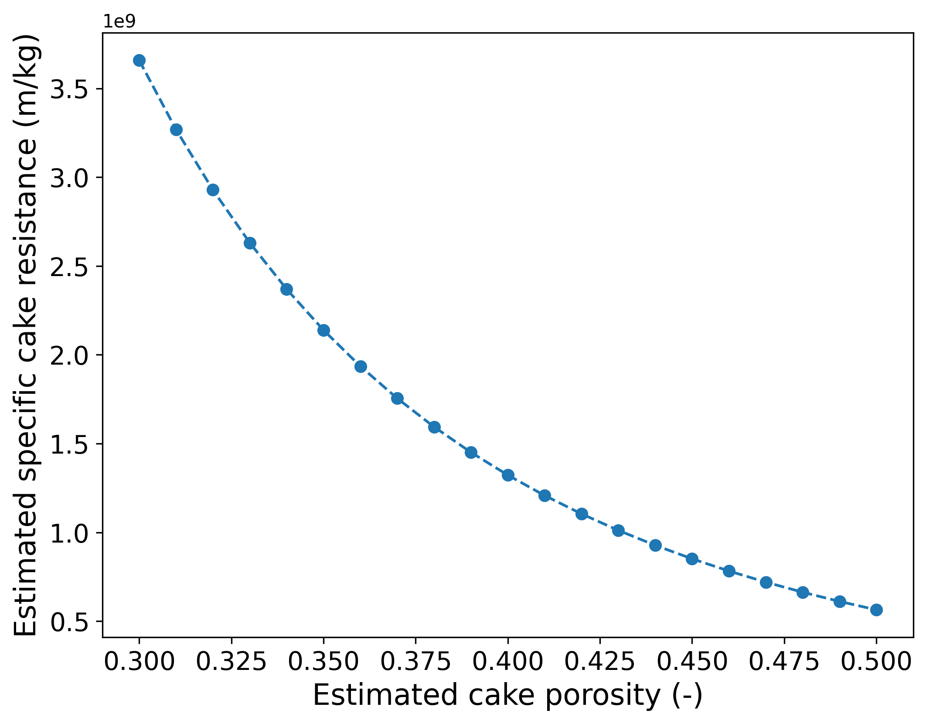

Figure 8. The relationship between estimated cake porosity and estimated specific cake resistance

(25/75 wt% 20/50 PMMA)

A sensitivity analysis based on 50/50 wt% 20/50 PMMA spheres found that the Poisson ratio and coefficient of restitution have little effect on the predicted cake porosity. However, the cohesion energy density and coefficient of friction has a significant effect on the simulation result as shown in Figure 9 and Figure 10. As shown in Figure 10, the estimated specific cake resistance can range from to depending on the cohesion energy density and coefficient of friction used in DEM simulation. Thus, the cake porosity and specific cake resistance cannot be determined by the CSD alone. The cohesive and friction force between the crystals should also be considered when predicting the cake structure. Nagy et al.15 estimated the cake porosity using the equation proposed by Ouchiyama and Tanaka16, which assumes the cake structure is random packing. The cake porosity estimated by their method is always lower than the average cake porosity of uniform sized spheres used16. In the work of Nagy et al.15, is estimated using the following equation

|  |  |
| --- | --- |
|  | (15) |

For a filtration system whose crystal diameter is significantly smaller than the filter medium diameter, is close to 0.375. Thus, the cake porosity estimated in the work of Nagy et al.15 will always be lower than 0.375. For cakes with porosity larger than 0.4, which is not uncommon in the literature,14, 25 this method will underestimate the cake porosity. Because Kozeny-Carman equation is sensitive to the estimated cake porosity, the estimated specific cake resistance determined Eq. (3) may be significantly larger than the true value.

In this work, it is recommended that the cohesion energy density be determined empirically from several filtration experiments. For several given experimental crystal size distributions, the cohesion energy density could be determined by minimizing the prediction error for the specific cake resistance as shown in Figure 10. According to Figure 9, for a cake porosity lower than 0.4, it is suggested to assume the crystals are frictionless as PMMA system in Table 4. For the cake porosity larger than 0.4, it is suggested to consider the friction force between crystals. According to the work of Wang et al.40, a friction coefficient of 0.05 can be used for the systems with wet surfaces. After the cohesion energy density is determined, the cake porosity and resistance for other crystal size distributions can be predicted by DEM simulation without further experiment.

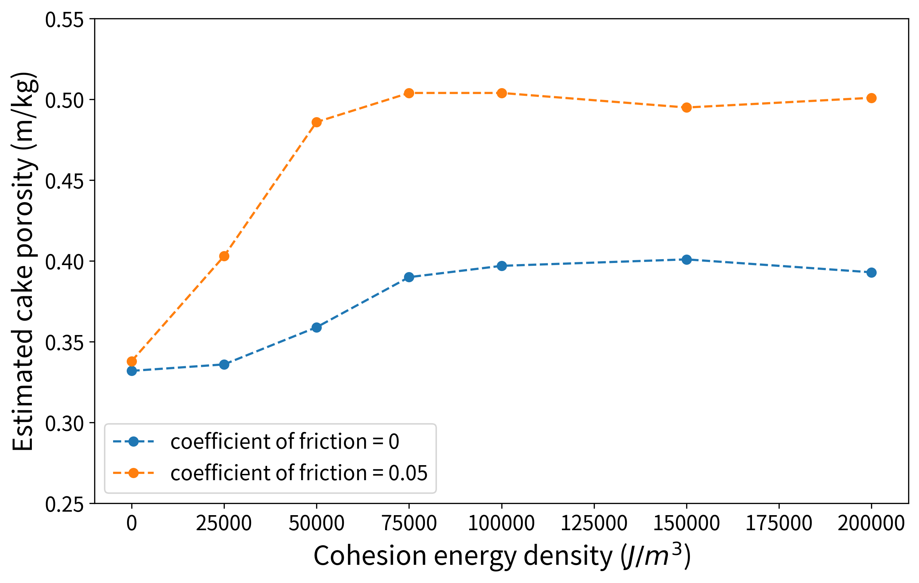

Figure 9. The influence of cohesion energy density on the estimated cake porosity

(50/50 wt% 20/50 PMMA)

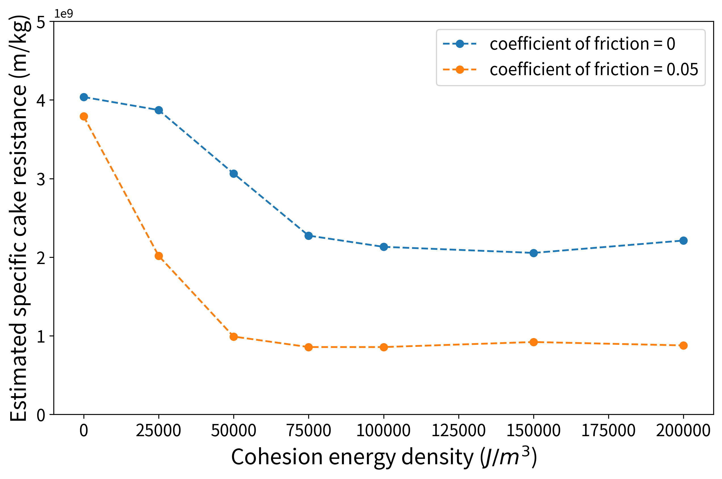

Figure 10. The influence of cohesion energy density on the estimated specific cake resistance

(50/50 wt% 20/50 PMMA)

## Case Study: Ammonium Alum System

To demonstrate the proposed method, an integrated evaporative crystallization-filtration process for the production of ammonium alum is studied. The process flowsheet and operating conditions are shown in Figure 11. The nucleation rate of ammonium alum can be expressed using the following equation, where *B*0 has units of #/L∙s, *MT* has units of g/L and *Gc* has units of m/s.38

|  |  |
| --- | --- |
|  | (16) |

The CSD of the crystalline product for different crystallizer volumes is shown in Figure 12. Part of the CSD is truncated in the DEM simulation as described in Section 3.1. As shown in Figure 12, the crystalline product from a larger crystallizer has a larger average crystal size and a broader CSD. This result can be explained by Figure 13. Assuming that the slurry concentration is fixed at 200 g/L, as shown in Figure 13, the nucleation rate decreases faster than the crystal growth rate when the crystallizer volume increases. Thus, fewer crystals are formed and the average crystal size increases when the crystallizer volume increases.

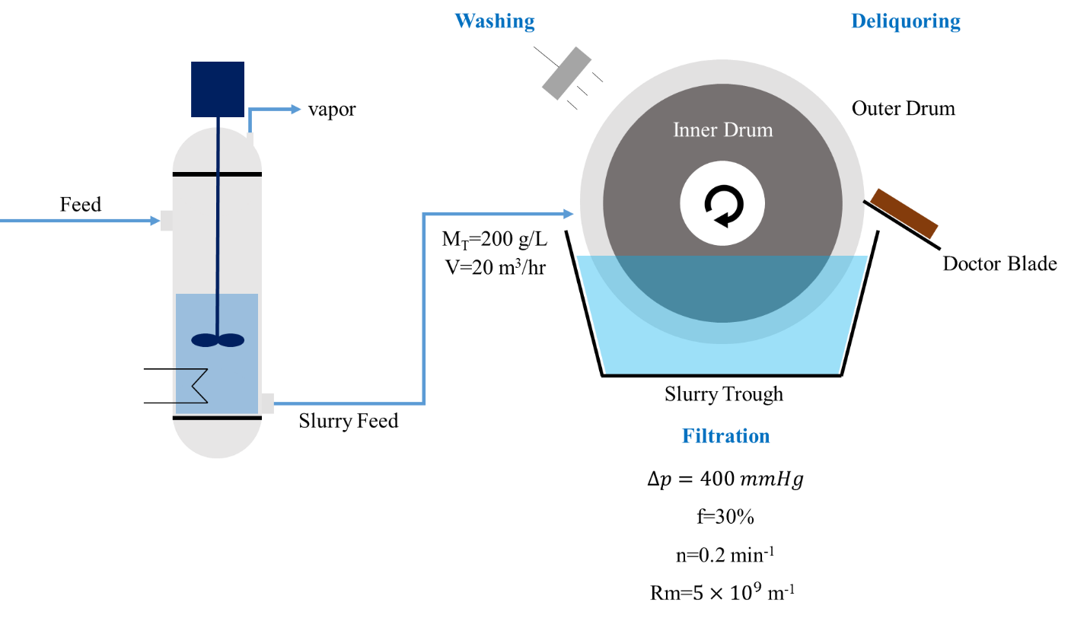

Figure 11. Process flowsheet of an integrated crystallization-filtration process

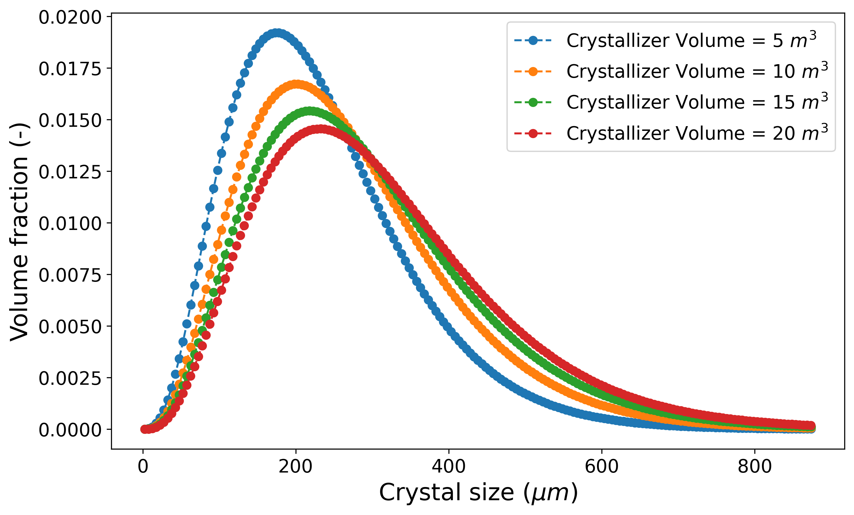

Figure 12. CSD of crystalline product with different crystallizer volume

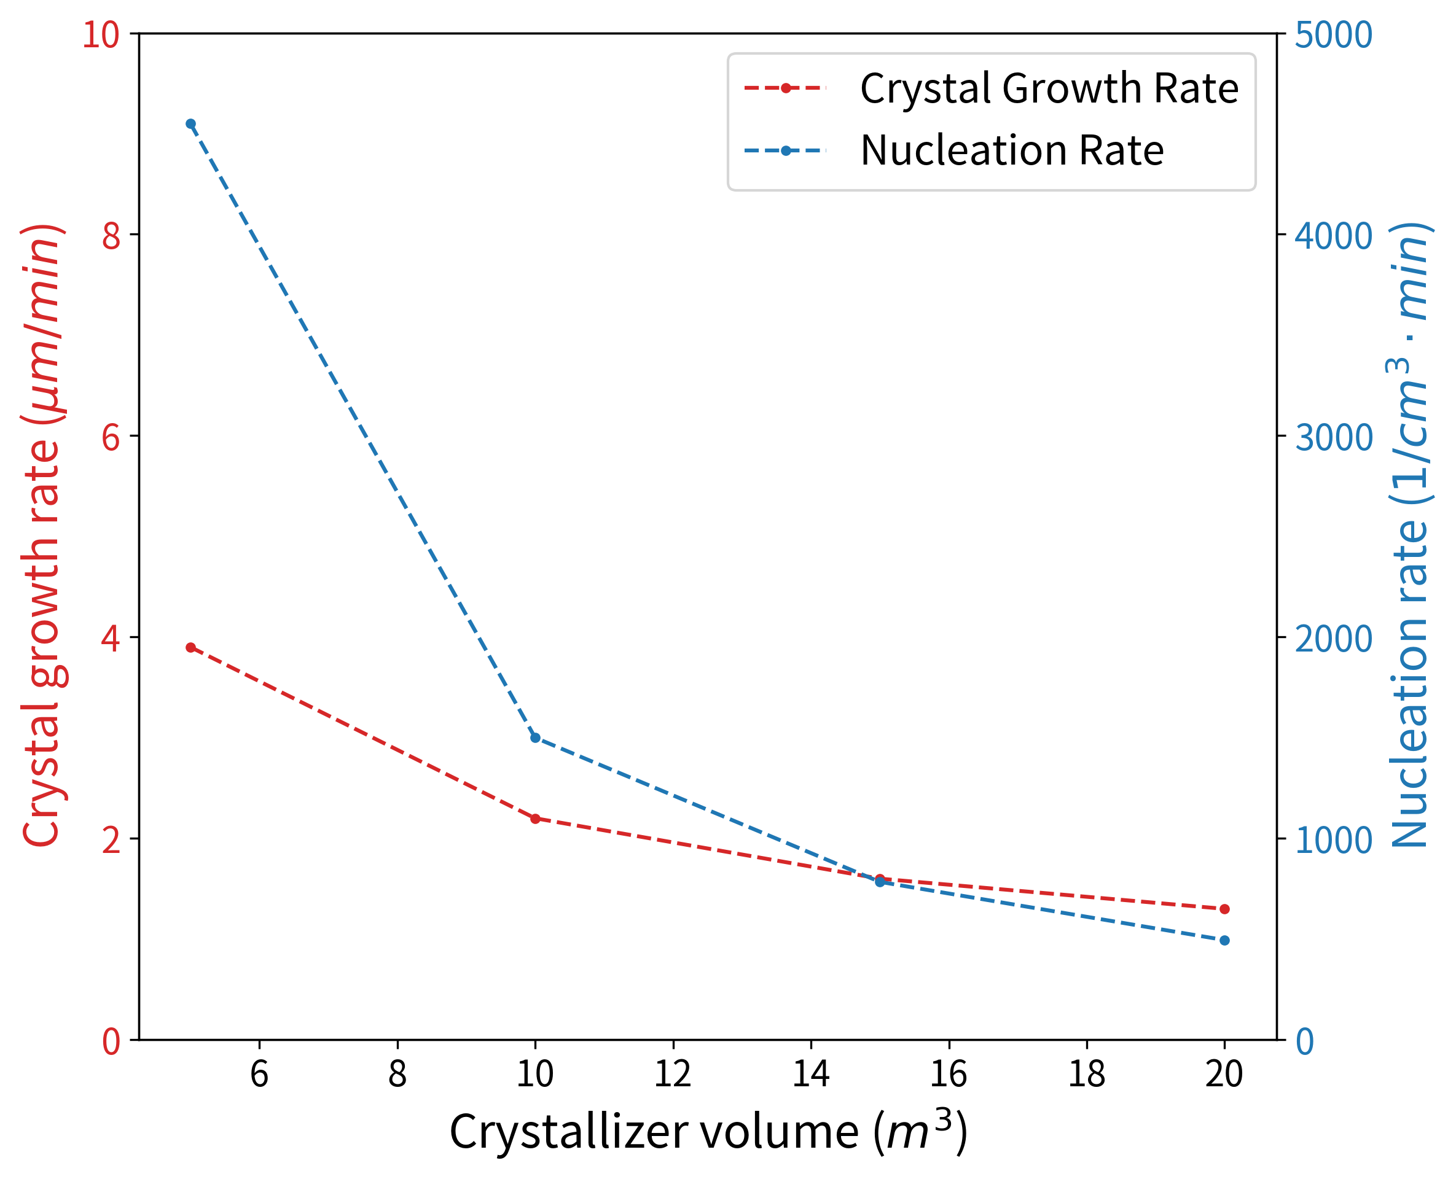

Figure 13. The growth rate and nucleation rate under different crystallizer volume

The parameters used to estimate the specific cake resistance are shown in Table 5. Each simulation took about 12 hours, which is significantly larger than the computation time (2 min) of PMMA system in Section 4.1. The difference demonstrates the difficulty in modelling the cake structure with broad CSD. Because the large particles are scarce, a subsystem with a large number of particles (in this case 100,000) should be used, which increases the computation burden of the DEM simulation. DEM simulation showed that the cake porosity only decreases from 0.293 to 0.292 when the crystallizer volume increases from 5 m3 to 20 m3, which means that the crystallizer volume has little effect on the crystal cake porosity in this case. Thus, the factor that most influences the estimated specific cake resistance is the summation term in Eq. (3). The simulated specific cake resistance and required filter area for each crystallizer volume are shown in Figure 14. As shown in Figure 14, the specific cake resistance decreases from m/kg to m/kg when the crystallizer volume increases from 5 m3 to 20 m3. However, the filter area required for the slurry only decreases from 3.4 m2 to 2.9 m2. This is because the filter medium resistance accounts for between 50 and 60% of overall filter resistance at the specified operating conditions. Thus, the decrease in the filter cake resistance has a limited effect on the required filter area.

In summary, if the product crystals are relatively large, the overall filter resistance may depend heavily on the filter medium resistance, and modifying the crystallizer design to decrease the filter cake resistance may not be warranted. As a rough estimation, for the operating conditions shown in Figure 11, if the volume average crystal size is smaller than 43 , the specific cake resistance will exceed m/kg, and the cake resistance will account for more than 80% of the overall resistance. In this case, improving filterability by modifying the crystallizer design may be effective. Using the method proposed in this work, the trade-off between crystallizer design and filter design can be analyzed quantitatively. If suitable correlations for crystallizer cost and filter cost are available, overall process economic optimization could be performed.

Table 5. Parameters used for ammonium alum system

|  |  |  |
| --- | --- | --- |
| Parameters | Value (*SI* unit) | Value (*micro* unit) |
| DEM Setting | | |
| particle number | 100,000 | 100,000 |
| size of time step | s | 0.5 |
| number of time step | 200,000 | 200,000 |
| settling velocity | 0.01 m/s | 0.01 |
| Particle Properties | | |
| density | 2450 kg/m3 | 2.45 |
| Young’s modulus | 5,000,000 Pa | 5000 |
| Poisson ratio | 0.2 | 0.2 |
| coefficient of restitution | 0.3 | 0.3 |
| coefficient of friction | 0 | 0 |
| cohesion energy density | 50,000 J/m3 | 50 |
| sphericity | 1 | 1 |

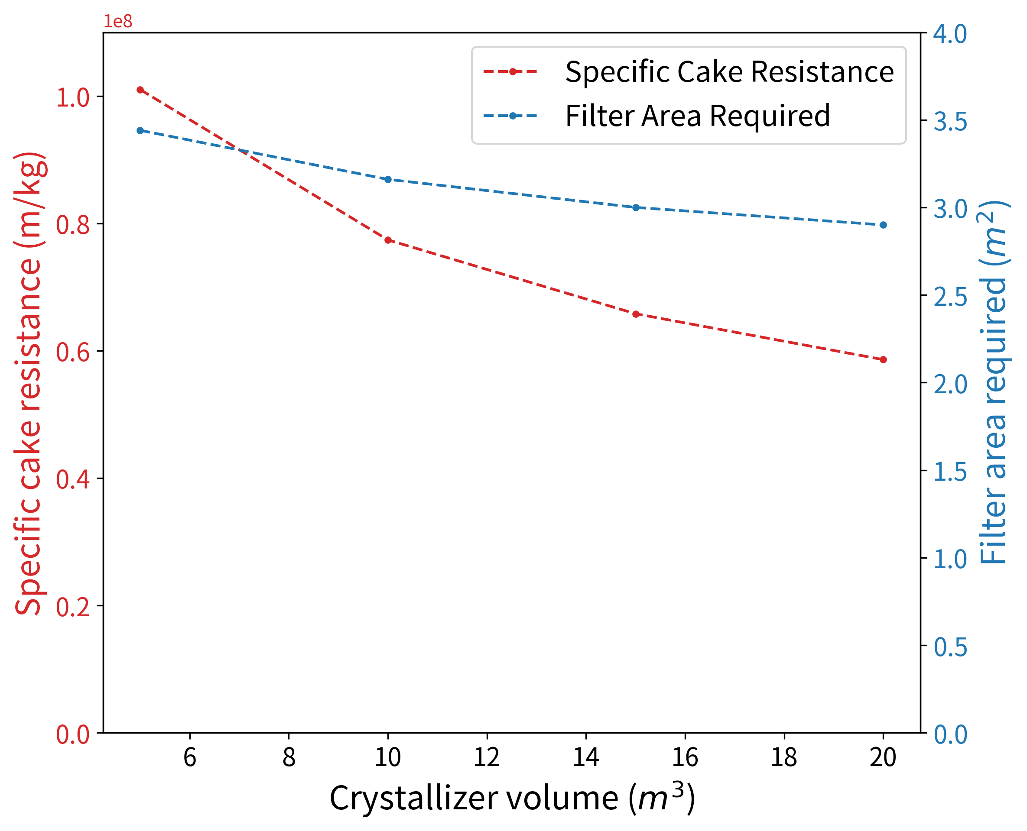

Figure 14. The specific cake resistance and filter area required for each crystallizer volume

# Conclusion

In this work, a method that combines the discrete element method and the Kozeny-Carman equation to estimate the filter cake filterability is proposed. The method can be combined with standard crystallizer models to predict the specific cake resistance based on the predicted crystal size distribution. The LIGGGHTS script is available in the GitHub project *Cake_Filterability_Simulator* (<https://github.com/mingchunNTU/Cake_Filterability_Simulator.git>). The proposed method is validated by comparing the simulation result with published experimental data. An integrated crystallization-filtration process for production of ammonium alum is simulated and analyzed to demonstrate the application of the method. The trade-off between crystallizer design and filter design is analyzed quantitatively. The results show that for crystals with relatively large size, the overall filter resistance depends heavily on the filter medium resistance, and the improvement in the filterability achieved by changing the crystallizer design is minimal. However, for smaller crystals, the filter cake resistance will contribute more to the overall resistance, and the optimization of the combined crystallization-filtration process will be important.

However, the proposed method has some limitations. First, the crystal cohesion energy density must be specified before the DEM simulations can be conducted. The cohesion energy density is difficult to predict and values are seldom found in the literature Furthermore, because the fluid phase is neglected in the DEM simulation, the compressibility of the filter cake cannot be modeled. Thus, it is suggested that several set of experiments should be conducted to estimate the compressibility of the filter cake and cohesion energy density of the crystals as shown in Figure 15. After the cake compressibility and cohesion energy density are estimated, the simulated specific cake resistance for different values of the pressure driving force can be substituted into the filter model such as the one given in Eq. (10) to calculate the required filter area. Furthermore, crystal shape also has a strong influence on filterability.13 However, in this work, the crystals are taken to be spheres in the DEM simulation. DEM calculations are much more challenging when the particles are non-spherical. Thus the method proposed here may not be practical if the particles have a very non-spherical shape such as plates or needles

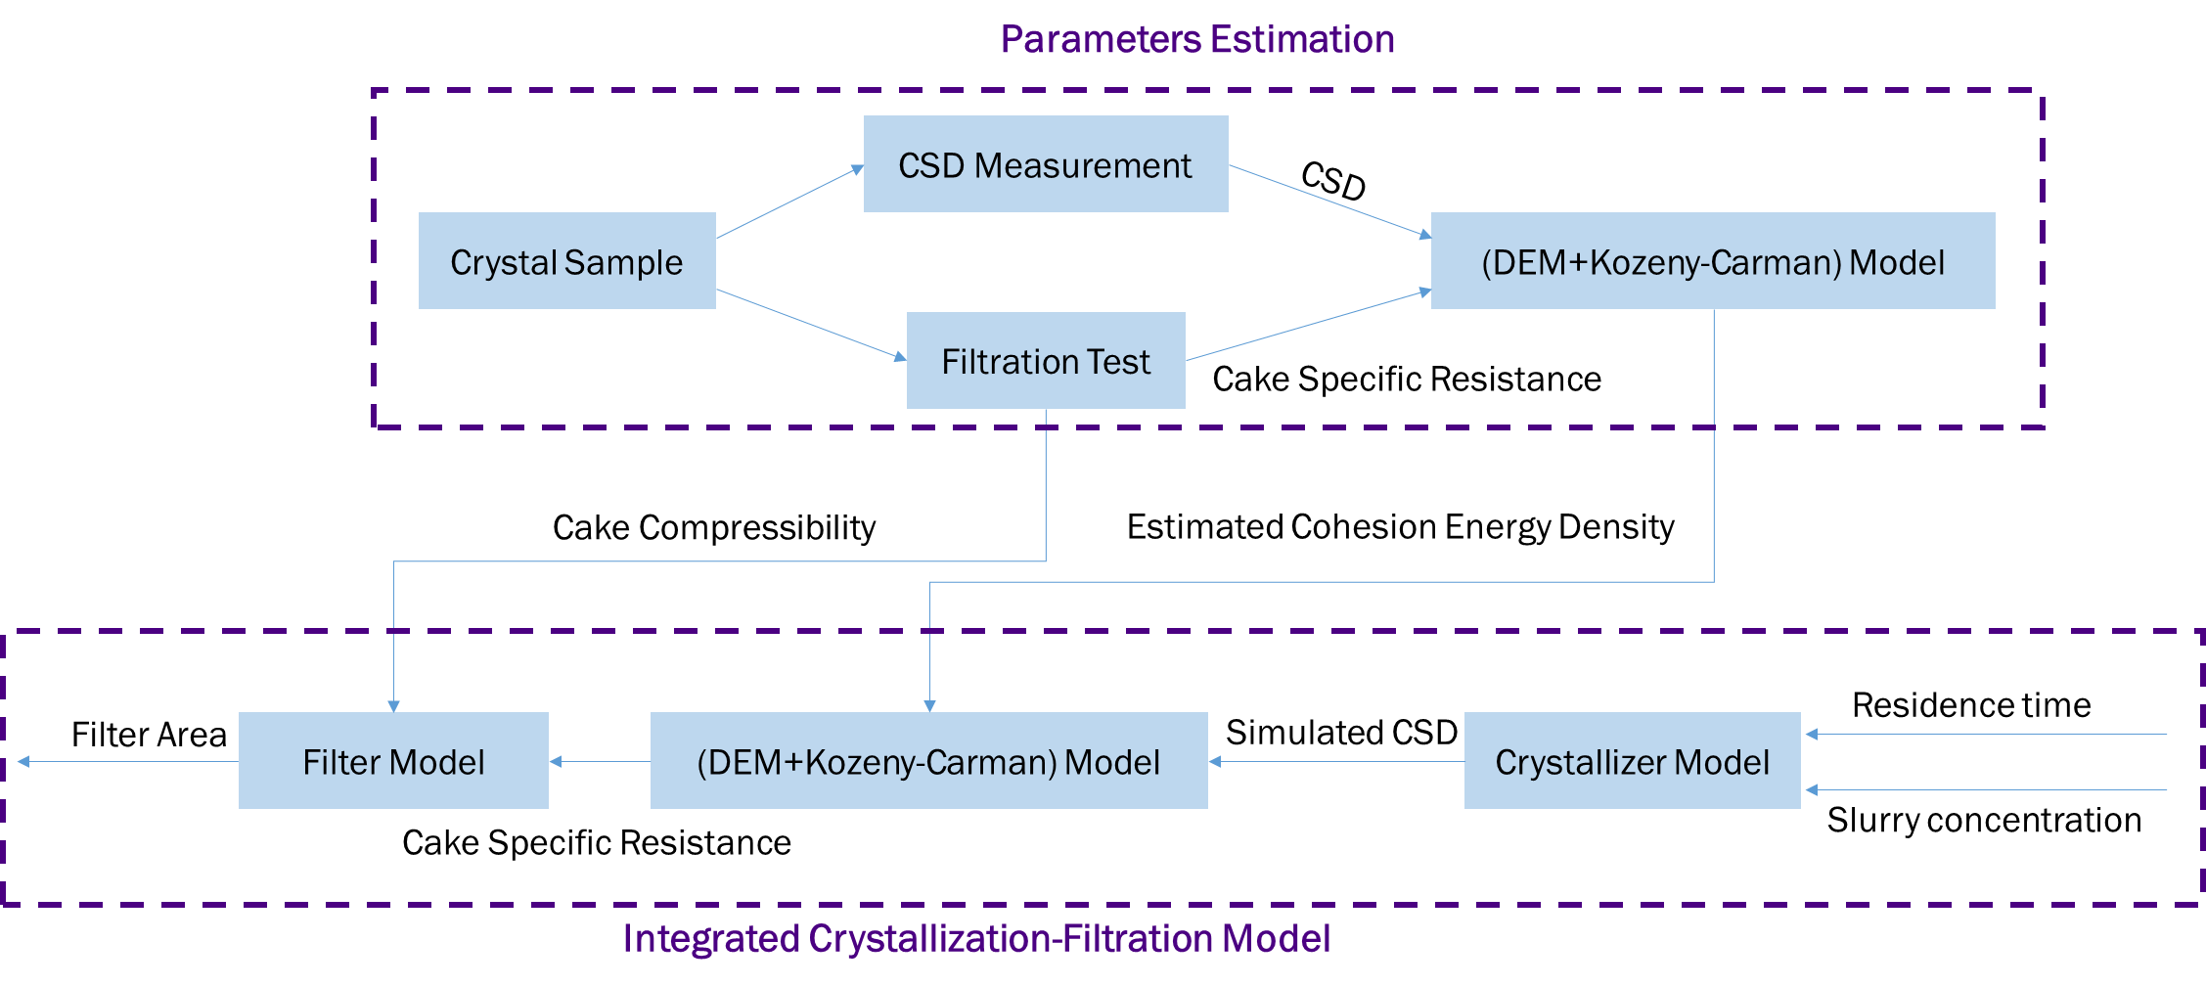

Figure 15. Procedure to establish an integrated crystallization-filtration model

# Acknowledgment

This work is sponsored by National Science and Technology Council of Taiwan under grant 111-2628-E-002-017-MY3.

# Nomenclature

A: filter area (m2)

Acontact: sphere-sphere contact area (m2)

b: number population density function (1/m4)

B0: nucleation rate (1/m3*s)

: particle size (m)

: filter medium diameter (m)

E: Young’s modulus of the particle (Pa)

f: the fraction of the drum immersed in the slurry (-)

: contact force of particle *j* on particle *i* (N)

: non-contact force of particle *k* on particle *i* (N)

: interaction force between fluid and particle *i* (N)

: force of gravity on particle *i* (N)

G: particle shear modulus (Pa)

Gc: crystal growth rate (m/s)

: particle *i* moment of inertia ()

: crystal shape factor (-)

L: crystal size (m)

: cake mass (kg)

: mass of particle *i* (kg)

: torque of particle *j* acting on particle *i* ()

MT: slurry concentration (kg/m3)

n: drum rotation speed (1/s)

: the volume fraction of particle with size (-)

: pressure drop across the filter (Pa)

: pressure drop across the filter cake (Pa)

: pressure drop across the filter medium (Pa)

r: particle radius (m)

s: cohesion energy density (J/m3)

: filter medium resistance (1/m)

: Rayleigh time step (s)

u: filtrate velocity (m/s)

vi: translational velocity of particle i (m/s)

V: Slurry flowrate (m3/hr)

: specific cake resistance (m/kg)

: porosity of filter cake (-)

: the average cake porosity of uniform sized spheres (-)

: viscosity (Pas)

: Poisson’s ratio of the particle (-)

: particle density (kg/m3)

: residence time of the crystallizer (s)

: particle sphericity (-)

: angular velocity of particle i (1/s)

# References

1. Tavare, N. S., *Industrial crystallization: process simulation analysis and design*. Springer Science & Business Media: 2013.

2. Wibowo, C.; Chang, W.-C.; Ng, K. M., Design of integrated crystallization systems. *AIChE Journal* **2001,** *47* (11), 2474-2492.

3. Anlauf, H., *Wet cake filtration: fundamentals, equipment, and strategies*. John Wiley & Sons: 2019.

4. Laky, D. J.; Casas-Orozco, D.; Destro, F.; Barolo, M.; Reklaitis, G. V.; Nagy, Z. K., Integrated synthesis, crystallization, filtration, and drying of active pharmaceutical ingredients: a model-based digital design framework for process optimization and control. In *Optimization of Pharmaceutical Processes*, Springer: 2022; pp 253-287.

5. Chang, W.-C.; Ng, K. M., Synthesis of processing system around a crystallizer. *AIChE Journal* **1998,** *44* (10), 2240-2251.

6. Beck, R.; Häkkinen, A.; Malthe-Sørenssen, D.; Andreassen, J.-P., The effect of crystallization conditions, crystal morphology and size on pressure filtration of l-glutamic acid and an aromatic amine. *Separation and Purification Technology* **2009,** *66* (3), 549-558.

7. Wakeman, R., The influence of particle properties on filtration. *Separation and Purification Technology* **2007,** *58* (2), 234-241.

8. Tseng, Y.-T.; Ward, J. D., Comparison of objective functions for batch crystallization using a simple process model and Pontryagin’s minimum principle. *Computers & Chemical Engineering* **2017,** *99*, 271-279.

9. Tseng, Y.-T.; Pan, H.-J.; Ward, J. D., Pareto-Optimal Fronts for Simple Crystallization Systems Using Pontryagin’s Minimum Principle. *Industrial & Engineering Chemistry Research* **2019,** *58* (31), 14239-14251.

10. Pan, H.-J.; Ward, J. D., Dimensionless framework for seed recipe design and optimal control of batch crystallization. *Industrial & Engineering Chemistry Research* **2021,** *60* (7), 3013-3026.

11. Féraud, J. P.; Bourcier, D.; Ode, D.; Puel, F., New filterability and compressibility test cell design for nuclear products. *Nuclear Engineering and Design* **2013,** *265*, 288-293.

12. Tien, C., *Introduction to cake filtration: analyses, experiments and applications*. Elsevier: 2006.

13. Perini, G.; Salvatori, F.; Ochsenbein, D. R.; Mazzotti, M.; Vetter, T., Filterability prediction of needle-like crystals based on particle size and shape distribution data. *Separation and Purification Technology* **2019,** *211*, 768-781.

14. Bourcier, D.; Féraud, J. P.; Colson, D.; Mandrick, K.; Ode, D.; Brackx, E.; Puel, F., Influence of particle size and shape properties on cake resistance and compressibility during pressure filtration. *Chemical Engineering Science* **2016,** *144*, 176-187.

15. Nagy, B.; Szilágyi, B.; Domokos, A.; Tacsi, K.; Pataki, H.; Marosi, G.; Nagy, Z. K.; Nagy, Z. K., Modeling of pharmaceutical filtration and continuous integrated crystallization-filtration processes. *Chemical Engineering Journal* **2021,** *413*, 127566.

16. Ouchiyama, N.; Tanaka, T., Porosity estimation from particle size distribution. *Industrial & Engineering Chemistry Fundamentals* **1986,** *25* (1), 125-129.

17. Li, B.; Zhang, H.; Saranteas, K.; Henson, M. A., A rigid body dynamics model to predict the combined effects of particle size and shape on pressure filtration. *Separation and Purification Technology* **2021,** *278*, 119462.

18. Zhu, H. P.; Zhou, Z. Y.; Yang, R. Y.; Yu, A. B., Discrete particle simulation of particulate systems: Theoretical developments. *Chemical Engineering Science* **2007,** *62* (13), 3378-3396.

19. Kieckhefen, P.; Pietsch, S.; Dosta, M.; Heinrich, S., Possibilities and Limits of Computational Fluid Dynamics–Discrete Element Method Simulations in Process Engineering: A Review of Recent Advancements and Future Trends. *Annual Review of Chemical and Biomolecular Engineering* **2020,** *11* (1), 397-422.

20. Dong, K. J.; Zou, R. P.; Yang, R. Y.; Yu, A. B.; Roach, G., DEM simulation of cake formation in sedimentation and filtration. *Minerals Engineering* **2009,** *22* (11), 921-930.

21. D'yachenko, E. N.; Dueck, J. H., Modeling of sedimentation and filtration layer formation by discrete element method. *Компьютерные исследования и моделирование* **2012,** *4* (1), 105-120.

22. Yue, C.; Zhang, Q.; Zhai, Z., Numerical simulation of the filtration process in fibrous filters using CFD-DEM method. *Journal of Aerosol Science* **2016,** *101*, 174-187.

23. Sheng, Y.; Wang, M.; Zhang, L.; Ren, Q., Analysis of filtration process of 3-D mesh spacer filter by using CFD-DEM simulation. *Powder Technology* **2022,** *396*, 785-793.

24. Hund, D.; Lösch, P.; Kerner, M.; Ripperger, S.; Antonyuk, S., CFD-DEM study of bridging mechanisms at the static solid-liquid surface filtration. *Powder Technology* **2020,** *361*, 600-609.

25. Sören, S.; Jürgen, T., Simulation of a Filtration Process by DEM and CFD. *International Journal of Mechanical Engineering and Mechatronics* **2012,** *1* (2), 28-35.

26. Qian, F.; Huang, N.; Lu, J.; Han, Y., CFD–DEM simulation of the filtration performance for fibrous media based on the mimic structure. *Computers & Chemical Engineering* **2014,** *71*, 478-488.

27. Deshpande, R.; Antonyuk, S.; Iliev, O., Study of the filter cake formed due to the sedimentation of monodispersed and bidispersed particles using discrete element method–computational fluid dynamics simulations. *AIChE Journal* **2019,** *65* (4), 1294-1303.

28. Li, B.; Dobosz, K. M.; Zhang, H.; Schiffman, J. D.; Saranteas, K.; Henson, M. A., Predicting the performance of pressure filtration processes by coupling computational fluid dynamics and discrete element methods. *Chemical Engineering Science* **2019,** *208*, 115162.

29. Burns, S. J.; Piiroinen, P. T.; Hanley, K. J., Critical time step for DEM simulations of dynamic systems using a Hertzian contact model. *International Journal for Numerical Methods in Engineering* **2019,** *119* (5), 432-451.

30. Volk, A.; Ghia, U.; Liu, G. R., Assessment of CFD-DEM solution error against computational cell size for flows through a fixed-bed of binary-sized particles. *Powder Technology* **2018,** *325*, 519-529.

31. Goniva, C.; Kloss, C.; König, A.; Pirker, S., An open source CFD-DEM perspective. *5th OpenFOAM* **2010**.

32. Kloss, C.; Goniva, C.; Hager, A.; Amberger, S.; Pirker, S., Models, algorithms and validation for opensource DEM and CFD–DEM. *Progress in Computational Fluid Dynamics, an International Journal* **2012,** *12* (2-3), 140-152.

33. Hager, A.; Kloss, C.; Goniva, C., Combining Open Source and Easy Access in the field of DEM and coupled CFD-DEM: LIGGGHTS®, CFDEM®coupling and CFDEM®workbench. In *Computer Aided Chemical Engineering*, Friedl, A.; Klemeš, J. J.; Radl, S.; Varbanov, P. S.; Wallek, T., Eds. Elsevier: 2018; Vol. 43, pp 1699-1704.

34. McCabe, W. L.; Smith, J. C.; Harriott, P., *Unit operations of chemical engineering*. McGraw-hill New York: 1993; Vol. 5.

35. Randolph, A., *Theory of particulate processes: analysis and techniques of continuous crystallization*. Elsevier: 2012.

36. Coetzee, C., Simplified Johnson-Kendall-Roberts (SJKR) contact model. *University of Stellenbosch report* **2020**.

37. Seville, J.; Tüzün, U.; Clift, R., *Processing of particulate solids*. Springer Science & Business Media: 2012; Vol. 9.

38. Garside, J.; Shah, M. B., Crystallization kinetics from MSMPR crystallizers. *Industrial & Engineering Chemistry Process Design and Development* **1980,** *19* (4), 509-514.

39. Kloss, C., *LIGGGHTS(R)-PUBLIC Documentation* 2014.

40. Yanzhong, W.; Bin, W.; Xiangyu, W., Wet friction-elements boundary friction mechanism and friction coefficient prediction. *Tribology in Industry* **2012,** *34* (4), 198.

1. E-mail: jeffward@ntu.edu.tw